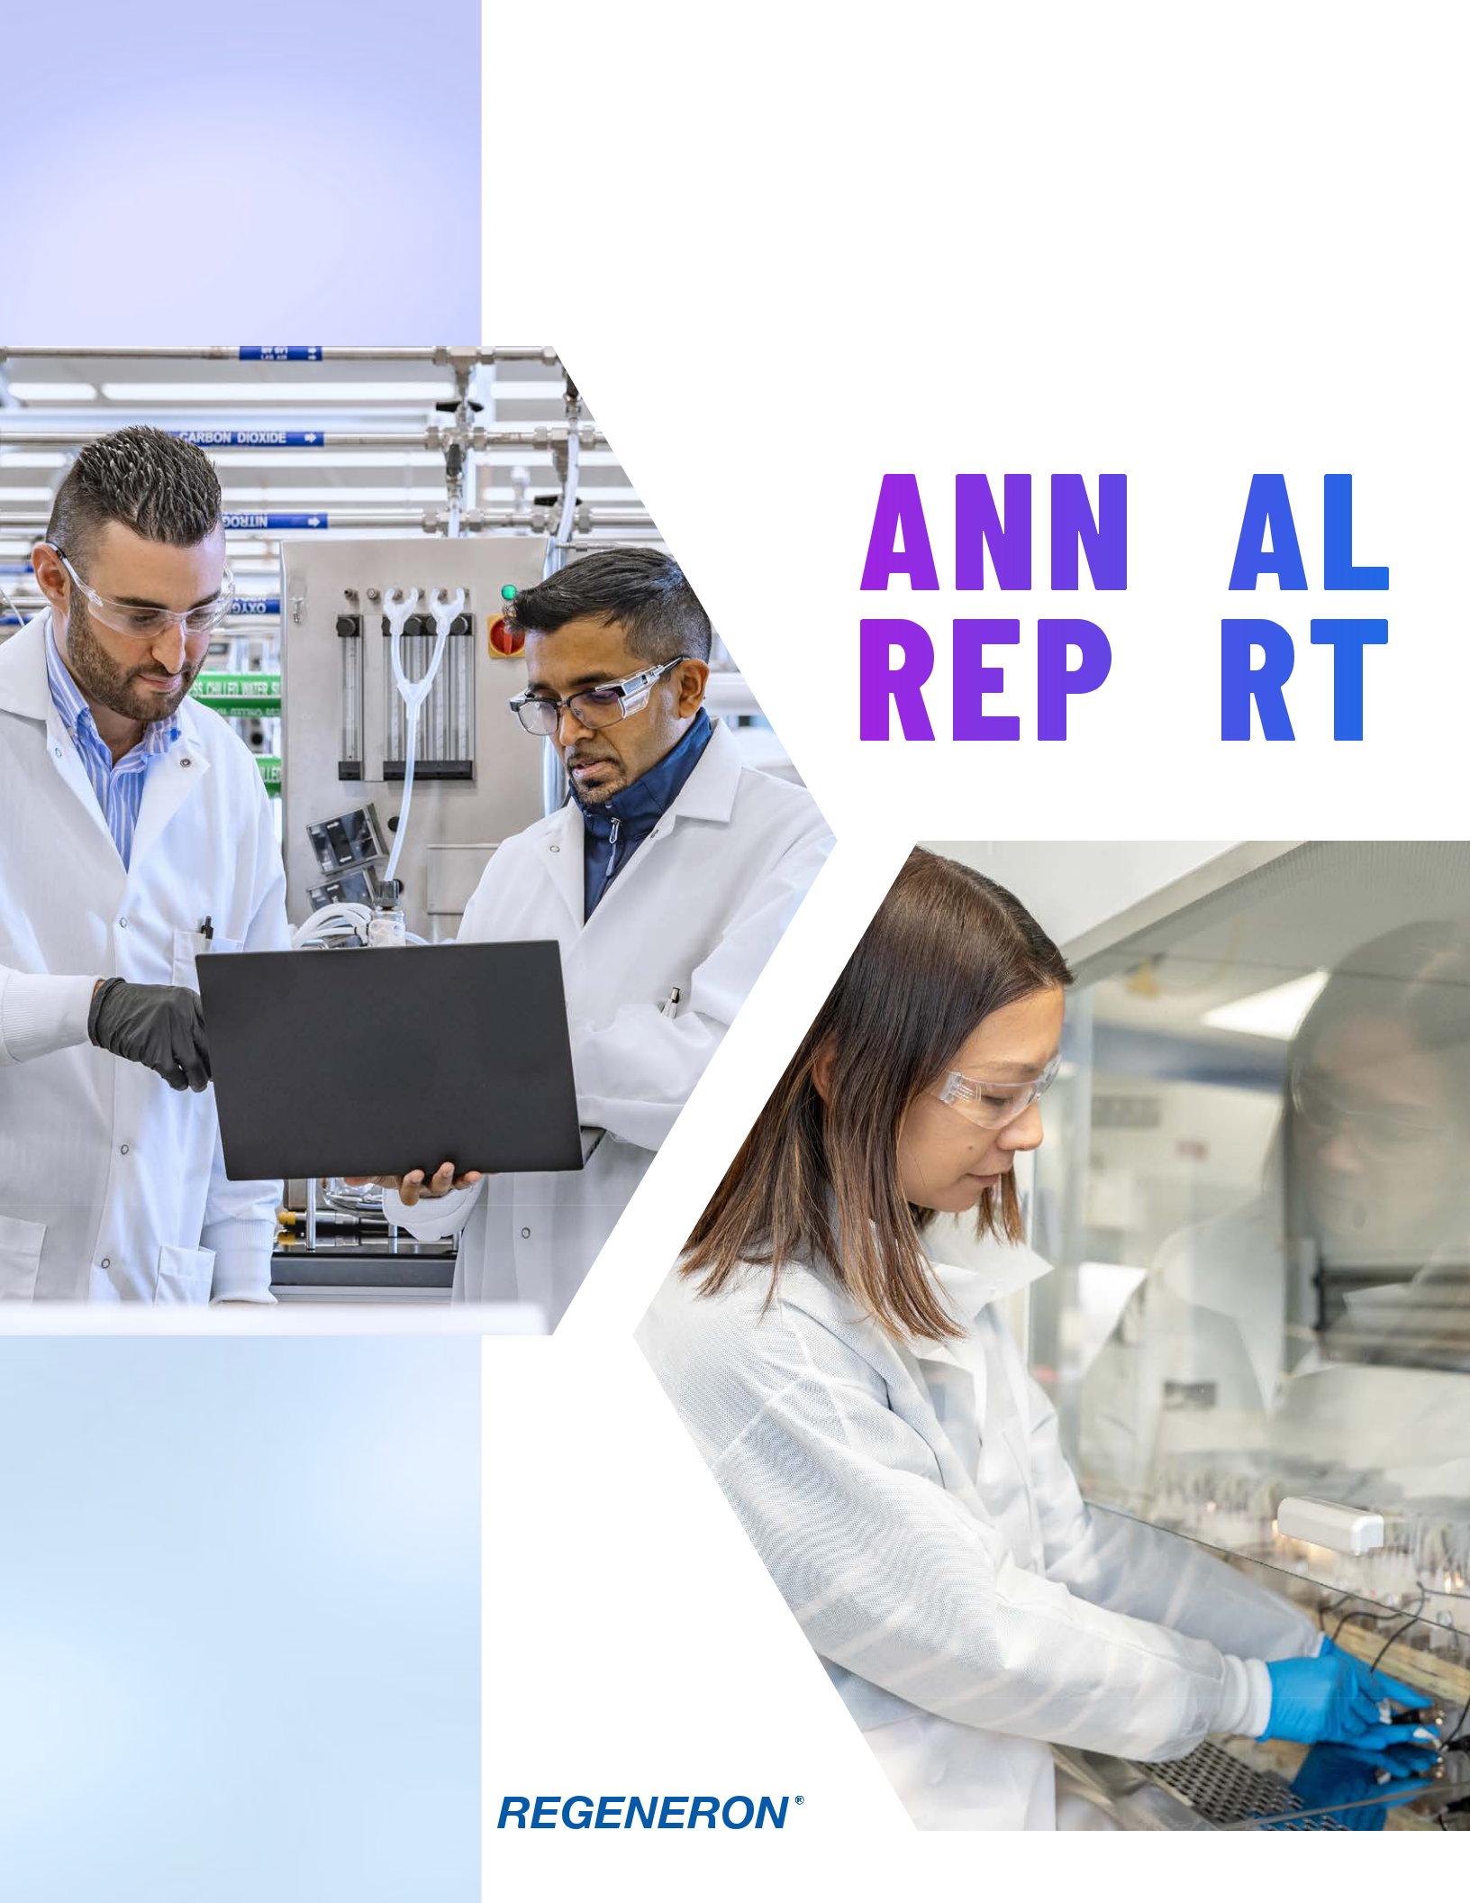

2025
ANNUAL

REPORT

2025 At-a-Glance


Financial Strength

- $14.3B in 2025 revenues

- 4 currently marketed blockbuster medicines: Dupixent® (dupilumab), EYLEA HD® (aflibercept) Injection 8 mg, EYLEA® (aflibercept) Injection, and Libtayo® (cemiplimab)

- Dupixent: >1.4M patients actively treated globally; $17.8B in 2025 global net product sales (recorded by our collaborator Sanofi)

- Retinal franchise (EYLEA HD and EYLEA): $7.9B in 2025 global net product sales (ex-U.S. sales of $3.5B recorded by our collaborator Bayer)

- Libtayo: $1.5B in 2025 global net product sales


Investing for Growth

- $5.9B invested in R&D in 2025, representing ~41% of 2025 revenues

- ~$6.6B anticipated R&D investment in 2026

- $9B committed to ongoing/upcoming U.S. manufacturing and R&D infrastructure expansion

- $3.8B returned to shareholders through share repurchases and dividends in 2025


Innovation Engine

- Nearly 50 clinical candidates across six therapeutic areas

- Advancing clinical programs with near-term impact in immunology and inflammation, cancer, hematology, neurology, cardiovascular and metabolic diseases, and rare diseases.

- 15 internally developed medicines approved or authorized over past ~15 years

- R&D powered by proprietary VelociSuite® technologies and the Regeneron

Genetics Center®


Responsibility

- Achieved or exceeded nearly all of our 2025 responsibility goals

- 10 years of our flagship social impact programs, the Regeneron Science Talent Search and Day for Doing Good

- Donated up to 500 doses of our Ebola medicine to the World Health Organization for use in countries most at risk

- Debuted 2030 responsibility goals focused on advancing our mission



FORM 10-K

UNITED STATES

SECURITIES AND EXCHANGE COMMISSION

Washington, D.C. 20549

FORM 10-K

(Mark One)

- ANNUAL REPORT PURSUANT TO SECTION 13 OR 15(d) OF THE SECURITIES EXCHANGE ACT OF 1934 For the fiscal year ended December 31, 2025
OR

- TRANSITION REPORT PURSUANT TO SECTION 13 OR 15(d) OF THE SECURITIES EXCHANGE ACT OF 1934 For the transition period from __________ to __________

Commission File Number: 000-19034

REGENERON PHARMACEUTICALS, INC.

 |  | (Exact name of registrant as specified in its charter)
 |  | New York |  |  | 13-3444607
(State or other jurisdiction of incorporation or organization) |  |  |  |  | (I.R.S. Employer Identification No.)
 | 777 Old Saw Mill River Road Tarrytown, New York 10591-6707
 | (Address of principal executive offices, including zip code)
 |  |  | (914) 847-7000
 |  | (Registrant's telephone number, including area code)
 | Securities registered pursuant to Section 12(b) of the Act:
 | Title of each class |  | Trading Symbol |  | Name of each exchange on which registered
Common Stock - par value $.001 per share |  |  | REGN |  | NASDAQ Global Select Market
 | Securities registered pursuant to section 12(g) of the Act: None
Indicate by check mark if the registrant is a well-known seasoned issuer, as defined in Rule 405 of the Securities Act. |  |  |  |  |  | Yes | ☒ | No | ☐
Indicate by check mark if the registrant is not required to file reports pursuant to Section 13 or Section 15(d) of the Act. |  |  |  |  |  | Yes | ☐ | No | ☒
Indicate by check mark whether the registrant (1) has filed all reports required to be filed by Section 13 or 15(d) of the Securities
Exchange Act of 1934 during the preceding 12 months (or for such shorter period that the registrant was required to file such reports), and |  |  |  |  |  | Yes | ☒ | No | ☐
(2) has been subject to such filing requirements for the past 90 days.
Indicate by check mark whether the registrant has submitted electronically every Interactive Data File required to be submitted pursuant to
Rule 405 of Regulation S-T (§232.405 of this chapter) during the preceding 12 months (or for such shorter period that the registrant was |  |  |  |  |  | Yes | ☒ | No | ☐
required to submit such files).

Indicate by check mark whether the registrant is a large accelerated filer, an accelerated filer, a non-accelerated filer, a smaller reporting company, or an emerging growth company. See the definitions of "large accelerated filer," "accelerated filer," "smaller reporting company," and "emerging growth company" in Rule 12b-2 of the Exchange Act.

Large accelerated filer ☒ Accelerated filer ☐ Non-accelerated filer ☐ Smaller reporting company ☐ Emerging growth company ☐

If an emerging growth company, indicate by check mark if the registrant has elected not to use the extended transition period for complying with any new |  | ☐
or revised financial accounting standards provided pursuant to Section 13(a) of the Exchange Act. |  | ☐
Indicate by check mark whether the registrant has filed a report on and attestation to its management’s assessment of the effectiveness of its internal
control over financial reporting under Section 404(b) of the Sarbanes-Oxley Act (15 U.S.C. 7262(b)) by the registered public accounting firm that |  | ☒
prepared or issued its audit report. |  | ☒
If securities are registered pursuant to Section 12(b) of the Act, indicate by check mark whether the financial statements of the registrant included in the |  | ☐
filing reflect the correction of an error to previously issued financial statements. |  | ☐
Indicate by check mark whether any of those error corrections are restatements that required a recovery analysis of incentive-based compensation received |  | ☐
by any of the registrant’s executive officers during the relevant recovery period pursuant to §240.10D-1(b). |  | ☐
Indicate by check mark whether the registrant is a shell company (as defined in Rule 12b-2 of the Act). | Yes ☐ No | ☒

The aggregate market value of the voting and non-voting common stock held by non-affiliates of the registrant was $54.8 billion, computed by reference to the closing sales price of the stock on NASDAQ on June 30, 2025, the last trading day of the registrant's most recently completed second fiscal quarter. For purposes of this calculation only, the registrant has assumed that all of its directors and executive officers, and no other persons, are its affiliates. This determination of affiliate status is not necessarily a determination for other purposes.

The number of shares outstanding of each of the registrant's classes of common stock as of January 22, 2026:

Class of Common Stock |  | Number of Shares
Class A Stock, $.001 par value |  | 1,817,146
Common Stock, $.001 par value | 103,902,660

DOCUMENTS INCORPORATED BY REFERENCE

Specified portions of the Registrant's definitive proxy statement to be filed in connection with solicitation of proxies for its 2026 Annual Meeting of Shareholders are incorporated by reference into Part III of this Form 10-K. Exhibit index is located on pages 91 to 94 of this filing.

 | REGENERON PHARMACEUTICALS, INC.
 | ANNUAL REPORT ON FORM 10-K
 | TABLE OF CONTENTS
PART I
Item 1. | Business
Item 1A. | Risk Factors
Item 1B. | Unresolved Staff Comments
Item 1C. | Cybersecurity
Item 2. | Properties
Item 3. | Legal Proceedings
Item 4. | Mine Safety Disclosures
PART II
Item 5. | Market for Registrant's Common Equity, Related Stockholder Matters,
Item 5. | and Issuer Purchases of Equity Securities
Item 6. | [Reserved]
Item 7. | Management's Discussion and Analysis of Financial Condition and
Item 7. | Results of Operations
Item 7A. | Quantitative and Qualitative Disclosures About Market Risk
Item 8. | Financial Statements and Supplementary Data
Item 9. | Changes in and Disagreements with Accountants on Accounting and
Item 9. | Financial Disclosure
Item 9A. | Controls and Procedures
Item 9B. | Other Information
Item 9C. | Disclosure Regarding Foreign Jurisdictions that Prevent Inspections
PART III
Item 10. | Directors, Executive Officers and Corporate Governance
Item 11. | Executive Compensation
Item 12. | Security Ownership of Certain Beneficial Owners and Management and
Item 12. | Related Stockholder Matters
Item 13. | Certain Relationships and Related Transactions, and Director
Item 13. | Independence
Item 14. | Principal Accountant Fees and Services
PART IV
Item 15. | Exhibits and Financial Statement Schedules
Item 16. | Form 10-K Summary


SIGNATURE PAGE

Page Numbers

2

36

70

71

72

72

72

72

74

74

88

88

89

89

89

90

90

90

90

90

90

91

94

95

"Altibodies™," "ARCALYST®," "Evkeeza®," "EYLEA®," "EYLEA HD®," "Inmazeb®," "Libtayo®," "Lynozyfic™," "Ordspono™," "Praluent®" (in the United States), "REGEN-COV®," "Regeneron®," "Regeneron Genetics Center®," "RGC®," "STEM-Fueled™," "Veloci-Bi®," "VelociGene®," "VelociHum®," "VelociMab®," "VelocImmune®," "VelociMouse®," "VelociSuite®," "VelociT®," "Veopoz®," and "ZALTRAP®" are trademarks of Regeneron Pharmaceuticals, Inc. Trademarks and trade names of other companies appearing in this report are, to the knowledge of Regeneron Pharmaceuticals, Inc., the property of their respective owners. This report refers to products of Regeneron Pharmaceuticals, Inc., its collaborators, and other parties. Consult the product label in each territory for specific information about such products.

PART I

Item 1. Business

This Annual Report on Form 10-K contains forward-looking statements that involve risks and uncertainties relating to future events and the future performance of Regeneron Pharmaceuticals, Inc. (where applicable, together with its subsidiaries, "Regeneron," "Company," "we," "us," and "our"), and actual events or results may differ materially from these forward-looking statements. Words such as "anticipate," "expect," "intend," "plan," "believe," "seek," "estimate," variations of such words, and similar expressions are intended to identify such forward-looking statements, although not all forward-looking statements contain these identifying words. These statements concern, and these risks and uncertainties include, among others:

- competing products and product candidates (including biosimilar products) that may be superior to, or more cost effective than, products marketed or otherwise commercialized by Regeneron and/or its collaborators or licensees (collectively, "Regeneron's Products") and product candidates being developed by Regeneron and/or its collaborators or licensees (collectively, "Regeneron's Product Candidates");

- uncertainty of the utilization, market acceptance, and commercial success of Regeneron's Products and Regeneron's Product Candidates and the impact of studies (whether conducted by Regeneron or others and whether mandated or voluntary) or recommendations and guidelines from governmental authorities and other third parties or other factors beyond Regeneron's control on the commercial success of Regeneron's Products and Regeneron's Product Candidates;
- the nature, timing, and possible success and therapeutic applications of Regeneron's Products and Regeneron's Product Candidates and research and clinical programs now underway or planned, including without limitation those discussed or referenced in this report, Regeneron's and its collaborators' earlier-stage programs, and the use of human genetics in Regeneron's research programs;

- the likelihood and timing of achieving any of our anticipated development milestones referenced in this report;

- safety issues resulting from the administration of Regeneron's Products and Regeneron's Product Candidates in patients, including serious complications or side effects in connection with the use of Regeneron's Products and Regeneron's Product Candidates in clinical trials;
- the likelihood, timing, and scope of possible regulatory approval and commercial launch of Regeneron's Product Candidates and new indications for Regeneron's Products, including without limitation those discussed or referenced in this report;
- the extent to which the results from the research and development programs conducted by us and/or our collaborators may be replicated in other studies and/or lead to advancement of product candidates to clinical trials, therapeutic applications, or regulatory approval;
- ongoing regulatory obligations and oversight impacting Regeneron's Products, research and clinical programs, and business, including those relating to patient privacy;
- determinations by regulatory and administrative governmental authorities which may delay or restrict our ability to continue to develop or commercialize Regeneron's Products and Regeneron's Product Candidates;

- our ability to manufacture and manage supply chains for multiple products and product candidates and risks associated with tariffs and other trade restrictions;
- the ability of our collaborators, suppliers, or other third parties (as applicable) to perform manufacturing, filling, finishing, packaging, labeling, distribution, and other steps related to Regeneron's Products and Regeneron's Product Candidates;
- the availability and extent of reimbursement or copay assistance for Regeneron's Products from third-party payors and other third parties, including private payor healthcare and insurance programs, health maintenance organizations, pharmacy benefit management companies, and government programs such as Medicare and Medicaid;
- coverage and reimbursement determinations by such payors and other third parties and new policies and procedures adopted by such payors and other third parties;
- changes to drug pricing regulations and requirements and our drug pricing strategy;
- other changes in laws, regulations, and policies affecting the healthcare industry;
- the costs of developing, producing, and selling products or unanticipated expenses;
- our ability to meet any of our financial projections or guidance and changes to the assumptions underlying those projections or guidance;
- the potential for any license or collaboration agreement, including our agreements with Sanofi and Bayer (or their respective affiliated companies, as applicable), to be cancelled or terminated;
- the impact of public health outbreaks, epidemics, or pandemics on our business; and
- risks associated with litigation and other proceedings and government investigations relating to the Company and/or its operations (including without limitation those described in Note 16 to our Consolidated Financial Statements included in this report), risks associated with intellectual property of other parties and pending or future litigation relating thereto (including without limitation the patent litigation and other related proceedings described further in Note 16 to our Consolidated Financial Statements included in this report), the ultimate outcome of any such proceedings and investigations, and the impact any of the foregoing may have on our business, prospects, operating results, and financial condition.

2

These statements are made based on management's current beliefs and judgment, and the reader is cautioned not to rely on any such statements. In evaluating such statements, shareholders and potential investors should specifically consider the various factors identified under Part I, Item 1A. "Risk Factors," which could cause actual events and results to differ materially from those indicated by such forward-looking statements. We do not undertake any obligation to update (publicly or otherwise) any forward-looking statement, whether as a result of new information, future events, or otherwise.

General

Regeneron Pharmaceuticals, Inc. is a fully integrated biotechnology company that invents, develops, manufactures, and commercializes medicines for people with serious diseases. Our products and product candidates in development are designed to help patients with eye diseases, allergic and inflammatory diseases, cancer, cardiovascular and metabolic diseases, neurological diseases, hematologic conditions, infectious diseases, and rare diseases.

Our core business strategy is to maintain a strong foundation in scientific research and drug development using our proprietary technologies, and to build on that foundation with our clinical development, manufacturing, and commercial capabilities. Our objective is to continue to advance as an integrated, multi-product biotechnology company that provides patients and medical professionals with important medicines for preventing and treating human diseases.

Selected financial information is summarized as follows:

 |  | Year Ended December 31,
(In millions, except per share data) |  | 2025 |  |  | 2024 |  |  | 2023
Revenues | $ | 14,342.9 | $ |  | 14,202.0 | $ |  | 13,117.2
Net income | $ | 4,504.9 | $ |  | 4,412.6 | $ |  | 3,953.6
Net income per share - diluted | $ | 41.48 | $ |  | 38.34 | $ |  | 34.77
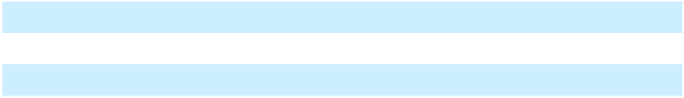

For purposes of this report, references to our products encompass products commercialized by us and/or our collaborators or licensees and references to our product candidates encompass product candidates in development by us and/or our collaborators or licensees (in the case of collaborated or licensed products or product candidates under the terms of the applicable collaboration or license agreements), unless otherwise stated or required by the context.

Products

Products that have received marketing approval are summarized in the table below. Certain products have also received marketing approval in countries outside the United States, European Union ("EU"), or Japan.

Product
EYLEA HD® (aflibercept) Injection
- _{mg}(a)

EYLEA® (aflibercept) Injection^{(a)}

Dupixent® (dupilumab) Injection^{(b)}

Disease
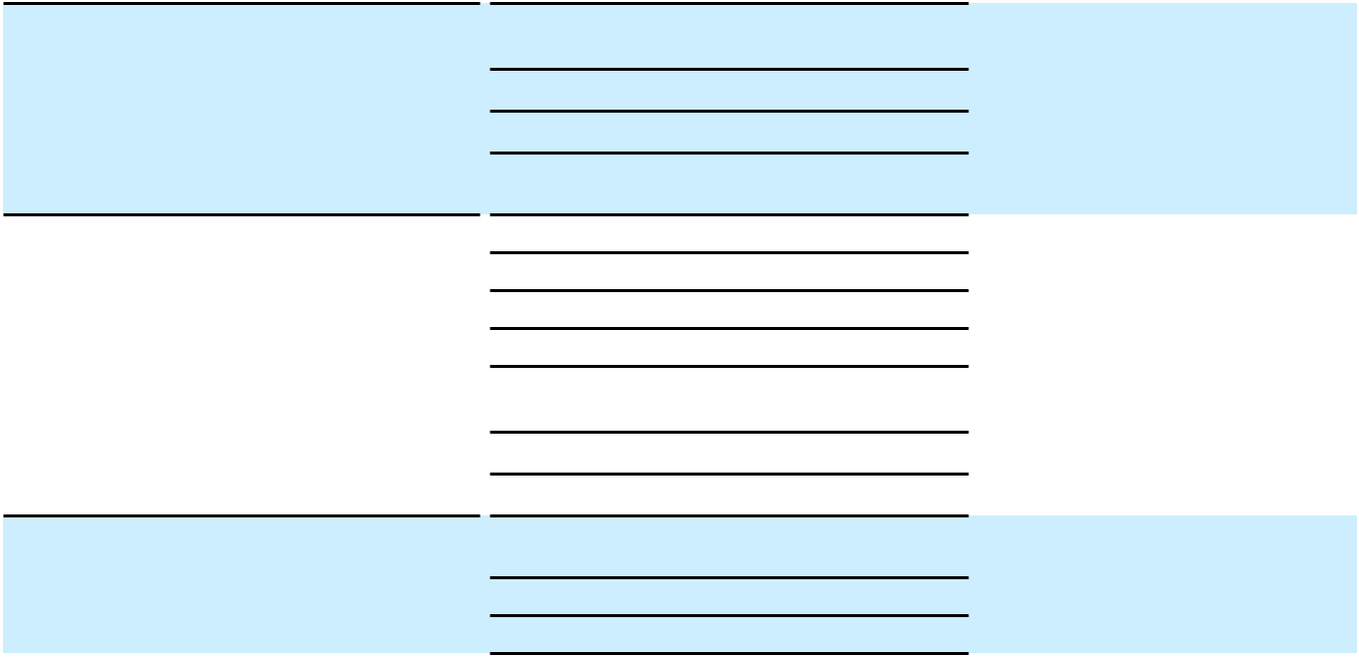

Wet age-related macular degeneration ("wAMD")

Diabetic macular edema ("DME")

Diabetic retinopathy ("DR")

Macular edema following retinal vein occlusion ("RVO")

wAMD

DME

DR

RVO

Myopic choroidal neovascularization ("mCNV")

Neovascular glaucoma ("NVG")

Retinopathy of prematurity ("ROP")

Atopic dermatitis (in patients aged 6 months and older)

Asthma (in adults and adolescents)

Asthma (in pediatrics 6–11 years of age)

Territory

U.S. |  | EU |  | Japan
a |  | a |  | a
a |  | a |  | a
a
a |  | a
a |  | a |  | a
a |  | a |  | a
a
a |  | a |  | a
 |  | a |  | a
 |  |  |  | a
a |  | a |  | a
a |  | a |  | a
a |  | a |  | a
a |  | a |  | a

3

Product (continued)
Dupixent® (dupilumab) Injection^{(b)}
(continued)

Libtayo® (cemiplimab) Injection

Praluent® (alirocumab) Injection^{(c)}

Kevzara® (sarilumab) Injection^{(b)}

Evkeeza® (evinacumab) Injection^{(d)}

Ordspono™ (odronextamab)

Disease
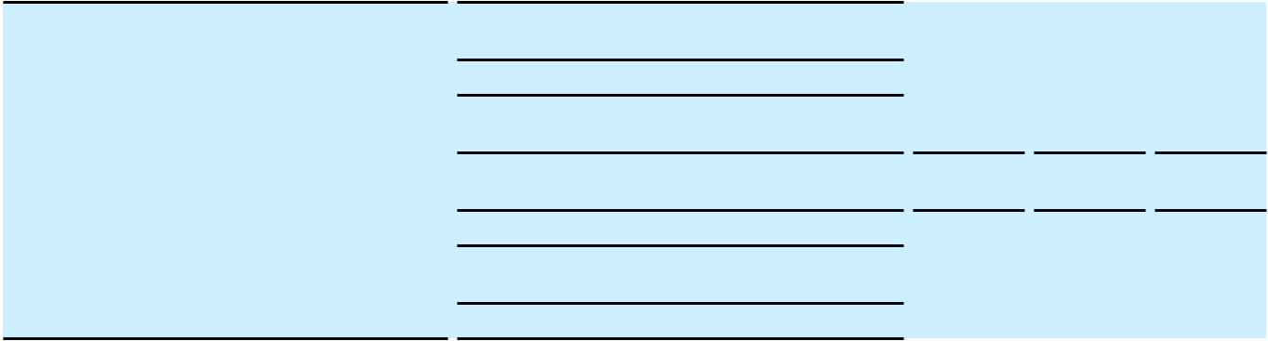

Chronic rhinosinusitis with nasal polyposis ("CRSwNP") (in adults)

CRSwNP (in adolescents)

Chronic obstructive pulmonary disease ("COPD")

Eosinophilic esophagitis ("EoE") (in patients aged 1 year and older)

Prurigo nodularis

Chronic spontaneous urticaria ("CSU") (in adults and adolescents)

Bullous pemphigoid

Metastatic or locally advanced first-line non-small cell lung cancer ("NSCLC"), monotherapy and in combination with chemotherapy

Metastatic or locally advanced basal cell carcinoma ("BCC")

Metastatic or locally advanced cutaneous squamous cell carcinoma ("CSCC")

Adjuvant CSCC

Metastatic or recurrent second-line cervical cancer
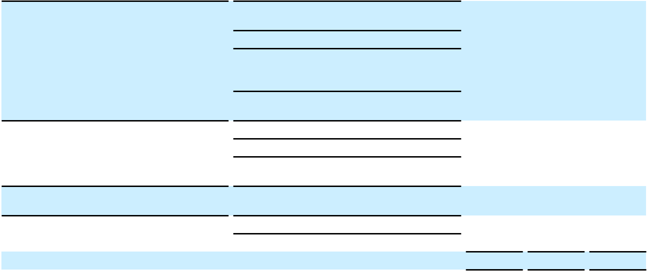
Cardiovascular risk reduction in patients at increased risk of cardiovascular events

Hypercholesterolemia

Heterozygous familial hypercholesterolemia ("HeFH") (in patients aged 8 years and older)

Homozygous familial hypercholesterolemia ("HoFH")

Rheumatoid arthritis ("RA")

Polymyalgia rheumatica ("PMR")

Polyarticular juvenile idiopathic arthritis ("pJIA")

HoFH (in adults, adolescents, and pediatrics)

Follicular lymphoma ("FL")

Diffuse large B-cell lymphoma ("DLBCL")

Territory

U.S. |  | EU |  | Japan
a |  | a |  | a
a
a |  | a |  | a

- a

a |  | a |  | a
a |  | a |  | a
a
a |  | a |  | a
a |  | a
a |  | a
a |  | a
 |  | a |  | a
a |  | a
a |  | a
a |  | a
a
a |  | a |  | a
a |  | a
a |  | a
a |  | a |  | a
 |  | a
 |  | a

Lynozyfic™ (linvoseltamab) |  | Relapsed/refractory multiple myeloma
Inmazeb® (atoltivimab, maftivimab, and |  | Infection caused by Zaire ebolavirus
odesivimab) Injection
Veopoz® (pozelimab) Injection |  | CD55-deficient protein-losing enteropathy
 |  | ("CHAPLE") (in patients aged 1 year and
 |  | older)
ARCALYST® (rilonacept) Injection^{(e)} |  | Cryopyrin-associated periodic syndromes
 |  | ("CAPS"), including familial cold auto-
 |  | inflammatory syndrome ("FCAS") and
 |  | Muckle-Wells syndrome ("MWS") (in
 |  | adults and adolescents)
 |  | Deficiency of interleukin-1 receptor
 |  | antagonist ("DIRA") (in adults,
 |  | adolescents, and pediatrics)
 |  | Recurrent pericarditis (in adults and
 |  | adolescents)
ZALTRAP® (ziv-aflibercept) Injection for |  | Metastatic colorectal cancer ("mCRC")
Intravenous Infusion^{(f)}
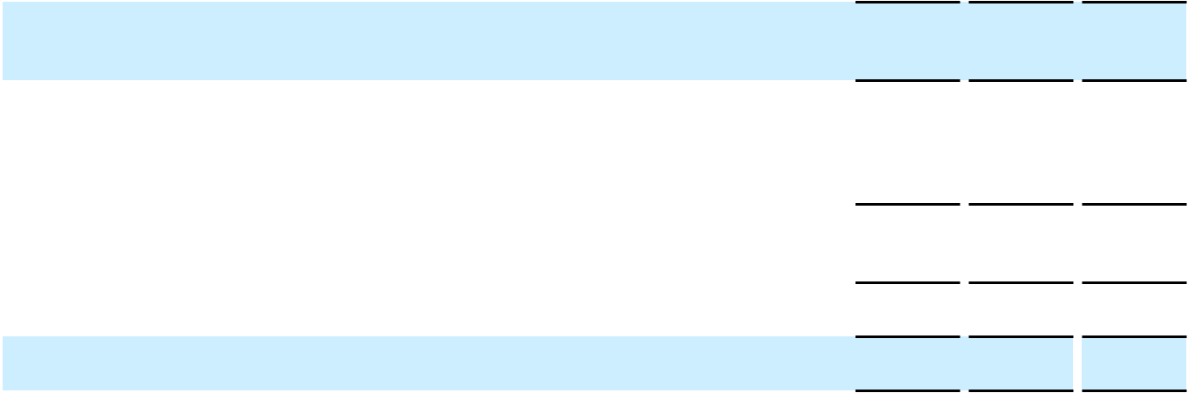

- a

a

a

a

a

a a a

4

Note: Refer to table below (net product sales of Regeneron-discovered products) for information regarding whether net product sales for a particular product are recorded by us or others. In addition, unless otherwise noted, products in the table above are generally approved for use in adults in the above-referenced diseases.

- In collaboration with Bayer outside the United States. Aflibercept 8 mg is known as EYLEA HD in the United States and EYLEA 8 mg in other countries.

- In collaboration with Sanofi

- The Company is responsible for the development and commercialization of Praluent in the United States and Sanofi is responsible for the development and commercialization of Praluent outside the United States

- The Company is responsible for the development and commercialization of Evkeeza in the United States and Ultragenyx is responsible for the development and commercialization of Evkeeza outside the United States

- Kiniksa is responsible for the development and commercialization of ARCALYST

- Sanofi is responsible for the development and commercialization of ZALTRAP

The table below includes net product sales of Regeneron-discovered products. Such net product sales are recorded by us or others, as further described in the footnotes to the table. We believe the information in the table is useful to investors as it demonstrates our pipeline productivity and our ability to innovate, discover, and develop new products, and bring those products to market either alone or based on contractual arrangements with other parties, which has a direct impact on our results of operations and financial condition. The table also shows the degree to which we, a collaborator, and/or a licensee is currently commercializing the products discovered by Regeneron. In addition, this information allows management and investors to assess the commercial trends and developments impacting Regeneron-discovered products. In arrangements where our collaborator or licensee is currently commercializing such products and is recording net product sales as a result, the net product sales shown in the table also are an important metric for management's review and assessment of (i) the revenues we record for our share of profits and/or royalties from such sales and (ii) the impact of our obligation to supply commercial product to certain of these collaborators or licensees.

 |  |  |  |  |  |  |  |  |  |  | Year Ended December 31,
 |  |  |  |  | 2025 |  |  |  |  |  |  |  |  | 2024 |  |  |  |  |  |  |  |  | 2023
(In millions) |  | U.S. |  | ROW^{(f)} |  |  |  | Total |  |  | U.S. |  |  | ROW |  |  | Total |  |  | U.S. |  |  | ROW |  |  | Total
EYLEA HD^{(a)} | $ | 1,636.9 | $ |  | 932.7 | $ |  | 2,569.6 | $ |  | 1,201.1 | $ |  | 239.9 | $ |  | 1,441.0 | $ |  | 165.8 | $ |  | — | $ |  | 165.8
EYLEA^{(a)} | $ | 2,747.8 |  | $ | 2,573.6 |  | $ | 5,321.4 |  | $ | 4,767.1 |  | $ | 3,336.9 |  | $ | 8,104.0 |  | $ | 5,719.6 |  | $ | 3,495.2 |  | $ | 9,214.8
Total EYLEA HD and EYLEA | $ | 4,384.7 | $ |  | 3,506.3 | $ |  | 7,891.0 | $ |  | 5,968.2 | $ |  | 3,576.8 | $ |  | 9,545.0 | $ |  | 5,885.4 | $ |  | 3,495.2 | $ |  | 9,380.6
Dupixent^{(b)} | $ | 13,187.0 | $ |  | 4,619.7 | $ |  | 17,806.7 | $ |  | 10,398.7 | $ |  | 3,749.3 | $ |  | 14,148.0 | $ |  | 8,855.6 | $ |  | 2,732.5 | $ |  | 11,588.1
Libtayo^{(c)} | $ | 944.7 | $ |  | 507.5 | $ |  | 1,452.2 | $ |  | 787.3 | $ |  | 429.5 | $ |  | 1,216.8 | $ |  | 538.8 | $ |  | 330.0 | $ |  | 868.8
Praluent^{(d)} | $ | 262.5 | $ |  | 594.3 | $ |  | 856.8 | $ |  | 241.7 | $ |  | 523.3 | $ |  | 765.0 | $ |  | 182.4 | $ |  | 456.5 | $ |  | 638.9
Kevzara^{(b)} | $ | 371.4 | $ |  | 203.2 | $ |  | 574.6 | $ |  | 270.2 | $ |  | 188.5 | $ |  | 458.7 | $ |  | 214.7 | $ |  | 171.2 | $ |  | 385.9
Other products^{(e)} | $ | 210.0 | $ |  | 113.3 | $ |  | 323.3 | $ |  | 202.9 | $ |  | 90.0 | $ |  | 292.9 | $ |  | 150.5 | $ |  | 686.2 | $ |  | 836.7
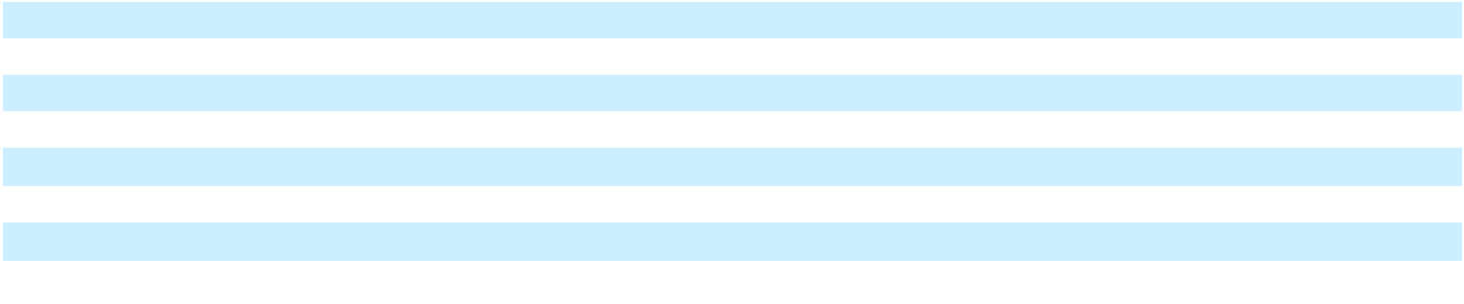

- We record net product sales of EYLEA HD and EYLEA in the United States, and Bayer records net product sales outside the United States. We record our share of profits in connection with sales outside the United States within Collaboration revenue; refer to Part II, Item 7. "Management's Discussion and Analysis of Financial Condition and Results of Operations - Results of Operations - Revenues - Bayer Collaboration Revenue" for such amounts.

- Sanofi records global net product sales of Dupixent and Kevzara, and we record our share of profits in connection with global sales of such products within Collaboration revenue. Refer to Part II, Item 7. "Management's Discussion and Analysis of Financial Condition and Results of Operations - Results of Operations - Revenues - Sanofi Collaboration Revenue" for such amounts.

- We record global net product sales of Libtayo and pay Sanofi a royalty on such sales

- We record net product sales of Praluent in the United States. Sanofi records net product sales of Praluent outside the United States and pays us a royalty on such sales, which is recorded within Other revenue.

- Included in this line item are products which are sold by us and others. Refer to Part II, Item 7. "Management's Discussion and Analysis of Financial Condition and Results of Operations - Results of Operations - Revenues" for a listing of net product sales recorded by us. Not included in this line item are net product sales of ARCALYST, which are recorded by Kiniksa.
- Rest of world ("ROW")

5

Programs in Clinical Development

Product candidates in Phase 2 and Phase 3 clinical development, which are being developed by us and/or our collaborators, are summarized in the table below.

There are numerous uncertainties associated with drug development, including uncertainties related to safety and efficacy data from each phase of drug development (including any post-approval studies), uncertainties related to the enrollment and performance of clinical trials, changes in regulatory requirements, changes to drug pricing and reimbursement regulations and requirements, and changes in the competitive landscape affecting a product candidate. The planning, execution, and results of our clinical programs are significant factors that can affect our operating and financial results.

Refer to Part I, Item 1A. "Risk Factors" for a description of risks and uncertainties that may affect our clinical programs. Any of such risks and uncertainties may, among other matters, negatively impact the development timelines set forth in the table below.

6

Clinical Program |  | Phase 2 |  | Phase 3 |  |  | Regulatory |  | 2025 and 2026
Clinical Program |  | Phase 2 |  | Phase 3 |  |  | Review^{(h)} |  | Events to Date
 |  |  |  |  | Ophthalmology
EYLEA HD (aflibercept) |  |  |  |  |  |  | –Pre-filled syringe |  | –Presented positive three-
_{8 mg}(a) |  |  |  |  |  |  | (U.S.) |  | year data from extension
 |  |  |  |  |  |  | –RVO (Japan) |  | study of Phase 3 wAMD
 |  |  |  |  |  |  | –RVO (Japan) |  | trial at Angiogenesis,
 |  |  |  |  |  |  |  |  | Exudation, and
 |  |  |  |  |  |  |  |  | Degeneration
 |  |  |  |  |  |  |  |  | ("Angiogenesis") 2025
 |  |  |  |  |  |  |  |  | annual meeting
 |  |  |  |  |  |  |  |  | –Presented positive data
 |  |  |  |  |  |  |  |  | from Phase 3 QUASAR
 |  |  |  |  |  |  |  |  | trial in RVO at
 |  |  |  |  |  |  |  |  | Angiogenesis 2025 annual
 |  |  |  |  |  |  |  |  | meeting
 |  |  |  |  |  |  |  |  | –Approved by FDA and
 |  |  |  |  |  |  |  |  | European Commission
 |  |  |  |  |  |  |  |  | ("EC") for RVO
 |  |  |  |  |  |  |  |  | –Approved by FDA for
 |  |  |  |  |  |  |  |  | every 4-week dosing
 |  |  |  |  |  |  |  |  | regimen for approved
 |  |  |  |  |  |  |  |  | indications
 |  |  |  |  |  |  |  |  | –FDA issued Complete
 |  |  |  |  |  |  |  |  | Response Letters ("CRLs")
 |  |  |  |  |  |  |  |  | for supplemental Biologics
 |  |  |  |  |  |  |  |  | License Application
 |  |  |  |  |  |  |  |  | ("sBLA") for addition of
 |  |  |  |  |  |  |  |  | extended dosing intervals
 |  |  |  |  |  |  |  |  | and for regulatory
 |  |  |  |  |  |  |  |  | application for pre-filled
 |  |  |  |  |  |  |  |  | syringe
 |  |  |  |  |  |  |  |  | –Submitted regulatory
 |  |  |  |  |  |  |  |  | application for pre-filled
 |  |  |  |  |  |  |  |  | syringe in U.S.
 |  |  |  |  |  |  |  |  | –Approved EC for extended
 |  |  |  |  |  |  |  |  | dosing intervals up to 6
 |  |  |  |  |  |  |  |  | months (24 weeks) in
 |  |  |  |  |  |  |  |  | wAMD and DME


Select Upcoming
Milestones

–U.S. Food and Drug Administration ("FDA") decision for pre-filled syringe (second quarter 2026)

7

Clinical Program
(continued)
Pozelimab^{(f)} (antibody to C5)

- cemdisiran^{(l)} (siRNA therapeutic targeting C5)

Dupixent (dupilumab)^{(b)} Antibody to IL-4R alpha subunit

Kevzara (sarilumab)^{(b)}
Antibody to IL-6R

Itepekimab^{(b)} (REGN3500) Antibody to IL-33

Regulatory
Phase 2 Phase 3 Review^{(h)}

–Geographic atrophy^{(q)}

Immunology & Inflammation


–Asthma in pediatrics | –CSU in pediatrics (2–
(2–5 years of age) | 11 years of age) (U.S.,
–Chronic pruritus of | EU, and Japan)
–Chronic pruritus of | –Bullous pemphigoid
unknown origin | –Bullous pemphigoid
("CPUO") | (EU and Japan)
–Lichen simplex | –Allergic fungal
chronicus | rhinosinusitis
 | ("AFRS") (U.S.)

–Systemic juvenile
idiopathic arthritis

("sJIA") (pivotal study)
–Chronic rhinosinusitis –COPD^{(e)}
without nasal polyposis

("CRSsNP") –CRSwNP

2025 and 2026
Events to Date

–Approved by Japan's Ministry of Health, Labour and Welfare ("MHLW") for asthma in pediatrics (6–11 years of age)

–Approved by MHLW for COPD

–Approved by FDA and EC for CSU in adults and adolescents

–Presented positive data from Phase 2/3 bullous pemphigoid trial at 2025 American Academy of Dermatology ("AAD") Annual Meeting

–Approved by FDA for bullous pemphigoid

–Reported that Phase 3 trial in AFRS met its primary and key secondary endpoints

–Approved by EC for pJIA

–Reported that Phase 3 trial (AERIFY-1) in COPD met its primary endpoint; second Phase 3 trial (AERIFY-2) did not meet same primary endpoint

Select Upcoming
Milestones

–Report initial results from lead-in cohort of Phase 3 study in geographic atrophy (combination and cemdisiran monotherapy) (second half 2026)

–EC decision on regulatory submission for bullous pemphigoid (first half 2026)

–FDA decision on sBLA for AFRS (February 2026)

8

Clinical Program |  | Phase 2 |  | Phase 3 |  | Regulatory |  | 2025 and 2026
(continued) |  | Phase 2 |  | Phase 3 |  | Review^{(h)} |  | Events to Date
Itepekimab^{(b)} (REGN3500) |  |  |  |  |  |  |  | –Discontinued Phase 2
(continued) |  |  |  |  |  |  |  | study in non-cystic fibrosis
 |  |  |  |  |  |  |  | bronchiectasis ("NCFB")
REGN5713-5715 |  |  |  | –Birch allergy |  |  |  | –Reported that Phase 3 trial
Multi-antibody therapy to |  |  |  |  |  |  |  | in birch allergy met its
Bet v 1 |  |  |  |  |  |  |  | primary and key secondary
 |  |  |  |  |  |  |  | endpoints
 |  |  |  |  |  |  |  | –Initiated second Phase 3
 |  |  |  |  |  |  |  | trial in birch allergy
REGN1908-1909^{(f)} |  |  |  | –Cat allergy |  |  |  | –Reported that Phase 3 trial
Multi-antibody therapy to |  |  |  |  |  |  |  | in cat allergy met its
Fel d 1 |  |  |  |  |  |  |  | primary and key secondary
 |  |  |  |  |  |  |  | endpoints
 |  |  |  | Solid Organ Oncology
Libtayo (cemiplimab)^{(g)} |  | –Neoadjuvant CSCC |  | –Early-stage CSCC |  | –Adjuvant CSCC |  | –Approved by FDA and EC
Antibody to PD-1 |  | –First-line NSCLC, |  | (intralesional) |  | (Japan) |  | for adjuvant CSCC
 |  | –First-line NSCLC, |  |  |  |  |  | –Reported positive data
 |  | BNT116^{(i)} combination |  |  |  |  |  | –Reported positive data
 |  | –Neoadjuvant NSCLC |  |  |  |  |  | from Phase 3 trial in
 |  | –Neoadjuvant NSCLC |  |  |  |  |  | adjuvant CSCC; results
 |  | –Neoadjuvant |  |  |  |  |  | presented at 2025 American
 |  | –Neoadjuvant |  |  |  |  |  | Society of Clinical
 |  | hepatocellular |  |  |  |  |  | Oncology ("ASCO")
 |  | carcinoma ("HCC") |  |  |  |  |  | Annual Meeting and
 |  |  |  |  |  |  |  | published in New England
 |  |  |  |  |  |  |  | Journal of Medicine
 |  |  |  |  |  |  |  | ("NEJM")


–Approved by MHLW for
NSCLC, monotherapy and

chemotherapy combination

–Reported positive five-year

follow-up data from Phase 3
trial in combination with
chemotherapy for NSCLC;
results presented at IASLC
2025 World Conference on

Lung Cancer ("WCLC")
Fianlimab^{(f)} (REGN3767) | –First-line advanced | –First-line metastatic
Antibody to LAG-3 | NSCLC (Phase 2/3) | melanoma^{(e)}
 | –Perioperative NSCLC | –Adjuvant melanoma

Select Upcoming
Milestones

–Initiate second Phase 3 study in cat allergy (first half 2026)

–Report results from Phase 3 study versus pembrolizumab in first-line metastatic melanoma (first half 2026)

9

Clinical Program |  | Phase 2 |  | Phase 3 |  | Regulatory |  | 2025 and 2026
(continued) |  | Phase 2 |  | Phase 3 |  | Review^{(h)} |  | Events to Date
Fianlimab^{(f)} (REGN3767) |  | –Perioperative |  |  |  |  |  | –Based on pre-planned
(continued) |  | melanoma |  |  |  |  |  | interim analysis of two
 |  |  |  |  |  |  |  | Phase 2/3 studies in first-
 |  |  |  |  |  |  |  | line advanced NSCLC,
 |  |  |  |  |  |  |  | Phase 2 portion of the
 |  |  |  |  |  |  |  | studies will continue
 |  |  |  |  |  |  |  | unchanged
Vidutolimod
Immune activator targeting
TLR9
Ubamatamab^{(f)} (REGN4018) |  | –Ovarian cancer |  |  |  |  |  | –Presented additional data
Bispecific antibody targeting |  |  |  |  |  |  |  | from Phase 2 study in
MUC16 and CD3 |  |  |  |  |  |  |  | platinum-resistant ovarian
 |  |  |  |  |  |  |  | cancer at European Society
 |  |  |  |  |  |  |  | for Medical Oncology
 |  |  |  |  |  |  |  | ("ESMO") 2025 Meeting
REGN5668^{(p)} |  | –Ovarian cancer
Bispecific antibody targeting
MUC16 and CD28
Nezastomig (REGN5678) |  | –Prostate cancer |  |  |  |  |  | –Reported additional data
Bispecific antibody targeting |  |  |  |  |  |  |  | from study in prostate
PSMA and CD28 |  |  |  |  |  |  |  | cancer at American
 |  |  |  |  |  |  |  | Association for Cancer
 |  |  |  |  |  |  |  | Research ("AACR") Annual
 |  |  |  |  |  |  |  | Meeting
Marlotamig (REGN7075) |  | –Solid tumors
Bispecific antibody targeting
EGFR and CD28
Davutamig (REGN5093) |  | –MET-altered
Bispecific antibody targeting |  | advanced NSCLC
two distinct MET epitopes
 |  |  |  | Hematology
Pozelimab^{(f)} (antibody to C5) |  |  |  | –Paroxysmal nocturnal
+ cemdisiran^{(l)} (siRNA |  |  |  | hemoglobinuria
therapeutic targeting C5) |  |  |  | ("PNH")^{(c)}
Ordspono (odronextamab) |  | –B-cell non-Hodgkin |  | –Lymphoma^{(c)(e)} |  |  |  | –FDA issued CRL for BLA
Bispecific antibody targeting |  | lymphoma |  | (multiple lines and |  |  |  | for relapsed/refractory FL
CD20 and CD3 |  | ("B-NHL") (pivotal |  | settings)
 |  | study)
Lynozyfic (linvoseltamab)^{(f)} |  | –Multiple myeloma |  | –Multiple myeloma^{(c)(e)} |  |  |  | –Approved by FDA and EC
Bispecific antibody targeting |  | precursor and related |  | (multiple lines and |  |  |  | for relapsed/refractory
BCMA and CD3 |  | conditions |  | settings) |  |  |  | multiple myeloma



Select Upcoming
Milestones

–Report Phase 2 data in first-line advanced NSCLC (first half 2026)

–Report results from Phase 3 study in PNH (fourth quarter 2026/first quarter 2027)

–Initiate additional Phase 3 studies in multiple myeloma and precursor conditions (2026)

10

Clinical Program |  | Phase 2 |  | Phase 3 |  | Regulatory |  | 2025 and 2026
(continued) |  | Phase 2 |  | Phase 3 |  | Review^{(h)} |  | Events to Date
Lynozyfic (linvoseltamab)^{(f)} |  |  |  |  |  |  |  | –Completed enrollment in
(continued) |  |  |  |  |  |  |  | Phase 3 confirmatory trial
 |  |  |  |  |  |  |  | (LINKER-MM3) in
 |  |  |  |  |  |  |  | relapsed/refractory multiple
Nexiguran ziclumeran |  |  |  |  |  |  |  | myeloma
Nexiguran ziclumeran |  |  |  | –Transthyretin |  |  |  | –Phase 3 ATTR-CM trial
(Nex-z, NTLA-2001)^{(j)} |  |  |  | amyloidosis with |  |  |  | enrollment on FDA clinical
TTR gene knockout using |  |  |  | cardiomyopathy |  |  |  | hold
CRISPR/Cas9 |  |  |  | ("ATTR-CM")^{(c)(m)}
 |  |  |  | –Hereditary
 |  |  |  | transthyretin
 |  |  |  | amyloidosis with
 |  |  |  | polyneuropathy
 |  |  |  | ("ATTRv-PN")^{(c)(m)}
REGN7508 |  | –Thrombosis |  | –Venous
Antibody to Factor XI |  |  |  | thromboembolism after
(catalytic domain) |  |  |  | total knee replacement
 |  |  |  | surgery
REGN9933 |  | –Thrombosis
Antibody to Factor XI
(A2 domain)
REGN7257 |  |  |  |  |  |  |  | –Discontinued study in
Antibody to IL2Rg |  |  |  |  |  |  |  | aplastic anemia
REGN7999 |  | –Iron overload in beta-
Antibody to TMPRSS6 |  | thalassemia
 |  |  |  | Internal Medicine/Neurology/Rare Diseases
Garetosmab^{(f)} (REGN2477) |  |  |  | –Fibrodysplasia |  | –FOP (U.S. and EU) |  | –Reported that Phase 3 trial
Antibody to Activin A |  |  |  | ossificans progressiva |  |  |  | in FOP met its primary
 |  |  |  | _{("FOP")}(c)(d)(e) |  |  |  | endpoint
Cemdisiran^{(l)} |  |  |  | –Myasthenia gravis^{(c)} |  |  |  | –Reported that Phase 3 trial
siRNA therapeutic targeting |  |  |  |  |  |  |  | in myasthenia gravis met its
C5 |  |  |  |  |  |  |  | primary and key secondary
 |  |  |  |  |  |  |  | endpoints
Mibavademab^{(f)(o)} |  | –Functional |  | –Generalized
(REGN4461) |  | hypothalamic |  | lipodystrophy^{(c)(d)(e)}
Agonist antibody to leptin |  | amenorrhea
receptor ("LEPR")
Trevogrumab^{(f)} (REGN1033) |  | –Obesity^{(n)} |  |  |  |  |  | –Reported 26-week results
Antibody to myostatin (GDF8) |  |  |  |  |  |  |  | from Phase 2 study in
 |  |  |  |  |  |  |  | obesity


Select Upcoming
Milestones

–Initiate additional Phase 3 studies in anticoagulation (first half 2026)

–Initiate Phase 3 studies in anticoagulation (first half 2026)

–FDA decision on BLA and EC decision on Marketing Authorization Application ("MAA") for FOP (second half 2026)

–Submit New Drug Application ("NDA") for myasthenia gravis (first quarter 2026)

–Report additional data from Phase 2 study in obesity (2026)

11

Clinical Program |  | Phase 2 |  | Phase 3 |  | Regulatory |  | 2025 and 2026
(continued) |  | Phase 2 |  | Phase 3 |  | Review^{(h)} |  | Events to Date
REGN7544 |  | –Postural orthostatic
Antagonist antibody to NPR1 |  | tachycardia syndrome
 |  | ("POTS")
 |  | –Sepsis-induced
 |  | hypotension
Rapirosiran (ALN-HSD)^{(k)} |  | –Metabolic
RNAi therapeutic targeting |  | dysfunction-associated
HSD17B13 |  | steatohepatitis
 |  | ("MASH")

Select Upcoming

Milestones

ALN-ANG3^{(k)(r)} –Diabetic kidney
RNAi therapeutic targeting disease

ANGPTL3

DB-OTO –Hearing deficit due to
AAV-based gene therapy variants of otoferlin
gene^{(c)(e)(m)} (Phase 1/2)
(pivotal study)

–Hearing deficit due to

variants of otoferlin
gene (U.S.)

–Presented updated data from Phase 1/2 trial and published in NEJM

–FDA granted Commissioner's National Priority Voucher

–FDA decision on BLA for hearing deficit due to variants of otoferlin gene (first half 2026)

12

Note 1: For purposes of the table above, a program is classified in Phase 2 or 3 clinical development after recruitment for the corresponding study or studies has commenced

Note 2: We have discontinued further clinical development of REGN5381, an agonist antibody to NPR1, which was previously being studied in heart failure and uncontrolled hypertension

- In collaboration with Bayer outside the United States

- In collaboration with Sanofi

- FDA granted Orphan Drug designation for one or more indications

- FDA granted Breakthrough Therapy designation for one or more indications

- FDA granted Fast Track designation for one or more indications

- Sanofi is entitled to receive royalties on sales of the product

- Studied as monotherapy and in combination with other antibodies and treatments

- Information in this column captures submissions to U.S., EU, and/or Japan regulatory authorities

- BioNTech's BNT116 is an mRNA cancer vaccine

- In collaboration with Intellia

- Alnylam is entitled to receive royalties on sales of the product

- Under the terms of our license agreement for cemdisiran, Alnylam is entitled to receive royalties on sales, as well as milestone payments

- FDA granted Regenerative Medicine Advanced Therapy ("RMAT") designation for one or more indications

- Studied in combination with semaglutide with and without garetosmab

- A Phase 2 study, sponsored by Eli Lilly, is also ongoing and testing the combination of tirzepatide and mibavademab compared with tirzepatide alone in patients with obesity

- Studied in combination with ubamatamab or fianlimab

- Geographic atrophy also studied with cemdisiran monotherapy

- Studied as monotherapy and in combination with Evkeeza (evinacumab)

13

Additional Information - Clinical Development Programs

EYLEA HD

In August 2025, the FDA extended the target action dates for the Company's FDA applications for EYLEA HD (pre-filled syringe, every-four-week dosing, and for the treatment of RVO). The delay resulted from observations from a July 2025 FDA general site inspection (not specific to EYLEA HD) at Catalent Indiana, LLC ("Catalent"), part of Novo Nordisk A/S, the manufacturing filler in the EYLEA HD BLA. The FDA extended the review periods after determining that the information submitted by the manufacturing filler in August 2025 to address the observations constituted a major amendment to each regulatory application.

In October 2025, the Company was notified by Catalent that they received an official action indicated ("OAI") letter from the FDA citing unresolved issues related to a July 2025 FDA general site inspection. On October 27, 2025, the FDA issued a CRL for the pre-filled syringe sBLA. The sole approvability issue cited in the CRL relates to unresolved inspection findings at Catalent. In December 2025, the Company submitted a regulatory application seeking approval of the EYLEA HD pre-filled syringe using a new manufacturer. The application has been accepted for review, a standard pre-licensing inspection has been scheduled, and an FDA decision on the Company's filing is expected in the second quarter of 2026.

In November 2025, the FDA approved EYLEA HD for the treatment of patients with RVO and for an every 4-week dosing option across approved indications. In addition, in December 2025, the FDA approved the addition of a new manufacturer to fill vials for EYLEA HD.

Itepekimab

In May 2025, the Company and Sanofi announced that a Phase 3 trial, AERIFY-1, in adults who were former smokers with inadequately controlled COPD met the primary endpoint of significantly reducing moderate or severe acute exacerbations by 27% compared to placebo at week 52, a clinically meaningful benefit. A second Phase 3 trial, AERIFY-2, did not meet the same primary endpoint, although a benefit was seen earlier in the trial. The safety profile of itepekimab observed in the Phase 3 trials was consistent with prior clinical trials. The Company and Sanofi are evaluating next steps.

Fianlimab

In April 2025, a pre-planned interim analysis was conducted on two ongoing Phase 2/3 studies evaluating the combination of fianlimab and cemiplimab in first-line advanced NSCLC. Due to limited follow-up, the Phase 2 portion of the studies will continue unchanged until additional data are available. The next analyses for these studies are expected in the first half of 2026, at which time a decision whether to advance to Phase 3 is expected to be made. No new safety signals were observed in either study.

Ordspono (odronextamab)

On July 30, 2025, the FDA issued a CRL for the BLA for odronextamab in relapsed/refractory follicular lymphoma after two or more lines of systemic therapy, which was also impacted by the Catalent Indiana LLC site inspection (as described in the "EYLEA HD" section above).

Descriptions of Marketed Products Studied in Additional Indications and Product Candidates in Late-Stage Clinical Development

EYLEA HD (aflibercept) 8 mg

EYLEA HD is a soluble fusion protein that acts as a vascular endothelial growth factor ("VEGF") inhibitor. Through a novel formulation, it is designed to deliver a concentrated dose of aflibercept to block VEGF-A and PLGF and inhibit the growth of new blood vessels and decrease vascular permeability to treat various retinal diseases, including wAMD, DME, DR, and RVO.

Dupixent (dupilumab)

Dupixent is a fully human monoclonal antibody that inhibits signaling of the IL-4 and IL-13 pathways, and is not an immunosuppressant. IL-4 and IL-13 are key and central drivers of the type 2 inflammation that play a major role in atopic dermatitis, asthma, CRSwNP, COPD, EoE, prurigo nodularis, CSU, bullous pemphigoid, and potentially other chronic allergic and inflammatory diseases.

Kevzara (sarilumab)

Kevzara is a fully human monoclonal antibody that binds specifically to the IL-6 receptor and inhibits IL-6-mediated signaling. IL-6 is an immune system protein produced in increased quantities in patients with inflammatory diseases such as RA and has been associated with disease activity, joint destruction, and other systemic problems.

14

Itepekimab

Itepekimab is an investigational, fully human monoclonal antibody that inhibits IL-33, a protein that is believed to play a key role in inflammation in COPD and CRSwNP.

REGN5713-5715

REGN5713-5715 is an investigational combination of two fully human monoclonal antibodies designed to treat allergic inflammatory conditions caused by the allergen Bet v 1, which is the main allergen responsible for birch pollen allergies. Birch pollen allergy is one of the most common causes of seasonal allergies that occur in the spring, and is also believed to trigger "oral allergy syndrome" food reactions to related allergens found in nuts and fruits such as apples, pears, and cherries.

REGN1908-1909

REGN1908-1909 is an investigational combination of two fully human monoclonal antibodies that is designed to specifically bind and block the Fel d 1 allergen, thus preventing it from binding and triggering the endogenous antibodies that cause allergies (i.e., immunoglobulin E antibodies). Cat allergy is primarily caused by exposure to Fel d 1, the major allergen in cat dander produced by all cats.

Libtayo (cemiplimab)

Libtayo is a fully human monoclonal antibody targeting the immune checkpoint receptor PD-1 on T-cells. The PD-1/PD-L1 immune checkpoint pathway is a well-known mechanism by which cancers evade immune destruction. Regeneron is studying Libtayo as a monotherapy and in combination with either conventional or novel therapeutic approaches in various solid tumors and blood cancers. It is also being studied in combination with proprietary anti-cancer assets of other companies. Libtayo has also been approved by regulatory authorities in a number of cancer indications, including as a treatment for advanced NSCLC, BCC, CSCC, and cervical cancer, and as an adjuvant treatment for patients with CSCC with a high risk of recurrence after surgery and radiation.

Fianlimab

Fianlimab is an investigational, fully human monoclonal antibody targeting the immune checkpoint receptor LAG-3 on T-cells. In melanoma and NSCLC, LAG-3 expression in the tumor microenvironment may be associated with therapeutic resistance to PD-1 inhibitors. Fianlimab is being investigated in combination with Libtayo to determine whether concurrent blockade of LAG-3 and PD-1 can help overcome this resistance and release the brakes on T-cell activation.

Pozelimab

Pozelimab is a fully human monoclonal antibody designed to block complement factor C5 in order to treat diseases mediated by abnormal complement pathway activity, and is approved by the FDA for CHAPLE. Pozelimab is being studied in investigational combinations with an investigational small interfering RNA ("siRNA") therapy, cemdisiran, in PNH and geographic atrophy.

Cemdisiran

Cemdisiran is an investigational siRNA therapy that reduces circulating levels of C5. Cemdisiran, as a monotherapy and in combination with pozelimab (C5 antibody), is being evaluated in trials for complement-mediated disorders, including myasthenia gravis, PNH, and geographic atrophy.

Ordspono (odronextamab)

Ordspono is a bispecific monoclonal antibody designed to bridge CD20 on cancer cells with CD3-expressing T cells to facilitate local T-cell activation and cancer-cell killing. We are studying Ordspono in several types of B-cell non-Hodgkin lymphoma, including in frontline settings.

15

Lynozyfic (linvoseltamab)

Lynozyfic is a bispecific monoclonal antibody designed to bind to CD3 while also binding and bridging T-cells to the BCMA protein on multiple myeloma cells. This may help to activate T-cells via their CD3 receptors and trigger targeted, T-cell mediated killing of multiple myeloma. Lynozyfic has been approved by regulatory authorities for relapsed or refractory multiple myeloma, and continues to be studied in multiple lines and settings of multiple myeloma.

Nex-z

Nex-z is an investigational CRISPR-based therapy to be systemically delivered to edit genes inside the human body and is being studied as a treatment for ATTR amyloidosis. ATTR amyloidosis is a progressive and fatal disorder resulting from deposition of insoluble amyloid fibrils into multiple organs and tissues leading to systemic failure. Delivered with in vivo technology, nex-z offers the possibility of halting and reversing the disease by driving a deep, consistent, and potentially lifelong reduction in transthyretin ("TTR") protein after a single dose.

REGN7508 and REGN9933

We are advancing a robust factor XI program to assess two mechanistically-distinct antibodies, REGN7508 (catalytic domain) and/or REGN9933 (A2 domain), across a variety of indications. These two antibodies were prospectively designed to have distinct profiles – with one designed to provide stronger anticoagulation and the other offering a lower risk of bleeding – potentially allowing physicians to tailor anticoagulation therapy for patients with different risk profiles.

Garetosmab

Garetosmab is an investigational, fully human monoclonal antibody that binds to and neutralizes Activin A, which drives the abnormal bone formation that is the main pathology of the ultra-rare genetic disorder FOP. This abnormal bone formation in soft tissue outside of the normal skeleton, a process known as heterotopic ossification, leads to loss of mobility and premature death in FOP patients. Garetosmab is being investigated to determine whether it can help reduce and/or prevent the formation of heterotopic bone lesions by neutralizing the Activin A protein.

Mibavademab

Mibavademab is an investigational, fully human monoclonal antibody that binds to and activates the leptin receptor, which modulates the control of food intake, energy expenditure, and glucose/lipid metabolism. We are studying mibavademab as a potential treatment for generalized lipodystrophy.

DB-OTO

DB-OTO is an investigational cell-selective, dual AAV vector gene therapy designed to provide durable, physiological hearing to individuals with profound, congenital hearing loss caused by variants of the otoferlin gene. The treatment aims to deliver a working copy of the otoferlin gene to replace the non-functional otoferlin protein using a modified, non-pathogenic virus that is delivered via an infusion into the cochlea under general anesthesia (similar to the procedure used for cochlear implantation). In this gene therapy, the newly introduced otoferlin gene is under the control of a proprietary cell-specific Myo15 promoter, which is intended to restrict expression only to hair cells that normally express otoferlin.

Other Programs

Our preclinical research programs include the areas of oncology/immuno-oncology, angiogenesis, ophthalmology, metabolic and related diseases, muscle diseases and disorders, inflammation and immune diseases, bone and cartilage, pain and neurobiology, auditory conditions, enzyme replacement therapy, cardiovascular diseases, infectious diseases, and diseases related to aging. These preclinical research programs include both rare diseases and those involving broader populations.

Research and Development Technologies

Many proteins that play an important role in biology and disease are secreted by cells or located on the cell surface. Moreover, cells communicate through secreted factors and surface molecules. Our scientists have developed two different technologies to make protein therapeutics that potently and specifically block, activate, or inhibit the action of specific cell surface or secreted molecules. The first technology fuses receptor components to the constant region of an antibody molecule to make a class of drugs we call "Traps." EYLEA HD, EYLEA, ZALTRAP, and ARCALYST are drugs generated using our Trap technology. VelociSuite® is our second technology platform, which is used for discovering, developing, and producing fully human antibodies that can address both secreted and cell-surface targets. We also leverage VelociSuite to produce new classes of bispecific antibodies, antibody-protein fusions, and antibody conjugates. Additionally, we use genetic medicine platforms as complementary approaches to these core technologies to potentially treat or cure diseases.

16

VelociSuite

VelociSuite consists of VelocImmune®, VelociGene®, VelociMouse®, VelociMab®, Veloci-Bi®, VelociT®, VelociHum®, and other related technologies. The VelocImmune mouse platform is utilized to produce fully human antibodies. VelocImmune was generated by leveraging our VelociGene technology (see below), in a process in which six megabases of mouse immunoglobulin gene loci were replaced, or "humanized," with corresponding human immunoglobulin gene loci. VelocImmune mice can be used efficiently to generate fully human antibodies to targets of therapeutic interest. VelocImmune and our entire VelociSuite offer the potential to increase the speed and efficiency through which human antibody therapeutics may be discovered and validated, thereby improving the overall efficiency of our early-stage drug development activities. We are utilizing the VelocImmune technology to produce our next generation of therapeutic antibody drug candidates for preclinical and clinical development.

Our VelociGene platform allows custom and precise manipulation of very large sequences of DNA to produce highly customized alterations of a specified target gene, or genes, and accelerates the production of knock-out and transgenic expression models. In producing knock-out models, a color or fluorescent marker may be substituted in place of the actual gene sequence, allowing for high-resolution visualization of precisely where the gene is active in the body during normal body functioning as well as in disease processes. For the optimization of preclinical development and pharmacology programs, VelociGene offers the opportunity to humanize targets by replacing the mouse gene with the human homolog or variants thereof. Thus, VelociGene allows scientists to rapidly identify the physical and biological effects of deleting or over-expressing the target gene, as well as to characterize and test potential therapeutic molecules.

Our VelociMouse technology platform allows for the direct and immediate generation of genetically altered mice from embryonic stem cells ("ES cells"), thereby avoiding the lengthy process involved in generating and breeding knockout mice from chimeras. Mice generated through this method are normal and healthy and exhibit a 100% germ-line transmission. Furthermore, mice developed using our VelociMouse technology are suitable for direct phenotyping or other studies.

We have also developed our VelociMab platform for the rapid screening of antibodies and rapid generation of expression cell lines for our Traps and our VelocImmune human antibodies.

We have utilized our VelociSuite technologies to develop a class of potential drug candidates, known as bispecific antibodies. Veloci-Bi allows for the generation of full-length bispecific antibodies similar to native antibodies that are amenable to production by standard antibody manufacturing techniques, and are likely to have favorable antibody-like pharmacokinetic properties. In the area of immunotherapies in oncology, we are exploring the use of bispecific antibodies that target tumor antigens and the CD3 receptor on T-cells to harness the oncolytic properties of T-cells. We are exploring additional indications and applications for our bispecific technologies, including CD28 and 4-1BB costimulatory bispecifics. We are also exploring a variety of alternative antibody formats (Altibodies™) that can bring binding partners together in restrained geometries.

The VelociT mouse extends our research and drug discovery capabilities into cell-mediated immunity and therapeutic T-cell receptors ("TCRs") for oncology and other indications. VelociT was developed by using our VelociGene technology to humanize genes encoding TCRα and TCRβ variable sequences, CD4 and CD8 co-receptors, β2m, and class-I and -II major histocompatibility complexes. As a result, VelociT mice can be utilized to produce fully human TCRs, providing for customized modeling of T-cell function in different diseases and a powerful platform for the discovery of unique TCR-based therapies. We are also able to produce antibodies that recognize intracellular peptides bound in the groove of human leukocyte antigen ("HLA"), enabling the targeting of intracellular proteins in cancer cells.

VelociHum is our immunodeficient mouse platform that can be used to accurately test human therapeutics against human immune cells and to study human tumor models. Through genetic humanizations, VelociHum mice have been optimized to allow for better development of human immune cells in vivo, as well as to allow for engraftment of primary patient-derived tumors that do not take in other commercially available mice.

17

Regeneron Genetics Center®

Regeneron Genetics Center LLC (RGC®), a wholly owned subsidiary of Regeneron Pharmaceuticals, Inc., leverages de-identified clinical, genomic, proteomic, and other types of molecular data from properly consented human volunteers from around the world to identify medically relevant associations in a blinded fashion designed to preserve a patient's privacy while uncovering the unique characteristics of their health and wellness. The objective of RGC is to expand the use of human genetics for discovering and validating genetic factors that cause or influence a range of diseases where there are major unmet medical needs, with the prospect of improving the drug discovery and development process and to advance innovation in clinical care design. RGC is undertaking multiple collaborative approaches to study design and implementation, including large population-based efforts that engage study participants to more discrete disease specific and founder populations with data on strategic phenotypes of interest. RGC utilizes laboratory automation and innovative approaches to cloud computing to achieve high-quality throughput, attaining over 3 million samples sequenced to date.

In January 2025, it was announced that RGC was selected by UK Biobank consortium members to complete proteomic assay data generation for the UK Biobank Pharma Proteomics Project.

In January 2025, RGC entered into an agreement with Truveta Inc. pursuant to which RGC will sequence exomes and conduct genotyping and imputation of up to ten million de-identified consented volunteers using biospecimens provided by Truveta health system members across the United States. In addition, central to the ongoing work of RGC is the portfolio of collaborations with over 150 academic and clinical collaborators around the world, including the University of Colorado, Geisinger Health System, Mayo Clinic, University of Pennsylvania, UCLA Medical Center, UK Biobank, University of Oxford, and the University of Cambridge. These collaborations provide access to biological samples and associated phenotype data from properly consented patient volunteers for purposes of genomic research. RGC undertakes genetic sequencing of these samples to create a unique resource of de-identified genetic data and associated phenotype data for research. Furthermore, RGC has deployed bulk RNA sequencing, whole genome sequencing, and an O-LINK proteomic assay to complement whole exome sequencing and genotyping. In addition, RGC leverages organoid models, siRNA, and CRISPR knockout models to validate genetic associations that lead to new therapeutic targets. RGC continues to publish results from its research efforts in journals and publications in partnership with its collaborators to advance the field of genomics.

These efforts at RGC have led to the identification of more than 40 novel genetic targets. Through our Regeneron Genetics Medicines initiative, we are currently advancing many of these targets using either our VelociSuite technologies or other technologies, such as siRNA gene silencing, genome editing, and targeted viral-based gene delivery and expression. See the "Collaboration, License, and Other Agreements" section below for descriptions of our agreements with Alnylam Pharmaceuticals, Inc. and Intellia Therapeutics, Inc.

Collaboration, License, and Other Agreements

Sanofi

We are collaborating with Sanofi on the global development and commercialization of Dupixent, Kevzara, and itepekimab. Under the terms of the collaboration, Sanofi is generally responsible for funding 80% to 100% of agreed-upon development expenses as incurred. We are obligated to reimburse Sanofi for 30% to 50% of development expenses that were funded by Sanofi (i.e., "development balance") based on our share of collaboration profits; however, we are only required to apply 20% of our share of profits from the collaboration each calendar quarter to reimburse Sanofi for these development expenses. As of December 31, 2025, the total amount of our contingent reimbursement obligation to Sanofi in connection with the development balance was approximately $595 million.

Under our collaboration agreement, Sanofi records product sales for commercialized products, and we have the right to co-commercialize such products on a country-by-country basis. We co-commercialize Dupixent in the United States and in certain countries outside the United States. We supply certain commercial bulk product to Sanofi. We and Sanofi equally share profits from sales within the United States, and share profits outside the United States on a sliding scale based on sales starting at 65% (Sanofi)/35% (us) and ending at 55% (Sanofi)/45% (us).

Bayer

We and Bayer are parties to a license and collaboration agreement for the global development and commercialization of EYLEA 8 mg and EYLEA outside the United States. Agreed-upon development expenses incurred by the Company and Bayer are generally shared equally. Bayer is responsible for commercialization activities outside the United States, and the companies share equally in profits from such sales.

We are obligated to reimburse Bayer for 50% of the development expenses that it has incurred under the agreement from our share of the collaboration profits. The reimbursement payment in any quarter will equal 5% of the then outstanding repayment

18

obligation, but never more than our share of the collaboration profits in the quarter unless we elect to reimburse Bayer at a faster rate.

Within the United States, we retain exclusive commercialization rights and are entitled to all profits from such sales. Alnylam

We and Alnylam Pharmaceuticals, Inc. are parties to a collaboration to discover, develop, and commercialize RNAi therapeutics for a broad range of diseases by addressing therapeutic disease targets expressed in the eye and central nervous system, in addition to a select number of targets expressed in the liver.

For each target nominated, we provide Alnylam with a specified amount of funding at program initiation and at lead candidate designation. Under the terms of the collaboration, the parties perform discovery research until designation of lead candidates. Following designation of a lead candidate, the parties may further advance such lead candidate under either a co-development and co-commercialization collaboration agreement ("Co-Co Collaboration Agreement") or a license agreement. The target nomination period of the collaboration agreement ends in May 2026.

For CNS programs and liver programs, under a Co-Co Collaboration Agreement, the party designated as the lead party will lead development and commercialization of the program and the parties will split profits and share costs equally, subject to certain co-funding opt-outs at specified clinical trial phases or under other conditions.

We have also entered into various license agreements with Alnylam, with us as the licensee, including for cemdisiran as a monotherapy and for a combination consisting of cemdisiran and pozelimab. Under a license agreement, the lead party is designated as the licensee and has the right to develop and commercialize the product under such program. The licensee will be responsible for its own expenses incurred. The licensee will pay to the licensor certain development and/or commercialization milestone payments, as well as tiered royalty payments to the licensor based on the aggregate annual sales of the product.

Intellia

We and Intellia Therapeutics, Inc. are parties to a license and collaboration agreement to advance CRISPR/Cas9 gene-editing technology for in vivo therapeutic development, including therapies focused on neurological and muscular diseases. We have the right to select targets under the license and collaboration agreement until April 2026.

Intellia leads the design of the editing methodology, we lead the design of the targeted viral vector delivery approach, and the parties share costs. Each company has the opportunity to lead potential development and commercialization of product candidates for a target, and the company that is not leading development and commercialization will have the option to enter into a co-development and co-commercialization agreement for the target.

Nex-z, which is in clinical development, is subject to a co-development and co-commercialization arrangement pursuant to which Intellia leads development activities and the parties share development expenses 75% (Intellia)/25% (us). If nex-z is commercialized, Intellia will lead commercialization activities and we will share in 25% of any profits or losses.

Hansoh

In July 2025, our license agreement with Hansoh Pharmaceuticals Group Company Limited to acquire development and commercial rights outside of mainland China, Hong Kong, and Macau for HS-20094 (a dual GLP-1/GIP receptor agonist currently in Phase 3 clinical development in China) became effective. In-licensing a late-stage GLP-1/GIP agonist enables us to study combinations with our products and product candidates in order to address muscle loss and potentially other comorbidities of obesity, such as cardiovascular diseases, diabetes, and liver conditions. Under the terms of the agreement, we made an $80.0 million up-front payment in July 2025. In addition, we are obligated to make additional payments upon achievement of development, regulatory, and sales milestones, as well as a low double-digit royalty on sales.

Tessera

In January 2026, our collaboration agreement with Tessera Therapeutics, Inc. to develop and commercialize TSRA-196 (Tessera's investigational program for the treatment of alpha-1 antitrypsin deficiency ("AATD")) became effective. Tessera will lead the initial first-in-human trial, while we will lead subsequent global development and commercialization. The parties will share worldwide development expenses and, if commercialized, any future profits or losses equally. Under the terms of the agreement, the Company made aggregate payments of $150.0 million in January 2026, consisting of an up-front payment and the purchase of Tessera preferred stock. In addition, we are obligated to make additional payments upon achievement of certain development milestones.

19

Manufacturing

We currently manufacture bulk drug materials and products at our manufacturing facilities in Rensselaer, New York and Limerick, Ireland. These facilities consist of owned and leased manufacturing, office, laboratory, and warehouse space. In addition, we have constructed a fill/finish facility in Rensselaer, New York that is undergoing process validation and has yet to be approved for commercial production.

We currently have approximately 100,000 liters of cell culture capacity at our Rensselaer facility and approximately 120,000 liters of cell culture capacity at our Limerick facility. Each of these facilities is approved by the FDA and certain other regulatory agencies to manufacture our bulk drug materials and products.

Certain bulk drug materials and products are also manufactured by our collaborators, and certain raw materials or products necessary for the manufacture and formulation of our products and product candidates are provided by single-source unaffiliated third-party suppliers. In addition, we rely on our collaborators or third parties to perform packaging, filling, finishing, labeling, distribution, laboratory testing, and other services related to the manufacture of our products and product candidates. See Part I, Item 1A. "Risk Factors - Risks Related to Manufacturing and Supply" for further information.

Among the conditions for marketing approval of a new drug or biologic product is the requirement that the prospective manufacturer's quality control and manufacturing procedures conform to the good manufacturing practice ("GMP") regulations of the health authority. In complying with standards set forth in these regulations, manufacturers must continue to expend time, money, and effort in the areas of production and quality control to ensure full technical compliance. Manufacturing establishments, both foreign and domestic, are also subject to inspections by or under the authority of the FDA and by other national, federal, state, and local agencies.

Commercial

We commercialize our products both in the United States and other countries through our commercial group, which includes experienced professionals in the fields of marketing, sales, professional education, patient education, reimbursement and market access, trade and distribution, commercial operations, commercial analytics, and market research. In addition, we also co-commercialize certain products sold by our collaborators in the United States and other countries.

We sell our marketed products primarily to wholesalers, specialty distributors, pharmacies, hospitals, government agencies, physicians, and other healthcare providers. We promote approved medicines to healthcare professionals via our team of field employees, as well as medical journals, medical exhibitions, distribution of literature and samples, and online channels. In addition, we advertise certain products directly to consumers and maintain websites with information about our medicines. The commercial group also evaluates opportunities for our targets and product candidates and prepares for market launches of new medicines.

For the year ended December 31, 2025, we had sales to two customers that each accounted for more than 10% of total gross product revenue. On a combined basis, our product sales to these customers accounted for 77% of our total gross product revenue for the year ended December 31, 2025.

Competition

We face substantial competition from pharmaceutical and biotechnology companies. Our ability to compete depends, to a great extent, on how fast we can develop safe and effective product candidates, complete clinical testing and approval processes, and supply commercial quantities of the product to the market. Competition among products approved for sale is based on efficacy, safety, reliability, ease of administration, dosing frequency, availability, price, patent and other intellectual property position, and other factors.

Marketed Products

The table below provides an overview of the current competitive landscape for key products marketed by us and/or our collaborators in such products' currently approved indications. The table below is provided for illustrative purposes only and is not exhaustive. For additional information regarding the substantial competition these marketed products face, including potential future competition from product candidates in clinical development, see also Part I, Item 1A. "Risk Factors - Risks Related to Commercialization of Our Marketed Products, Product Candidates, and New Indications for Our Marketed Products - The commercial success of our products and product candidates is subject to significant competition."

20

Marketed Product |  |  | Competitor Product |  |  |  | Competitor |  | Indication |  | Territory^{(a)}
EYLEA HD and
EYLEA^{(b)} |  |  | Branded Competitor Products
 |  |  | Vabysmo™ (faricimab- |  | Genentech/Roche |  |  |  | wAMD, DME, RVO, |  | United States, EU,
 |  |  | svoa) |  |  |  |  |  | and choroidal |  | Japan
 |  |  |  |  |  |  |  |  | neovascularization
 |  |  |  |  |  |  |  |  | ("CNV") with
 |  |  |  |  |  |  |  |  | angioid streaks
 |  |  | Avastin® (bevacizumab) |  | Genentech/Roche |  |  |  | wAMD, DME, and |  | United States, EU,
 |  |  |  |  |  |  |  |  | RVO (for each used |  | Japan
 |  |  |  |  |  |  |  |  | off-label and
 |  |  |  |  |  |  |  |  | repackaged)
 |  |  | Lucentis® (ranibizumab |  | Novartis AG and |  |  |  | wAMD, DME, RVO, |  | United States, EU,
 |  |  | injection) |  | Genentech/Roche |  |  |  | DR, CNV, and ROP |  | Japan
 |  |  | Lytenava™ (bevacizumab |  | Outlook Therapeutics, |  |  |  | wAMD |  | EU
 |  |  | gamma) |  | Inc.
 |  |  | Susvimo® (ranibizumab |  | Genentech/Roche |  |  |  | wAMD, DME, DR |  | United States
 |  |  | ocular implant)
 |  |  | Beovu® (brolucizumab) |  | Novartis AG |  |  |  | wAMD, DME |  | United States, EU,
 |  |  | Injection |  |  |  |  |  |  |  | Japan
 |  |  | Ozurdex® (dexamethasone |  | Allergan/AbbVie Inc. |  |  |  | DME, RVO |  | United States, EU,
 |  |  | intravitreal implant) |  |  |  |  |  |  |  | Japan
 |  |  | Iluvien® (fluocinolone |  | Alimera Sciences, Inc. |  |  |  | DME |  | United States, EU
 |  |  | acetonide intravitreal
 |  |  | implant)
 |  |  | Biosimilar Competitor Products
 |  |  | Pavblu® (aflibercept-ayyh) |  | Amgen Inc. |  |  |  | wAMD, DME, RVO, |  | United States, EU^{(c)}
 |  |  | (biosimilar referencing |  |  |  |  |  | and DR
 |  |  | EYLEA)
 |  |  | Afqlir® (aflibercept) |  | Sandoz |  |  |  | wAMD, DME, RVO, |  | _{EU}(c)
 |  |  | (biosimilar referencing |  |  |  |  |  | and mCNV
 |  |  | EYLEA)
 |  |  | Eiyzey (aflibercept) |  | Sam Chun Dang |  |  |  | wAMD, DME, RVO, |  | _{EU}(c)
 |  |  | (biosimilar referencing |  |  |  |  |  | and mCNV
 |  |  | EYLEA)
 |  |  | Byooviz™ (ranibizumab- |  | Samsung Bioepis Co., |  |  |  | wAMD, DME, RVO, |  | United States, EU,
 |  |  | nuna) (biosimilar |  | Ltd. and Harrow, Inc. |  |  |  | DR, and CNV |  | Japan
 |  |  | referencing Lucentis)
 |  |  | Ximluci® (ranibizumab) |  | Xbrane Biopharma AB |  |  |  | wAMD, DME, RVO, |  | EU
 |  |  | (biosimilar referencing |  | and STADA Arzneimittel |  |  |  | proliferative DR, and
 |  |  | Lucentis) |  | AG |  |  |  | CNV
 |  |  | Cimerli™ (ranibizumab- |  | Formycon AG, Bioeq AG, |  |  |  | wAMD, DME, RVO, |  | United States, EU
 |  |  | eqrn) (biosimilar |  | Sandoz, and Teva Ltd. |  |  |  | DR, and CNV
 |  |  | referencing Lucentis)
 |  |  | Nufymco® (ranibizumab- |  | Formycon AG, Bioeq AG, |  |  |  | wAMD, DME, RVO, |  | United States
 |  |  | leyk) (biosimilar |  | and Zydus Lifesciences |  |  |  | DR, and mCNV
 |  |  | referencing Lucentis) |  | Limited
Dupixent |  |  | Ebglyss® (lebrikizumab) |  | Almirall S.A., Eli Lilly |  |  |  | Moderate-to-severe |  | United States, EU,
 |  |  |  |  | and Company |  |  |  | atopic dermatitis |  | Japan
 |  |  | Rinvoq® (upadacitinib) |  | AbbVie |  |  |  | Moderate-to-severe |  | United States, EU,
 |  |  |  |  |  |  |  |  | atopic dermatitis |  | Japan
 |  |  | Nemluvio®/Mitchga® |  | Galderma; Maruho Co., |  |  |  | Moderate-to-severe |  | United States, EU,
 |  |  | (nemolizumab) |  | Ltd./Chugai |  |  |  | atopic dermatitis, |  | Japan
 |  |  |  |  | Pharmaceutical Co., Ltd. |  |  |  | pruritus associated
 |  |  |  |  |  |  |  |  | with atopic
 |  |  |  |  |  |  |  |  | dermatitis, prurigo
 |  |  |  |  |  |  |  |  | nodularis


21

Marketed Product |  | Competitor Product |  | Competitor |  | Indication |  | Territory^{(a)}
(continued) |  | Competitor Product |  | Competitor |  | Indication |  | Territory^{(a)}
Dupixent (continued) |  | Adbry™/Adtralza® |  | LEO Pharma Inc. |  | Moderate-to-severe |  | United States, EU,
 |  | (tralokinumab) |  |  |  | atopic dermatitis |  | Japan
 |  | Cibinqo® (abrocitinib) |  | Pfizer |  | Moderate-to-severe |  | United States, EU,
 |  |  |  |  |  | atopic dermatitis |  | Japan
 |  | Tezspire™ (tezepelumab- |  | AstraZeneca/Amgen |  | Asthma, nasal polyps |  | United States, EU,
 |  | ekko) |  |  |  |  |  | Japan
 |  | Fasenra® (benralizumab) |  | AstraZeneca |  | Asthma |  | United States, EU,
 |  |  |  |  |  |  |  | Japan
 |  | Nucala® (mepolizumab) |  | GlaxoSmithKline |  | Asthma, nasal |  | United States, EU,
 |  |  |  | ("GSK") |  | polyps, COPD |  | Japan
 |  | Exdensur® (depemokimab) |  | GSK |  | Asthma, CRSwNP |  | United States,
 |  |  |  |  |  |  |  | Japan
 |  | Xolair® (omalizumab) |  | Roche/Novartis |  | Asthma, nasal |  | United States, EU,
 |  |  |  |  |  | polyps, CSU |  | Japan
 |  | Omlyclo® (biosimilar |  | Celltrion |  | Asthma, nasal |  | United States, EU
 |  | referencing Xolair) |  |  |  | polyps, CSU
 |  | Rhapsido® |  | Novartis AG |  | CSU |  | United States
Libtayo |  | Keytruda® |  | Merck & Co., Inc. |  | Various cancers |  | United States, EU,
 |  | (pembrolizumab) |  |  |  |  |  | Japan
 |  | Opdivo® (nivolumab) |  | Bristol-Myers Squibb |  | Various cancers |  | United States, EU,
 |  |  |  |  |  |  |  | Japan
 |  | Tecentriq® (atezolizumab) |  | Roche |  | Various cancers |  | United States, EU,
 |  |  |  |  |  |  |  | Japan
 |  | Imfinzi® (durvalumab) |  | AstraZeneca |  | Various cancers |  | United States, EU,
 |  |  |  |  |  |  |  | Japan
 |  | Bavencio® (avelumab) |  | Pfizer/Merck KGaA |  | Various cancers |  | United States, EU,
 |  |  |  |  |  |  |  | Japan
 |  | Jemperli® (dostarlimab) |  | GSK |  | Various cancers |  | United States, EU
 |  | Unloxcyt™ (cosibelimab) |  | Checkpoint Therapeutics, |  | CSCC |  | United States
 |  |  |  | Inc.


- Except as noted in footnote (b) below, this table focuses on products that have received marketing approval in one or more of the specified indications in the United States, EU, and/or Japan. Certain products listed in this table have also received marketing approval in countries outside the United States, EU, and Japan.

- In addition to the products listed in this table, certain other biosimilar products referencing EYLEA have received marketing approval in the United States, EU, and/or Japan but have not yet launched in such jurisdictions. The timing of any launch of these biosimilar products will depend on, among other factors, the outcome of the pending patent litigation proceedings and the settlement terms of the previously pending litigation proceedings described in Note 16 to our Consolidated Financial Statements and the expiration of the patents protecting EYLEA (including those set forth under "Patents, Trademarks, and Trade Secrets" below).

- This product has launched in one or more countries in the EU

Product Candidates

Our late-stage and earlier-stage clinical candidates (including those being developed pursuant to agreements with our collaborators) face competition from many pharmaceutical and biotechnology companies. For example, we are aware of other pharmaceutical and biotechnology companies actively engaged in the research and development of antibody-based products (including bispecific antibodies, multispecific antibodies, and/or antibody-drug conjugates) and gene therapy-based products against targets that are also the targets of our early- and late-stage product candidates. These companies are using various technologies in competition with our VelocImmune technology and our other antibody generation technologies, including their own antibody generation technologies and other approaches such as RNAi, chimeric antigen receptor T ("CAR-T") cell, and gene therapy technologies. We are also aware of other companies developing or marketing small molecules that may compete with our antibody product candidates in various indications, if such product candidates obtain regulatory approval in those indications.

For additional information regarding our product candidates (including those being developed in collaboration with our collaborators) and the substantial competition they face, see also Part I, Item 1A. "Risk Factors - Risks Related to Commercialization of Our Marketed Products, Product Candidates, and New Indications for Our Marketed Products - The commercial success of our products and product candidates is subject to significant competition."

22

Other Areas

Many pharmaceutical and biotechnology companies are attempting to discover new therapeutics for indications in which we invest substantial time and resources. In these and related areas, intellectual property rights have been sought and certain rights have been granted to competitors and potential competitors of ours, and we may be at a substantial competitive disadvantage in such areas as a result of, among other things, our inferior intellectual property position or lack of experience, trained personnel, and expertise. A number of corporate and academic competitors are involved in the discovery and development of novel therapeutics that are the focus of other research or development programs we are now conducting. Some of these competitors are currently conducting advanced preclinical and clinical research programs in these areas. These and other competitors also may have established substantial intellectual property and other competitive advantages.

If any of these or other competitors announces a successful clinical study involving a product that may be competitive with one of our product candidates or the grant of marketing approval by a regulatory agency for a competitive product, such developments may have an adverse effect on our business, operating results, financial condition, cash flows, or future prospects.

We also compete with academic institutions, governmental agencies, and other public or private research organizations, which conduct research, seek patent and other intellectual property protection, and establish collaborative arrangements for the development and marketing of products that would provide royalties or other consideration for use of their technology. These institutions have become more active in seeking patent and other intellectual property protection and licensing arrangements to collect royalties or other consideration for use of the technology they have developed. Products developed in this manner may compete directly with products we develop. We also compete with others in acquiring technology from these institutions, agencies, and organizations.

Patents, Trademarks, and Trade Secrets

We rely on a combination of intellectual property laws, including patent, trademark, copyright, trade secret, and domain name protection laws, as well as confidentiality and license agreements, to protect our intellectual property and proprietary rights.

Our success depends, in part, on our ability to obtain patents, maintain trade secret protection, and operate without infringing on the proprietary rights of third parties (see Part I, Item 1A. "Risk Factors - Risks Related to Intellectual Property and Market Exclusivity - We may be restricted in our development, manufacturing, and/or commercialization activities by patents or other proprietary rights of others, and could be subject to awards of damages if we are found to have infringed such patents or rights"; and Note 16 to our Consolidated Financial Statements). Our policy is to file patent applications to protect technology, inventions, and improvements that we consider important to our business and operations. We hold an ownership interest in a number of issued patents in the United States and other countries with respect to our products and technologies. In addition, we hold an ownership interest in thousands of patent applications in the United States and other countries.

Our patent portfolio includes granted patents and pending patent applications covering our VelociSuite technologies, including our VelocImmune mouse platform (used to generate fully human antibodies). Patent protection for certain of our VelociSuite technologies extends to 2042 based on remaining issued patents, and we continue to file new patent applications directed to improvements to these technology platforms.

Our patent portfolio also includes issued patents and pending applications relating to commercialized products and our product candidates in clinical development. These patents cover, among other things, proteins, DNA and RNA molecules, manufacturing patents, method of use patents, and pharmaceutical compositions and formulations.

The following table describes our U.S. patents, European patents ("EP"), and Japanese patents ("JP") that are of particular relevance to key products marketed or otherwise commercialized by us and/or our collaborators. The noted expiration dates include any patent term adjustments, and certain of these patents may also be entitled to term extensions. We continue to pursue additional patents and patent term extensions in the United States and other jurisdictions covering various aspects of our products that may, if issued, extend exclusivity beyond the expiration of the patents listed in the table below. One or more patents with the same or earlier expiry date may fall under the same "general subject matter class" for certain products and may not be separately listed. We also own various patents with claims relating to methods of making, formulating, and/or using the active molecules contained within our key products, but that do not cover indications, methods of use or processes currently approved by regulatory agencies or used by us and/or our collaborators. Such patents are not listed in the following table.

Product |  | Molecule |  | Territory |  | Patent No. |  | General Subject |  | Expiration
Product |  | Molecule |  | Territory |  | Patent No. |  | Matter Class |  | Expiration
EYLEA HD |  | aflibercept (8 mg) |  | US |  | 11,066,458 |  | Formulation |  | June 14, 2027
 |  |  |  | US | 11,084,865 |  |  | Formulation |  | June 14, 2027
 |  |  |  | US | 11,103,552 |  |  | Formulation |  | May 15, 2039

23

Product |  | Molecule |  | Territory |  | Patent No. |  | General Subject |  | Expiration
(continued) |  | Molecule |  | Territory |  | Patent No. |  | Matter Class |  | Expiration
EYLEA HD |  |  |  | US |  | 10,828,345 |  | Methods of Treatment |  | January 11, 2032
(continued) |  |  |  | US | 12,168,036 |  |  | Methods of Treatment |  | May 10, 2039
 |  |  |  | EP | 4,185,318 |  |  | Methods of Treatment |  | May 16, 2042
 |  |  |  | JP | 7,235,770 |  |  | Formulation |  | March 30, 2040
EYLEA^{(a)} |  | aflibercept (2 mg) |  | US | 8,092,803 |  |  | Formulation |  | June 21, 2027
 |  |  |  | US | 11,066,458 |  |  | Formulation |  | June 14, 2027
 |  |  |  | US | 11,084,865 |  |  | Formulation |  | June 14, 2027
 |  |  |  | US | 11,732,024 |  |  | Formulation |  | June 14, 2027
 |  |  |  | US | 12,331,099 |  |  | Formulation |  | June 14, 2027
 |  |  |  | US | 10,828,345 |  |  | Methods of Treatment |  | January 11, 2032
 |  |  |  | US | 11,559,564 |  |  | Methods of Treatment |  | January 11, 2032
 |  |  |  | US | 11,707,506 |  |  | Methods of Treatment |  | January 11, 2032
 |  |  |  | US | 11,730,794 |  |  | Methods of Treatment |  | January 11, 2032
 |  |  |  | US | 11,986,511 |  |  | Methods of Treatment |  | January 11, 2032
 |  |  |  | EP | 2364691 |  |  | Formulation |  | June 14, 2027
 |  |  |  | EP | 2944306 |  |  | Formulation |  | June 14, 2027^{(b)}
 |  |  |  | EP | 2944306 |  |  | Formulation |  | (May 25, 2028)^{(b)}
 |  |  |  |  |  |  |  | (Supplementary
 |  |  |  |  |  |  |  | Protection Certificate)
 |  |  |  | JP | 5,216,002 |  |  | Formulation |  | February 27, 2028 –
 |  |  |  |  |  |  |  |  |  | October 1, 2029(d)
 |  |  |  | JP | 7,733,706 |  |  | Methods of Treatment |  | January 11, 2032
Dupixent |  | dupilumab |  | US | 7,608,693 |  |  | Composition of Matter |  | March 28, 2031^{(e)}
 |  |  |  | US | 8,735,095 |  |  | Composition of Matter |  | October 2, 2027
 |  |  |  | US | 8,945,559 |  |  | Formulation |  | October 17, 2032
 |  |  |  | US | 9,238,692 |  |  | Formulation |  | October 5, 2031
 |  |  |  | US | 10,435,473 |  |  | Formulation |  | October 5, 2031
 |  |  |  | US | 11,059,896 |  |  | Formulation |  | October 5, 2031
 |  |  |  | US | 11,926,670 |  |  | Formulation |  | October 5, 2031
 |  |  |  | US | 8,075,887 |  |  | Methods of Treatment |  | April 17, 2028
 |  |  |  | US | 8,337,839 |  |  | Methods of Treatment |  | October 2, 2027
 |  |  |  | US | 9,290,574 |  |  | Methods of Treatment |  | July 10, 2034
 |  |  |  | US | 9,574,004 |  |  | Methods of Treatment |  | December 22, 2033
 |  |  |  | US | 10,066,017 |  |  | Methods of Treatment |  | January 21, 2036
 |  |  |  | US | 10,730,948 |  |  | Methods of Treatment |  | July 10, 2034
 |  |  |  | US | 11,421,036 |  |  | Methods of Treatment |  | July 10, 2034
 |  |  |  | US | 10,137,193 |  |  | Methods of Treatment |  | March 18, 2036
 |  |  |  | US | 10,485,844 |  |  | Methods of Treatment |  | September 21, 2037
 |  |  |  | US | 10,059,771 |  |  | Methods of Treatment |  | June 20, 2034
 |  |  |  | US | 11,214,621 |  |  | Methods of Treatment |  | January 21, 2036
 |  |  |  | US | 11,167,004 |  |  | Methods of Treatment |  | September 21, 2037
 |  |  |  | US | 11,034,768 |  |  | Methods of Treatment |  | March 28, 2039
 |  |  |  | US | 11,292,847 |  |  | Methods of Treatment |  | May 10, 2039
 |  |  |  | US | 11,845,800 |  |  | Methods of Treatment |  | December 22, 2033
 |  |  |  | US | 12,090,201 |  |  | Methods of Treatment |  | February 3, 2043
 |  |  |  | US | 12,291,571 |  |  | Methods of Treatment |  | December 25, 2034
 |  |  |  | US | 12,398,212 |  |  | Methods of Treatment |  | July 5, 2042


24

Product |  | Molecule |  | Territory |  | Patent No. |  | General Subject |  | Expiration
(continued) |  | Molecule |  | Territory |  | Patent No. |  | Matter Class |  | Expiration
Dupixent |  |  |  | EP |  | 2356151 |  | Composition of Matter |  | October 27, 2029^{(b)}
(continued) |  |  |  | EP | 2356151 |  |  | Composition of Matter |  | (September 28,
 |  |  |  |  |  |  |  | (Supplementary |  | 2032)^{(b})/(March 28,
 |  |  |  |  |  |  |  | Protection Certificate) |  | 2033)^{(c)}
 |  |  |  | EP | 3715372 |  |  | Composition of Matter |  | October 27, 2029
 |  |  |  | EP | 3010539 |  |  | Methods of Treatment |  | June 20, 2034
 |  |  |  | EP | 2888281 |  |  | Methods of Treatment |  | August 20, 2033
 |  |  |  | EP | 3064511 |  |  | Methods of Treatment |  | October 27, 2029
 |  |  |  | EP | 3107575 |  |  | Methods of Treatment |  | February 20, 2035
 |  |  |  | EP | 3019191 |  |  | Methods of Treatment |  | July 10, 2034
 |  |  |  | EP | 3703818 |  |  | Methods of Treatment |  | October 29, 2038
 |  |  |  | EP | 4011915 |  |  | Methods of Treatment |  | August 20, 2033
 |  |  |  | EP | 3515465 |  |  | Methods of Treatment |  | September 21, 2037
 |  |  |  | EP | 3613432 |  |  | Methods of Treatment |  | June 20, 2034
 |  |  |  | EP | 3973987 |  |  | Methods of Treatment |  | February 20, 2035
 |  |  |  | EP | 4374919 |  |  | Methods of Treatment |  | September 4, 2033
 |  |  |  | EP | 2624865 |  |  | Formulation |  | October 5, 2031
 |  |  |  | EP | 3354280 |  |  | Formulation |  | October 5, 2031
 |  |  |  | JP | 5,291,802 |  |  | Composition of Matter |  | October 27, 2029 –
 |  |  |  |  |  |  |  |  |  | October 27, 2034^{(d)}
 |  |  |  | JP | 7,100,731 |  |  | Composition of Matter |  | October 27, 2029
 |  |  |  | JP | 5,918,246 |  |  | Formulation |  | October 5, 2031 –
 |  |  |  |  |  |  |  |  |  | September 14, 2035^{(d)}
 |  |  |  | JP | 6,231,605 |  |  | Formulation |  | October 5, 2031 –
 |  |  |  |  |  |  |  |  |  | March 3, 2034
 |  |  |  | JP | 6,396,565 |  |  | Formulation |  | October 5, 2031 –
 |  |  |  |  |  |  |  |  |  | October 5, 2036
 |  |  |  | JP | 5,844,772 |  |  | Methods of Treatment |  | October 27, 2029 –
 |  |  |  |  |  |  |  |  |  | February 22, 2034
 |  |  |  | JP | 6,306,588 |  |  | Methods of Treatment |  | August 20, 2033 –
 |  |  |  |  |  |  |  |  |  | August 29, 2034^{(d)}
 |  |  |  | JP | 6,353,838 |  |  | Methods of Treatment |  | September 4, 2033
 |  |  |  | JP | 6,637,113 |  |  | Methods of Treatment |  | September 4, 2033
 |  |  |  | JP | 6,673,840 |  |  | Methods of Treatment |  | February 20, 2035
 |  |  |  | JP | 6,463,351 |  |  | Methods of Treatment |  | June 20, 2034 –
 |  |  |  |  |  |  |  |  |  | September 2, 2035^{(d)}
 |  |  |  | JP | 6,640,977 |  |  | Methods of Treatment |  | June 20, 2034 –
 |  |  |  |  |  |  |  |  |  | September 6, 2034
 |  |  |  | JP | 6,861,630 |  |  | Methods of Treatment |  | November 13, 2035
 |  |  |  | JP | 6,893,265 |  |  | Methods of Treatment |  | February 20, 2035
 |  |  |  | JP | 6,898,421 |  |  | Methods of Treatment |  | June 20, 2034
 |  |  |  | JP | 6,901,545 |  |  | Methods of Treatment |  | September 4, 2033
 |  |  |  | JP | 6,923,594 |  |  | Methods of Treatment |  | August 20, 2033
 |  |  |  | JP | 7,164,530 |  |  | Methods of Treatment |  | September 21, 2037
 |  |  |  | JP | 7,216,122 |  |  | Methods of Treatment |  | November 13, 2035
 |  |  |  | JP | 7,216,157 |  |  | Methods of Treatment |  | August 20, 2033
 |  |  |  | JP | 7,256,231 |  |  | Methods of Treatment |  | September 4, 2033
 |  |  |  | JP | 7,315,545 |  |  | Methods of Treatment |  | October 29, 2038
 |  |  |  | JP | 7,343,547 |  |  | Methods of Treatment |  | February 20, 2035


25

Product
(continued) Molecule

Dupixent
(continued)

Libtayo cemiplimab

Territory JP

JP

JP

US

US

US

US

US

US

US

EP

EP

EP

EP

EP

JP

JP

JP

JP

JP

JP

JP

JP

JP

Patent No. |  | General Subject
Patent No. |  | Matter Class
7,609,901 |  | Methods of Treatment
7,630,012 |  | Methods of Treatment
7,736,667 |  | Methods of Treatment
9,987,500 |  | Composition of Matter
10,737,113 |  | Composition of Matter
11,603,407 |  | Formulation
10,457,725 |  | Methods of Treatment
11,292,842 |  | Methods of Treatment
11,505,600 |  | Methods of Treatment
11,926,668 |  | Methods of Treatment
3097119 |  | Composition of Matter
3606504 |  | Formulation
4249512 |  | Formulation
3455258 |  | Methods of Treatment
3932951 |  | Methods of Treatment
6,425,730 |  | Composition of Matter
6,711,883 |  | Composition of Matter
7,174,009 |  | Composition of Matter
7,562,606 |  | Composition of Matter
7,229,171 |  | Formulation
7,240,512 |  | Methods of Treatment
7,324,710 |  | Methods of Treatment
7,384,949 |  | Methods of Treatment
7,656,012 |  | Methods of Treatment

Expiration August 20, 2033

February 20, 2035

August 5, 2040

September 18, 2035

April 10, 2035

March 21, 2038 May 12, 2037

July 18, 2038

July 2, 2038

February 20, 2038

January 23, 2035

March 23, 2038

March 23, 2038

May 12, 2037

May 12, 2037

January 23, 2035 –

March 15, 2039^{(d)}
January 23, 2035 –

August 13, 2037^{(d)}
January 23, 2035 –

March 9, 2035^{(d)}
January 23, 2035

March 23, 2038

May 25, 2041

February 20, 2038

February 20, 2038

February 20, 2038

- See Note 16 to our Consolidated Financial Statements for information regarding inter partes review and post-grant review petitions filed in the U.S. Patent and Trademark Office and patent infringement proceedings relating to EYLEA

- Supplementary protection certificates ("SPCs") are pending or have been granted in various European countries, extending the original patent terms in those countries, where granted, to the applicable dates indicated in parentheses

- SPC term extensions are pending or have been granted in various European countries based on the completion of a pediatric investigation program, extending the term of the SPC in those countries, where granted, an additional 6 months to the applicable dates indicated in parentheses

- The patent term extension ("PTE") system in Japan allows for a patent to be extended more than once provided the later approval is directed to a different indication from that of the previous approval. This may result in multiple PTE approvals for a given patent, each with its own expiration date. In this table, date ranges are shown for the expiration of Japanese patents for which multiple PTEs have been granted, with the later date indicating the latest expiring PTE for the corresponding patent.

- A patent term extension has been granted by the U.S. Patent and Trademark Office, extending the original patent term (October 2, 2027), insofar as it covers Dupixent, to March 28, 2031

In addition to our patent portfolio, in the United States and certain other countries, our competitive position may be enhanced due to the availability of market exclusivity under relevant law (for additional information regarding market exclusivity, see Part I, Item 1A. "Risk Factors - Risks Related to Intellectual Property and Market Exclusivity - Loss or limitation of patent rights, and regulatory pathways for biosimilar competition, have in the past reduced and could reduce in the future the duration of market exclusivity for our products"). The effect of expiration of a patent relating to a particular product also depends upon other factors, such as the nature of the market and the position of the product in it, the growth of the market, the complexities and economics of the process for manufacture of the active ingredient of the product, and the requirements of new drug provisions of the Federal Food, Drug, and Cosmetic Act or similar laws and regulations in other countries.

We also are the nonexclusive licensee of a number of additional patents and patent applications. These include a license agreement with Bristol-Myers Squibb, E. R. Squibb & Sons, L.L.C., and Ono Pharmaceutical Co., Ltd. to obtain a license under certain patents owned and/or exclusively licensed by one or more of these parties that includes the right to develop and sell

26

Libtayo. Under the agreement, we paid royalties of 8.0% on worldwide sales of Libtayo through December 31, 2023, and are obligated to pay royalties of 2.5% from January 1, 2024 through December 31, 2026.

Patent law relating to the patentability and scope of claims in the biotechnology field is evolving and our patent rights are subject to this additional uncertainty. The degree of patent protection that will be afforded to our products in the United States and other important commercial markets is uncertain and is dependent upon the scope of protection decided upon by the patent offices, courts, and governments in these countries. There is no certainty that our existing patents or others, if obtained, will provide us protection from competition or provide commercial benefit.

Others may independently develop similar products or processes to those developed by us, duplicate any of our products or processes or, if patents are issued to us, design around any products and processes covered by our patents. We expect to continue, when appropriate, to file product and process applications with respect to our inventions. However, we may not file any such applications or, if filed, the patents may not be issued. Patents issued to or licensed by us may be infringed by the products or processes of others.

We seek to file and maintain trademarks around the world based on commercial activities in most jurisdictions where we have, or desire to have, a business presence for a particular product or service. Trademark protection varies in accordance with local law, and continues in some countries as long as the trademark is used and in other countries as long as the trademark is registered. Trademark registrations generally are for fixed but renewable terms.

Defense and enforcement of our intellectual property rights is expensive and time consuming, even if the outcome is favorable to us. It is possible that patents issued or licensed to us will be successfully challenged, that a court may find that we are infringing validly issued patents of third parties, or that we may have to alter or discontinue the development of our products or pay licensing fees to take into account patent rights of third parties (see Part I, Item 1A. "Risk Factors - Risks Related to Intellectual Property and Market Exclusivity - We may be restricted in our development, manufacturing, and/or commercialization activities by patents or other proprietary rights of others, and could be subject to awards of damages if we are found to have infringed such patents or rights"; and Note 16 to our Consolidated Financial Statements).

Government Regulation

Regulation by government authorities in the United States and other countries is a significant factor in the research, development, manufacture, and marketing of our products and our product candidates. A summary of the primary areas of government regulation that are relevant to our business is provided below. For a description of material regulatory risks we face, also refer to Part I, Item 1A. "Risk Factors."

Preclinical Requirements

The activities required before a product candidate may be marketed in the United States or elsewhere begin with preclinical tests. Preclinical tests include laboratory evaluations of, among other things, product chemistry and formulation and toxicological and pharmacological studies in animal species to assess the toxicity and dosing of the product candidate. In the United States, certain preclinical trials must comply with the FDA's Good Laboratory Practice requirements ("GLPs") and the U.S. Department of Agriculture's Animal Welfare Act. The results of these studies must be submitted to the FDA or the relevant regulatory authority outside the United States as part of an IND or other clinical trial application (as applicable), which must be reviewed by the FDA or the relevant government authority before proposed clinical testing can begin in the applicable country or jurisdiction. In the United States, unless the FDA raises concerns, the IND becomes effective 30 days following its receipt by the FDA, and the clinical trial proposed in the IND may begin. The FDA or other regulatory authorities may ask for additional data in order to begin a clinical trial. Rules that are equivalent in scope but which vary in application apply in other countries.

Product Approval

All of our product candidates require regulatory approval by relevant government authorities before they can be commercialized. In particular, human therapeutic products are subject to rigorous preclinical and clinical trials and other pre-market approval requirements by the FDA, European Medicines Agency ("EMA"), and regulatory authorities of other jurisdictions. The structure and substance of the FDA and other countries' pharmaceutical regulatory practices may evolve over time. The ultimate outcome and impact of such developments cannot be predicted.

27

Clinical trials involve the administration of a drug or biologic to healthy human volunteers or to patients under the supervision of a qualified investigator. The conduct of clinical trials is subject to extensive regulation, including compliance with the FDA's bioresearch monitoring regulations and Good Clinical Practice requirements ("GCPs"), which establish standards for recruiting for, conducting, recording data from, and reporting the results of, clinical trials, and are intended to assure that the data and reported results are credible, representative, and accurate, and that the rights, safety, and well-being of study participants are protected. Clinical trials must be conducted under protocols that detail the study objectives, parameters for monitoring safety, and the efficacy criteria, if any, to be evaluated. In addition, each clinical trial must be reviewed and approved by, and conducted under the auspices of, an Institutional Review Board ("IRB") for each clinical site within the United States or, where applicable, an Ethics Committee and/or the competent authority for clinical sites outside the United States. Companies sponsoring the clinical trials, investigators, and IRBs/Ethics Committees also must comply with, as applicable, regulations and guidelines for obtaining informed consent from the study patients, following the protocol and investigational plan, adequately monitoring the clinical trial, and timely reporting of adverse events. Foreign studies conducted under an IND must meet the same requirements that apply to studies being conducted in the United States. Data from a foreign study not conducted under an IND generally may be submitted in support of an application for marketing approval if the study was conducted in accordance with GCPs and the FDA is able to validate the data. The sponsor of a clinical trial or the sponsor's designated responsible party may be required to register certain information about the trial and disclose certain results on government or independent registry websites, such as clinicaltrials.gov.

Typically, clinical testing involves a three-phase process, which may overlap or be subdivided in some cases. Phase 1 trials are usually conducted with a small number of healthy volunteers to determine the early safety profile, metabolism, and pharmacological actions of the product candidate, the side effects associated with increasing doses, and, if possible, to gain early evidence of effectiveness. Although Phase 1 trials are typically conducted in healthy human subjects, in some instances, the trial subjects are patients with the targeted disease or condition. Phase 2 clinical trials are conducted with a relatively small sample of the intended patient population to provide enough data to evaluate the preliminary safety, tolerability, and efficacy of different potential doses of the product candidate. Phase 3 clinical trials are larger trials conducted with patients with the target disease or disorder intended to gather additional information about dosage, safety, and effectiveness necessary to evaluate the drug's or biologic's overall risk-benefit profile. Phase 3 data often form the core basis on which the FDA and comparable foreign regulatory authorities evaluate a product candidate's safety and effectiveness when considering the product application for regulatory approval. If concerns arise about the safety of the product candidate, the FDA or other regulatory authorities can stop clinical trials by placing them on a "clinical hold" pending receipt of additional data, which can result in a delay or termination of a clinical development program. The sponsoring company, the FDA or other regulatory authorities, or the IRB or Ethics Committee and competent authority may suspend or terminate a clinical trial at any time on various grounds, including a finding that the patients are being exposed to an unacceptable health risk.

The results of the preclinical and clinical testing of a drug or biologic product candidate are then submitted to the FDA in the form of an NDA for a drug or a BLA for a biologic for evaluation to determine whether the product candidate may be approved for commercial sale under the Federal Food, Drug, and Cosmetic Act or Public Health Service Act. When an NDA or BLA is submitted, the FDA makes an initial determination as to whether the application is sufficiently complete to be accepted for review. If the application is not, the FDA may refuse to accept the application for filing and request additional information. A refusal to file, which requires resubmission of the NDA or BLA with the requested additional information, delays review of the application. If the application is accepted for review, the FDA reviews the application to determine, among other things, whether a product is safe and effective for its intended use and whether the manufacturing controls are adequate to assure and preserve the product's identity, strength, quality, and purity.

FDA performance goals generally provide for action on an NDA or BLA within 10 months of the 60-day filing date (or within 12 months of the application submission). That deadline can be extended by FDA under certain circumstances, including by the FDA's requests for additional information. The targeted action date can be 6 months after the 60-day filing date (or 8 months after application submission) for product candidates that are granted priority review designation because they are intended to treat serious or life-threatening conditions and demonstrate the potential to address unmet medical needs. The FDA has other programs to expedite development and review of product candidates that address serious or life-threatening conditions.

For some applications, the FDA may convene an advisory committee to seek insights and recommendations on issues relevant to approval of the application. Although the FDA is not bound by the recommendation of an advisory committee, the agency considers such recommendations carefully when making decisions. Before approving a new drug or biologic product, the FDA also requires that the facilities at which the product will be manufactured or advanced through the supply chain be in compliance with current Good Manufacturing Practices, or cGMP, requirements and regulations governing, among other things, the manufacture, shipment, and storage of the product. The FDA will typically inspect such facilities for compliance with these requirements and regulations prior to approving a marketing application. The FDA also can audit the sponsor of the NDA or BLA to determine if the clinical studies were conducted in compliance with current GCPs. After review of an NDA or BLA, the FDA may grant marketing approval, request additional information, or issue a CRL outlining the deficiencies in the submission. The CRL may require additional testing or information, including additional preclinical or clinical data, for the FDA to reconsider the

28

application. Even if such additional information and data are submitted, the FDA may decide that the application still does not meet the standards for approval. Data from clinical trials are not always conclusive and the FDA may interpret data differently than the sponsor. If FDA grants approval, an approval letter authorizes commercial marketing of the product candidate with specific prescribing information for specific indications.

Any approval required by the FDA for any of our product candidates may not be obtained on a timely basis, or at all. The designation of a clinical trial as being of a particular phase is not necessarily indicative that such a trial will be sufficient to satisfy the parameters of a particular phase, and a clinical trial may contain elements of more than one phase notwithstanding the designation of the trial as being of a particular phase. The results of preclinical studies or early-stage clinical trials may not predict long-term safety or efficacy of our compounds when they are tested or used more broadly in humans. Additionally, as a condition of approval, the FDA may impose restrictions that could affect the commercial prospects of a product and increase our costs, such as a Risk Evaluation and Mitigation Strategy ("REMS") to mitigate certain specific safety risks, and/or post-approval commitments or requirements to conduct additional clinical trials or non-clinical studies or to conduct surveillance programs to monitor the product's effects.

Approval of a product candidate by comparable regulatory authorities in jurisdictions outside the United States is generally required prior to commencement of marketing of the product in those jurisdictions. The approval procedure varies among jurisdictions and may involve different or additional testing, and the time required to obtain such approval may differ from that required for FDA approval. Approval by a regulatory authority in one jurisdiction does not guarantee approval by comparable regulatory authorities in other jurisdictions. In the European Economic Area ("EEA") (which is comprised of 27 Member States of the EU plus Norway, Iceland, and Liechtenstein), medicinal products can only be commercialized after a related Marketing Authorization has been granted. Marketing authorization for certain drugs and biologics (including medicinal products that are derived from biotechnology processes) that contain a new active substance indicated for the treatment of certain diseases (such as cancer, diabetes, neurodegenerative diseases, or autoimmune and other immune dysfunctions) or that are designated orphan medicines must be obtained through a centralized procedure, which allows a company to submit a single application to the EMA. If a related positive opinion is provided by the EMA, the EC will grant a centralized marketing authorization that is valid in the EEA.

In many jurisdictions, pediatric data or an approved Pediatric Investigation Plan ("PIP"), or a waiver of such studies, is required to have been approved by regulatory authorities prior to submission of a marketing application. In some EU countries, we may also be required to have an approved PIP before we can begin enrolling pediatric patients in a clinical trial. In the United States, under the Pediatric Research Equity Act ("PREA"), certain applications for approval must include an assessment, generally based on clinical study data, of the safety and effectiveness of the subject product in relevant pediatric populations, unless a waiver or deferral is granted. However, a pediatric study plan is not required for orphan products and the timing of the submission is subject to negotiation with FDA, but such plan cannot be submitted later than submission of an application for marketing approval.

Various federal, state, and foreign statutes and regulations also govern or influence the research, manufacture, safety, labeling, storage, record keeping, marketing, transport, and other aspects of developing and commercializing pharmaceutical product candidates. The lengthy process of seeking these approvals and the compliance with applicable statutes and regulations require the expenditure of substantial resources. Any failure by us or our collaborators or licensees to obtain, or any delay in obtaining, regulatory approvals could adversely affect the manufacturing or marketing of our products and our ability to receive product or royalty revenue.

For additional information regarding U.S. and foreign regulatory approval processes and requirements, see Part I, Item 1A. "Risk Factors - Risks Related to Maintaining Approval of Our Marketed Products and the Development and Obtaining Approval of Our Product Candidates and New Indications for Our Marketed Products - Obtaining and maintaining regulatory approval for drug and biologic products is costly, time-consuming, and highly uncertain. If we or our collaborators do not maintain regulatory approval for our marketed products, or obtain regulatory approval for our product candidates, we will not be able to market or sell them; and if we do not obtain approvals for new indications for our marketed products, we may not be able to realize the full commercial potential of such products. Any of the foregoing may materially and negatively impact our business, prospects, operating results, and financial condition."

Post-Approval Regulation

The FDA and comparable regulatory authorities in other jurisdictions may also require us to conduct additional clinical trials or to make certain changes related to a product after granting approval of the product. The FDA has the explicit authority to require postmarketing studies (also referred to as post-approval studies) and labeling changes based on new safety information and may impose and enforce a REMS at the time of approval or after the product is on the market. Post-approval modifications to the drug or biologic, such as changes in indications, labeling, or manufacturing processes or facilities, may require a sponsor to develop additional data or conduct additional preclinical studies or clinical trials, to be submitted in a new or supplemental NDA or BLA, which would require FDA approval.

29

Following approval, the FDA and comparable regulatory authorities outside the United States regulate the marketing and promotion of our products, which must comply with the Food, Drug, and Cosmetic Act and applicable FDA regulations and standards thereunder and equivalent foreign laws. The review of promotional activities by the FDA and comparable regulatory authorities outside the United States includes, but is not limited to, healthcare provider-directed and direct-to-consumer advertising, communications regarding unapproved uses, industry-sponsored scientific and educational activities, promotional activities involving the Internet, and sales representatives' communications. FDA and comparable foreign regulatory authorities' regulations impose restrictions on manufacturers' communications regarding unapproved uses, but under certain conditions manufacturers may engage in non-promotional, balanced, scientific communication regarding such use. Failure to comply with applicable FDA and comparable foreign regulatory authorities' requirements and restrictions in this area may subject a company to adverse publicity and enforcement action by the FDA, the Department of Justice, or the Office of the Inspector General of the Department of Health and Human Services, as well as state authorities and comparable regulatory authorities outside the United States. This could subject a company to a range of penalties that could have a significant commercial impact, including civil and criminal fines and agreements that materially restrict the manner in which a company promotes or distributes a drug or biologic. See Part I, Item 1A. "Risk Factors - Other Regulatory and Litigation Risks - Our business activities have been, and may in the future be, challenged under U.S. federal or state and foreign healthcare laws, which may subject us to civil or criminal proceedings, investigations, or penalties."

Adverse-event reporting and submission of periodic reports are required following marketing approval. The FDA requires NDA and BLA holders to employ a system for obtaining and reviewing safety information, adverse events, and product complaints associated with each drug or biologic and to submit safety reports to the FDA, with expedited reporting timelines in certain situations. Based on new safety information after approval, the FDA can, among other things, mandate product labeling changes, require new post-marketing studies, impose or modify a REMS for the product, or suspend or withdraw approval of the product. We may be subject to audits by the FDA and other regulatory authorities to determine whether we are complying with the applicable requirements. Rules that are equivalent in scope but which vary in application apply in jurisdictions outside the United States in which we sell products.

The holder of an EU marketing authorization for a medicinal product must also comply with the EU's pharmacovigilance legislation. This includes requirements to conduct pharmacovigilance, or the assessment and monitoring of the safety of medicinal products. Marketing authorization holders are required to maintain a Pharmacovigilance System Master File ("PSMF"), which seeks to support and document compliance of the marketing authorization holder with the requirements of EU pharmacovigilance legislation. Marketing authorization holders are also required to have a Qualified Person for Pharmacovigilance ("QPPV"), who, among other things, maintains the PSMF. A QPPV must reside in the EEA and must also prepare pharmacovigilance reports, respond to potential requests from competent authorities concerning pharmacovigilance on a 24-hour basis, and provide competent authorities with any other information that may be relevant to the safety of the medicinal product in accordance with Good Pharmacovigilance Practices.

The EC can also require marketing authorization holders to conduct post-authorization safety and/or efficacy studies. A post-authorization safety study ("PASS") is a study that is carried out after a medicinal product has been authorized for marketing to obtain further information on a medicinal product's safety, or to measure the effectiveness of risk-management measures. Such studies may be clinical trials or non-interventional studies. A post-authorization efficacy study ("PAES") is a study that is carried out for complementing available efficacy data in the light of well-reasoned scientific uncertainties on aspects of the evidence of benefits that are to be or only can be addressed post-authorization. The EC may, in particular, impose a PASS and/or PAES on a marketing authorization holder when a marketing authorization is granted subject to conditions. The EC may grant a conditional marketing authorization in the interest of public health, when there is less comprehensive clinical data available than typically would be required, if the EC considers that the benefit of immediate availability may outweigh the risk that the absence of the required clinical data poses.

In addition, we and our third-party suppliers are required to maintain compliance with cGMP, and are subject to inspections by the FDA or comparable regulatory authorities in other jurisdictions to seek to confirm such compliance. Changes of suppliers or modifications in methods of manufacturing may require amending our application(s) to the FDA or such comparable foreign regulatory authorities and acceptance of the change by the FDA or such comparable foreign regulatory authorities prior to release of product(s). FDA regulations also require investigation and correction of any deviations from cGMP and impose reporting and documentation requirements upon us and our third-party suppliers. Prescription drug manufacturers in the U.S. must comply with applicable provisions of the Drug Supply Chain Security Act and provide and receive product tracing information, maintain appropriate licenses, ensure they only work with other properly licensed entities, and have procedures in place to identify and properly handle suspect and illegitimate products. We may also be subject to state regulations related to the manufacturing and distribution of our products.

Failure to comply with these laws, regulations, and conditions of product approval may lead the FDA and comparable regulatory authorities in other jurisdictions to take regulatory action or seek sanctions, including fines, issuance of warning letters, civil

30

penalties, injunctions, suspension of manufacturing operations, operating restrictions, withdrawal of FDA approval of a product, seizure or recall of products, and criminal prosecution.

Pricing and Reimbursement

Sales in the United States of our marketed products are dependent, in large part, on the availability and extent of reimbursement from third-party payors, including private payor healthcare and insurance programs, health maintenance organizations, pharmacy benefit management companies, and government programs such as Medicare and Medicaid. Sales of our marketed products in other countries are dependent, in large part, on coverage and reimbursement mechanisms and programs administered by health authorities in those countries. See Part I, Item 1A. "Risk Factors - Risks Related to Commercialization of Our Marketed Products, Product Candidates, and New Indications for Our Marketed Products - Product reimbursement and coverage policies and practices, pricing regulations and requirements, and our pricing strategy could change due to various factors beyond our control, which may adversely impact our business, prospects, operating results, and financial condition."

We participate in, and have certain price reporting obligations to, the Medicaid Drug Rebate program, state Medicaid supplemental rebate program(s), and other governmental pricing programs. We also have obligations to report the average sales price for certain drugs to the Medicare program. Under the Medicaid Drug Rebate program, we are required to pay a rebate to each state Medicaid program for our covered outpatient drugs that are dispensed to Medicaid beneficiaries and paid for by a state Medicaid program as a condition of having federal funds being made available for our drugs under Medicaid and Part B of the Medicare program.

Medicaid is a joint federal and state program that is administered by the states for low-income and disabled beneficiaries. Medicaid rebates are based on pricing data reported by us on a monthly and quarterly basis to the Centers for Medicare & Medicaid Services ("CMS"), the federal agency that administers the Medicaid and Medicare programs. These data include the average manufacturer price and, in the case of innovator products, the best price for each drug which, in general, represents the lowest price available from the manufacturer to any entity in the U.S. in any pricing structure, calculated to include all sales and associated rebates, discounts, and other price concessions. The amount of the rebate is adjusted upward if the average manufacturer price increases more than inflation (measured by reference to the Consumer Price Index - Urban).

If we become aware that our Medicaid reporting for a prior quarter was incorrect, or has changed as a result of recalculation of the pricing data, we are obligated to resubmit the corrected data for up to three years after those data originally were due, which revisions could affect our rebate liability for prior quarters. If we fail to pay the required rebate amount or report pricing data on a timely basis, we may be subject to civil monetary penalties and/or termination of our Medicaid Drug Rebate program agreement, in which case federal payments may not be available under Medicaid or Medicare Part B for our covered outpatient drugs. For additional information regarding risks related to our price reporting and rebate payment obligations, see Part I, Item 1A. "Risk Factors - Other Regulatory and Litigation Risks - If we fail to comply with our reporting and payment obligations under the

Medicaid Drug Rebate program or other governmental pricing programs, we could be subject to additional reimbursement requirements, penalties, sanctions, and fines, which could have a material adverse effect on our business, financial condition, results of operations, and future prospects."

Medicare is a federal program that is administered by the federal government that covers individuals age 65 and over or that are disabled as well as those with certain health conditions. Medicare Part B generally covers drugs that must be administered by physicians or other healthcare practitioners; are provided in connection with certain durable medical equipment; or are certain oral anti-cancer drugs and certain oral immunosuppressive drugs. Medicare Part B pays for such drugs under a payment methodology based on the average sales price of the drugs. Manufacturers, including us, are required to report average sales price information to CMS on a quarterly basis. The manufacturer-submitted information may be used by CMS to calculate Medicare payment rates. Manufacturers must pay refunds to Medicare for single-source drugs or biological products, or biosimilar biological products, reimbursed under Medicare Part B and packaged in single-dose containers or single-use packages for units of discarded drug reimbursed by Medicare Part B in excess of 10% of total allowed charges under Medicare Part B for that drug. Manufacturers that fail to pay refunds could be subject to civil monetary penalties. Further, the Inflation Reduction Act ("IRA") has established a Medicare Part B inflation rebate scheme under which, generally speaking, manufacturers owe rebates if the average sales price of a Part B drug increases faster than the pace of inflation. Failure to timely pay a Part B inflation rebate is subject to a civil monetary penalty.

The IRA also created a drug price negotiation program requiring the government to set prices for select high-expenditure drugs covered under Medicare Parts B and D. Starting in 2023 and 2026, the government is authorized to select Part D and Part B drugs, respectively, for inclusion in the drug price negotiation program, with established prices to go into effect for selected Part D drugs in 2026 and for selected Part B drugs in 2028, in each case absent certain disqualifying events. Failure to comply with requirements under the drug price negotiation program is subject to an excise tax and a civil monetary penalty. This or any other legislative change could impact the market conditions for our products. See Part I, Item 1A. "Risk Factors - Risks Related to Commercialization of Our Marketed Products, Product Candidates, and New Indications for Our Marketed Products - Product

31

reimbursement and coverage policies and practices, pricing regulations and requirements, and our pricing strategy could change due to various factors beyond our control, which may adversely impact our business, prospects, operating results, and financial condition."

Civil monetary penalties can be applied if we are found to have knowingly submitted any false pricing or other information to the government, if we are found to have made a misrepresentation in the reporting of our average sales price, or if we fail to submit the required data on a timely basis. Such conduct also could be grounds for CMS to terminate our Medicaid drug rebate agreement, in which case federal payments may not be available under Medicaid or Medicare Part B for our covered outpatient drugs.

Federal law requires that any company that participates in the Medicaid Drug Rebate program also participate in the Public Health Service's 340B drug pricing program (the "340B program") in order for federal funds to be available for the manufacturer's drugs under Medicaid and Medicare Part B. The 340B program, which is administered by the Health Resources and Services Administration ("HRSA"), requires participating manufacturers to agree to charge statutorily defined covered entities no more than the 340B "ceiling price" for the manufacturer's covered outpatient drugs. Covered entities include hospitals that serve a disproportionate share of financially needy patients, community health clinics, and other entities that receive certain types of grants under the Public Health Service Act. The federal Patient Protection and Affordable Care Act (the "PPACA") expanded the list of covered entities to include certain free-standing cancer hospitals, critical access hospitals, rural referral centers, and sole community hospitals, but exempts "orphan drugs" from the ceiling price requirements for these covered entities. The 340B ceiling price is calculated using a statutory formula, which is based on the average manufacturer price and Medicaid rebate amount for the covered outpatient drug as calculated under the Medicaid Drug Rebate program. In general, products subject to Medicaid price reporting and rebate liability are also subject to the 340B ceiling price calculation and discount requirement.

HRSA issued a final regulation regarding the calculation of the 340B ceiling price and the imposition of civil monetary penalties on manufacturers that knowingly and intentionally overcharge covered entities. If we are found to have knowingly and intentionally charged 340B covered entities more than the statutorily mandated ceiling price, we could be subject to significant civil monetary penalties and/or such failure also could be grounds for HRSA to terminate our agreement to participate in the 340B program, in which case our covered outpatient drugs would no longer be eligible for federal payment under Medicaid or Medicare Part B. Moreover, HRSA has established an administrative dispute resolution ("ADR") process for claims by covered entities that a manufacturer has engaged in overcharging, and by manufacturers that a covered entity violated the prohibitions against diversion or duplicate discounts. Such claims are to be resolved through an ADR panel of government officials rendering a decision that could be appealed only in federal court. An ADR proceeding could subject us to onerous procedural requirements and could result in additional liability. HRSA has also implemented a price reporting system under which we are required to report our 340B ceiling prices to HRSA on a quarterly basis, which then publishes those prices to 340B covered entities.

In order to be eligible to have our products paid for with federal funds under the Medicaid and Medicare Part B programs and purchased by certain federal agencies and grantees, we participate in the U.S. Department of Veterans Affairs ("VA") Federal Supply Schedule ("FSS") pricing program. FSS participation is required for our products to be purchased by the VA, Department of Defense ("DoD"), Coast Guard, and Public Health Service ("PHS"). Prices for innovator drugs purchased by the VA, DoD, Coast Guard, and PHS are subject to a cap (known as the "Federal Ceiling Price") equal to 76% of the annual non-federal average manufacturer price ("non-FAMP") minus, if applicable, an additional discount. The additional discount applies if non-FAMP increases more than inflation (measured by reference to the Consumer Price Index - Urban). We also participate in the Tricare Retail Pharmacy Program, under which we pay quarterly rebates to DoD for prescriptions of our innovator drugs dispensed to Tricare beneficiaries through Tricare Retail network pharmacies. The governing statute provides for civil monetary penalties for failure to provide information timely or for knowing submission of false information to the government.

Medicare Part D provides coverage to enrolled Medicare patients for self-administered drugs (i.e., drugs that are not administered by a physician). Medicare Part D is administered by private prescription drug plans approved by the U.S. government and, subject to detailed program rules and government oversight, each drug plan establishes its own Medicare Part D formulary for prescription drug coverage and pricing, which the drug plan may modify from time to time. The prescription drug plans negotiate pricing with manufacturers and pharmacies, and may condition formulary placement on the availability of manufacturer discounts. In addition, effective January 1, 2025, the IRA replaced the coverage gap discount program with a new manufacturer discount program under which manufacturers, including us, are required to provide to CMS a 10% discount on covered Part D drugs utilized by Medicare Part D beneficiaries when those beneficiaries are in the initial phase of the Part D benefit design (i.e., the phase during which the beneficiary must pay a copayment or coinsurance amount) and a 20% discount when those beneficiaries are in the catastrophic phase of Part D coverage (i.e., the phase after the beneficiary incurs costs above the initial phase's annual out-of-pocket limit). In addition, the IRA has established a Medicare Part D inflation rebate scheme under which, generally speaking, manufacturers will owe additional rebates if the average manufacturer price of a Part D drug increases faster than the pace of inflation. Failure to timely pay a Part D manufacturer discount program amount or inflation rebate or otherwise comply with obligations under the Medicare Part D inflation rebate scheme is subject to a civil monetary penalty.

32

Private payor healthcare and insurance providers, health maintenance organizations, and pharmacy benefit managers in the United States are adopting more aggressive utilization management techniques and are increasingly requiring significant discounts and rebates from manufacturers as a condition to including products on formulary with favorable coverage and copayment/ coinsurance. These payors may not cover or adequately reimburse for use of our products or may do so at levels that disadvantage them relative to competitive products.

Outside the United States, within the EU, our products are paid for by a variety of payors, with governments being the primary source of payment. Government health authorities in the EU determine or influence reimbursement of products, and set prices or otherwise regulate pricing. Negotiating prices with governmental authorities can delay commercialization of our products. Governments may use a variety of cost-containment measures to control the cost of products, including price cuts, mandatory rebates, value-based pricing, and reference pricing (i.e., referencing prices in other countries or prices of competitive products and using those reference prices to set a price). Budgetary pressures in many EU countries are continuing to cause governments to consider or implement various cost-containment measures, such as price freezes, increased price cuts and rebates, and expanded generic substitution and patient cost-sharing.

Other Regulatory Requirements

We are subject to healthcare "fraud and abuse" laws, such as the federal civil False Claims Act, the anti-kickback provisions of the federal Social Security Act, and other state and federal laws and regulations. Federal and state anti-kickback laws prohibit, among other things, payments or other remuneration to induce or reward someone to purchase, prescribe, endorse, or recommend a product that is reimbursed under federal or state healthcare programs. Federal false claims laws prohibit any person from knowingly presenting, or causing to be presented, a false claim for payment of government funds, or knowingly making, or causing to be made, a false statement to get a false claim paid. We are also subject to federal and state transparency laws that require manufacturers to report transfers of value made to certain healthcare professionals and healthcare organizations. We also have similar reporting obligations in other countries based on laws, regulations, and/or industry trade association requirements. See Part I, Item 1A. "Risk Factors - Other Regulatory and Litigation Risks - Our business activities have been, and may in the future be, challenged under U.S. federal or state and foreign healthcare laws, which may subject us to civil or criminal proceedings, investigations, or penalties."

We are subject to the Foreign Corrupt Practices Act, or FCPA, and similar anti-bribery or anti-corruption laws, regulations or rules of other countries in which we operate, including the U.K. Bribery Act. See Part I, Item 1A. "Risk Factors - Other Regulatory and Litigation Risks - Risks from the improper conduct of employees, agents, contractors, or collaborators could adversely affect our reputation and our business, prospects, operating results, and financial condition."

We are subject to privacy and data protection laws in the United States and abroad, including health privacy laws, data breach notification laws, consumer protection laws, data localization laws, biometric privacy laws, and genetic privacy laws.

In the United States, there are numerous federal and state laws and regulations governing data privacy of personal data and the collection, use, disclosure, and protection of health data, genetic data, consumer data, and children's data. At the federal level, most U.S. healthcare providers, including research institutions from which we or our collaborators obtain clinical trial data, are subject to privacy and security regulations promulgated under the Health Insurance Portability and Accountability Act of 1996, the Health Information Technology for Economic and Clinical Health Act, and their implementing regulations (collectively, "HIPAA"). While Regeneron is not directly subject to HIPAA, other than potentially with respect to providing certain employee benefits, we could be subject to criminal penalties if we, our affiliates, or our agents knowingly receive protected health information in a manner that is not permitted under HIPAA. The Federal Trade Commission ("FTC") also sets expectations for taking appropriate steps to safeguard consumers' personal information and for providing a level of privacy or security commensurate to promises made to individuals. Failure to meet these FTC standards may constitute unfair or deceptive acts or practices in violation of Section 5 of the FTC Act. The FTC also has the power to enforce the Health Breach Notification Rule, which imposes notification obligations on companies for breaches of certain health information contained in personal health records. Enforcement by the FTC under the FTC Act and Health Breach Notification Rule can result in civil penalties or enforcement actions. In addition, at the state level, many state consumer privacy laws recently went into effect and many other consumer privacy laws are expected to go into effect in the near future. These laws include certain transparency and other requirements to protect personal data and grant residents with certain rights regarding their personal data. These laws and regulations are constantly evolving and may impose limitations on our business activities.

Outside the United States, our activities subject us to additional data protection authority oversight and require us to comply with stringent local and regional data privacy laws. Such laws include the EU's General Data Protection Regulations ("GDPR"), which has a wide range of compliance obligations relating to the processing and protection of personal data. Violations of the GDPR carry significant financial penalties for noncompliance. The GDPR also confers a private right of action on data subjects and consumer associations to file complaints with data protection authorities, seek judicial remedies, and obtain compensation for damages resulting from violations of the GDPR. Many other jurisdictions outside the United States have adopted and continue to

33

adopt varying privacy and data protection legislation, the continued emergence of which has increased the costs and complexity of compliance.

In addition to the foregoing, our present business is, and our future business may be, subject to regulation under the United States Atomic Energy Act, the Clean Air Act, the Clean Water Act, the Comprehensive Environmental Response, Compensation and Liability Act, the National Environmental Policy Act, the Toxic Substances Control Act, the Resource Conservation and Recovery Act, national restrictions, and other current and potential future local, state, federal, and foreign regulations.

Business Segments

We manage our business as one segment which includes all activities related to the discovery, development, and commercialization of medicines for serious diseases. For additional information related to our one segment, see our Consolidated Financial Statements and related notes.

Human Capital Resources

We compete in the highly competitive biotechnology and pharmaceuticals industries. Attracting, developing, and retaining skilled and experienced employees in research and development, manufacturing, sales and marketing, and other positions is crucial to our ability to compete effectively. Our ability to recruit and retain such employees depends on a number of factors, including our corporate culture, informed by our values and behaviors (which we call "The Regeneron Way") and our philosophy of "Doing Well by Doing Good"; talent development and career opportunities; and compensation and benefits.

Integrity is a core value at Regeneron. Both the Company and each of our employees have a responsibility to act ethically and with integrity at all times. Our Code of Business Conduct and Ethics brings together Regeneron's key policy principles and establishes the Company's expectations for all of our employees to act in accordance with applicable laws, rules, and regulations.

Workforce Profile

As of December 31, 2025, we had 15,410 full-time employees, consisting of 11,961 employed in the United States, 2,149 employed in Ireland, and 1,300 employed in other countries (primarily in the United Kingdom, Japan, and Germany). Of these employees, 2,591 were within our research and preclinical development organization, 2,274 were within our global clinical development and regulatory affairs organization, and 6,717 were within our industrial operations and product supply organization. Company-wide, over 1,800 of our full-time employees hold a Ph.D. and/or M.D. We also supplement our workforce with independent contractors, contingent workers, and temporary workers, as needed. Outside the United States, some of our employees are represented by works councils. Our management considers its relations with our employees to be good.

Culture and Development

Our employees represent a broad range of backgrounds, just like the people who take our medicines, and bring a wide array of perspectives and experiences that have helped us maintain our leadership position in the biotechnology and pharmaceuticals industries and the global marketplace. Our strategy is rooted in the understanding that a better workplace drives better science and that better science drives a better world. We believe that by fostering an inclusive culture and bringing different voices and perspectives to the discourse, we improve our ability to fulfill our mission to repeatedly bring important medicines to patients with serious diseases. Our employee-led cross-functional resource groups, open to all, help colleagues to connect around common interests and support our culture of inclusion and collaboration. In recent years, we have expanded our mentoring program and inclusive leadership workshops for senior leaders and new managers to increase leadership skills and connection among employees. In addition, in order to better understand our employees' perspectives, we measure inclusion and belonging as part of our annual employee engagement survey.

We invest significant resources to develop talent with the right capabilities to deliver the growth and innovation needed to support our continued success. Our Talent department is dedicated to promoting individual, leader, team, and organizational development through a number of tools and services. We offer a variety of professional development courses for our employees and support employee continuing education, including through educational reimbursement and tuition forgiveness programs. In addition, we continue to invest in our current and future leaders through a number of leadership development courses and programs and feedback and coaching opportunities. In 2025, approximately 25% of job openings were filled by existing employees who were seeking career development opportunities.

We continue to invest in the science, engineering, technology, and math ("STEM") talent pipeline with our most significant philanthropic investments in science education, a commitment we call STEM-Fueled™ – our long-standing collection of programs and partnerships that fuel future scientific innovators to pursue bold ideas and advance world-changing solutions. This commitment includes our $100 million, 10-year commitment to support the Regeneron Science Talent Search ("STS"), the oldest and most prestigious high school science and mathematics competition in the United States, and $34 million, 5-year title

34

sponsorship of the Regeneron International Science and Engineering Fair ("ISEF"), the world's largest global science competition for high school students.

Employee Engagement

We believe engaging our employees, from their first day and throughout their career, is key to fostering new ideas and driving commitment and productivity. We communicate frequently and transparently with our employees through a variety of communication methods, including video and written communications, company forums and town halls, annual engagement surveys, and pulse surveys.

Supporting our communities is at the heart of Regeneron's culture and we encourage community involvement to foster employee engagement. We are committed to fostering employee volunteerism and continue to deliver on our global responsibility goal to drive employee volunteer levels above national standards. Employees are encouraged and empowered to support organizations and causes that are important to them including through, among other things, our matching gift program, volunteer-time-off policy, and our annual company-wide service event, Day for Doing Good. In 2025, over 7,600 employees volunteered nearly 42,000 hours, including approximately 47% of our employees who volunteered nearly 28,700 hours to approximately 230 nonprofits during our Day for Doing Good. Additionally, through our Matching Gift Program, we matched approximately $2.4 million in employee contributions in 2025, supporting nearly 2,500 charities. In 2025, we were named to the Civic 50 of most community-minded companies in the United States for the ninth consecutive year.

The success of our employee engagement efforts is demonstrated by our employee retention rate of nearly 93% in 2025, as well as the fact that 81% of our employees who responded to our annual engagement survey said Regeneron is a great place to work. Additionally, we have placed in the top five for the past 15 years in Science magazine's annual "Top Employers Survey" of the global biotechnology and pharmaceutical industry.

Employee Wellness, Health, and Safety

The wellbeing of our employees is a primary focus as we believe that the most productive people are those who are at their best, both physically and mentally. We provide several programs related to employee health and wellness, including onsite amenities and programs such as meditation and prayer rooms and fitness centers. We also prioritize mental health initiatives and have taken further action to reduce or remove barriers to quality mental healthcare for our employees and their family members. In addition, we provide support for work-life balance through flex-time, remote working arrangements, child and elder care, and paid parental leave, among others.

Occupational health and safety is critical to our success. We are committed to meeting or exceeding all environmental, health, safety ("EHS") and security regulations and have a range of programs, policies, and procedures to ensure the safety of all people who come to work at Regeneron. In addition, our global responsibility goals included a commitment to focus on workplace injury prevention in our drive toward zero incidents.

Compensation and Benefits

We are committed to rewarding and supporting our employees in order to continue to attract and retain top talent. We believe this commitment supports our core strategy of creating and advancing a high-quality product pipeline and delivering medicines to people in need. Employee engagement, commitment, and achievements are key drivers of pipeline success and therefore our long-term performance. The primary underpinning of our pay philosophy is to award stock-based pay to all eligible employees to ensure that when we deliver for patients and for shareholders, everyone shares in the upside growth. Our practice, therefore, has been to award initial stock-based grants to all new hires, in addition to our comprehensive annual stock-based compensation program. Total employee compensation packages (which vary by country and region) include market-competitive pay (with the opportunity to receive above-market rewards), broad-based grants of stock-based awards, comprehensive healthcare benefits, parental leave, child and elder care support, retirement savings options, and matching contributions in connection with employee savings plans.

Corporate Information

We make available free of charge on or through our Internet website (http://www.regeneron.com) our Annual Report on Form 10-K, Quarterly Reports on Form 10-Q, Current Reports on Form 8-K, and, if applicable, amendments to those reports filed or furnished pursuant to Section 13(a) or 15(d) of the Exchange Act, as soon as reasonably practicable after we electronically file such material with, or furnish it to, the Securities and Exchange Commission ("SEC").

Investors and other interested parties should note that we use our media and investor relations website (http:// investor.regeneron.com) and our social media channels to publish important information about Regeneron, including information that may be deemed material to investors. We encourage investors and other interested parties to review the information we may

35

publish through our media and investor relations website and the social media channels listed on our media and investor relations website, in addition to our SEC filings, press releases, conference calls, and webcasts.

The information contained on our websites and social media channels is not included as a part of, or incorporated by reference into, this report.

Item 1A. Risk Factors

We operate in an environment that involves a number of significant risks and uncertainties. We caution you to read the following risk factors, which have affected, and/or in the future could affect, our business, prospects, operating results, and financial condition. The risks described below include forward-looking statements, and actual events and our actual results may differ materially from these forward-looking statements. Additional risks and uncertainties not currently known to us or that we currently deem immaterial may also impair our business, prospects, operating results, and financial condition. Furthermore, additional risks and uncertainties are described under other captions in this report and should also be considered by our investors. For purposes of this section (as well as this report in general), references to our products encompass products marketed or otherwise commercialized by us and/or our collaborators or licensees; and references to our product candidates encompass product candidates in development by us and/or our collaborators or licensees (in the case of collaborated or licensed products or product candidates under the terms of the applicable collaboration or license agreements), unless otherwise stated or required by the context. In this section, we first provide a summary of the more significant risks and uncertainties we face and then provide a full set of risk factors and discuss them in greater detail.

Summary of Risk Factors

As noted above, we are subject to a number of risks that if realized could materially harm our business, prospects, operating results, and financial condition. Some of the more significant risks and uncertainties we face include those summarized below. The summary below is not exhaustive and is qualified by reference to the full set of risk factors set forth in this "Risk Factors" section. Please carefully consider all of the information in this Form 10-K, including the full set of risks set forth in this "Risk Factors" section, and in our other filings with the SEC before making an investment decision regarding Regeneron.

Commercialization Risks

- We are substantially dependent on the success of EYLEA HD, EYLEA, and Dupixent.

- Sales of our products are dependent on the availability and extent of coverage and reimbursement or copay assistance from third-party payors and other third parties, including private payors and government programs such as Medicare and Medicaid.

- Product reimbursement and coverage policies and practices, pricing regulations and requirements, and our pricing strategy could change due to various factors beyond our control, such as drug price control measures that have been or may be enacted or introduced in the United States by various federal and state authorities.

- The commercial success of our products is subject to significant competition from products or product candidates that may be superior to, or more established or cost effective than, our products or product candidates, including biosimilars.
- We and our collaborators on which we rely to commercialize some of our marketed products may be unable to continue to successfully commercialize or co-commercialize our products, both in and outside the United States.

Regulatory and Development Risks

- Drug development and obtaining and maintaining regulatory approval for drug and biologic products is costly, time-consuming, and highly uncertain.

- Serious complications or side effects in connection with the use or development of our products or product candidates could cause our regulatory approvals to be revoked or limited or lead to delay or discontinuation of development of our product candidates or new indications for our marketed products.

- We may be unable to formulate or manufacture our product candidates in a way that is suitable for clinical or commercial use, which would delay or prevent continued development of such candidates and/or receipt of regulatory approval or commercial sale.

- Many of our products are intended to be used in combination with drug-delivery devices, which may result in additional regulatory, commercialization, and other risks.

36

Intellectual Property and Market Exclusivity Risks

- We may not be able to protect the confidentiality of our trade secrets, and our patents or other means of defending our intellectual property may be insufficient to protect our proprietary rights.

- Patents or proprietary rights of others may restrict our development, manufacturing, and/or commercialization efforts and subject us to patent litigation and other proceedings that could find us liable for damages.
- Loss or limitation of patent rights, and regulatory pathways for biosimilar competition, have in the past reduced and could reduce in the future the duration of market exclusivity for our products.

Manufacturing and Supply Risks

- We rely on limited internal and contracted manufacturing and supply chain capacity, which could adversely affect our ability to commercialize our products and to advance our clinical pipeline. As we increase our production in response to higher product demand or in anticipation of potential regulatory approvals, our current manufacturing capacity will likely not be sufficient, and our dependence on our collaborators and/or contract manufacturers may increase, to produce adequate quantities of drug material for both commercial and clinical purposes.
- Expanding our manufacturing capacity and establishing fill/finish capabilities has been and will continue to be costly and we may be unsuccessful in doing so in a timely manner, which could delay or prevent the launch and successful commercialization of our products approved for marketing and could jeopardize our clinical development programs.
- Our ability to manufacture products may be impaired if any of our or our collaborators' manufacturing activities, or the activities of other third parties involved in our manufacture and supply chain, are found to infringe patents of others.
- If sales of our marketed products do not meet the levels currently expected, or if the launch of any of our product candidates is delayed or unsuccessful, we may face costs related to excess inventory or unused capacity at our manufacturing facilities and at the facilities of third parties or our collaborators.

- Third-party service or supply failures, failures at our manufacturing facilities in Rensselaer, New York and Limerick, Ireland, or failures at the facilities of any other party participating in the supply chain would adversely affect our ability to supply our products.

- Our or our collaborators' or contract manufacturers' failure to meet the stringent requirements of governmental regulation in the manufacture of drug products or product candidates could result in incurring substantial remedial costs, delays in the development or approval of our product candidates or new indications for our marketed products and/or in their commercial launch if regulatory approval is obtained, and a reduction in sales.

Other Regulatory and Litigation Risks

- If the testing or use of our products harms people, or is perceived to harm them even when such harm is unrelated to our products, we could be subject to costly and damaging product liability claims.

- Our business activities have been, and may in the future be, challenged under U.S. federal or state and foreign healthcare laws, which may subject us to civil or criminal proceedings, investigations, or penalties.
- If we fail to comply with our reporting and payment obligations under the Medicaid Drug Rebate program or other governmental pricing programs, we could be subject to additional reimbursement requirements, penalties, sanctions, and fines.

- We face risks from the improper conduct of our employees, agents, contractors, or collaborators, including those relating to potential non-compliance with relevant laws and regulations such as the Foreign Corrupt Practices Act and the U.K. Bribery Act.

- Our operations are subject to environmental, health, and safety laws and regulations, including those governing the use of hazardous materials.
- Changes in laws, regulations, and policies affecting the healthcare industry could adversely affect our business.

- Tax liabilities, tariffs and other trade restrictions, and other risks associated with our operations outside the United States could adversely affect our business.
- We face risks related to the personal data we collect, process, and share.

37

Risks Related to Our Reliance on or Transactions with Third Parties

- If our collaborations with Sanofi or Bayer or other third parties are terminated or breached, our ability to develop, manufacture, and commercialize certain of our products and product candidates in the time expected, or at all, may be materially harmed.

- Our collaborators and service providers may fail to perform adequately in their efforts to support the development, manufacture, and commercialization of our drug candidates and current and future products.
- We have undertaken and may in the future undertake strategic acquisitions, and any difficulties from integrating such acquisitions or failure to realize the expected benefits from such acquisitions could adversely affect our business, operating results, and financial condition.

Other Risks Related to Our Business and Our Common Stock

- Our business is dependent on our key personnel and will be harmed if we cannot recruit or retain key members of our senior management team, including leaders in our research, development, manufacturing, and commercial organizations.

- Significant disruptions of information technology systems or breaches of data security could adversely affect our business.
- Public health outbreaks, epidemics, or pandemics have adversely affected and may in the future adversely affect our business.
- Our indebtedness could adversely impact our business.

- Our stock price is extremely volatile.

- Our existing shareholders may be able to exert substantial influence over matters requiring shareholder approval and over our management.

* * *

Risks Related to Commercialization of Our Marketed Products, Product Candidates, and New Indications for Our Marketed Products

We are substantially dependent on the success of EYLEA HD, EYLEA, and Dupixent.

We are substantially dependent on the success of EYLEA HD and EYLEA. Net product sales of these products have historically represented a substantial portion of our revenues, and we expect this concentration of our net sales to continue in the future with an increasing dependence on EYLEA HD relative to our historical dependence on EYLEA. For the years ended December 31, 2025 and 2024, our aggregate EYLEA HD and EYLEA net product sales in the United States represented 31% and 42% of our total revenues, respectively. For the year ended December 31, 2025, EYLEA HD U.S. net product sales represented 37% of our aggregate EYLEA HD and EYLEA U.S. net product sales. If we experience difficulty with the commercialization of EYLEA HD or EYLEA in the United States or if Bayer experiences any difficulty with the commercialization of EYLEA HD or EYLEA outside the United States, if EYLEA HD net product sales do not sufficiently offset any sustained decline of EYLEA net product sales in or outside the United States, or if we and Bayer are unable to maintain or obtain marketing approvals of these products (as applicable), we may experience a reduction in revenue and may not be able to stay profitable at the levels we previously achieved or at all, and our business, prospects, operating results, and financial condition may be materially harmed.

Commercialization of EYLEA HD and EYLEA in the United States and elsewhere is subject to significant competition (as described further below under "The commercial success of our products and product candidates is subject to significant competition"), which we expect to continue to increase in the future. For the year ended December 31, 2025, EYLEA U.S. net product sales declined by 42% compared to the corresponding period in 2024 as a result of competitive pressures and other factors described under Part II, Item 7. "Management's Discussion and Analysis of Financial Condition and Results of Operations – Results of Operations." Following the expiration of the U.S. regulatory exclusivity period for EYLEA in May 2024, several biosimilar versions of EYLEA have been approved by the FDA, and one such product has launched in the United States. EYLEA and/or EYLEA HD net product sales recorded by us are likely to continue to be negatively impacted by biosimilar competition in the United States, including competition from additional biosimilar versions of EYLEA expected to launch in the United States in the second half of 2026, which may have a material adverse impact on our results of operations. In addition, we expect that competition for EYLEA and/or EYLEA HD outside the United States will continue to increase as biosimilar versions of EYLEA (including those already approved but not yet launched) are brought to market in additional countries, which may negatively impact the amount of collaboration revenue we earn from Bayer. While the FDA recently approved EYLEA HD for the treatment of RVO and for an every 4-week dosing regimen across approved indications and we continue to work toward FDA approval of the EYLEA HD pre-filled syringe as discussed under Part I, Item 1. "Business - Programs in Clinical Development - Additional Information - Clinical Development Programs - EYLEA HD," there can be no assurance that such milestones (including potential FDA approval of the EYLEA HD pre-filled syringe) will help accelerate any potential future growth of EYLEA HD net product

38

sales. The degree to which EYLEA HD net product sales may offset further potential decreases in EYLEA net product sales, resulting from the factors discussed above or otherwise, is uncertain.

We also are substantially dependent on our share of profits from the commercialization of Dupixent under our collaboration with Sanofi (the "Antibody Collaboration"). For the years ended December 31, 2025 and 2024, Sanofi collaboration revenue (most of which is attributable to our share of profits from the commercialization of Dupixent) represented 41% and 32% of our total revenues, respectively. If we or Sanofi were to experience any difficulty with the commercialization of Dupixent or if we or Sanofi are unable to maintain current marketing approvals of Dupixent, we may experience a reduction in revenue and our business, prospects, operating results, and financial condition may be materially harmed.

If we or our collaborators are unable to continue to successfully commercialize our products, our business, prospects, operating results, and financial condition will be materially harmed.

We expect that the degree of commercial success of our marketed products will continue to depend on many factors, including the following (as applicable):

- effectiveness of the commercial strategy in and outside the United States for the marketing of our products, including pricing strategy;

- sufficient coverage of, and reimbursement or copay assistance for, our marketed products by third-party payors and other third parties, including Medicare and Medicaid in the United States and other government and private payors in the United States and foreign jurisdictions, as well as U.S. and foreign payor restrictions on eligible patient populations and the reimbursement process (including drug price control measures that have been or may be enacted or introduced in the United States by various federal and state authorities);

- our ability and our collaborators' ability to maintain sales of our marketed products in the face of competitive products and to differentiate our marketed products from competitive products, including as applicable product candidates currently in clinical development; and, in the case of EYLEA HD and EYLEA, the existing and potential new branded and biosimilar competition (discussed further under "The commercial success of our products and product candidates is subject to significant competition - Marketed Products" below) and the willingness of retinal specialists and patients to start or continue treatment with such products or to switch from a competitive product to one of our products;

- the safety and efficacy of our marketed products seen in a broader patient group (i.e., real-world use);

- the effect of existing and new healthcare laws and regulations currently being considered or implemented in the United States and globally, including measures requiring the U.S. government in the future to negotiate the prices of certain drugs and price reporting and other disclosure requirements and the potential impact of such requirements on physician prescribing practices and payor coverage;

- serious complications or side effects in connection with the use of our marketed products, as discussed under "Risks Related to Maintaining Approval of Our Marketed Products and the Development and Obtaining Approval of Our Product Candidates and New Indications for Our Marketed Products - Serious complications or side effects in connection with the use or development of our products or product candidates could cause our regulatory approvals to be revoked or limited or lead to delay or discontinuation of development of our product candidates or new indications for our marketed products, which could severely harm our business, prospects, operating results, and financial condition" below;

- maintaining and successfully monitoring commercial manufacturing arrangements for our marketed products with third parties who perform fill/finish and bulk product manufacturing or other steps in the manufacture of such products to ensure that they meet our standards and those of regulatory authorities, including the FDA, which extensively regulate and monitor, and have been increasing their focus on, pharmaceutical manufacturing facilities;

- our ability to meet the demand for commercial supplies of our marketed products;

- the outcome of the pending proceedings relating to EYLEA (described further in Note 16 to our Consolidated Financial Statements included in this report), as well as other risks relating to our marketed products and product candidates associated with intellectual property of other parties and pending or future litigation relating thereto (as discussed under "Risks Related to Intellectual Property and Market Exclusivity" below);

- the outcome of the pending government proceedings and investigations and other matters described in Note 16 to our Consolidated Financial Statements included in this report (including the civil proceedings initiated or joined by the U.S. Department of Justice and the U.S. Attorney's Office for the District of Massachusetts); and

- the results of post-approval studies, whether conducted by us or by others and whether mandated by regulatory agencies or voluntary, and studies of other products that could implicate an entire class of products or are perceived to do so.

More detailed information about the risks related to the commercialization of our marketed products is provided in the risk factors below.

39

We and our collaborators are subject to significant ongoing regulatory obligations and oversight with respect to the products we or our collaborators commercialize. If we or our collaborators fail to maintain regulatory compliance for any of such products, the applicable marketing approval may be withdrawn, which would materially harm our business, prospects, operating results, and financial condition.

We and our collaborators are subject to significant ongoing regulatory obligations and oversight with respect to the products we or they commercialize for the products' currently approved indications in the United States, EU, Japan, and other countries. If we or our collaborators fail to maintain regulatory compliance or satisfy other obligations for such products' currently approved indications (including because the product does not meet the relevant endpoints of any required post-approval studies (such as those required under an accelerated approval by the FDA or other similar type of approval), or for any of the reasons discussed below under "Risks Related to Maintaining Approval of Our Marketed Products and the Development and Obtaining Approval of Our Product Candidates and New Indications for Our Marketed Products - Obtaining and maintaining regulatory approval for drug and biologic products is costly, time-consuming, and highly uncertain. If we or our collaborators do not maintain regulatory approval for our marketed products, or obtain regulatory approval for our product candidates, we will not be able to market or sell them; and if we do not obtain approvals for new indications for our marketed products, we may not be able to realize the full commercial potential of such products. Any of the foregoing may materially and negatively impact our business, prospects, operating results, and financial condition."), the applicable marketing approval may be withdrawn, which would materially harm our business, prospects, operating results, and financial condition. Failure to comply may also subject us to sanctions, product recalls, or withdrawals of previously approved marketing applications. See also "Risks Related to Manufacturing and Supply -

Our or our collaborators' or contract manufacturers' failure to meet the stringent requirements of governmental regulation in the manufacture of drug products or product candidates could result in incurring substantial remedial costs, delays in the development or approval of our product candidates or new indications for our marketed products and/or in their commercial launch if regulatory approval is obtained, and a reduction in sales" below.

Sales of our marketed products are dependent on the availability and extent of coverage and reimbursement and copay assistance from third-party payors and other third parties.

Sales of our marketed products in the United States are dependent, in large part, on the availability and extent of coverage and reimbursement from third-party payors, including private payor healthcare and insurance programs, health maintenance organizations, pharmacy benefit management companies ("PBMs"), and government programs such as Medicare and Medicaid. Such sales are also impacted by the ability of patients to afford copays and the availability and extent of copay assistance, including copay assistance provided by other third parties (such as not-for-profit patient assistance funds). Sales of our marketed products in other countries are also dependent, in large part, on complex coverage and reimbursement mechanisms and programs in those countries.

Our revenues and profitability will be materially adversely affected if such third-party payors and other third parties do not adequately defray or reimburse the cost of our marketed products. If third-party payors do not provide coverage and reimbursement with respect to our marketed products or provide an insufficient level of coverage and reimbursement, such products may be too costly for many patients to afford them, and physicians may not prescribe them. Many third-party payors cover only selected drugs, or may prefer selected drugs, making drugs that are not covered or preferred by such payors more expensive for patients. Third-party payors may also require prior authorization for reimbursement, require failure on another type of treatment, or impose other utilization management restrictions before covering a particular drug, particularly with respect to higher-priced drugs. Further, sales of our marketed products (such as EYLEA HD and EYLEA) in the United States may be adversely impacted by the lack of sufficient copay assistance from not-for-profit patient assistance funds. For example, a loss in market share to compounded bevacizumab due to patient affordability constraints impacted U.S. net product sales of EYLEA for the year ended December 31, 2025, as further described under Part II, Item 7. "Management's Discussion and Analysis of Financial Condition and Results of Operations – Results of Operations." If independent not-for-profit patient assistance funds that provide patient copay assistance are unable to support eligible patients, this will likely have a continued negative impact on patient affordability resulting in lower utilization of higher-cost anti-VEGF agents.

As our currently marketed products and most of our product candidates are biologics, bringing them to market may cost more than bringing traditional, small-molecule drugs to market due to the complexity associated with the research, development, production, supply, and regulatory review of such products. Given cost sensitivities in many healthcare systems, our currently marketed products and product candidates are likely to be subject to continued pricing pressures, which may have an adverse impact on our business, prospects, operating results, and financial condition.

In addition, in order for private insurance and governmental payors (such as Medicare and Medicaid in the United States) to reimburse the cost of our marketed products, we must maintain, among other things, our FDA registration and our National Drug Code, formulary approval by PBMs, and recognition by insurance companies and CMS. There is no certainty that we will be able

40

to obtain or maintain the applicable requirements for reimbursement (including relevant formulary coverage, as discussed further below) of our current and future marketed products, which may have a material adverse effect on our business.

In addition, PBMs and other managed-care organizations often develop formularies to reduce their cost for medications. The breadth of the products covered by formularies varies considerably from one PBM to another. Failure to be included in such formularies or to achieve favorable formulary status may negatively impact the utilization and market share of our marketed products. If our marketed products are not included within an adequate number of formularies, adequate reimbursement levels are not provided, the eligible insured patient population for our products is limited, or a key payor refuses to provide reimbursement for our products in a particular jurisdiction altogether, this could have a material adverse effect on our and our collaborators' ability to commercialize the applicable product.

In many countries outside the United States, pricing, coverage, and level of reimbursement of prescription drugs are subject to governmental control, and we and our collaborators may be unable to obtain coverage, pricing, and/or reimbursement on terms that are favorable to us or necessary for us or our collaborators to successfully commercialize our marketed products in those countries. In some of these countries, the proposed pricing for a drug must be approved before it may be lawfully marketed. The requirements governing drug pricing and reimbursement vary widely from country to country, and may take into account the clinical effectiveness, cost, and service impact of existing, new, and emerging drugs and treatments. For example, the EU provides options for its member states to restrict the range of medicinal products for which their national health insurance systems provide reimbursement and to control the prices of medicinal products for human use. A member state may approve a specific price for the medicinal product or it may instead adopt a system of direct or indirect limitations on the profitability of the medicinal product placed on the market. In addition, in many countries outside the United States, we or our collaborators must participate in a tender process for public procurement of our products, and any failure to obtain acceptable pricing in the tender process could adversely affect our business. Our results of operations may suffer if we or our collaborators are unable to market our products in countries outside the United States or if coverage and reimbursement for our marketed products in such countries is limited or delayed. As discussed below under "If we are unable to establish sufficient commercial capabilities outside the

United States for products we intend to commercialize or co-commercialize outside the United States, our business, prospects, operating results, and financial condition may be adversely affected," we will need to manage these and other commercialization-related risks in order for us to successfully maintain and/or further develop sufficient commercial capabilities outside the United States.

Product reimbursement and coverage policies and practices, pricing regulations and requirements, and our pricing strategy could change due to various factors beyond our control, which may adversely impact our business, prospects, operating results, and financial condition.

Government and other third-party payors (including PBMs) are challenging the prices charged for healthcare products and increasingly limiting, and attempting to limit, both coverage and level of reimbursement for prescription drugs, such as by requiring outcomes-based or other pay-for-performance pricing arrangements. They are also imposing restrictions on eligible patient populations and the reimbursement process, including by means of required prior authorizations and utilization management criteria, such as step therapy (i.e., requiring the use of less costly medications before more costly medications are approved for coverage). Private payor healthcare and insurance providers, health maintenance organizations, and PBMs are increasingly requiring significant discounts and rebates from manufacturers as a condition to including products on formulary with favorable coverage and copayment/coinsurance. In addition, many payors continue to adopt benefit plan changes that shift a greater portion of prescription costs to patients, including more limited benefit plan designs, higher patient copay or coinsurance obligations, and limitations on patients' use of commercial manufacturer copay payment assistance programs (including through copay accumulator adjustment or maximization programs). Some states have also enacted or are considering legislation to control the prices and reimbursement of prescription drugs, including by establishing Prescription Drug Affordability Boards (or similar entities) to review high-cost drugs, setting upper payment limits, and/or implementing marketing cost disclosure and transparency measures. Additionally, state Medicaid programs have been increasingly requesting that manufacturers, including Regeneron, pay supplemental rebates and requiring prior authorization by the state program for use of any prescription drug for which supplemental rebates are not being paid. It is likely that federal and state legislatures and health agencies will continue to focus on additional healthcare reform measures in the future that will impose additional constraints on prices and reimbursements for our marketed products.

Further, there have been several recent U.S. Congressional inquiries, executive orders, and recently approved or proposed federal and state legislation, regulations, and policies (in addition to those already in effect) designed to, among other things, bring more transparency to drug pricing, review the relationship between pricing and manufacturer patient programs, reduce the out-of-pocket cost of prescription drugs, and reform government program reimbursement methodologies for drugs. Notably, in 2022 the U.S. Congress passed the Inflation Reduction Act ("IRA"), which includes, among other items, provisions regarding the following:

41

- Implementation of a Medicare Drug Price Negotiation Program (the "Medicare Drug Price Negotiation Program"). The Medicare Drug Price Negotiation Program requires the government to set prices for select high-expenditure drugs covered under Medicare Parts B and D. Starting in 2023 and 2026, the government is authorized to select Part D and Part B drugs, respectively, for inclusion in the Medicare Drug Price Negotiation Program, with established prices to go into effect for selected Part D drugs in 2026 and for selected Part B drugs in 2028, in each case absent certain disqualifying events.

- Medicare Inflation Based Rebates. The IRA includes measures requiring manufacturers to pay rebates where increases to the average sales price or average manufacturer price of drugs covered under Medicare Parts B and D, respectively, exceed the rate of inflation.

- Medicare Part D Program Redesign. The IRA implements changes to the Medicare Part D benefits to limit patient out-of-pocket drug costs and shift program liabilities from patients to other stakeholders, including health plans, manufacturers, and the government.

The full extent to which the policy changes described above will ultimately impact reimbursement levels of our marketed products, including those covered under Medicare Part B (such as EYLEA HD and EYLEA), or our product candidates that may be covered under Medicare Part B or Medicare Part D in the future, is currently unclear. In addition, the current U.S. administration is pursuing other measures to reduce the cost of drugs in the United States. For example, in May 2025, an executive order directed the U.S. Department of Health and Human Services ("HHS") and other federal agencies to take certain steps intended to, among other things, reduce the prices of drugs sold in the United States to match the lowest price available for the same drugs in comparably developed nations (commonly referred to as "most-favored-nation" ("MFN") pricing). In July 2025, as a follow-up to this executive order, President Trump sent a letter to several pharmaceutical companies (including Regeneron) requesting that within the next 60 days they, among other matters, provide their existing drugs at MFN rates to Medicaid patients, guarantee MFN pricing for newly launched drugs, and provide for direct-to-consumer and direct-to-business distribution models for high-volume, high-rebate prescription drugs. In addition, a prior executive order from April 2025 directed the HHS to take appropriate steps to, among other things, modify certain provisions of the Medicare Drug Price Negotiation Program, develop and implement a payment model to reduce the price of high-cost prescription drugs and biological products covered by Medicare, accelerate approval of generic and biosimilar products, and facilitate the ability of states to import pharmaceuticals from other countries. In response to these executive orders, in December 2025, the Center for Medicare and Medicaid Innovation proposed two mandatory Medicare payment models that, if enacted into law, would apply to certain drugs covered under Medicare Parts B and D and test whether alternative methodologies for calculating inflationary rebates based on international reference pricing would reduce Medicare spending. It is currently unclear how and to what extent the measures described in this paragraph may be implemented and what impact any such implementation would have on our Company.

At the state level, legislatures are becoming increasingly aggressive in passing legislation and implementing regulations designed to control pharmaceutical and biological product pricing, including price or patient reimbursement constraints, discounts, restrictions on certain product access, price and marketing cost disclosure and transparency measures, and measures that could expand the applicability of the ceiling price under the federal government's 340B program (see also "Other Regulatory and Litigation Risks - If we fail to comply with our reporting and payment obligations under the Medicaid Drug Rebate program or other governmental pricing programs, we could be subject to additional reimbursement requirements, penalties, sanctions, and fines, which could have a material adverse effect on our business, financial condition, results of operations, and future prospects."). In some cases, these measures are designed to encourage importation from other countries and bulk purchasing. A reduction in the availability or extent of reimbursement from U.S. government programs (including as a result of the legislation, proposals, initiatives, and developments described above) could have a material adverse effect on the sales of our marketed products. Economic pressure on state budgets may also have a similar impact.

The commercial success of our products and product candidates is subject to significant competition.

Marketed Products

We face substantial competition from pharmaceutical and biotechnology companies. Many of our competitors have substantially greater research, preclinical and clinical product development, and manufacturing capabilities, as well as financial, marketing, and human resources, than we do. Our competitors, regardless of their size, may also enhance their competitive position if they acquire or discover patentable inventions, form collaborative arrangements, or merge with other pharmaceutical or biotechnology companies. There is significant actual and potential future competition for each of our marketed products.

EYLEA HD and EYLEA. EYLEA HD and EYLEA face significant competition in the marketplace. For example, each of EYLEA HD and EYLEA competes in one or more of its approved indications with other VEGF inhibitors. These include Genentech/ Roche's Vabysmo® (faricimab-svoa) and Susvimo® (ranibizumab ocular implant); Novartis and Genentech/Roche's Lucentis® (ranibizumab); Novartis' Beovu® (brolucizumab); and a biosimilar version of Lucentis commercialized in the United States by Biogen Inc. In addition, biosimilar versions of EYLEA have been approved and/or launched both in and outside the United States, including Amgen's Pavblu™ (aflibercept-ayyh) (launched in the United States in the fourth quarter of 2024). We are aware of

42

several other companies developing biosimilar versions of EYLEA, EYLEA HD, and/or other approved anti-VEGF treatments. We expect that biosimilar competition for EYLEA will continue to increase as additional biosimilar versions of EYLEA are launched in the United States and other countries, the timing of which will depend on, among other factors, the outcome of the pending patent litigation proceedings and the settlement terms of the previously pending litigation proceedings described in Note 16 to our Consolidated Financial Statements included in this report and the expiration of the patents protecting EYLEA (including those set forth under Part I - Item 1. "Business - Patents, Trademarks, and Trade Secrets"). Ophthalmologists are also using off-label, third-party repackaged versions of Genentech/Roche's approved VEGF antagonist, bevacizumab, for the treatment of certain of EYLEA HD's and EYLEA's respective indications, and we are aware of another company developing an ophthalmic formulation of such product that has been approved in the EU. In DME and RVO, EYLEA HD and EYLEA also compete with intravitreal implants of corticosteroids. We are also aware of a number of companies working on the development of product candidates and extended delivery devices for the potential treatment of one or more of EYLEA HD's and EYLEA's respective indications, including those that act by blocking VEGF and VEGF receptors (including therapies designed to extend the treatment interval) and/or other targets. Other potentially competitive products in development include products for use in combination with EYLEA and/or other anti-VEGF treatments, small-molecule tyrosine kinase inhibitors, gene therapies, and other eye-drop formulations, devices, and oral therapies. There also is a risk that third parties repackage ZALTRAP for off-label use and sale for the treatment of diseases of the eye, even though ZALTRAP has not been manufactured and formulated for use in intravitreal injections. We are aware of claims by third parties, including those based on published clinical data, alleging that ZALTRAP may be safely administered to the eye.

EYLEA HD was launched in August 2023 and entered the highly competitive environment described above. Our success in commercializing EYLEA HD will continue to depend on a number of factors, including the degree of success of our uptake efforts as compared to those of relevant competition, the extent to which we and our collaborators are able to differentiate EYLEA HD from competitive products (such as on the basis of dosing frequency, the method of administration, or the breadth of indications in which the product is approved), the safety and efficacy of EYLEA HD seen in a broader patient group (i.e., real-world use), the extent of payor coverage, reimbursement, and copay assistance, and the applicability of any restrictions imposed by payors, such as step therapy.

Dupixent. The market for Dupixent's current and potential future indications is also increasingly competitive. There are systemic JAK inhibitors and antibodies against IL-13 and IL-4Ra approved or in development for atopic dermatitis. There is also an antibody against IL-31R approved for atopic dermatitis and prurigo nodularis. In addition, a number of companies are developing antibodies against other targets, including OX40(L), that may compete with Dupixent in atopic dermatitis and other indications (including asthma and/or prurigo nodularis). In asthma, competitors to Dupixent include antibodies against the IL-5 ligand or the IL-5 receptor, immunoglobulin E, or thymic stromal lymphopoietin ("TSLP"); and some of these antibodies are either approved or in development for indications that also compete or may compete in the future with Dupixent in CRSwNP, EoE, COPD, and CSU where approved. There are several other potentially competitive products in development that may compete with Dupixent in asthma, COPD, and potential future indications, including antibodies against the IL-33 ligand or receptor. Dupixent also faces competition from a Bruton tyrosine kinase inhibitor in CSU and may in the future face competition from inhaled products in asthma, COPD, and potential future indications.

Libtayo. Libtayo also faces significant competition. There are several competitors that are marketing and/or developing antibodies against PD-1 and/or PDL-1 (some of which were approved in the relevant indications and commercialized before Libtayo), including Merck's Keytruda® (pembrolizumab), Bristol-Myers Squibb's Opdivo® (nivolumab), Roche's Tecentriq® (atezolizumab), AstraZeneca's Imfinzi® (durvalumab), and Sun Pharma's Unloxcyt™ (cosibelimab). While Libtayo is currently approved for intravenous administration only, certain of these products are also approved or in development for subcutaneous use.

Other marketed products. There is also significant actual and potential future competition for other products marketed or otherwise commercialized by us and/or our collaborators under our collaboration agreements with them. For example, Lynozyfic faces significant actual and potential future competition from other bispecific antibodies and CAR-T cell therapies targeting BCMA, GPRC5D, and/or other targets that are currently approved or in development for the treatment of relapsed/refractory multiple myeloma. In addition, there are several companies that are marketing and/or developing antibodies or other molecules (such as small interfering RNA molecules, or siRNAs, and oral small molecules) against PCSK9, ANGPTL3 and IL-6 and/or IL-6R, which currently (or, for product candidates in development, may in the future if approved) treat the same conditions as Praluent, Evkeeza, and Kevzara, respectively.

Product Candidates

Our VelocImmune® technology, other antibody generation technologies, and late-stage and earlier-stage clinical candidates face competition from many pharmaceutical and biotechnology companies using various technologies, including antibody generation technologies and other approaches such as RNAi, CAR-T cell, and gene therapy technologies. For example, we are aware of other pharmaceutical and biotechnology companies actively engaged in the research and development of antibody-based products

43

(including bispecific antibodies, multispecific antibodies, and/or antibody-drug conjugates) and gene therapy-based products against targets that are also the targets of our early- and late-stage product candidates. We are also aware of other companies developing or marketing small molecules or other treatments that may compete with our antibody-based product candidates in various indications, if such product candidates obtain regulatory approval in those indications. If any of these or other competitors announces a successful clinical study involving a product that may be competitive with one of our product candidates or the grant of marketing approval by a regulatory agency for a competitive product, such developments may have an adverse effect on our business or future prospects. In addition, the first product to reach the market in a therapeutic area is often at a significant competitive advantage relative to later entrants to the market. Accordingly, the relative speed with which we, or our collaborators, can develop our product candidates, complete the clinical trials and approval processes, and, if such product candidates are approved for marketing and sale, supply commercial quantities to the market is expected to continue to be an important competitive factor. Due to the uncertainties associated with developing pharmaceutical products, we may not be the first to obtain marketing approval for a product against any particular target, which may have a material adverse effect on our business or future prospects. While we evaluate market opportunities for our product candidates, there can be no assurance that our estimates will accurately reflect the market opportunity at the time of launch or that our product candidates will meet internal or external expectations and be successful commercially due to existing or potential future competition or otherwise.

We face increasing competition from Chinese biotechnology and pharmaceutical companies, including Chinese state-owned or state-backed enterprises, with respect to both our marketed products and product candidates. China has become one of the world's leading developers of new drugs, and Chinese companies benefit from a regulatory regime that enables rapid, low-cost clinical trials that facilitate innovation. Furthermore, we compete with other large pharmaceutical companies, many of which have invested significantly in China, in acquiring or licensing Chinese product candidates, and we may not be as successful as our competitors in identifying or accessing such assets.

We rely on our collaborations with Bayer and Sanofi for commercializing some of our marketed products.

While we have established our own sales and marketing organization for EYLEA HD and EYLEA in the United States for its currently approved indications, we have no sales, marketing, commercial, or distribution capabilities for EYLEA HD or EYLEA outside the United States. Under the terms of our license and collaboration agreement with Bayer (which is terminable by Bayer at any time upon six or twelve months' advance notice, depending on the circumstances giving rise to termination), we rely on Bayer (and, in Japan, Santen pursuant to a Co-Promotion and Distribution Agreement with Bayer's Japanese affiliate) for sales, marketing, and distribution of EYLEA HD and EYLEA outside the United States.

In addition, under the terms of our Antibody Collaboration, we and Sanofi co-commercialize Dupixent in the United States and, as further discussed below, certain jurisdictions outside the United States. As a result, we rely in part on Sanofi's sales and marketing organization for Dupixent. If we and Sanofi fail to coordinate our sales and marketing efforts effectively, sales of Dupixent may be materially adversely affected. Sanofi also maintains other important responsibilities relating to Dupixent. For example, Sanofi records product sales for Dupixent in the United States and leads negotiations with payors relating to this product. We also rely on Sanofi for sales, marketing, and distribution of Dupixent in many countries outside the United States. While we exercised our option under the Antibody Collaboration to co-commercialize Dupixent in certain jurisdictions outside the United States, we continue to rely in considerable part on Sanofi's sales and marketing organization in such jurisdictions. As described in Note 16 to our Consolidated Financial Statements included in this report, we have sued Sanofi and certain of its affiliated entities (the "Antibody Collaboration Litigation") alleging that the defendants breached certain provisions of the agreement governing the Antibody Collaboration (the "Collaboration Agreement"). These provisions concern Sanofi's obligation to provide Regeneron with full access to material information relating to the commercialization of Dupixent or other products commercialized pursuant to the Collaboration Agreement and Regeneron's audit rights under the Collaboration Agreement. It is not possible to determine what impact (if any) the Antibody Collaboration Litigation may have on the Antibody Collaboration and our business relationship with Sanofi, or whether we will be successful in the Antibody Collaboration Litigation.

If we and our collaborators are unsuccessful in continuing to commercialize the marketed products subject to such collaborations, or if Bayer or Sanofi terminate their respective collaborations with us, our business, prospects, operating results, and financial condition would be materially impaired. While we have some commercial presence outside the United States, our commercial capabilities outside the United States are still limited and would need to be further developed or outsourced. Therefore, termination of the Bayer collaboration agreement or our Antibody Collaboration with Sanofi would create substantial new and additional risks to the successful commercialization of the applicable products, particularly outside the United States. For additional information regarding our collaborations with Bayer and Sanofi, see "Risks Related to Our Reliance on or Transactions with Third Parties - If our collaboration with Bayer for EYLEA HD and EYLEA is terminated, or Bayer materially breaches its obligations thereunder, our business, prospects, operating results, and financial condition, and our ability to continue to commercialize EYLEA HD and EYLEA outside the United States would be materially harmed" below and "Risks Related to Our Reliance on or Transactions with Third Parties - If our Antibody Collaboration with Sanofi is terminated, or Sanofi materially breaches its obligations thereunder, our business, prospects, operating results, and financial condition, and our ability to

44

develop, manufacture, and commercialize certain of our products and product candidates in the time expected, or at all, may be materially harmed" below.

Sales of our marketed products recorded by us and our collaborators could be reduced by imports from countries where such products may be available at lower prices.

Our sales of products we commercialize in the United States and our collaborators' sales of products they commercialize or co-commercialize with us under our collaboration agreements with them in the United States and other countries (which impact our share of any profits from the commercialization of these products under the relevant collaboration agreements and, therefore, our results of operations) may be reduced if the applicable product is imported into those countries from lower priced markets, whether legally or illegally (a practice known as parallel trading or reimportation). Parallel traders (who may repackage or otherwise alter the original product or sell it through alternative channels such as mail order or the Internet) take advantage of the price differentials between markets arising from factors including sales costs, market conditions, tax rates, or national regulation of prices. Under our arrangement with Bayer, pricing and reimbursement for EYLEA HD and EYLEA outside the United States are the responsibility of Bayer. Similarly, under our Antibody Collaboration with Sanofi, pricing and reimbursement for the products commercialized or co-commercialized thereunder outside the United States are the responsibility of Sanofi. Prices for our marketed products in jurisdictions outside the United States are based on local market economics and competition and are likely to differ from country to country. In the United States, prices for pharmaceuticals are generally higher than in the bordering nations of Canada and Mexico and sales of our marketed products in the United States may be reduced if the applicable product marketed in those bordering nations is imported into the United States. In addition, there are proposals to legalize the import of pharmaceuticals from outside the United States into the United States and, as discussed above under "Product reimbursement and coverage policies and practices, pricing regulations and requirements, and our pricing strategy could change due to various factors beyond our control, which may adversely impact our business, prospects, operating results, and financial condition," an executive order from April 2025 directed the Secretary of the HHS to take appropriate steps to facilitate such importation at the state level. If such or other similar proposals were to be implemented, our future revenues derived from sales of our marketed products could be reduced. Parallel-trading practices also are of particular relevance to the EU, where they have been encouraged by the current regulatory framework. These types of imports may exert pressure on the pricing of our marketed products in a particular market or reduce sales recorded by us or our collaborators, thereby adversely affecting our results of operations.

We may be unsuccessful in continuing the commercialization of our marketed products or in commercializing our product candidates or new indications for our marketed products, if approved, which would materially and adversely affect our business, profitability, and future prospects.

Even if clinical trials demonstrate the safety and effectiveness of any of our product candidates for a specific disease and the necessary regulatory approvals are obtained, the commercial success of any of our product candidates or new indications for our marketed products will depend upon, among other things, their acceptance by patients, the medical community, and third-party payors and on the ability of our Company, our collaborators, or other third parties on which we rely (as applicable) to successfully manufacture, market, and distribute those products in substantial commercial quantities or to establish and manage the required infrastructure to do so, including large-scale information technology systems and a large-scale distribution network. Establishing and maintaining sales, marketing, and distribution capabilities are expensive and time-consuming. In addition, we may need to further develop or acquire these capabilities as we and/or our collaborators continue to pursue the development of drugs generated by means other than our established "Trap" or VelociSuite technologies, such as siRNA gene silencing, genome editing, and targeted viral-based gene delivery and expression. Even if we obtain regulatory approval for our product candidates or new indications, if they are not successfully commercialized, we will not be able to recover the significant investment we have made in developing such products and our business, prospects, operating results, and financial condition would be severely harmed.

The commercial success of our products may also be adversely affected by guidelines or recommendations to healthcare providers, administrators, payors, and patient communities that result in decreased use of our products. Such guidelines or recommendations may be published not only by governmental agencies, but also professional societies, practice management groups, private foundations, and other interested parties.

Our marketed products and product candidates are typically delivered either by intravenous infusion or by intravitreal or subcutaneous injections. These methods of administration are generally disfavored by patients when compared to tablet or capsule delivery, which could adversely affect the commercial success of such marketed products or, if they receive marketing approval, product candidates.

We are dependent upon a small number of customers for a significant portion of our revenue, and the loss of or significant reduction in sales to these customers would adversely affect our results of operations.

We sell our marketed products for which we record net product sales in the United States to several distributors and specialty pharmacies, as applicable (collectively, "distributor customers"), which generally sell the product directly to healthcare providers

45

or other pharmacies (as applicable). For the years ended December 31, 2025 and 2024, our product sales to two distributor customers accounted on a combined basis for 77% and 74% of our total gross product revenue, respectively. We expect significant distributor customer concentration to continue for the foreseeable future. Our ability to generate and grow sales of our products will depend, in part, on the extent to which our distributor customers are able to provide adequate distribution of our products to healthcare providers. Although we believe we can find additional distributors, if necessary, our revenue during any period of disruption could suffer and we might incur additional costs. In addition, these distributor customers are responsible for a significant portion of our net trade accounts receivable balances. The loss of any large distributor customer, a significant reduction in sales we make to them, any cancellation of orders they have made with us, or any failure to pay for the products we have shipped to them could adversely affect our results of operations. Commercialization of any of our marketed products may also be adversely impacted by vertical integration of private payor healthcare and insurance programs, health maintenance organizations, and PBMs, or further consolidation among the healthcare providers served or operated by our distributor customers if, for example, one or more consolidated groups of healthcare providers determines not to use (or decides to switch from) such marketed product in favor of a competing product. See also "The commercial success of our products and product candidates is subject to significant competition - Marketed Products" above.

If we are unable to establish sufficient commercial capabilities outside the United States for products we intend to commercialize or co-commercialize outside the United States, our business, prospects, operating results, and financial condition may be adversely affected.

While we have made progress with establishing commercial capabilities in certain jurisdictions outside the United States in recent years (primarily in connection with our acquisition of the worldwide rights to Libtayo in 2022 and the exercise of our option under the Antibody Collaboration to co-commercialize Dupixent in certain jurisdictions outside the United States), our commercial capabilities and experience with commercializing products outside the United States (as well as obtaining and/or maintaining regulatory approvals and securing pricing and reimbursement for our products outside the United States) are still somewhat limited. There may be other circumstances in which we need to establish further commercial capabilities outside the United States, including because we decide to commercialize other products independently (such as Lynozyfic and Ordspono, which we recently launched in the EU); we are unable to find an appropriate collaborator; or an existing collaborator decides to opt out or breaches its obligations to us with respect to a particular product.

In order to commercialize or co-commercialize any products outside the United States beyond what we have done so far, we must build or enhance our sales, marketing, distribution, regulatory, managerial, and other capabilities in the relevant markets or make arrangements with third parties to perform these services, any of which will likely be expensive and time consuming and could delay product launch or the co-commercialization of a product in one or more markets outside the United States. We cannot be certain that we will be able to successfully develop requisite commercial capabilities outside the United States within an acceptable time frame, without incurring substantial expenses, or at all. These and other difficulties relating to commercializing our products outside the United States may harm our business, prospects, operating results, and financial condition.

Risks Related to Maintaining Approval of Our Marketed Products and the Development and Obtaining Approval of Our Product Candidates and New Indications for Our Marketed Products

Obtaining and maintaining regulatory approval for drug and biologic products is costly, time-consuming, and highly uncertain. If we or our collaborators do not maintain regulatory approval for our marketed products, or obtain regulatory approval for our product candidates, we will not be able to market or sell them; and if we do not obtain approvals for new indications for our marketed products, we may not be able to realize the full commercial potential of such products. Any of the foregoing may materially and negatively impact our business, prospects, operating results, and financial condition.

We cannot sell or market products without regulatory approval or other authorization. If we or our collaborators do not maintain regulatory approval for our marketed products, or obtain regulatory approval for our product candidates or new indications of our marketed products (or are materially delayed in doing so), the value of our Company and our business, prospects, operating results, and financial condition may be materially harmed.

In the United States, we (which, for purposes of this risk factor, includes our collaborators, unless otherwise stated or required by the context) must obtain and maintain approval from the FDA for each drug and biologic we intend to sell. We must obtain and maintain similar regulatory approvals from comparable foreign regulatory authorities in order to sell drugs and biologics outside the United States. Obtaining FDA or comparable foreign regulatory authority approval for a new drug or biologic or indication is typically a lengthy and expensive process, and approval is highly uncertain. We cannot predict with certainty if or when we might submit for regulatory approval for our product candidates currently under development. Any approvals we may obtain may not cover all of the clinical indications for which we are seeking approval. Also, an approval might contain significant limitations in the form of narrow indications, warnings, precautions, or contra-indications with respect to conditions of use. Additionally, in the United States, the FDA may determine that a REMS is necessary to ensure that the benefits of a new product outweigh its risks, and the product can therefore be approved. A REMS may include various elements, ranging from a medication guide or patient

46

package insert to limitations on who may prescribe or dispense the drug or biologic, depending on what the FDA considers necessary for the safe use of the drug or biologic. The FDA has substantial discretion in the approval process (including with respect to setting specific conditions for submission) and may either refuse to accept an application for substantive review or may form the opinion after review of an application that the application is insufficient to allow approval of a product candidate. If the FDA does not accept from us an application for review or approve our application, it may require that we conduct additional clinical, preclinical, or manufacturing validation studies or additional analyses of data from existing studies and submit the data before it will reconsider our application. Depending on the extent of these or any other studies or analyses that might be required, approval of any applications that we submit may be delayed significantly, or we may be required to expend considerably more resources. Any such additional studies or analyses, if performed and completed, may not be considered sufficient by the FDA to make our applications approvable. If any of these outcomes occur, we may be forced to delay or abandon applications for approval. For example, in October 2023, the FDA issued a CRL for the sBLA for Dupixent in CSU stating that additional efficacy data were required to support an approval, which delayed by nearly 18 months the FDA's April 2025 approval of Dupixent in this indication.

In certain instances (such as when we use a biomarker-based test to identify and enroll specific patients in a clinical trial), regulatory approval of a companion diagnostic to our therapeutic product candidate may be required as a condition for regulatory approval of the therapeutic product candidate. We may need to rely on third parties to provide companion diagnostics for use with our product candidates. Such third parties may be unable or unwilling on terms acceptable to us to provide such companion diagnostics or to obtain timely regulatory approval of or product labeling updates for such companion diagnostics, which could negatively impact regulatory approval of our product candidates or may result in increased development costs or delays.

The FDA may also require us to conduct additional clinical trials after granting approval of a product. The FDA has the explicit authority to require post-marketing studies (also referred to as post-approval studies), labeling changes based on new safety information, and compliance with FDA-approved REMS. Post-approval studies, whether conducted by us or by others and whether mandated by regulatory agencies or voluntary, and other data about our marketed products (or data about products similar to our marketed products that implicate an entire class of products or are perceived to do so) may result in changes in product labeling, restrictions on use, product withdrawal or recall, loss of approval, or lower sales of our products. Obligations equivalent in scope, but which can vary widely in application, apply in jurisdictions outside the United States.

According to the FDA policies under the Prescription Drug User Fee Act, the FDA system of review times for new drugs and biologics includes standard review and priority review. While the FDA has performance goals that provide for action on NDA and BLA submissions by certain deadlines, the FDA's review goals are subject to change and the duration of the FDA's review depends on a number of factors, including the number and types of other applications that are submitted to the FDA around the same time period or are pending. The FDA's review of our regulatory submissions has in the past been delayed, and may be delayed in the future, due to the FDA's request for additional information or for other reasons, including those beyond our control (such as the 2025 reduction and any future reductions of staffing or other resources at the FDA, as discussed further below).

The functioning of the FDA is affected by a variety of factors, such as shifting government priorities, budgets and funding levels, authorization and payment of user fees, the ability to hire and retain key personnel, as well as other statutory, regulatory, and policy changes impacting HHS, the FDA, or other HHS agencies. U.S. policy changes have recently been implemented at a rapid pace, and additional changes may occur. For example, efforts implemented or commenced in 2025 to reduce the size and budgets of U.S. government agencies, downsize the federal workforce, and restructure parts of the executive branch of the federal government have directly or indirectly impacted agencies that support research and development activities or are otherwise important to our business, including the HHS and the FDA. If legislation, administrative action, or changes in policy prevent the FDA or other regulatory authorities from conducting routine inspections, reviews, or other regulatory activities, it could significantly impact the ability of the FDA to provide feedback on our clinical programs, meet with or engage in other informal interactions with us, and review and process our regulatory submissions (including our pending regulatory submissions) in a timely manner. These developments may also reduce the FDA's capacity to engage in pre-approval or guidance meetings or meetings to negotiate labeling or post-marketing commitments. Furthermore, changes in FDA personnel and policy (such as the 2025 reductions in communication and policymaking roles) may negatively impact the transparency of agency actions, lead to modifications in FDA approval requirements, and alter the FDA's existing guidance pertinent to the development strategy for our products and product candidates. In addition, the U.S. government has shut down multiple times in the recent past and certain regulatory agencies, such as the FDA, had to furlough employees and stop some of their activities. A prolonged government shutdown or a widespread freeze on federal funding could significantly impact the ability of the FDA to timely review and process our regulatory submissions or cause other agencies that support the FDA to slow their work. Any such factors could have a material adverse effect on our business.

If we believe we meet eligibility requirements, we may apply for various regulatory incentives in the United States, such as breakthrough therapy designation, fast track designation, accelerated approval, priority review, or the Commissioner's National Priority Voucher (CNPV) program, where potentially available, that serve to expedite drug development and/or review, and we

47

may also seek similar designations elsewhere in the world. Often, regulatory agencies have broad discretion in determining whether or not product candidates qualify for such regulatory incentives and benefits, and we may fail to obtain beneficial regulatory designations from the FDA or other regulatory agencies. Even if obtained, such designations may not result in faster development processes, reviews, or approvals compared to drugs or biologics considered for approval under conventional FDA procedures. In addition, the FDA may later decide that any of our development programs no longer meets the conditions for a beneficial regulatory designation (including due to factors beyond our control, such as intervening competitive developments) or decide that the time period for FDA review or approval will not be shortened. FDA guidance relating to accelerated approval of oncology therapeutics indicates that a confirmatory trial for a particular oncology product candidate should be underway when the related marketing application is submitted to the FDA and also states that the FDA may require that a confirmatory trial for a particular oncology product candidate be well underway, if not fully enrolled, by the time of the accelerated approval action. Application of this guidance and related rules to our product candidates may result in a delay of the FDA review and approval process despite any earlier beneficial regulatory designation such product candidates may have received. For example, in March 2024, the FDA issued CRLs concerning our BLA for odronextamab for the treatment of relapsed/refractory FL and DLBCL due to the enrollment status of confirmatory Phase 3 trials, which, along with the July 2025 CRL discussed below, has delayed any potential FDA approval of odronextamab.

The FDA and comparable foreign regulatory authorities enforce GCPs and other regulations and legal requirements through periodic inspections of trial sponsors, clinical research organizations ("CROs"), principal investigators, and trial sites. If we or any of the third parties conducting our clinical studies are determined to have failed to fully comply with GCPs, the study protocol or applicable regulations, the clinical data generated in those studies may be deemed unreliable. This and similar instances of non-compliance with GCPs could result in non-approval of our product candidates by the FDA or foreign regulatory authorities such as the EC, or we or the FDA or such other regulatory authorities may decide to conduct additional inspections or require additional clinical studies, which would delay our development programs, require us to incur additional costs, and could substantially harm our business, prospects, operating results, and financial condition.

Before approving a new drug or biologic product, the FDA and such comparable foreign regulatory authorities require that the facilities at which the product will be manufactured or advanced through the supply chain be in compliance with current Good Manufacturing Practices, or cGMP, requirements and regulations governing the manufacture, shipment, and storage of the product. Additionally, manufacturers of drugs and biological products and their facilities are subject to payment of substantial user fees and continual review and periodic inspections by the FDA and other regulatory authorities for compliance with cGMP regulations and adherence to any commitments made in the applicable NDA or BLA. These cGMP requirements and regulations are not prescriptive instructions on how to manufacture products, but rather a series of principles that must be observed during manufacturing; as a result, the manner in which such principles are implemented may not be specifically delineated, which can be challenging as the FDA and comparable foreign regulatory authorities increasingly scrutinize compliance with these requirements and regulations. As a result, manufacturing product candidates in compliance with these regulatory requirements is complex, time-consuming, and expensive. To be successful, our products must be manufactured in compliance with regulatory requirements, and at competitive costs. If we or any of our third-party manufacturers, product packagers, labelers, or other parties performing steps in the supply chain are unable to maintain regulatory compliance with cGMP, the FDA and comparable foreign regulatory authorities can impose monetary penalties or other civil or criminal sanctions, including, among other things, refusal to approve a pending application for a new drug or biologic product, or revocation of a pre-existing approval. We have recently received several CRLs from the FDA for regulatory submissions concerning our products or product candidates due to the FDA's findings from inspections at third-party manufacturers responsible for filling drug product. These include the July 2025 CRL concerning the BLA for odronextamab in relapsed/refractory FL, which has delayed further any potential FDA approval of odronextamab in this indication; and the October 2025 CRL concerning our regulatory application seeking approval of the EYLEA HD pre-filled syringe (as discussed in Part I, Item 1. "Business - Programs in Clinical Development - Additional Information - Clinical Development Programs - EYLEA HD"), which has delayed further any potential FDA approval of the EYLEA HD pre-filled syringe. For additional information, see "Risks Related to Manufacturing and Supply - Our or our collaborators' or contract manufacturers' failure to meet the stringent requirements of governmental regulation in the manufacture of drug products or product candidates could result in incurring substantial remedial costs, delays in the development or approval of our product candidates or new indications for our marketed products and/or in their commercial launch if regulatory approval is obtained, and a reduction in sales." Our business, prospects, operating results, and financial condition may be materially harmed as a result of noncompliance with the requirements and regulations described in this paragraph.

We are also subject to ongoing requirements imposed by the FDA and comparable foreign regulatory authorities governing the labeling, packaging, storage, distribution, safety surveillance, advertising, promotion, record-keeping, and reporting of safety and other post-marketing information. The holder of an approved NDA, BLA, or foreign equivalent is obligated to monitor and report adverse events and any failure of a product to meet the specifications in the application. The holder of an approved NDA, BLA, or foreign equivalent must also submit new or supplemental applications and obtain FDA or other regulatory approval for certain

48

changes to the approved product, product labeling, or manufacturing process. Advertising and promotional materials must comply with FDA regulations and those of foreign regulatory authorities and may be subject to other potentially applicable federal and state laws. The applicable regulations in jurisdictions outside the U.S. grant similar powers to the competent authorities and impose similar obligations on companies.

In addition to the FDA and other regulatory agency regulations in the United States, we are subject to a variety of foreign regulatory requirements governing human clinical trials, manufacturing, marketing and approval, and commercial sale and distribution of drugs and biologics in jurisdictions outside the United States. The foreign regulatory approval process is similarly a lengthy and expensive process, the result of which is highly uncertain, and foreign regulatory requirements generally include the risks associated with FDA approval as well as jurisdiction-specific regulations. We and our collaborators must maintain regulatory compliance for the products we or they commercialize in jurisdictions outside the United States. From time to time, we may hold a product's marketing approval in a jurisdiction outside the United States where we have less experience and where our regulatory capabilities are more limited; for example, this is now the case for Libtayo in many jurisdictions outside the United States (including Europe and Japan) due to the transition under the Amended and Restated Immuno-oncology License and Collaboration Agreement with Sanofi. In addition, actions by a regulatory agency in a country or region with respect to a product candidate may have an impact on the approval process for that product candidate in another country or region. Foreign regulatory authorities may ask for additional data in order to begin a clinical study, including Phase 3 clinical trials required to submit an MAA in the EU. In addition, such authorities often have the authority to require post-approval studies, such as a PASS and/or a PAES, which involve various risks similar to those described above. Whether or not we obtain FDA approval for a product in the United States, we must obtain approval of the product by the comparable regulatory authorities in jurisdictions outside the United States before we can market that product or any other product in those jurisdictions.

Furthermore, we are subject to extensive pharmacovigilance reporting and other pharmacovigilance requirements, which may differ in the numerous jurisdictions in which we conduct clinical trials or commercialize a product. Failure to comply with any such requirements may result in the premature closure of the clinical trials and other enforcement actions by the relevant regulatory authorities. For example, if we do not manage to retain a QPPV, to maintain a PSMF, or to comply with other pharmacovigilance obligations in the EEA, our clinical trials may be closed prematurely, our marketing authorization may be suspended, and we may be subject to other enforcement actions by the national competent authorities of the EEA or the EC.

Preclinical and clinical studies required for our product candidates and new indications of our marketed products are expensive and time-consuming, and their outcome is highly uncertain. If any such studies are delayed or yield unfavorable results, regulatory approval for our product candidates or new indications of our marketed products may be delayed or become unobtainable.

As described above, we must conduct extensive testing of our product candidates and new indications of our marketed products before we can obtain regulatory approval to market and sell them. We need to conduct both preclinical animal testing and human clinical trials. Conducting such studies is a lengthy, time-consuming, and expensive process. These tests and trials may not achieve favorable results for many reasons, including, among others, failure of the product candidate to demonstrate safety or efficacy; the development of serious or life-threatening adverse events (or side effects) caused by or connected with exposure to the product candidate (or prior or concurrent exposure to other products or product candidates); difficulty in enrolling and maintaining subjects in a clinical trial; clinical trial design that may not make it possible to enroll or retain a sufficient number of patients to achieve a statistically significant result or the desired level of statistical significance for the endpoint in question; lack of sufficient supplies of the product candidate or comparator drug; and the failure of clinical investigators, trial monitors, contractors, consultants, or trial subjects to comply with the trial plan, protocol, or applicable regulations related to GLPs or GCPs. Certain of these risks may be exacerbated as we pursue development of drugs generated by means other than our established "Trap" or VelociSuite technologies, such as siRNA gene silencing, genome editing, and targeted viral-based gene delivery and expression. A clinical trial may also fail because the dose(s) of the investigational drug included in the trial were either too low or too high to determine the optimal effect of the investigational drug in the disease setting.

Additionally, conducting clinical trials in countries outside the United States presents additional risks, including political and economic risks that are not present in the United States, such as armed conflict and economic embargoes or boycotts. For example, we and our collaborators are currently conducting and may in the future conduct or initiate clinical trials with sites in Russia, Ukraine, and/or Israel. While we currently do not expect the Russia-Ukraine or Hamas-Israel armed conflict or related developments to have a significant impact on our ability to obtain results from clinical trials conducted by us or our collaborators, further escalation (whether in these countries or surrounding areas) may adversely affect our ability to adequately conduct certain clinical trials and maintain compliance with relevant protocols due to, among other reasons, the prioritization of hospital resources away from clinical trials, reallocation or evacuation of site staff and subjects, or as a result of government-imposed curfews, warfare, violence, or other governmental action or other events that restrict movement. These developments may also result in our inability to access sites for monitoring or to obtain data from affected sites or patients going forward. We could also experience disruptions in our supply chain or limits to our ability to provide sufficient investigational materials in such countries and

49

surrounding regions. Clinical trial sites may suspend or terminate the trials being conducted and patients could be forced to evacuate or choose to relocate, making them unavailable for initial or further participation in such trials. Alternative sites in these areas may not be available and we may need to find other countries to conduct the relevant trials. Furthermore, military action may prevent the FDA or other regulatory agencies from inspecting clinical sites in these countries. Such interruptions may delay our plans for clinical development and approvals for our product candidates.

We will need to reevaluate any drug candidate that does not test favorably and either conduct new studies, which are expensive and time consuming, or abandon that drug development program. If preclinical testing yields unfavorable results, product candidates may not advance to clinical trials. The failure of clinical trials to demonstrate the safety and effectiveness of our clinical candidates for the desired indication(s) would preclude the successful development of those candidates for such indication(s), in which event our business, prospects, operating results, and financial condition may be materially harmed.

Furthermore, an increasing number of our products and product candidates (including Libtayo) are being studied in combination with agents and treatments developed by us or our collaborators. There may be additional risks and unforeseen safety issues resulting from such combined administration, any of which may materially adversely impact clinical development of these product candidates and our ability to obtain regulatory approval.

In some jurisdictions such as the EU, initiating Phase 3 clinical trials and clinical trials in the pediatric population is subject to a requirement to obtain approval or a waiver from the competent authorities of the EU Member States and/or the EMA. If we do not obtain such approval, our ability to conduct clinical trials and obtain marketing authorizations or approvals may be severely impaired and our business may be adversely impacted.

Certain of our research and development activities are conducted at our existing facilities primarily located in Tarrytown, New York. As we continue to expand, we may lease, operate, purchase, or construct additional facilities to expand our research and development capabilities in the future. Expanding our research and laboratory facilities may require significant time and resources. Further, we may be unable to pursue our research and development efforts if the relevant facility were to cease operations due to fire, climate change, natural disasters, acts of war or terrorism, or other disruptions. Any related delays may interfere with our research and development efforts and our business may be adversely impacted.

Successful development of our current and future product candidates is uncertain.

Only a small minority of all research and development programs ultimately result in commercially successful drugs. Clinical trials may not demonstrate statistically sufficient effectiveness and safety to obtain the requisite regulatory approvals for these product candidates in these indications. Many companies in the biopharmaceutical industry, including our Company, have suffered significant setbacks in clinical trials, even after promising results had been obtained in earlier trials. For example, in May 2025, we and Sanofi announced that one of two Phase 3 trials evaluating itepekimab in adults who were former smokers with inadequately controlled COPD did not meet its primary endpoint, as further described under Part I, Item 1. "Business - Programs in Clinical Development - Additional Information - Clinical Development Programs - Itepekimab." In a number of instances, we have terminated the development of product candidates due to a lack of or only modest effectiveness and/or safety concerns, and clinical trials evaluating our product candidates have failed to meet the relevant endpoints. Moreover, even if we obtain positive results from preclinical testing or clinical trials, we may not achieve the same success in future trials, or the FDA and analogous foreign regulatory authorities may deem the results insufficient for an approval. If concerns arise about the safety of a product candidate or non-compliance with the protocol or applicable regulatory requirements, the FDA or other regulatory authorities can delay or suspend a clinical trial by placing it on a full or partial "clinical hold" pending receipt of additional data or the satisfaction of other conditions. A clinical hold may require us to spend significant resources to address the underlying causes of the clinical hold and may result in a delay in the clinical program, which may be significant. In addition, if we are not able to successfully address such underlying causes or our response is not deemed adequate to lift the clinical hold, the clinical program may have to be terminated. Furthermore, changes in FDA personnel may alter the FDA's advice with respect to our development strategy and lead to delays or rejections of our clinical trial protocols or data. Any such clinical program delays or terminations may adversely affect our business.

Many of our clinical trials are conducted under the oversight of Independent Data Monitoring Committees ("IDMCs"). These independent oversight bodies are made up of external experts who review the progress of ongoing clinical trials, including available safety and efficacy data, and make recommendations concerning a trial's continuation, modification, or termination based on interim, unblinded data. Any of our ongoing clinical trials may be discontinued or amended in response to recommendations made by responsible IDMCs based on their review of such interim trial results. The recommended termination or material modification of any of our ongoing late-stage clinical trials by an IDMC could negatively impact the future development of our product candidate(s), and our business, prospects, operating results, and financial condition may be materially harmed.

50

We are studying our product candidates in a wide variety of indications in clinical trials. Many of these trials are exploratory studies designed to evaluate the safety profile of these compounds and to identify what diseases and uses, if any, are best suited for these product candidates. These product candidates may not demonstrate the requisite efficacy and/or safety profile to support continued development for some or all of the indications that are being, or are planned to be, studied, which would diminish our clinical "pipeline" and could negatively affect our future prospects and the value of our Company.

Serious complications or side effects in connection with the use or development of our products or product candidates could cause our regulatory approvals to be revoked or limited or lead to delay or discontinuation of development of our product candidates or new indications for our marketed products, which could severely harm our business, prospects, operating results, and financial condition.

During the conduct of clinical trials, patients report changes in their health, including illnesses, injuries, and discomforts, to their study doctor. Often, it is not possible to determine whether or not the drug candidate being studied caused these conditions. Various illnesses, injuries, and discomforts have been reported from time-to-time during clinical trials of our product candidates and new indications for our marketed products. It is possible that as we test our drug candidates or new indications in larger, longer, and more extensive or complex clinical programs (including those evaluating combination therapies), or as use of these drugs becomes more widespread if they receive regulatory approval, illnesses, injuries, and discomforts that were observed in earlier trials, as well as conditions that did not occur or went undetected in previous trials, will be reported by patients. Many times, side effects are only detectable after investigational drugs are tested in large-scale, Phase 3 clinical trials or, in some cases, after they are made available to patients after approval. If additional clinical experience indicates that any of our product candidates or new indications for our marketed products has many side effects or causes serious or life-threatening side effects, the development of the product candidate may be delayed or fail, or, if the product candidate has received regulatory approval, such approval may be revoked, which would severely harm our business, prospects, operating results, and financial condition.

For example, with respect to EYLEA HD and EYLEA, there are many potential safety concerns associated with significant blockade of VEGF, as well as risks inherent in their intravitreal administration. While the safety of EYLEA HD was similar to EYLEA in clinical trials, it is possible that the use of EYLEA HD outside the clinical trial setting in a broader patient group (i.e., real-world use) may yield different outcomes or patient experiences. In addition, there are risks inherent in subcutaneous injections (which are used for administering most of our antibody-based products and product candidates, such as Dupixent) and intravenous administration (which is used for some of our other antibody-based products and product candidates, such as Libtayo). Some of our marketed products, such as Dupixent and Libtayo, are being studied in additional indications, as shown in the table under Part I, Item 1. "Business - Programs in Clinical Development." There is no guarantee that the safety data from these trials will be consistent with the known safety profiles of these products or that regulatory approval of any of these additional indications will be successfully obtained. Commercialization of our other products and potential future commercialization of our product candidates may also be impacted by actions of third parties on which we rely, such as manufacturers of syringes or other devices used in the administration of our products. These and other complications or issues or side effects could harm further development and/or commercialization of our products and product candidates.

We may be unable to formulate or manufacture our product candidates in a way that is suitable for clinical or commercial use, which would delay or prevent continued development of such candidates and/or receipt of regulatory approval or commercial sale, which could materially harm our business, prospects, operating results, and financial condition.

If we are unable to continue to develop suitable product formulations or manufacturing processes to support large-scale clinical testing of our product candidates, we may be unable to supply necessary materials for our clinical trials, which would delay or prevent the development of our product candidates. Similarly, if we are unable, directly or through our collaborators or third parties, to supply sufficient quantities of our products or develop formulations of our product candidates suitable for commercial use, we will be unable to obtain regulatory approval for those product candidates.

Many of our products are intended to be used and, if approved, our product candidates may be used in combination with drug-delivery devices, which may result in additional regulatory, commercialization, and other risks.

Many of our products are used and some of our products and product candidates may be used, if approved, in combination with a drug-delivery device, including a pre-filled syringe, patch pump, auto-injector, or other delivery system. For example, in the United States and the EU, EYLEA is approved in the 2mg pre-filled syringe; and in the EU, EYLEA HD is approved in the 8 mg pre-filled syringe. The success of our products and product candidates may depend to a significant extent on the performance of such devices, some of which may be novel or comprised of complex components. Given the increased complexity of the review process when approval of the product and device is sought under a single marketing application and the additional risks resulting from a product candidate's designation as a combination product discussed below, our product candidates used with such drug-delivery devices may be substantially delayed in receiving regulatory approval or may not be approved at all. The FDA review process and criteria for such applications are not well established, which could also lead to delays in the approval process. The FDA has substantial discretion in the approval process and may either refuse to accept an application for substantive review or

51

may form the opinion after review of an application that the application is insufficient to allow approval of a drug-delivery device. For example, in October 2025, the FDA issued a CRL for the regulatory application seeking approval of the EYLEA HD pre-filled syringe, which has delayed further any potential FDA approval of the EYLEA HD pre-filled syringe. There can be no assurance that FDA approval of the EYLEA HD pre-filled syringe will be obtained in the currently anticipated time frame or at all. See Part I, Item 1. "Business - Programs in Clinical Development - Additional Information - Clinical Development Programs - EYLEA HD" for more information.

In addition, some of these drug-delivery devices may be provided by single-source, third-party providers or our collaborators. In any such case, we may be dependent on the sustained cooperation of those third-party providers or collaborators to supply and manufacture the devices; to conduct the studies and prepare related documentation required for approval or clearance by the applicable regulatory agencies; and to continue to meet the applicable regulatory and other requirements to maintain approval or clearance once it has been received. In addition, other parties may allege that our drug-delivery devices infringe patents or other intellectual property rights. Failure to successfully develop or supply the devices, delays in or failure of the studies conducted by us, our collaborators, or third-party providers, or failure of our Company, our collaborators, or the third-party providers to obtain or maintain regulatory approval or clearance of the devices could result in increased development costs, delays in or failure to obtain regulatory approval, and associated delays in a product or product candidate reaching the market. Loss of regulatory approval or clearance of a device that is used with our product may also result in the removal of our product from the market. Further, failure to successfully develop or supply and manufacture these devices, or to gain or maintain their approval, could adversely affect sales of the related products.

In the United States, each component of a combination product is subject to the requirements established by the FDA for that type of component, whether a drug, biologic, or device. The determination whether a product is a combination product or two separately regulated products is made by the FDA on a case-by-case basis. Although a single marketing application is generally sufficient for the approval, clearance, or licensure of a combination product, the FDA may determine that separate marketing applications are necessary. In addition, submitting separate marketing applications may be necessary to receive some benefit that accrues only from approval under a particular type of application. This could significantly increase the resources and time required to bring a particular combination product to market.

Risks Related to Intellectual Property and Market Exclusivity

For purposes of this subsection, references to our intellectual property (including patents, trademarks, copyrights, and trade secrets) include that of our collaborators and licensees, unless otherwise stated or required by the context.

If we cannot protect the confidentiality of our trade secrets, or our patents or other means of defending our intellectual property are insufficient to protect our proprietary rights, our business and competitive position will be harmed.

Our business requires using sensitive and proprietary technology and other information that we protect as trade secrets. We seek to prevent improper disclosure of these trade secrets through confidentiality agreements and other means. If our trade secrets are improperly disclosed, by our current or former employees, our collaborators, or otherwise, it could help our competitors and adversely affect our business. Our ability to protect our trade secrets may be impaired by a number of risks and uncertainties, including those discussed under "Other Regulatory and Litigation Risks - The use of social media platforms could give rise to liability, breaches of data security and privacy laws, or reputational damage," "Other Regulatory and Litigation Risks - There are inherent risks related to our increasing use of artificial intelligence-based solutions," and "Other Risks Related to Our Business - Significant disruptions of information technology systems or breaches of data security could adversely affect our business" below. We will be able to protect our proprietary rights only to the extent that our proprietary technologies and other information are covered by valid and enforceable patents or are effectively maintained as trade secrets. The patent position of biotechnology companies, including our Company, involves complex legal and factual questions and, therefore, enforceability cannot be predicted with certainty. Our patents may be challenged, invalidated, held to be unenforceable, or circumvented. For example, certain of our U.S. patents (including those pertaining to our key products, such as EYLEA HD and EYLEA) have been and may in the future be challenged by parties who file a request for post-grant review or inter partes review under the America Invents Act of 2011 or ex parte reexamination (see Note 16 to our Consolidated Financial Statements included in this report for additional information). Post-grant proceedings are increasingly common in the United States and are costly to defend. In addition, patent applications filed outside the United States may be challenged by other parties, for example, by filing pre-grant third-party observations that argue against patentability or a post-grant opposition. Such opposition proceedings are increasingly common in Europe and are costly to defend. For example, certain of our European patents, including those pertaining to EYLEA and Dupixent, are subject to opposition proceedings before the European Patent Office (the "EPO") and/or patent offices of various European countries (see Note 16 to our Consolidated Financial Statements included in this report for additional information). We have pending patent applications in the United States Patent and Trademark Office (the "USPTO"), the EPO, and the patent offices of other foreign jurisdictions, and it is likely that we will need to defend patents from challenges by others from time to time in the future. Our patent rights may not provide us with a proprietary position or competitive advantages against

52

competitors. Furthermore, even if the outcome is favorable to us, the enforcement of our intellectual property rights can be extremely expensive and time consuming.

Changes in either the patent laws or their interpretation in the United States and other countries may diminish our ability to protect our inventions or our ability to obtain, maintain, and enforce our intellectual property rights. Any such changes could also affect the value of our intellectual property or narrow the scope of our patents. We cannot be certain that our intellectual property rights related to any current or future product or product candidate or technology would not be eliminated, narrowed, or weakened by any such change or other rulemaking.

Additionally, the United States' and other government actions related to Russia's invasion of Ukraine may limit or prevent filing, prosecution, and maintenance of patent applications in Russia. These actions could result in abandonment or lapse of our patents or patent applications, resulting in partial or complete loss of patent rights in Russia. Further, a decree was adopted by the Russian government in March 2022, allowing Russian companies and individuals to exploit inventions owned by patent holders from the United States without consent or compensation. Consequently, we are not able to prevent third parties from practicing our inventions in Russia or from selling or importing products made using our inventions in and into Russia.

We also currently hold issued trademark registrations and have trademark applications pending in the United States and other jurisdictions, any of which may be the subject of a governmental or third-party objection, which could prevent the maintenance or issuance of the trademark. As our products mature, our reliance on our trademarks to differentiate us from our competitors increases. As a result, if we are unable to prevent third parties from adopting, registering, or using trademarks that infringe, dilute or otherwise violate our trademark rights, our business could be adversely affected.

We may be restricted in our development, manufacturing, and/or commercialization activities by patents or other proprietary rights of others, and could be subject to awards of damages if we are found to have infringed such patents or rights.

Our commercial success depends significantly on our ability to operate without infringing the patents and other proprietary rights of others (including those relating to trademarks, copyrights, and trade secrets). Other parties may allege that they own blocking patents to our products in clinical development or even to products that have received regulatory approval and are being or have been commercialized, either because they claim to hold proprietary rights to the composition of a product or the way it is manufactured or the way it is used. Moreover, other parties may allege that they have blocking patents to antibody-based products made using our VelocImmune technology, or any other of our technologies, either because of the way the antibodies are discovered or produced or because of a proprietary composition covering an antibody or the antibody's target.

We have been in the past, are currently, and may in the future be involved in patent litigation and other proceedings involving patents and other intellectual property. For example, we are currently party to patent infringement and other proceedings relating to EYLEA, as described in Note 16 to our Consolidated Financial Statements included in this report.

We are aware of patents and pending patent applications owned by others that claim compositions and methods of treatment relating to targets and conditions that we are also pursuing with our products and/or product candidates. Although we do not believe that any of our products or our late-stage product candidates infringe any valid claim in these patents or patent applications, these other parties could initiate lawsuits for patent infringement and assert that their patents are valid and cover our products or our late-stage product candidates, similar to the patent infringement proceedings referred to above. Further, we are aware of a number of patent applications of others that, if granted with claims as currently drafted, may cover our current or planned activities. It could be determined that our products and/or actions in manufacturing or selling our products or product candidates infringe such patents.

Patent holders could assert claims against us for damages and seek to prevent us from manufacturing, selling, or developing our products or product candidates, and a court may find that we are infringing validly issued patents of others. In the event that the manufacture, use, or sale of any of our products or product candidates infringes on the patents or violates other proprietary rights of others, we may be prevented from pursuing product development, manufacturing, and commercialization of those drugs and may be required to pay costly damages. In addition, in the event that we assert our patent rights against other parties that we believe are infringing our patent rights, such parties may challenge the validity of our patents and we may become the target of litigation, which may result in an outcome that is unfavorable to us. Any of these adverse developments may materially harm our business, prospects, operating results, and financial condition. In any event, legal disputes are likely to be costly and time consuming to defend.

We seek to obtain licenses to patents when, in our judgment, such licenses are needed or advisable. For example, in 2018, we and Sanofi entered into a license agreement with Bristol-Myers Squibb, E. R. Squibb & Sons, and Ono Pharmaceutical to obtain a license under certain patents owned and/or exclusively licensed by one or more of these parties that includes the right to develop and sell Libtayo. If any licenses are required, we may not be able to obtain such licenses on commercially reasonable terms, if at

53

all. The failure to obtain any such license could prevent us from developing or commercializing any one or more of our products or product candidates, which could severely harm our business.

In addition, other parties may have regulatory exclusivity in the United States or foreign jurisdictions for products relating to targets or conditions we are also pursuing, which could prevent or delay our ability to apply for or obtain regulatory approval for our product candidates in such jurisdictions. For example, under the Orphan Drug Act in the United States, if a product candidate with an orphan drug designation subsequently receives FDA approval for indication(s) within the scope of such designation, the product will be entitled to orphan drug exclusivity for such indication(s), barring the FDA from approving for seven years in such approved indication(s) another sponsor's application for a product candidate considered under the FDA regulations to be the same drug as the previously-approved drug with orphan drug exclusivity. This orphan drug exclusivity does not block approval of competing products intended for the orphan exclusivity-protected indication but containing a different active moiety or principal molecular structure, or containing the same active moiety or principal molecular structure but intended for a different indication. Similarly, in the EU, a designated orphan drug is provided up to 10 years of market exclusivity in the orphan indication, during which time the EMA is generally precluded from accepting a MAA for a similar medicinal product. In both the United States and the EU, if a sponsor can demonstrate that a new product is safer, more effective, or otherwise clinically superior to the original orphan product, orphan exclusivity will not bar approval of the new product.

Loss or limitation of patent rights, and regulatory pathways for biosimilar competition, have in the past reduced and could reduce in the future the duration of market exclusivity for our products.

In the pharmaceutical and biotechnology industries, the majority of an innovative product's commercial value is usually realized during the period in which it has market exclusivity. In the United States and some other countries, when market exclusivity expires and generic or biosimilar versions of a product are approved and marketed, there usually are very substantial and rapid declines in the product's sales.

If our late-stage product candidates or other clinical candidates are approved for marketing in the United States or elsewhere, market exclusivity for those products will generally be based upon patent rights and/or certain regulatory forms of exclusivity. As described above under "If we cannot protect the confidentiality of our trade secrets, or our patents or other means of defending our intellectual property are insufficient to protect our proprietary rights, our business and competitive position will be harmed," the scope and enforceability of our patent rights may vary from country to country. The failure to obtain patent and other intellectual property rights, or limitations on the use, or the loss, of such rights could materially harm us. Absent patent protection or regulatory exclusivity for our products, it is possible, both in the United States and elsewhere, that generic, biosimilar, and/or interchangeable versions of those products may be approved and marketed, which would likely result in substantial and rapid reductions in revenues from sales of those products.

Under the PPACA, there is an abbreviated path in the United States for regulatory approval of products that are demonstrated to be "biosimilar" or "interchangeable" with an FDA-approved biological product. The PPACA provides a regulatory mechanism that allows for FDA approval of biologics that are similar to innovative biologics on the basis of less extensive data than is required by a full BLA. Under this regulation, an application for approval of a biosimilar may be filed four years after approval of the innovator product. However, qualified innovative biological products receive 12 years of regulatory exclusivity, meaning that the FDA may not approve a biosimilar version until 12 years after the innovative biological product was first approved by the FDA. However, the term of regulatory exclusivity may not remain at 12 years in the United States and could be shortened if, for example, the PPACA is amended. A number of jurisdictions outside the United States (such as the EU) have also established abbreviated pathways for regulatory approval of biological products that are biosimilar to earlier versions of biological products.

The increased likelihood of generic and biosimilar competition has exacerbated the risk of loss of innovators' market exclusivity. It is also not possible to predict changes in United States regulatory law that might reduce drug or biological product regulatory exclusivity. Due to this risk, and uncertainties regarding patent protection, the length of market exclusivity for any particular product we currently or may in the future commercialize is inherently uncertain. Biosimilar versions of EYLEA have been recently approved and/or launched in the United States, EU, and other jurisdictions, with additional biosimilar versions of EYLEA and/or EYLEA HD in development, as discussed further under "Risks Related to Commercialization of Our Marketed Products, Product Candidates, and New Indications for Our Marketed Products - The commercial success of our products and product candidates is subject to significant competition - Marketed Products" above. As an EYLEA biosimilar has been launched in the United States following the expiration of the U.S. regulatory exclusivity period for EYLEA (i.e., the period during which no biosimilar product could be approved by the FDA) in May 2024, EYLEA no longer has U.S. market exclusivity. Similarly, as EYLEA biosimilars have also been recently launched in certain jurisdictions outside the United States, EYLEA no longer has market exclusivity in those jurisdictions. In addition, as EYLEA HD does not benefit from regulatory exclusivity in the United States, market exclusivity for EYLEA HD in the United States is based solely on our patent rights pertaining to this product (which are subject to the risks and uncertainties discussed above under "If we cannot protect the confidentiality of our trade secrets, or our patents or other means of defending our intellectual property are insufficient to protect our proprietary rights, our

54

business and competitive position will be harmed."). Any future loss of market exclusivity for a product would likely negatively affect revenues from product sales of that product and thus our financial results and condition and could have a material negative impact on our business.

Risks Related to Manufacturing and Supply

We rely on limited internal and contracted manufacturing and supply chain capacity, which could adversely affect our ability to commercialize our marketed products and, if approved, our product candidates and to advance our clinical pipeline.

We have large-scale manufacturing operations in Rensselaer, New York and Limerick, Ireland. Manufacturing facilities operated by us and by third-party contract manufacturers engaged by us would be inadequate to produce the active pharmaceutical ingredients of our current marketed products and our product candidates in sufficient clinical quantities if our clinical pipeline advances as planned or if there is greater demand than currently expected for our marketed products. In addition to expanding our internal capacity, we intend to continue to rely on our collaborators and/or contract manufacturers to produce commercial quantities of drug material needed for commercialization of our products. As we increase our production in anticipation of potential regulatory approval for our product candidates, our current manufacturing capacity will likely not be sufficient, and our dependence on our collaborators and/or contract manufacturers may increase, to produce adequate quantities of drug material for both commercial and clinical purposes. The COVID-19 pandemic exacerbated, and this or other public health outbreaks, epidemics, or pandemics may in the future further exacerbate, certain of these risks. For example, the impact of having to prioritize certain manufacturing-related resources for our COVID-19 monoclonal antibodies included, among other things, drawing down inventory safety stock levels for certain of our other products (including Dupixent and EYLEA). Depending on the demand for our products and other relevant factors, we may not be able to replenish our inventory safety stock to the levels we deem prudent or supply our products and product candidates in sufficient quantities to satisfy our commercial and development needs. We also currently rely entirely on other parties (such as contract manufacturers) and our collaborators for filling and finishing services, and expect to increase our reliance on other parties and/or our collaborators for bulk product manufacturing in the future. Generally, in order for other parties to perform any step in the manufacturing and supply chain, we must transfer technology to the other party, which can be time consuming and may not be successfully accomplished without considerable cost and expense, or at all. We depend on the parties we have engaged for these purposes to perform effectively on a timely basis and to comply with regulatory requirements. If for any reason they are unable to do so, and as a result we are unable to directly or through other parties manufacture and supply sufficient commercial and clinical quantities of our products on acceptable terms, or if we should encounter delays or other difficulties with our collaborators, contract manufacturers, warehouses, shipping, testing laboratories, or other parties involved in our supply chain which adversely affect the timely manufacture and supply of our products or product candidates, our business, prospects, operating results, and financial condition may be materially harmed.

Expanding our manufacturing capacity and establishing fill/finish capabilities has been and will continue to be costly and we may be unsuccessful in doing so in a timely manner, which could delay or prevent the launch and successful commercialization of our marketed products and product candidates or other indications for our marketed products if they are approved for marketing and could jeopardize our current and future clinical development programs.

In addition to our existing manufacturing facilities in Rensselaer, New York and Limerick, Ireland, we may lease, operate, purchase, or construct additional facilities to conduct expanded manufacturing or other related activities in the future. Expanding our manufacturing capacity to supply commercial quantities of the active pharmaceutical ingredients for our marketed products and our product candidates if they are approved for marketing, and to supply clinical drug material to support the continued growth of our clinical programs, will require substantial additional expenditures, time, and various regulatory approvals and permits. This also holds true for establishing fill/finish capabilities in the future, for which we have constructed a fill/finish facility in Rensselaer, New York that is currently undergoing process validation and has yet to be approved for commercial production. In addition, we may need to develop or acquire additional manufacturing capabilities as we and/or our collaborators continue to pursue the development of drugs generated by means other than our established "Trap" or VelociSuite technologies, such as siRNA gene silencing, genome editing, and targeted viral-based gene delivery and expression. Further, we will need to hire and train significant numbers of employees and managerial personnel to staff our expanding manufacturing and supply chain operations, as well as any future fill/finish activities. Start-up costs can be large, and scale-up entails significant risks related to process development and manufacturing yields. In addition, we may face difficulties or delays in developing or acquiring the necessary production equipment and technology to manufacture sufficient quantities of our product candidates at reasonable costs and in compliance with applicable regulatory requirements. The FDA and analogous foreign regulatory authorities must determine that any existing and expanded manufacturing facilities and any fill/finish activities conducted by us, our collaborators, or our contract manufacturers comply, or continue to comply, with cGMP requirements for both clinical and commercial production and license them, or continue to license them, accordingly, and such facilities must also comply with applicable environmental, safety, and other governmental permitting requirements. We may not successfully expand or establish sufficient manufacturing or any future fill/finish capabilities or manufacture our products in a cost-effective manner or in compliance with cGMPs and other regulatory requirements, and we and our collaborators or contract manufacturers may not be able to build or

55

procure additional capacity in the required timeframe to meet commercial demand for our products (or product candidates if they receive regulatory approval) and to continue to meet the requirements of our clinical programs. This would interfere with our efforts to successfully commercialize our marketed products, and it could also delay or require us to discontinue one or more of our clinical development programs. As a result, our business, prospects, operating results, and financial condition could be materially harmed.

Our ability to manufacture products may be impaired if any of our or our collaborators' manufacturing activities, or the activities of other third parties involved in our manufacture and supply chain, are found to infringe patents of others.

Our ability to continue to manufacture products in our Rensselaer, New York and Limerick, Ireland facilities and at additional facilities (if any) in the future (including our ability to conduct any fill/finish activities in the future), the ability of our collaborators or contract manufacturers to manufacture products at their facilities, and our ability to utilize other third parties to produce our products, to supply raw materials or other products, or to perform fill/finish services or other steps in our manufacture and supply chain, depends on our and their ability to operate without infringing the patents or other intellectual property rights of others. Other parties may allege that our or our collaborators' manufacturing activities, or the activities of contract manufacturers or other third parties involved in our manufacture and supply chain (which may be located in jurisdictions outside the United States), infringe patents or other intellectual property rights. A judicial or regulatory decision in favor of one or more parties making such allegations could directly or indirectly preclude the manufacture of our products to which those intellectual property rights apply on a temporary or permanent basis, which could materially harm our business, prospects, operating results, and financial condition.

If sales of our marketed products do not meet the levels currently expected, or if the launch of any of our product candidates is delayed or unsuccessful, we may face costs related to excess inventory or unused capacity at our manufacturing facilities and at the facilities of third parties or our collaborators.

We use our manufacturing facilities primarily to produce bulk product for commercial supply of our marketed products and clinical and preclinical candidates for ourselves and our collaborations. We also plan to use such facilities to produce bulk product for commercial supply of new indications of our marketed products and new product candidates if they are approved for marketing or otherwise authorized for use. If our clinical candidates are discontinued or their clinical development is delayed, if the launch of new indications for our marketed products or new product candidates is delayed or does not occur, or if such products are launched and the launch is unsuccessful or the product is subsequently recalled or marketing approval is rescinded, we may have to absorb related overhead costs and inefficiencies, as well as similar costs of third-party contract manufacturers that currently, or may in the future, perform services for us. In addition, if we or our collaborators carry excess inventory, it may be necessary to write down or write off such excess inventory or incur an impairment charge with respect to the facility where such product is manufactured, which could adversely affect our operating results. For example, during each of the years ended December 31, 2022 and 2021, we recorded a substantial charge to write down inventory related to REGEN-COV®.

Third-party service or supply failures, or other failures, business interruptions, or other disasters affecting our manufacturing facilities in Rensselaer, New York and Limerick, Ireland, the manufacturing facilities of our collaborators or contract manufacturers, or the facilities of any other party participating in the supply chain, would adversely affect our ability to supply our products.

Bulk drug materials are currently manufactured at our manufacturing facilities in Rensselaer, New York and Limerick, Ireland, as well as at our collaborators' and contract manufacturers' facilities. We and our collaborators and contract manufacturers would be unable to manufacture these materials if the relevant facility were to cease production due to regulatory requirements or actions, business interruptions, labor shortages or disputes, supply chain interruptions or constraints (including with respect to natural gas and other raw materials), contaminations, fire, climate change, natural disasters, acts of war or terrorism, or other problems.

Many of our products and product candidates are very difficult to manufacture. As our products and most of our product candidates are biologics, they require processing steps that are more difficult than those required for many other chemical pharmaceuticals. Accordingly, multiple steps are needed to control the manufacturing processes. Problems with these manufacturing processes, even minor deviations from the normal process or from the materials used in the manufacturing process (which may not be detectable by us or our collaborators in a timely manner), have led in the past and could lead in the future to product defects or manufacturing failures, resulting in lot failures, product recalls, product liability claims, and/or insufficient inventory. Also, the complexity of our manufacturing process may make it difficult, time-consuming, and expensive to transfer our technology to our collaborators or contract manufacturers.

Certain raw materials or other products necessary for the manufacture and formulation of our marketed products and product candidates, some of which are difficult to source, are provided by single-source unaffiliated third-party suppliers. In addition, we rely on certain third parties or our collaborators to perform filling, finishing, distribution, laboratory testing, and other services related to the manufacture of our marketed products and product candidates, and to supply various raw materials and other

56

products. We would be unable to obtain these raw materials, other products, or services for an indeterminate period of time if any of these third parties were to cease or interrupt production or otherwise fail to supply these materials, products, or services to us for any reason, including due to regulatory requirements or actions (including recalls), adverse financial developments at or affecting the supplier, failure by the supplier to comply with cGMPs, contaminations, business interruptions, or labor shortages or disputes (in each case, including as a result of public health outbreaks, epidemics, or pandemics or other geopolitical developments, such as the armed conflict between Russia and Ukraine). Regional or single-source dependencies may in some cases accentuate these risks. For example, the pharmaceutical industry generally, and in some instances our Company or our collaborators or other third parties on which we rely, depend on China-based suppliers or service providers for certain raw materials, products and services, or other activities. Our ability or the ability of our collaborators or such other third parties to continue to engage these China-based suppliers or service providers for certain preclinical research programs and clinical development programs could be restricted due to geopolitical developments between the United States and China, including as a result of the escalation of tariffs or other trade restrictions or the recently enacted BIOSECURE Act. See also "Other Regulatory and Litigation Risks - We face risks associated with tariffs and other trade restrictions, which may have a material adverse impact on our results of operations and financial condition" below. In any such circumstances, we may not be able to engage a backup or alternative supplier or service provider in a timely manner or at all. This, in turn, could materially and adversely affect our or our collaborators' ability to manufacture or supply marketed products and product candidates or advance our or our collaborators' preclinical research or clinical development programs, which could materially and adversely affect our business and future prospects.

Certain of the raw materials required in the manufacture and testing of our products and product candidates may be derived from biological sources, including mammalian tissues, bovine serum, and human serum albumin. There are certain regulatory restrictions on using these biological source materials. If we or our collaborators or contract manufacturers are required to substitute for these sources to comply with such regulatory requirements, our clinical development or commercial activities may be delayed or interrupted.

Our or our collaborators' or contract manufacturers' failure to meet the stringent requirements of governmental regulation in the manufacture of drug products or product candidates could result in incurring substantial remedial costs, delays in the development or approval of our product candidates or new indications for our marketed products and/or in their commercial launch if regulatory approval is obtained, and a reduction in sales.

We and our collaborators, contract manufacturers, and other third-party providers are required to maintain compliance with cGMPs, and are subject to inspections by the FDA or comparable agencies in other jurisdictions to confirm such compliance. Changes of suppliers or modifications of methods of manufacturing may require amending the relevant application(s) relating to our products or product candidates to the FDA or such comparable foreign agencies and acceptance of the change by the FDA or such comparable foreign agencies prior to release of product(s). Because we produce multiple products and product candidates at our facilities in Rensselaer, New York and Limerick, Ireland, there are increased risks associated with cGMP compliance. In recent years, the FDA issued CRLs to multiple companies (including us, as further discussed in this report or previously disclosed) citing unresolved inspection findings at third-party manufacturers, which prevented the timely approval of such companies' marketing applications. Our inability, or the inability of our collaborators, contract manufacturers, and third-party fill/ finish or other service providers, to demonstrate ongoing cGMP compliance has in the past required us, and could in the future require us, to engage in lengthy and expensive remediation efforts, identify and onboard new service providers, withdraw or recall product, halt or interrupt clinical trials, and/or interrupt commercial supply of any marketed products, and could also delay or prevent our obtaining regulatory approval for our product candidates or new indications for our marketed products. Any delay, interruption, or other issue that arises in the manufacture, fill/finish, packaging, or storage of any drug product or product candidate as a result of a failure of our facilities or the facilities or operations of our collaborators, contract manufacturers, or other third parties to pass any regulatory agency inspection or maintain cGMP compliance could significantly impair our ability to develop, obtain approval for, and successfully commercialize our products, which would substantially harm our business, prospects, operating results, and financial condition. Any finding of non-compliance could also increase our costs, cause us to delay the development of our product candidates, result in delay in our obtaining, or our not obtaining, regulatory approval of product candidates or new indications for our marketed products, and cause us to lose revenue from any marketed products, which could be seriously detrimental to our business, prospects, operating results, and financial condition. We recently received several CRLs from the FDA for regulatory submissions concerning our products or product candidates due to the FDA's findings from inspections at third-party manufacturers responsible for filling drug product, as discussed above under "Risks Related to Maintaining Approval of Our Marketed Products and the Development and Obtaining Approval of Our Product Candidates and New Indications for Our Marketed Products - Obtaining and maintaining regulatory approval for drug and biologic products is costly, time-consuming, and highly uncertain. If we or our collaborators do not maintain regulatory approval for our marketed products, or obtain regulatory approval for our product candidates, we will not be able to market or sell them; and if we do not obtain approvals for new indications for our marketed products, we may not be able to realize the full commercial potential of such products. Any of the foregoing may materially and negatively impact our business, prospects, operating results, and

57

financial condition." Significant noncompliance with the requirements discussed in this paragraph could also result in the imposition of monetary penalties or other civil or criminal sanctions and damage our reputation.

Other Regulatory and Litigation Risks

If the testing or use of our products harms people, or is perceived to harm them even when such harm is unrelated to our products, we could be subject to costly and damaging product liability claims.

The testing, manufacturing, marketing, and sale of drugs for use in people expose us to product liability risk. Any informed consent or waivers obtained from people who enroll in our clinical trials may not protect us from liability or the cost of litigation. From time to time, we are subject to claims by patients that they have been injured by a side effect associated (or alleged to be associated) with one of our products or product candidates. Any such product liability claim, regardless of merit, may be costly and time consuming to investigate and defend and may have a negative impact on our reputation or business, including the degree to which we or our collaborators are able to successfully commercialize the applicable product or, if regulatory approval is obtained, product candidate. See also "Risks Related to Commercialization of Our Marketed Products, Product Candidates, and New Indications for Our Marketed Products - If we or our collaborators are unable to continue to successfully commercialize our products, our business, prospects, operating results, and financial condition will be materially harmed" above. We may face product liability claims and be found responsible even if injury arises from the acts or omissions of third parties who provide fill/ finish or other services. To the extent we maintain product liability insurance in relevant periods, such insurance may not cover all potential liabilities or may not completely cover any liability arising from any such litigation. Moreover, in the future we may not have access to liability insurance or be able to maintain our insurance on acceptable terms.

Our business activities have been, and may in the future be, challenged under U.S. federal or state and foreign healthcare laws, which may subject us to civil or criminal proceedings, investigations, or penalties.

The FDA regulates the marketing and promotion of our products, which must comply with the Food, Drug, and Cosmetic Act and applicable FDA implementing standards. The FDA's review of promotional activities includes healthcare provider-directed and direct-to-consumer ("DTC") advertising, certain communications regarding unapproved uses, industry-sponsored scientific and educational activities, and sales representatives' communications. The current U.S. administration, HHS, and FDA have recently announced an initiative intended to ensure transparency and accuracy in DTC prescription drug advertisements through a series of reforms that have included and are expected to continue to include FDA rulemaking, additional enforcement action, and expanded regulatory oversight of social media promotional activities. Failure to comply with applicable FDA requirements for advertising and promotional activities (including those that currently apply or may apply in the future to DTC advertising) may subject a company to adverse enforcement action by the FDA, the Department of Justice, or the Office of the Inspector General of HHS, as well as state authorities. This could subject a company to a range of penalties or other consequences that could have a significant commercial impact, including warning letters, civil and criminal fines, and agreements that materially restrict the manner in which a company promotes or distributes a drug. Any such failures could also cause significant reputational harm. The applicable regulations in countries outside the U.S. grant similar powers to the competent authorities and impose similar obligations on companies.

In addition to FDA and related regulatory requirements, we are subject to healthcare "fraud and abuse" laws, such as the federal civil False Claims Act, the anti-kickback provisions of the federal Social Security Act, and other state and federal laws and regulations. The U.S. federal healthcare program anti-kickback statute (the "AKS") prohibits, among other things, knowingly and willfully offering, paying, soliciting, or receiving payments or other remuneration, directly or indirectly, to induce or reward someone to purchase, prescribe, endorse, arrange for, or recommend a product or service that is reimbursed under federal healthcare programs such as Medicare or Medicaid. If we provide payments or other remuneration to a healthcare professional to induce the prescribing of our products, we could face liability under state and federal anti-kickback laws.

The federal civil False Claims Act prohibits any person from, among other things, knowingly presenting, or causing to be presented, a false claim for payment to the federal government, or knowingly making, or causing to be made, a false statement to get a false claim paid. The False Claims Act also permits a private individual acting as a "whistleblower" to bring actions on behalf of the federal government alleging violations of the statute and to share in any monetary recovery. Pharmaceutical companies have been investigated and/or prosecuted under these laws for a variety of alleged promotional and marketing activities, such as allegedly providing free product to customers with the expectation that the customers would bill federal programs for the product; reporting to pricing services inflated average wholesale prices that were then used by federal programs to set reimbursement rates; engaging in promotion for uses that the FDA has not approved, known as off-label uses, that caused claims to be submitted to Medicaid for non-covered off-label uses; and submitting inflated best price information to the Medicaid Rebate program. Pharmaceutical and other healthcare companies also are subject to other federal false claims laws, including, among others, federal criminal fraud and false statement statutes that extend to non-government health benefit programs. The majority of states also have statutes or regulations similar to the federal anti-kickback law and false claims laws, which apply to items and services reimbursed under Medicaid and other state programs, or, in several states, apply regardless of the payor.

58

Sanctions under these federal and state laws may include civil monetary penalties, administrative fines and penalties, damages, exclusion of a manufacturer's products from reimbursement under government programs, criminal fines, and imprisonment for individuals and the curtailment or restructuring of operations. Even if it is determined that we have not violated these laws, government investigations into these issues typically require the expenditure of significant resources and generate negative publicity, which would harm our business, prospects, operating results, and financial condition. Because of the breadth of these laws and the narrowness of the safe harbors, it is possible that some of our business activities could be challenged under one or more of such laws. As described further in Note 16 to our Consolidated Financial Statements included in this report, we are party to civil proceedings initiated or joined by the U.S. Department of Justice and the U.S. Attorney's Office for the District of Massachusetts concerning certain business activities. Any adverse decision, finding, allegation, or exercise of enforcement or regulatory discretion in any such proceedings or investigations could harm our business, prospects, operating results, and financial condition.

We continue to dedicate significant resources to comply with these requirements. In addition, a number of states have legislation requiring pharmaceutical companies to establish marketing compliance programs, file periodic reports with the state, or make periodic public disclosures on sales, marketing, pricing, clinical trials, and other activities; restrict when pharmaceutical companies may provide meals or gifts to prescribers or engage in other marketing-related activities; require identification or licensing of sales representatives; and restrict the ability of manufacturers to offer copay support to patients for certain prescription drugs. Many of these requirements and standards are new or uncertain, and the penalties for failure to comply with these requirements may be unclear. If we are found not to be in full compliance with these laws, we could face enforcement actions, fines, and other penalties, and could receive adverse publicity, which would harm our business, prospects, operating results, and financial condition. Additionally, access to such data by fraud-and-abuse investigators and industry critics may draw scrutiny to our collaborations with reported entities.

If we fail to comply with our reporting and payment obligations under the Medicaid Drug Rebate program or other governmental pricing programs, we could be subject to additional reimbursement requirements, penalties, sanctions, and fines, which could have a material adverse effect on our business, financial condition, results of operations, and future prospects.

We participate in the Medicaid Drug Rebate program, the Public Health Service's 340B program (which is administered by HRSA), the VA FSS pricing program, the Tricare Retail Pharmacy Program, and other federal and state government pricing programs. Such programs often require us to provide discounts and/or pay rebates to certain government payors and/or private purchasers. See Part I, Item 1, "Business - Government Regulation - Pricing and Reimbursement" for additional information on these programs.

Pricing and rebate calculations vary across products and programs, are complex, and are often subject to interpretation by us, governmental or regulatory agencies, and the courts. Such interpretation can change and evolve over time. For example, in the case of our Medicaid pricing data, if we become aware that our reporting for a prior quarter was incorrect, or has changed as a result of recalculation of the pricing data, we are obligated to resubmit the corrected data for up to three years after those data originally were due. Such restatements and recalculations increase our costs for complying with the laws and regulations governing the Medicaid Drug Rebate program and could result in an overage or underage in our rebate liability for past quarters. Price recalculations also may affect the ceiling price at which we are required to offer our products under the 340B program.

Civil monetary penalties can be applied if we fail to pay the required rebate, if we are found to have knowingly submitted any false price or product information to the government, if we are found to have made a misrepresentation in the reporting of our average sales price, if we fail to submit the required price data on a timely basis, or if we are found to have knowingly and intentionally charged 340B covered entities more than the statutorily mandated ceiling price. CMS could also decide to terminate our Medicaid drug rebate agreement, or HRSA could decide to terminate our 340B program participation agreement, in which case federal payments may not be available under Medicaid or Medicare Part B for our covered outpatient drugs.

Our failure to comply with our reporting and payment obligations under the Medicaid Drug Rebate program and other governmental programs could negatively impact our operating results. In September 2024, CMS modified the regulations governing the Medicaid Drug Rebate program, which could further increase our costs and the complexity of compliance, impact rebate liabilities, and be time-consuming to implement. Other regulations and coverage expansion by various governmental agencies relating to the Medicaid Drug Rebate program may have a similar impact.

In addition, the final regulation issued by HRSA regarding the calculation of the 340B ceiling price and the imposition of civil monetary penalties on manufacturers that knowingly and intentionally overcharge covered entities has affected our obligations and potential liability under the 340B program. We are also required to report the 340B ceiling prices for our covered outpatient drugs to HRSA, which then publishes them to 340B covered entities. There is ongoing litigation involving other parties that may change the number of third-party contract pharmacies that can dispense drugs that manufacturers sell to 340B covered entities. The outcome of this litigation may change the scope of the 340B program in the coming years. Any charge by HRSA that we

59

have violated the requirements of the program or the regulation could negatively impact our operating results. Moreover, HRSA established an ADR process for claims by covered entities that a manufacturer has engaged in overcharging, and by manufacturers that a covered entity violated the prohibitions against diversion or duplicate discounts. Such claims are to be resolved through an ADR panel of government officials rendering a decision that could be appealed only in federal court. An ADR proceeding could subject us to onerous procedural requirements and could result in additional liability. Further, any future changes to the definition of average manufacturer price and the Medicaid rebate amount under the PPACA or otherwise could affect our 340B ceiling price calculations and negatively impact our results of operations.

We have obligations to report the average sales price for certain of our drugs to the Medicare program. Statutory or regulatory changes or CMS guidance, including provisions included in the recent CMS calendar year 2026 Medicare Physician Fee Schedule final rule, could affect the average sales price calculations for our products and the resulting Medicare payment rate, and could negatively impact our results of operations.

Pursuant to applicable law, knowing provision of false information in connection with price reporting or contract-based requirements under the VA FSS and/or Tricare programs can subject a manufacturer to civil monetary penalties. These program and contract-based obligations also contain extensive disclosure and certification requirements. If we overcharge the government in connection with our arrangements with FSS or Tricare, we are required to refund the difference to the government. Failure to make necessary disclosures or to identify contract overcharges can result in allegations against us under the False Claims Act and other laws and regulations. Unexpected refunds to the government, and/or response to a government investigation or enforcement action, could be expensive and time-consuming, and could have a material adverse effect on our business, financial condition, results of operations, and future prospects.

Risks from the improper conduct of employees, agents, contractors, or collaborators could adversely affect our reputation and our business, prospects, operating results, and financial condition.

We cannot ensure that our compliance controls, policies, and procedures will in every instance protect us from acts committed by our employees, agents, contractors, or collaborators that would violate the laws or regulations of the jurisdictions in which we operate, including, without limitation, healthcare, employment, foreign corrupt practices, trade restrictions and sanctions, environmental, competition, and privacy laws and regulations. Such improper actions could subject us to civil or criminal investigations, and monetary and injunctive penalties, and could adversely impact our ability to conduct business, operating results, and reputation.

In particular, our business activities outside the United States (which have recently expanded and continue to expand due to, in part, our efforts to establish further commercialization and co-commercialization capabilities in certain jurisdictions outside the United States) are subject to the Foreign Corrupt Practices Act, or FCPA, and similar anti-bribery or anti-corruption laws, regulations or rules of other countries in which we operate, including the U.K. Bribery Act. The FCPA generally prohibits offering, promising, giving, or authorizing others to give anything of value, either directly or indirectly, to a non-U.S. government official in order to influence official action, or otherwise obtain or retain business. The FCPA also requires public companies to make and keep books and records that accurately and fairly reflect the transactions of the corporation and to devise and maintain an adequate system of internal accounting controls. Our business is heavily regulated and therefore involves significant interaction with public officials, including officials of non-U.S. governments. Additionally, in many other countries, the healthcare providers who prescribe pharmaceuticals are employed by their government, and the purchasers of pharmaceuticals are government entities; therefore, our dealings with these prescribers and purchasers are subject to regulation under the FCPA. There is no certainty that all of our employees, agents, contractors, or collaborators, or those of our affiliates, will comply with all applicable laws and regulations, particularly given the high level of complexity of these laws. Violations of these laws and regulations could result in fines, criminal sanctions against us, our officers, or our employees, requirements to obtain export licenses, cessation of business activities in sanctioned countries, implementation of compliance programs, and prohibitions on the conduct of our business. Any such violations could include prohibitions on our ability to offer our products in one or more countries and could materially damage our reputation, our brand, our ability to expand internationally, our ability to attract and retain employees, and our business, prospects, operating results, and financial condition.

60

Our operations are subject to environmental, health, and safety laws and regulations, including those governing the use of hazardous materials. Compliance with these laws and regulations is costly, and we may incur substantial liability arising from our activities involving the use of hazardous materials.

As a fully integrated biotechnology company with significant research and development and manufacturing operations, we are subject to extensive environmental, health, and safety laws and regulations, including those governing the use of hazardous materials. Our research and development and manufacturing activities involve the controlled use of chemicals, infectious agents (such as viruses, bacteria, and fungi), radioactive compounds, and other hazardous materials. The cost of compliance with environmental, health, and safety regulations is substantial. If an accident involving these materials or an environmental discharge were to occur, we could be held liable for any resulting damages, or face regulatory actions (including the imposition of monetary penalties), which could exceed our resources or insurance coverage. In addition, if we fail to obtain or maintain required permits and registrations, we may be subject to administrative fines and penalties or other regulatory actions, which could adversely affect our business.

Changes in laws, regulations, and policies affecting the healthcare industry could adversely affect our business.

All aspects of our business, including research and development, manufacturing, marketing, pricing, sales, intellectual property rights, and the framework for dispute resolution and asserting our rights against others, are subject to extensive legislation and regulation. Changes in applicable U.S. federal, state, and foreign laws and agency regulations and policies could have a materially negative impact on our business.

As described above, the PPACA and potential regulations thereunder easing the entry of competing follow-on biologics into the marketplace, other new legislation or implementation of existing statutory provisions on importation of lower-cost competing drugs from other jurisdictions, and legislation on comparative effectiveness research are examples of previously enacted and possible future changes in laws that could adversely affect our business. In addition, in April 2023, the European Commission published a proposal to replace the current pharmaceutical legislative framework in the EU. While it is uncertain whether such proposal will be adopted in its current form, there may ultimately be a number of changes to the current regulatory framework in the EU, including a reduction of the data protection and market exclusivity periods provided thereby.

The U.S. federal or state governments could carry out other significant changes in legislation, regulation, or government policy, including with respect to government reimbursement changes or drug price control measures or the PPACA or other healthcare reform laws. As discussed above under "Risks Related to Commercialization of Our Marketed Products, Product Candidates, and New Indications for Our Marketed Products - Product reimbursement and coverage policies and practices, pricing regulations and requirements, and our pricing strategy could change due to various factors beyond our control, which may adversely impact our business, prospects, operating results, and financial condition," the current U.S. administration is pursuing various measures to reduce the cost of drugs in the United States, and different or additional measures may be pursued in the future. While it is not possible to predict whether and when any such changes will occur, changes in the laws, regulations, and policies governing the development and approval of our product candidates and the commercialization, importation, and reimbursement of our products could adversely affect our business. In addition, our development and commercialization activities could be harmed or delayed by a shutdown of the U.S. government, including the FDA. For example, a prolonged shutdown may significantly delay the FDA's ability to timely review and process any submissions we have filed or may file or cause other regulatory delays, which could materially and adversely affect our business. The FDA's ability to timely review and process any submissions we have filed or may file in the future may also be affected by the recent efforts to reduce the size and budgets of U.S. government agencies, downsize the federal workforce, and implement other U.S. policy changes, as discussed above under "Risks Related to Maintaining Approval of Our Marketed Products and the Development and Obtaining Approval of Our Product Candidates and New Indications for Our Marketed Products - Obtaining and maintaining regulatory approval for drug and biologic products is costly, time-consuming, and highly uncertain. If we or our collaborators do not maintain regulatory approval for our marketed products, or obtain regulatory approval for our product candidates, we will not be able to market or sell them; and if we do not obtain approvals for new indications for our marketed products, we may not be able to realize the full commercial potential of such products. Any of the foregoing may materially and negatively impact our business, prospects, operating results, and financial condition."

61

Risks associated with our operations outside the United States could adversely affect our business.

We have operations and conduct business in many countries outside the United States and have been significantly expanding the scope of these activities in existing and/or additional countries, including EU countries and Japan. For example, as discussed above, we now have commercial presence in many jurisdictions outside the United States in connection with our commercialization of Libtayo and co-commercialization of Dupixent, and we expect this commercial presence to continue to increase as we expand our commercialization activities for other products outside the United States (including Lynozyfic and Ordspono, which recently launched in the EU). Consequently, we are, and will continue to be, subject to risks related to operating in countries outside the United States, particularly those in which we have not previously established operations, and many of these risks will increase as we expand our activities in such jurisdictions. These risks include:

- unfamiliar foreign laws or regulatory requirements or unexpected changes to those laws or requirements, including those with which we and/or our collaborators must comply in order to maintain our marketing authorizations outside the United States, and the cost of compliance with such foreign laws and regulatory requirements;
- other laws and regulatory and industry trade association requirements to which our business activities abroad are subject, such as the FCPA and the U.K. Bribery Act (discussed in greater detail above under "Risks from the improper conduct of employees, agents, contractors, or collaborators could adversely affect our reputation and our business, prospects, operating results, and financial condition"), as well as labor and employment laws and regulations;

- changes in the political or economic condition of a specific country or region, including as a result of the Russia-Ukraine or Hamas-Israel armed conflict;
- fluctuations in the value of foreign currency versus the U.S. dollar;

- tariffs, trade protection measures, import or export licensing requirements, trade embargoes, sanctions (including those administered by the Office of Foreign Assets Control of the U.S. Department of the Treasury), other trade barriers (including further legislation or actions taken by the United States or other countries that restrict trade), and protectionist or retaliatory measures taken by the United States or other countries (discussed in greater detail below under "We face risks associated with tariffs and other trade restrictions, which may have a material adverse impact on our results of operations and financial condition");

- difficulties in attracting and retaining qualified personnel; and

- cultural differences in the conduct of business.

We have large-scale manufacturing operations in Limerick, Ireland and have also established offices in the United Kingdom, Germany, Japan, and other countries outside the United States. Changes impacting our ability to conduct business in the those countries, or changes to the regulatory regime applicable to our operations in those countries (such as with respect to the approval of our product candidates), may materially and adversely impact our business, prospects, operating results, and financial condition.

We face risks associated with tariffs and other trade restrictions, which may have a material adverse impact on our results of operations and financial condition.

Our Company faces risks associated with tariffs and other trade protection measures (including tariffs that have been or may in the future be imposed by the United States or other countries), import or export licensing requirements, trade embargoes, sanctions (including those administered by the Office of Foreign Assets Control of the U.S. Department of the Treasury), other trade barriers (including further legislation or actions taken by the United States or other countries that restrict trade), and protectionist or retaliatory measures taken by the United States or other countries.

The United States has recently imposed significant tariffs on imports from other countries, including a baseline tariff of 10% on imports into the United States and higher tariffs on multiple designated countries, such as "reciprocal" tariffs at varying rates. Such tariffs have prompted retaliatory measures from several countries, which may further escalate. Certain of these tariffs have been subsequently paused or modified, and the situation remains fluid. While pharmaceutical products are currently excluded from the baseline and "reciprocal" tariffs imposed by the United States, such tariffs still apply to the raw materials and other products necessary for the manufacture and formulation of our marketed products and product candidates. In addition, the U.S. Department of Commerce has initiated an investigation under Section 232 of the Trade Expansion Act of 1962, as amended, to determine the effects of importing pharmaceuticals and pharmaceutical ingredients on national security. This investigation may lead to the imposition of tariffs on pharmaceutical imports, consistent with the current U.S. administration's stated policy objective of reshoring pharmaceutical manufacturing to the United States. Further, in July 2025, the United States and the EU announced the framework of a trade agreement that generally imposes a 15% tariff on imports from the EU. Under this agreement, pharmaceutical products would not be subject to any future Section 232 investigation duties in excess of this 15% rate. The U.S. Supreme Court is currently considering legal challenges to tariffs imposed under the International Emergency Economic Powers Act, such as the baseline and reciprocal tariffs discussed above. The outcome of this decision could impact trade agreements entered into by the United States and the wider tariff environment in which we operate.

62

We face significant risks from the existing tariffs imposed by the United States (such as those discussed above) and potential new tariffs as well as their secondary effects, including other countries' imposition of retaliatory tariffs and non-tariff barriers. Depending on how the existing tariffs are applied and whether additional tariffs are imposed, our products that are manufactured partly or entirely outside of the United States could be subject to tariff duties when they are imported to the United States for further manufacturing, packaging, and/or sale to customers. In addition, like all U.S. importers, our Company could pay more for foreign-sourced inputs, which could adversely affect our operating costs in the United States. Our results of operations and financial condition may be materially adversely affected due to the impact of the foregoing.

We may incur additional tax liabilities related to our operations.

We are subject to income tax in the United States and foreign jurisdictions in which we operate. Significant judgment is required in determining our worldwide tax liabilities, and our effective tax rate is derived from the applicable statutory tax rates and relative earnings in each taxing jurisdiction. We record liabilities for uncertain tax positions that involve significant management judgment as to the application of law. Domestic or foreign taxing authorities have previously disagreed, and may in the future disagree, with our interpretation of tax law as applied to the operations of Regeneron and its subsidiaries or with the positions we may take with respect to particular tax issues on our tax returns. Consequently, tax assessments or judgments in excess of accrued amounts that we have estimated in preparing our financial statements may materially and adversely affect our reported effective tax rate or our cash flows. Further, other factors may adversely affect our effective tax rate, including changes in the mix of our profitability from country to country, tax effects of stock-based compensation (which depend in part on the price of our stock and, therefore, are beyond our control), and changes in tax laws or regulations. For example, the OECD Pillar Two framework has influenced tax laws in countries in which we operate, including the implementation of minimum taxes. Changes to these or other laws and regulations or their interpretations, including those resulting from the "One Big Beautiful Bill Act" signed into law in July 2025 (as discussed further in Note 15 to our Consolidated Financial Statements included in this report), could materially adversely impact our effective tax rate or cash flows.

We face risks related to the personal data we collect, process, and share.

Our ability to conduct our business is significantly dependent on the data that we collect, process, and share in discovering, developing, and commercializing drug products. These data are often considered personal data and are therefore regulated by privacy and data protection laws in and outside the United States, including health privacy laws, data breach notification laws, consumer protection laws, data localization laws, biometric privacy laws, and genetic privacy laws. Such laws may apply to our operations and/or those of our collaborators and business partners and may impose restrictions on our collection, use, and dissemination of individuals' health and other personal data, including data that we may receive throughout the clinical trial process, in the course of our research collaborations, from individuals who enroll in our patient assistance programs, from healthcare professionals that interact with us, or from our own employees. Laws and regulations in this area are constantly evolving and are often not interpreted consistently by regulatory authorities, institutional review boards/ethics committees, or clinical trial sites.

In the United States, there are numerous federal and state laws and regulations governing data privacy of personal data and the collection, use, disclosure, and protection of health data, genetic data, consumer data, and children's data. At the federal level, most U.S. healthcare providers, including research institutions from which we or our collaborators obtain clinical trial data, are subject to privacy and security regulations promulgated under HIPAA. While Regeneron is not directly subject to HIPAA, other than potentially with respect to providing certain employee benefits, we could be subject to criminal penalties if we, our affiliates, or our agents knowingly receive protected health information in a manner that is not permitted under HIPAA. The FTC also sets expectations for taking appropriate steps to safeguard consumers' personal information and for providing a level of privacy or security commensurate to promises made to individuals. Failure to meet these FTC standards may constitute unfair or deceptive acts or practices in violation of Section 5 of the FTC Act. The FTC also has the power to enforce the Health Breach Notification Rule, which imposes notification obligations on companies for breaches of certain health information contained in personal health records. Enforcement by the FTC under the FTC Act and Health Breach Notification Rule can result in civil penalties or enforcement actions. In addition, at the state level, many state consumer privacy laws recently went into effect and many other consumer privacy laws are expected to go into effect in the near future. These laws include certain transparency and other requirements to protect personal data and grant residents with certain rights regarding their personal data. These laws and regulations are constantly evolving and may impose limitations on our business activities.

Outside the United States, we have operations and conduct business in several countries and have been significantly expanding the scope of these activities in those and/or additional countries, as discussed above under "Risks associated with our operations outside the United States could adversely affect our business." We also conduct clinical trials in these and many other countries around the world. These activities subject us to additional data protection authority oversight and require us to comply with stringent local and regional data privacy laws. Such laws include the GDPR, which has a wide range of compliance obligations relating to the processing and protection of personal data. Violations of the GDPR carry significant financial penalties for

63

noncompliance. The GDPR also confers a private right of action on data subjects and consumer associations to file complaints with data protection authorities, seek judicial remedies, and obtain compensation for damages resulting from violations of the GDPR. Many other jurisdictions outside the United States have adopted and continue to adopt varying privacy and data protection legislation, the continued emergence of which has increased the costs and complexity of compliance.

If we or any of our collaborators fail to comply with applicable federal, state, local, or foreign regulatory requirements, we could be subject to a range of regulatory actions that could result in fines or other penalties or otherwise affect our or any such collaborators' ability to commercialize our products. Any threatened or actual government enforcement action could also generate adverse publicity and could result in additional regulatory oversight.

The use of social media platforms could give rise to liability, breaches of data security and privacy laws, or reputational damage.

We use social media to communicate about our products and our business. The misuse of social media platforms by our employees or third parties on which we rely in contravention of our social media policy or other legal or contractual requirements may give rise to liability, lead to the loss of trade secrets or other intellectual property, or result in public exposure of sensitive data. Furthermore, negative posts or comments about us or our products in social media could seriously damage our reputation, brand image, and goodwill.

There are inherent risks related to our increasing use of artificial intelligence-based solutions.

We are increasingly utilizing artificial intelligence ("AI")-based solutions in various facets of our operations and continue to explore further use cases for AI. The use of AI solutions by our employees or third parties on which we rely may lead to the impermissible use or public disclosure of sensitive data. In the United States and in many jurisdictions outside the United States, new regulations have recently passed or have been proposed to ensure the ethical use, privacy, and security of AI solutions and the data processed thereby. The misuse of AI solutions in contravention of our internal policies, data protection laws, other applicable laws, or contractual requirements may give rise to liability, lead to the loss of trade secrets or other intellectual property, result in reputational harm, or lead to outcomes with unintended biases or other consequences. The misuse of AI solutions could also result in unauthorized access and use of personal data of our employees, clinical trial participants, collaborators, or other third parties. Any of these events could have a material adverse effect on our business, prospects, operating results, and financial condition and could adversely affect the price of our Common Stock.

Risks Related to Our Reliance on or Transactions with Third Parties

If our Antibody Collaboration with Sanofi is terminated, or Sanofi materially breaches its obligations thereunder, our business, prospects, operating results, and financial condition, and our ability to develop, manufacture, and commercialize certain of our products and product candidates in the time expected, or at all, may be materially harmed.

We rely on support from Sanofi to develop, manufacture, and commercialize certain of our products and product candidates. With respect to the products and product candidates that we are co-developing with Sanofi under our Antibody Collaboration (currently consisting of Dupixent, Kevzara, and itepekimab), Sanofi initially funds a significant portion of development expenses incurred in connection with the development of these products and product candidates. In addition, we rely on Sanofi to lead much of the clinical development efforts, assist with or lead efforts to obtain and maintain regulatory approvals, and lead the commercialization efforts for these products and product candidates.

If Sanofi terminates the Antibody Collaboration or fails to comply with its obligations thereunder, our business, prospects, operating results, and financial condition may be materially harmed. We would be required to either expend substantially more resources than we have anticipated to support our development efforts or cut back on such activities. If Sanofi does not perform its obligations with respect to the products and product candidates it is co-developing and/or co-commercializing with us, our ability to develop, manufacture, and commercialize these products and product candidates may be adversely affected. As described in Note 16 to our Consolidated Financial Statements included in this report, we have commenced the Antibody Collaboration Litigation against Sanofi and certain of its affiliated entities. It is not possible to determine what impact (if any) the Antibody Collaboration Litigation may have on the Antibody Collaboration and our business relationship with Sanofi, or whether we will be successful in the Antibody Collaboration Litigation. While we have some commercial presence outside the United States, our commercial capabilities outside the United States are still limited and would need to be further developed or outsourced for products commercialized under our Antibody Collaboration (see also "Risks Related to Commercialization of Our Marketed Products, Product Candidates, and New Indications for Our Marketed Products - If we are unable to establish sufficient commercial capabilities outside the United States for products we intend to commercialize or co-commercialize outside the United States, our business, prospects, operating results, and financial condition may be adversely affected" above). Termination of the Antibody Collaboration may create substantial new and additional risks to the successful development and commercialization of the products and product candidates subject to such collaborations, particularly outside the United States.

64

If our collaboration with Bayer for EYLEA HD and EYLEA is terminated, or Bayer materially breaches its obligations thereunder, our business, prospects, operating results, and financial condition, and our ability to continue to commercialize EYLEA HD and EYLEA outside the United States would be materially harmed.

We rely on Bayer with respect to the commercialization of EYLEA HD and EYLEA outside the United States. Bayer is responsible for obtaining and maintaining regulatory approval outside the United States, as well as providing all sales, marketing, and commercial support for the product outside the United States. In particular, Bayer has responsibility for selling EYLEA HD and EYLEA outside the United States using its sales force and, in Japan, in cooperation with Santen pursuant to a Co-Promotion and Distribution Agreement with Bayer's Japanese affiliate. If Bayer and, in Japan, Santen do not perform their obligations in a timely manner, or at all, our ability to commercialize EYLEA HD and EYLEA outside the United States will be significantly adversely affected. Bayer has the right to terminate its collaboration agreement with us at any time upon six or twelve months' advance notice, depending on the circumstances giving rise to termination. If Bayer were to terminate its collaboration agreement with us, we may not have the resources or skills to replace those of our collaborator, which could require us to seek another collaboration that might not be available on favorable terms or at all, and could cause significant issues for the commercialization of EYLEA HD and EYLEA outside the United States and result in substantial additional costs and/or lower revenues to us. We have limited commercial capabilities outside the United States and would have to develop or outsource these capabilities (see also "Risks Related to Commercialization of Our Marketed Products, Product Candidates, and New Indications for Our Marketed Products - If we are unable to establish sufficient commercial capabilities outside the United States for products we intend to commercialize or co-commercialize outside the United States, our business, prospects, operating results, and financial condition may be adversely affected" above). Termination of the Bayer collaboration agreement would create substantial new and additional risks to the successful commercialization of EYLEA HD and EYLEA.

Our collaborators and service providers may fail to perform adequately in their efforts to support the development, manufacture, and commercialization of our drug candidates and current and future products.

We depend upon third-party collaborators, including Sanofi and Bayer, and service providers such as CROs, outside testing laboratories, clinical investigator sites, third-party manufacturers, fill/finish providers, and product packagers and labelers, to assist us in the manufacture and preclinical and clinical development of our product candidates. We also depend, or will depend, on some of these or other third parties in connection with the commercialization of our marketed products and our product candidates and new indications for our marketed products if they are approved for marketing. If any of our existing collaborators or service providers breaches or terminates its agreement with us or does not perform its development or manufacturing services under an agreement in a timely manner (including as a result of its inability to perform due to financial or other relevant constraints) or in compliance with applicable GMPs, GLPs, or GCP standards, we could experience additional costs, delays, and difficulties in the manufacture or development of, or in obtaining approval by regulatory authorities for, or successfully commercializing our product candidates. See also "Risks Related to Manufacturing and Supply - Our or our collaborators' or contract manufacturers' failure to meet the stringent requirements of governmental regulation in the manufacture of drug products or product candidates could result in incurring substantial remedial costs, delays in the development or approval of our product candidates or new indications for our marketed products and/or in their commercial launch if regulatory approval is obtained, and a reduction in sales."

We and our collaborators rely on third-party service providers to support the distribution of our marketed products and for many other related activities in connection with the commercialization of these marketed products. Despite our or our collaborators' arrangements with them, these third parties may not perform adequately. If these service providers do not perform their services adequately, sales of our marketed products will suffer.

We have undertaken and may in the future undertake strategic acquisitions, and any difficulties from integrating such acquisitions could adversely affect our business, operating results, and financial condition.

We may acquire companies, businesses, products, or product candidates that complement or augment our existing business. For example, in May 2022 and September 2023, we completed our acquisition of Checkmate Pharmaceuticals, Inc. and Decibel Therapeutics, Inc., respectively; and in April 2024, we acquired full development and commercialization rights to 2seventy bio, Inc.'s oncology and autoimmune preclinical and clinical stage cell therapy pipeline. The process of proposing, negotiating, completing, and integrating any such acquisition is lengthy and complex. Other companies may compete with us for such acquisitions. In addition, we may not be able to integrate any acquired business successfully or operate any acquired business profitably. Integrating any newly acquired business could be expensive and time consuming. Integration efforts often take a significant amount of time, place a significant strain on managerial, operational, and financial resources, result in a loss of key personnel of the acquired business, and could prove to be more difficult or expensive than we predict. The diversion of our management's attention and any delay or difficulties encountered in connection with any acquisitions we may consummate could result in the disruption of our ongoing business or inconsistencies in standards, controls, systems, practices, policies, and procedures of our Company and the acquired business that could negatively affect our ability to maintain third-party relationships.

65

Moreover, we may need to raise additional funds through public or private debt or equity financing to acquire any businesses, products, or product candidates, which may result in dilution for shareholders or the incurrence of indebtedness.

As part of our efforts to acquire companies, businesses, products, or product candidates or to enter into other significant transactions, we will conduct business, legal, research and development, regulatory, and financial due diligence with the goal of identifying and evaluating material risks involved in the transaction. Despite our efforts, we ultimately may be unsuccessful in ascertaining or evaluating all such risks and, as a result, might not realize the intended advantages of the transaction. If we fail to realize the expected benefits from acquisitions we have consummated or may consummate in the future, whether as a result of unidentified risks or liabilities, integration difficulties, product development or regulatory setbacks (including those relating to issues that may have arisen before we completed the transaction in question), litigation with current or former employees and other events, our business, operating results, and financial condition could be adversely affected. For any acquired product candidates, we will also need to make certain assumptions about, among other things, development costs, the likelihood of receiving regulatory approval, and the market for any such product candidates. Our assumptions may prove to be incorrect, which could cause us to fail to realize the anticipated benefits of these transactions.

In addition, we may experience significant charges to earnings in connection with our efforts to consummate acquisitions. For transactions that are ultimately not consummated, these charges may include fees and expenses for investment bankers, attorneys, accountants, and other advisors in connection with our efforts. Even if our efforts to consummate a particular transaction are successful, we may incur substantial charges for closure costs associated with elimination of duplicate operations and facilities, acquired in-process research and development charges, or intangible asset impairment charges. In either case, the incurrence of these charges could adversely affect our operating results for particular periods.

Other Risks Related to Our Business

We are dependent on our key personnel and if we cannot recruit or retain leaders in our research, development, manufacturing, and commercial organizations, our business will be harmed.

We are highly dependent on certain of our executive officers and other key members of our senior management team. If we are not able to retain (or for any other reason lose the services of) any of these persons, our business may suffer. In particular, we depend on the services of Leonard S. Schleifer, M.D., Ph.D., our Board co-Chair, President and Chief Executive Officer, and George D. Yancopoulos, M.D., Ph.D., our Board co-Chair, President and Chief Scientific Officer. We are also highly dependent on the expertise and services of other senior management members leading our research, development, manufacturing, and commercialization efforts. There is intense competition in the biotechnology industry for qualified scientists and managerial personnel in the research, development, manufacturing, and commercialization of drugs. We may not be able to continue to attract and retain the qualified personnel necessary to continue to advance our business and achieve our strategic objectives.

Significant disruptions of information technology systems or breaches of data security could adversely affect our business.

Our business is increasingly dependent on critical, complex, and interdependent information technology systems, including Internet-based systems, to support business processes as well as internal and external communications. The size and complexity of our computer systems could give rise to unidentified or unremedied systems weaknesses or breakdowns and malicious intrusions, which could impact key business processes, including those related to drug manufacturing. We have outsourced significant elements of our information technology infrastructure and operations to third parties, which may allow them to access our confidential information and may also make our systems vulnerable to service interruptions or to security breaches from inadvertent or intentional actions by such third parties or others. We may also be exposed to vulnerabilities due to end-of-life issues impacting hardware or software utilized in our operations.

In addition, our systems are potentially vulnerable to data security breaches – whether by employees or others – which may expose sensitive data to unauthorized persons. Data security breaches could lead to the loss of trade secrets or other intellectual property, result in demands for ransom or other forms of extortion, or lead to the public exposure of personal information (including sensitive personal information) of our employees, clinical trial patients, customers, and others. Such attacks are of ever-increasing levels of sophistication and are made by groups and individuals with a wide range of motives (including industrial espionage or extortion) and expertise, including by organized criminal groups, "hacktivists," nation states, and others. As a company with an increasingly global presence, our systems are subject to frequent attacks and incidents. For example, in the past we have experienced, and may experience in the future, various types of cybersecurity incidents, including unauthorized access to our IT systems, data security breaches, malware incursions, denial-of-service attacks, phishing campaigns, and other similar disruptions. Similar incidents have been experienced and may in the future be experienced by certain third parties on which we rely. Although we believe, based on an assessment of the relevant facts available to us, that none of these incidents has had a material adverse impact on our operations to date, there can be no assurance that a future incident would not result in material harm to our business, prospects, operating results, and financial condition. There is also the potential that our systems may be directly or indirectly affected as nation-states conduct global cyberwarfare.

66

Due to the nature of some of these attacks, there is a risk that an intrusion may remain undetected for a period of time. While we continue to make investments to improve the protection and resilience of data and information technology, and to oversee and monitor the security measures of our suppliers and/or service providers, there can be no assurance that our efforts will prevent service interruptions or security breaches or that our business continuity and disaster recovery plans will effectively remedy any such issues or other adverse developments in a timely manner or at all. In addition, we depend in part on third-party security measures over which we do not have full control to protect against data security breaches.

If we or our suppliers and/or service providers fail to maintain or protect our information technology systems and data security effectively and in compliance with U.S. and foreign laws, or fail to anticipate, detect, plan for, or manage disruptions to these systems, we or our suppliers and/or service providers could have difficulty preventing, detecting, or mitigating the impact of such disruptions or security breaches, which could result in disruptions to our operations, legal proceedings, liability under U.S. and foreign laws (including those that protect the privacy of personal information), government investigations, breach of contract claims, and damage to our reputation (in each case in the U.S. or globally), which could have a material adverse effect on our business, prospects, operating results, and financial condition.

The foregoing risks may be exacerbated as we periodically upgrade or enhance our information technology systems. For example, we are in the early stages of a multi-year project to implement a new enterprise resource planning ("ERP") system. Upgrading or implementing new business processes and information technology systems, including our new ERP system, requires the commitment of significant personnel, training, and financial resources, and includes risks to our business operations. If we do not successfully implement our new ERP system or other information technology systems improvements, or if there are delays or difficulties in implementing these systems, we may not realize anticipated productivity improvements or cost efficiencies, and we may experience operational difficulties and challenges in effectively managing our business, any of which could have a material adverse effect on our business, prospects, operating results, and financial condition.

Public health outbreaks, epidemics, or pandemics have adversely affected and may in the future adversely affect our business.

The COVID-19 pandemic previously adversely affected, and actual or threatened public health outbreaks, epidemics, or pandemics may in the future adversely affect, among other things, the economic and financial markets and labor resources of the countries in which we operate; our manufacturing and supply chain operations, research and development efforts, commercial operations and sales force, administrative personnel, third-party service providers, and business partners and customers; and the demand for our marketed products.

Such disruptions in our operations could materially adversely impact our business, prospects, operating results, and financial condition. To the extent a public health outbreak, epidemic, or pandemic adversely affects our business, prospects, operating results, or financial condition, it may also have the effect of heightening many of the other risks described in this "Risk Factors" section.

Our indebtedness could adversely impact our business.

We have certain indebtedness and contingent liabilities, including milestone and royalty payment obligations. As of December 31, 2025, we had an aggregate of $2.706 billion of outstanding indebtedness under our senior unsecured notes and the lease financing facility. We may also incur additional debt in the future. Any such indebtedness could:

- limit our ability to access capital markets and incur additional debt in the future;

- require us to dedicate a substantial portion of our cash flow from operations to payments on our indebtedness, thereby reducing the availability of our cash flow for other purposes, including business development efforts, research and development, and mergers and acquisitions; and
- limit our flexibility in planning for, or reacting to, changes in our business and the industry in which we operate, thereby placing us at a competitive disadvantage compared to competitors that have less debt.

Changes in foreign currency exchange rates could have a material adverse effect on our operating results.

Our revenue from outside the United States will increase as our products, whether marketed or otherwise commercialized by us or our collaborators, gain marketing approval in such jurisdictions. Our primary foreign currency exposure relates to movements in the Japanese yen, euro, British pound sterling, Canadian dollar, Chinese yuan, and Australian dollar. If the U.S. dollar weakens against a specific foreign currency, assuming all other variables remained constant, our revenues will increase, having a positive impact on net income, but our overall expenses will increase, having a negative impact. Conversely, if the U.S. dollar strengthens against a specific foreign currency, assuming all other variables remained constant, our revenues will decrease, having a negative impact on net income, but our overall expenses will decrease, having a positive impact. Therefore, significant changes in foreign exchange rates can impact our operating results and the financial condition of our Company. For example, as previously reported, the amount of our share of profits we earned in connection with commercialization of antibodies outside the United States was adversely impacted in 2022 by the U.S. dollar strengthening against foreign currencies, including the Japanese yen and the euro.

67

Our investments are subject to risks and other external factors that may result in losses or affect the liquidity of these investments.

As of December 31, 2025, we had $3.118 billion in cash and cash equivalents and $16.229 billion in marketable and other securities (including $515.8 million in equity securities). Our investments consist primarily of debt securities, including investment-grade corporate bonds. These fixed-income investments are subject to external factors that may adversely affect their market value or liquidity, such as interest rate, liquidity, market, and issuer credit risks, including actual or anticipated changes in credit ratings. The equity securities we hold may experience significant volatility and may decline in value or become worthless if the issuer experiences an adverse development. Furthermore, our equity investments could be subject to dilution (and decline in value) as a result of the issuance of additional equity interests by the applicable issuer. If any of our investments suffer market price declines, such declines may have an adverse effect on our financial condition and operating results.

Risks Related to Our Common Stock

Our stock price is extremely volatile.

There has been significant volatility in our stock price and generally in the market prices of biotechnology companies' securities. Various factors and events may have a significant impact on the market price of our Common Stock. These factors include, by way of example:

- net product sales of our marketed products (as recorded by us or our collaborators), in particular EYLEA HD, EYLEA, Dupixent, and Libtayo, our ability and our collaborators' ability to maintain sales of our marketed products in the face of competitive products and to differentiate our marketed products from competitive products, and our overall operating results;

- if any of our product candidates or our new indications for our marketed products receive regulatory approval, net product sales of, and profits from, these product candidates and new indications;
- market acceptance of, and the market share for, our marketed products, especially EYLEA HD, EYLEA, Dupixent, and Libtayo;
- whether our net product sales and net profits underperform, meet, or exceed the expectations of investors or analysts;

- U.S. or other major market launch of a biosimilar version of one of our key marketed products (such as EYLEA or EYLEA HD);
- announcement of actions by the FDA or foreign regulatory authorities or their respective advisory committees regarding our, or our collaborators', or our competitors', currently pending or future application(s) for regulatory approval of product candidate(s) or new indications for marketed products;

- announcement of submission of an application for regulatory approval of one or more of our, or our competitors', product candidates or new indications for marketed products;
- progress, delays, or results in clinical trials of our or our competitors' product candidates or new indications for marketed products;
- announcement of technological innovations or product candidates by us or competitors;

- claims by others that our products or technologies infringe their patents;

- challenges by others to our patents in the EPO and in the USPTO and developments relating to patent litigation and other proceedings and government investigations relating to our Company and operations;
- public concern as to the safety or effectiveness of any of our marketed products or product candidates or new indications for our marketed products;
- pricing or reimbursement actions, decisions, or recommendations by government authorities, insurers, or other organizations (such as health maintenance organizations and PBMs) affecting the coverage, reimbursement, copay assistance, or use of any of our marketed products or competitors' products;

- developments in our relationships with collaborators or key customers;

- developments in the biotechnology industry or in government regulation of healthcare, including those relating to compounding (i.e., a practice in which a pharmacist, a physician, or, in the case of an outsourcing facility, a person under the supervision of a pharmacist, combines, mixes, or alters ingredients of a drug to create a medication tailored to the needs of an individual patient);

- large sales of our Common Stock by our executive officers or other employees, directors, or significant shareholders (or the expectation of any such sales);
- changes in tax rates, laws, or interpretation of tax laws;

- arrivals and departures of key personnel;

- changes in trade, economic, and other policies of the United States or other countries, such as the imposition or threat of tariffs (including tariffs that have been or may in the future be imposed by the United States or other countries), other trade barriers, or protectionist or retaliatory measures taken by the United States or other countries;
- other market conditions;

68

- impact of public health outbreaks, epidemics, or pandemics on our business;

- our ability to repurchase our Common Stock under any share repurchase program on favorable terms or at all and our ability to continue to declare cash dividends on our Common Stock and Class A Stock;
- trading activity that results from the rebalancing of stock indices in which our Common Stock is included, or the inclusion or exclusion of our Common Stock from such indices;
- other factors identified in these "Risk Factors"; and

- the perception by the investment community or our shareholders of any of the foregoing factors.

The trading price of our Common Stock has been, and could continue to be, subject to wide fluctuations in response to these and other factors, including the sale or attempted sale of a large amount of our Common Stock in the market. As discussed in greater detail under "Future sales of our Common Stock by our significant shareholders or us may depress our stock price and impair our ability to raise funds in new share offerings" below, a large percentage of our Common Stock is owned by a small number of our principal shareholders. As a result, the public float of our Common Stock (i.e., the portion of our Common Stock held by public investors, as opposed to the Common Stock held by our directors, officers, and principal shareholders) may be lower than the public float of other large public companies with broader public ownership. Therefore, the trading price of our Common Stock may fluctuate significantly more than the stock market as a whole. These factors may exacerbate the volatility in the trading price of our Common Stock and may negatively impact your ability to liquidate your investment in Regeneron at the time you wish at a price you consider satisfactory. Broad market fluctuations may also adversely affect the market price of our Common Stock. Securities class action litigation is often initiated against companies following periods of volatility in their stock price. For example, in January 2025, a putative class action civil complaint was filed against the Company and certain current and former executive officers of the Company asserting violations of federal securities laws, as further described in Note 16 to our Consolidated Financial Statements included in this report. This type of litigation could result in substantial costs and divert our management's attention and resources, and could also require us to make substantial payments to satisfy judgments or to settle litigation, which may harm our business, prospects, operating results, and financial condition.

Future sales of our Common Stock by our significant shareholders or us may depress our stock price and impair our ability to raise funds in new share offerings.

A small number of our shareholders beneficially own a substantial amount of our Common Stock. As of December 31, 2025, our five largest shareholders plus Dr. Schleifer, our Chief Executive Officer, beneficially owned approximately 31.7% of our outstanding shares of Common Stock, assuming, in the case of our Chief Executive Officer, the conversion of his Class A Stock into Common Stock and the exercise of all options held by him which are exercisable within 60 days of December 31, 2025. If our significant shareholders or we sell substantial amounts of our Common Stock in the public market, or there is a perception that such sales may occur, the market price of our Common Stock could fall. Sales of Common Stock by our significant shareholders also might make it more difficult for us to raise funds by selling equity or equity-related securities in the future at a time and price that we deem appropriate.

There can be no assurance that we will continue to repurchase shares of our Common Stock or continue to declare cash dividends.

In 2025, our board of directors authorized our most recent share repurchase program to repurchase up to $3.0 billion of our Common Stock (of which $1.486 billion remained available as of December 31, 2025). In 2025, our board of directors also initiated a quarterly cash dividend program. Any future share repurchases, share repurchase program authorizations, or dividend declarations will depend upon, among other factors, our cash balances and potential future capital requirements, our results of operations and financial condition, the price of our Common Stock on the NASDAQ Global Select Market, and other factors that we may deem relevant. Our share repurchases and dividend payments may change from time to time, and we can provide no assurance that we will repurchase shares of our Common Stock at favorable prices, in particular amounts, or at all, or that we will maintain or increase our quarterly cash dividend payments or declare future cash dividends. A reduction in our share repurchases or reduction in, or elimination of, our quarterly cash dividend payments could have an adverse effect on our stock price.

Our existing shareholders may be able to exert substantial influence over matters requiring shareholder approval and over our management.

Holders of Class A Stock, who are generally the shareholders who purchased their stock from us before our initial public offering, are entitled to ten votes per share, while holders of Common Stock are entitled to one vote per share. As of December 31, 2025, holders of Class A Stock held 14.9% of the combined voting power of all shares of Common Stock and Class A Stock then outstanding. These shareholders, if acting together, would be in a position to substantially influence the election of our directors and the vote on certain corporate transactions that require majority or supermajority approval of the combined classes, including mergers and other business combinations. This may result in our taking corporate actions that other shareholders may not consider to be in their best interest and may affect the price of our Common Stock. As of December 31, 2025:

69

- our current executive officers and directors beneficially owned 5.2% of our outstanding shares of Common Stock, assuming conversion of their Class A Stock into Common Stock and the exercise of all options and release of all restricted stock units held by such persons which are exercisable or releasable within 60 days of December 31, 2025, and 17.3% of the combined voting power of our outstanding shares of Common Stock and Class A Stock, assuming the exercise of all options and release of all restricted stock units held by such persons which are exercisable or releasable within 60 days of December 31, 2025; and

- our five largest shareholders plus Dr. Schleifer, our Chief Executive Officer, beneficially owned approximately 31.7% of our outstanding shares of Common Stock, assuming, in the case of our Chief Executive Officer, the conversion of his Class A Stock into Common Stock and the exercise of all options held by him which are exercisable within 60 days of December 31, 2025. In addition, these five shareholders plus our Chief Executive Officer held approximately 40.1% of the combined voting power of our outstanding shares of Common Stock and Class A Stock, assuming the exercise of all options held by our Chief Executive Officer which are exercisable within 60 days of December 31, 2025.

The anti-takeover effects of provisions of our charter, by-laws, and of New York corporate law, as well as the contractual provisions in our investor and collaboration agreements and certain provisions of our compensation plans and agreements, could deter, delay, or prevent an acquisition or other "change of control" of us and could adversely affect the price of our Common Stock.

Our certificate of incorporation, our by-laws, and the New York Business Corporation Law contain various provisions that could have the effect of delaying or preventing a change in control of our Company or our management that shareholders may consider favorable or beneficial. Some of these provisions could discourage proxy contests and make it more difficult for shareholders to elect directors and take other corporate actions. These provisions could also limit the price that investors might be willing to pay in the future for shares of our Common Stock. These provisions include:

- authorization to issue "blank check" preferred stock, which is preferred stock that can be created and issued by the board of directors without prior shareholder approval, with rights senior to those of our Common Stock and Class A Stock;

- a staggered board of directors (which, pursuant to an amendment to our certificate of incorporation approved by shareholders in June 2025, will be phased out beginning in 2026 and result in the annual election of all of our directors commencing with the 2028 annual meeting of shareholders);

- a requirement that removal of directors may only be effected for cause and only upon the affirmative vote of at least eighty percent (80%) of the outstanding shares entitled to vote for directors, as well as a requirement that any vacancy on the board of directors may be filled only by the remaining directors;

- a provision whereby any action required or permitted to be taken at any meeting of shareholders may be taken without a meeting, only if, prior to such action, all of our shareholders consent, the effect of which is to require that shareholder action may only be taken at a duly convened meeting;

- a requirement that any shareholder seeking to bring business before an annual meeting of shareholders must provide timely notice of this intention in writing and meet various other requirements; and
- under the New York Business Corporation Law, in addition to certain restrictions which may apply to "business combinations" involving our Company and an "interested shareholder," a plan of merger or consolidation of our Company must be approved by two-thirds of the votes of all outstanding shares entitled to vote thereon. See the risk factor above captioned "Our existing shareholders may be able to exert substantial influence over matters requiring shareholder approval and over our management."

Further, certain of our current or former collaborators are currently bound by "standstill" provisions under their respective agreements with us. These include the January 2014 amended and restated investor agreement between us and Sanofi, as amended, which contractually prohibits Sanofi from seeking to directly or indirectly exert control of our Company or acquiring more than 30% of our Class A Stock and Common Stock, taken together.

In addition, our Change in Control Severance Plan and the employment agreement with our Chief Executive Officer, each as amended and restated, provide for severance benefits in the event of termination as a result of a change in control of our Company. Also, equity awards issued under our long-term incentive plans may become fully vested in connection with a "change in control" of our Company, as defined in the plans. These contractual provisions may also have the effect of deterring, delaying, or preventing an acquisition or other change in control.

Item 1B. Unresolved Staff Comments

None.

70

Item 1C. Cybersecurity

Risk Management and Strategy

We regularly assess risks from cybersecurity threats; monitor our information systems for potential vulnerabilities; and test those systems pursuant to our cybersecurity policies, processes, and practices, which are integrated into our overall risk management program. To protect our information systems from cybersecurity threats, we use various security tools that are designed to help identify, escalate, investigate, resolve, and recover from security incidents in a timely manner. Our Technology Risk Management Committee, which is comprised of representatives from our business operations and support functions (e.g., legal, finance, internal audit, commercial, privacy), assesses cybersecurity risks based on probability and potential impact to key business systems and processes. Cybersecurity risks that are considered high are incorporated into our overall risk management program. A mitigation plan is developed for each identified high risk, with progress on risk mitigation reported to the Technology Risk Management Committee and tracked as part of our overall risk management program, which is overseen by the Audit Committee of our board of directors.

We collaborate with third parties to assess the effectiveness of our cybersecurity prevention and response systems and processes. These include cybersecurity assessors, consultants, and other external cybersecurity experts to assist in the identification, verification, and validation of cybersecurity risks, as well as to support associated mitigation plans when necessary. We have also developed a process to conduct due diligence on third parties with which we work to oversee and identify material risks from cybersecurity threats associated with our use of those third parties' services, including those that perform cybersecurity services.

To date, the Company is not aware of risks from cybersecurity threats, including those resulting from any previous cybersecurity incidents, that have materially affected or are reasonably likely to materially affect our Company, including our business strategy, results of operations, or financial condition. Refer to the risk factor captioned "Significant disruptions of information technology systems or breaches of data security could adversely affect our business" in Part I, Item 1A. "Risk Factors" for additional information regarding cybersecurity risks and potential related impacts on our Company.

Governance

Our board of directors oversees our risk management process, including as it pertains to cybersecurity risks, directly and through its committees. The Audit Committee of the board oversees our risk management program, which focuses on the most significant risks we face in the short-, intermediate-, and long-term timeframe. Audit Committee meetings include discussions of specific risk areas throughout the year, including, among others, those relating to cybersecurity threats, and reports from the Chief Audit Executive on our enterprise risk profile on an annual basis. The Audit Committee reviews our cybersecurity risk profile with management on a periodic basis using key performance and/or risk indicators. These key performance indicators are metrics and measurements designed to assess the effectiveness of our cybersecurity program in the prevention, detection, mitigation, and remediation of cybersecurity incidents.

We take a risk-based approach to cybersecurity and have implemented cybersecurity policies throughout our operations that are designed to address cybersecurity threats and incidents. The Company's Chief Information Security Officer ("CISO"), in coordination with the Chief Digital & Technology Officer and the Technology Risk Management Committee, is responsible for the establishment and maintenance of our cybersecurity program, as well as the assessment and management of cybersecurity risks. The current CISO has over 35 years of experience in technology and information security, including operating in the role of the CISO for several large companies in the pharmaceutical and healthcare industries, and possesses the requisite education, skills, experience, and industry certifications expected of an individual assigned to these duties. The CISO provides periodic updates on our cybersecurity risk profile to management's Technology Risk Management Committee and the Audit Committee of our board of directors.

71

Item 2. Properties

We conduct our research, development, manufacturing, and administrative activities at our owned and leased facilities. A summary of our significant owned and leased properties is provided below.

Location |  | Approximate |  | Use |  | Leased/
Location |  | Square Feet |  | Use |  | Owned
Tarrytown, New York |  | 1,800,000 |  | Corporate headquarters, laboratory, and office space |  | Leased or
 |  |  |  |  |  | Owned^{(a)}
Rensselaer, New York | 1,600,000 |  |  | Manufacturing, warehouse, laboratory, fill/finish^{(b)}, and office |  | Owned
 |  |  |  | space
Limerick, Ireland | 950,000 |  |  | Manufacturing, warehouse, laboratory, and office space |  | Owned


- Approximately 1,500,000 square feet is leased pursuant to a lease financing facility and approximately 300,000 square feet is owned. Refer to Part II, Item 7. "Management's Discussion and Analysis of Financial Condition and Results of Operations - Liquidity and Capital Resources - Tarrytown, New York Corporate Headquarters Lease" for further details regarding the lease financing facility.

- Our fill/finish facility in Rensselaer, New York is currently undergoing process validation and has yet to be approved for commercial production

In addition to the properties summarized in the table above, we own an approximate 100-acre parcel of land adjacent to our Tarrytown, New York location, which we are in the process of developing, primarily to expand our research and support facilities to accommodate our growth. In 2024, we also acquired an approximate 1,000,000 square foot facility in Saratoga Springs, New York, and we are in the process of designing and developing this property for production support activities and expanding our manufacturing capacity.

Item 3. Legal Proceedings

The information called for by this item is incorporated herein by reference to the information set forth in Note 16 to our Consolidated Financial Statements included in this report.

Item 4. Mine Safety Disclosures

Not applicable.

PART II

Item 5. Market for Registrant's Common Equity, Related Stockholder Matters, and Issuer Purchases of Equity Securities Market Information
Our Common Stock, par value $.001 per share, is quoted on The NASDAQ Global Select Market under the symbol "REGN." Our Class A Stock, par value $.001 per share, is not publicly quoted or traded.

Holders

As of January 22, 2026, there were 150 shareholders of record of our Common Stock and 14 shareholders of record of our Class A Stock.

Dividends

In 2025, we initiated a quarterly cash dividend program. In January 2026, our board of directors declared a cash dividend of $0.94 per share on our Common Stock and Class A stock, which will be payable to our shareholders in March 2026. We currently intend to continue to pay a quarterly cash dividend, although the amount and timing of any future dividends are subject to authorization by our board of directors and will depend on various factors. Refer to Part II, Item 7. "Management's Discussion and Analysis of Financial Condition and Results of Operations - Liquidity and Capital Resources - Dividends" for further details.

72

Stock Performance Graph

Set forth below is a line graph comparing the cumulative total shareholder return on Regeneron's Common Stock with the cumulative total return of (i) the NASDAQ US Benchmark Pharmaceuticals Total Return Index ("NQ US Pharma TR Index"), and (ii) Standard & Poor's 500 Stock Index ("S&P 500") for the period from December 31, 2020 through December 31, 2025. The comparison assumes that $100 was invested on December 31, 2020 in our Common Stock and in both of the foregoing indices. All values assume reinvestment of the pre-tax value of dividends paid by companies included in these indices. The historical stock price performance of our Common Stock shown in the graph below is not necessarily indicative of future stock price performance.
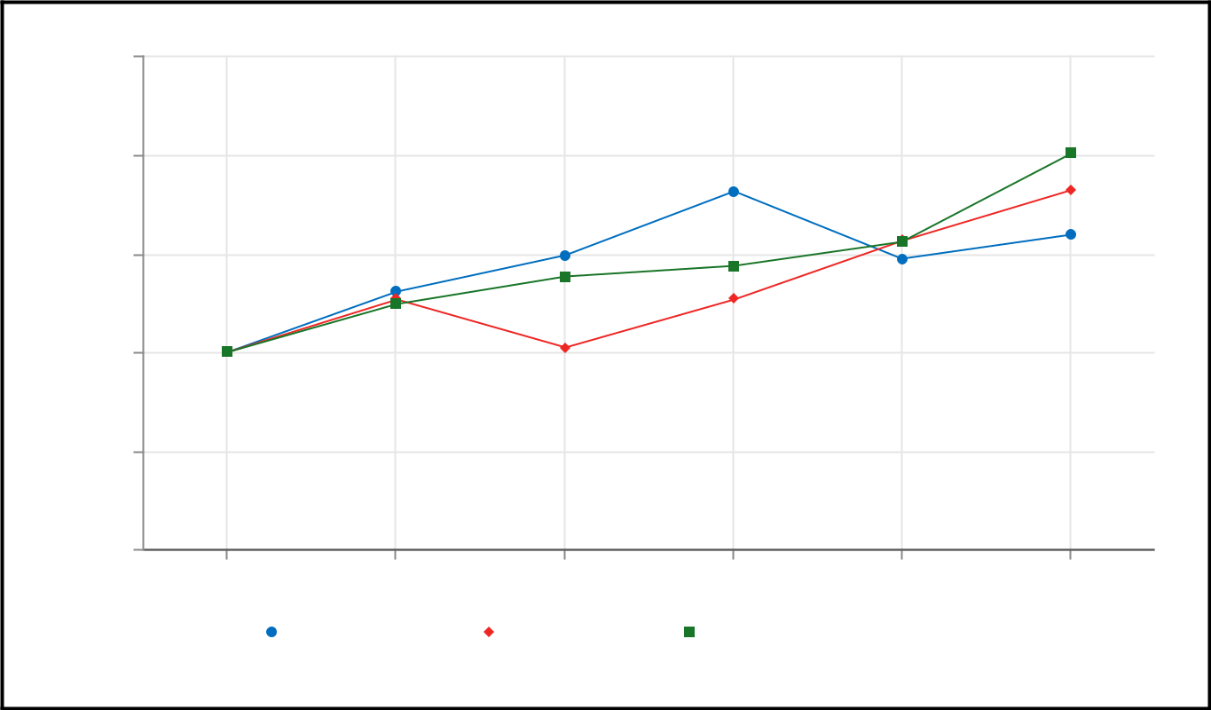

$250.00

$200.00

$150.00

$100.00

$50.00

$0.00

12/31/2020 |  | 12/31/2021 | 12/31/2022 |  | 12/31/2023 |  | 12/31/2024 | 12/31/2025
 |  | Regeneron |  | S&P 500 |  | NQ US Pharma TR Index

 | 12/31/2020 |  |  | 12/31/2021 |  |  | 12/31/2022 |  |  | 12/31/2023 |  |  | 12/31/2024 |  |  | 12/31/2025
Regeneron | $ | 100.00 | $ |  | 130.72 | $ |  | 149.34 | $ |  | 181.80 | $ |  | 147.45 | $ |  | 159.77
S&P 500 | $ | 100.00 | $ |  | 126.89 | $ |  | 102.22 | $ |  | 126.99 | $ |  | 156.59 | $ |  | 182.25
NQ US Pharma TR Index | $ | 100.00 | $ |  | 124.39 | $ |  | 138.51 | $ |  | 143.88 | $ |  | 156.19 | $ |  | 200.89

This performance graph shall not be deemed "filed" for purposes of Section 18 of the Securities Exchange Act of 1934, as amended, or incorporated by reference into any filing of ours under the Securities Act of 1933, as amended, or the Securities Exchange Act, except as shall be expressly set forth by specific reference in such filing.

73

Issuer Purchases of Equity Securities

The table below reflects shares of Common Stock we repurchased under our share repurchase programs, as well as Common Stock withheld by us for employees to satisfy their tax withholding obligations arising upon the vesting of restricted stock granted under one of our long-term incentive plans, during the three months ended December 31, 2025. Refer to Part II, Item 7. "Management's Discussion and Analysis of Financial Condition and Results of Operations - Liquidity and Capital Resources" for further details of our share repurchase programs.

 |  |  |  |  |  |  | Total Number of |  |  | Approximate Dollar
 |  |  |  |  |  |  | Total Number of |  |  | Value of Shares that
 |  |  |  |  |  |  | Shares Purchased |  |  | May Yet Be
 |  | Total Number of |  |  | Average Price |  | as Part of Publicly |  |  | Purchased Under the
Period |  | Total Number of |  |  | Average Price |  | Announced |  |  | Programs
Period |  | Shares Purchased |  |  | Paid per Share |  | Programs |  |  | (In millions)
10/1/2025–10/31/2025 | 394,828 |  | $ |  | 592.94 | 394,828 |  | $ |  | 1,922.3
11/1/2025–11/30/2025 | 330,630 |  | $ |  | 689.69 | 325,234 |  | $ |  | 1,697.9
12/1/2025–12/31/2025 |  | 594,493 | $ |  | 735.19 |  | 283,758 | $ |  | 1,486.0
Total^{(a)} | 1,319,951 |  |  |  |  | 1,003,820
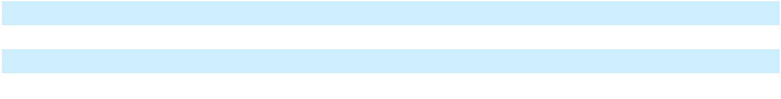

- The difference between the total number of shares purchased and the total number of shares purchased as part of publicly announced programs relates to Common Stock withheld by us for employees to satisfy their tax withholding obligations arising upon the vesting of restricted stock granted under one of our long-term incentive plans

Item 6. [Reserved]

Item 7. Management's Discussion and Analysis of Financial Condition and Results of Operations

The following discussion should be read in conjunction with the consolidated financial statements and related notes included elsewhere in this report. Refer to Part II, Item 7 in our Annual Report on Form 10-K for the fiscal year ended December 31, 2024 (filed with the SEC on February 5, 2025) for additional discussion of our financial condition and results of operations for the year ended December 31, 2023, as well as our financial condition and results of operations for the year ended December 31, 2024 compared to the year ended December 31, 2023.

Overview

Regeneron Pharmaceuticals, Inc. is a fully integrated biotechnology company that invents, develops, manufactures, and commercializes medicines for people with serious diseases. Our research and development efforts have led to numerous products that have received marketing approval and approximately 45 product candidates currently in clinical development (including a number of marketed products for which we are investigating additional indications), most of which were homegrown in our laboratories.

Our ability to generate profits and to generate positive cash flow from operations over the next several years depends significantly on the success in commercializing our products, including EYLEA HD and Dupixent. We expect to continue to incur substantial expenses related to our research and development activities, and our research and development activities and related costs which are not reimbursed by collaborators are expected to expand and require additional resources. We also expect to incur substantial costs related to the commercialization of our marketed products. Our financial results may fluctuate from quarter to quarter and will depend on, among other factors, the net sales of our products; the scope and progress of our research and development efforts; the timing of certain expenses; the continuation of our collaborations, in particular with Sanofi and Bayer, including our share of collaboration profits from sales of commercialized products and the amount of reimbursement of our research and development expenses that we receive from collaborators; and the amount of income tax expense we incur, which is partly dependent on the profits or losses we earn in each of the countries in which we operate. There is uncertainty surrounding whether or when new products or new indications for marketed products will receive regulatory approval or, if any such approval is received, whether we will be able to successfully commercialize such products and whether or when they may become profitable.

74

Critical Accounting Estimates

The preparation of financial statements in accordance with accounting principles generally accepted in the United States of America ("GAAP") requires management to make estimates and assumptions that affect reported amounts and related disclosures in the financial statements. Critical accounting estimates are those estimates made in accordance with GAAP that involve a significant level of estimation uncertainty and have had or are reasonably likely to have a material impact on our results of operations or financial condition.

Management believes the current assumptions used to estimate amounts reflected in our Consolidated Financial Statements are appropriate. However, if actual experience differs from the assumptions used in estimating amounts reflected in our Consolidated Financial Statements, the resulting changes could have a material adverse effect on our results of operations, and, in certain situations, could have a material adverse effect on our liquidity and financial condition. The critical accounting estimates that impact our Consolidated Financial Statements are described below.

Product Revenue

We recognize revenue from product sales at a point in time when our customer is deemed to have obtained control of the product, which generally occurs upon receipt or acceptance by our customer. The amount of revenue we recognize from product sales may vary due to rebates, chargebacks, and discounts provided under governmental and other programs, distribution-related fees, and other sales-related deductions. In order to determine the transaction price, we estimate, utilizing the expected value method, the amount of variable consideration to which we will be entitled. This estimate is based upon contracts with customers, healthcare providers, payors and government agencies, statutorily-defined discounts applicable to government-funded programs, historical experience, estimated payor mix, and other relevant factors. Calculating these provisions involves estimates and judgments. We review our estimates of rebates, chargebacks, and other applicable provisions each period and record any necessary adjustments in the current period's net product sales. Refer to the "Results of Operations - Revenues - Net Product Sales" section below for further details regarding our provisions, and credits/payments, for sales-related deductions.

Collaborative Arrangements

We have entered into various collaborative arrangements to research, develop, manufacture, and commercialize products and/or product candidates. Our collaboration agreements may require us to deliver various rights, services, and/or goods across the entire life cycle of a product or product candidate. In agreements involving multiple goods or services promised to be transferred to our collaborator, we assess, at the inception of the contract, whether each promise represents a separate obligation (i.e., is "distinct"), or whether such promises should be combined as a single unit of account.

If our collaborator performs research and development work or commercialization-related activities and the parties share the related costs, we also recognize, as expense (e.g., research and development expense or selling, general and administrative expense, as applicable) in the period when our collaborator incurs such expenses, the portion of the collaborator's expenses that we are obligated to reimburse. Our collaborators provide us with estimated expenses for the most recent fiscal quarter. The estimates are revised, if necessary, in subsequent periods if actual expenses differ from those estimates.

Under certain of the Company's collaboration agreements, product sales and cost of sales may be recorded by the Company's collaborators as they are deemed to be the principal in the transaction. In arrangements where we:

- supply commercial product to our collaborator, we may be reimbursed for our manufacturing costs as commercial product is shipped to the collaborator (however, recognition of such cost reimbursements may be deferred until the product is sold by our collaborator to third-party customers);

- share in any profits or losses arising from the commercialization of such products, we record our share of the variable consideration, representing net product sales less cost of goods sold and shared commercialization and other expenses, in the period in which such underlying sales occur and costs are incurred by the collaborator; and

- receive royalties and/or sales-based milestone payments from our collaborator, we recognize such amounts in the period earned.

Our collaborators provide us with estimates of product sales and our share of profits or losses, as applicable, for each quarter. The estimates are revised, if necessary, in subsequent periods if our actual share of profits or losses differ from those estimates.

75

Stock-based Compensation

We recognize stock-based compensation expense for equity grants under our long-term incentive plans to employees and non-employee members of our board of directors based on the grant-date fair value of those awards. The grant-date fair value of an award is generally recognized as compensation expense over the award's requisite service period. Stock-based compensation expense also includes an estimate, which is made at the time of grant, of the number of awards that are expected to be forfeited. The forfeiture rate estimate is calculated by considering both historical forfeiture experience and an estimate of expected future forfeitures for currently outstanding unvested awards. This estimate is reviewed at least annually and revised, if necessary, in subsequent periods if actual forfeitures differ from those estimates. The assumptions used in computing the fair value of equity awards reflect our best estimates but involve uncertainties related to market and other conditions, many of which are outside our control. Changes in any of these assumptions may materially affect the fair value of awards granted and the amount of stock-based compensation recognized in future periods.

We use the Black-Scholes model to compute the estimated fair value of stock option awards. Using this model, fair value is calculated based on assumptions with respect to (i) expected volatility of our Common Stock price, (ii) the periods of time over which employees and members of our board of directors are expected to hold their options prior to exercise (expected lives), (iii) expected dividend yield on our Common Stock, which is based on our historical practice and expectation of future dividend payments, and (iv) risk-free interest rates, which are based on quoted U.S. Treasury rates for securities with maturities approximating the options' expected lives. Expected volatility is estimated based on actual movements in our stock price over the most recent historical periods equivalent to the options' expected lives. Expected lives are principally based on our historical exercise experience with previously issued employee and board of director option grants.

We use a Monte Carlo simulation to compute the estimated fair value of performance-based restricted stock units that are subject to vesting based on the Company's attainment of pre-established criteria that include a market condition.

For performance-based restricted stock units that contain a performance condition, we recognize stock-based compensation expense if and when we determine that it is probable the performance condition will be achieved (based on the number of shares expected to be vested and issued). We reassess the probability of achievement at each reporting period and adjust compensation cost, as necessary. If there are any changes in our probability assessment, we recognize a cumulative catch-up adjustment in the period of the change in estimate, with the remaining unrecognized expense recognized prospectively over the remaining requisite service period. If we subsequently determine that the performance criteria are not met or are not expected to be met, any amounts previously recognized as compensation expense are reversed in the period when such determination is made.

See Note 13 to our Consolidated Financial Statements for stock-based compensation expense and related assumptions used in determining the fair value of our awards.

Income Taxes

We recognize deferred tax assets and liabilities for the expected future tax consequences of events that have been included in the financial statements or tax returns, including deferred tax assets and liabilities for expected amounts of Net CFC Tested Income (“NCTI”) (formerly known as global intangible low-taxed income ("GILTI")) inclusions. Deferred tax assets and liabilities are determined as the difference between the tax basis of assets and liabilities and their respective financial reporting amounts ("temporary differences") at enacted tax rates in effect for the years in which the differences are expected to reverse. A valuation allowance is established for deferred tax assets for which it is more likely than not that some portion or all of the deferred tax assets will not be realized. We periodically re-assess the need for a valuation allowance against our deferred tax assets based on all available evidence, including scheduled reversals of deferred tax liabilities, projected future taxable income, tax planning strategies, results of recent operations, and our historical earnings experience by taxing jurisdiction. Significant judgment is required in making this assessment.

We recognize the financial statement effects of a tax position when our assessment is that there is more than a 50% probability that the position will be sustained upon examination by a taxing authority based upon its technical merits. Uncertain tax positions are recorded based upon certain recognition and measurement criteria. Significant judgment is required in making this assessment, and, therefore, we re-evaluate uncertain tax positions and consider various factors, including, but not limited to, changes in tax law, the measurement of tax positions taken or expected to be taken in tax returns, the effective settlement of matters subject to audit, information obtained during in-process audit activities, and changes in facts or circumstances related to a tax position. We adjust the amount of the liability to reflect any subsequent changes in the relevant facts and circumstances surrounding the uncertain tax positions.

76

Inventories

We capitalize inventory costs associated with our products prior to regulatory approval when, based on management's judgment, future commercialization is considered probable and future economic benefit is expected to be realized; otherwise, such costs are expensed. The determination to capitalize inventory costs is based on various factors, including status and expectations of the regulatory approval process, any known safety or efficacy concerns, potential labeling restrictions, and any other impediments to obtaining regulatory approval.

We periodically analyze our inventory levels to identify inventory that may expire prior to expected sale or has a cost basis in excess of its estimated realizable value. In addition, our products are subject to strict quality control and monitoring which we perform throughout the manufacturing process. If certain batches or units of product no longer meet quality specifications or become obsolete due to expiration, we record a charge to write down such inventory to its estimated realizable value.

Acquisitions

We make certain judgments to determine whether a transaction should be accounted for as a business combination or as an asset acquisition.

In a business combination, the acquisition method of accounting generally requires that the assets acquired and liabilities assumed be recorded as of the date of the acquisition at their respective fair values. There can be significant judgment involved in determining the estimated fair values of such assets and liabilities. Amounts allocated to acquired in-process research and development are capitalized as indefinite-lived intangible assets. Any excess of the purchase price (consideration transferred) over the fair values of net assets acquired is recorded as goodwill. Contingent consideration obligations are recorded at fair value as of the acquisition date and remeasured each subsequent reporting period until the contingencies have been resolved. The fair value of contingent consideration liabilities is determined using inputs that may include the probability of achieving certain milestones and estimated discount rates.

If it is determined that the assets acquired do not meet the definition of a business, or if substantially all of the fair value of the assets acquired are concentrated in a single identifiable asset, then the transaction is accounted for as an asset acquisition rather than a business combination. In an asset acquisition, assets acquired are recorded at cost, goodwill is not recorded, and acquired in-process research and development with no alternative future use is charged to expense.

Intangible Assets

Intangible assets acquired in a business combination are recorded at fair value, while intangible assets acquired in connection with an asset acquisition are recorded at cost.

Payments to acquire intangible assets in an asset acquisition may include up-front payments and contingent consideration. With regard to contingent consideration in an asset acquisition, the Company recognizes regulatory milestones upon achievement, royalties in the period in which the underlying sales occur, and sales-based milestones when the milestone is deemed probable by the Company of being achieved. If contingent consideration is recognized subsequent to the acquisition date in an asset acquisition, the amount of such consideration is recorded as an addition to the cost basis of the intangible asset with a cumulative catch-up adjustment for amortization expense as if the additional amount of consideration had been accrued from the outset of the acquisition.

Indefinite-lived intangible assets are subject to impairment testing until completion or abandonment of the associated research and development efforts. Definite-lived intangible assets are amortized over the estimated useful lives of the assets based on the pattern in which the economic benefits of the intangible assets are consumed; if that pattern cannot be reliably determined, a straight-line basis is used.

Intangible assets are reviewed for recoverability whenever events or changes in circumstances (e.g., changes in economic, regulatory, or legal conditions) indicate that the carrying amount of the asset may not be recoverable. If an indicator of impairment exists, we compare the projected undiscounted cash flows to be generated by the asset to the intangible asset's carrying amount. If the projected undiscounted cash flows of the intangible asset are less than the carrying amount, the intangible asset is written down to its fair value in the period in which the impairment occurs.

Contingencies

We accrue, based on management's judgment, for an estimated loss when the potential loss from claims or legal proceedings is considered probable and the amount can be reasonably estimated. As additional information becomes available, or, based on specific events such as the outcome of litigation or settlement of claims, we reassess the potential liability related to pending claims and litigation, and may change our estimates.

77

Results of Operations

Net Income

 |  | Year Ended December 31,
(In millions, except per share data) |  | 2025 |  |  | 2024 |  |  | 2023
Revenues | $ | 14,342.9 | $ |  | 14,202.0 | $ |  | 13,117.2
Operating expenses |  | 10,765.0 |  |  | 10,211.3 |  |  | 9,070.1
Income from operations |  | 3,577.9 |  |  | 3,990.7 |  |  | 4,047.1
Other income (expense) |  | 1,652.8 |  |  | 789.2 |  |  | 152.2
Income before income taxes |  | 5,230.7 |  |  | 4,779.9 |  |  | 4,199.3
Income tax expense |  | 725.8 |  |  | 367.3 |  |  | 245.7
Net income | $ | 4,504.9 |  | $ | 4,412.6 |  | $ | 3,953.6
Net income per share - diluted | $ | 41.48 | $ |  | 38.34 | $ |  | 34.77
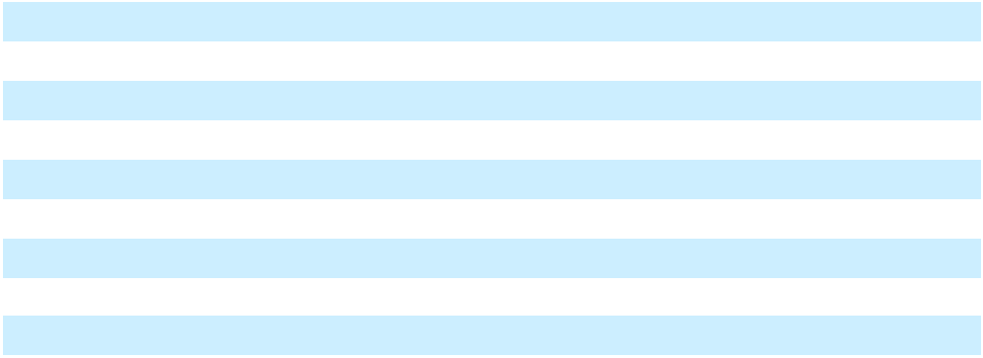

Revenues
 |  | Year Ended December 31, |  |  |  |  |  |  |  |  | $ Change
(In millions) |  | 2025 |  |  | 2024 |  |  | 2023 |  | 2025 vs. 2024 |  |  | 2024 vs. 2023
Net product sales:
EYLEA HD - U.S. | $ | 1,636.9 | $ |  | 1,201.1 | $ |  | 165.8 | $ |  | 435.8 | $ |  | 1,035.3
EYLEA - U.S. |  | 2,747.8 |  |  | 4,767.1 |  |  | 5,719.6 |  |  | (2,019.3) |  |  | (952.5)
Total EYLEA HD and EYLEA - U.S. |  | 4,384.7 |  |  | 5,968.2 |  |  | 5,885.4 |  |  | (1,583.5) |  |  | 82.8
Libtayo - U.S. |  | 944.7 |  |  | 787.3 |  |  | 538.8 |  |  | 157.4 |  |  | 248.5
Libtayo - ROW |  | 507.5 |  |  | 429.5 |  |  | 324.3 |  |  | 78.0 |  |  | 105.2
Total Libtayo - Global |  | 1,452.2 |  |  | 1,216.8 |  |  | 863.1 |  |  | 235.4 |  |  | 353.7
Praluent - U.S. |  | 262.5 |  |  | 241.7 |  |  | 182.4 |  |  | 20.8 |  |  | 59.3
Evkeeza - U.S. |  | 162.2 |  |  | 125.7 |  |  | 77.3 |  |  | 36.5 |  |  | 48.4
Inmazeb - U.S. |  | 37.4 |  |  | 76.8 |  |  | 69.8 |  |  | (39.4) |  |  | 7.0
Other products - Global |  | 10.1 |  |  | — |  |  | — |  |  | 10.1 |  |  | —
Total net product sales | $ | 6,309.1 | $ |  | 7,629.2 | $ |  | 7,078.0 | $ |  | (1,320.1) | $ |  | 551.2
Collaboration revenue:
Sanofi | $ | 5,884.0 | $ |  | 4,531.4 | $ |  | 3,799.5 | $ |  | 1,352.6 | $ |  | 731.9
Bayer |  | 1,422.4 |  |  | 1,499.0 |  |  | 1,487.5 |  |  | (76.6) |  |  | 11.5
Roche |  | — |  |  | 1.4 |  |  | 211.0 |  |  | (1.4) |  |  | (209.6)
Other |  | 24.8 |  |  | 26.0 |  |  | 5.1 |  |  | (1.2) |  |  | 20.9
Other revenue |  | 702.6 |  |  | 515.0 |  |  | 536.1 |  |  | 187.6 |  |  | (21.1)
Total revenues | $ | 14,342.9 | $ |  | 14,202.0 | $ |  | 13,117.2 | $ |  | 140.9 | $ |  | 1,084.8

Net Product Sales

Net product sales of EYLEA HD increased in 2025 compared to 2024, due to higher sales volumes, partly offset by a lower net selling price. EYLEA HD was approved by the FDA in August 2023.

Net product sales of EYLEA decreased in 2025 compared to 2024, due to (i) lower sales volumes as a result of continued competitive pressures (as described below), loss in market share to compounded bevacizumab due to patient affordability constraints, and the continued transition of patients to EYLEA HD, and (ii) a lower net selling price.

EYLEA net product sales have been, and are likely to continue to be, negatively impacted by increased competition from other anti-VEGF products, including biosimilars, as well as the transition of patients from EYLEA to EYLEA HD. The magnitude and

78

duration of such impact is presently unknown. For more information, see Part I, Item 1A. "Risk Factors - Risks Related to Commercialization of Our Marketed Products, Product Candidates, and New Indications for Our Marketed Products - We are substantially dependent on the success of EYLEA HD, EYLEA, and Dupixent" and "The commercial success of our products and product candidates is subject to significant competition - Marketed Products." In addition, if independent not-for-profit patient assistance funds that provide copay assistance are unable to support eligible patients, this will likely have a continued negative impact on patient affordability resulting in lower utilization of higher-cost anti-VEGF agents.

Revenue from product sales is recorded net of applicable provisions for rebates, chargebacks, and discounts; distribution-related fees; and other sales-related deductions. The following table summarizes the provisions, and credits/payments, for sales-related deductions:

 |  |  | Rebates, |  | Distribution- |  |  |  | Other Sales-
(In millions) |  | Chargebacks, |  |  |  |  |  |  | Related |  |  | Total
 |  | and Discounts |  |  | Related Fees |  |  |  | Deductions |  |  | Total
Balance as of December 31, 2022 |  | $ | 353.9 | $ |  | 111.4 | $ |  | 81.5 | $ |  | 546.8
Provisions |  |  | 2,074.5 |  |  | 439.2 |  |  | 155.3 |  |  | 2,669.0
Credits/payments |  |  | (1,972.7) |  |  | (388.3) |  |  | (157.5) |  |  | (2,518.5)
Balance as of December 31, 2023 |  |  | 455.7 |  |  | 162.3 |  |  | 79.3 |  |  | 697.3
Provisions |  |  | 2,447.3 |  |  | 462.7 |  |  | 143.0 |  |  | 3,053.0
Credits/payments |  |  | (2,363.9) |  |  | (497.2) |  |  | (128.8) |  |  | (2,989.9)
Balance as of December 31, 2024 |  |  | 539.1 |  |  | 127.8 |  |  | 93.5 |  |  | 760.4
Provisions |  |  | 2,751.7 |  |  | 421.1 |  |  | 119.7 |  |  | 3,292.5
Credits/payments |  |  | (2,659.2) |  |  | (400.7) |  |  | (122.2) |  |  | (3,182.1)
Balance as of December 31, 2025 |  | $ | 631.6 | $ |  | 148.2 | $ |  | 91.0 | $ |  | 870.8
Sanofi Collaboration Revenue
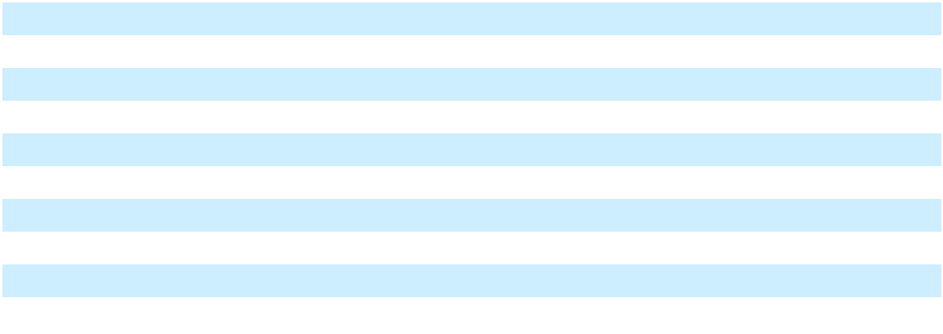

 |  | Year Ended December 31,
(In millions) |  | 2025 |  |  | 2024 |  |  | 2023
Regeneron's share of profits | $ | 5,241.6 | $ |  | 3,923.5 | $ |  | 3,136.5
Sales-based milestones earned |  | — |  |  | — |  |  | 50.0
Reimbursement for manufacturing of commercial supplies^{(a)} |  | 642.4 |  |  | 607.9 |  |  | 613.0
Total Sanofi collaboration revenue | $ | 5,884.0 | $ |  | 4,531.4 | $ |  | 3,799.5
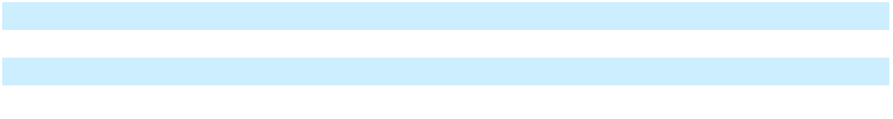

- Corresponding costs incurred by the Company in connection with such manufacturing is recorded within Cost of collaboration and contract manufacturing

Global net product sales of Dupixent and Kevzara are recorded by Sanofi, and we and Sanofi share profits on such sales.

Regeneron's share of profits in connection with the commercialization of Dupixent and Kevzara is summarized below:

 |  | Year Ended December 31,
(In millions) |  | 2025 |  |  | 2024 |  |  | 2023
Dupixent and Kevzara net product sales | $ | 18,381.3 | $ |  | 14,606.7 | $ |  | 11,974.0
Regeneron's share of collaboration profits in connection with
 |  | 6,171.3 |  |  | 4,527.2 |  |  | 3,596.3
commercialization of antibodies |  | 6,171.3 |  |  | 4,527.2 |  |  | 3,596.3
Reimbursement of development expenses incurred by Sanofi |  | (929.7) |  |  | (603.7) |  |  | (459.8)
in accordance with Regeneron's payment obligation^{(a)} |  | (929.7) |  |  | (603.7) |  |  | (459.8)
Regeneron's share of profits | $ | 5,241.6 | $ |  | 3,923.5 | $ |  | 3,136.5
Regeneron's share of profits as a percentage of Dupixent and
Regeneron's share of profits as a percentage of Dupixent and |  | 29% |  |  | 27% |  |  | 26%
Kevzara net product sales |  | 29% |  |  | 27% |  |  | 26%
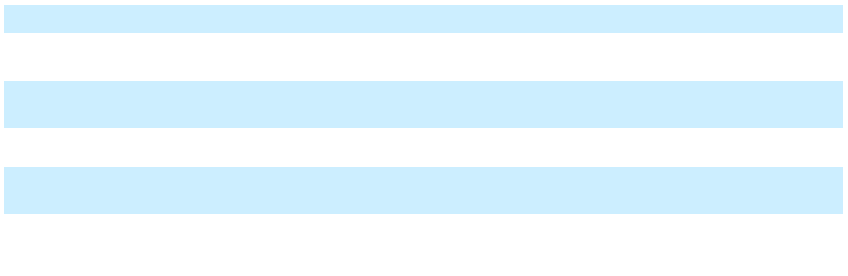

- See "Liquidity and Capital Resources - Additional Funding Requirements" below for additional details on our contingent reimbursement obligation

79

The increase in our share of profits during the year ended December 31, 2025, compared to 2024, was driven by higher profits primarily associated with an increase in Dupixent sales.

Bayer Collaboration Revenue

 |  | Year Ended December 31,
(In millions) |  | 2025 |  |  | 2024 |  |  | 2023
Regeneron's share of profits | $ | 1,282.7 | $ |  | 1,403.3 | $ |  | 1,376.4
Reimbursement for manufacturing of commercial supplies^{(a)} |  | 139.7 |  |  | 95.7 |  |  | 111.1
Total Bayer collaboration revenue | $ | 1,422.4 | $ |  | 1,499.0 | $ |  | 1,487.5
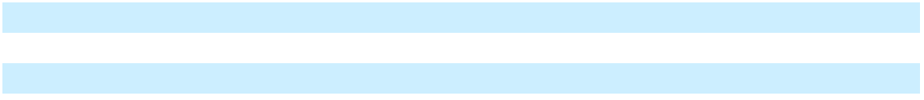

- Corresponding costs incurred by the Company in connection with such manufacturing is recorded within Cost of collaboration and contract manufacturing

Bayer records net product sales of EYLEA 8 mg and EYLEA outside the United States, and we and Bayer share profits on such sales.

Regeneron's share of profits in connection with commercialization of EYLEA 8 mg and EYLEA outside the United States is summarized below:

 |  | Year Ended December 31,
(In millions) |  | 2025 |  |  | 2024 |  |  | 2023
EYLEA 8 mg and EYLEA net product sales outside the | $ | 3,506.3 | $ |  | 3,576.8 | $ |  | 3,495.2
United States
Regeneron's share of collaboration profit from sales outside
Regeneron's share of collaboration profit from sales outside | $ | 1,347.3 | $ |  | 1,469.7 | $ |  | 1,436.1
the United States
Reimbursement of development expenses incurred by Bayer |  | (64.6) |  |  | (66.4) |  |  | (59.7)
in accordance with Regeneron's payment obligation^{(a)} |  | (64.6) |  |  | (66.4) |  |  | (59.7)
Regeneron's share of profits | $ | 1,282.7 | $ |  | 1,403.3 | $ |  | 1,376.4
Regeneron's share of profits as a percentage of EYLEA 8 mg
Regeneron's share of profits as a percentage of EYLEA 8 mg |  | 37% |  |  | 39% |  |  | 39%
and EYLEA net product sales outside the United States |  | 37% |  |  | 39% |  |  | 39%
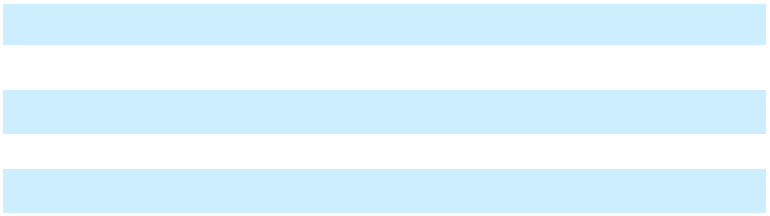

- See "Liquidity and Capital Resources - Additional Funding Requirements" below for additional details on our contingent reimbursement obligation

The decrease in our share of profits for the year ended December 31, 2025, compared to the same period in 2024, was primarily driven by lower profits associated with a decrease in EYLEA sales outside the United States.

Roche Collaboration Revenue

Under the terms of the Roche collaboration, Roche distributed and recorded net product sales of Ronapreve™ outside the United States, and the parties shared gross profits from sales based on a pre-specified formula. In 2023, total Roche collaboration revenue was $211.0 million. Net product sales of Ronapreve outside the United States declined as a result of new variants of the SARS-CoV-2 virus emerging that are not susceptible to the treatment.

80

Other Revenue

(In millions)
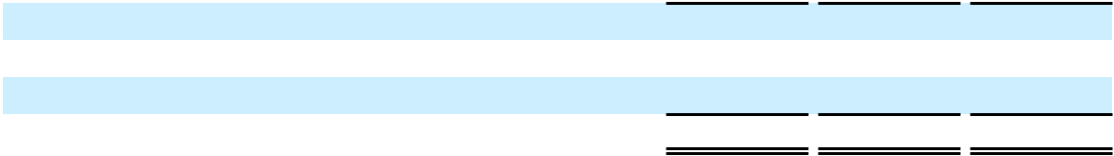

Royalties on sales of Novartis' Ilaris® (canakinumab)^{(a)}

Regeneron's share of profits from sales of ARCALYST^{(b)}
Other^{(c)}

Total other revenue

Year Ended December 31,

2025 2024 2023

- 274.8 $177.5 $153.8

231.2 115.2 60.4

196.6 222.3 321.9

$ 702.6 $ 515.0 $ 536.1

- In connection with our agreement with Novartis, the tiered royalty rates start at 4% and reach 15% after annual sales exceed $1.5 billion

- In connection with our license agreement with Kiniksa Pharmaceuticals, Ltd., we are entitled to receive 50% of Kiniksa's profits from sales of ARCALYST

- Consists primarily of amounts earned in connection with manufacturing product for others; corresponding costs incurred by the Company in connection with such manufacturing is recorded within Cost of collaboration and contract manufacturing

Operating Expenses
 |  | Year Ended December 31, |  |  |  |  |  |  |  |  | Change
(In millions, except headcount data) |  | 2025 |  |  | 2024 |  |  | 2023 |  | 2025 vs. 2024 |  |  | 2024 vs. 2023
Research and development^{(a)} | $ | 5,850.2 | $ |  | 5,132.0 | $ |  | 4,439.0 | $ |  | 718.2 | $ |  | 693.0
Acquired in-process research and |  | 124.1 |  |  | 101.0 |  |  | 186.1 |  |  | 23.1 |  |  | (85.1)
development |  | 124.1 |  |  | 101.0 |  |  | 186.1 |  |  | 23.1 |  |  | (85.1)
Selling, general, and administrative^{(a)} |  | 2,700.0 |  |  | 2,954.4 |  |  | 2,631.3 |  |  | (254.4) |  |  | 323.1
Cost of goods sold |  | 1,140.8 |  |  | 1,087.3 |  |  | 932.1 |  |  | 53.5 |  |  | 155.2
Cost of collaboration and contract |  | 959.9 |  |  | 883.2 |  |  | 883.7 |  |  | 76.7 |  |  | (0.5)
manufacturing^{(b)} |  | 959.9 |  |  | 883.2 |  |  | 883.7 |  |  | 76.7 |  |  | (0.5)
Other operating (income) expense, net |  | (10.0) |  |  | 53.4 |  |  | (2.1) |  |  | (63.4) |  |  | 55.5
Total operating expenses | $ | 10,765.0 | $ |  | 10,211.3 | $ |  | 9,070.1 | $ |  | 553.7 | $ |  | 1,141.2
Average headcount |  | 15,261 |  |  | 14,383 |  |  | 12,698 |  |  | 878 |  |  | 1,685
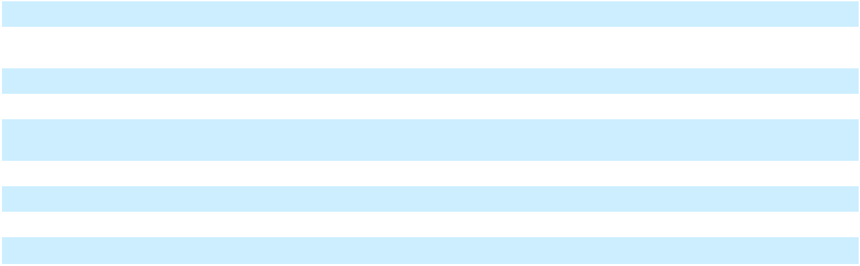

- Includes costs incurred net of any cost reimbursements from collaborators

- Includes costs incurred in connection with manufacturing drug supplies for collaborators and others

Operating expenses in 2025 and 2024 included stock-based compensation expense of $993.7 million and $982.8 million, respectively. As of December 31, 2025, unrecognized stock-based compensation expense related to unvested stock options and unvested restricted stock was $385.8 million and $1.493 billion, respectively. We expect to recognize this stock-based compensation expense related to stock options and restricted stock over weighted-average periods of 1.7 years and 2.3 years, respectively.

81

Research and Development Expenses

The following table summarizes our direct research and development expenses by clinical development program and other significant categories of research and development expenses. Direct research and development expenses are comprised primarily of costs paid to third parties for clinical and product development activities, including costs related to preclinical research activities, clinical trials, and the portion of research and development expenses incurred by our collaborators that we are obligated to reimburse. Indirect research and development expenses have not been allocated directly to each program, and primarily consist of costs to compensate personnel, overhead and infrastructure costs to maintain our facilities, and other costs related to activities that benefit multiple projects. Clinical manufacturing costs primarily consist of costs to manufacture bulk drug product for clinical development purposes as well as related drug filling, packaging, and labeling costs. Clinical manufacturing costs also include pre-launch commercial supplies which did not meet the criteria to be capitalized as inventory (see "Critical Accounting Estimates - Inventories" above). The table below also includes reimbursements of research and development expenses by collaborators, as when we are entitled to reimbursement of all or a portion of such expenses that we incur under a collaboration, we record those reimbursable amounts in the period in which such costs are incurred.

 |  | Year Ended December 31, |  |  |  |  |  |  |  |  | $ Change
(In millions) |  | 2025 |  |  | 2024* |  |  | 2023* |  | 2025 vs. 2024 |  |  | 2024 vs. 2023
Direct research and development expenses:
Fianlimab | $ | 207.9 | $ |  | 215.5 | $ |  | 112.2 | $ |  | (7.6) | $ |  | 103.3
Lynozyfic (linvoseltamab) |  | 166.0 |  |  | 141.9 |  |  | 78.7 |  |  | 24.1 |  |  | 63.2
Ordspono (odronextamab) |  | 165.4 |  |  | 129.4 |  |  | 96.3 |  |  | 36.0 |  |  | 33.1
Itepekimab |  | 111.8 |  |  | 96.2 |  |  | 70.3 |  |  | 15.6 |  |  | 25.9
Dupixent (dupilumab) |  | 111.2 |  |  | 128.8 |  |  | 168.0 |  |  | (17.6) |  |  | (39.2)
EYLEA HD (aflibercept) 8 mg |  | 90.4 |  |  | 98.3 |  |  | 96.2 |  |  | (7.9) |  |  | 2.1
Libtayo (cemiplimab) |  | 76.1 |  |  | 79.1 |  |  | 105.3 |  |  | (3.0) |  |  | (26.2)
Trevogrumab |  | 73.7 |  |  | 33.0 |  |  | 1.5 |  |  | 40.7 |  |  | 31.5
Pozelimab/cemdisiran |  | 67.2 |  |  | 79.4 |  |  | 60.2 |  |  | (12.2) |  |  | 19.2
Other product candidates in clinical |  | 688.4 |  |  | 587.2 |  |  | 506.9 |  |  | 101.2 |  |  | 80.3
development and other research programs |  | 688.4 |  |  | 587.2 |  |  | 506.9 |  |  | 101.2 |  |  | 80.3
Total direct research and development expenses |  | 1,758.1 |  |  | 1,588.8 |  |  | 1,295.6 |  |  | 169.3 |  |  | 293.2
Indirect research and development expenses:
Payroll and benefits |  | 1,800.8 |  |  | 1,681.7 |  |  | 1,537.0 |  |  | 119.1 |  |  | 144.7
Lab supplies and other research and |  | 258.2 |  |  | 241.5 |  |  | 210.6 |  |  | 16.7 |  |  | 30.9
development costs |  | 258.2 |  |  | 241.5 |  |  | 210.6 |  |  | 16.7 |  |  | 30.9
Occupancy and other operating costs |  | 635.4 |  |  | 614.9 |  |  | 518.2 |  |  | 20.5 |  |  | 96.7
Total indirect research and development |  | 2,694.4 |  |  | 2,538.1 |  |  | 2,265.8 |  |  | 156.3 |  |  | 272.3
expenses |  | 2,694.4 |  |  | 2,538.1 |  |  | 2,265.8 |  |  | 156.3 |  |  | 272.3
Clinical manufacturing costs |  | 1,391.2 |  |  | 1,195.9 |  |  | 1,053.9 |  |  | 195.3 |  |  | 142.0
Priority review voucher |  | 155.0 |  |  | — |  |  | — |  |  | 155.0 |  |  | —
Reimbursement of research and development |  | (148.5) |  |  | (190.8) |  |  | (176.3) |  |  | 42.3 |  |  | (14.5)
expenses by collaborators |  | (148.5) |  |  | (190.8) |  |  | (176.3) |  |  | 42.3 |  |  | (14.5)
Total research and development expenses | $ | 5,850.2 | $ |  | 5,132.0 | $ |  | 4,439.0 | $ |  | 718.2 | $ |  | 693.0
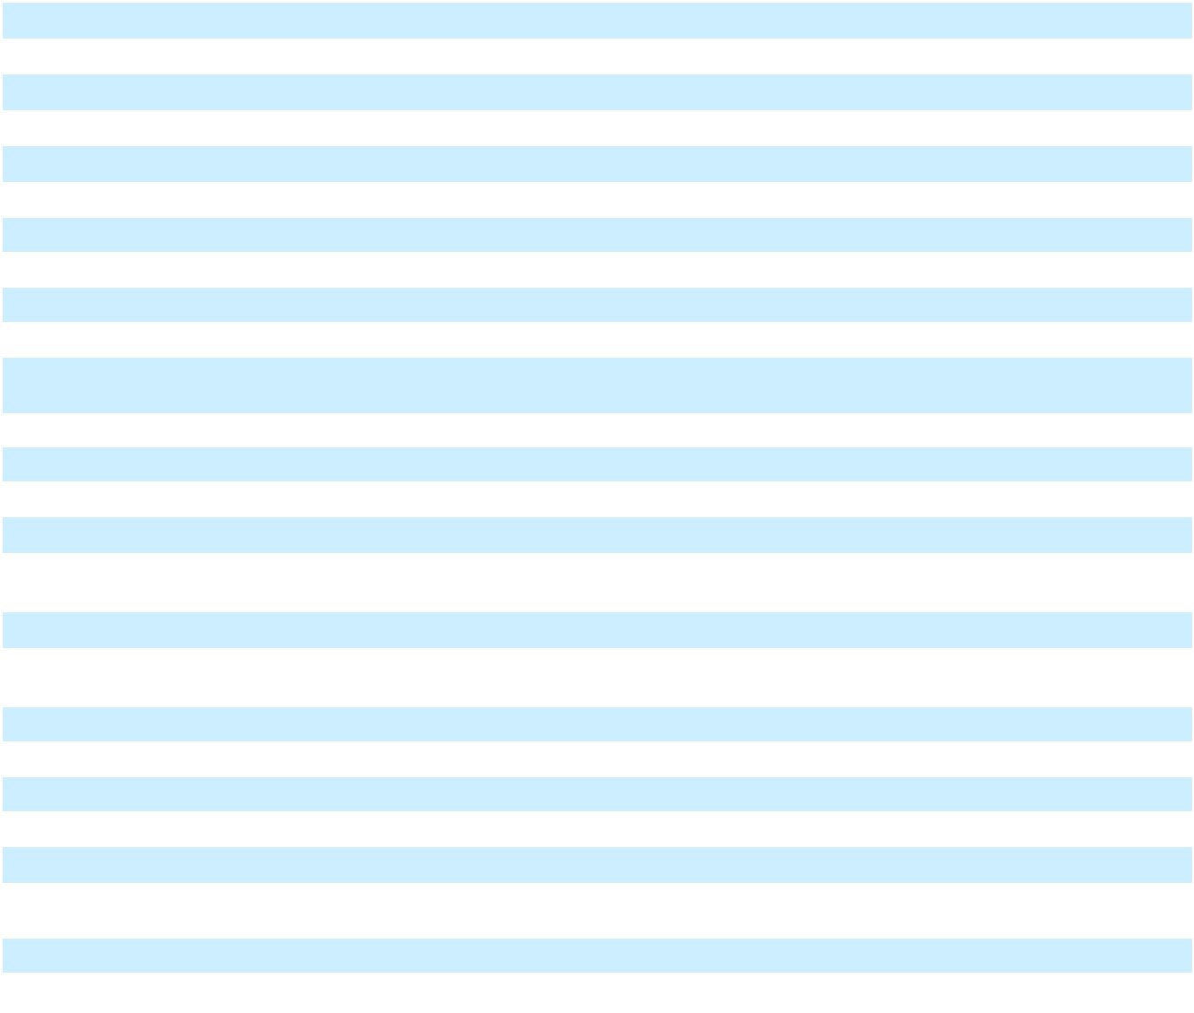

- Certain prior year amounts have been reclassified to conform to the current year's presentation

82

Research and development expenses included stock-based compensation expense of $545.4 million and $543.8 million in 2025 and 2024, respectively. Research and development expenses in 2025 included $155.0 million related to an FDA Rare Pediatric Disease Priority Review Voucher ("PRV"). During the fourth quarter of 2025, we made the decision to utilize the PRV for a regulatory submission; this PRV was purchased by us, and capitalized as an intangible asset, in the second quarter of 2025.

There are numerous uncertainties associated with drug development, including uncertainties related to safety and efficacy data from each phase of drug development, uncertainties related to the enrollment and performance of clinical trials, changes in regulatory requirements, changes in the competitive landscape affecting a product candidate, and other risks and uncertainties described in Part I, Item 1A. "Risk Factors." There is also variability in the duration and costs necessary to develop a product candidate, potential opportunities and/or uncertainties related to future indications to be studied, and the estimated cost and scope of the projects. The lengthy process of seeking FDA and other applicable approvals, and subsequent compliance with applicable statutes and regulations, require the expenditure of substantial resources. Any failure by us to obtain, or delay in obtaining, regulatory approvals could materially adversely affect our business. We are unable to reasonably estimate if our product candidates in clinical development will generate material product revenues and net cash inflows.

Acquired In-Process Research and Development ("IPR&D") Expenses

Acquired IPR&D expenses in 2025 included an $80.0 million up-front payment in connection with our license agreement with Hansoh Pharmaceuticals Group Company Limited.

Acquired IPR&D expenses in 2024 included a $45.0 million development milestone in connection with our collaboration agreement with Sonoma Biotherapeutics, Inc.

Selling, General, and Administrative Expenses

Selling, general, and administrative expenses decreased in 2025, compared to 2024, primarily due to lower charitable contributions to Good Days, an independent non-profit patient assistance organization with a Retinal Vascular and Neovascular Disease Fund (the "Fund"). In July 2025, we launched a matching program for donations made to the Fund and committed to quarterly matching donations through the end of 2025. During the fourth quarter of 2025, we recognized approximately $60 million in connection with matching donations made to the Fund. We have also recently committed to matching donations for up to a total of $200 million during 2026.

Selling, general, and administrative expenses included stock-based compensation expense of $362.9 million and $355.0 million in 2025 and 2024, respectively.

Cost of Goods Sold
 | Year Ended December 31,
(In millions, except gross margin on net product sales) | 2025 |  |  | 2024 |  |  | 2023
Cost of goods sold | $ 1,140.8 | $ |  | 1,087.3 | $ |  | 932.1
Gross margin on net product sales^{(a)} | 82% |  |  | 86% |  |  | 87%

- Gross margin on net product sales represents gross profit expressed as a percentage of total net product sales recorded by the Company. Gross profit is calculated as net product sales (see "Net Product Sales" section above) less cost of goods sold.

Gross margin on net product sales decreased in 2025, compared to 2024, partly due to ongoing investments to support our manufacturing operations and higher inventory write-offs and reserves. In addition, gross margin on net product sales decreased due to higher amortization expense associated with our Libtayo intangible asset as each quarter we record additions to the intangible asset related to royalties due to Sanofi.

Other Operating (Income) Expense

Other operating (income) expense, net, in 2024 reflected a charge of $53.4 million related to the increase in the estimated fair value of the contingent consideration liability recognized in connection with our 2023 acquisition of Decibel Therapeutics, Inc.

83

Other Income (Expense)
 |  |  | Year Ended December 31,
 | (In millions) |  | 2025 |  |  | 2024* |  |  | 2023*
 | Gains (losses) on marketable and other securities, net | $ | 946.1 | $ |  | 118.3 | $ |  | (266.4)
 | Interest income |  | 716.8 |  |  | 711.4 |  |  | 495.9
 | Other |  | 33.7 |  |  | 14.7 |  |  | (4.3)
 | Other income (expense), net |  | 1,696.6 |  |  | 844.4 |  |  | 225.2
 | Interest expense |  | (43.8) |  |  | (55.2) |  |  | (73.0)
 | Total other income (expense) | $ | 1,652.8 | $ |  | 789.2 | $ |  | 152.2
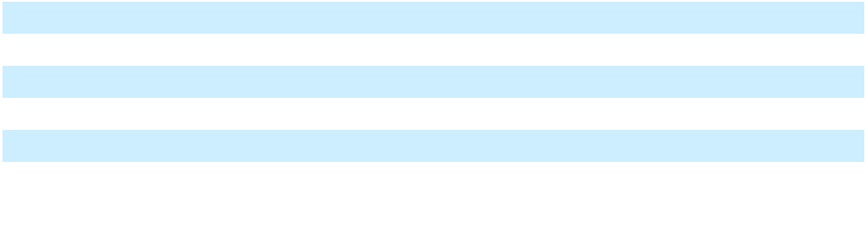
- Certain prior year amounts have been reclassified to conform to the current year's presentation

Income Taxes

 | Year Ended December 31,
(In millions, except effective tax rate) | 2025 |  |  | 2024 |  |  | 2023
Income tax expense | $ 725.8 | $ |  | 367.3 | $ |  | 245.7
Effective tax rate | 13.9% |  |  | 7.7% |  |  | 5.9%

On July 4, 2025, bill H.R. 1, commonly referred to as the "One Big Beautiful Bill Act" or "OBBBA," was signed into law, with certain provisions effective in 2025 and other provisions becoming effective in 2026. The OBBBA significantly revises U.S. corporate income tax laws by, among other things, restoring the option for immediate expense recognition for U.S.-based research and development expenditures and making permanent the ability to claim first-year bonus depreciation on qualified property. The OBBBA also modifies U.S. taxation on foreign earnings by, among other things, changing the tax rates for global intangible low-taxed income (now known as Net CFC Tested Income) and foreign-derived intangible income (now known as foreign-derived deduction eligible income), modifying the allocation of expenses in calculating foreign tax credits, as well as changing foreign tax credit limitations. As a result of the OBBBA being signed into law, we recognized a charge of $44.5 million in the third quarter of 2025 related to the re-measurement of our U.S. net deferred tax assets.

Our effective tax rate for 2025 was positively impacted, compared to the U.S. federal statutory rate, primarily by income earned in foreign jurisdictions with tax rates lower than the U.S. federal statutory rate and federal tax credits for research activities, partially offset by the impact of the OBBBA being signed into law. In addition, our effective tax rate for 2025 was positively impacted by the release of liabilities for uncertain tax positions recognized upon the effective settlement of the IRS audit of our 2017 and 2018 federal income tax returns.

Our effective tax rate for 2025, compared to 2024, included a lower benefit from stock-based compensation.

Our effective tax rate for 2024 was positively impacted, compared to the U.S. federal statutory rate, primarily by stock-based compensation, income earned in foreign jurisdictions with tax rates lower than the U.S. federal statutory rate, and federal tax credits for research activities.

84

Liquidity and Capital Resources

Our financial condition is summarized as follows:

 |  | As of December 31,
(In millions) |  | 2025 |  |  | 2024 |  |  | $ Change
Financial assets:
Cash and cash equivalents | $ | 3,118.1 | $ |  | 2,488.2 | $ |  | 629.9
Marketable securities - current |  | 5,487.1 |  |  | 6,524.3 |  |  | (1,037.2)
Marketable securities - noncurrent |  | 10,260.6 |  |  | 8,900.1 |  |  | 1,360.5
 | $ | 18,865.8 | $ |  | 17,912.6 | $ |  | 953.2
Working capital:
Current assets | $ | 18,021.9 | $ |  | 18,660.9 | $ |  | (639.0)
Current liabilities |  | 4,368.4 |  |  | 3,944.3 |  |  | 424.1
 | $ | 13,653.5 | $ |  | 14,716.6 | $ |  | (1,063.1)
Borrowings and finance lease liabilities:
Long-term debt | $ | 1,985.9 | $ |  | 1,984.4 | $ |  | 1.5
Finance lease liabilities | $ | 720.0 | $ |  | 720.0 | $ |  | —
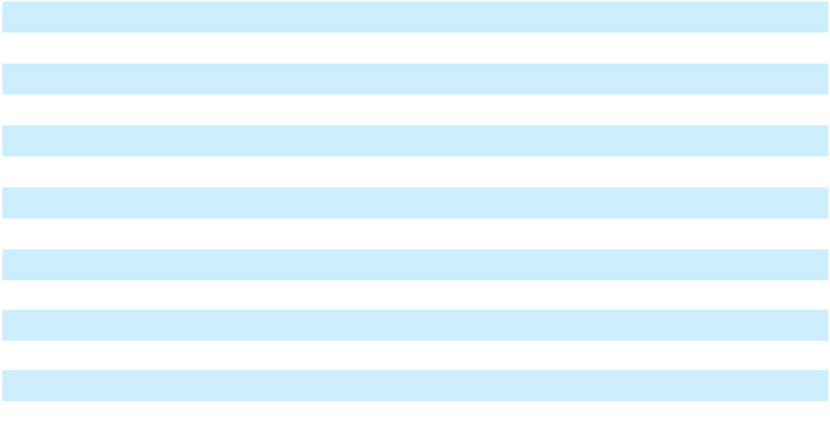

As of December 31, 2025, we also had borrowing availability of $750.0 million under a revolving credit facility (see further description under "Credit Facility" below).

Sources and Uses of Cash

 |  | Year Ended December 31, |  |  |  |  |  |  |  |  | $ Change
(In millions) |  | 2025 |  |  | 2024 |  |  | 2023 |  | 2025 vs. 2024 |  |  | 2024 vs. 2023
Cash flows provided by (used in):
Operating activities | $ | 4,978.9 | $ |  | 4,420.5 | $ |  | 4,594.0 | $ |  | 558.4 | $ |  | (173.5)
Investing activities | $ | (629.1) | $ |  | (2,468.1) | $ |  | (3,185.1) | $ |  | 1,839.0 | $ |  | 717.0
Financing activities | $ | (3,715.4) | $ |  | (2,200.5) | $ |  | (1,790.1) | $ |  | (1,514.9) | $ |  | (410.4)
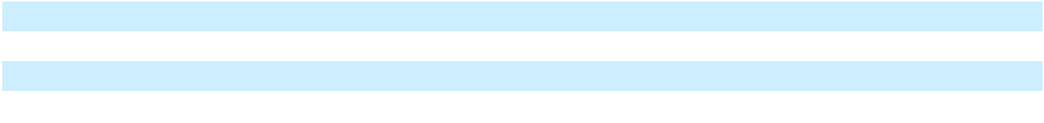

Cash Flows from Operating Activities

In 2025, Other, net included a $155.0 million charge in connection with a fourth quarter 2025 decision to utilize a PRV for a regulatory submission; such amount was previously capitalized as an intangible asset as described in the "Cash Flows from Investing Activities" section below.

Cash Flows from Investing Activities

Capital expenditures in 2025 primarily included costs incurred in connection with the expansion of our research, preclinical manufacturing, and support facilities at our Tarrytown, New York corporate headquarters, as well as costs associated with the expansion of our manufacturing facilities. We expect to incur capital expenditures of $1.100 billion to $1.300 billion in 2026, including in connection with the continued expansion of our facilities in Tarrytown, New York and developing our property in Saratoga Springs, New York for production support activities and additional manufacturing capacity. We expect continued significant capital expenditures over the next several years related to these expansion projects.

85

In 2025, payments for intangible assets included $155.0 million related to a second quarter 2025 purchase of a PRV from a third party. In addition, payments for intangible assets in 2025, 2024, and 2023 included $160.3 million, $125.7 million, and $207.8 million, respectively, for contingent consideration paid to Sanofi in connection with our acquisition of worldwide rights to Libtayo in 2022.

Cash Flows from Financing Activities

Proceeds from issuances of Common Stock, in connection with exercises of employee stock options, were $635.9 million during 2025, compared to $1.465 billion during 2024 and $1.146 billion during 2023. In addition, payments in connection with Common Stock tendered for employee tax obligations were $532.1 million during 2025, compared to $1.029 billion during 2024 and $700.6 million during 2023. For information related to repurchases of Common Stock, see "Share Repurchase Programs" section below.

Credit Facility

The Company is party to an agreement with a syndicate of lenders (the "Credit Agreement") which provides for a $750.0 million senior unsecured five-year revolving credit facility (the "Credit Facility"). The Credit Agreement includes an option for the Company to elect to increase the commitments under the Credit Facility and/or to enter into one or more tranches of term loans in the aggregate principal amount of up to $500.0 million, subject to the consent of the lenders providing the additional commitments or term loans, as applicable, and certain other conditions. The Credit Agreement also provides a $50.0 million sublimit for letters of credit.

Proceeds of the loans under the Credit Facility may be used to finance working capital needs, and for general corporate or other lawful purposes, of Regeneron and its subsidiaries. Regeneron Pharmaceuticals, Inc. has guaranteed all obligations under the Credit Facility. The Credit Agreement includes an option for us to elect to extend the maturity date of the Credit Facility beyond December 2027, subject to the consent of the extending lenders and certain other conditions. Amounts borrowed under the Credit Facility may be prepaid, and the commitments under the Credit Facility may be terminated, at any time without premium or penalty.

We had no borrowings outstanding under the Credit Facility as of December 31, 2025.

The Credit Agreement contains operating covenants and a maximum total leverage ratio financial covenant. We were in compliance with all covenants of the Credit Agreement as of December 31, 2025.

Share Repurchase Programs

Our board of directors has authorized share repurchase programs, including a share repurchase program for up to $3.0 billion of our Common Stock which was authorized in February 2025. The share repurchase programs permit the Company to make repurchases through a variety of methods, including open-market transactions (including pursuant to a trading plan adopted in accordance with Rule 10b5-1 of the Exchange Act), privately negotiated transactions, accelerated share repurchases, block trades, and other transactions in compliance with Rule 10b-18 of the Exchange Act. Repurchases may be made from time to time at management's discretion, and the timing and amount of any such repurchases will be determined based on share price, market conditions, legal requirements, and other relevant factors. The programs have no time limit and can be discontinued at any time. There can be no assurance as to the timing or number of shares of any repurchases in the future. As of December 31, 2025, $1.486 billion remained available for share repurchases under our share repurchase programs.

Dividends

In 2025, our board of directors declared quarterly cash dividends of $0.88 per share on our Common Stock and Class A Stock.

Each quarterly dividend was paid to our shareholders in the quarter in which the dividend was declared.

Additionally, in January 2026, our board of directors declared a cash dividend of $0.94 per share on our Common Stock and Class A Stock. The dividend will be payable on March 5, 2026 to our shareholders of record as of February 20, 2026.

We currently intend to continue to pay a quarterly cash dividend on our outstanding Common Stock and Class A Stock. Amounts and timing of any future cash dividends are subject to authorization by our board of directors in its sole discretion, after taking into consideration our financial condition and other relevant factors described under "There can be no assurance that we will continue to repurchase shares of our Common Stock or continue to declare cash dividends" in Part I, Item 1A. "Risk Factors."

86

Tarrytown, New York Corporate Headquarters Lease

We lease laboratory and office facilities for our corporate headquarters in Tarrytown, New York (the "Facility") under the Third Amended and Restated Lease and Remedies Agreement (the "Lease") with BA Leasing BSC, LLC, an affiliate of Banc of America Leasing & Capital, LLC ("BAL"), as lessor, and the Third Amended and Restated Participation Agreement (the "Participation Agreement") with Bank of America, N.A., as administrative agent, and a syndicate of lenders (collectively with BAL, the "Participants"), as rent assignees. The Lease, Participation Agreement, and certain related agreements provide for $720.0 million of lease financing (previously advanced by the Participants in March 2017 in connection with the acquisition by BAL of the Facility and our lease of the Facility from BAL), which matures when the term of the Lease expires in March 2027, at which time all amounts outstanding thereunder will become payable in full. We have the option to further extend the maturity date of the Participation Agreement and the term of the Lease for an additional five-year period, subject to the consent of the Participants and certain other conditions. We also have the option to (a) purchase the Facility by paying an amount equal to the outstanding principal amount of the Participants' advances under the Participation Agreement, all accrued and unpaid yield thereon, and all other outstanding amounts under the Participation Agreement, Lease, and certain related documents or (b) sell the Facility to a third party on behalf of BAL.

Pursuant to the Lease, we pay all maintenance, insurance, taxes, and other costs arising out of the use of the Facility. We are also required to make monthly payments of basic rent to satisfy the yield payable to the Participants on their outstanding advances under the Participation Agreement. Such advances accrue yield at a variable rate per annum based on the one-month forward-looking Secured Overnight Financing Rate ("SOFR") term rate, plus a spread adjustment, plus an applicable margin that varies with our debt rating and total leverage ratio.

The agreements governing the Lease financing contain financial and operating covenants. Such financial covenants and certain of the operating covenants are substantially similar to the covenants set forth in our Credit Agreement. We were in compliance with all such covenants as of December 31, 2025.

Additional Funding Requirements

The amount required to fund operations will depend on various factors, including the potential regulatory approval and commercialization of our product candidates and the timing thereof and the extent and cost of our research and development programs. We believe that our existing capital resources, borrowing availability under the Credit Facility, funds generated by anticipated product sales, and funding for reimbursement of research and development expenses that we are entitled to receive under our collaboration agreements, will enable us to meet our anticipated operating needs for the foreseeable future.

We expect to continue to incur significant costs in connection with our research and development activities. The amount of funding that will be required depends upon the results of our research and preclinical programs and early-stage clinical trials, regulatory requirements, the duration and results of clinical trials underway and of additional clinical trials that we decide to initiate, and the various factors that affect the cost of each trial, including the size of trials, fees charged for services provided by clinical trial investigators and other third parties, the costs for manufacturing the product candidate for use in the trials, and other expenses.

We also anticipate continuing to incur substantial commercialization costs for our marketed products. Commercialization costs over the next few years will depend on, among other things, the market potential for product candidates, whether commercialization costs are shared with a collaborator, and regulatory approval of additional product candidates.

We expect that expenses related to the filing, prosecution, defense, and enforcement of patents and other intellectual property will be substantial.

Liabilities for unrecognized tax benefits totaled $1.578 billion as of December 31, 2025. Due to their nature, there is a high degree of uncertainty regarding the period and amounts of potential future cash settlement with tax authorities. See Note 15 to our Consolidated Financial Statements.

We enter into collaboration and licensing agreements that may require us to pay (i) amounts contingent upon the occurrence of various future events (e.g., upon the achievement of various development and commercial milestones), which, in the aggregate, could be significant, and/or (ii) royalties calculated based on a percentage of net product sales. The specific timing of these contingent payments cannot be predicted. See Note 3 to our Consolidated Financial Statements.

87

As described in Part I, Item 1. "Collaboration, License, and Other Agreements," under our collaborations with Sanofi and Bayer, we and our collaborator share profits in connection with commercialization of drug products. If the applicable collaboration is profitable, we have contingent contractual obligations to reimburse Sanofi and Bayer for a defined percentage (generally 50%) of agreed-upon development expenses funded by Sanofi and Bayer (i.e., "development balance"). These reimbursements are deducted each quarter, in accordance with a formula, from our share of the collaboration profits otherwise payable to us, unless, in the case of Bayer, we elect to reimburse these expenses at a faster rate. As of December 31, 2025, our contingent reimbursement obligation to Sanofi in connection with the development balance was approximately $595 million and our contingent reimbursement obligation to Bayer was approximately $296 million. Therefore, we continue to expect that a portion of our share of profits from sales under our collaborations with Sanofi and Bayer will be used to reimburse our collaborators for these obligations.

Future Impact of Recently Issued Accounting Standards

See Note 1 to our Consolidated Financial Statements for a description of recently issued accounting standards.

Item 7A. Quantitative and Qualitative Disclosures About Market Risk

Interest Rate Risk

Our earnings and cash flows are subject to fluctuations due to changes in interest rates, principally in connection with our investments in marketable securities, which consist primarily of corporate bonds and U.S. treasury securities. We do not believe we are materially exposed to changes in interest rates related to our investments, and we do not currently use interest rate derivative instruments to manage exposure to interest rate changes of our investments. We estimate that a 100 basis point, or 1%, unfavorable change in interest rates would have resulted in a $198.3 million and $163.0 million decrease in the fair value of our investment portfolio as of December 31, 2025 and 2024, respectively.

In addition to our investments in marketable securities, we also have exposure to changes in interest rates in connection with our variable rate Tarrytown, New York lease (as described in Part II, Item 7. "Management's Discussion and Analysis of Financial Condition and Results of Operations - Liquidity and Capital Resources - Tarrytown, New York Corporate Headquarters Lease"). Our interest rate exposure is offset by our investments in marketable securities. We continue to monitor our interest rate risk and may utilize derivative instruments and/or other strategies in the future to further mitigate our interest rate exposure.

Credit Quality Risk

We have an investment policy that includes guidelines on acceptable investment securities, minimum credit quality, maturity parameters, and diversification. Nonetheless, deterioration of the credit quality of an investment security subsequent to purchase may subject us to the risk of not being able to recover the full principal value of the security.

Foreign Exchange Risk

Significant changes in foreign exchange rates of the countries outside the United States where our products are sold or where operating expenses are incurred may impact our operating results and financial condition.

Our collaborators market certain products outside the United States, and we share in profits with these collaborators from commercialization of products. In addition, pursuant to the applicable terms of the agreements with our collaborators, we also share in certain worldwide development and/or commercialization-related expenses incurred by our collaborators.

We also incur worldwide development expenses for product candidates we are developing independently, incur expenses outside the United States in connection with our international operations, and record product sales for certain products outside the United States.

As sales outside the United States continue to grow, and as we expand our international operations, we will continue to assess and implement strategies, including foreign currency hedging, to mitigate our foreign exchange risk.

Market Price Risk

We are exposed to price risk on equity securities included in our investment portfolio. Our investments in equity securities include companies with which we have entered into collaboration and other strategic arrangements. As of December 31, 2025 and 2024, the carrying value of our investments in equity securities was $515.8 million and $1.307 billion, respectively. Changes in the fair value of our equity securities are included in Other income (expense), net on the Statements of Operations.

Item 8. Financial Statements and Supplementary Data

The information required by this Item is set forth beginning on page F-1 of this report and is incorporated herein by reference.

88

Item 9. Changes in and Disagreements with Accountants on Accounting and Financial Disclosure

None.

Item 9A. Controls and Procedures

Evaluation of Disclosure Controls and Procedures

Our management, with the participation of our principal executive officer and principal financial officer, conducted an evaluation of the effectiveness of our disclosure controls and procedures (as such term is defined in Rules 13a-15(e) or 15d-15(e) under the Securities Exchange Act of 1934, as amended (the "Exchange Act")), as of the end of the period covered by this Annual Report on Form 10-K. Based on this evaluation, our principal executive officer and principal financial officer each concluded that, as of the end of such period, our disclosure controls and procedures were effective in ensuring that information required to be disclosed by us in the reports that we file or submit under the Exchange Act is recorded, processed, summarized, and reported on a timely basis, and is accumulated and communicated to our management, including our principal executive officer and principal financial officer, as appropriate to allow timely decisions regarding required disclosures.

Management's Report on Internal Control over Financial Reporting

Our management is responsible for establishing and maintaining adequate internal control over financial reporting, as such term is defined in Rules 13a-15(f) or 15d-15(f) under the Exchange Act. Our management conducted an evaluation of the effectiveness of our internal control over financial reporting as of December 31, 2025 using the framework in Internal Control - Integrated Framework (2013) issued by the Committee of Sponsoring Organizations of the Treadway Commission. Based on that evaluation, our management has concluded that our internal control over financial reporting was effective as of December 31, 2025. The effectiveness of the Company's internal control over financial reporting as of December 31, 2025 has been audited by PricewaterhouseCoopers LLP, an independent registered public accounting firm, as stated in their report which appears under Part IV, Item 15.

Because of its inherent limitations, internal control over financial reporting may not prevent or detect misstatements. Also, projections of any evaluation of effectiveness to future periods are subject to the risk that controls may become inadequate because of changes in conditions, or that the degree of compliance with the policies or procedures may deteriorate.

Changes in Internal Control over Financial Reporting

There has been no change in our internal control over financial reporting (as such term is defined in Rules 13a-15(f) or 15d-15(f) under the Exchange Act) during the quarter ended December 31, 2025 that has materially affected, or is reasonably likely to materially affect, our internal control over financial reporting.

Inherent Limitations on Effectiveness of Controls

Our management, including our principal executive officer and principal financial officer, does not expect that our disclosure controls and procedures or internal controls over financial reporting will prevent all errors and all fraud. A control system, no matter how well conceived and operated, can provide only reasonable, not absolute, assurance that the objectives of the system are met and cannot detect all deviations. Because of the inherent limitations in all control systems, no evaluation of controls can provide absolute assurance that all control issues and instances of fraud or deviations, if any, within the company have been detected. Projections of any evaluation of effectiveness to future periods are subject to the risks that controls may become inadequate because of changes in conditions, or that the degree of compliance with the policies or procedures may deteriorate.

Item 9B. Other Information

As disclosed in the table below, during the three months ended December 31, 2025, certain of our directors and/or executive officers adopted plans for trading arrangements intended to satisfy the affirmative defense conditions of Rule 10b5-1(c) of the Exchange Act.

 |  |  |  | Date of Plan |  | Scheduled End |  | Total Number of
Name |  | Position |  | Date of Plan |  | Date of Trading |  | Securities to Be Sold
Name |  | Position |  | Adoption |  | Arrangement^{(a)} |  | Under the Plan
Jason Pitofsky |  | Senior Vice President, Controller | 11/10/2025 |  | 5/10/2026 |  | 3,261
Arthur F. Ryan |  | Director | 10/31/2025 |  | 1/29/2027 |  | 1,200
Huda Y. Zoghbi, M.D. |  | Director | 11/20/2025 |  | 1/3/2027 |  | 2,438

- The trading arrangement may expire on an earlier date if and when all transactions under the arrangement are completed

89

Item 9C. Disclosure Regarding Foreign Jurisdictions that Prevent Inspections Not applicable.
PART III

Item 10. Directors, Executive Officers and Corporate Governance

The information required by this item (other than the information set forth in the next paragraph in this Item 10) will be included in our definitive proxy statement with respect to our 2026 Annual Meeting of Shareholders to be filed with the SEC, and is incorporated herein by reference.

We have adopted a code of business conduct and ethics that applies to our officers, directors, and employees. The full text of our code of business conduct and ethics can be found on our website (http://www.regeneron.com) under the "Governance" heading on the "Investors & Media" page. We may satisfy the disclosure requirements under Item 5.05 of Form 8-K regarding an amendment to, or a waiver from, a provision of our code of business conduct and ethics that applies to our principal executive officer, principal financial officer, principal accounting officer, or controller, or persons performing similar functions, by posting such information on our website where it is accessible through the same link noted above.

Item 11. Executive Compensation

The information called for by this item will be included in our definitive proxy statement with respect to our 2026 Annual Meeting of Shareholders to be filed with the SEC, and is incorporated herein by reference.

Item 12. Security Ownership of Certain Beneficial Owners and Management and Related Stockholder Matters

The information called for by this item will be included in our definitive proxy statement with respect to our 2026 Annual Meeting of Shareholders to be filed with the SEC, and is incorporated herein by reference.

Item 13. Certain Relationships and Related Transactions, and Director Independence

The information called for by this item will be included in our definitive proxy statement with respect to our 2026 Annual Meeting of Shareholders to be filed with the SEC, and is incorporated herein by reference.

Item 14. Principal Accountant Fees and Services

The information called for by this item will be included in our definitive proxy statement with respect to our 2026 Annual Meeting of Shareholders to be filed with the SEC, and is incorporated herein by reference.

90

PART IV

Item 15. Exhibits and Financial Statement Schedules

- 1. Financial Statements

The consolidated financial statements filed as part of this report are listed on the Index to Financial Statements on page F-1.

2. Financial Statement Schedules

All schedules for which provision is made in the applicable accounting regulations of the SEC are not required under the related instructions or are inapplicable and, therefore, have been omitted.

3. Exhibits

 |  | Exhibit |  | Description
 |  | Number
3.1 |  |  |  | Restated Certificate of Incorporation, as amended. (Incorporated by reference from the Form 10-Q for Regeneron
 |  |  |  | Pharmaceuticals, Inc. (the "Registrant"), for the quarter ended June 30, 2025, filed August 1, 2025.)
3.2 |  |  |  | Amended and Restated By-Laws. (Incorporated by reference from the Form 8-K for the Registrant filed
 |  |  |  | December 21, 2016.)
3.2.1 |  |  |  | Amendment to the Amended and Restated By-Laws effective June 9, 2023. (Incorporated by reference from the
 |  |  |  | Form 8-K for the Registrant filed June 14, 2023.)
4.1 |  |  |  | Description of Securities Registered Pursuant to Section 12 of the Securities Exchange Act of 1934.
4.2 |  |  |  | Indenture, dated August 12, 2020, between the Registrant and U.S. Bank National Association. (Incorporated by
 |  |  |  | reference from the Form 8-K for the Registrant, filed August 12, 2020.)
4.3 |  |  |  | First Supplemental Indenture, dated August 12, 2020, between the Registrant and U.S. Bank National
 |  |  |  | Association. (Incorporated by reference from the Form 8-K for the Registrant, filed August 12, 2020.)
4.4 |  |  |  | Form of 1.750% Senior Note due 2030 (included in Exhibit 4.3).
4.5 |  |  |  | Form of 2.800% Senior Note due 2050 (included in Exhibit 4.3).
10.1 + |  |  |  | Regeneron Pharmaceuticals, Inc. 2014 Long-Term Incentive Plan. (Incorporated by reference from the
 |  |  |  | Registration Statement on Form S-8 for the Registrant, filed June 16, 2014.)
10.1.1 + |  |  |  | Form of stock option agreement and related notice of grant for use in connection with the grant of non-qualified
 |  |  |  | stock options to the Registrant's executive officers under the Regeneron Pharmaceuticals, Inc. 2014 Long-Term
 |  |  |  | Incentive Plan (revised). (Incorporated by reference from the Form 8-K for the Registrant, filed November 19,
 |  |  | 2015.)
10.1.2 + |  |  |  | Form of stock option agreement and related notice of grant for use in connection with the grant of non-qualified
 |  |  |  | stock options to the Registrant's non-employee directors under the Regeneron Pharmaceuticals, Inc. 2014 Long-
 |  |  |  | Term Incentive Plan (revised). (Incorporated by reference from the Form 10-K for the Registrant, for the year
 |  |  |  | ended December 31, 2015, filed February 11, 2016.)
10.2 + |  |  |  | Amended and Restated Regeneron Pharmaceuticals, Inc. 2014 Long-Term Incentive Plan. (Incorporated by
 |  |  |  | reference from the Registration Statement on Form S-8 for the Registrant, filed June 12, 2017.)
10.2.1 + |  |  |  | Form of stock option agreement and related notice of grant for use in connection with the grant of non-qualified
 |  |  |  | stock options to the Registrant's executive officers under the Amended and Restated Regeneron Pharmaceuticals,
 |  |  |  | Inc. 2014 Long-Term Incentive Plan. (Incorporated by reference from the Form 10-K for the Registrant, for the
 |  |  |  | year ended December 31, 2017, filed February 8, 2018.)
10.2.2 + |  |  |  | Form of stock option agreement and related notice of grant for use in connection with the grant of non-qualified
 |  |  |  | stock options to the Registrant's non-employee directors under the Amended and Restated Regeneron
 |  |  |  | Pharmaceuticals, Inc. 2014 Long-Term Incentive Plan. (Incorporated by reference from the Form 10-K for the
 |  |  |  | Registrant, for the year ended December 31, 2017, filed February 8, 2018.)
10.2.3 + |  |  |  | Form of stock option agreement and related notice of grant for use in connection with the grant of non-qualified
 |  |  |  | stock options to the Registrant's executive officers under the Amended and Restated Regeneron Pharmaceuticals,
 |  |  |  | Inc. 2014 Long-Term Incentive Plan (revised 2018). (Incorporated by reference from the Form 10-K for the
 |  |  |  | Registrant, for the year ended December 31, 2018, filed February 7, 2019.)
10.2.4 + |  |  |  | Form of stock option agreement and related notice of grant for use in connection with the grant of non-qualified
 |  |  |  | stock options to the Registrant's non-employee directors under the Amended and Restated Regeneron
 |  |  |  | Pharmaceuticals, Inc. 2014 Long-Term Incentive Plan (revised 2018). (Incorporated by reference from the Form
 |  |  |  | 10-K for the Registrant, for the year ended December 31, 2018, filed February 7, 2019.)
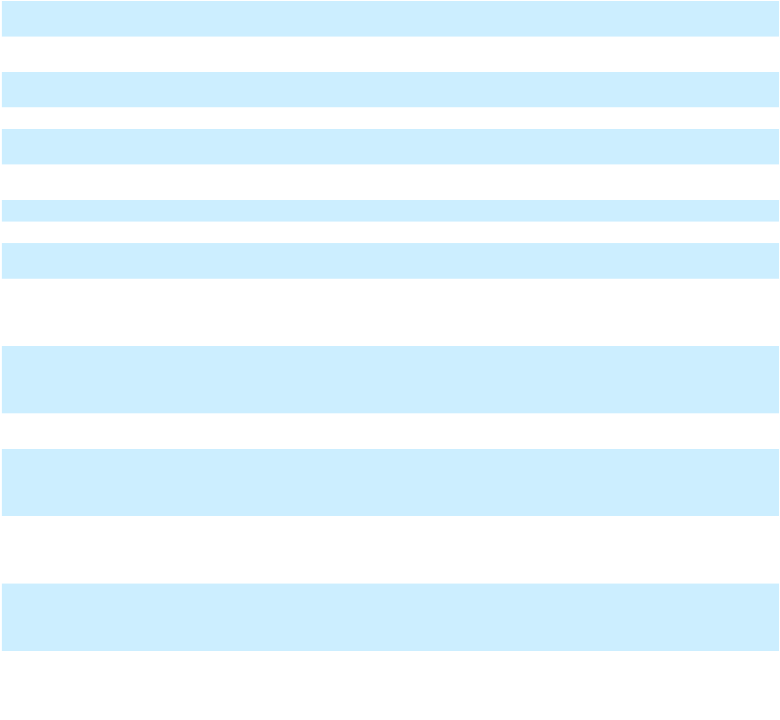

91

10.2.5 +

10.2.6 +

10.2.7 +

10.2.8 +

10.3 +

10.3.1 +

10.3.2 +

10.3.3 +

10.3.4 +

10.3.5 +

10.3.6 +

10.3.7 +

10.3.8 +

10.3.9 +

10.3.10 +

10.4 +

10.4.1 +

Form of restricted stock unit award agreement and related notice of grant for use in connection with the grant of restricted stock units to the Registrant's non-employee directors under the Amended and Restated Regeneron Pharmaceuticals, Inc. 2014 Long-Term Incentive Plan. (Incorporated by reference from the Form 10-K for the Registrant, for the year ended December 31, 2018, filed February 7, 2019.)
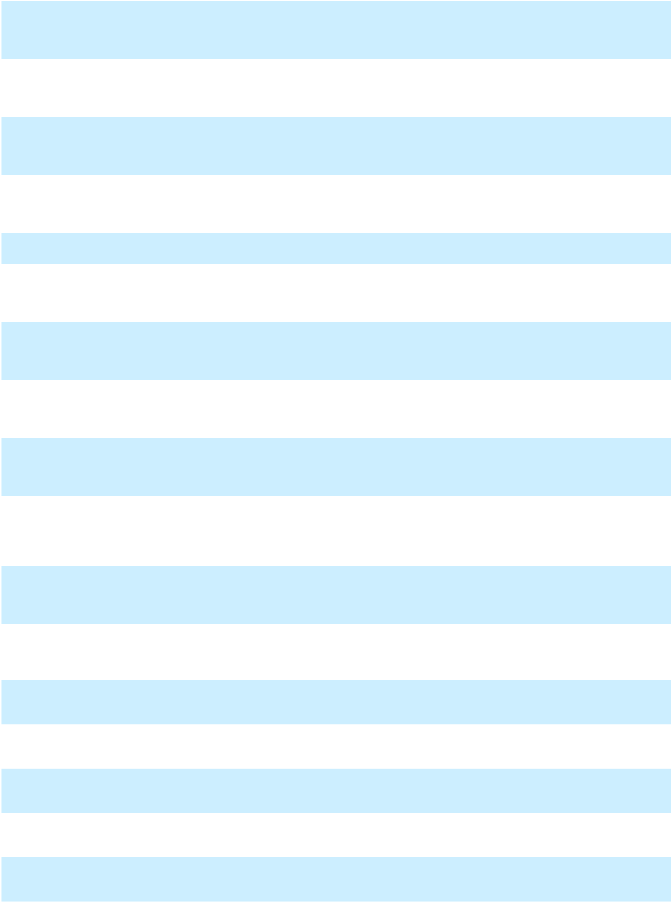

Form of stock option agreement and related notice of grant for use in connection with the grant of non-qualified stock options to the Registrant's executive officers under the Amended and Restated Regeneron Pharmaceuticals, Inc. 2014 Long-Term Incentive Plan (revised 2019). (Incorporated by reference from the Form 10-K for the Registrant, for the year ended December 31, 2019, filed February 7, 2020.)

Form of stock option agreement and related notice of grant for use in connection with the grant of non-qualified stock options to the Registrant's non-employee directors under the Amended and Restated Regeneron Pharmaceuticals, Inc. 2014 Long-Term Incentive Plan (revised 2019). (Incorporated by reference from the Form 10-K for the Registrant, for the year ended December 31, 2019, filed February 7, 2020.)

Form of restricted stock unit award agreement and related notice of grant for use in connection with the grant of restricted stock units to the Registrant's non-employee directors under the Amended and Restated Regeneron Pharmaceuticals, Inc. 2014 Long-Term Incentive Plan (revised 2019). (Incorporated by reference from the Form 10-K for the Registrant, for the year ended December 31, 2019, filed February 7, 2020.)

Second Amended and Restated Regeneron Pharmaceuticals, Inc. 2014 Long-Term Incentive Plan. (Incorporated by reference from the Registration Statement on Form S-8 for the Registrant, filed June 16, 2020.)
Form of stock option agreement and related notice of grant for use in connection with the grant of non-qualified stock options to the Registrant's executive officers under the Second Amended and Restated Regeneron Pharmaceuticals, Inc. 2014 Long-Term Incentive Plan. (Incorporated by reference from the Form 10-K for the Registrant, for the year ended December 31, 2020, filed February 8, 2021.)

Form of restricted stock award agreement and related notice of grant for use in connection with the grant of restricted stock awards to the Registrant's executive officers under the Second Amended and Restated Regeneron Pharmaceuticals, Inc. 2014 Long-Term Incentive Plan. (Incorporated by reference from the Form 10-K for the Registrant, for the year ended December 31, 2020, filed February 8, 2021.)

Form of stock option agreement and related notice of grant for use in connection with the grant of non-qualified stock options to the Registrant's non-employee directors under the Second Amended and Restated Regeneron Pharmaceuticals, Inc. 2014 Long-Term Incentive Plan. (Incorporated by reference from the Form 10-K for the Registrant, for the year ended December 31, 2020, filed February 8, 2021.)

Form of restricted stock unit award agreement and related notice of grant for use in connection with the grant of restricted stock units to the Registrant's non-employee directors under the Second Amended and Restated Regeneron Pharmaceuticals, Inc. 2014 Long-Term Incentive Plan. (Incorporated by reference from the Form 10-K for the Registrant, for the year ended December 31, 2020, filed February 8, 2021.)

Form of performance restricted stock unit award agreement and related notice of grant for use in connection with the grant of performance restricted stock units to Leonard S. Schleifer, M.D., Ph.D. and George D. Yancopoulos, M.D., Ph.D. under the Second Amended and Restated Regeneron Pharmaceuticals, Inc. 2014 Long-Term Incentive Plan. (Incorporated by reference from the Form 10-K for the Registrant, for the year ended December 31, 2020, filed February 8, 2021.)

Form of stock option agreement and related notice of grant for use in connection with the grant of non-qualified stock options to the Registrant's executive officers under the Second Amended and Restated Regeneron Pharmaceuticals, Inc. 2014 Long-Term Incentive Plan (revised 2023). (Incorporated by reference from the Form 10-K for the Registrant, for the year ended December 31, 2023, filed February 5, 2024.)

Form of restricted stock award agreement and related notice of grant for use in connection with the grant of restricted stock awards to the Registrant's executive officers under the Second Amended and Restated Regeneron Pharmaceuticals, Inc. 2014 Long-Term Incentive Plan (revised 2023). (Incorporated by reference from the Form 10-K for the Registrant, for the year ended December 31, 2023, filed February 5, 2024.)

Form of stock option agreement and related notice of grant for use in connection with the grant of non-qualified stock options to the Registrant's executive officers under the Second Amended and Restated Regeneron Pharmaceuticals, Inc. 2014 Long-Term Incentive Plan (revised 2025).

Form of restricted stock award agreement and related notice of grant for use in connection with the grant of restricted stock awards to the Registrant's executive officers under the Second Amended and Restated Regeneron Pharmaceuticals, Inc. 2014 Long-Term Incentive Plan (revised 2025).

Form of restricted stock unit award agreement and related notice of grant for use in connection with the grant of restricted stock units to the Registrant's non-employee directors under the Second Amended and Restated Regeneron Pharmaceuticals, Inc. 2014 Long-Term Incentive Plan. (revised 2025).

Amended and Restated Employment Agreement, dated as of November 14, 2008, between the Registrant and Leonard S. Schleifer, M.D., Ph.D. (Incorporated by reference from the Form 10-K for the Registrant, for the year ended December 31, 2008, filed February 26, 2009.)

Waiver and Consent, dated as of April 14, 2023, pursuant to the Amended and Restated Employment Agreement, dated as of November 14, 2008, between the Registrant and Leonard S. Schleifer, M.D., Ph.D. (Incorporated by reference from the Form 10-Q for the Registrant, for the quarter ended June 30, 2023, filed August 3, 2023.)

92

10.5 + Regeneron Pharmaceuticals, Inc. Change in Control Severance Plan, amended and restated effective as of November 14, 2008. (Incorporated by reference from the Form 10-K for the Registrant, for the year ended December 31, 2008, filed February 26, 2009.)
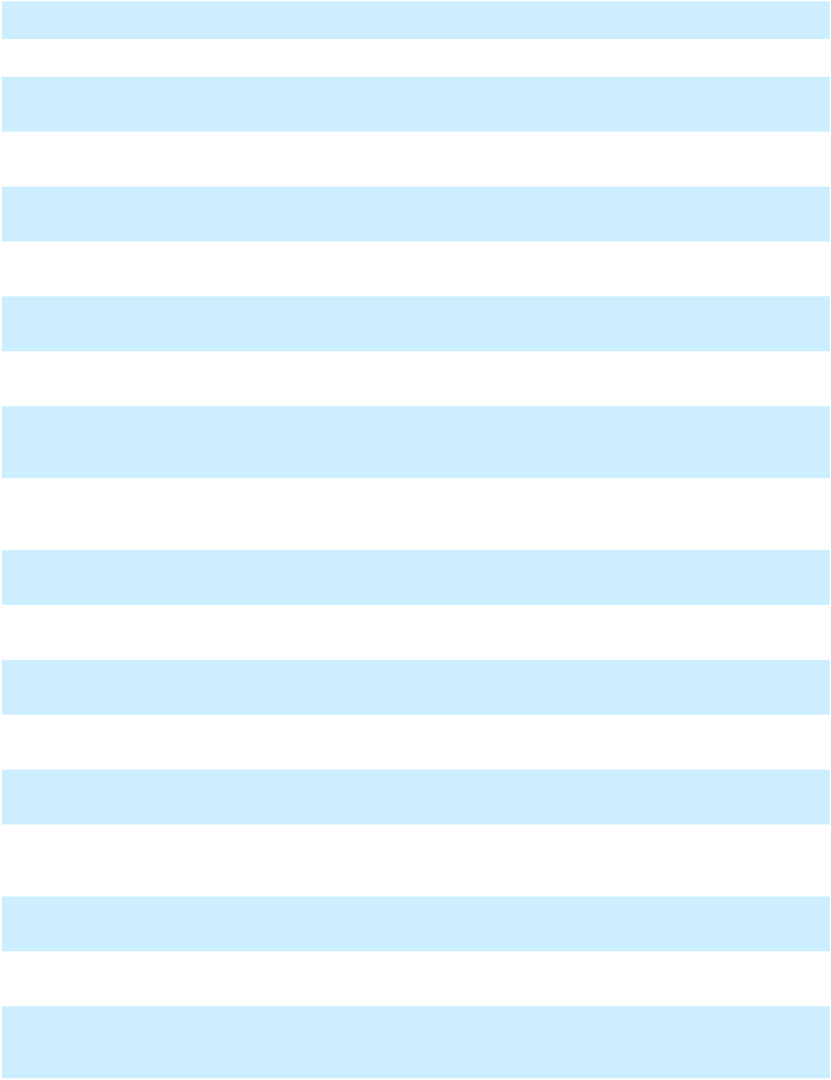
10.6 + Regeneron Pharmaceuticals, Inc. Cash Incentive Bonus Plan. (Incorporated by reference from the Form 8-K for the Registrant, filed June 17, 2015.)

10.6.1 + First Amendment to Cash Incentive Bonus Plan. (Incorporated by reference from the Form 10-Q for the Registrant, for the quarter ended March 31, 2023, filed May 4, 2023.)

10.7* IL-1 Antibody Termination Agreement by and between Novartis Pharma AG, Novartis Pharmaceuticals Corporation and the Registrant, dated as of June 8, 2009. (Incorporated by reference from the Form 10-Q for the Registrant, for the quarter ended June 30, 2009, filed August 4, 2009.)

10.8* License and Collaboration Agreement, dated as of October 18, 2006, by and between Bayer HealthCare LLC and the Registrant. (Incorporated by reference from the Form 10-Q for the Registrant, for the quarter ended September 30, 2006, filed November 6, 2006.)

10.8.1** Restated Amendment Agreement, dated December 30, 2014 and entered into effective as of May 7, 2012, by and between Bayer HealthCare LLC and the Registrant. (Incorporated by reference from the Form 10-K for the Registrant, for the year ended December 31, 2024, filed February 5, 2025.)

10.8.2** Second Amendment Agreement, dated December 19, 2019, by and between Bayer HealthCare LLC and the Registrant. (Incorporated by reference from the Form 10-K for the Registrant, for the year ended December 31, 2019, filed February 7, 2020.)

10.9* Amended and Restated License and Collaboration Agreement, dated as of November 10, 2009, by and among Aventis Pharmaceuticals Inc., sanofi-aventis Amerique du Nord, and the Registrant. (Incorporated by reference from the Form 10-K/A for the Registrant, for the year ended December 31, 2009, filed June 2, 2010.)

10.9.1** First Amendment to Amended and Restated License and Collaboration Agreement by and between the Registrant and Aventis Pharmaceuticals Inc., dated May 1, 2013. (Incorporated by reference from the Form 10-Q for the Registrant, for the quarter ended June 30, 2023, filed August 3, 2023.)

10.9.2* Amendment No. 2 to Amended and Restated License and Collaboration Agreement, dated July 27, 2015 and entered into effective as of July 1, 2015, by and between the Registrant and Sanofi Biotechnology SAS, as successor-in-interest to Aventis Pharmaceuticals, Inc. (Incorporated by reference from the Form 10-Q for the Registrant, for the quarter ended June 30, 2025, filed August 1, 2025.)

10.9.3** Third Amendment to Amended and Restated License and Collaboration Agreement, dated as of April 5, 2020, and effective as of April 1, 2020, by and between the Registrant, Sanofi Biotechnology SAS, and Sanofi. (Incorporated by reference from the Form 10-Q for the Registrant, for the quarter ended June 30, 2020, filed August 5, 2020.)

10.9.4** Fourth Amendment to Amended and Restated License and Collaboration Agreement, dated as of October 6, 2021, by and between the Registrant, Sanofi Biotechnology SAS, and Sanofi. (Incorporated by reference from the Form 10-K for the Registrant, for the year ended December 31, 2021, filed February 7, 2022.)

10.9.5** Fifth Amendment to Amended and Restated License and Collaboration Agreement, dated as of June 1, 2022, by and between the Registrant, Sanofi Biotechnology SAS, and Sanofi. (Incorporated by reference from the Form 10-Q for the Registrant, for the quarter ended June 30, 2022, filed August 3, 2022.)

10.10** Praluent Cross License & Commercialization Agreement, dated as of April 5, 2020, and effective as of April 1,
2020, by and between the Registrant and Sanofi Biotechnology SAS. (Incorporated by reference from the Form

10-Q for the Registrant, for the quarter ended June 30, 2020, filed August 5, 2020.)

10.11 Amended and Restated Investor Agreement, dated as of January 11, 2014, by and among Sanofi, sanofi-aventis US LLC, Aventis Pharmaceuticals Inc., sanofi-aventis Amerique du Nord, and the Registrant. (Incorporated by reference from the Form 8-K for the Registrant, filed January 13, 2014.)

10.11.1 Amendment to the Amended and Restated Investor Agreement, dated as of May 25, 2020, by and among the Registrant, Sanofi, Sanofi-Aventis US LLC, and Aventisub LLC. (Incorporated by reference from the Form 8-K for the Registrant, filed May 29, 2020.)

10.12*** Credit Agreement, dated as of December 19, 2022, by and among the Registrant, as a borrower and guarantor, certain direct subsidiaries of the Registrant, as the initial subsidiary borrowers, the lenders and issuing banks party thereto, and JPMorgan Chase Bank, N.A., as administrative agent, swingline lender, and an issuing bank. (Incorporated by reference from the Form 8-K for the Registrant, filed December 20, 2022.)

10.13** Amended and Restated Immuno-oncology License and Collaboration Agreement, dated as of June 1, 2022, by and between the Registrant and Sanofi Biotechnology SAS. (Incorporated by reference from the Form 10-Q for the Registrant, for the quarter ended June 30, 2022, filed August 3, 2022.)

10.14* Purchase Agreement, dated as of December 30, 2016, by and among BMR-Landmark at Eastview LLC and BMR-Landmark at Eastview IV LLC and the Registrant. (Incorporated by reference from the Form 10-K for the Registrant, for the year ended December 31, 2016, filed February 9, 2017.)

10.15*** Third Amended and Restated Participation Agreement, dated as of March 27, 2023, by and among Old Saw Mill Holdings LLC, as lessee, Bank of America, N.A., as administrative agent, BA Leasing BSC, LLC, as lessor, and the rent assignees party thereto from time to time. (Incorporated by reference from the Form 8-K for the Registrant, filed March 29, 2023.)

93

10.16*** | Third Amended and Restated Lease and Remedies Agreement, dated as of March 27, 2023, between Old Saw
 | Mill Holdings LLC, as lessee, and BA Leasing BSC, LLC, as lessor. (Incorporated by reference from the Form
 | 8-K for the Registrant, filed March 29, 2023.)
10.17*** | Third Amended and Restated Guaranty, dated as of March 27, 2023, made by the Registrant, Regeneron
 | Healthcare Solutions, Inc., and Regeneron Genetics Center LLC, as guarantors. (Incorporated by reference from
 | the Form 8-K for the Registrant, filed March 29, 2023.)
10.18** | Master Agreement, dated as of April 8, 2019, by and between the Registrant and Alnylam Pharmaceuticals, Inc.
 | (Incorporated by reference from the Form 10-Q for the Registrant, for the quarter ended June 30, 2019, filed
 | August 6, 2019.)
10.18.1** | Form of Co-Co Collaboration Agreement (Exhibit B to Master Agreement contained in Exhibit 10.18).
10.18.2** | Form of License Agreement (Exhibit C to Master Agreement contained in Exhibit 10.18).
10.18.3** | Amendment No. 1 to Master Agreement, dated as of April 10, 2023, by and between the Registrant and Alnylam
 | Pharmaceuticals, Inc. (Incorporated by reference from the Form 10-Q for the Registrant, for the quarter ended
 | June 30, 2023, filed August 3, 2023.)
10.18.4** | Amendment No. 2 to Master Agreement, dated as of March 7, 2024, by and between the Registrant and Alnylam
 | Pharmaceuticals, Inc. (Incorporated by reference from the Form 10-Q for the Registrant, for the quarter ended
 | March 31, 2024, filed May 2, 2024.)
10.18.5** | Amendment No. 3 to Master Agreement, dated as of August 1, 2024, by and between the Registrant and Alnylam
 | Pharmaceuticals, Inc. (Incorporated by reference from the Form 10-Q for the Registrant, for the quarter ended
 | September 30, 2024, filed October 31, 2024.)
19.1 | Insider Trading Policy. (Incorporated by reference from the Form 10-K for the Registrant, for the year ended
 | December 31, 2024, filed February 5, 2025.)
21.1 | Subsidiaries of the Registrant.
23.1 | Consent of PricewaterhouseCoopers LLP, Independent Registered Public Accounting Firm.
24.1 | Power of Attorney (included on the signature page of this Annual Report on Form 10-K).
31.1 | Certification of Principal Executive Officer pursuant to Rule 13a-14(a) under the Securities Exchange Act of
 | 1934.
31.2 | Certification of Principal Financial Officer pursuant to Rule 13a-14(a) under the Securities Exchange Act of
 | 1934.
32 | Certification of Principal Executive Officer and Principal Financial Officer pursuant to 18 U.S.C. Section 1350.
97.1 | Clawback Policy. (Incorporated by reference from the Form 10-K for the Registrant, for the year ended
 | December 31, 2023, filed February 5, 2024.)
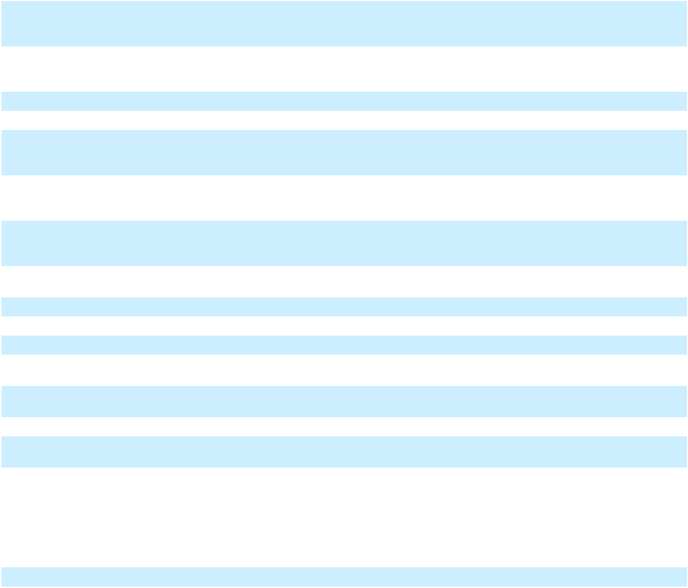
- Interactive Data Files pursuant to Rule 405 of Regulation S-T formatted in Inline Extensible Business Reporting Language ("Inline XBRL"): (i) the Registrant's Consolidated Balance Sheets as of December 31, 2025 and 2024;

  - the Registrant's Consolidated Statements of Operations and Comprehensive Income for the years ended December 31, 2025, 2024, and 2023; (iii) the Registrant's Consolidated Statements of Stockholders’ Equity for the years ended December 31, 2025, 2024, and 2023; (iv) the Registrant's Consolidated Statements of Cash Flows for the years ended December 31, 2025, 2024, and 2023; and (v) the notes to the Registrant's Consolidated Financial Statements.

- Cover Page Interactive Data File (formatted as Inline XBRL and contained in Exhibit 101).

_______

* Portions of this document have been omitted and filed separately with the SEC pursuant to requests for confidential treatment pursuant to Rule 24b-2

  - Certain confidential portions of this Exhibit were omitted in accordance with Item 601(b)(10) of Regulation S-K. The Registrant agrees to furnish supplementally a copy of all confidential portions of this Exhibit that were omitted to the SEC upon its request.

  - Certain of the exhibits and/or schedules to this Exhibit have been omitted in accordance with Item 601(a)(5) of Regulation S-K. The Registrant agrees to furnish supplementally a copy of all omitted exhibits and schedules of this Exhibit to the SEC upon its request.

    - Indicates a management contract or compensatory plan or arrangement

Item 16. Form 10-K Summary

None.

94

SIGNATURES

Pursuant to the requirements of Section 13 or 15(d) of the Securities Exchange Act of 1934, the registrant has duly caused this report to be signed on its behalf by the undersigned, thereunto duly authorized.

REGENERON PHARMACEUTICALS, INC.

Date: February 4, 2026 By: /s/ LEONARD S. SCHLEIFER

Leonard S. Schleifer, M.D., Ph.D.

President and Chief Executive Officer

95

POWER OF ATTORNEY

KNOW ALL PERSONS BY THESE PRESENTS, that each person whose signature appears below constitutes and appoints Leonard S. Schleifer and Christopher Fenimore, and each of them, his or her true and lawful attorney-in-fact and agent, with the full power of substitution and resubstitution, for him or her and in his or her name, place, and stead, in any and all capacities therewith, to sign any and all amendments to this Annual Report on Form 10-K, and to file the same, with all exhibits thereto, and other documents in connection therewith, with the Securities and Exchange Commission, granting unto each said attorney-in-fact and agent full power and authority to do and perform each and every act and thing requisite and necessary to be done, as fully to all intents and purposes as such person might or could do in person, hereby ratifying and confirming all that each said attorney-in-fact and agent, or either of them, or their or his substitute or substitutes, may lawfully do or cause to be done by virtue hereof.

Pursuant to the requirements of the Securities Exchange Act of 1934, this report has been signed below by the following persons on behalf of the registrant and in the capacities and on the dates indicated:

Signature

/s/ LEONARD S. SCHLEIFER Leonard S. Schleifer, M.D., Ph.D.

/s/ CHRISTOPHER FENIMORE Christopher Fenimore

/s/ JASON PITOFSKY

Jason Pitofsky

/s/ GEORGE D. YANCOPOULOS

George D. Yancopoulos, M.D., Ph.D.

/s/ BONNIE L. BASSLER Bonnie L. Bassler, Ph.D. /s/ MICHAEL S. BROWN

Michael S. Brown, M.D. /s/ N. ANTHONY COLES N. Anthony Coles, M.D.

/s/ JOSEPH L. GOLDSTEIN

Joseph L. Goldstein, M.D.

/s/ KATHRYN GUARINI

Kathryn Guarini, Ph.D.

/s/ CHRISTINE A. POON

Christine A. Poon

/s/ ARTHUR F. RYAN

Arthur F. Ryan

/s/ DAVID P. SCHENKEIN

David P. Schenkein, M.D.

/s/ GEORGE L. SING

George L. Sing

/s/ CRAIG B. THOMPSON

Craig B. Thompson, M.D.

/s/ HUDA Y. ZOGHBI

Huda Y. Zoghbi, M.D.

 | Title |  |  | Date
Board co-Chair, President and Chief
Executive Officer (Principal Executive |  |  | February 4, 2026
Officer)
Executive Vice President, Finance and
Chief Financial Officer (Principal |  |  | February 4, 2026
Financial Officer)
Senior Vice President, Controller |  |  | February 4, 2026
(Principal Accounting Officer)
Board co-Chair, President and Chief |  |  | February 4, 2026
Scientific Officer
Director |  |  | February 4, 2026
Director |  |  | February 4, 2026
Director |  |  | February 4, 2026
Director |  |  | February 4, 2026
Director |  |  | February 4, 2026
Director |  |  | February 4, 2026
Director |  |  | February 4, 2026
Director |  |  | February 4, 2026
Director |  |  | February 4, 2026
Director |  |  | February 4, 2026
Director |  |  | February 4, 2026

96

REGENERON PHARMACEUTICALS, INC.

INDEX TO FINANCIAL STATEMENTS
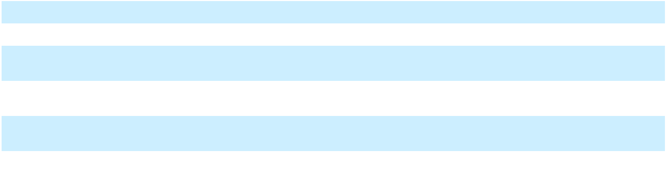

Report of Independent Registered Public Accounting Firm (PCAOB ID 238)

Consolidated Balance Sheets as of December 31, 2025 and 2024

Consolidated Statements of Operations and Comprehensive Income for the Years Ended December 31, 2025, 2024, and 2023

Consolidated Statements of Stockholders' Equity for the Years Ended December 31, 2025, 2024, and 2023

Consolidated Statements of Cash Flows for the Years Ended December 31, 2025, 2024, and 2023

Notes to Consolidated Financial Statements

Page Numbers

F-2

F-4

F-5

F-6

F-8

F-9 to F-38

F-1

Report of Independent Registered Public Accounting Firm

To the Board of Directors and Stockholders of Regeneron Pharmaceuticals, Inc.

Opinions on the Financial Statements and Internal Control over Financial Reporting

We have audited the accompanying consolidated balance sheets of Regeneron Pharmaceuticals, Inc. and its subsidiaries (the "Company") as of December 31, 2025 and 2024, and the related consolidated statements of operations and comprehensive income, of stockholders' equity and of cash flows for each of the three years in the period ended December 31, 2025, including the related notes (collectively referred to as the "consolidated financial statements"). We also have audited the Company's internal control over financial reporting as of December 31, 2025, based on criteria established in Internal Control - Integrated Framework (2013) issued by the Committee of Sponsoring Organizations of the Treadway Commission (COSO).

In our opinion, the consolidated financial statements referred to above present fairly, in all material respects, the financial position of the Company as of December 31, 2025 and 2024, and the results of its operations and its cash flows for each of the three years in the period ended December 31, 2025 in conformity with accounting principles generally accepted in the United States of America. Also in our opinion, the Company maintained, in all material respects, effective internal control over financial reporting as of December 31, 2025, based on criteria established in Internal Control - Integrated Framework (2013) issued by the COSO.

Basis for Opinions

The Company's management is responsible for these consolidated financial statements, for maintaining effective internal control over financial reporting, and for its assessment of the effectiveness of internal control over financial reporting, included in Management's Report on Internal Control over Financial Reporting appearing under Item 9A. Our responsibility is to express opinions on the Company's consolidated financial statements and on the Company's internal control over financial reporting based on our audits. We are a public accounting firm registered with the Public Company Accounting Oversight Board (United States) (PCAOB) and are required to be independent with respect to the Company in accordance with the U.S. federal securities laws and the applicable rules and regulations of the Securities and Exchange Commission and the PCAOB.

We conducted our audits in accordance with the standards of the PCAOB. Those standards require that we plan and perform the audits to obtain reasonable assurance about whether the consolidated financial statements are free of material misstatement, whether due to error or fraud, and whether effective internal control over financial reporting was maintained in all material respects.

Our audits of the consolidated financial statements included performing procedures to assess the risks of material misstatement of the consolidated financial statements, whether due to error or fraud, and performing procedures that respond to those risks. Such procedures included examining, on a test basis, evidence regarding the amounts and disclosures in the consolidated financial statements. Our audits also included evaluating the accounting principles used and significant estimates made by management, as well as evaluating the overall presentation of the consolidated financial statements. Our audit of internal control over financial reporting included obtaining an understanding of internal control over financial reporting, assessing the risk that a material weakness exists, and testing and evaluating the design and operating effectiveness of internal control based on the assessed risk. Our audits also included performing such other procedures as we considered necessary in the circumstances. We believe that our audits provide a reasonable basis for our opinions.

Definition and Limitations of Internal Control over Financial Reporting

A company's internal control over financial reporting is a process designed to provide reasonable assurance regarding the reliability of financial reporting and the preparation of financial statements for external purposes in accordance with generally accepted accounting principles. A company's internal control over financial reporting includes those policies and procedures that
- pertain to the maintenance of records that, in reasonable detail, accurately and fairly reflect the transactions and dispositions of the assets of the company; (ii) provide reasonable assurance that transactions are recorded as necessary to permit preparation of financial statements in accordance with generally accepted accounting principles, and that receipts and expenditures of the company are being made only in accordance with authorizations of management and directors of the company; and (iii) provide reasonable assurance regarding prevention or timely detection of unauthorized acquisition, use, or disposition of the company's assets that could have a material effect on the financial statements.

F-2

Because of its inherent limitations, internal control over financial reporting may not prevent or detect misstatements. Also, projections of any evaluation of effectiveness to future periods are subject to the risk that controls may become inadequate because of changes in conditions, or that the degree of compliance with the policies or procedures may deteriorate.

Critical Audit Matters

The critical audit matter communicated below is a matter arising from the current period audit of the consolidated financial statements that was communicated or required to be communicated to the audit committee and that (i) relates to accounts or disclosures that are material to the consolidated financial statements and (ii) involved our especially challenging, subjective, or complex judgments. The communication of critical audit matters does not alter in any way our opinion on the consolidated financial statements, taken as a whole, and we are not, by communicating the critical audit matter below, providing a separate opinion on the critical audit matter or on the accounts or disclosures to which it relates.

Certain Reserves for Uncertain Tax Positions

As described in Notes 1 and 15 to the consolidated financial statements, the Company's reserves for uncertain tax positions were $1,577.9 million as of December 31, 2025. Certain reserves for uncertain tax positions represent a significant portion of the consolidated balance. The Company recognizes the financial statement effects of a tax position when management's assessment is that there is more than a 50% probability that the position will be sustained upon examination by a taxing authority based upon its technical merits. Uncertain tax positions are recorded based upon certain recognition and measurement criteria. Management re-evaluates uncertain tax positions and considers various factors, including, but not limited to, changes in tax law, the measurement of tax positions taken or expected to be taken in tax returns, the effective settlement of matters subject to audit, information obtained during in-process audit activities, and changes in facts or circumstances related to a tax position. The Company adjusts the amount of the liability to reflect any subsequent changes in the relevant facts and circumstances surrounding the uncertain tax positions.

The principal considerations for our determination that performing procedures relating to certain reserves for uncertain tax positions is a critical audit matter are (i) the significant judgment by management when determining certain reserves for uncertain tax positions; (ii) a high degree of auditor judgment, subjectivity, and effort in performing procedures and evaluating management's determination of certain reserves for uncertain tax positions; (iii) the assessment and evaluation of audit evidence available to support certain reserves for uncertain tax positions is complex; and (iv) the audit effort involved the use of professionals with specialized skill and knowledge.

Addressing the matter involved performing procedures and evaluating audit evidence in connection with forming our overall opinion on the consolidated financial statements. These procedures included testing the effectiveness of controls relating to the recognition of reserves for uncertain tax positions. These procedures also included, among others (i) testing the information used in the calculation of certain reserves for uncertain tax positions, such as international and federal filing positions, and the related final tax returns; (ii) testing the calculation of certain reserves for uncertain tax positions; and (iii) evaluating management's assessment of the technical merits of the tax positions and estimates of the amount of tax benefits expected to be sustained, as well as the likelihood of the possible outcomes, for certain reserves for uncertain tax positions. Professionals with specialized skill and knowledge were used to assist in evaluating the technical merits and the tax benefits expected to be sustained and the application of relevant tax laws.

/s/ PricewaterhouseCoopers LLP

Florham Park, New Jersey

February 4, 2026

We have served as the Company’s auditor since 1989.

F-3

REGENERON PHARMACEUTICALS, INC.

CONSOLIDATED BALANCE SHEETS

(In millions, except per share data)

 |  | December 31,
ASSETS |  | 2025 |  |  | 2024
Current assets: | $ | 3,118.1 | $ |  | 2,488.2
Cash and cash equivalents
Marketable securities |  | 5,487.1 |  |  | 6,524.3
Accounts receivable, net |  | 5,741.1 |  |  | 6,211.9
Inventories |  | 3,200.8 |  |  | 3,087.3
Prepaid expenses and other current assets |  | 474.8 |  |  | 349.2
Total current assets |  | 18,021.9 |  |  | 18,660.9
Marketable securities |  | 10,260.6 |  |  | 8,900.1
Property, plant, and equipment, net |  | 5,120.4 |  |  | 4,599.7
Intangible assets, net |  | 1,257.4 |  |  | 1,148.6
Deferred tax assets |  | 4,077.2 |  |  | 3,314.1
Other noncurrent assets |  | 1,821.2 |  |  | 1,136.0
Total assets | $ | 40,558.7 |  | $ | 37,759.4
LIABILITIES AND STOCKHOLDERS' EQUITY
Current liabilities: | $ | 939.0 | $ |  | 789.5
Accounts payable
Accrued expenses and other current liabilities |  | 2,876.4 |  |  | 2,527.1
Deferred revenue |  | 553.0 |  |  | 627.7
Total current liabilities |  | 4,368.4 |  |  | 3,944.3
Long-term debt |  | 1,985.9 |  |  | 1,984.4
Finance lease liabilities |  | 720.0 |  |  | 720.0
Deferred revenue |  | 208.7 |  |  | 185.7
Other noncurrent liabilities |  | 2,018.8 |  |  | 1,571.4
Total liabilities |  | 9,301.8 |  |  | 8,405.8
Commitments and contingencies
Stockholders' equity:
Preferred Stock, par value $.01 per share; 30.0 shares authorized; shares issued and |  | — |  |  | —
outstanding - none |  | — |  |  | —
Class A Stock, convertible, par value $.001 per share; 40.0 shares authorized; shares |  | — |  |  | —
issued and outstanding - 1.8 in 2025 and 2024 |  | — |  |  | —
Common Stock, par value $.001 per share; 320.0 shares authorized; shares issued - |  | 0.1 |  |  | 0.1
137.6 in 2025 and 136.0 in 2024 |  | 0.1 |  |  | 0.1
Additional paid-in capital |  | 13,995.0 |  |  | 12,855.9
Retained earnings |  | 35,797.1 |  |  | 31,672.9
Accumulated other comprehensive income (loss) |  | 77.5 |  |  | (7.9)
Treasury Stock, at cost; 33.7 shares in 2025 and 28.2 shares in 2024 |  | (18,612.8) |  |  | (15,167.4)
Total stockholders' equity |  | 31,256.9 |  |  | 29,353.6
Total liabilities and stockholders' equity | $ | 40,558.7 |  | $ | 37,759.4


The accompanying notes are an integral part of the financial statements.

F-4

REGENERON PHARMACEUTICALS, INC.

CONSOLIDATED STATEMENTS OF OPERATIONS AND COMPREHENSIVE INCOME

(In millions, except per share data)

 |  | Year Ended December 31,
Statements of Operations |  | 2025 |  |  | 2024 |  |  | 2023
Revenues:
Net product sales | $ | 6,309.1 | $ |  | 7,629.2 | $ |  | 7,078.0
Collaboration revenue |  | 7,331.2 |  |  | 6,057.8 |  |  | 5,503.1
Other revenue |  | 702.6 |  |  | 515.0 |  |  | 536.1
 |  | 14,342.9 |  |  | 14,202.0 |  |  | 13,117.2
Expenses:
Research and development |  | 5,850.2 |  |  | 5,132.0 |  |  | 4,439.0
Acquired in-process research and development |  | 124.1 |  |  | 101.0 |  |  | 186.1
Selling, general, and administrative |  | 2,700.0 |  |  | 2,954.4 |  |  | 2,631.3
Cost of goods sold |  | 1,140.8 |  |  | 1,087.3 |  |  | 932.1
Cost of collaboration and contract manufacturing |  | 959.9 |  |  | 883.2 |  |  | 883.7
Other operating (income) expense, net |  | (10.0) |  |  | 53.4 |  |  | (2.1)
 |  | 10,765.0 |  |  | 10,211.3 |  |  | 9,070.1
Income from operations |  | 3,577.9 |  |  | 3,990.7 |  |  | 4,047.1
Other income (expense):
Other income (expense), net |  | 1,696.6 |  |  | 844.4 |  |  | 225.2
Interest expense |  | (43.8) |  |  | (55.2) |  |  | (73.0)
 |  | 1,652.8 |  |  | 789.2 |  |  | 152.2
Income before income taxes |  | 5,230.7 |  |  | 4,779.9 |  |  | 4,199.3
Income tax expense |  | 725.8 |  |  | 367.3 |  |  | 245.7
Net income | $ | 4,504.9 |  | $ | 4,412.6 |  | $ | 3,953.6
Net income per share - basic | $ | 43.07 | $ |  | 40.90 | $ |  | 37.05
Net income per share - diluted | $ | 41.48 | $ |  | 38.34 | $ |  | 34.77
Weighted average shares outstanding - basic |  | 104.6 |  |  | 107.9 |  |  | 106.7
Weighted average shares outstanding - diluted |  | 108.6 |  |  | 115.1 |  |  | 113.7
Statements of Comprehensive Income
Net income | $ | 4,504.9 | $ |  | 4,412.6 | $ |  | 3,953.6
Other comprehensive income (loss), net of tax:
Unrealized gain on debt securities |  | 83.0 |  |  | 73.6 |  |  | 158.2
Gain (loss) on foreign currency translation |  | 2.4 |  |  | (0.6) |  |  | (0.3)
Comprehensive income | $ | 4,590.3 |  | $ | 4,485.6 |  | $ | 4,111.5


The accompanying notes are an integral part of the financial statements.

F-5

REGENERON PHARMACEUTICALS, INC.

CONSOLIDATED STATEMENTS OF STOCKHOLDERS' EQUITY

(In millions)
 |  |  |  |  |  |  |  |  |  |  | Additional |  |  |  |  | Accumulated |  |  |  |  |  | Total
 | Class A Stock |  |  |  |  | Common Stock |  |  |  |  | Additional |  |  |  |  | Other |  | Treasury Stock |  |  |  | Total
 |  |  |  |  |  |  |  |  |  |  | Paid-in |  | Retained |  | Comprehensive |  |  |  |  |  |  | Stockholders'
 | Shares |  | Amount |  |  | Shares |  | Amount |  |  | Capital |  | Earnings |  | Income (Loss) |  |  | Shares |  | Amount |  | Equity
Balance, December 31, 2022 | 1.8 | $ |  | — | 130.4 |  | $ |  | 0.1 | $ 9,949.3 |  | $ 23,306.7 |  | $ |  | (238.8) |  | (22.6) | $ (10,353.3) |  | $22,664.0
Issuance of Common Stock for equity awards | — |  |  | — | 3.5 |  |  |  | — | 1,152.2 |  |  | — |  |  | — |  | — |  | — | 1,152.2
granted under long-term incentive plans | — |  |  | — |  |  |  |  | — |  |  |  | — |  |  |  |  | — |  | —
Common Stock tendered upon exercise of
stock options and vesting of restricted stock | — |  |  | — | (0.8) |  |  |  | — | (708.4) |  |  | — |  |  | — |  | — |  | — | (708.4)
for employee tax obligations | — |  |  | — |  |  |  |  | — |  |  |  | — |  |  |  |  | — |  | —
Issuance/distribution of Common Stock for | — |  |  | — |  | — |  |  | — | 66.6 |  |  | — |  |  | — |  | 0.1 | 7.5 |  | 74.1
401(k) Savings Plan | — |  |  | — |  | — |  |  | — |  |  |  | —
Repurchases of Common Stock | — |  |  | — |  | — |  |  | — |  | — |  | — |  |  | — |  | (3.0) | (2,214.6) |  | (2,214.6)
Stock-based compensation charges | — |  |  | — |  | — |  |  | — | 894.3 |  |  | — |  |  | — |  | — |  | — | 894.3
Net income | — |  |  | — |  | — |  |  | — |  | — | 3,953.6 |  |  |  | — |  | — |  | — | 3,953.6
Other comprehensive income, net of tax | — |  |  | — |  | — |  |  | — |  | — |  | — |  |  | 157.9 |  | — |  | — |  | 157.9
Balance, December 31, 2023 | 1.8 |  |  | — | 133.1 |  |  |  | 0.1 | 11,354.0 |  | 27,260.3 |  |  |  | (80.9) |  | (25.5) | (12,560.4) |  | 25,973.1
Issuance of Common Stock for equity awards | — |  |  | — | 4.1 |  |  |  | — | 1,454.6 |  |  | — |  |  | — |  | — |  | — | 1,454.6
granted under long-term incentive plans | — |  |  | — |  |  |  |  | — |  |  |  | — |  |  |  |  | — |  | —
Common Stock tendered upon exercise of
stock options and vesting of restricted stock | — |  |  | — | (1.2) |  |  |  | — | (1,021.3) |  |  | — |  |  | — |  | — |  | — | (1,021.3)
for employee tax obligations | — |  |  | — |  |  |  |  | — |  |  |  | — |  |  |  |  | — |  | —
Issuance/distribution of Common Stock for | — |  |  | — |  | — |  |  | — | 71.7 |  |  | — |  |  | — |  | 0.1 | 6.9 |  | 78.6
401(k) Savings Plan | — |  |  | — |  | — |  |  | — |  |  |  | —
Repurchases of Common Stock | — |  |  | — |  | — |  |  | — |  | — |  | — |  |  | — |  | (2.8) | (2,613.9) |  | (2,613.9)
Stock-based compensation charges | — |  |  | — |  | — |  |  | — | 996.9 |  |  | — |  |  | — |  | — |  | — | 996.9
Net income | — |  |  | — |  | — |  |  | — |  | — | 4,412.6 |  |  |  | — |  | — |  | — | 4,412.6
Other comprehensive income, net of tax | — |  |  | — |  | — |  |  | — |  | — |  | — |  |  | 73.0 |  | — |  | — |  | 73.0
Balance, December 31, 2024 | 1.8 |  |  | — | 136.0 |  |  |  | 0.1 | 12,855.9 |  | 31,672.9 |  |  |  | (7.9) |  | (28.2) | (15,167.4) |  | 29,353.6
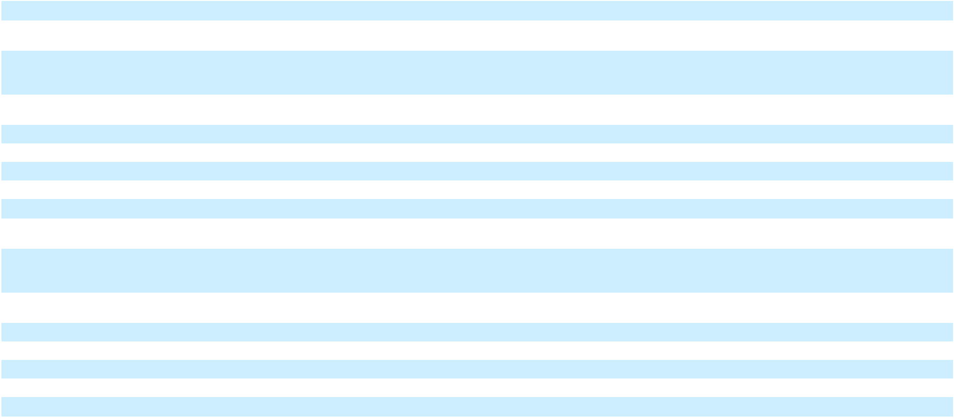

F-6

 | CONSOLIDATED STATEMENTS OF STOCKHOLDERS' EQUITY (continued)
 |  |  |  |  |  |  |  |  |  |  | Additional |  |  |  |  | Accumulated |  |  |  |  |  | Total
 |  | Class A Stock |  |  |  |  | Common Stock |  |  |  | Additional |  |  |  |  | Other |  | Treasury Stock |  |  |  | Total
 |  |  |  |  |  |  |  |  |  |  | Paid-in |  | Retained |  | Comprehensive |  |  |  |  |  |  | Stockholders'
 |  | Shares |  | Amount |  |  | Shares |  | Amount |  | Capital |  | Earnings |  | Income (Loss) |  |  | Shares |  | Amount |  | Equity
Issuance of Common Stock for equity awards |  | — |  |  | — | 2.6 |  |  | — | 637.4 |  |  | — |  |  | — |  | — |  | — | 637.4
granted under long-term incentive plans |  | — |  |  | — |  |  |  | — |  |  |  | — |  |  |  |  | — |  | —
Common Stock tendered upon exercise of
stock options and vesting of restricted stock |  | — |  |  | — | (1.0) |  |  | — | (576.2) |  |  | — |  |  | — |  | — |  | — | (576.2)
for employee tax obligations |  | — |  |  | — |  |  |  | — |  |  |  | — |  |  |  |  | — |  | —
Issuance/distribution of Common Stock for |  | — |  |  | — |  | — |  | — | 72.2 |  |  | — |  |  | — |  | 0.1 | 10.8 |  | 83.0
401(k) Savings Plan |  | — |  |  | — |  | — |  | — |  |  |  | —
Repurchases of Common Stock |  | — |  |  | — |  | — |  | — |  | — |  | — |  |  | — |  | (5.6) | (3,456.2) |  | (3,456.2)
Dividends declared |  | — |  |  | — |  | — |  | — | 4.1 |  | (380.7) |  |  |  | — |  | — |  | — | (376.6)
Stock-based compensation charges |  | — |  |  | — |  | — |  | — | 1,001.6 |  |  | — |  |  | — |  | — |  | — | 1,001.6
Net income |  | — |  |  | — |  | — |  | — |  | — | 4,504.9 |  |  |  | — |  | — |  | — | 4,504.9
Other comprehensive income, net of tax |  | — |  |  | — |  | — |  | — |  | — |  | — |  |  | 85.4 |  | — |  | — |  | 85.4
Balance, December 31, 2025 | 1.8 |  | $ |  | — | 137.6 |  | $0.1 |  | $ 13,995.0 |  | $ 35,797.1 |  | $ |  | 77.5 |  | (33.7) | $ (18,612.8) |  | $31,256.9
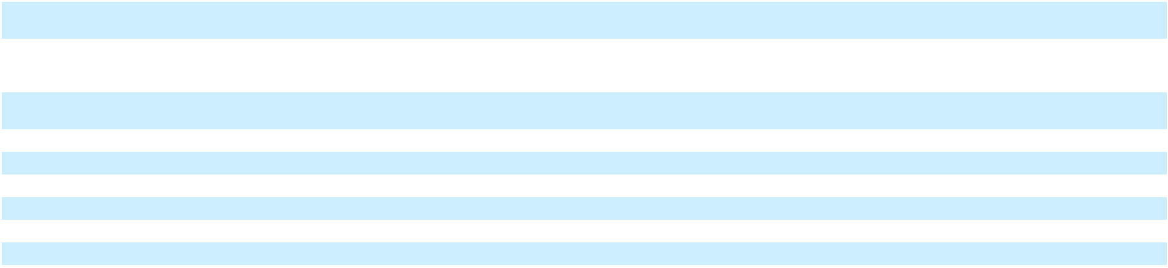

The accompanying notes are an integral part of the financial statements.

F-7

REGENERON PHARMACEUTICALS, INC.

CONSOLIDATED STATEMENTS OF CASH FLOWS

(In millions)

 |  | Year Ended December 31,
Cash flows from operating activities: |  | 2025 |  |  | 2024 |  |  | 2023
Net income | $ | 4,504.9 | $ |  | 4,412.6 | $ |  | 3,953.6
Adjustments to reconcile net income to net cash provided by operating activities:
Depreciation and amortization |  | 543.7 |  |  | 482.9 |  |  | 421.0
Stock-based compensation expense |  | 993.7 |  |  | 982.8 |  |  | 885.0
(Gains) losses on marketable and other securities, net |  | (946.1) |  |  | (118.3) |  |  | 266.4
Other, net |  | 135.5 |  |  | 36.1 |  |  | (0.1)
Deferred income taxes |  | (785.4) |  |  | (757.3) |  |  | (837.8)
Changes in assets and liabilities:
Decrease (increase) in accounts receivable |  | 498.1 |  |  | (554.0) |  |  | (338.8)
Increase in inventories |  | (275.3) |  |  | (619.7) |  |  | (271.7)
Increase in prepaid expenses and other assets |  | (375.3) |  |  | (407.5) |  |  | (120.1)
(Decrease) increase in deferred revenue |  | (51.7) |  |  | 227.8 |  |  | 37.9
Increase in accounts payable, accrued expenses, and other liabilities |  | 736.8 |  |  | 735.1 |  |  | 598.6
Total adjustments |  | 474.0 |  |  | 7.9 |  |  | 640.4
Net cash provided by operating activities |  | 4,978.9 |  |  | 4,420.5 |  |  | 4,594.0
Cash flows from investing activities:
Purchases of marketable and other securities |  | (10,958.3) |  |  | (16,617.4) |  |  | (11,646.0)
Sales or maturities of marketable and other securities |  | 11,546.2 |  |  | 15,027.3 |  |  | 9,442.2
Capital expenditures |  | (898.4) |  |  | (755.9) |  |  | (718.6)
Proceeds from sale of property, plant, and equipment |  | — |  |  | 20.1 |  |  | —
Payments for intangible assets |  | (315.3) |  |  | (125.7) |  |  | (207.8)
Acquisitions, net of cash acquired |  | (3.3) |  |  | (16.5) |  |  | (54.9)
Net cash used in investing activities |  | (629.1) |  |  | (2,468.1) |  |  | (3,185.1)
Cash flows from financing activities:
Proceeds from issuance of Common Stock |  | 635.9 |  |  | 1,465.3 |  |  | 1,145.5
Payments in connection with Common Stock tendered for employee tax obligations |  | (532.1) |  |  | (1,029.1) |  |  | (700.6)
Repurchases of Common Stock |  | (3,438.6) |  |  | (2,603.3) |  |  | (2,235.0)
Dividends paid |  | (370.3) |  |  | — |  |  | —
Other |  | (10.3) |  |  | (33.4) |  |  | —
Net cash used in financing activities |  | (3,715.4) |  |  | (2,200.5) |  |  | (1,790.1)
Effect of exchange rate changes on cash, cash equivalents, and restricted cash |  | 0.3 |  |  | (0.7) |  |  | (0.4)
Net increase (decrease) in cash, cash equivalents, and restricted cash |  | 634.7 |  |  | (248.8) |  |  | (381.6)
Cash, cash equivalents, and restricted cash at beginning of period |  | 2,489.0 |  |  | 2,737.8 |  |  | 3,119.4
Cash, cash equivalents, and restricted cash at end of period | $ | 3,123.7 | $ |  | 2,489.0 | $ |  | 2,737.8
Supplemental disclosure of cash flow information
Cash paid for interest (net of amounts capitalized) | $ | 41.6 | $ |  | 52.6 | $ |  | 73.1


The accompanying notes are an integral part of the financial statements.

F-8

REGENERON PHARMACEUTICALS, INC.

NOTES TO CONSOLIDATED FINANCIAL STATEMENTS

1. Business Overview and Summary of Significant Accounting Policies Organization and Business
Regeneron Pharmaceuticals, Inc. and its subsidiaries ("Regeneron," "Company," "we," "us," and "our") is a fully integrated biotechnology company that invents, develops, manufactures, and commercializes medicines for people with serious diseases. The Company's products and product candidates in development are designed to help patients with eye diseases, allergic and inflammatory diseases, cancer, cardiovascular and metabolic diseases, neurological diseases, hematologic conditions, infectious diseases, and rare diseases. The Company's research and development efforts have led to numerous products that have received marketing approval. The Company is a party to collaboration and license agreements to develop and commercialize, as applicable, certain products and product candidates (see Note 3).

The Company's business is subject to certain risks including, but not limited to, uncertainties relating to conducting research activities, product development, obtaining regulatory approvals, competition, and obtaining and enforcing patents.

Basis of Presentation

The consolidated financial statements include the accounts of Regeneron and its wholly-owned subsidiaries. Intercompany balances and transactions are eliminated in consolidation.

Use of Estimates

The preparation of financial statements in conformity with generally accepted accounting principles requires management to make estimates and assumptions that affect the amounts reported in the financial statements and accompanying notes. Actual results could differ from those estimates.

Concentration of Credit Risk

Financial instruments which potentially expose the Company to concentrations of credit risk consist of cash, cash equivalents, and certain investments. In accordance with the Company's policies, the Company mandates asset diversification and monitors exposure with its counterparties.

In addition, receivables from customers (see Note 2) and collaborators (see Note 3) may subject the Company to credit risk. The Company has contractual payment terms with each of its customers and collaborators, and the Company monitors their financial performance and credit worthiness so that it can properly assess and respond to any changes in their credit profile.

Significant Accounting Policies

Cash and Cash Equivalents

The Company considers all highly liquid debt instruments with a maturity of three months or less when purchased to be cash equivalents. The carrying amount reported in the Consolidated Balance Sheet for cash and cash equivalents approximates its fair value.

Debt and Equity Securities

The Company has an investment policy that includes guidelines on acceptable investment securities, minimum credit quality, maturity parameters, and diversification. The Company invests its cash primarily in debt securities. The Company classifies its investments in debt securities as available-for-sale, with such investments carried at fair value and unrealized gains and losses included in accumulated other comprehensive income (loss). Realized gains and losses on available-for-sale debt securities are included in other income (expense), net. The Company reviews its portfolio of available-for-sale debt securities, using both quantitative and qualitative factors, to determine if declines in fair value below cost have resulted from a credit-related loss or other factors. If the decline in fair value is due to credit-related factors, a loss is recognized in net income, whereas if the decline in fair value is not due to credit-related factors, the loss is recorded in other comprehensive income (loss).

The Company also has investments in equity securities that are carried at fair value, with changes in fair value recognized within other income (expense), net. The Company has elected to measure certain equity investments it holds that do not have readily determinable fair values at cost less impairment, if any, and adjusts for observable price changes in orderly transactions for identical or similar investments of the same issuer within other income (expense), net.

F-9

Accounts Receivable

The Company's trade accounts receivable arise from product sales and represent amounts due from its customers. In addition, the Company records accounts receivable arising from its collaboration and licensing agreements. The Company provides allowances against receivables for estimated losses, if any, that may result from a counterparty's inability to pay. Amounts determined to be uncollectible are written-off against the allowance.

Inventories

Inventories are stated at the lower of cost or net realizable value. The Company determines the cost of inventory using the first-in, first-out, or FIFO, method.

The Company capitalizes inventory costs associated with the Company's products prior to regulatory approval when, based on management's judgment, future commercialization is considered probable and future economic benefit is expected to be realized; otherwise, such costs are expensed. The determination to capitalize inventory costs is based on various factors, including status and expectations of the regulatory approval process, any known safety or efficacy concerns, potential labeling restrictions, and any other impediments to obtaining regulatory approval.

The Company periodically analyzes its inventory levels to identify inventory that may expire prior to expected sale or has a cost basis in excess of its estimated realizable value. In addition, the Company's products are subject to strict quality control and monitoring which the Company performs throughout the manufacturing process. If certain batches or units of product no longer meet quality specifications or become obsolete due to expiration, the Company records a charge to write down such inventory to its estimated realizable value.

Property, Plant, and Equipment

Property, plant, and equipment are stated at cost, net of accumulated depreciation. Depreciation is calculated on a straight-line basis over the estimated useful lives of the assets. Leasehold improvements are amortized over the shorter of the estimated useful lives of the assets or the remaining lease term. Costs of construction of certain long-lived assets include capitalized interest, which is amortized over the estimated useful life of the related asset. Expenditures for maintenance and repairs which do not materially extend the useful lives of the assets are charged to expense as incurred. The cost and accumulated depreciation or amortization of assets retired or sold are removed from the respective accounts, and any gain or loss is recognized within income from operations. The estimated useful lives of property, plant, and equipment are as follows:
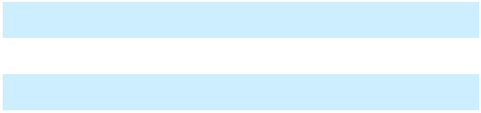

Building and improvements 10–50 years

Laboratory and other equipment 3–10 years

Furniture and fixtures 5 years

The Company periodically assesses the recoverability of long-lived assets, such as property, plant, and equipment, and evaluates such assets for impairment whenever events or changes in circumstances indicate that the carrying amount of an asset may not be recoverable.

Leases

The Company determines if an arrangement is a lease considering whether there is an identified asset and the contract conveys the right to control its use. Leases with an initial term of 12 months or less are not recorded on the balance sheet. The Company includes options to extend or terminate a lease when determining the lease term if it is reasonably certain that it will exercise that option. The Company accounts for lease components (e.g., rental payments) separately from non-lease components (e.g., common area maintenance costs).

Lease liabilities are recognized at the lease commencement date based on the present value of the remaining lease payments, discounted using the rate implicit in the lease. For leases where an implicit rate is not readily determinable, the Company uses its incremental borrowing rate based on information available at the lease commencement date. Lease expense for operating leases is recognized on a straight-line basis over the expected lease term.

Acquisitions

The Company makes a determination whether a transaction should be accounted for as a business combination or as an asset acquisition.

In a business combination, the acquisition method of accounting generally requires that the assets acquired and liabilities assumed be recorded as of the date of the acquisition at their respective fair values. Amounts allocated to acquired in-process research and

F-10

development are capitalized as indefinite-lived intangible assets. Any excess of the purchase price (consideration transferred) over the fair values of net assets acquired is recorded as goodwill. Contingent consideration obligations are recorded at fair value as of the acquisition date and remeasured each subsequent reporting period until the contingencies have been resolved, with any changes in fair value recorded in Other operating (income) expense, net.

If it is determined that the assets acquired do not meet the definition of a business, or if substantially all of the fair value of the assets acquired are concentrated in a single identifiable asset, then the transaction is accounted for as an asset acquisition rather than a business combination. In an asset acquisition, assets acquired are recorded at cost, goodwill is not recognized, and acquired in-process research and development with no alternative future use is charged to expense.

Intangible Assets

Intangible assets acquired in a business combination are recorded at fair value, while intangible assets acquired in connection with an asset acquisition are recorded at cost.

Payments to acquire intangible assets in an asset acquisition may include up-front payments and contingent consideration. With regard to contingent consideration in an asset acquisition, the Company recognizes regulatory milestones upon achievement, royalties in the period in which the underlying sales occur, and sales-based milestones when the milestone is deemed probable by the Company of being achieved. If contingent consideration is recognized subsequent to the acquisition date in an asset acquisition, the amount of such consideration is recorded as an addition to the cost basis of the intangible asset with a cumulative catch-up adjustment for amortization expense as if the additional amount of consideration had been accrued from the outset of the acquisition.

Indefinite-lived intangible assets are subject to impairment testing until completion or abandonment of the associated research and development efforts. Definite-lived intangible assets are amortized to Cost of goods sold over the estimated useful lives of the assets based on the pattern in which the economic benefits of the intangible assets are consumed; if that pattern cannot be reliably determined, a straight-line basis is used.

Intangible assets are reviewed for recoverability whenever events or changes in circumstances indicate that the carrying amount of the asset may not be recoverable. If an indicator of impairment exists, the Company compares the projected undiscounted cash flows to be generated by the asset to the intangible asset's carrying amount. If the projected undiscounted cash flows of the intangible asset are less than the carrying amount, an impairment loss is recognized within operating expenses and the intangible asset is written down to its fair value in the period in which the impairment occurs.

Product Revenue

Revenue from product sales is recognized at a point in time when the Company's customer is deemed to have obtained control of the product, which generally occurs upon receipt or acceptance by its customer.

The amount of revenue the Company recognizes from product sales may vary due to rebates, chargebacks, discounts, distribution-related fees, and other sales-related deductions. In order to determine the transaction price, the Company estimates, utilizing the expected value method, the amount of variable consideration to which the Company will be entitled. This estimate is based upon contracts with customers, healthcare providers, payors, and government agencies, statutorily-defined discounts applicable to government-funded programs, historical experience, estimated payor mix, and other relevant factors. The Company reviews its estimates of rebates, chargebacks, and other applicable provisions each period and records any necessary adjustments in the current period's net product sales.

- Rebates: The Company's rebates include amounts paid to managed care organizations, group purchasing organizations, state Medicaid programs, the Medicare Part D program, and other rebate programs. Outside the United States, the Company's rebates are generally contractual or legislatively mandated. The Company estimates reductions to product sales for each type of rebate and records an allowance for rebates in the same period in which the related product sales are recognized. The Company's liability for rebates consists of estimates for claims related to the current and prior periods that have not been paid and estimates for claims that will be made related to product that exists in the distribution channel at the end of the period.

F-11

- Chargebacks and Discounts: The Company's reserves related to discounted pricing to eligible physicians, Veterans' Administration ("VA"), Public Health Services, and others (collectively, "qualified healthcare providers") represent the Company's estimated obligations resulting from contractual commitments to sell products to qualified healthcare providers at prices lower than the list prices the Company charges to its customers (e.g., distributors and specialty pharmacies). The Company's customers charge the Company for the difference between what they pay for the products and the discounted selling price to the qualified healthcare providers. The Company estimates reductions to product sales for each type of chargeback and records an allowance for chargebacks in the same period that the related product sales are recognized. The Company's reserve for chargebacks consists of amounts for which it expects to issue credit based on expected sales by its customers to qualified healthcare providers and chargebacks that customers have claimed but for which the Company has not yet issued credit.

- Distribution-Related Fees: The Company has written contracts with its customers that include terms for distribution-related fees. The Company estimates and records distribution and related fees due to its customers generally based on gross sales.

- Other Sales-Related Deductions: The Company's other sales-related deductions include copay assistance programs and product returns. The Company estimates and records other sales-related deductions generally based on gross sales, written contracts, and other relevant factors. Consistent with industry practice, the Company generally offers its customers a limited right to return product purchased directly from the Company, which is principally based upon the product's expiration date. Product returned is generally not resalable given the nature of the Company's products and method of administration. The Company develops estimates for product returns based upon historical experience, shelf life of the product, and other relevant factors. The Company monitors product supply levels in the distribution channel, as well as sales by its customers, using product-specific data provided by its customers. If necessary, the Company's estimates of product returns may be adjusted in the future based on actual returns experience, known or expected changes in the marketplace, or other factors.

Collaborative Arrangements

The Company has entered into various collaborative arrangements to research, develop, manufacture, and commercialize products and/or product candidates. Although each of these arrangements is unique in nature, such arrangements involve a joint operating activity where both parties are active participants in the activities of the collaboration and exposed to significant risks and rewards dependent on the commercial success of the activities.

In arrangements where the Company does not deem its collaborator to be its customer, payments to and from its collaborator are presented in the Company's statement of operations based on the nature of Regeneron's business operations, the nature of the arrangement, including the contractual terms, and the nature of the payments. In general, the presentation of such amounts is summarized below.

Nature/Type of Payment |  | Statement of Operations Presentation
Regeneron's share of profits or losses in connection with |  | Collaboration revenue
commercialization of products
Reimbursement for manufacturing of commercial supplies |  | Collaboration revenue
Royalties and/or sales-based milestones earned |  | Collaboration revenue
Reimbursement of Regeneron's research and development expenses |  | Reduction to Research and development expense
Regeneron's obligation for its share of collaborator's research and |  | Research and development expense
development expenses
Reimbursement of Regeneron's commercialization-related expenses |  | Reduction to Selling, general, and administrative expense
Regeneron's obligation to pay collaborator for its share of gross |  | Cost of goods sold
profits when Regeneron is deemed to be the principal
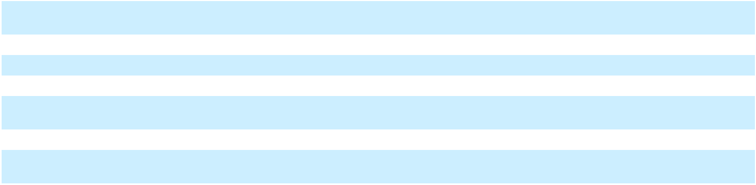

In agreements involving multiple goods or services promised to be transferred to the Company's collaborator, the Company assesses, at the inception of the contract, whether each promise represents a separate obligation (i.e., is "distinct"), or whether such promises should be combined as a single unit of account.

When the Company is entitled to reimbursement of all or a portion of the expenses (e.g., research and development expenses) that it incurs under a collaboration, it records those reimbursable amounts in the period in which such costs are incurred.

When the Company enters into an arrangement with another party to fund its research and development expenses, the Company considers whether the costs that it may be obligated to repay represent a liability within the scope of Accounting Standards Codification ("ASC") 730-20, Research and Development. If the Company concludes that such funding does not represent a substantive and genuine transfer of risk, a liability is recorded.

F-12

If the Company's collaborator performs research and development work or commercialization-related activities and the parties share the related costs, the Company also recognizes, as expense (e.g., research and development expense or selling, general, and administrative expense, as applicable) in the period when its collaborator incurs such expenses, the portion of the collaborator's expenses that the Company is obligated to reimburse. The Company's collaborators provide the Company with estimated expenses for the most recent fiscal quarter. The estimates are revised, if necessary, in subsequent periods if actual expenses differ from those estimates.

Under certain of the Company's collaboration agreements, product sales and cost of sales may be recorded by the Company's collaborators as they are deemed to be the principal in the transaction. In arrangements where the Company:

- supplies commercial product to its collaborator, the Company may be reimbursed for its manufacturing costs as commercial product is shipped to the collaborator (however, recognition of such cost reimbursements may be deferred until the product is sold by the Company's collaborator to third-party customers);

- shares in any profits or losses arising from the commercialization of such products, the Company records its share of the variable consideration, representing net product sales less cost of goods sold and shared commercialization and other expenses, in the period in which such underlying sales occur and costs are incurred by the collaborator; and
- receives royalties and/or sales-based milestone payments from its collaborator, the Company recognizes such amounts in the period earned.

The Company's collaborators provide it with estimates of product sales and the Company's share of profits or losses, as applicable, for each quarter. The estimates are revised, if necessary, in subsequent periods if the Company's actual share of profits or losses differ from those estimates.

Research and Development Expenses

Research and development expenses include costs attributable to the conduct of research and development programs, including the cost of salaries, payroll taxes, employee benefits, materials, supplies, depreciation on and maintenance of research equipment, costs related to research collaboration and licensing agreements, clinical trial expenses, the cost of services provided by outside contractors, including services related to the Company's clinical trials, the cost of manufacturing drug for use in research and development, amounts that the Company is obligated to reimburse to collaborators for research and development expenses that they incur, and the allocable portions of facility costs. Costs associated with research and development are expensed as incurred.

For each clinical trial that the Company conducts, certain clinical trial costs are expensed immediately, while others are expensed over time based on the expected total number of patients in the trial, the rate at which patients enter and remain in the trial, and/or the period over which clinical investigators, contract research organizations ("CROs"), or other third-party service providers are expected to provide services. In the event of early termination of a clinical trial, the Company accrues and recognizes expenses in an amount based on its estimate of the remaining noncancelable obligations associated with the winding-down of the clinical trial, including any applicable penalties.

Acquired In-Process Research and Development ("IPR&D") Expenses

Acquired IPR&D expenses may include in-process research and development acquired in connection with asset acquisitions, as well as up-front, opt-in, development milestone payments, and premiums paid on equity securities related to collaboration and licensing agreements.

Stock-based Compensation

The Company recognizes stock-based compensation expense for equity grants under the Company's long-term incentive plans (including stock options, restricted stock awards, and restricted stock units (both time-based and performance-based)) to employees and non-employee members of the Company's board of directors based on the grant-date fair value of those awards. The grant-date fair value of an award is generally recognized as compensation expense over the award's requisite service period. Stock-based compensation expense also includes an estimate, which is made at the time of grant, of the number of awards that are expected to be forfeited. The forfeiture rate estimate is calculated by considering both historical forfeiture experience and an estimate of expected future forfeitures for currently outstanding unvested awards. This estimate is reviewed at least annually and revised, if necessary, in subsequent periods if actual forfeitures differ from those estimates.

The Company uses the Black-Scholes model to compute the estimated fair value of stock option awards. Additionally, the Company uses a Monte Carlo simulation to compute the estimated fair value of performance-based restricted stock units that are subject to vesting based on the Company’s attainment of pre-established criteria that include a market condition.

For performance-based restricted stock units that contain a performance condition, the Company recognizes stock-based compensation expense if and when the Company determines that it is probable the performance condition will be achieved (based

F-13

on the number of shares expected to be vested and issued). The Company reassesses the probability of achievement at each reporting period and adjusts compensation cost, as necessary. If there are any changes in the Company's probability assessment, the Company recognizes a cumulative catch-up adjustment in the period of the change in estimate, with the remaining unrecognized expense recognized prospectively over the remaining requisite service period. If the Company subsequently determines that the performance criteria are not met or are not expected to be met, any amounts previously recognized as compensation expense are reversed in the period when such determination is made.

Income Taxes

The provision for income taxes includes U.S. federal, state, local, and foreign taxes. Income taxes are accounted for under the liability method. Deferred tax assets and liabilities are recognized for the expected future tax consequences of events that have been included in the financial statements or tax returns, including deferred tax assets and liabilities for expected amounts of Net CFC Tested Income (“NCTI”) (formerly known as global intangible low-taxed income ("GILTI")) inclusions. Deferred tax assets and liabilities are determined as the difference between the tax basis of assets and liabilities and their respective financial reporting amounts ("temporary differences") at enacted tax rates in effect for the years in which the differences are expected to reverse. A valuation allowance is established for deferred tax assets for which it is more likely than not that some portion or all of the deferred tax assets will not be realized.

The Company recognizes the financial statement effects of a tax position when management's assessment is that there is more than a 50% probability that the position will be sustained upon examination by a taxing authority based upon its technical merits. Uncertain tax positions are recorded based upon certain recognition and measurement criteria. The Company re-evaluates uncertain tax positions and considers various factors, including, but not limited to, changes in tax law, the measurement of tax positions taken or expected to be taken in tax returns, the effective settlement of matters subject to audit, information obtained during in-process audit activities, and changes in facts or circumstances related to a tax position. The Company adjusts the amount of the liability to reflect any subsequent changes in the relevant facts and circumstances surrounding the uncertain tax positions. The Company recognizes interest and penalties related to income tax matters in income tax expense.

Per Share Data

Basic net income per share is computed by dividing net income by the weighted average number of shares of Common Stock and Class A Stock outstanding. Net income per share is presented on a combined basis, inclusive of Common Stock and Class A Stock outstanding, as each class of stock has equivalent economic rights. Basic net income per share excludes restricted stock until vested. Diluted net income per share includes the potential dilutive effect of common stock equivalents as if such securities were converted or exercised during the period, when the effect is dilutive. Common stock equivalents include outstanding stock options and unvested restricted stock under the Company's long-term incentive plans, which are included under the treasury stock method when dilutive.

Recently Issued Accounting Standards
Standard/Description |  | Effective Date |  | Impact of Adoption on the
Standard/Description |  | Effective Date |  | Company's Financial Statements
ASU 2023-09: In December 2023, the FASB issued amended |  | January 1, 2025 |  | Adopted prospectively; see Note 15
guidance related to improvements to income tax disclosures.
The amendments require annually (i) enhanced disclosures in
connection with an entity's effective tax rate reconciliation
and (ii) income taxes paid disaggregated by jurisdiction.


ASU 2024-03: In November 2024, the FASB issued new guidance which requires disclosure of disaggregated income statement expense information about specific categories (including purchases of inventory, employee compensation, depreciation, and intangible asset amortization) in the notes to financial statements.

January 1, 2027 for Currently evaluating impact
annual reporting
periods and January
1, 2028 for interim

reporting periods

ASU 2025-06: In September 2025, the FASB issued new January 1, 2028 Early adopted January 1, 2026; no
guidance to modernize the accounting for software costs by significant impact expected
updating the criteria as to when entities are required to start
capitalizing internal-use software (by removing all references
to software development "projects stages").

F-14

2. Product Sales

Net product sales consist of the following:

 |  |  | Year Ended December 31,
(In millions) |  |  | 2025 |  |  | 2024 |  |  | 2023
EYLEA HD® | U.S. | $ | 1,636.9 | $ |  | 1,201.1 | $ |  | 165.8
EYLEA® | U.S. |  | 2,747.8 |  |  | 4,767.1 |  |  | 5,719.6
Total EYLEA HD and EYLEA | U.S. |  | 4,384.7 |  |  | 5,968.2 |  |  | 5,885.4
Libtayo® | U.S. |  | 944.7 |  |  | 787.3 |  |  | 538.8
Libtayo | Rest of world |  | 507.5 |  |  | 429.5 |  |  | 324.3
Total Libtayo | Global |  | 1,452.2 |  |  | 1,216.8 |  |  | 863.1
Praluent® | U.S. |  | 262.5 |  |  | 241.7 |  |  | 182.4
Evkeeza® | U.S. |  | 162.2 |  |  | 125.7 |  |  | 77.3
Inmazeb® | U.S. |  | 37.4 |  |  | 76.8 |  |  | 69.8
Other products | Global |  | 10.1 |  |  | — |  |  | —
 |  | $ | 6,309.1 | $ |  | 7,629.2 | $ |  | 7,078.0
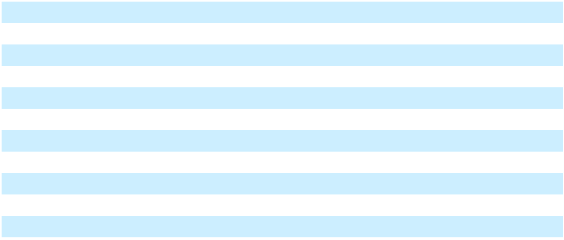

As of December 31, 2025 and 2024, the Company had $3.458 billion and $4.278 billion, respectively, of trade accounts receivable that were recorded within Accounts receivable, net. As of December 31, 2025 and 2024, two individual customers accounted for 87% and 79%, respectively, of the Company's net trade accounts receivable balances.

The Company had product sales to certain customers that each accounted for more than 10% of total gross product revenue for the years ended December 31, 2025, 2024, and 2023. Sales to each of these customers as a percentage of the Company's total gross product revenue are as follows:

 | Year Ended December 31,
 | 2025 |  | 2024 |  | 2023
Customer A | 50 % | 50 % |  | 51 %
Customer B | 27 % | 24 % |  | 25 %
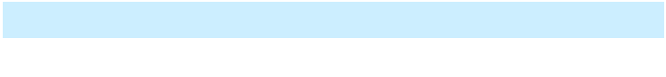

Revenue from product sales is recorded net of applicable provisions for rebates, chargebacks, and discounts, distribution-related fees, and other sales-related deductions. Accruals for chargebacks and discounts are recorded as a direct reduction to accounts receivable. Accruals for rebates, distribution-related fees, and other sales-related deductions are recorded within accrued liabilities. The following table summarizes the provisions, and credits/payments, for sales-related deductions:

 |  | Rebates, |  | Distribution- |  |  |  | Other Sales-
(In millions) | Chargebacks, |  |  |  |  |  |  | Related |  |  | Total
(In millions) | and Discounts |  |  |  | Related Fees |  |  | Deductions |  |  | Total
Balance as of December 31, 2022 | $ | 353.9 | $ |  | 111.4 | $ |  | 81.5 | $ |  | 546.8
Provisions |  | 2,074.5 |  |  | 439.2 |  |  | 155.3 |  |  | 2,669.0
Credits/payments |  | (1,972.7) |  |  | (388.3) |  |  | (157.5) |  |  | (2,518.5)
Balance as of December 31, 2023 |  | 455.7 |  |  | 162.3 |  |  | 79.3 |  |  | 697.3
Provisions |  | 2,447.3 |  |  | 462.7 |  |  | 143.0 |  |  | 3,053.0
Credits/payments |  | (2,363.9) |  |  | (497.2) |  |  | (128.8) |  |  | (2,989.9)
Balance as of December 31, 2024 |  | 539.1 |  |  | 127.8 |  |  | 93.5 |  |  | 760.4
Provisions |  | 2,751.7 |  |  | 421.1 |  |  | 119.7 |  |  | 3,292.5
Credits/payments |  | (2,659.2) |  |  | (400.7) |  |  | (122.2) |  |  | (3,182.1)
Balance as of December 31, 2025 | $ | 631.6 | $ |  | 148.2 | $ |  | 91.0 | $ |  | 870.8
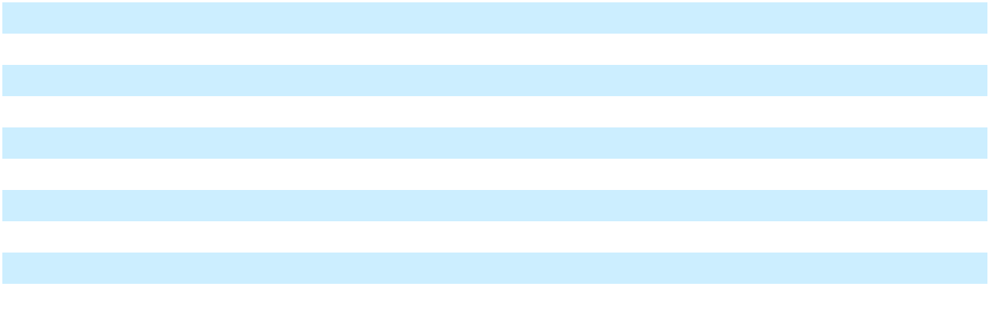

F-15

3. Collaboration, License, and Other Agreements

a. Sanofi

The Company is party to a global, strategic collaboration with Sanofi to research, develop, and commercialize fully human monoclonal antibodies, which currently consists of Dupixent® (dupilumab), Kevzara® (sarilumab), and itepekimab.

Sanofi is generally responsible for funding 80% to 100% of agreed-upon development expenses as incurred. The Company is obligated to reimburse Sanofi for 30% to 50% of development expenses that were funded by Sanofi (i.e., "development balance") based on the Company's share of collaboration profits. The Company is required to apply 20% of its share of profits from the collaboration each calendar quarter to reimburse Sanofi for these development expenses. The Company's contingent reimbursement obligation to Sanofi in connection with the development balance was approximately $595 million as of December 31, 2025.

Sanofi leads commercialization activities for products under the collaboration, subject to the Company's right to co-commercialize such products. The Company co-commercializes Dupixent in the United States and in certain countries outside the United States. The Company supplies certain commercial bulk product to Sanofi. The parties equally share profits from sales within the United States. The parties share profits outside the United States on a sliding scale based on sales starting at 65% (Sanofi)/35% (Regeneron) and ending at 55% (Sanofi)/45% (Regeneron).

In addition to profit sharing, the Company was entitled to receive sales milestone payments from Sanofi. During the year ended December 31, 2023, the Company earned the final $50.0 million sales-based milestone from Sanofi upon aggregate annual sales of antibodies outside the United States exceeding $3.0 billion on a rolling twelve-month basis.

Amounts recognized in the Company's Statements of Operations in connection with its Sanofi collaboration are as follows:

 | Statement of Operations |  |  | Year Ended December 31,
(In millions) | Classification |  |  | 2025 |  |  | 2024 |  |  | 2023
Regeneron's share of profits | Collaboration revenue |  | $ | 5,241.6 | $ |  | 3,923.5 | $ |  | 3,136.5
Sales-based milestones earned | Collaboration revenue |  | $ | — | $ |  | — | $ |  | 50.0
Reimbursement for manufacturing of | Collaboration revenue |  | $ | 642.4 | $ |  | 607.9 | $ |  | 613.0
commercial supplies
Regeneron's obligation for its share of | (R&D expense)
Sanofi R&D expenses, net of
reimbursement of R&D expenses |  |  | $ | (69.5) | $ |  | (46.8) | $ |  | (83.7)
Reimbursement of commercialization- | Reduction of SG&A expense |  | $ | 729.3 | $ |  | 655.4 | $ |  | 534.4
related expenses
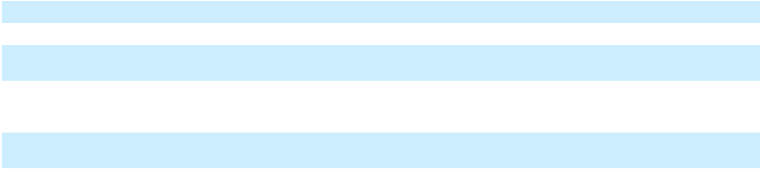

The following table summarizes contract balances in connection with the Company's Sanofi collaboration:

 |  | As of December 31,
(In millions) |  | 2025 |  |  | 2024
Accounts receivable, net | $ | 1,610.6 | $ |  | 1,216.2
Deferred revenue | $ | 442.3 | $ |  | 571.7
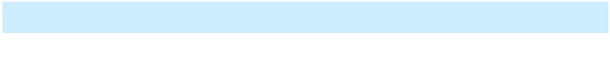

b. Bayer

The Company is party to a license and collaboration agreement with Bayer for the global development and commercialization of EYLEA 8 mg (aflibercept 8 mg) and EYLEA (aflibercept) outside the United States. The parties generally share equally agreed-upon development expenses as incurred. The Company is also obligated to use commercially reasonable efforts to supply clinical and commercial bulk product to Bayer.

F-16

Bayer is responsible for commercialization activities outside the United States, and the companies share equally in profits from such sales. Within the United States, the Company is responsible for commercialization and retains profits from such sales. The Company is obligated to reimburse Bayer out of the Company's share of the collaboration profits for 50% of the agreed-upon development expenses that Bayer has incurred in accordance with a formula based on the amount of development expenses that Bayer has incurred and the Company's share of the collaboration profits, or at a faster rate at the Company's option; the Company's contingent reimbursement obligation to Bayer was approximately $296 million as of December 31, 2025.

Amounts recognized in the Company's Statements of Operations in connection with its Bayer collaboration are as follows:

 | Statement of Operations |  |  | Year Ended December 31,
(In millions) | Classification |  |  | 2025 |  |  | 2024 |  |  | 2023
Regeneron's share of profits | Collaboration revenue |  | $ | 1,282.7 | $ |  | 1,403.3 | $ |  | 1,376.4
Reimbursement for manufacturing of | Collaboration revenue |  | $ | 139.7 | $ |  | 95.7 | $ |  | 111.1
commercial supplies
Regeneron's obligation for its share of Bayer | (R&D expense)
R&D expenses, net of reimbursement of
R&D expenses |  |  | $ | (20.0) | $ |  | (48.5) | $ |  | (44.0)


The following table summarizes contract balances in connection with the Company's Bayer collaboration:

 |  | As of December 31,
(In millions) |  | 2025 |  |  | 2024
Accounts receivable, net | $ | 287.6 | $ |  | 349.9
Deferred revenue | $ | 295.7 | $ |  | 216.3
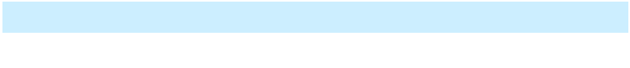

c. Other

In addition to the collaboration and license agreements discussed above, the Company has collaboration and license agreements that are not individually significant to its operating results or financial condition at this time. Pursuant to the terms of those agreements, the Company may (i) incur, and/or get reimbursed for, research and development expenses, and/or (ii) be required to pay, and/or may receive, additional amounts contingent upon the occurrence of various future events (e.g., upon the achievement of development and commercial milestones), which in the aggregate could be significant.

In January 2026, the Company's collaboration agreement with Tessera Therapeutics, Inc. to develop and commercialize TSRA-196 (Tessera's investigational program for the treatment of alpha-1 antitrypsin deficiency ("AATD")) became effective. Under the terms of the agreement, the Company made aggregate payments of $150.0 million in January 2026, consisting of an up-front payment and the purchase of Tessera preferred stock. The portion related to the up-front payment will be recorded to Acquired IPR&D expense in the first quarter of 2026.

Acquired IPR&D Expenses

During the year ended December 31, 2025, the Company recorded to Acquired IPR&D expense an $80.0 million up-front payment in connection with its license agreement with Hansoh Pharmaceuticals Group Company Limited to acquire development and commercial rights outside mainland China, Hong Kong, and Macau for HS-20094 (a dual GLP-1/GIP receptor agonist currently in Phase 3 clinical development in China).

During the year ended December 31, 2024, the Company recorded to Acquired IPR&D expense a $45.0 million development milestone in connection with its collaboration agreement with Sonoma Biotherapeutics, Inc.

During the year ended December 31, 2023, the Company recorded to Acquired IPR&D expense a $100.0 million development milestone in connection with its collaboration agreement with Alnylam Pharmaceuticals, Inc., a $45.0 million up-front payment in connection with its collaboration agreement with Sonoma, and a $30.0 million extension payment under its collaboration agreement with Intellia Therapeutics, Inc.

Royalties

The Company has also in-licensed patent and/or technology pursuant to agreements which contain provisions that require the Company to pay royalties, as defined, at rates that range from 0.5% to 12.5%, in the event the Company sells or licenses any proprietary products developed under the respective agreements. For the years ended December 31, 2025, 2024, and 2023, the Company recorded royalty expense (net of reimbursements from collaborators, as applicable) of $81.3 million, $82.9 million, and $117.6 million, respectively, based on product sales under various licensing agreements.

F-17

4. Marketable Securities

Marketable securities as of December 31, 2025 and 2024 consist of both available-for-sale debt securities of investment grade issuers (see below and Note 5) as well as equity securities of publicly traded companies (see Note 5).

The following tables summarize the Company's investments in available-for-sale debt securities:

(In millions) |  | Amortized |  |  |  | Unrealized |  |  |  |  |  | Fair
As of December 31, 2025 |  | Cost Basis |  |  |  | Gains |  |  | Losses |  |  | Value
Corporate bonds |  | $ | 10,141.0 |  | $ | 80.9 | $ |  | (2.4) | $ |  | 10,219.5
U.S. government and government agency obligations |  |  | 4,352.2 |  |  | 15.2 |  |  | (0.1) |  |  | 4,367.3
Commercial paper |  |  | 540.8 |  |  | 0.3 |  |  | — |  |  | 541.1
Certificates of deposit |  |  | 265.7 |  |  | 0.2 |  |  | — |  |  | 265.9
Asset-backed securities |  |  | 241.4 |  |  | 1.4 |  |  | — |  |  | 242.8
Sovereign bonds |  |  | 76.3 |  |  | 0.5 |  |  | — |  |  | 76.8
 |  | $ | 15,617.4 |  | $ | 98.5 | $ |  | (2.5) | $ |  | 15,713.4
As of December 31, 2024
Corporate bonds |  | $ | 8,226.9 |  | $ | 25.1 | $ |  | (31.4) | $ |  | 8,220.6
U.S. government and government agency obligations |  |  | 4,820.5 |  |  | 3.4 |  |  | (6.9) |  |  | 4,817.0
Commercial paper |  |  | 548.3 |  |  | 0.4 |  |  | — |  |  | 548.7
Certificates of deposit |  |  | 380.6 |  |  | 0.5 |  |  | — |  |  | 381.1
Asset-backed securities |  |  | 279.0 |  |  | 0.6 |  |  | (0.3) |  |  | 279.3
Sovereign bonds |  |  | 82.7 |  |  | 0.1 |  |  | (0.4) |  |  | 82.4
 |  | $ | 14,338.0 |  | $ | 30.1 | $ |  | (39.0) | $ |  | 14,329.1
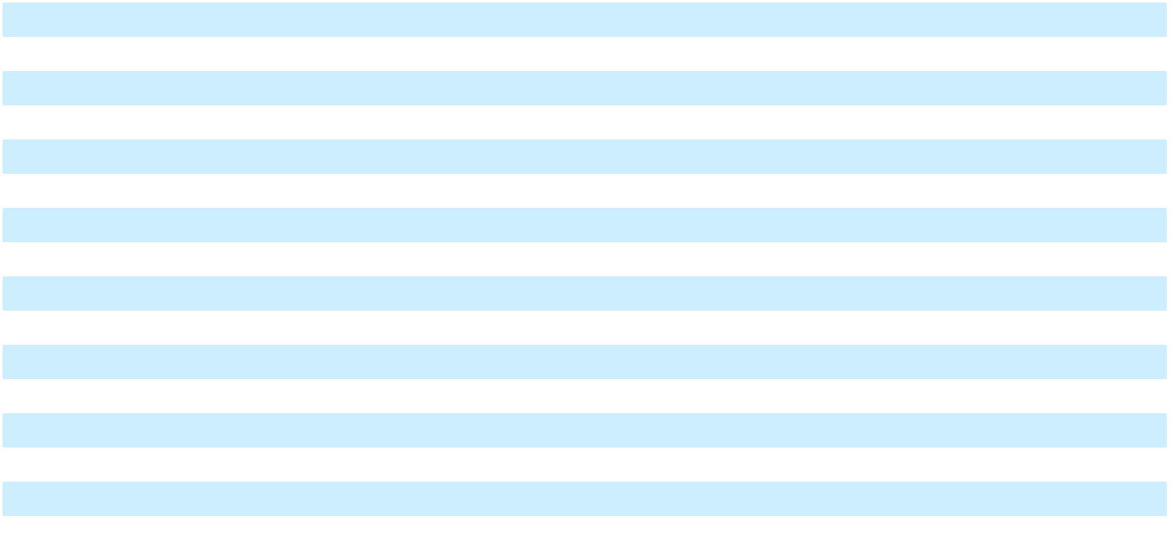

The Company classifies its investments in available-for-sale debt securities based on their contractual maturity dates. The available-for-sale debt securities as of December 31, 2025 mature at various dates through December 2032. The fair values of available-for-sale debt securities by contractual maturity consist of the following:

 |  | As of December 31,
(In millions) |  | 2025 |  |  | 2024
Maturities within one year | $ | 5,487.1 | $ |  | 6,524.3
Maturities after one year through five years |  | 10,224.8 |  |  | 7,804.8
Maturities after five years |  | 1.5 |  |  | —
 | $ | 15,713.4 | $ |  | 14,329.1
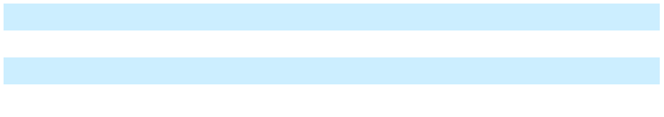

Amounts reclassified from Accumulated other comprehensive income (loss) into Other income (expense), net related to realized gains/losses on sales of available-for-sale debt securities; such amounts were not material for the years ended December 31, 2025, 2024, and 2023.

The Company recognized interest income of $716.8 million, $711.4 million, and $495.9 million for the years ended December 31, 2025, 2024, and 2023, respectively, in Other income (expense), net.

F-18

5. Fair Value Measurements

The table below summarizes the Company's assets and liabilities which are measured at fair value on a recurring basis. The following fair value hierarchy is used to classify assets and liabilities, based on inputs to valuation techniques utilized to measure fair value:

- Level 1 - Quoted prices in active markets for identical assets or liabilities

- Level 2 - Significant other observable inputs, such as quoted market prices for similar instruments in active markets, quoted prices for identical or similar instruments in markets that are not active, or model-based valuations in which significant inputs used are observable

- Level 3 - Significant other unobservable inputs

(In millions) |  |  |  |  |  | Fair Value Measurements at Reporting Date
As of December 31, 2025 |  |  | Fair Value |  |  | Level 1 |  |  | Level 2 |  |  | Level 3
Assets:
Cash equivalents |  | $ | 2,121.6 |  | $ | 1,127.7 | $ |  | 993.9 | $ |  | —
Available-for-sale debt securities:
Corporate bonds |  |  | 10,219.5 |  |  | — |  |  | 10,219.5 |  |  | —
U.S. government and government agency obligations |  |  | 4,367.3 |  |  | — |  |  | 4,367.3 |  |  | —
Commercial paper |  |  | 541.1 |  |  | — |  |  | 541.1 |  |  | —
Certificates of deposit |  |  | 265.9 |  |  | — |  |  | 265.9 |  |  | —
Asset-backed securities |  |  | 242.8 |  |  | — |  |  | 242.8 |  |  | —
Sovereign bonds |  |  | 76.8 |  |  | — |  |  | 76.8 |  |  | —
Equity securities^{(a)} |  |  | 34.3 |  |  | 34.3 |  |  | — |  |  | —
Total assets |  | $ | 17,869.3 |  | $ | 1,162.0 | $ |  | 16,707.3 | $ |  | —
Liabilities:
Contingent consideration |  | $ | 10.3 |  | $ | — | $ |  | — | $ |  | 10.3
As of December 31, 2024
Assets:
Cash equivalents |  | $ | 1,452.2 |  | $ | 1,264.2 | $ |  | 188.0 | $ |  | —
Available-for-sale debt securities:
Corporate bonds |  |  | 8,220.6 |  |  | — |  |  | 8,220.6 |  |  | —
U.S. government and government agency obligations |  |  | 4,817.0 |  |  | — |  |  | 4,817.0 |  |  | —
Commercial paper |  |  | 548.7 |  |  | — |  |  | 548.7 |  |  | —
Certificates of deposit |  |  | 381.1 |  |  | — |  |  | 381.1 |  |  | —
Asset-backed securities |  |  | 279.3 |  |  | — |  |  | 279.3 |  |  | —
Sovereign bonds |  |  | 82.4 |  |  | — |  |  | 82.4 |  |  | —
Equity securities^{(a)} |  |  | 1,095.3 |  |  | 1,095.3 |  |  | — |  |  | —
Total assets |  | $ | 16,876.6 |  | $ | 2,359.5 | $ |  | 14,517.1 | $ |  | —
Liabilities:
Contingent consideration |  | $ | 52.3 |  | $ | — | $ |  | — | $ |  | 52.3


- Includes equity securities of $33.3 million and $43.2 million as of December 31, 2025 and 2024, respectively, that are subject to transfer restrictions expiring in April 2026

In addition to the investments summarized in the table above, the Company classified the following investments within Other noncurrent assets:

- As of December 31, 2025 and 2024, $334.0 million and $159.8 million, respectively, of equity securities that do not have a readily determinable fair value. The change in carrying value of such investments was a result of additional purchases.

F-19

- As of December 31, 2025 and 2024, equity securities held through ownership interest in an investment fund of $147.5 million and $52.0 million, respectively, which are measured at fair value based on Level 3 inputs. The change in carrying value was primarily the result of additional purchases by the fund.

Amounts recognized in Other income (expense), net, related to the Company's investments in public equity securities consist of the following:

 |  | Year Ended December 31,
(In millions) |  | 2025 |  |  | 2024 |  |  | 2023
Net gains (losses) recognized during the period | $ | 955.6 | $ |  | 117.7 | $ |  | (235.6)
Less: Net gains recognized on investments sold during |  | 966.2 |  |  | — |  |  | 6.0
the period |  | 966.2 |  |  | — |  |  | 6.0
Net unrealized gains (losses) recognized on investments | $ | (10.6) | $ |  | 117.7 | $ |  | (241.6)
still held as of period end date
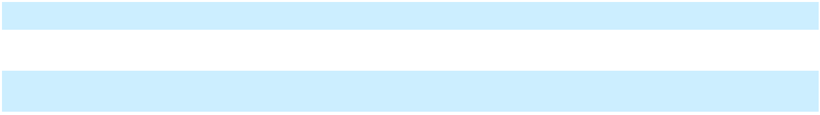

Other Fair Value Disclosures

The fair value of the Company's long-term debt (see Note 10), which was determined based on Level 2 inputs, was estimated to be $1.576 billion and $1.484 billion as of December 31, 2025 and 2024, respectively.

6. Inventories

Inventories consist of the following:

 |  | As of December 31,
(In millions) |  | 2025 |  |  | 2024
Raw materials | $ | 641.5 | $ |  | 879.5
Work-in-process |  | 1,641.6 |  |  | 1,342.3
Finished goods |  | 190.2 |  |  | 139.8
Deferred costs |  | 727.5 |  |  | 725.7
 | $ | 3,200.8 | $ |  | 3,087.3
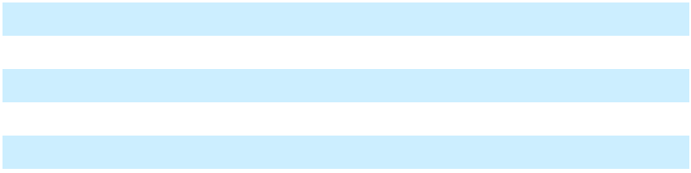

Deferred costs represent the costs of product manufactured and shipped to the Company's collaborators for which recognition of revenue has been deferred. For the years ended December 31, 2025, 2024, and 2023, Cost of goods sold included inventory write-offs and reserves of $172.9 million, $126.3 million, and $102.3 million, respectively.

7. Property, Plant, and Equipment
Property, plant, and equipment, net consists of the following:
 |  | As of December 31,
(In millions) |  | 2025 |  |  | 2024
Building and improvements | $ | 3,105.9 | $ |  | 2,573.2
Leasehold improvements |  | 174.4 |  |  | 154.5
Laboratory equipment |  | 1,543.7 |  |  | 1,494.5
Computer equipment and software |  | 522.0 |  |  | 450.8
Furniture, office equipment, and other |  | 219.7 |  |  | 203.8
Land |  | 278.8 |  |  | 288.2
Construction in progress |  | 1,890.2 |  |  | 1,721.6
 |  | 7,734.7 |  |  | 6,886.6
Accumulated depreciation and amortization |  | (2,614.3) |  |  | (2,286.9)
 | $ | 5,120.4 | $ |  | 4,599.7
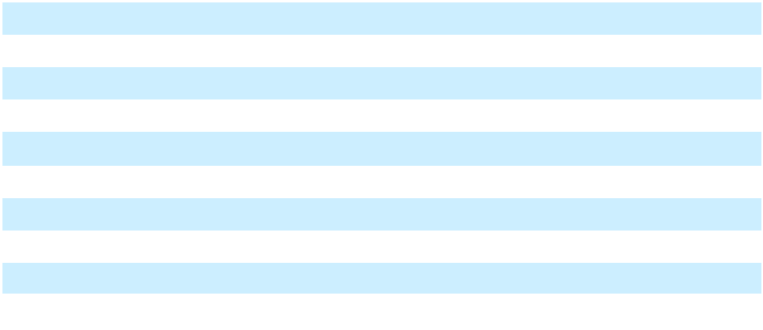

Property, plant, and equipment in the table above includes leased property under the Company's finance lease at its Tarrytown, New York corporate headquarters. See Note 11.

F-20

Depreciation and amortization expense on property, plant, and equipment was $364.8 million, $354.1 million, and $328.8 million for the years ended December 31, 2025, 2024, and 2023, respectively.

As of December 31, 2025 and 2024, $4.332 billion and $3.884 billion, respectively, of the Company's net property, plant, and equipment was located in the United States and $788.0 million and $715.9 million, respectively, was located outside the United States (primarily in Ireland).

8. Intangible Assets

Intangible assets, net consist of the following:

 |  |  |  |  |  |  |  |  |  | As of December 31,
 |  |  |  |  |  |  | 2025 |  |  |  |  |  |  |  |  | 2024
 | Estimated |  |  | Gross |  | Accumulated |  |  |  | Net |  |  | Gross |  | Accumulated |  |  |  | Net
(In millions) | Useful |  |  | Carrying |  |  |  |  | Carrying |  |  |  | Carrying |  |  |  |  | Carrying
(In millions) | Life |  |  | Amount |  | Amortization |  |  |  | Amount |  |  | Amount |  | Amortization |  |  |  | Amount
Acquired product
rights - Libtayo | 13 years $ |  |  | 1,635.3 | $ |  | (431.9) | $ |  | 1,203.4 | $ |  | 1,347.7 | $ |  | (254.3) | $ |  | 1,093.4
Other intangibles | 8 years |  |  | 10.0 |  |  | (8.8) |  |  | 1.2 |  |  | 10.0 |  |  | (7.6) |  |  | 2.4
Acquired in-process
research and
development | Indefinite |  |  | 52.8 |  |  | — |  |  | 52.8 |  |  | 52.8 |  |  | — |  |  | 52.8
 | $ |  |  | 1,698.1 | $ |  | (440.7) | $ |  | 1,257.4 | $ |  | 1,410.5 | $ |  | (261.9) | $ |  | 1,148.6


During the years ended December 31, 2025 and 2024, the Company recorded additions to the Libtayo intangible asset related to contingent consideration due to Sanofi in connection with the acquisition of worldwide rights to Libtayo in 2022.

Amortization expense on intangible assets was $178.8 million, $128.9 million, and $92.2 million for the years ended December 31, 2025, 2024, and 2023, respectively.

As of December 31, 2025, assuming no changes in the gross carrying amount of intangible assets, amortization expense is estimated to be approximately $124 million for each of the years ending December 31, 2026 through December 31, 2030.

In addition to the intangible assets summarized in the table above, during the second quarter of 2025, the Company recorded an indefinite-lived intangible asset in connection with the purchase of a U.S. Food and Drug Administration ("FDA") Rare Pediatric Disease Priority Review Voucher ("PRV") from a third party for $155.0 million. During the fourth quarter of 2025, the Company made the decision to utilize the PRV for a regulatory submission, and as a result, the carrying amount was expensed to Research and development.

9. Accrued Expenses and Other Current Liabilities

Accrued expenses and other current liabilities consist of the following:

 |  | As of December 31,
(In millions) |  | 2025 |  |  | 2024
Accrued payroll and related costs | $ | 773.0 | $ |  | 640.9
Accrued clinical expenses |  | 357.2 |  |  | 315.7
Accrued sales-related costs |  | 875.6 |  |  | 786.2
Income tax-related costs |  | 351.3 |  |  | 213.2
Other accrued expenses and liabilities |  | 519.3 |  |  | 571.1
 | $ | 2,876.4 | $ |  | 2,527.1
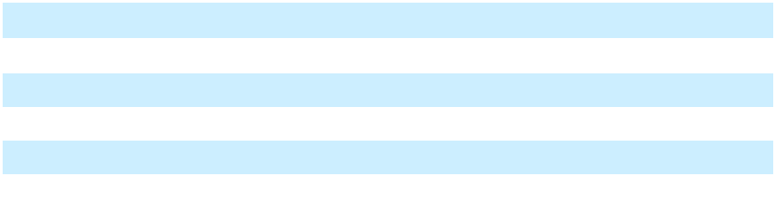

F-21

10. Debt

a. Senior Notes

Long-term debt, net of underwriting discounts and offering expenses (which are being amortized as additional interest expense over the period of issuance through maturity), consists of the following:

 |  | As of December 31,
(In millions) |  | 2025 |  |  | 2024
1.750% Senior Notes due September 2030 | $ | 1,244.5 | $ |  | 1,243.3
2.800% Senior Notes due September 2050 |  | 741.4 |  |  | 741.1
 | $ | 1,985.9 | $ |  | 1,984.4

Interest on each series of senior notes is payable semi-annually until the applicable maturity dates. Interest expense related to the debt was $44.4 million in each of the years ended December 31, 2025, 2024, and 2023.

b. Credit Facility

The Company is party to an agreement with a syndicate of lenders (the "Credit Agreement") which provides for a $750.0 million senior unsecured five-year revolving credit facility (the "Credit Facility"). The Credit Agreement includes an option for the Company to elect to increase the commitments under the Credit Facility and/or to enter into one or more tranches of term loans in the aggregate principal amount of up to $500.0 million, subject to the consent of the lenders providing the additional commitments or term loans, as applicable, and certain other conditions. The Credit Agreement also provides a $50.0 million sublimit for letters of credit.

Proceeds of the loans under the Credit Facility may be used to finance working capital needs, and for general corporate or other lawful purposes, of Regeneron and its subsidiaries. Regeneron Pharmaceuticals, Inc. has guaranteed all obligations under the Credit Facility. The Credit Agreement includes an option for the Company to elect to extend the maturity date of the Credit Facility beyond December 2027, subject to the consent of the extending lenders and certain other conditions.

The Company had no borrowings outstanding under the Credit Facility as of December 31, 2025.

The Credit Agreement contains operating covenants and a maximum total leverage ratio financial covenant. The Company was in compliance with all covenants of the Credit Agreement as of December 31, 2025.

11. Leases

The Company conducts certain of its research, development, and administrative activities at leased facilities. The Company also leases vehicles and other assets.

Tarrytown, New York Corporate Headquarters

The Company leases laboratory and office facilities for its corporate headquarters in Tarrytown, New York (the "Facility") under the Third Amended and Restated Lease and Remedies Agreement (the "Lease") with BA Leasing BSC, LLC, an affiliate of Banc of America Leasing & Capital, LLC ("BAL"), as lessor, and the Third Amended and Restated Participation Agreement (the "Participation Agreement") with Bank of America, N.A., as administrative agent, and a syndicate of lenders (collectively with BAL, the "Participants"), as rent assignees. The Lease, Participation Agreement, and certain related agreements provide for $720.0 million of lease financing (previously advanced by the Participants in March 2017 in connection with the acquisition by BAL of the Facility and the Company's lease of the Facility from BAL), which matures when the term of the Lease expires in March 2027, at which time all amounts outstanding thereunder will become payable in full. The Company has the option to further extend the maturity date of the Participation Agreement and the term of the Lease for an additional five-year period, subject to the consent of the Participants and certain other conditions. The Company also has the option to (a) purchase the Facility by paying an amount equal to the outstanding principal amount of the Participants' advances under the Participation Agreement, all accrued and unpaid yield thereon, and all other outstanding amounts under the Participation Agreement, Lease, and certain related documents or (b) sell the Facility to a third party on behalf of BAL.

Pursuant to the Lease, the Company pays all maintenance, insurance, taxes, and other costs arising out of the use of the Facility. The Company is also required to make monthly payments of basic rent to satisfy the yield payable to the Participants on their outstanding advances under the Participation Agreement. Such advances accrue yield at a variable rate per annum based on the one-month forward-looking Secured Overnight Financing Rate ("SOFR") term rate, plus a spread adjustment, plus an applicable margin that varies with the Company's debt rating and total leverage ratio.

F-22

The Lease is classified as a finance lease as the Company has the option to purchase the Facility under terms that make it reasonably certain to be exercised. The agreements governing the Lease financing contain financial and operating covenants. Such financial covenants and certain of the operating covenants are substantially similar to the covenants set forth in the Credit Agreement. The Company was in compliance with all such covenants as of December 31, 2025.

Aggregate Lease Information

Amounts recognized in the Consolidated Balance Sheet related to the Company's leases are included in the table below.

As of December 31,

(In millions) Classification 2025 2024
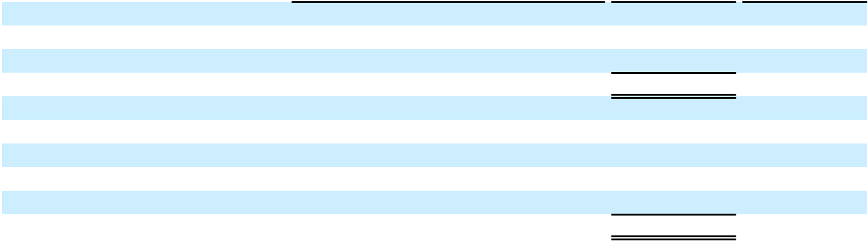

Assets:

Finance lease right-of-use assets | Property, plant, and equipment, net^{(a)} | $
Operating lease right-of-use assets | Other noncurrent assets^{(b)}
 |  | $
Liabilities:
Finance lease liabilities - noncurrent | Finance lease liabilities | $
Operating lease liabilities - current | Accrued expenses and other current liabilities
Operating lease liabilities - noncurrent | Other noncurrent liabilities
 |  | $

576.7 | $ | 591.2
245.8 |  | 217.4
822.5 | $ | 808.6
720.0 | $ | 720.0
37.8 |  | 30.3
229.0 |  | 204.1
986.8 | $ | 954.4

- Finance lease right-of-use assets were recorded net of accumulated amortization of $162.9 million and $148.4 million as of December 31, 2025 and 2024, respectively

- Operating lease right-of-use assets were recorded net of accumulated amortization of $68.8 million and $78.4 million as of December 31, 2025 and 2024, respectively

Lease costs consist of the following:

 |  | Year Ended December 31,
(In millions) |  | 2025 |  |  | 2024 |  |  | 2023
Operating lease costs | $ | 35.8 | $ |  | 36.5 | $ |  | 19.2
Finance lease costs:
Amortization of finance lease right-of-use assets |  | 14.5 |  |  | 14.5 |  |  | 14.5
Interest on finance lease liabilities |  | 39.1 |  |  | 46.1 |  |  | 45.0
Total finance lease costs |  | 53.6 |  |  | 60.6 |  |  | 59.5
Total lease costs
Total lease costs | $ | 89.4 | $ |  | 97.1 | $ |  | 78.7
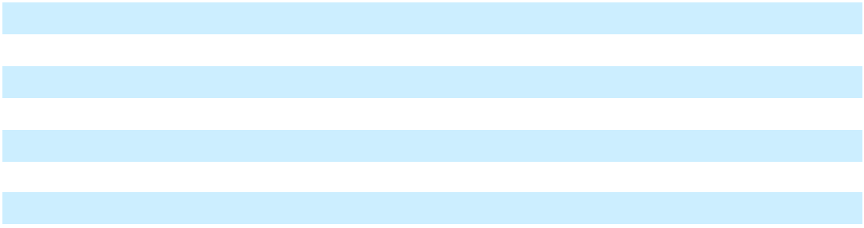

Other information related to the Company's leases includes the following:

 | As of December 31,
 | 2025 | 2024
Weighted-average remaining lease term (in years):
Finance leases | 1.2 | 2.2
Operating leases | 6.9 | 7.2
Weighted-average discount rate:
Finance leases | 4.40% | 5.03%
Operating leases | 5.38% | 5.52%
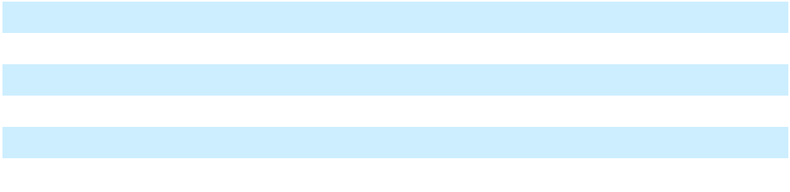

F-23

Supplemental cash flow information related to the Company's leases includes the following:

 |  | Year Ended December 31,
(In millions) |  | 2025 |  |  | 2024 |  |  | 2023
Cash paid for amounts included in the measurement of operating lease | $ | 39.6 | $ |  | 41.4 | $ |  | 22.5
liabilities (included within cash flows from operating activities)
Right-of-use assets obtained in exchange for operating lease liabilities | $ | 59.1 | $ |  | 188.1 | $ |  | 31.9

The following is a maturity analysis of the Company's lease liabilities as of December 31, 2025:

(In millions) |  | Finance Leases |  |  | Operating Leases |  |  | Total
2026 | $ | 33.7 | $ |  | 52.1 | $ |  | 85.8
2027 |  | 727.6 |  |  | 52.3 |  |  | 779.9
2028 |  | — |  |  | 48.5 |  |  | 48.5
2029 |  | — |  |  | 40.3 |  |  | 40.3
2030 |  | — |  |  | 31.2 |  |  | 31.2
Thereafter |  | — |  |  | 97.5 |  |  | 97.5
Total undiscounted lease payments |  | 761.3 |  |  | 321.9 |  |  | 1,083.2
Imputed interest |  | (41.3) |  |  | (55.1) |  |  | (96.4)
Total lease liabilities | $ | 720.0 | $ |  | 266.8 | $ |  | 986.8
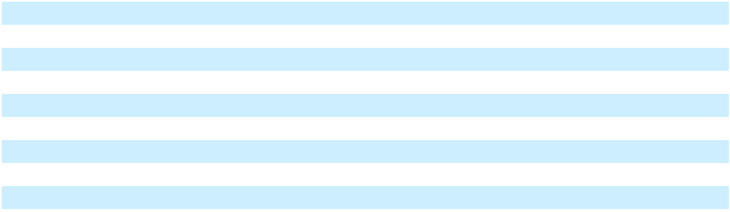

12. Stockholders' Equity

The Company's Restated Certificate of Incorporation, as amended, provides for the issuance of up to 40 million shares of Class A Stock, par value $0.001 per share, and 320 million shares of Common Stock, par value $0.001 per share. Shares of Class A Stock are convertible, at any time, at the option of the holder into shares of Common Stock on a share-for-share basis. Holders of Class A Stock have rights and privileges identical to Common Stockholders except that each share of Class A is entitled to ten votes per share, while each share of Common Stock is entitled to one vote per share. Class A Stock may only be transferred to specified Permitted Transferees, as defined. Under the Company's Restated Certificate of Incorporation, the Company's board of directors is authorized to issue up to 30 million shares of Preferred Stock, in series, with rights, privileges, and qualifications of each series determined by the board of directors.

a. Share Repurchase Programs

The Company's board of directors has authorized share repurchase programs, including a share repurchase program for up to $3.0 billion of the Company's Common Stock which was authorized in February 2025. The programs have no time limit and can be discontinued at any time.

The table below summarizes the shares of the Company's Common Stock that the Company repurchased under its share repurchase programs and the cost of such shares, which were recorded as Treasury Stock.

 |  | Year Ended December 31,
(In millions) |  | 2025 |  |  | 2024 |  |  | 2023
Number of shares |  | 5.6 |  |  | 2.8 |  |  | 2.9
Total cost of shares | $ | 3,456.2 | $ |  | 2,613.9 | $ |  | 2,214.6

As of December 31, 2025, $1.486 billion remained available for share repurchases under the Company's share repurchase programs.

b. Dividends

In 2025, the Company's board of directors declared quarterly cash dividends of $0.88 per share on its Common Stock and Class A Stock. Each quarterly dividend was paid to the Company's shareholders in the quarter in which the dividend was declared.

Additionally, in January 2026, the Company's board of directors declared a cash dividend of $0.94 per share on its Common Stock and Class A Stock. The dividend will be payable to the Company's shareholders in March 2026.

F-24

13. Long-Term Incentive Plans

The Company has used long-term incentive plans for the purpose of granting equity awards to employees of the Company, including officers, and non-employee members of the Company's board of directors (collectively, "Participants"). The Participants may receive awards as determined by a committee of independent members of the Company's board of directors or, to the extent authorized by such committee with respect to certain Participants, a duly authorized employee (collectively, the "Committee"). The incentive plan currently used by the Company is the Second Amended and Restated Regeneron Pharmaceuticals, Inc. 2014 Long-Term Incentive Plan (the "Second Amended and Restated 2014 Incentive Plan"). It was most recently adopted and approved by the Company's shareholders in 2020. As of the most recent shareholder approval date, the Second Amended and Restated 2014 Incentive Plan provided for the issuance of up to 22.3 million shares of Common Stock in respect of awards. In addition, upon expiration, forfeiture, surrender, exchange, cancellation, or termination of any award previously granted under the Amended and Restated Regeneron Pharmaceuticals, Inc. 2014 Long-Term Incentive Plan (the "Amended and Restated 2014 Incentive Plan"), the Regeneron Pharmaceuticals, Inc. 2014 Long-Term Incentive Plan (the "Original 2014 Incentive Plan"), or the Second Amended and Restated 2000 Long-Term Incentive Plan (the "2000 Incentive Plan"), any shares subject to such award are added to the pool of shares available for grant under the Second Amended and Restated 2014 Incentive Plan.

The awards that may be made under the Second Amended and Restated 2014 Incentive Plan include: (a) non-qualified stock options and incentive stock options, (b) restricted stock awards, (c) shares of phantom stock (also referred to as restricted stock units, which may be time- or performance-based), and (d) other awards. Any award granted may (but is not required to) be subject to vesting based on the attainment by the Company of performance goals pre-established by the Committee.

Stock option awards grant Participants the right to purchase shares of Common Stock at prices determined by the Committee, with exercise prices that are equal to or greater than the average of the high and low market prices of the Company's Common Stock on the date of grant (the "Market Price"). Options vest over a period of time determined by the Committee, generally on a pro rata basis over a four-year period. The Committee also determines the expiration date of each option. The maximum term of options that have been awarded under the 2000 Incentive Plan, the Original 2014 Incentive Plan, the Amended and Restated 2014 Incentive Plan, and the Second Amended and Restated 2014 Incentive Plan (collectively, the "Incentive Plans") is ten years.

Restricted stock awards grant Participants shares of restricted Common Stock. Such shares are nontransferable for a period determined by the Committee ("vesting period"). Should employment terminate, as specified in the Incentive Plans, except as determined by the Committee in its discretion and subject to the applicable Incentive Plan documents, the ownership of any unvested restricted stock awards will be transferred to the Company.

Phantom stock awards provide the Participant the right to receive Common Stock or an amount of cash based on the value of the Common Stock at a future date. The award is subject to such restrictions, if any, as the Committee may impose at the date of grant or thereafter, including a specified period of employment or the achievement of performance goals. Time-based restricted stock units and performance-based restricted stock units are each a type of phantom stock award permitted under the Second Amended and Restated 2014 Incentive Plan.

The Incentive Plans contain provisions that allow for the Committee to provide for the immediate vesting of awards upon a change in control of the Company, as defined in the Incentive Plans.

As of December 31, 2025, there were 12.4 million shares available for future grants under the Second Amended and Restated 2014 Incentive Plan.

F-25

a. Stock Options

The table below summarizes the activity related to stock option awards under the Company's Incentive Plans during 2025.

 |  |  | Weighted |  |  | Weighted-
 | Number of |  |  |  |  | Average
 | Number of |  | -Average |  |  | Remaining |  | Intrinsic Value
 | Shares |  | Exercise |  |  | Contractual
 | (In millions) |  |  | Price |  | Term |  |  | (In millions)
Outstanding as of December 31, 2024 | 12.7 | $ |  | 588.47
2025: Granted | 0.7 | $ |  | 691.40
Forfeited | (0.4) | $ |  | 752.01
Exercised | (1.2) | $ |  | 519.17
Outstanding as of December 31, 2025 | 11.8 | $ |  | 596.65 |  | 5.7 years | $ |  | 2,185.9
Vested and expected to vest as of
Vested and expected to vest as of | 11.5 | $ |  | 592.93 |  | 5.7 years | $ |  | 2,178.9
December 31, 2025 | 11.5 |  |  | 592.93 |  | 5.7 years |  |  | 2,178.9
Exercisable as of December 31, 2025 | 8.7 | $ |  | 536.47 |  | 4.7 years | $ |  | 2,100.0
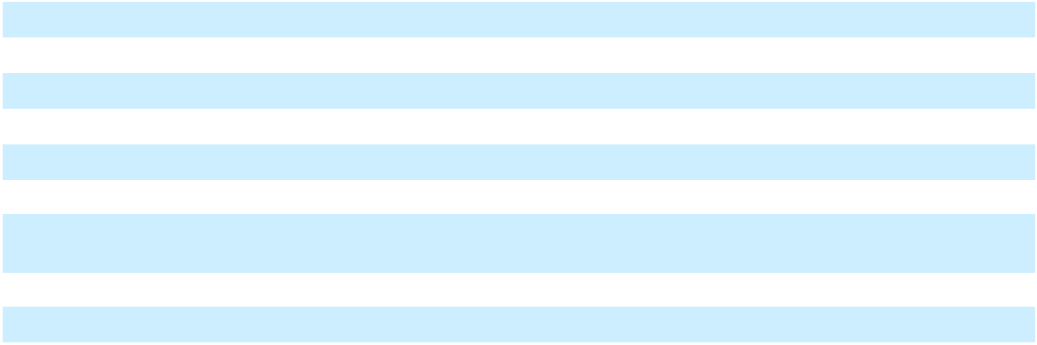

The Company satisfies stock option exercises with newly issued shares of the Company's Common Stock. The total intrinsic value of stock options exercised during 2025, 2024, and 2023 was $193.6 million, $1.682 billion, and $1.096 billion, respectively. The intrinsic value represents the amount by which the market price of the underlying stock exceeds the exercise price of an option.

The table below summarizes the weighted-average exercise prices and weighted-average grant-date fair values of options granted during the years ended December 31, 2025, 2024, and 2023.

 | Number of |  | Weighted- |  |  | Weighted-
 | Options |  |  | Average
 | Granted |  |  | Exercise |  |  | Average
 | (In millions) |  |  | Price |  | Fair Value
2025:
Exercise price equal to Market Price | 0.7 | $ |  | 691.40 | $ |  | 206.58
2024:
Exercise price equal to Market Price | 1.9 | $ |  | 786.79 | $ |  | 235.32
2023:
Exercise price equal to Market Price | 1.6 | $ |  | 835.91 | $ |  | 264.37
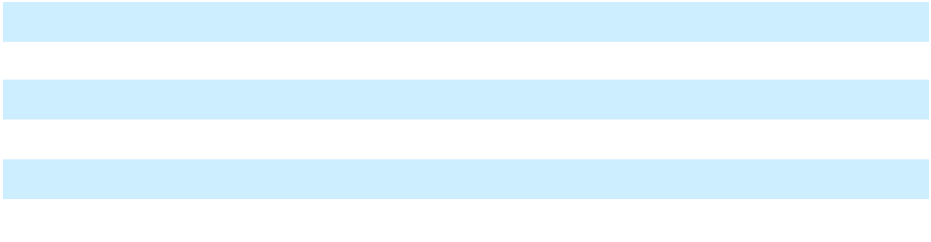

For the years ended December 31, 2025, 2024, and 2023, the Company recognized $351.9 million, $376.0 million, and $357.1 million, respectively, of stock-based compensation expense related to stock option awards (net of amounts capitalized as inventory, which were not material for each of the three years). As of December 31, 2025, there was $385.8 million of stock-based compensation cost related to unvested stock options, net of estimated forfeitures, which had not yet been recognized. The Company expects to recognize this compensation cost over a weighted-average period of 1.7 years.

Fair Value Assumptions:

The following table summarizes the weighted average values of the assumptions used in computing the fair value of option grants during 2025, 2024, and 2023.

 | 2025 |  | 2024 |  | 2023
Expected volatility | 26 % | 25 % |  | 26 %
Expected lives from grant date | 5.3 years |  | 5.0 years |  | 5.1 years
Expected dividend yield | 0.49 % | 0 % |  | 0 %
Risk-free interest rate | 3.79 % | 4.11 % |  | 4.29 %
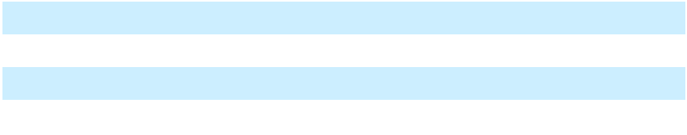

F-26

Expected volatility has been estimated based on actual movements in the Company's stock price over the most recent historical periods equivalent to the options' expected lives. Expected lives are principally based on the Company's historical exercise experience with previously issued option grants. Expected dividend yield is based on the Company's historical practice and expectation of future dividend payments. During 2024 and 2023, the expected dividend yield was zero as the Company had not paid dividends nor did it expect to at the time of option grants. The risk-free interest rates are based on quoted U.S. Treasury rates for securities with maturities approximating the options' expected lives.

b. Restricted Stock Awards and Time-Based Restricted Stock Units

A summary of the Company's activity related to restricted stock awards and time-based restricted stock units (excluding performance-based restricted stock units, which are detailed further below) (collectively, "restricted stock") during 2025 is summarized below.

 | Number of |  |  | Weighted-
 | Number of |  | Average Grant
 | Shares/Units |  |  | Date Fair
 | (In millions) |  |  | Value
Unvested as of December 31, 2024 | 2.5 | $ |  | 760.35
2025: Granted | 1.4 | $ |  | 718.94
Vested | (0.7) | $ |  | 734.49
Forfeited | (0.1) | $ |  | 753.77
Unvested as of December 31, 2025 | 3.1 | $ |  | 748.08
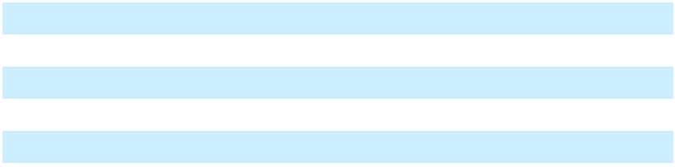

For the years ended December 31, 2025, 2024, and 2023, the Company recognized $589.8 million, $554.7 million, and $475.9 million, respectively, of stock-based compensation expense related to restricted stock (net of amounts capitalized as inventory, which were not material for each of the three years). As of December 31, 2025, there was $1.493 billion of stock-based compensation cost related to unvested restricted stock which had not yet been recognized. The Company expects to recognize this compensation cost over a weighted-average period of 2.3 years.

c. Performance-based Restricted Stock Units

Performance-based restricted stock units ("PSUs") have been granted to certain members of senior management of the Company. PSUs may be earned based upon the attainment of pre-established performance criteria, which may include a market and/or performance condition. Depending on the terms of the PSUs and the outcome of the pre-established performance criteria, a recipient may ultimately earn the target number of PSUs granted or a specified multiple thereof at the end of a 4–6 year vesting period, as applicable.

The table below summarizes activity related to PSUs during 2025. The number of unvested PSUs represents the maximum number of units that are eligible to be earned.
 | Number of |  |  | Weighted-
 | Number of |  | Average Grant
 | Shares/Units |  |  | Date Fair
 | (In millions) |  |  | Value
Unvested as of December 31, 2024 | 1.4 | $ |  | 247.91
2025: Vested | (1.2) | $ |  | 209.59
Unvested as of December 31, 2025 | 0.2 | $ |  | 485.61
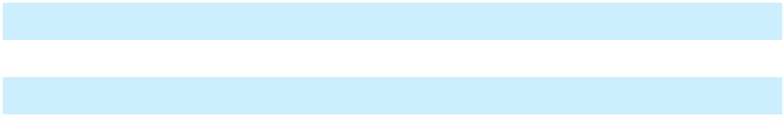

For each of the years ended December 31, 2025, 2024, and 2023 the Company recognized $52.0 million of stock-based compensation expense related to PSUs. As of December 31, 2025, there was no stock-based compensation cost expected to be recognized related to unvested PSUs.

F-27

14. Employee Savings Plans

The Company maintains the Regeneron Pharmaceuticals, Inc. 401(k) Savings Plan, as amended and restated (the "Savings Plan"). The terms of the Savings Plan allow U.S. employees (as defined by the Savings Plan) to contribute to the Savings Plan a percentage of their compensation. In addition, the Company may make discretionary contributions, as defined, to the accounts of participants under the Savings Plan. The Company also maintains additional employee savings plans outside the United States, which cover eligible employees.

Expenses recognized by the Company related to contributions to such plans were $95.7 million, $90.2 million, and $84.7 million for the years ended December 31, 2025, 2024, and 2023, respectively.

15. Income Taxes

The Company is subject to U.S. federal, state, and foreign income taxes. Components of income before income taxes consist of the following:

 |  | Year Ended December 31,
(In millions) |  | 2025 |  |  | 2024 |  |  | 2023
United States | $ | (476.3) | $ |  | (411.3) | $ |  | (362.3)
Foreign |  | 5,707.0 |  |  | 5,191.2 |  |  | 4,561.6
 | $ | 5,230.7 | $ |  | 4,779.9 | $ |  | 4,199.3
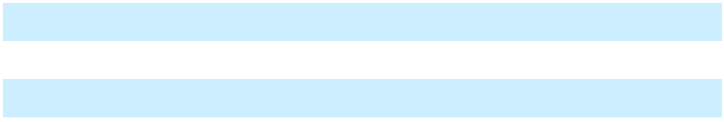

Components of income tax expense consist of the following:

 |  | Year Ended December 31,
(In millions) |  | 2025 |  |  | 2024 |  |  | 2023
Current:
Federal | $ | 1,012.3 | $ |  | 1,092.6 | $ |  | 667.9
State |  | 19.8 |  |  | (11.1) |  |  | 7.7
Foreign |  | 479.1 |  |  | 43.1 |  |  | 407.9
Total current tax expense |  | 1,511.2 |  |  | 1,124.6 |  |  | 1,083.5
Deferred:
Federal |  | (845.2) |  |  | (935.5) |  |  | (834.5)
State |  | (15.5) |  |  | (4.9) |  |  | (6.5)
Foreign |  | 75.3 |  |  | 183.1 |  |  | 3.2
Total deferred tax benefit |  | (785.4) |  |  | (757.3) |  |  | (837.8)
 | $ | 725.8 | $ |  | 367.3 | $ |  | 245.7
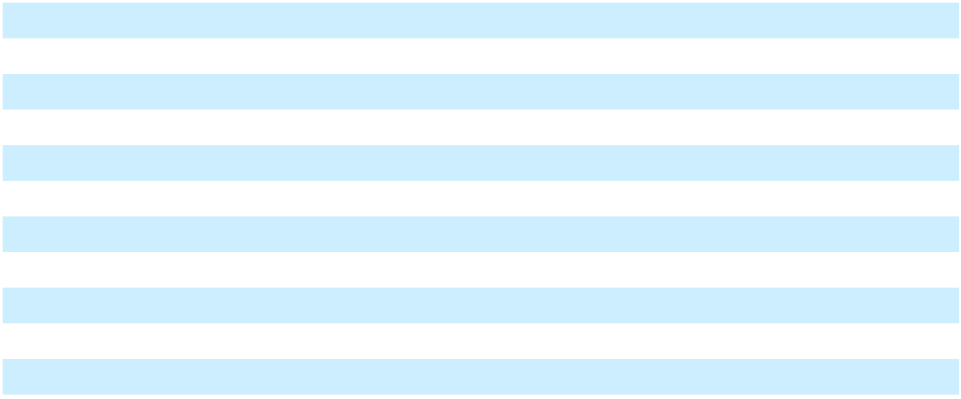

Cash paid for income taxes, net of refunds received, by jurisdiction for the year ended December 31, 2025 is as follows:

(In millions) |  | 2025
Federal | $ | 576.5
State |  | 5.3
Foreign:
Ireland |  | 645.2
Other |  | 26.0
 | $ | 1,253.0
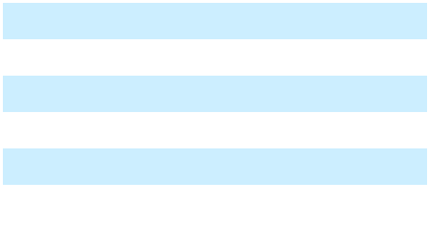

Cash paid for income taxes, net of refunds received, were $743.0 million and $870.3 million for the years ended December 31, 2024 and 2023, respectively.

F-28

On July 4, 2025, bill H.R. 1, commonly referred to as the "One Big Beautiful Bill Act" or "OBBBA," was signed into law, with certain provisions effective in 2025 and others in 2026. The OBBBA significantly revises U.S. corporate income tax laws by, among other things, restoring the option for immediate expense recognition for U.S.-based research and development expenditures and making permanent the ability to claim first-year bonus depreciation on qualified property. The OBBBA also modifies U.S. taxation on foreign earnings by, among other things, changing the tax rates for Net CFC Tested Income (formerly known as global intangible low-taxed income ("GILTI")) and foreign-derived intangible income (now known as foreign-derived deduction eligible income), modifying the allocation of expenses in calculating foreign tax credits, as well as changing foreign tax credit limitations. As a result of the OBBBA being signed into law, the Company recognized a charge of $44.5 million in 2025 related to the re-measurement of the Company's U.S. net deferred tax assets.

A reconciliation of the U.S. federal statutory tax rate to the Company's effective tax rate for the year ended December 31, 2025 is as follows:

 |  | 2025
(In millions, except percent) |  | Amount |  |  | Percent
U.S. federal statutory tax rate | $ | 1,098.4 |  |  | 21.0 | %
Foreign tax effects:
Ireland:
Statutory tax rate difference between Ireland and United States |  | (480.3) |  |  | (9.2)
Domestic top-up tax |  | 120.0 |  |  | 2.3
Other |  | (5.8) |  |  | (0.1)
Other foreign jurisdictions |  | 7.7 |  |  | 0.1
Tax credits:
Research and development and orphan drug tax credits |  | (133.3) |  |  | (2.5)
Effect of cross-border tax laws:
Foreign-derived deduction eligible income |  | (20.6) |  |  | (0.4)
Net CFC tested income ("NCTI"), net of foreign tax credit ("FTC") |  | (82.7) |  |  | (1.6)
Subpart F income, net of FTC |  | 8.3 |  |  | 0.1
Changes in unrecognized tax benefits^{(a)} |  | 124.2 |  |  | 2.4
Effect of changes in tax laws or rates enacted in the current period |  | 44.5 |  |  | 0.9
Nontaxable or nondeductible items:
Stock-based compensation |  | 14.1 |  |  | 0.3
Other permanent differences |  | 27.0 |  |  | 0.5
Other adjustments |  | 4.3 |  |  | 0.1
Effective tax rate | $ | 725.8 |  |  | 13.9 | %
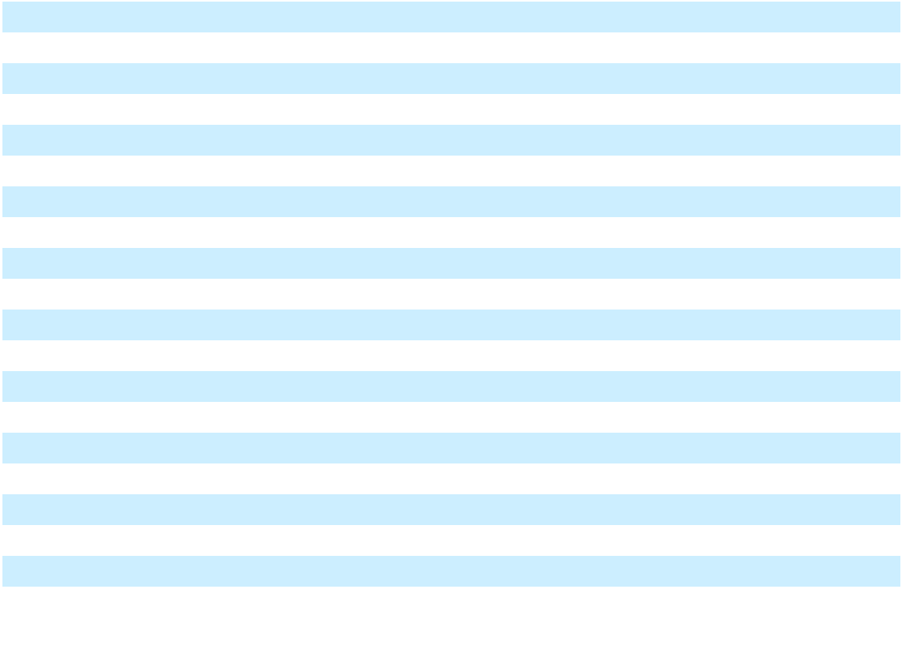

- Changes in unrecognized tax benefits for all jurisdictions are aggregated within this category

A reconciliation of the U.S. federal statutory tax rate to the Company's effective tax rate for the years ended December 31, 2024 and 2023 is as follows:

 | 2024 |  | 2023
U.S. federal statutory tax rate | 21.0 % | 21.0 %
Stock-based compensation | (4.9) | (4.6)
Taxation of non-U.S. operations | (4.0) | (6.6)
Tax credits | (3.5) | (3.2)
Foreign-derived deduction eligible income | (0.8) | (0.3)
Other permanent differences | (0.1) |  | (0.4)
Effective tax rate | 7.7 % | 5.9 %
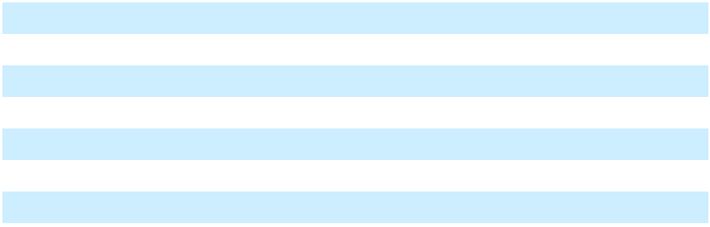

F-29

Deferred income taxes reflect the net tax effects of temporary differences between the carrying amounts of assets and liabilities for financial reporting purposes and the amounts used for income tax purposes. Significant components of the Company's deferred tax assets and liabilities are as follows:

 |  | As of December 31,
(In millions) |  | 2025 |  |  | 2024
Deferred tax assets:
Capitalized research and development expenses | $ | 3,146.2 | $ |  | 2,530.2
Deferred compensation |  | 452.0 |  |  | 419.7
Fixed assets and intangible assets |  | 192.6 |  |  | 145.1
Accrued expenses |  | 158.8 |  |  | 185.0
Tax attribute carryforwards |  | 79.6 |  |  | 84.1
Other |  | 49.9 |  |  | 43.0
Total deferred tax assets |  | 4,079.1 |  |  | 3,407.1
Deferred tax liabilities:
Unrealized gains on investments |  | (1.9) |  |  | (93.0)
Net deferred tax assets | $ | 4,077.2 | $ |  | 3,314.1
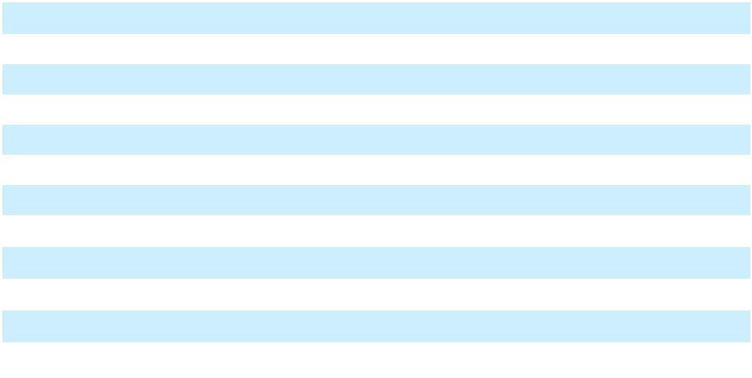

The Company's federal income tax returns for 2019 through 2024 remain open to examination by the IRS. The Company's 2019 and 2020 federal income tax returns are currently under audit by the IRS. In general, the Company's state income tax returns from 2017 to 2024 remain open to examination. The Company's income tax returns outside the United States remain open to examination from 2020 to 2024. The United States and many states generally have statutes of limitation ranging from 3 to 5 years; however, those statutes could be extended due to the Company's tax credit carryforward position. In general, tax authorities have the ability to review income tax returns in which the statute of limitation has previously expired to adjust the tax credits generated in those years.

The following table reconciles the beginning and ending amounts of unrecognized tax benefits:

(In millions) |  | 2025 |  |  | 2024 |  |  | 2023
Balance as of January 1 | $ | 1,313.7 | $ |  | 696.4 | $ |  | 542.8
Gross increases related to current year tax |  | 401.9 |  |  | 353.5 |  |  | 153.4
positions |  | 401.9 |  |  | 353.5 |  |  | 153.4
Gross (decreases) increases related to prior year |  | (43.1) |  |  | 264.8 |  |  | 3.2
tax positions |  | (43.1) |  |  | 264.8 |  |  | 3.2
Gross decreases due to settlements and lapse of |  | (94.6) |  |  | (1.0) |  |  | (3.0)
statutes of limitations |  | (94.6) |  |  | (1.0) |  |  | (3.0)
Balance as of December 31 | $ | 1,577.9 | $ |  | 1,313.7 | $ |  | 696.4
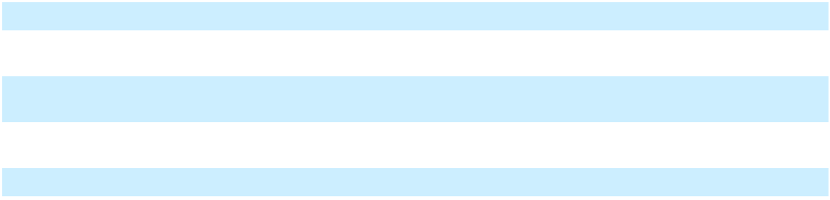

In 2025, 2024, and 2023, the increases in unrecognized tax benefits primarily related to the Company's calculation of certain tax credits and other items related to the Company's international operations. In 2025, the Company released liabilities for uncertain tax positions in connection with the settlement of the IRS audit of the Company's 2017 and 2018 federal income tax returns. Interest expense related to unrecognized tax benefits was $201.7 million, $165.4 million, and $77.2 million in 2025, 2024, and 2023, respectively.

The amount of net unrecognized tax benefits that, if settled, would impact the effective tax rate is $520.9 million, $635.4 million, and $442.5 million as of December 31, 2025, 2024, and 2023, respectively.

F-30

16. Legal Matters

From time to time, the Company is a party to legal proceedings in the course of the Company's business. The outcome of any such proceedings, regardless of the merits, is inherently uncertain. If the Company is unable to prevail in one or more of such proceedings, its consolidated financial position, results of operations, and future cash flows may be materially adversely impacted. Costs associated with the Company's involvement in legal proceedings are expensed as incurred. The Company recognizes gain contingencies associated with such proceedings when the award or recovery is realized or realizable and loss contingencies when it is probable that a liability will be incurred and the amount of loss can be reasonably estimated. As of December 31, 2025 and 2024, the Company's accruals for loss contingencies were not material. There are certain loss contingencies that the Company deems reasonably possible for which the possible loss or range of possible loss is not estimable at this time.

a. Proceedings Relating to EYLEA (aflibercept) Injection

- United States

As described in greater detail below, the Company has filed several patent infringement lawsuits against various parties in the United States alleging infringement of certain Company patents pertaining to EYLEA, and certain of these patents have also been subject to post-grant proceedings before the United States Patent and Trademark Office ("USPTO").

(i) U.S. Patent Litigation

In 2025, the Company entered into settlement agreements resulting in the dismissal of the previously disclosed patent infringement lawsuits before the United States District Court for the Northern District of West Virginia against Mylan Pharmaceuticals Inc. ("Mylan") and Biocon Biologics Inc. ("Biocon"); Celltrion, Inc. ("Celltrion"); Formycon AG ("Formycon"); and Sandoz Inc. ("Sandoz"). The lawsuits each alleged infringement of certain Company patents, including the Company's U.S. Patent No. 11,084,865 (the "'865 Patent"). Pursuant to the settlement agreements, these parties are precluded from launching their respective aflibercept 2 mg biosimilars until the second half of 2026 (Mylan/Biocon), fourth quarter of 2026 (Sandoz and Formycon), and December 31, 2026 (Celltrion).

On January 10, 2024, the Company filed a patent infringement lawsuit against Amgen Inc. ("Amgen") in the United States District Court for the Central District of California (subsequently transferred to the United States District Court for the Northern District of West Virginia) alleging that Amgen's filing for FDA approval of an aflibercept 2 mg biosimilar infringed certain Company patents. On September 23, 2024, the court denied the Company's motion for a preliminary injunction, which decision was affirmed by the Federal Circuit on March 14, 2025. On June 17, 2025, the Company filed an additional patent infringement lawsuit against Amgen in the United States District Court for the Central District of California alleging that Amgen's continued commercialization of its aflibercept 2 mg biosimilar infringes the Company's U.S. Patent No. 12,331,099. On September 12, 2025, Amgen filed its answer and counterclaims alleging, among other things, that the Company obtained numerous patents fraudulently, rendering them unenforceable, and that obtaining and enforcing certain Company patents violated Section 2 of the Sherman Antitrust Act of 1890, as amended (the "Sherman Antitrust Act"). On November 12, 2025, the Company filed a motion to dismiss Amgen's affirmative defenses and counterclaims.

(ii) Post-Grant Proceedings Before the USPTO

On November 20, 2024, November 29, 2024, and January 15, 2025, Samsung Bioepis, Formycon, and Celltrion, respectively, filed inter partes review ("IPR") petitions in the USPTO against the '865 Patent, each seeking a declaration that the '865 Patent is invalid. On June 6, 2025, the USPTO denied institution of Samsung and Formycon's respective IPR petitions, and on June 25, 2025, the USPTO denied institution of Celltrion's IPR petition.

On July 14, 2025, Fresenius Kabi SwissBioSim GmbH filed IPR petitions in the USPTO against the '865 Patent and U.S. Patent No. 10,828,345 (the "'345 Patent"), seeking a declaration that the '865 Patent and '345 Patent are invalid. On November 20, 2025, and January 6, 2026, the USPTO denied institution of Fresenius' IPR petitions against the '865 Patent and the '345 Patent, respectively.

- Outside the United States

As described in greater detail below, the Company has filed patent infringement lawsuits against various parties in several jurisdictions outside the United States alleging infringement of certain Company patents pertaining to EYLEA, and certain of these patents have also been subject to post-grant proceedings before the European Patent Office (the "EPO") and/or other comparable foreign authorities.

F-31

(i) Multijurisdictional Settlements

Biocon. On December 13, 2025, the Company and Bayer entered into a settlement agreement with Biocon and its affiliated entities in respect of all jurisdictions outside the United States with the exception of Canada (separately settled in March 2024, as previously disclosed). Pursuant to the settlement agreement, all pending judicial and administrative proceedings related to Biocon's aflibercept 2 mg biosimilar product has been dismissed and Biocon is permitted to launch such biosimilar product in the United Kingdom in January 2026 and in the rest of the jurisdictions covered by the settlement in March 2026 or, in each case, earlier in certain circumstances.

Celltrion. On January 21, 2026, the Company and Bayer entered into a settlement agreement with Celltrion in respect of all jurisdictions outside the United States with the exceptions of Canada (separately settled in July 2024, as previously disclosed) and Singapore (separately settled in November 2025). Pursuant to the settlement agreement, all pending judicial and administrative proceedings related to Celltrion's aflibercept 2 mg biosimilar product, including the previously disclosed litigation in South Korea, has or will be dismissed and Celltrion is permitted to launch such biosimilar product in South Korea and the United Kingdom in January 2026 and in the rest of the jurisdictions covered by the settlement in the second quarter of 2026, or earlier in certain circumstances.

Alvotech. On January 28, 2026, the Company and Bayer entered into a settlement agreement with Alvotech HF ("Alvotech") in respect of all jurisdictions outside the United States. Pursuant to the settlement agreement, all pending judicial and administrative proceedings related to Alvotech's aflibercept 2 mg biosimilar product, including the litigation in Germany discussed below, has or will be dismissed and Alvotech is permitted to launch such biosimilar product in Canada, the United Kingdom, and Japan in January 2026 (November 2026 in the case of the DME indication in Japan) and in the rest of the jurisdictions covered by the settlement in May 2026.

Samsung Bioepis. On January 29, 2026, the Company and Bayer entered into a settlement agreement with Samsung Bioepis in respect of all jurisdictions outside the United States with the exception of Canada (separately settled in October 2024, as previously disclosed). Pursuant to the settlement agreement, all pending judicial and administrative proceedings related to Samsung Bioepis' aflibercept 2 mg biosimilar product, including the litigation in the United Kingdom, Germany, the Netherlands, and South Korea discussed below, has or will be dismissed and Samsung Bioepis is permitted to maintain its biosimilar on the market in South Korea and launch such biosimilar product in the United Kingdom in January 2026, the rest of Europe in April 2026, and the rest of the jurisdictions covered by the settlement in May 2026.

(ii) Europe

(I) EPO Post-Grant Proceedings

Various parties, including Amgen and other, anonymous parties, are seeking revocation of the Company's European Patent Nos. 2,944,306 (the "'306 Patent"), 3,716,992 (the "'992 Patent"), and 3,384,049 (the "'049 Patent") before the Opposition Division ("OD") of the EPO. On November 26, 2024, following an oral hearing, the OD announced its decision to revoke the '306 Patent. On March 11, 2025, the Company appealed the OD's decision, and an oral hearing concerning the appeal has been scheduled for October 2026. On October 22, 2025, following an oral hearing, the OD upheld the validity of the '992 Patent's claims in amended form. An oral hearing concerning the '049 Patent has been scheduled for April 2026.

(II) Country-Specific Proceedings

The Company is also party to proceedings against various parties, including Samsung Bioepis, Formycon, Amgen, Alvotech, Celltrion, Sandoz, and/or their affiliated entities, before several European national courts (including those in Belgium, France, Germany, Italy, the Netherlands, and the United Kingdom). In certain of these proceedings, the counterparties are seeking revocation of one or more Company patents pertaining to EYLEA, including the '306 Patent, the '992 Patent, the Company's European Patent No. 2,364,691 (the "'691 Patent"), and the Company's European Patent No. 1,183,353 (as extended by Supplementary Protection Certificate 2013C/029), and/or a declaration that their respective aflibercept 2 mg biosimilars would not infringe these patents, and in the same or other proceedings, the Company is alleging infringement of such patents. As noted above, the Company and Bayer recently entered into settlement agreements with Samsung Bioepis, Alvotech, and Celltrion, pursuant to which the proceedings discussed below have been or will be dismissed with respect to these parties. Key recent developments in the proceedings set forth below are as follows:

- United Kingdom:

  - Following trials held in June 2025, the High Court of England and Wales issued a decision in October 2025 that found that Formycon and Samsung Bioepis's aflibercept 2 mg biosimilar products do not infringe the '691 and '306 Patents; upheld the '691 Patent as valid; and invalidated the '306 Patent. In December 2025, the Company appealed this decision.

F-32

    - Proceedings in the United Kingdom concerning the '992 Patent are stayed pending resolution of the EPO proceedings concerning this patent.

  - Germany:

    - Following a June 2025 trial concerning the revocation proceeding brought by Samsung Bioepis, the German Federal Patent Court upheld the '691 Patent as valid.
    - In October 2025, the Munich Regional Court issued a decision that found that Formycon's aflibercept biosimilar product infringes the '691 Patent and granted the Company's motion for a permanent injunction, enjoining Formycon from selling its aflibercept 2 mg biosimilar in Germany and several other EU countries (including Spain and the Netherlands) until the expiration of the '691 Patent.

    - In January 2026, the Munich Regional Court issued decisions that found that each of Alvotech's, Celltrion's, and Sandoz's aflibercept 2 mg biosimilar products infringes the '691 Patent and granted the Company's motions for preliminary injunctions, enjoining such parties from selling their aflibercept 2 mg biosimilars in Germany and, in the case of Alvotech, also several other EU countries (including France, Spain, Italy, and the Netherlands).

  - Netherlands:

    - Following a trial held in July 2025, the District Court of the Hague issued a decision in October 2025 that upheld the '691 and '306 Patents as valid; found that Samsung Bioepis's aflibercept 2 mg biosimilar product infringes the '691 and '306 Patents; and granted the Company's request for a permanent injunction, enjoining Samsung Bioepis from selling its aflibercept 2 mg biosimilar in the Netherlands until the expiration of the '691 and '306 Patents.

- Canada

In 2025, the Company, Bayer Inc., and Bayer Healthcare LLC entered into settlement agreements resulting in the dismissal of the previously disclosed patent infringement lawsuits and/or invalidation proceedings before the Federal Court of Canada against Amgen Canada Inc. ("Amgen Canada") and Sandoz Canada Inc. Pursuant to the settlement agreements, the Company, Bayer Inc., and Bayer Healthcare LLC are no longer seeking a declaration that Amgen Canada's or Sandoz's respective aflibercept 2 mg biosimilar products infringe the asserted Company patents.

(iv) South Korea

As noted above, the Company and Bayer recently entered into settlement agreements with Samsung Bioepis and Celltrion, pursuant to which the proceedings discussed below have been or will be dismissed with respect to these parties.

On December 13, 2022, Samsung Bioepis initiated invalidation proceedings before the Intellectual Property Trial and Appeal Board of the Korean Intellectual Property Office ("KIPO") against the Company's Korean Patent No. 1406811 (the "'811 Patent"), seeking revocation of the '811 Patent in its entirety. On October 23, 2024, the KIPO maintained the '811 Patent as valid. On October 30, 2025, the IP High Court overturned the decision of the KIPO and invalidated the '811 Patent; the Company has appealed that decision.

The Company and, as applicable, Bayer Consumer Care AG, have also filed patent infringement lawsuits in the Seoul Central District Court against various parties including Samsung Bioepis and its parent company Samsung Biologics Co., Ltd. (collectively, "Samsung"), Sam Chun Dang Pharm. Co., Ltd. and OPTUS Pharmaceutical Co., Ltd., and Celltrion. These lawsuits seek damages and/or injunctive relief and allege that the making, constructing, using, or selling of an aflibercept 2 mg biosimilar by the relevant defendant(s) would infringe one or more claims of the '811 Patent and/or the Company's Korean Patent Nos. 659477 (the "'477 Patent") and 2519234 (the "'234 Patent"). On February 7, 2025, the Seoul Central District Court granted the Company's preliminary injunction request against Samsung on the basis of the '811 Patent. Also on February 7, 2025, the Seoul Central District Court denied Regeneron's preliminary injunction request against Celltrion. In light of the decision of the IP High Court discussed above, on December 3, 2025, the Seoul High Court issued a decision lifting the preliminary injunction against Samsung.

(v) Australia

On June 4, 2025, the Company, Bayer Consumer Care AG, and Bayer Australia filed a patent infringement lawsuit against Sandoz Pty Ltd. and a request for a preliminary injunction in the Federal Court of Australia alleging that the importing, selling, supplying, or otherwise disposing of an aflibercept 2 mg biosimilar would infringe one or more claims of the Company's Australian Patent No. 2012205599. On September 3, 2025, the court denied the Company's request for a preliminary injunction. On November 26, 2025, the parties entered into a settlement agreement, pursuant to which this lawsuit has been dismissed.

F-33

(vi) Japan

On October 10, 2025, the Company filed a patent infringement lawsuit in the Osaka District Court against Fuji Pharma Co., Ltd. alleging that the making, constructing, using, or selling of an aflibercept 2 mg biosimilar by the defendant would infringe one or more claims of the Company's Japanese Patent No. 7,733,706.

b. Proceedings Relating to EYLEA (aflibercept) Injection Pre-filled Syringe

On July 17, 2020, the Company filed an antitrust lawsuit (as amended on January 25, 2021) against Novartis Pharma AG, Novartis Pharmaceuticals Corporation, and Novartis Technology LLC (collectively, "Novartis") and Vetter Pharma International GmbH in the United States District Court for the Southern District of New York seeking a judgment that the defendants' conduct relating to Novartis's attempt to assert its U.S. Patent No. 9,220,631 against Regeneron in 2020 violated Sections 1 and 2 of the Sherman Antitrust Act, and constituted tortious interference with contract. The Company is also seeking injunctive relief and treble damages. On September 21, 2021, this lawsuit was transferred to the Northern District of New York. On June 10, 2022, the Company filed an appeal of the District Court's decision to dismiss the amended complaint with the U.S. Court of Appeals for the Second Circuit (the "Second Circuit"). On March 18, 2024, the Second Circuit reversed the District Court's decision to dismiss the amended complaint and remanded the lawsuit to the District Court for further proceedings consistent with the Second Circuit's opinion. On November 19, 2024, the Company moved to transfer the lawsuit back to the Southern District of New York, which motion was granted on December 5, 2024.

c. Proceedings Relating to Praluent (alirocumab) Injection

On May 27, 2022, the Company filed a lawsuit against Amgen in the United States District Court for the District of Delaware, alleging that, beginning in 2020, Amgen engaged in an anticompetitive bundling scheme which was designed to exclude Praluent from the market in violation of federal and state laws. The lawsuit seeks damages for harm caused by the alleged scheme, as well as injunctive relief restraining Amgen from continuing its alleged anticompetitive conduct. A trial was held in May 2025. On May 15, 2025, the jury reached a verdict in Regeneron's favor on nine of the ten counts submitted to it and awarded Regeneron $135.6 million in compensatory damages and $271.2 million in punitive damages. On June 20, 2025, Amgen filed a post-trial motion for judgment as a matter of law or, in the alternative, for a new trial. Also on June 20, 2025, the Company filed a post-trial motion for

- permanent injunctive relief, (ii) a constructive trust, and (iii) prejudgment interest. An oral hearing on Amgen's and Regeneron's respective post-trial motions was held on August 27, 2025.

d. Department of Justice Matters

On June 24, 2020, the U.S. Attorney's Office for the District of Massachusetts filed a civil complaint in the U.S. District Court for the District of Massachusetts alleging violations of the federal Anti-Kickback Statute and asserting causes of action under the federal False Claims Act and state law (the "June 2020 Civil Complaint") relating to the Company's support of 501(c)(3) organizations that provide financial assistance to patients. On September 27, 2023, the court (i) denied in part and granted in part the Company's motion for summary judgment and (ii) denied in its entirety the motion for partial summary judgment filed by the U.S. Attorney's Office for the District of Massachusetts. On October 25, 2023, the court certified for interlocutory appeal a portion of the court's September 27, 2023 order that addressed the causation standard applicable to the alleged violations of the federal Anti-Kickback Statute and federal False Claims Act. On February 18, 2025, the U.S. Court of Appeals for the First Circuit affirmed the portion of the court's September 27, 2023 order that had been certified for interlocutory appeal. On October 1, 2025, the U.S. Attorney's Office for the District of Massachusetts filed a second motion for partial summary judgment.

On June 3, 2021, the United States District Court for the Central District of California unsealed a qui tam complaint (as amended on October 29, 2021) filed against the Company, Regeneron Healthcare Solutions, Inc., and Sanofi-Aventis U.S. LLC by two qui tam plaintiffs (known as relators) purportedly on behalf of the United States and various states (the "State Plaintiffs"). The amended complaint alleges violations of the federal Anti-Kickback Statute and asserts causes of action under the federal False Claims Act and state law relating to allegedly unlawful remuneration and assistance provided to prescribers. Also on June 3, 2021, the United States and the State Plaintiffs notified the court of their decision to decline to intervene in the case. On January 14, 2022, the Company filed a motion to dismiss the amended complaint in its entirety. On July 25, 2023, the court granted in part and denied in part the Company's motion to dismiss. On September 1, 2023, the Company filed a second motion to dismiss the amended complaint or, in the alternative, a motion for judgment on the pleadings. On July 31, 2024 and August 15, 2024, respectively, the District Court granted the Company's second motion to dismiss the amended complaint with respect to the remaining causes of action under federal law and declined to exercise supplemental jurisdiction over the remaining causes of action under state law. On August 26, 2024, the qui tam plaintiffs filed a notice of appeal. Oral argument on the appeal was held on November 18, 2025.

In June 2021, the Company received a civil investigative demand ("CID") from the U.S. Department of Justice pursuant to the federal False Claims Act relating to, among other things, alleged inflated reimbursement rates for EYLEA by excluding

F-34

applicable discounts, rebates, and benefits from the average sales price reported to the Centers for Medicare & Medicaid Services. On March 28, 2024, the U.S. District Court for the District of Massachusetts unsealed a qui tam complaint against the Company and others by two qui tam plaintiffs, purportedly on behalf of the United States and various states and municipalities, asserting causes of action under the federal False Claims Act and state and local laws, and alleging violations of the federal Anti-Kickback statute related to, among other things, the alleged conduct described above. Also on March 28, 2024, the U.S. Department of Justice and the U.S. Attorney's Office for the District of Massachusetts filed a civil complaint in partial intervention (the "March 2024 Civil Complaint") of the qui tam action, in the same court, asserting causes of action under the federal False Claims Act and a claim for unjust enrichment related to the alleged conduct described above. On June 25, 2024, the States of Colorado, Georgia, Michigan, North Carolina, Texas, and Washington filed a civil complaint in partial intervention (the "June 2024 Civil Complaint") in the same court asserting causes of action under various state laws related to the same alleged conduct. On April 29, 2025, the court denied the Company's motion to dismiss the March 2024 Civil Complaint and the June 2024 Civil Complaint. On June 18, 2025, the States of Maine, Nebraska, Ohio, Oregon, and Wyoming intervened in the action and filed a consolidated complaint asserting causes of action under their respective state laws.

e. Proceedings Initiated by Other Payors

The Company is party to several lawsuits relating to the conduct alleged in the June 2020 Civil Complaint discussed under "d. Department of Justice Matters" above. These lawsuits were filed by UnitedHealthcare Insurance Company and United Healthcare Services, Inc. (collectively, "UHC") and Humana Inc. ("Humana") in the United States District Court for the Southern District of New York on December 17, 2020 and July 22, 2021, respectively; and by Blue Cross and Blue Shield of Massachusetts, Inc. and Blue Cross and Blue Shield of Massachusetts HMO Blue, Inc. (collectively, "BCBS"), Medical Mutual of Ohio ("MMO"), Horizon Healthcare Services, Inc. d/b/a Horizon Blue Cross Blue Shield of New Jersey ("Horizon"), and Local 464A United Food and Commercial Workers Union Welfare Service Benefit Fund ("Local 464A") in the U.S. District Court for the District of Massachusetts on December 20, 2021, February 23, 2022, April 4, 2022, and June 17, 2022, respectively. These lawsuits allege causes of action under state law and the federal Racketeer Influenced and Corrupt Organizations Act ("RICO") and seek monetary damages and equitable relief. The MMO and Local 464A lawsuits are putative class action lawsuits. On December 29, 2021, the lawsuits filed by UHC and Humana were stayed by the United States District Court for the Southern District of New York pending resolution of the proceedings before the U.S. District Court for the District of Massachusetts concerning the allegations in the June 2020 Civil Complaint. On September 27, 2022, the lawsuits filed by BCBS, MMO, and Horizon were stayed by the U.S. District Court for the District of Massachusetts pending resolution of the proceedings before the same court concerning the allegations in the June 2020 Civil Complaint; and, in light of these stays, the parties to the Local 464A action have also agreed to stay that matter.

On June 24, 2024, a group of plaintiffs purporting to be assignees of claims by various Medicare Advantage plans and related entities filed a putative class action complaint in the U.S. District Court for the District of Columbia on behalf of Medicare Advantage plans and other payors. The lawsuit relates to the conduct alleged in the June 2020 Civil Complaint, March 2024 Civil Complaint, and June 2024 Civil Complaint discussed under "d. Department of Justice Matters" above. The lawsuit alleges causes of action under state law and RICO and seeks monetary damages and equitable relief. On October 22, 2024, the Company filed a motion to transfer the proceedings to the U.S. District Court for the District of Massachusetts or, in the alternative, to stay the proceedings or dismiss the proceedings. On January 28, 2025, pursuant to a stipulation among the parties, the proceedings were transferred to the U.S. District Court for the District of Massachusetts. On February 1, 2025, the parties jointly filed a stipulation to stay the action pending resolution of the proceedings before the same court concerning the allegations in the June 2020 Civil Complaint.

F-35

f. Shareholder Derivative Complaint – Department of Justice June 2020 Civil Complaint Matters

On June 29, 2021, an alleged shareholder filed a shareholder derivative complaint in the New York Supreme Court, naming the then-current and certain former members of the Company's board of directors and certain then-current and former executive officers of the Company as defendants and Regeneron as a nominal defendant. The complaint asserts that the individual defendants breached their fiduciary duties in relation to the allegations in the June 2020 Civil Complaint discussed under "d. Department of Justice Matters" above. The complaint seeks an award of damages allegedly sustained by the Company; an order requiring Regeneron to take all necessary actions to reform and improve its corporate governance and internal procedures; disgorgement from the individual defendants of all profits and benefits obtained by them resulting from their sales of Regeneron stock; and costs and disbursements of the action, including attorneys' fees. On July 28, 2021, the defendants filed a notice of removal, removing the case from the New York Supreme Court to the U.S. District Court for the Southern District of New York. On September 23, 2021, the plaintiff moved to remand the case to the New York Supreme Court. Also on September 23, 2021, the individual defendants moved to dismiss the complaint in its entirety. On December 19, 2022, the U.S. District Court for the Southern District of New York denied the plaintiff's motion to remand the case and granted a motion to stay the case pending resolution of the proceedings before the U.S. District Court for the District of Massachusetts concerning the allegations in the June 2020 Civil Complaint. As a result of the stay, the court also terminated the Company's motion to dismiss the complaint without prejudice. The Company can therefore renew the motion to dismiss upon conclusion of the stay.

g. Shareholder Derivative Complaints – Department of Justice March 2024 Civil Complaint Matters

In 2025, various purported shareholders of the Company filed several shareholder derivative complaints in the U.S. District Court for the Southern District of New York or the Supreme Court of the State of New York against members of the Company's board of directors and certain current and former executive officers of the Company as defendants and Regeneron as a nominal defendant. The complaints allege that the individual defendants, among other things, breached their fiduciary duties to the Company by failing to properly manage and oversee the Company in connection with the conduct alleged in the March 2024 Civil Complaint discussed under "d. Department of Justice Matters" above, and one lawsuit also alleges a breach of fiduciary duty relating to the conduct alleged in the second amended putative class action civil complaint discussed under "i. Class Action Civil Complaint" below. The complaints also allege that the individual defendants breached the federal securities laws, wasted corporate assets, and unjustly enriched themselves at the expense of the Company. The complaints seek, among other things, an award of damages allegedly sustained by the Company as a result of the alleged misconduct of the individual defendants; an order requiring the individual defendants to take all necessary actions to reform and improve the Company's corporate governance and internal procedures; and costs and disbursements of the applicable action, including attorneys' fees. Certain of these shareholder derivative complaints have been consolidated by the U.S. District Court for the Southern District of New York. The shareholder derivative complaints filed in the Supreme Court of the State of New York have been removed to the U.S. District Court for the Southern District of New York and motions to remand are pending.

h. Shareholder Derivative Complaint – Director Compensation

On July 22, 2025, an alleged shareholder filed a shareholder derivative complaint in the New York Supreme Court, naming the current non-employee members of our board of directors, and the co-Chairs of our board of directors (who also serve as our President and Chief Executive Officer and our President and Chief Scientific Officer, respectively) as defendants and Regeneron as a nominal defendant. The complaint asserts that the individual defendants breached their fiduciary duties and/or were unjustly enriched when they approved and/or received allegedly excessive non-employee director compensation in 2024 and 2025, and that this allegedly excessive compensation was a waste of corporate assets. The complaint seeks damages in favor of Regeneron for the alleged breaches of fiduciary duties, unjust enrichment, and waste of corporate assets; improvements to Regeneron's corporate governance and internal procedures; equitable relief, including restitution from the individual defendants; and award of the costs of the action, including attorneys' fees. On September 25, 2025, the Company filed a motion to dismiss the complaint.

i. Class Action Civil Complaint

On January 7, 2025 (as amended on September 8, 2025 and October 30, 2025), a purported shareholder filed a putative class action civil complaint, on behalf of himself and all others similarly situated, in the U.S. District Court for the Southern District of New York against the Company and certain current and former executive officers of the Company. The second amended complaint asserts violations of federal securities laws in connection with statements or disclosures purportedly related to the conduct alleged in the March 2024 Civil Complaint discussed under "d. Department of Justice Matters" above as well as allegations relating to the launch of EYLEA HD. On July 10, 2025, the court appointed a lead plaintiff and lead counsel for the action. On November 17, 2025, the Company filed a motion to dismiss the second amended complaint.

F-36

j. Sanofi Litigation

On November 18, 2024, the Company filed a lawsuit (as amended on December 20, 2024) in the United States District Court for the Southern District of New York against Sanofi and certain of its affiliated entities. The lawsuit alleges that the defendants breached certain provisions of the parties' Amended and Restated License and Collaboration Agreement, dated as of November 10, 2009 (as amended, the "Collaboration Agreement"), concerning Sanofi's obligation to provide Regeneron with full access to material information relating to the commercialization of Dupixent or other products commercialized pursuant to the Collaboration Agreement and Regeneron's audit rights under the Collaboration Agreement. The lawsuit seeks a declaratory judgment, injunctive relief, damages, and other relief. On July 3, 2025, Sanofi filed a motion to dismiss the complaint.

17. Net Income Per Share

The calculations of basic and diluted net income per share are as follows:

 |  | Year Ended December 31,
(In millions, except per share data) |  | 2025 |  |  | 2024 |  |  | 2023
Net income - basic and diluted | $ | 4,504.9 | $ |  | 4,412.6 | $ |  | 3,953.6
Weighted average shares - basic |  | 104.6 |  |  | 107.9 |  |  | 106.7
Effect of dilutive securities:
Stock options |  | 1.9 |  |  | 4.8 |  |  | 4.9
Restricted stock awards and restricted stock units |  | 2.1 |  |  | 2.4 |  |  | 2.1
Weighted average shares - diluted |  | 108.6 |  |  | 115.1 |  |  | 113.7
Net income per share - basic | $ | 43.07 | $ |  | 40.90 | $ |  | 37.05
Net income per share - diluted | $ | 41.48 | $ |  | 38.34 | $ |  | 34.77
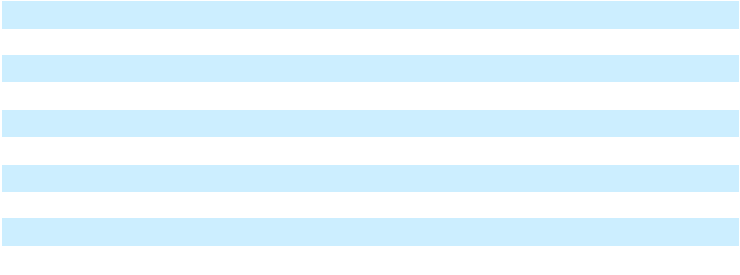

Shares which have been excluded from diluted per share amounts because their effect would have been antidilutive include the following:

 | Year Ended December 31,
(Shares in millions) | 2025 |  | 2024 |  | 2023
Stock options | 6.2 | 1.6 |  | 1.8
Restricted stock awards and restricted stock units | 0.2 |  | — |  | —

18. Statement of Cash Flows

The following provides a reconciliation of cash, cash equivalents, and restricted cash reported within the Consolidated Balance Sheets to the total of the same such amounts shown in the Consolidated Statements of Cash Flows:

 |  |  | December 31,
(In millions) |  | 2025 |  |  | 2024 |  |  | 2023
Cash and cash equivalents | $ | 3,118.1 | $ |  | 2,488.2 |  | $ | 2,730.0
Restricted cash included in Other current assets |  | 5.6 |  |  | 0.8 |  |  | —
Restricted cash included in Other noncurrent assets |  | — |  |  | — |  |  | 7.8
Total cash, cash equivalents, and restricted cash shown | $ | 3,123.7 | $ |  | 2,489.0 |  | $ | 2,737.8
in the Consolidated Statements of Cash Flows |  |  |  |  |  |  | $ | 2,737.8
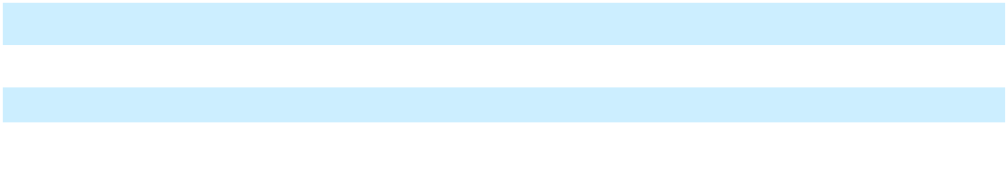

Restricted cash consists of amounts held pursuant to contractual arrangements and for dividends payable on certain equity awards.

F-37

Supplemental disclosure of non-cash investing and financing activities
 |  |  |  | As of December 31,
(In millions) |  | 2025 |  |  | 2024 |  |  | 2023
Accrued capital expenditures | $ | 178.8 | $ |  | 151.6 | $ |  | 75.4
Accrued contingent consideration in | $ | 58.9 | $ |  | 62.7 | $ |  | 71.6
connection with acquisitions

19. Segment Information

The Company operates in one business segment, which includes all activities related to the discovery, development, and commercialization of medicines for serious diseases. The determination of a single business segment is consistent with the consolidated financial information regularly provided to the Company's chief operating decision maker ("CODM"). The Company's CODM is its Chief Executive Officer, who reviews and evaluates consolidated net income for purposes of assessing performance, making operating decisions, allocating resources, and planning and forecasting for future periods.

In addition to the significant expense categories included within consolidated net income presented on the Company's Consolidated Statements of Operations, see below for disaggregated amounts that comprise research and development expenses:

 |  | Year Ended December 31,
(In millions) |  | 2025 |  |  | 2024 |  |  | 2023
Direct research and development expenses^{(a)} | $ | 1,758.1 | $ |  | 1,588.8 | $ |  | 1,295.6
Indirect research and development expenses:
Payroll and benefits |  | 1,800.8 |  |  | 1,681.7 |  |  | 1,537.0
Lab supplies and other research and |  | 258.2 |  |  | 241.5 |  |  | 210.6
development costs |  | 258.2 |  |  | 241.5 |  |  | 210.6
Occupancy and other operating costs |  | 635.4 |  |  | 614.9 |  |  | 518.2
Total indirect research and development |  | 2,694.4 |  |  | 2,538.1 |  |  | 2,265.8
expenses |  | 2,694.4 |  |  | 2,538.1 |  |  | 2,265.8
Clinical manufacturing costs |  | 1,391.2 |  |  | 1,195.9 |  |  | 1,053.9
Priority review voucher |  | 155.0 |  |  | — |  |  | —
Reimbursement of research and development |  | (148.5) |  |  | (190.8) |  |  | (176.3)
expenses by collaborators |  | (148.5) |  |  | (190.8) |  |  | (176.3)
Total research and development expenses | $ | 5,850.2 | $ |  | 5,132.0 | $ |  | 4,439.0
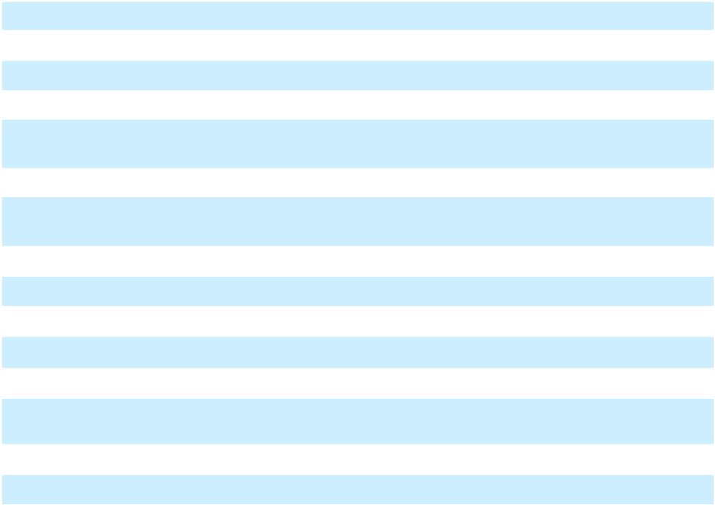

- Direct research and development expenses are comprised primarily of costs paid to third parties for clinical and product development activities, and the portion of research and development expenses incurred by our collaborators that we are obligated to reimburse

F-38

Directors

Bonnie L. Bassler, Ph.D.

Andrew K. Golden University Professor and Squibb Professor in Molecular Biology at Princeton University

Michael S. Brown, M.D.

Regental Professor of Molecular Genetics and Internal Medicine and Director of the Jonsson Center for Molecular Genetics at The University of Texas Southwestern Medical Center at Dallas

N. Anthony Coles, M.D.

Former Chair, President and Chief Executive Officer of Cerevel Therapeutics Holdings, Inc., the parent entity of Cerevel Therapeutics, Inc.

Joseph L. Goldstein, M.D.

Regental Professor of Molecular Genetics and Internal Medicine and Chair of the Department of Molecular Genetics at The University of Texas Southwestern Medical Center at Dallas

Kathryn Guarini, Ph.D.

Former Chief Information Officer of International Business Machines Corporation (IBM)

Christine A. Poon

Former Vice Chair and Worldwide Chair of Pharmaceuticals at Johnson & Johnson

Arthur F. Ryan

Former Chief Executive Officer and Chair of the Board of Prudential Financial, Inc.

David P. Schenkein, M.D.

General Partner and co-Lead of Life Sciences at GV (formerly Google Ventures)

Leonard S. Schleifer, M.D., Ph.D.

Board co-Chair, President and Chief Executive Officer of Regeneron Pharmaceuticals, Inc.

George L. Sing

Chief Executive Officer of GanD, Inc. and Chair of Grace Science, LLC

Craig B. Thompson, M.D.

Former President and Chief Executive Officer of Memorial Sloan Kettering Cancer Center

George D. Yancopoulos, M.D., Ph.D.

Board co-Chair, President and Chief Scientific Officer of Regeneron Pharmaceuticals, Inc.

Huda Y. Zoghbi, M.D.

Professor in the Departments of Pediatrics, Molecular and Human Genetics, and Neurology and Neuroscience at Baylor College of Medicine

Executive Officers

Leonard S. Schleifer, M.D., Ph.D. | Marion McCourt
Board co-Chair, President and Chief Executive Officer | Executive Vice President, Commercial
George D. Yancopoulos, M.D., Ph.D. | Andrew J. Murphy, Ph.D.
Board co-Chair, President and Chief Scientific Officer | Executive Vice President, Co-Chief Scientific Officer
Christopher Fenimore | Jason Pitofsky
Executive Vice President, Finance and | Senior Vice President, Controller
Chief Financial Officer | Daniel P. Van Plew
Joseph J. LaRosa | Daniel P. Van Plew
Joseph J. LaRosa | Executive Vice President and General Manager,
Executive Vice President, General Counsel and Secretary | Industrial Operations and Product Supply

Corporate Information
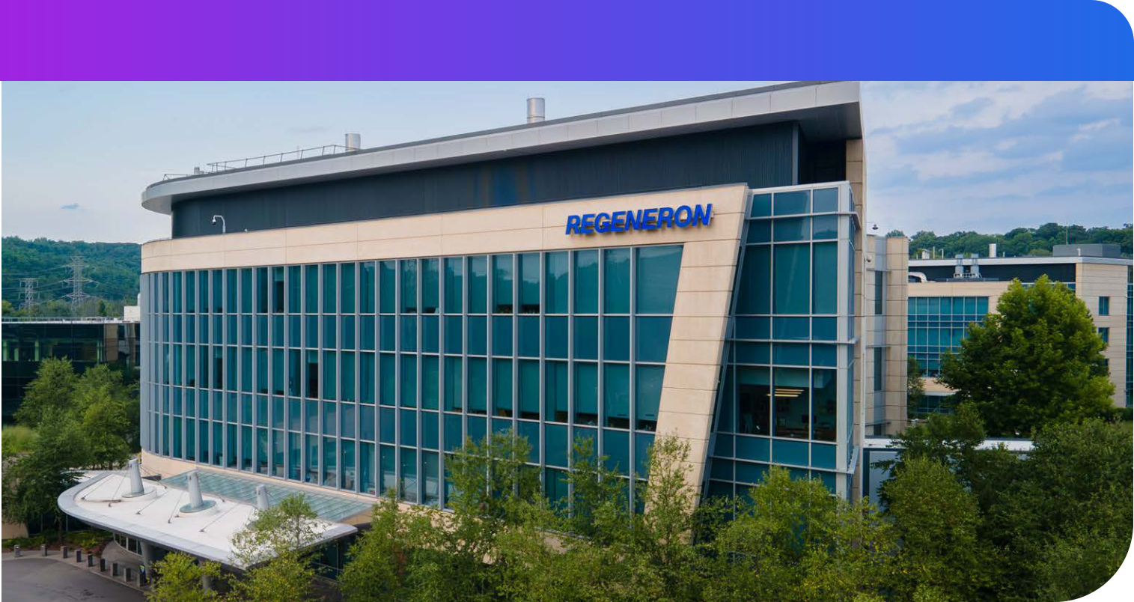

Common Stock and Related Matters

Our Common Stock is traded on The NASDAQ Global Select Market under the symbol “REGN.” Our Class A Stock is not publicly quoted or traded.

Shareholders’ Inquiries

Inquiries relating to stock transfer or lost certificates and notices of changes of address should be directed to our Transfer Agent, Equiniti Trust Company, LLC, 55 Challenger Road, Floor 2, Ridgefield Park, NJ 07660, (800)-937-5449, wwwequiniticom. General information regarding the Company, recent press releases, and filings with the U.S. Securities and Exchange Commission are available on our website at www.regeneron.com, or can be obtained by contacting our Investor Relations Department at (914) 847-7741 or invest@regeneroncom.

Transfer Agent & Registrar | Annual Meeting
Equiniti Trust Company, LLC | The 2026 Annual Meeting of Shareholders will
55 Challenger Road, Floor 2 | be held virtually via the Internet at
Ridgefield Park, NJ 07660 | www virtualshareholdermeeting com/REGN2026
 | on June 12, 2026 at 10:30 a.m., Eastern Time.

Corporate Office

777 Old Saw Mill River Road Tarrytown, New York 10591-6707 (914) 847-7000

Independent Registered Public Accounting Firm

PricewaterhouseCoopers LLP



