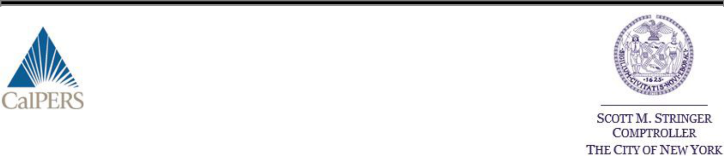

May 19, 2015

Dear Fellow Regeneron Pharmaceutical Inc. Shareowner:

Support Shareowner Proposal #5 Requesting Proxy Access

The California Public Employees Retirement System (CalPERS) and the New York City Pension Funds urge shareowners to vote “FOR” proposal #5 – a non-binding proposal to give shareowners effective access to the director nomination process – at the Regeneron Pharmaceutical Inc. annual meeting on June 12, 2015. Collectively, our funds have $468 billion in assets and are substantial long-term Regeneron Pharmaceutical Inc. shareowners, with approximately 348,062 shares.

Proxy Access a Fundamental Shareowner Right

Providing access to a company’s proxy to permit shareowners the ability to nominate directors to the board is one of the most important rights given to the owners of a company. Without effective proxy access, the director election process simply becomes a ratification of corporate management’s slate of nominees. Therefore, we believe long-term shareowners should have meaningful access to this process on the terms specified in the proposal #5. The proposed thresholds include:

- Beneficial ownership of at least 3 percent of the outstanding stock;

- Three years of continuous ownership; and

- Ability to nominate up to 25 percent of the board.

Proposed Terms Based on Thoughtful SEC Proxy Access Rulemaking in 2010

Before adopting its now vacated proxy access rule in 2010, the SEC undertook careful analysis, both internally and through the public comment process. It was the SEC that determined that a 3 percent ownership threshold was appropriate, stating, “The ownership threshold we are establishing should not expose issuers to excessively frequent and costly election contests conducted through use of Rule 14a11, but it is also not so high as to make use of the rule unduly inaccessible as a practical matter.” The proposed holding period and slate size limitation are also consistent with the SEC rule.

CFA Institute Concludes Proxy Access Would Benefit the Markets and Boardroom

A 2014 report published by the CFA Institute found that giving investors access to the proxy to nominate directors would benefit shareowners and the capital markets.¹ The specific report findings include:

- Proxy access has the potential to enhance board performance and raise US market capitalization by between $3.5 billion and $140.3 billion.
- Proxy access reform will not hinder board performance.

- http://www.cfapubs.org/doi/pdf/10.2469/ccb.v2014.n9.1

- Proxy access is used infrequently and with little disruption in other markets around the world where it is allowed.

US Companies of Varying Sizes Embrace Meaningful Proxy Access

In 2015, a growing number of U.S. companies across industries have agreed to voluntarily adopt proxy access for shareowners that have collectively held 3 percent for 3 years – recent examples include Abercrombie & Fitch, Bank of America, Big Lots, First Merit, General Electric, Kindred Healthcare, Prudential Financial, Splunk, Staples, Wendy’s, Whiting Petroleum, and Yum Brands. These companies are voluntarily adopting the provisions, thereby rejecting the common corporate assertion that proxy access is costly, distracting, and favored mainly by special interest groups.

Support Proxy Access and Director Accountability – Vote “FOR” Shareowner Proposal #5

Proxy access is fundamental to a sustainable system of corporate governance that fosters director accountability and long-term value creation. We believe fully accountable governance structures should be in place to offer shareowners certain protections and a meaningful voice in the boardroom – effective access to the director nomination process does just that. Please vote “FOR” proxy access proposal #5.

Should you have any questions please feel free to contact Todd Mattley, CalPERS Investment Officer and Global Head of Proxy Voting at Todd_Mattley@calpers.ca.gov or 916-795-0565.

Thank you for your support.

Sincerely,
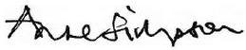

Anne Simpson

Senior Portfolio Manager – Investments
Director of CalPERS Global Governance
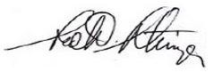

Scott M. Stringer

New York City Comptroller

PLEASE NOTE: The cost of this solicitation is being borne entirely by CalPERS and is being done through the use of the mail and telephone communication. CalPERS is not asking for your proxy card. Please do not send us your proxy card. For additional information, please contact Garland Associates, Inc. at (561) 366-1165

CalPERS Public Employees’ Retirement System Shareowner Alert

