UNITED STATES

SECURITIES AND EXCHANGE COMMISSION
WASHINGTON, D.C. 20549

FORM 8-K

CURRENT REPORT

Pursuant to Section 13 or 15(d) of the

Securities Exchange Act of 1934

Date of Report (Date of earliest event reported): January 8, 2013 (January 8, 2013)

REGENERON PHARMACEUTICALS, INC.

 | (Exact Name of Registrant as Specified in Charter)
New York | 000-19034 |  |  | 13-3444607
(State or other jurisdiction |  | (Commission |  | (IRS Employer
of Incorporation) |  | File No.) |  | Identification No.)
 | 777 Old Saw Mill River Road, Tarrytown, New York 10591-6707
 | (Address of principal executive offices, including zip code)
 | (914) 847-7000
 | (Registrant’s telephone number, including area code)

Check the appropriate box below if the Form 8-K filing is intended to simultaneously satisfy the filing obligation of the registrant under any of the following provisions:

- Written communications pursuant to Rule 425 under the Securities Act (17 CFR 230.425)

- Soliciting material pursuant to Rule 14a-12 under the Exchange Act (17 CFR 240.14a-12)

- Pre-commencement communications pursuant to Rule 14d-2(b) under the Exchange Act (17 CFR 240.14d-2(b))

- Pre-commencement communications pursuant to Rule 13e-4(c) under the Exchange Act (17 CFR 240.13e-4(c))

Item 7.01 Regulation FD Disclosure.

On January 8, 2013, at the J.P. Morgan Healthcare Conference in San Francisco, California, Leonard S. Schleifer, M.D., Ph.D., President and Chief Executive Officer of Regeneron Pharmaceuticals, Inc., is providing a corporate update. A copy of the presentation is furnished as Exhibit 99.1 to this Current Report on Form 8-K.

Item 9.01 Financial Statements and Exhibits.

(d) Exhibits

99.1 Presentation by Leonard S. Schleifer, M.D., Ph.D., President and Chief Executive Officer of Regeneron Pharmaceuticals, Inc., at the J.P. Morgan Healthcare Conference.

SIGNATURES

Pursuant to the requirements of the Securities Exchange Act of 1934, the registrant has duly caused this report to be signed on its behalf by the undersigned hereunto duly authorized.

Date: January 8, 2013 | REGENERON PHARMACEUTICALS, INC.
 | By: | /s/ Joseph J. LaRosa
 | Name: | Joseph J. LaRosa
 | Title: | Senior Vice President, General Counsel and Secretary

 | Exhibit Index
Number |  | Description
99.1 | Presentation by Leonard S. Schleifer, M.D., Ph.D., President and Chief Executive | Officer | of Regeneron Pharmaceuticals, Inc., at the J.P. Morgan Healthcare Conference.


Exhibit 99.1

J.P. Morgan Healthcare Conference January 2013

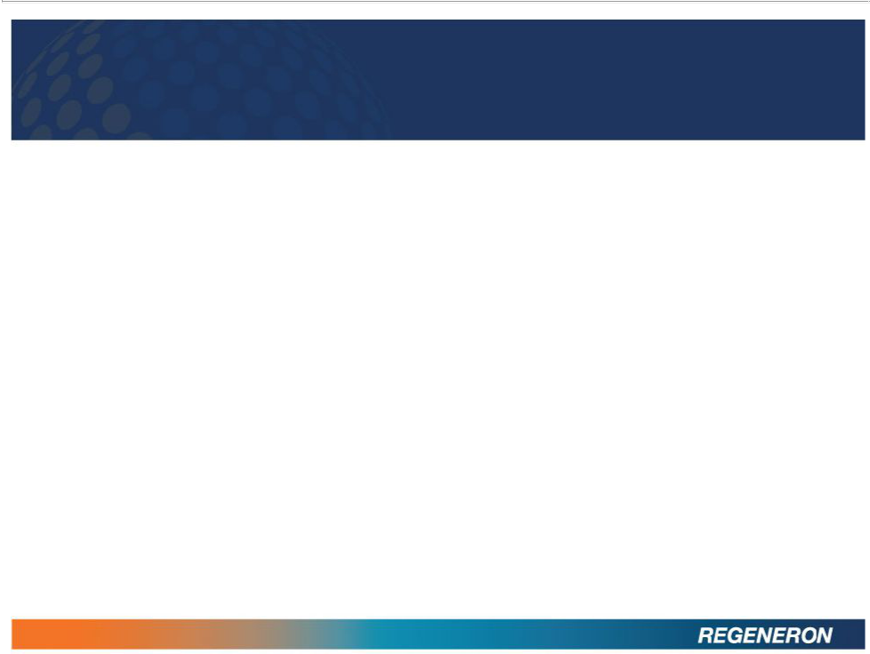
SAFE HARBOR STATEMENT

Except for historical information, the matters contained in this presentation may constitute forward-looking statements that involve risks and uncertainties, including risks

and uncertainties related to product development and clinical trials, unforeseen safety issues resulting from the administration of products and product candidates in patients, uncertainties related to the need for regulatory and other government approvals, government regulations, risks related to third party patents and proprietary technology, litigation, the need for additional capital, uncertainty of market acceptance of Regeneron’s products and product candidates, the ability of the Company to meet any of its sales or other financial projections, the receipt of future payments, the continuation of business partnerships, and additional risks detailed from time to time in Regeneron’s filings with the Securities and Exchange Commission (SEC). Please refer to Regeneron’s Form 10-K for the year ended December 31, 2011 and its Form 10-Q for the quarter ended September 30, 2012 for additional information on these risks and uncertainties and for other information related to our business.

Because forward-looking statements involve risks and uncertainties, actual results may differ materially from current results expected by Regeneron. Regeneron is providing this information as of the original date of this presentation and expressly disclaims any duty to update any information contained in these materials, including without limitation any sales forecasts and any other forward-looking statements.

2

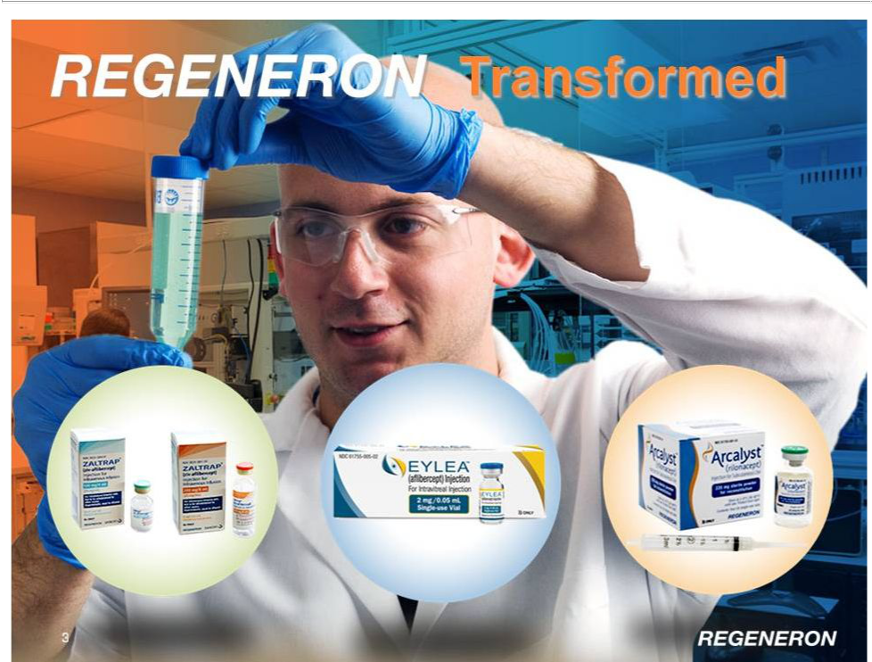

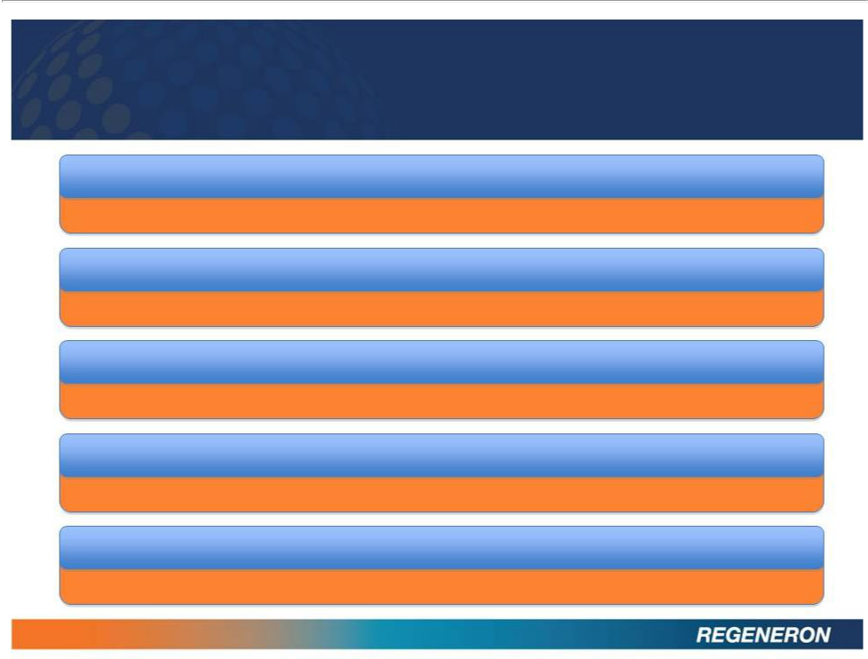
REGENERON TRANSFORMED

EYLEA® LAUNCH HAS EXCEEDED EXPECTATIONS

One of the top 5 biopharmaceutical launches of all time

MULTIPLE REGULATORY APPROVALS

EYLEA US, EU, Japan, Australia, and other countries; ZALTRAP US

FOUR FULL QUARTERS OF PROFITABILITY

GAAP & Non-GAAP

STRONG FINANCIAL POSITION

Year end cash and receivables of ~$1.2B

WORLD’S #1 BIOPHARMACEUTICAL EMPLOYER

Science magazine annual poll; “Biotechnology Company of the Year” by Scrip Intelligence

4

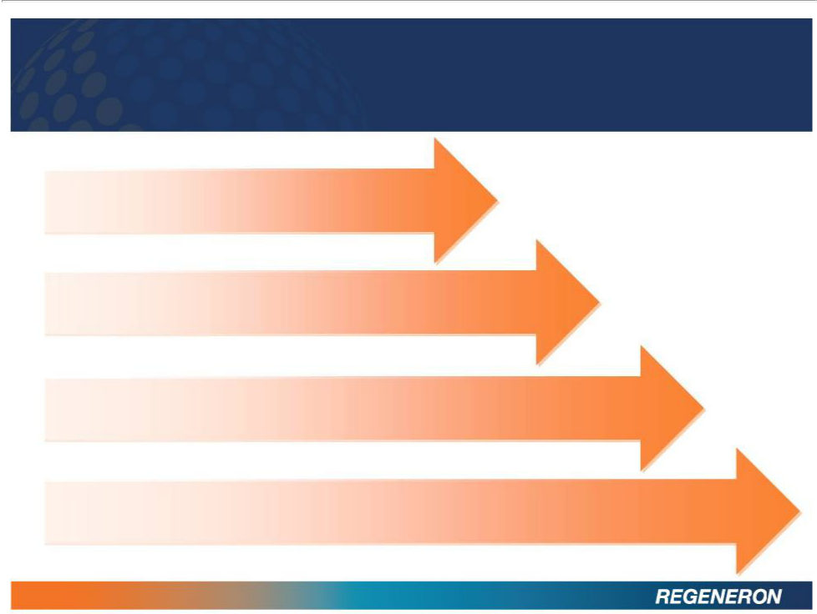
REGENERON LOOKING FORWARD

EYLEA
Increasing market share, expanding

geographies and indications, securing future

ZALTRAP
Global launch; Novel combinations

FINANCIAL
Continuing growth in sales and profits

RESEARCH & DEVELOPMENT
Expanding late stage pipeline with REGN727 (PCSK9), Sarilumab (IL6R), & REGN668 (IL4R) Continuing to invest in early stage pipeline and innovative technologies

5

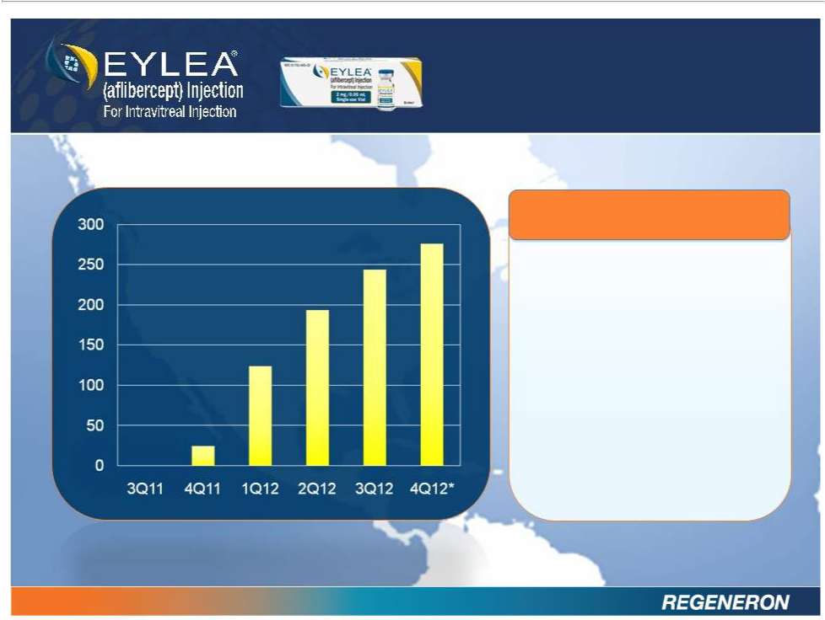
EXCEEDING

EXPECTATIONS

U.S. LAUNCH

EYLEAnet product

sales of $276 million

in 4Q12*

$838 million in full year

2012*

2013 EYLEA U.S. net sales

guidance: ~50% growth

(i.e. ~$1.2B to $1.3B)

* 4Q12 Sales Estimate

6

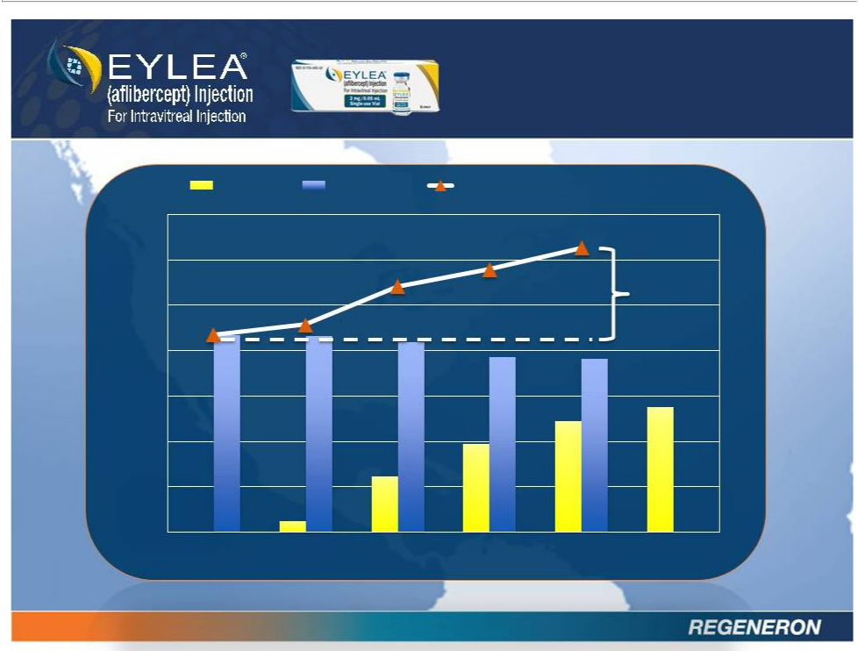

EYLEA Lucentis

700

600

500

400

300

200

100

0

3Q11 4Q11 1Q12

* 4Q12 Sales Estimate

7

EXPANDING BRANDED MARKET

EYLEA & Lucentis Total

+47 %

2Q12 3Q12 4Q12

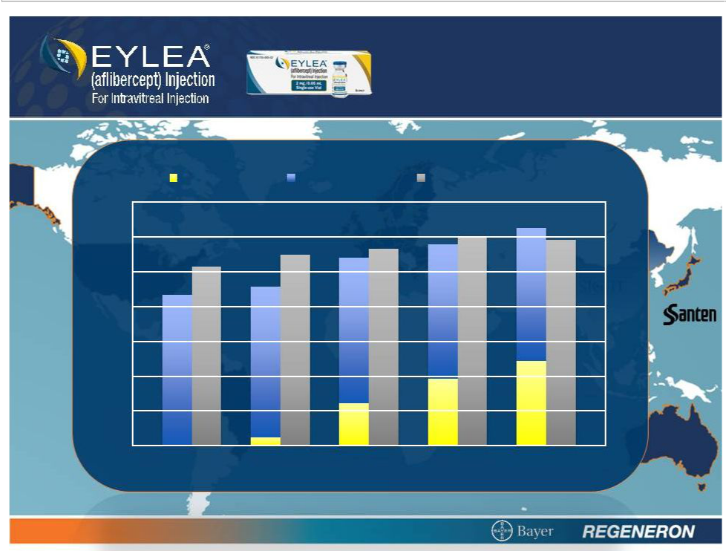
EXPANDING

GEOGRAPHY

US: EYLEA US: Lucentis exUS: Lucentis

700

600

500

400

300

200

100

0
3Q11 4Q11 1Q12 2Q12 3Q12

8

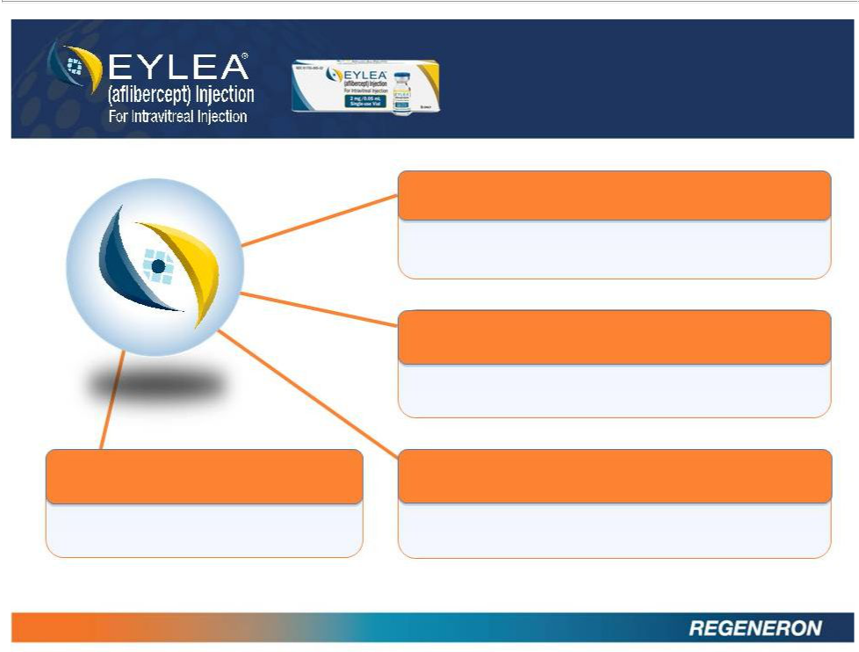
BROADENING

INDICATIONS

Diabetic Macular Edema (DME)

Trials fully enrolled

Branch Retinal Vein Occlusion (BRVO)

Trial enrolling

Myopic CNV

Central Retinal Vein Occlusion (CRVO)

Trial fully enrolled in Asia

Approved in U.S.; Filings globally

9

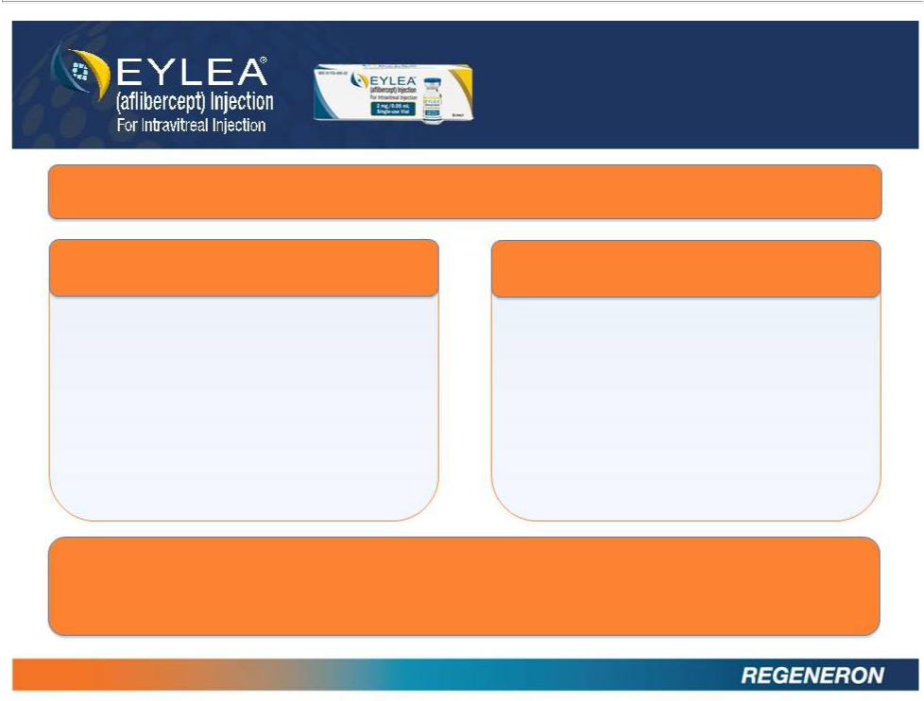
SECURING

THE FUTURE

Novel Targets in Development for Retinal Disease

PDGFR

High affinity, fully-human antibody to PDGFR

Goal to enter clinic with co-formulated product in 2H13

ANG2

High affinity, fully human antibody to ang2

Goal to enter into ophthalmology clinical development in 2013

Novel formulation and delivery of EYLEA as well as evaluation of new technologies

10

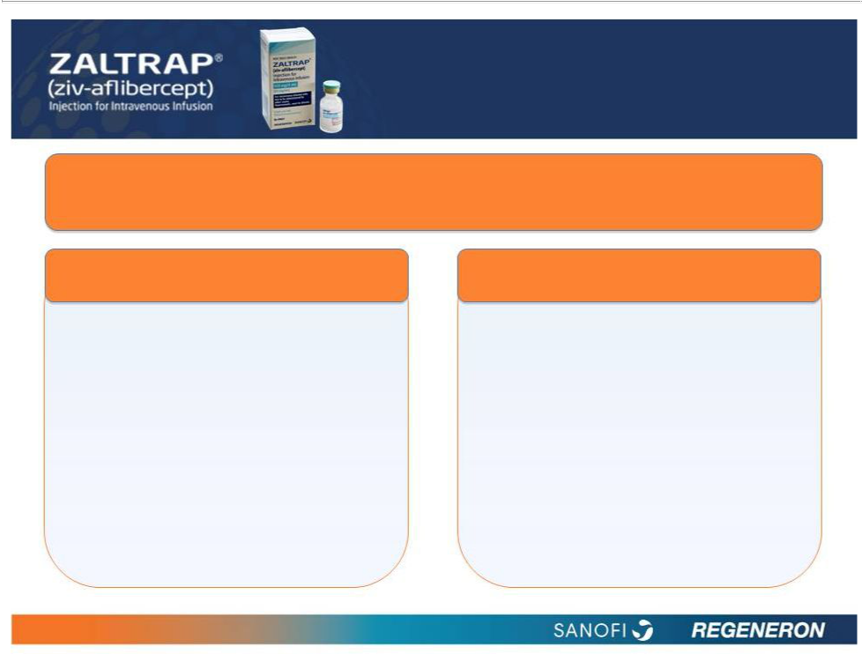
OPPORTUNITIES

IN CANCER

ZALTRAP is the only agent that has demonstrated a statistically significant improvement in overall survival in combination with FOLFIRI versus FOLFIRI alone in patients who progressed on a prior oxaliplatin-containing regimen.

Approved in the US

Approved and launched in U.S.

Discovered by Regeneron and co-developed with Sanofi

Regeneron has worldwide co-commercialization rights

Pending Approval in the EU

Positive recommendation for approval by European CHMP

EU approval expected 1Q13

Regeneron has worldwide co-commercialization rights

11

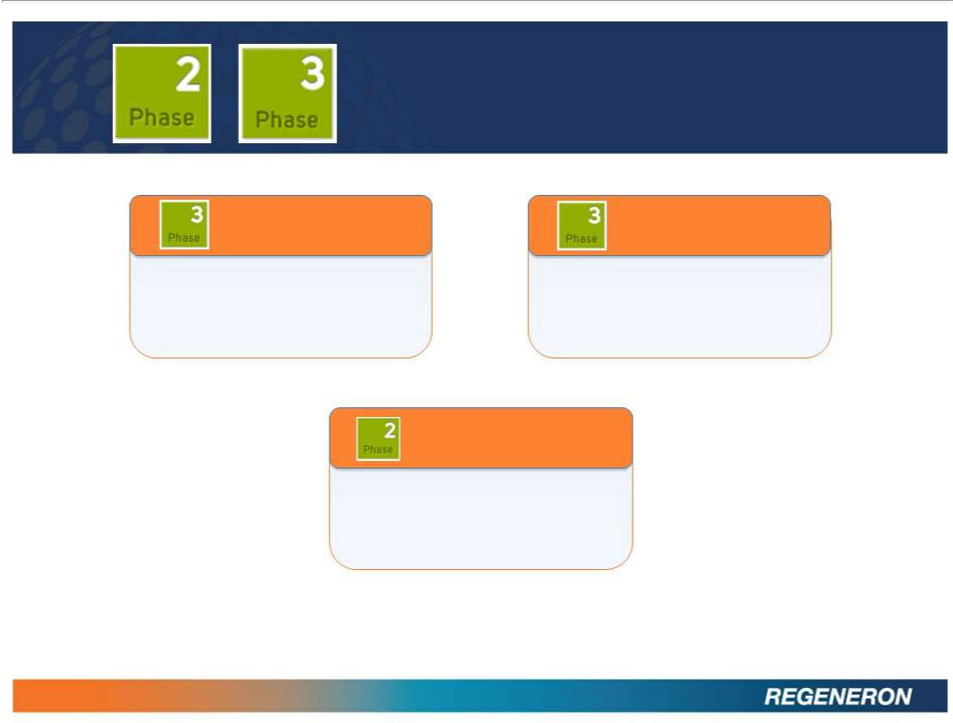
EXPANDING LATE

STAGE PIPELINE

REGN727

Sarilumab

PCSK9 antibody for

elevated cholesterol

IL6R antibody for

rheumatoid arthritis

REGN668

IL4R antibody for Asthma

and Atopic Dermatitis

12

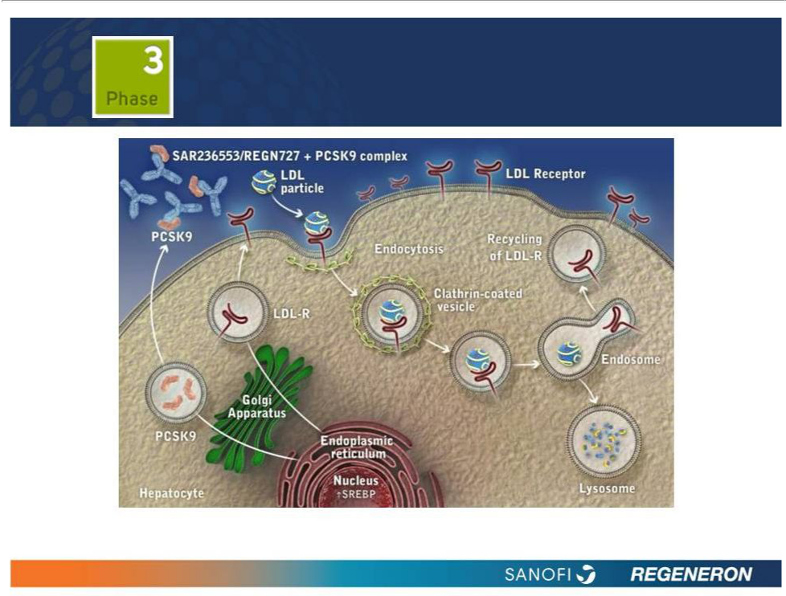
PCSK9: BLOCKING PCSK9 CAN POTENTIALLY LOWER LDL-C LEVELS¹⁻⁵

- Tibolla G et al. Nutr Metab Cardiovasc Dis 2011;21:835-43. (2) Akram ON et al. Arterioscler Thromb Vasc Biol 2010;30:1279-81.

- Duff CJ et al. Expert Opin Ther Targets 2011;15:157-68. (4) Horton JD et al. J Lipid Res 2009;50 Suppl:S172-7. (5) Cariou B et al. Atherosclerosis 2011;216:258-65.

13

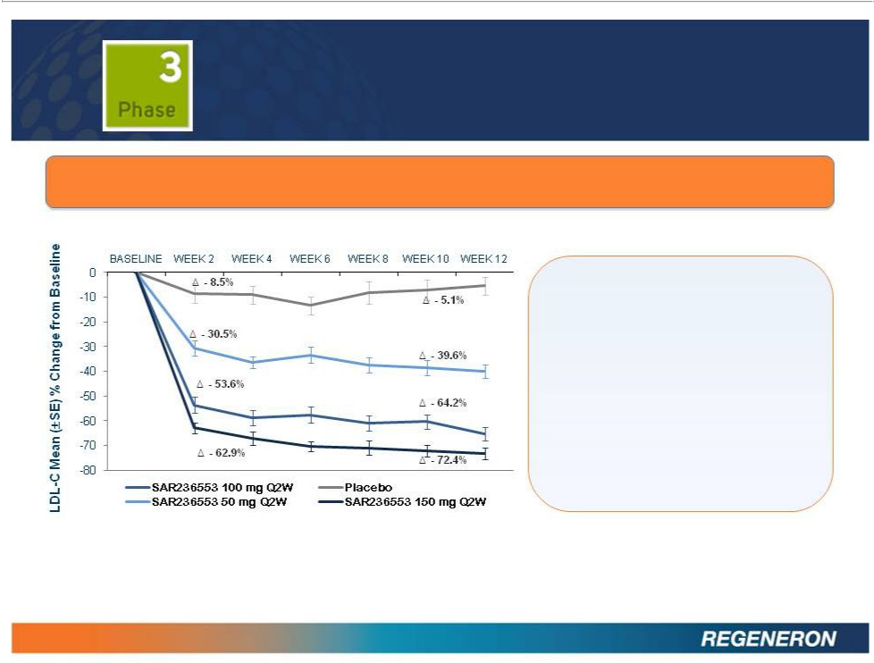
REGN727:

LDL CHOLESTEROL REDUCTION

Change in Calculated LDL-C at Bi-Weekly Intervals from Baseline to Week 12 in Patients With Primary Hypercholesterolemia.

Phase 2 data published in The
Lancet, Journal of the American

College of Cardiology, and NEJM

Significantly reduced mean LDL-C

by 40% to 72% over 8 to 12 weeks
in patients on stable dose of statins

Most common adverse event

was injection site reaction

Mean percentage change in calculated LDL-C from baseline to weeks 2, 4, 6, 8, 10, and 12 in the modified intent-to-treat (mITT) population, by treatment group. Week 12 estimation using LOCF method.

*Data from Phase 2 , dose-ranging study. Patients were on background atorvastatin therapy of 10, 20, or 40 mg.

Decrease in LDL-C shown is at week 12.

14

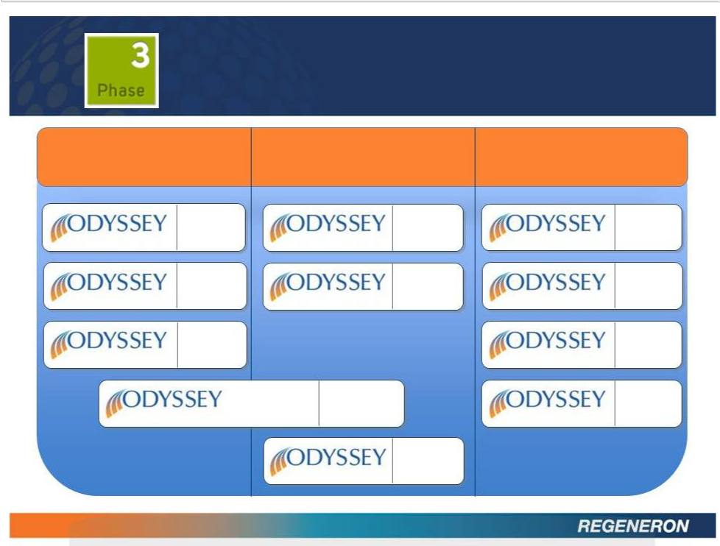
REGN727:

LDL CHOLESTEROL REDUCTION

Heterozygous Familial High Cholesterol at High Additional

Hypercholesterolemia Cardiovascular Risk populations/studies

 | N=471
FH I | 18 months
 | N=250
FH II | 18 months
 | N=105
HIGH FH | 18 months
LONG TERM

15

COMBO I

COMBO II

N=2,100

18 months

OUTCOMES

N=306

12 months

N=660

24 months

N=18,000

(Event

Driven)

 | N=100
MONO | 6 months
 | N=250
ALTERNATIVE | 6 months
 | N=350
OPTIONS I | 6 months
 | N=300
OPTIONS II | 6 months

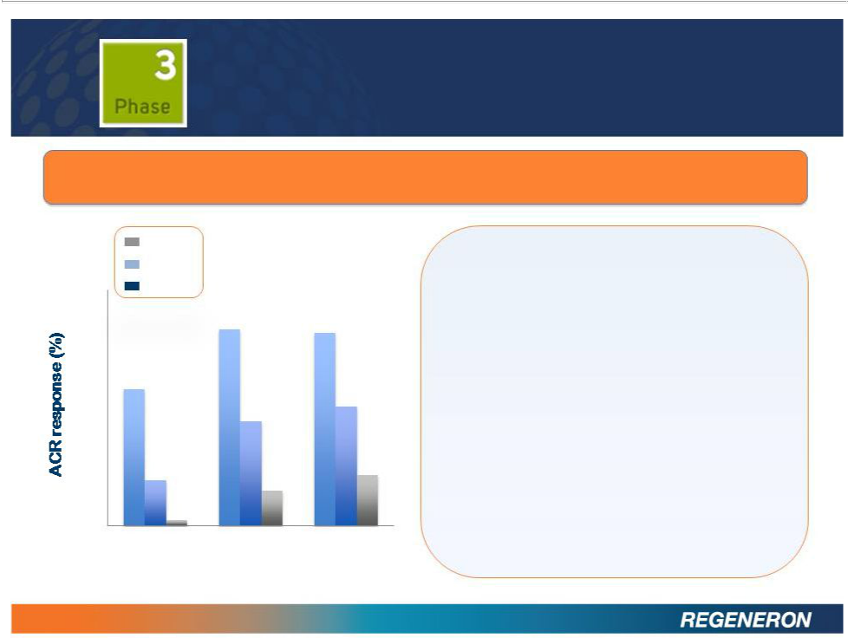
SARILUMAB:

RHEUMATOID ARTHRITIS

Significant improvements in signs and symptoms of moderate-to-severe RA in patients receiving sarilumab in combination with methotrexate in Phase 2 study.

ACR20

ACR50
- ACR70

70

60

- 46.2

40

30

- 15.4

 | Sarilumab is a fully human, high
 | affinity, interleukin-6 receptor (IL-6R)
66.7 | antibody
66.7 | 65.4
 | Positive Phase 2 study in rheumatoid
 | arthritis
 | 40.4
35.3 | Types and incidence of adverse
 | events consistent with those previously
 | reported with IL-6 inhibition
 | 17.3
11.8

10

0

1.9

Phase 3 MOBILITY trial fully enrolled Phase 3 TARGET trial enrolling

Placebo

150 mg q2w 200mg q2w

*p<0.01 versus placebo (only unadjusted p-values

<0.01 are considered statistically significant)

16

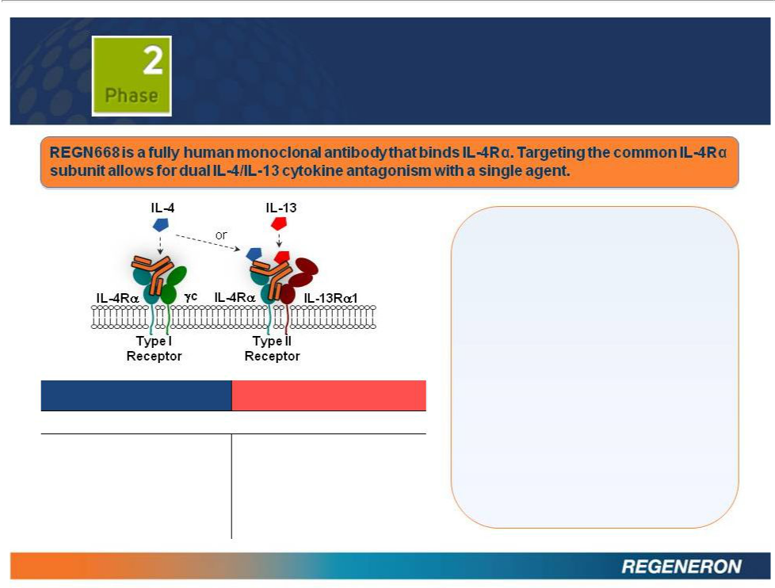
REGN668:

ASTHMA AND ATOPIC DERMATITIS

 | IL-4 |  | IL-13
Dominant (some overlapping) functions in :
• | Initiation and drive of T_{H}2 | • | Airway hyper responsiveness
 | differentiation |  | (AHR)
• Activation and growth of B |  | • | Goblet cell hyperplasia
 | cells | • | Tissue remodeling
• Class switching to IgE and |  | • | Fibrosis
 | IgG1a | • | Regulation of gastrointestinal
• | Recruitment of eosinophils |  | parasite expulsion

17

Positive proof of concept data for atopic dermatitis to be submitted for presentation at a medical conference in 2013

Positive proof of concept data for asthma to be submitted for presentation at a medical conference in 2013

Phase 2b initiation in both indications expected mid-year

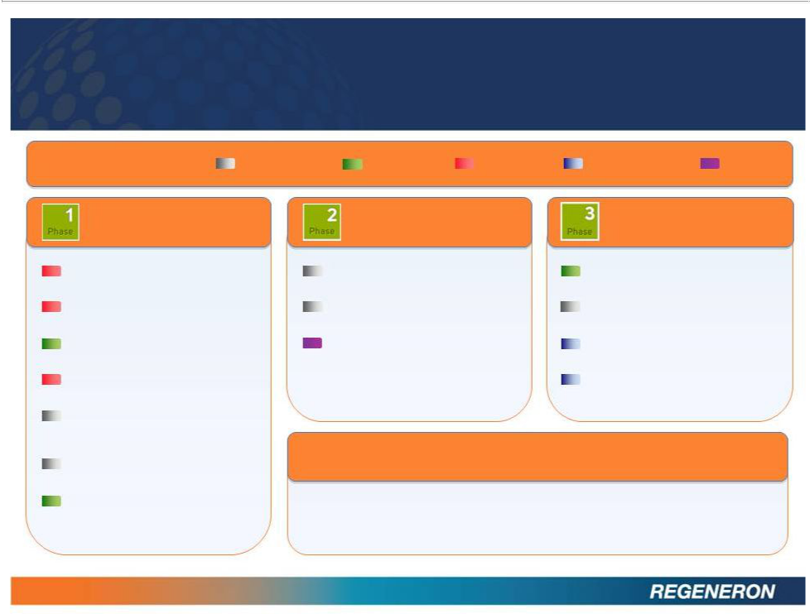
BROAD ANTIBODY PIPELINE

Therapeutic Focus Legend: Inflammation Metabolism Oncology Ophthalmology Pain

Phase 1

REGN421 (DII4 Antibody)

Advanced malignancies

REGN910 (ANG2 Antibody)

Advanced malignancies

REGN1033 (GDF8 Antibody)

Metabolic disorders

REGN1400 (ERBB3 Antibody)

Advanced malignancies

REGN846

(undisclosed target)

Atopic dermatitis

REGN1154
(undisclosed target)

REGN1500
(undisclosed target)

*Remains on clinical hold by the FDA

18

Phase 2 Phase 3

REGN668 (IL-4R Antibody) REGN727 (PCSK9 Antibody)

Eosinophilic asthma LDL cholesterol reduction

REGN668 (IL-4R Antibody) Sarilumab (IL-6R Antibody)

Atopic dermatitis Rheumatoid arthritis

REGN475* (NGF Antibody) EYLEA

Osteoarthritis Diabetic macular edema

EYLEA

Branch Retinal Vein Occlusion

Novel Antibody Technologies in Preclincal Development

Bispecific Antibodies

Long Acting Technologies

Antibody Drug Conjugates

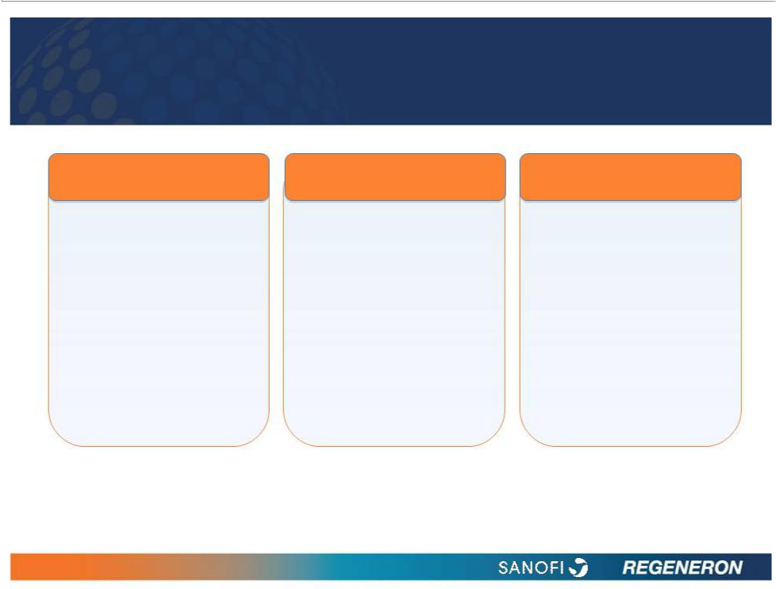
SANOFI ANTIBODY COLLABORATION

Discovery Development

$160 million of annual Sanofi funds
funding through 2017 approximately 100% of
(plus possible clinical development cost*

tail period through 2020)

Current antibodies

include:

• REGN727 (Phase 3)

• Sarilumab (Phase 3)

• REGN668 (Phase 2)

• 3 additional in Phase 1

Commercialization

Regeneron retains 50% of profits in US**

Regeneron retains 35% to 45% of profits ex-US**

Co-promotion rights in US and other major market countries

*100% development funding by Sanofi for all opted-in antibodies except 80% of an antibody’s Phase 3 costs incurred after receipt of the first positive results in a Phase 3 trial for that antibody.

**Regeneron repays Sanofi for 50% of development costs out of profits. Repayment capped in any year at 10% of Regeneron share of total antibody profits

19

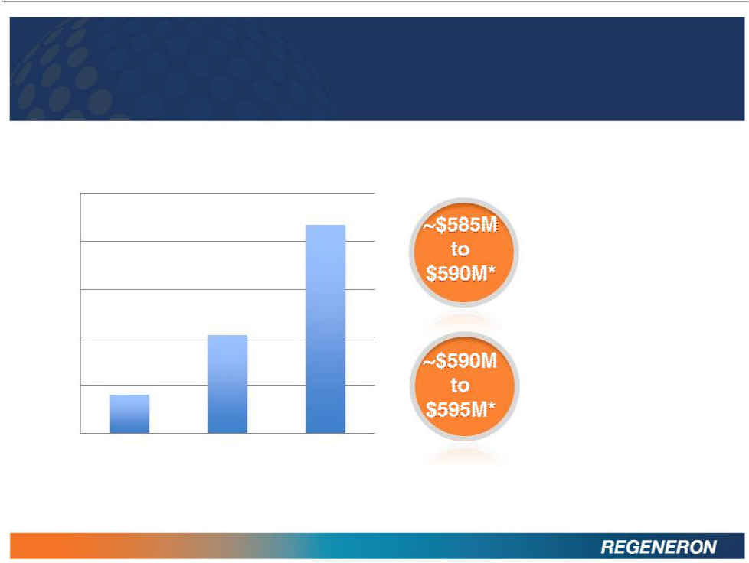
FINANCIALS

Non-GAAP Net Income

$250

$200

$150

$100

$50
$0
1Q12 | 2Q12 | 3Q12

* Unaudited Estimate

20

Year-end 2012

cash and

securities

Year-end 2012

trade receivables

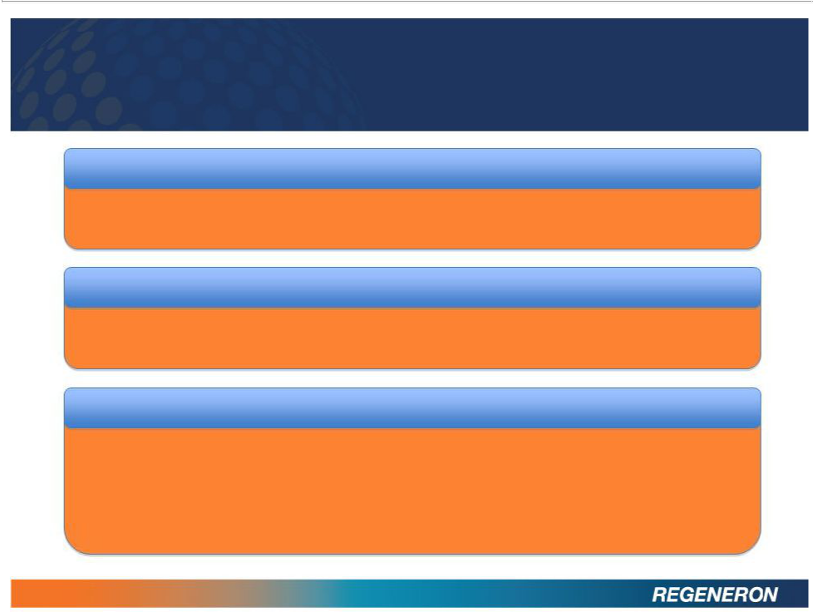
THE YEAR AHEAD

COMMERCIAL MILESTONES

- EYLEA US sales guidance of ~50% growth (i.e. $1.2B to $1.3B)

- EYLEA ex-US launch in multiple additional countries

EXPECTED REGULATORY MILESTONES

- EYLEA approval in CRVO outside the U.S.

- ZALTRAP approval in metastatic colorectal cancer outside the U.S.

EXPECTED CLINICAL MILESTONES

- Top-line 1-year Phase 3 EYLEA results in DME by year end

- REGN668 Phase 1b data in Atopic Dermatitis to be presented at a medical conference

- REGN668 Phase 2a data in Asthma to be presented at a medical conference

- Sarilumab additional Phase 3 trials in RA to start

- Enrollment updates for REGN727 in hypercholesterolemia

21

