UNITED STATES

SECURITIES AND EXCHANGE COMMISSION
WASHINGTON, D.C. 20549

FORM 8-K

CURRENT REPORT

Pursuant to Section 13 or 15(d)
of the Securities Exchange Act of 1934

Date of Report (Date of earliest event reported): October 3, 2013 (October 3, 2013)

REGENERON PHARMACEUTICALS, INC.

 | (Exact Name of Registrant as Specified in Charter)
New York | 000-19034 |  |  | 13-3444607
(State or other jurisdiction |  | (Commission |  | (IRS Employer
of Incorporation) |  | File No.) |  | Identification No.)
 |  | 777 Old Saw Mill River Road,
 |  | Tarrytown, New York 10591-6707
 | (Address of principal executive offices, including zip code)
 | (914) 847-7000
 | (Registrant’s telephone number, including area code)

Check the appropriate box below if the Form 8-K filing is intended to simultaneously satisfy the filing obligation of the registrant under any of the following provisions:

- Written communications pursuant to Rule 425 under the Securities Act (17 CFR 230.425)

- Soliciting material pursuant to Rule 14a-12 under the Exchange Act (17 CFR 240.14a-12)

- Pre-commencement communications pursuant to Rule 14d-2(b) under the Exchange Act (17 CFR 240.14d-2(b))

- Pre-commencement communications pursuant to Rule 13e-4(c) under the Exchange Act (17 CFR 240.13e-4(c))

Item 7.01. Regulation FD Disclosure.

On October 3, 2013, at the 22nd Congress of the European Academy of Dermatology and Venereology held in Istanbul, Turkey, data from a Phase 2 trial evaluating dupilumab, a human monoclonal antibody, in patients with atopic dermatitis were presented at an oral session by Prof. Diamant Thaçi, University of Lübeck, Germany. A copy of the slides that were presented is furnished as Exhibit 99.1 to this Current Report on Form 8-K and is incorporated herein by reference.

Item 9.01. Financial Statements and Exhibits.

- Exhibits.

99.1 Presentation entitled “Safety and efficacy of dupilumab for moderate-to-severe atopic dermatitis in patients using topical corticosteroids (TCS): Greater efficacy observed with combination therapy compared to TCS alone.”

SIGNATURES

Pursuant to the requirements of the Securities Exchange Act of 1934, the registrant has duly caused this report to be signed on its behalf by the undersigned hereunto duly authorized.

Date: October 3, 2013 | REGENERON PHARMACEUTICALS, INC.
 | By: | /s/ Joseph J. LaRosa
 | Name: | Joseph J. LaRosa
 | Title: | Senior Vice President, General Counsel and Secretary

 |  | Exhibit Index
Number |  | Description
99.1 |  | Presentation entitled “Safety and efficacy of dupilumab for moderate-to-severe atopic dermatitis in patients using topical corticosteroids (TCS): Greater efficacy
 |  | observed with combination therapy compared to TCS alone.”


Exhibit 99.1

Safety and efficacy of dupilumab for moderate-to-severe atopic dermatitis in patients using topical corticosteroids (TCS): Greater efficacy observed with combination therapy compared to TCS alone

Diamant Thaçi,¹ Margitta Worm,² Haobo Ren,³ Steven Weinstein,³ Neil Graham,³ Gianluca Pirozzi,4 Franck Skobieranda,4 Marius Ardeleanu³

¹Universität zu Lübeck, Lübeck, Germany; ²Charite-Universitätsmedzin Berlin, Berlin, Germany; ³Regeneron Pharmaceuticals, Inc., Tarrytown, USA; ⁴Sanofi, Bridgewater, USA


Disclosures

D Thaçi is a consultant for Astellas, Novartis, Regeneron, Celgene, Abbott, Pfizer, Janssen-Cilag, MSD, Leo-Pharma

M Worm has nothing to disclose

H Ren, S Weinstein, N Graham, and M Ardeleanu are employees and shareholders of Regeneron

G Pirozzi is an employee and shareholder of Sanofi

F Skobieranda was an employee of Sanofi when the study was conducted

Study (NCT01639040) funded by Regeneron Pharmaceuticals, Inc. and Sanofi


Introduction

Moderate-to-severe atopic dermatitis (AD) is characterized by eczematous dermatitis with intractable pruritus associated with sleep disturbance and lower quality-of-life

For many patients, current therapies are inadequate and can be associated with unwanted side effects

IL-4 and IL-13 are thought to be central to T-helper 2 (Th2) inflammation, which mediates many features of AD

Dupilumab is a fully human monoclonal antibody targeting the IL-4 receptor alpha subunit (IL-4R ), thus blocking the intracellular signaling of both IL-4 and IL-13

Earlier clinical trials indicated that dupilumab monotherapy had an acceptable safety profile and was efficacious in patients with moderate to severe AD who cannot be adequately controlled with topical medications

Since topical corticosteroids (TCS) are commonly used in AD, we assessed the safety and efficacy of dupilumab co-administered with TCS

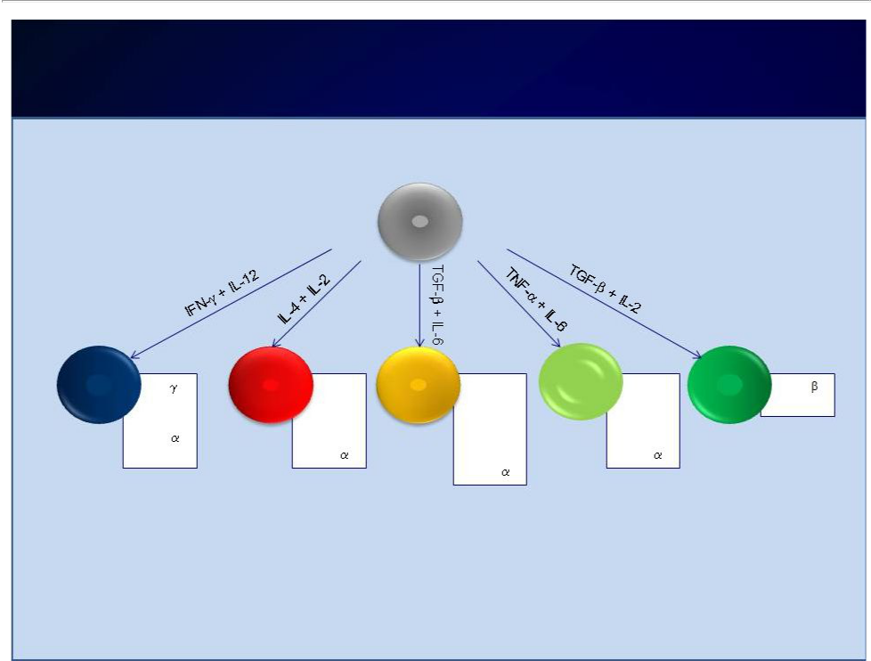
T cells in immune mediated diseases

T naive

Th1 IFN- | Th2 IL-4 |  | Th17 IL-17A |  | Th22 IL-22 |  |  | iTreg TGF-
IL-2 | GATA-3 | IL-5 | RORc2 | IL-17F | ? | IL-13 |  | Foxp3 | IL-10
(IL-10) | GATA-3 | IL-10 | RORc2 | IL-21 | ? | (IL-10) |  | Foxp3
TNF- |  | IL-13 |  | IL-22 |  | FGF´s
LT-a |  | (TNF- ) |  | (IL-10) |  | (TNF- | )
 |  |  |  | (TNF- )
INFLAMMATION | ALLERGY |  | INFLAMMATION, |  | EPITHELIAL |  |  | LIMITATION
INFLAMMATION |  |  | INFECTION |  | INTEGRITY

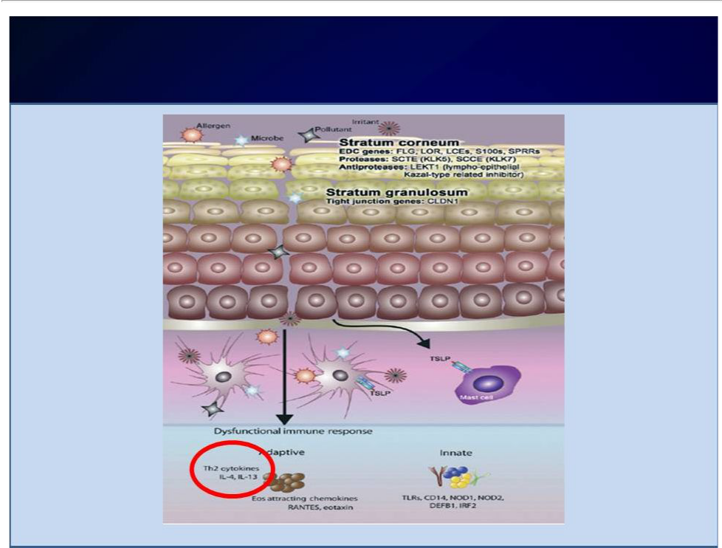
Atopic dermatitis: a disease of altered skin barrier and immune dysregulation

Boguniewicz M, Leung DM. Immunol Rev. 2011 Jul;242(1):233-46.

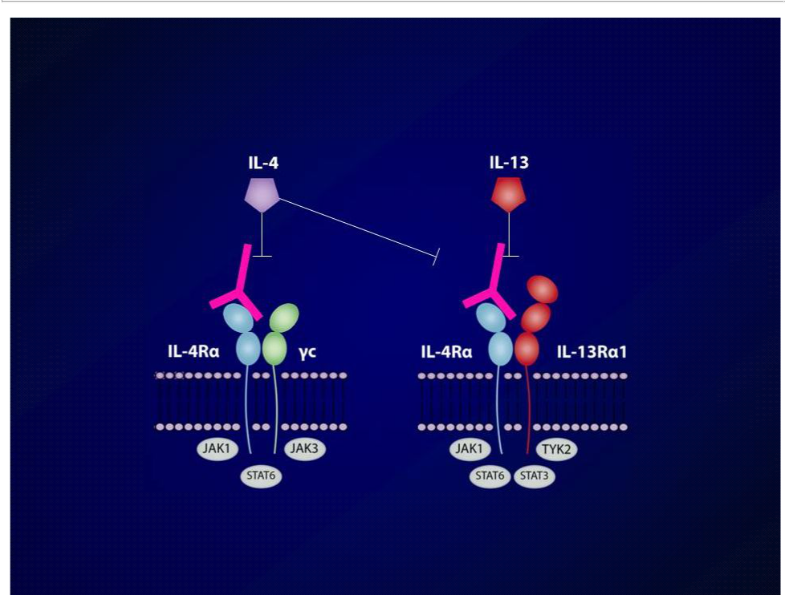
Dupilumab blocks the IL-4/IL-13 receptor/ligand system

Type I Receptor | Type II Receptor
B cells, T cells, Monocytes, | Epithelial cells, Smooth muscle
Eosinophils, Fibroblasts | cells, Fibroblasts, Monocytes,
 | Activated B cells


Randomized, double-blind, parallel-group, placebo-controlled study (NCT01639040) conducted in EU

Screening

Adult

moderate-to-

severe AD

patients

n=31

Study treatment | Safety follow-up
(weekly SC injection for 4 wks) | (7 wks)
All patients received concomitant treatment | Topical treatment of any
with a potent TCS product on a standardized | residual active AD lesions
regimen: daily applications to active lesions, | continues at the discretion of
followed by applications two days per week | the investigator
once lesions were under control

Dupilumab 300 mg + TCS (n=21)

Placebo + TCS (n=10)

Study endpoints:

• Primary endpoint was incidence and severity of adverse events (AEs)

• Exploratory efficacy endpoints included EASI-50, IGA 1, SCORAD score


Key inclusion/exclusion criteria

Inclusion

- Male or female 18 yrs

- Chronic AD > 2 yrs

- IGA 3

- SCORAD > 20

- 10% BSA of AD involvement

- Active AD lesion(s) for which treatment with potent TCS is indicated

Exclusion

- Hypersensitivity to TCS

- 50% of the cumulative lesional surface located on face, flexural, or genital areas (generally unsuitable for treatment with potent TCS)

- Acute or chronic infections

- Recent treatment with immuno-suppressive/immunomodulating drugs

- Significant co-morbidities or lab abnormalities


Baseline demographics

 | Placebo + TCS
 | (n=10)
Mean age, yrs (SD) | 37.8 (16.7)
Race, n (%)
Caucasian | 10 (100%)
Non-Caucasian | 0

Gender, n (%)

Dupilumab SC 300 mg +TCS (n=21)

36.0 (11.3)

- (95.2%)

1 (4.8%)

Male | 5 (50.0%) | 8 (38.1%)
Female | 5 (50.0%) | 13 (61.9%)
Mean BMI, kg/m²
(SD) | 23.92 (3.47) | 25.26 (3.26)


Baseline disease characteristics

 | [mean (SD)]
 |  |  | Dupilumab SC
 | Placebo + TCS |  | 300 mg +TCS
 | (n=10) |  | (n=21)
AD duration, yrs | 32.4 | (16.8) | 30.9 | (13.0)
EASI score (0-72) | 24.10 | (12.70) | 23.12 | (12.35)
IGA score (0-5) | 3.35 (0.47) |  | 3.43 (0.60)
SCORAD score (0-103) | 58.20 | (13.83) | 66.31 | (13.01)
% BSA of AD | 38.85 | (24.05) | 40.43 | (20.91)
Pruritus Numeric Rating
Scale (NRS) score (0-10) | 5.00 (1.40) |  | 6.43 (2.00)

EASI=Eczema Area Severity Index; IGA=Investigator’s Global Assessment; SCORAD=scoring of atopic dermatitis; BSA = baseline body surface area; NRS=numeric rating scale


Treatment emergent adverse events

Total number of AEs

Total number of serious AEs Deaths

Number (%) of patients discontinued from study due to AE

Number (%) of patients with:

Any AE

Any serious AE

Most common AEs ( 5% in dupilumab groups)

Placebo + TCS | Dupilumab + TCS
(n = 10) | (n = 21)
14 | 41
1 | 0
0 | 0
1 (10.0%) | 0
7 (70.0) | 12 (57.1)
1 (10.0) | 0

• Nasopharyngitis | 2 (20.0) | 5 (23.8)
• Headache | 1 (10.0) | 3 (14.3)
• Oropharyngeal pain | 1 (10.0) | 3 (14.3)
• Rhinitis | 0 | 2 (9.5)
• Cough | 0 | 2 (9.5)
• Influenza | 0 | 2 (9.5)
• Somnolence | 0 | 2 (9.5)

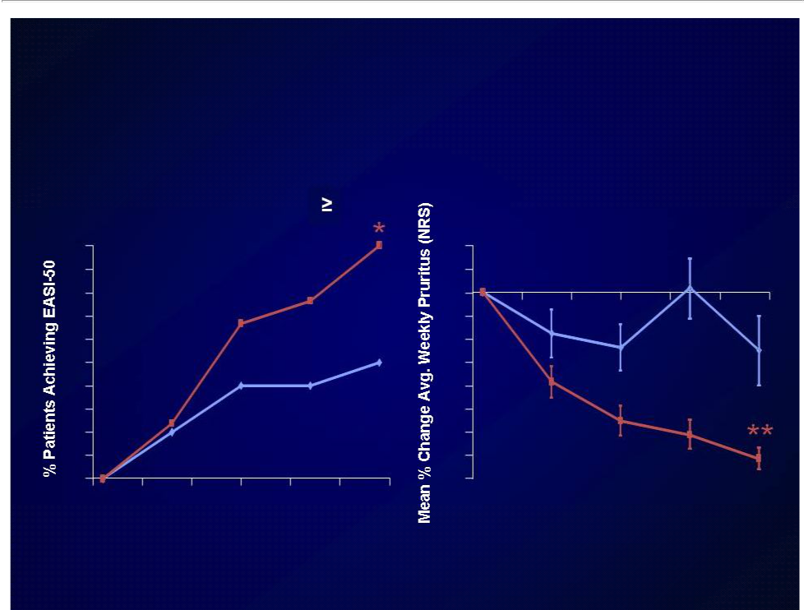
Dupilumab+TCS significantly improved measures of efficacy vs TCS alone

 | EASI-50 Responders |  | Pruritus Numeric Rating Scale
 | (Patients achieving 50%
100 | Reduction in EASI) | 20 | Placebo+TCS
90 | 300 mg DPL+TCS | 10

80 |  |  |  |  |  |  | 0
70 |  |  |  |  |  |  | -10
60 |  |  |  |  |  |  | -20
50 |  |  |  |  |  |  | -30
40 |  |  |  | Placebo+TCS |  |  | -40
30 |  |  |  |  |  |  | -50
20 |  |  |  |  |  |  | -60
10 |  |  |  |  |  |  | -70
0 | 5 | 10 | 15 | 20 | 25 | 30 | -80
0 |  |  |  |  |  |  | 0

Study Day

*p=0.0015
DPL=dupilumab

TCS=topical corticosteroids

300 mg DPL+TCS

5 10 15 20 25 30

Study Day

**p=0.0051

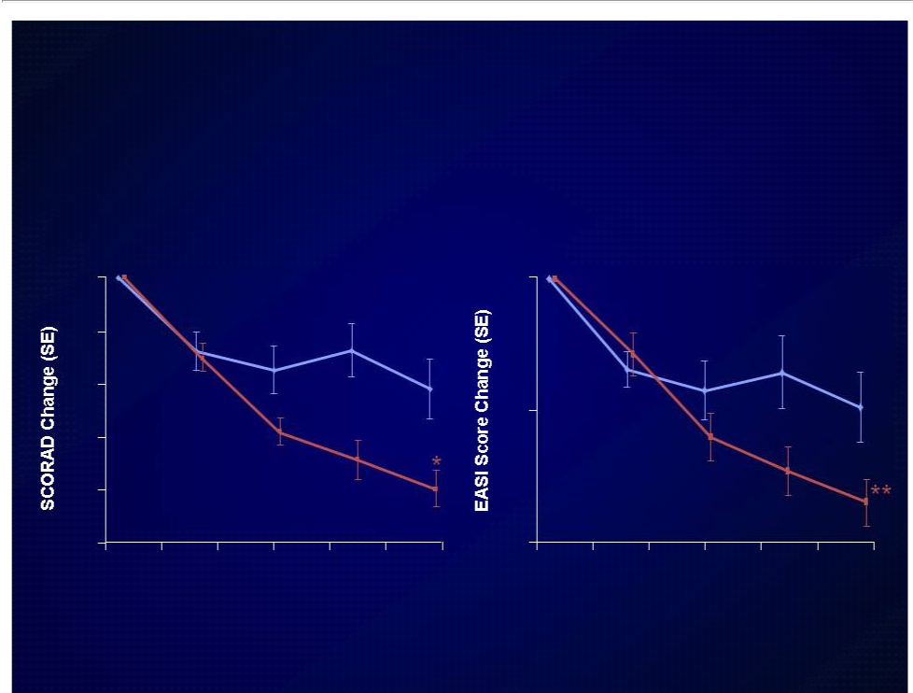
Dupilumab+TCS significantly improved measures of efficacy vs TCS alone

 |  | SCORAD |  |  |  |  |  |  |  | EASI
0 |  |  |  |  |  |  | 0
 |  |  | Placebo+TCS |  |  |  |  |  |  |  | Placebo+TCS
-10
-20
 |  |  |  |  |  |  | -10
-30
-40 |  |  | 300 mg DPL+TCS |  |  |  |  |  | 300 mg DPL+TCS
-50 | 5 | 10 | 15 | 20 | 25 | 30 | -20 | 5 | 10 | 15 | 20 | 25 | 30
0 |  |  |  |  |  |  | 0
 |  |  | Study Day |  |  |  |  |  |  | Study Day
 | *p=0.0191 |  |  |  |  |  |  | **p=0.0042
DPL=dupilumab

TCS=topical corticosteroids

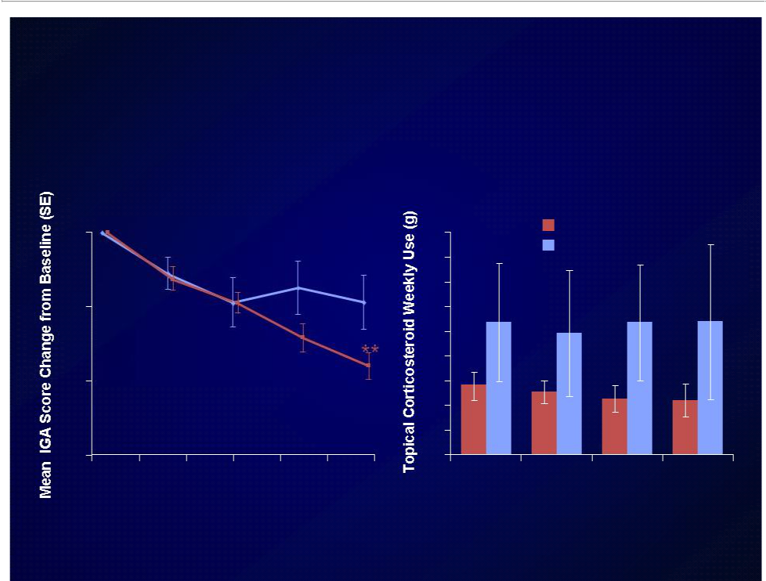
Dupilumab+TCS achieved superior clinical outcomes vs TCS alone

IGA Score TCS Used Weekly (g)

⁰ Placebo+TCS

-1.0
-2.0 |  |  | 300 mg DPL+TCS
-3.0 | 5 | 10 | 15 | 20 | 25 | 30
0

Study Day

**p=0.0281

DPL=dupilumab

TCS=topical corticosteroids

45

40

35

30

25

20

15

10

5

0

300 mg DPL+TCS

Placebo+TCS

*

Wk 1 Wk 2 Wk 3 Wk 4

*p=0.1413


Summary

In this study of adults with moderate-to-severe AD, concomitant treatment with SC dupilumab+TCS exhibited an acceptable safety profile (primary endpoint)

– Most common treatment-emergent AEs were nasopharyngitis (23.8% vs 20% for placebo), headache and oropharyngeal pain (both14.3% vs 10% for placebo)

At 4 weeks, dupilumab+TCS group achieved superior clinical outcomes compared to TCS alone (exploratory efficacy endpoints)

– EASI-50: 100% responder rate for dupilumab +TCS, compared to 50% for placebo+TCS

– Significantly better improvement from baseline in EASI, SCORAD, IGA, and pruritus NRS for dupilumab + TCS vs. Placebo + TCS

Patients on dupilumab + TCS used approximately 50% less TCS during the treatment period compared with patients on placebo + TCS (48.7g vs 99.4g), associated with faster clearing of active AD lesions


Acknowledgements

All participating patients

Investigators

Diamant Thaci | Beate Schwarz | Maris Juszkiewicz-Borowiec
Margitta Worm | Noemi Bakos | Andrzej Kaszuba
Martin Kaatz | Lajos Kemeny | Dorota Bystrzanowska
Rolf Dominicus | Marcin Ambroziak | Athanasios Tsianakas
Beatrice Gerlach | Maria Czubek

Sanofi |  | Regeneron
Jennifer Cairns | Marius Ardeleanu | Tara Coughlan | Melissa Hager | Jacquie Kuritzky
Jeffrey Ming | Elisa Babilonia | Judy Cusick | Jennifer Hamilton | Vicky Lai
Susan Slaytylak-Cheeks | Nancee Basinger | Evelyn Dorsey | Rebecca Indibi | Haobo Ren
 | Warren Brooks | Kristen Dougherty | Richard Kao | Dawn Rich
 | Josh Cantor | Chad Fish | Dan Kropas | Tara Seeliger
 | Linda Williams | Usman Chaudhry



BACK UP

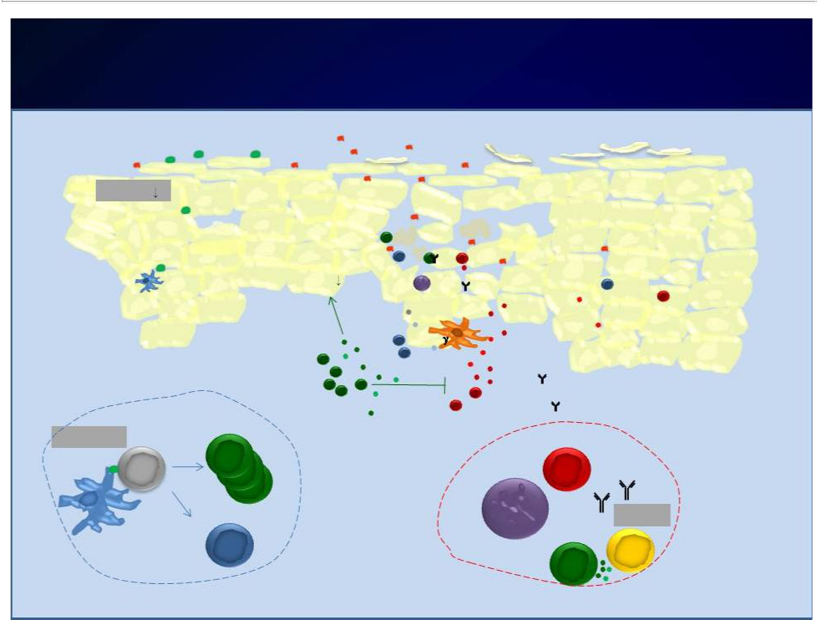
The march of atopic eczema

(Aero)allergen | microbial products/
(Aero)allergen | auto-antigens

filaggrin

acute eczema: allergen-specific

immune response

(Th2, IgE, eosinophils)

filaggrin

IL-13

IL-4

TSLP

Th2

T naive

APC

Th1

local lymph node

chronic eczema: microorganisms,

auto-allergy, remodelling

(Th1, Th2, Th17/Th22)

IFN-^{IDEC}

IL-22

IL-17

Th17

Eosinophil _{IgE}

dermal vessel | B cell
dermal vessel | Th2

