UNITED STATES

SECURITIES AND EXCHANGE COMMISSION
Washington, D.C. 20549

FORM 8-K

CURRENT REPORT

Pursuant to Section 13 or 15(d)
of the Securities Exchange Act of 1934

Date of Report (Date of earliest event reported): January 14, 2014 (January 14, 2014)

REGENERON PHARMACEUTICALS, INC.

(Exact name of registrant as specified in its charter)

New York
(State or other jurisdiction
of incorporation)

000-19034 | 13-3444607
(Commission | (I.R.S. Employer
File Number) | Identification No.)
777 Old Saw Mill River Road, Tarrytown, New York | 10591-6707
(Address of principal executive offices) | (Zip Code)
Registrant’s telephone number, including area code: (914) 847-7000

Check the appropriate box below if the Form 8-K filing is intended to simultaneously satisfy the filing obligation of the registrant under any of the following provisions (see General Instructions A.2. below):

- Written communications pursuant to Rule 425 under the Securities Act (17 CFR 230.425)

- Soliciting material pursuant to Rule 14a-12 under the Exchange Act (17 CFR 240.14a-12)

- Pre-commencement communications pursuant to Rule 14d-2(b) under the Exchange Act (17 CFR 240.14d-2(b))

- Pre-commencement communications pursuant to Rule 13e-4(c) under the Exchange Act (17 CFR 240.13e-4(c))

Item 2.02. Results of Operations and Financial Condition.

On January 14, 2014, at the 32nd Annual J.P. Morgan Healthcare Conference in San Francisco, California, Leonard S. Schleifer, M.D., Ph.D., President and Chief Executive Officer of Regeneron Pharmaceuticals, Inc., is providing a corporate update. Dr. Schleifer’s presentation includes information regarding the Company’s preliminary U.S. net sales of EYLEA® (aflibercept) Injection for the fourth quarter and full year 2013. A copy of the presentation is furnished as Exhibit 99.1 to this Current Report on Form 8-K and is incorporated by reference herein.

Item 9.01. Financial Statements and Exhibits

- Exhibits.

99.1 Presentation by Leonard S. Schleifer, M.D., Ph.D., President and Chief Executive Officer of Regeneron Pharmaceuticals, Inc., at the 32nd Annual J.P. Morgan Healthcare Conference.

SIGNATURES

Pursuant to the requirements of the Securities Exchange Act of 1934, the registrant has duly caused this report to be signed on its behalf by the undersigned thereunto duly authorized.

REGENERON PHARMACEUTICALS, INC.

/s/ Joseph J. LaRosa

Joseph J. LaRosa

Senior Vice President, General Counsel and Secretary

Date: January 14, 2014

 | EXHIBIT INDEX
Number |  | Description
99.1 | Presentation by Leonard S. Schleifer, M.D., Ph.D., President and Chief Executive Officer of Regeneron Pharmaceuticals, Inc., at the 32nd Annual J.P. Morgan
 | Healthcare Conference.
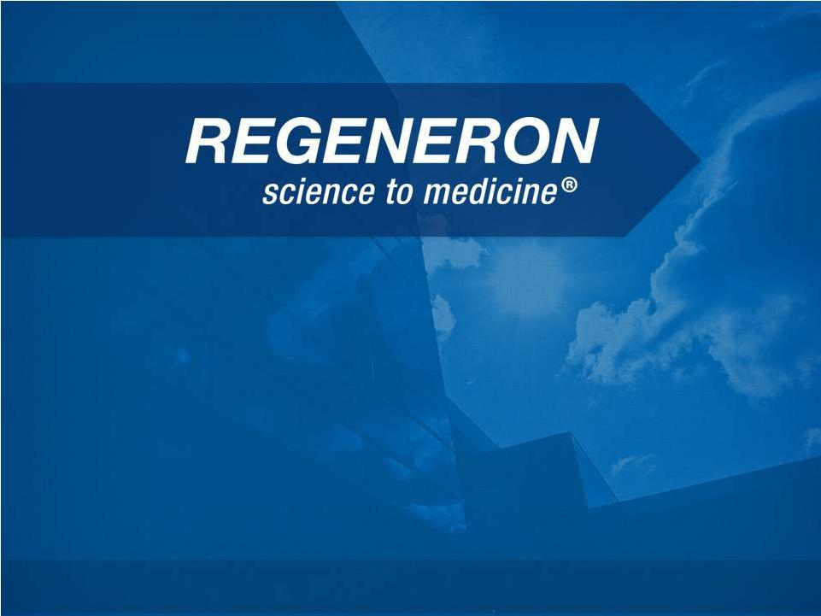
Exhibit 99.1

J.P. Morgan Healthcare Conference

January 2014

Leonard S. Schleifer, M.D., Ph.D.

Chief Executive Officer

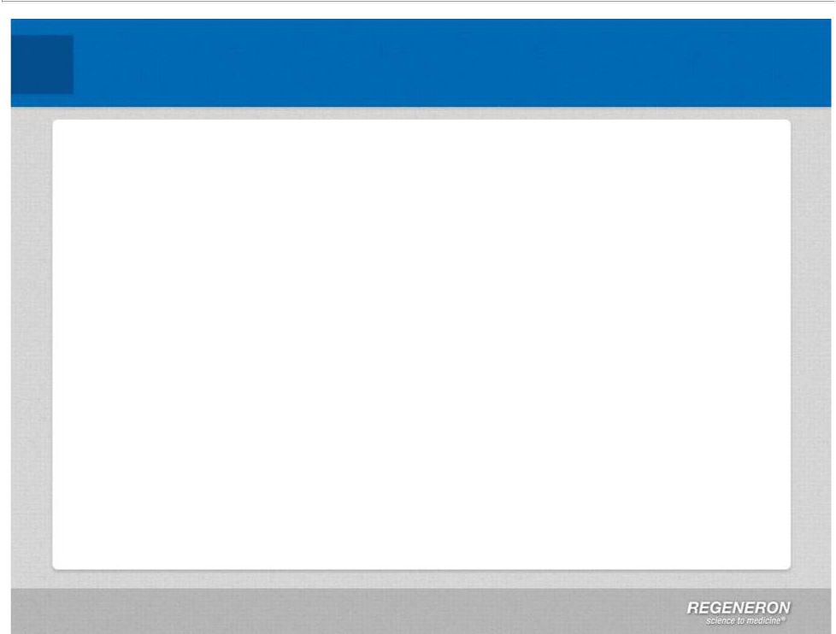
Safe Harbor Statement

This presentation includes forward-looking statements that involve risks and uncertainties relating to future events and the future performance of Regeneron Pharmaceuticals, Inc. (“Regeneron” or the “Company”), and actual events or results may differ materially from these forward-looking statements. Words such as “anticipate,” “expect,” “intend,” “plan,” “believe,” “seek,” “estimate,” variations of such words and similar expressions are intended to identify such forward-looking statements, although not all forward-looking statements contain these identifying words. These statements concern, and these risks and uncertainties include, among others, the nature, timing, and possible success and therapeutic applications of Regeneron's products, product candidates, and research and clinical programs now underway or planned; unforeseen safety issues resulting from the administration of products and product candidates in patients, including serious complications or side effects in connection with the use of Regeneron’s product candidates in clinical trials; the likelihood and timing of possible regulatory approval and commercial launch of Regeneron's late-stage product candidates and new indications for marketed products, including without limitationEYLEA®, Alirocumab, Sarilumab, and Dupilumab; ongoing regulatory obligations and oversight and determinations by regulatory and administrative governmental authorities which may delay or restrict Regeneron's ability to continue to develop or commercialize Regeneron's products and product candidates; competing drugs and product candidates that may be superior to Regeneron's products and product candidates; uncertainty of market acceptance and commercial success of Regeneron's products and product candidates; the ability of Regeneron to manufacture and manage supply chains for multiple products and product candidates; coverage and reimbursement determinations by third-party payers, including Medicare and Medicaid; unanticipated expenses; the costs of developing, producing, and selling products; the ability of Regeneron to meet any of its sales or other financial projections or guidance and changes to the assumptions underlying those projections or guidance, including without limitation those relating to non-GAAP unreimbursed R&D, non-GAAP SG&A and capital expenditures, the potential for any license or collaboration agreement, including Regeneron's agreements with Sanofi and Bayer HealthCare, to be cancelled or terminated without any further product success; and risks associated with third party intellectual property and pending or future litigation relating thereto. A more complete description of these and other material risks can be found in Regeneron's filings with the U.S. Securities and Exchange Commission, including its Form 10-K for the fiscal year ended December 31, 2012 and its Form 10-Q for the quarterly period ended September 30, 2013, in each case including in the sections thereof captioned “Item 1A. Risk Factors.” Any forward-looking statements are made based on management's current beliefs and judgment, and the reader is cautioned not to rely on any forward-looking statements made by Regeneron. Regeneron does not undertake any obligation to update publicly any forward-looking statement, including without limitation any financial projection or guidance, whether as a result of new information, future events, or otherwise.

This presentation uses non-GAAP net income, non-GAAP unreimbursed R&D, and non-GAAP SG&A, which are financial measures that are not calculated in accordance with the U.S. Generally Accepted Accounting Principles (“GAAP”). Regeneron believes that the presentation of these non-GAAP measures is useful to investors because they exclude, as applicable, (i) non-cash share-based compensation expense which fluctuates from period to period based on factors that are not within the Company's control, such as the Company's stock price on the dates share-based grants are issued, (ii) non-cash interest expense related to the Company's convertible senior notes since this is not deemed useful in evaluating the Company's operating performance, (iii) non-cash income tax expense, since the Company does not currently pay, or expect to pay in the near future, significant cash income taxes due primarily to the utilization of net operating loss and tax credit carry-forwards; therefore, non-cash income tax expense is not deemed useful in evaluating the Company's operating performance, and (iv) a non-cash tax benefit as a result of releasing substantially all of the valuation allowance associated with the Company’s deferred tax assets. Non-GAAP unreimbursed R&D represents non-GAAP R&D expenses reduced by R&D expense reimbursements from the Company's collaboration partners. Management uses these non-GAAP measures for planning, budgeting, forecasting, assessing historical performance, and making financial and operational decisions, and also provides forecasts to investors on this basis. However, there are limitations in the use of these and other non-GAAP financial measures as they exclude certain expenses that are recurring in nature. Furthermore, the Company's non-GAAP financial measures may not be comparable with non-GAAP information provided by other companies. Any non-GAAP financial measure presented by Regeneron should be considered supplemental to, and not a substitute for, measures of financial performance prepared in accordance with GAAP. A reconciliation of the Company's GAAP to non-GAAP results is included at the end of this presentation.

Page 2 | Copyright Regeneron 2014

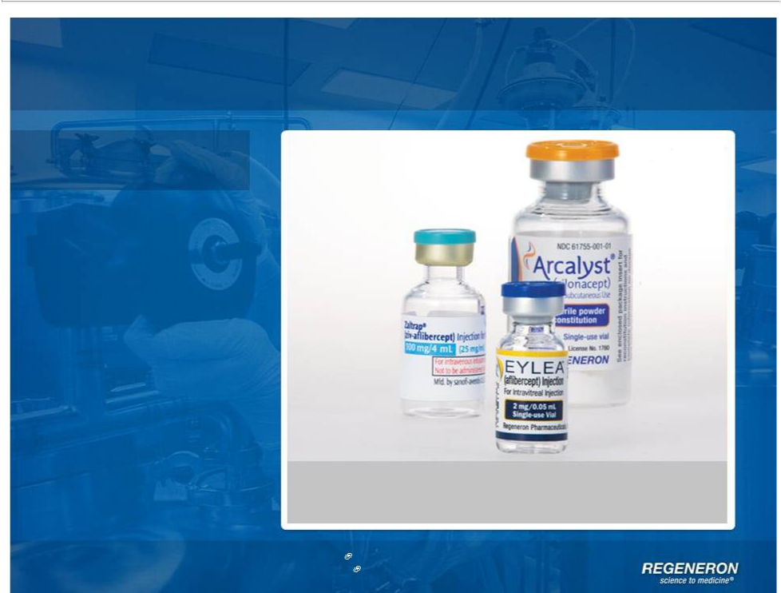
Regeneron Today

Products

Three approved products with sales in 50+ countries around the world*

Page 3 | Copyright Regeneron 2014 | *EYLEA | ex-U.S is partnered with Bayer HealthCare.
Page 3 | Copyright Regeneron 2014 | ZALTRAP | is partnered with Sanofi

Regeneron Today

Products

Pipeline

Phase 1 Phase 2 Phase 3

Alirocumab (REGN727)

PSCK9 Antibody for LDL cholesterol reduction

Sarilumab (REGN88)

IL-6R Antibody for Rheumatoid arthritis

Dupilumab (REGN668)

IL-4R Antibody for asthma, atopic dermatitis, nasal polyposis

Sarilumab (REGN88)

IL-6R Antibody for Non-infectious Uveitis

REGN1033 (GDF8) Antibody for Metabolic disorders

Fasinumab (NGF antibody)

on clinical hold

Enoticumab (REGN421)

DII4 Antibody for Advanced malignancies

Nesvacumab (REGN910)
Ang2 Antibody for Advanced malignancies

REGN1400 (ErbB3) Antibody for Advanced malignancies

REGN1154 (undisclosed target)

REGN1500 (undisclosed target)

REGN1193 (undisclosed target)

REGN1908-1909 (undisclosed target)

REGN2009 (undisclosed target)

Page 4 | Copyright Regeneron 2014

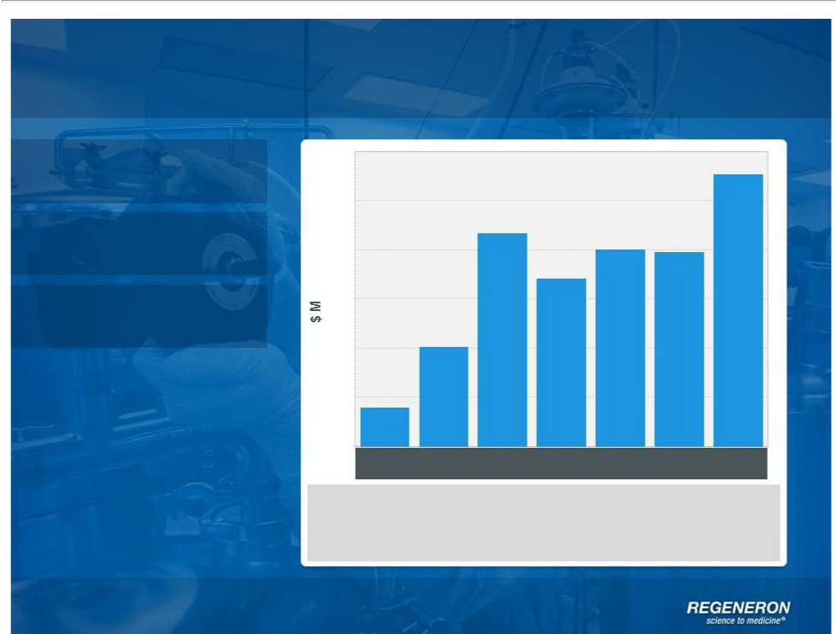
Regeneron Today

Products

Pipeline

Profits

300

Non-GAAP Net Income*

250

200

150

100

50

0

1Q12 2Q12 3Q12 4Q12 1Q13 2Q13 3Q13

$65M in approval milestones received in 3Q12

$20M in upfront payments to Sanofi for rights to PDGF and ANG2 antibodies in 2Q13

$45M in milestonepaymentsfrom Bayer for ex-U.S. EYLEA® in 3Q13

Non-GAAP net income excludes non-cash share-based compensation expense, non-cash interest and non-cash income tax expense See page 38 for GAAP to non-GAAP reconciliation

Page 5 | Copyright Regeneron 2014


Regeneron Today

Products

Pipeline

Profits

Awards

Regeneron named top employer in global biopharmaceutical industry by Science Magazine for second year in a row

Named the best place to work by The Scientist in 2013

CEO and CSO named "Management Team of the Year" by Scrip Intelligence

Dupilumab named “Clinical Advance of the Year” by Scrip Intelligence

Page 6 | Copyright Regeneron 2014

Regeneron Today

Products

Pipeline

Profits

Awards

People

Regeneron named top employer in global biopharmaceutical industry by Science Magazine for second year in a row

Number of employees grew by 20 percent in 2013 to 2,340

In four locations: Tarrytown, NY; Basking Ridge, NJ; Rensselaer, NY; and Limerick, Ireland

Page 7 | Copyright Regeneron 2014

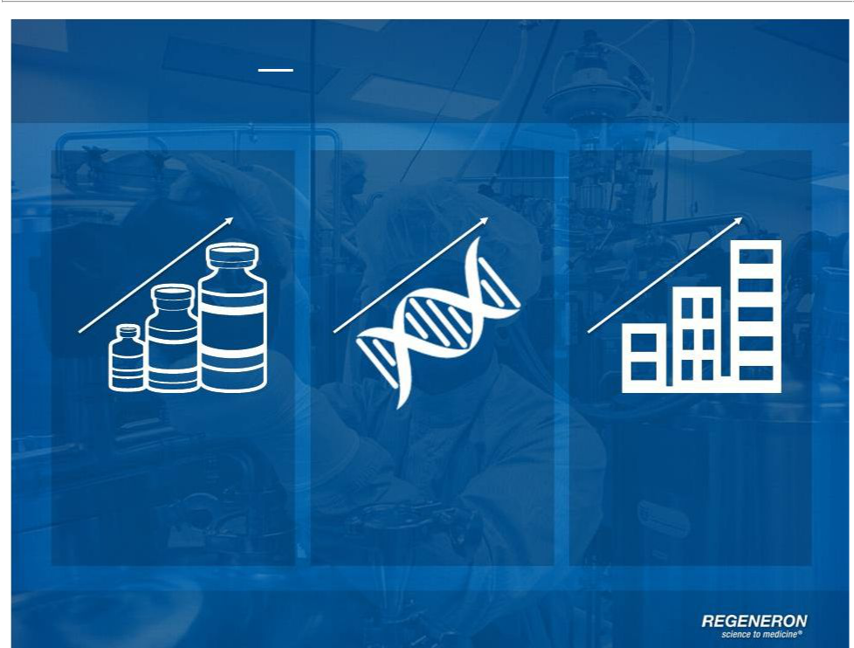
Regeneron Building on Success

Continuing | Investment in | Organic Growth
Top Line Growth | R&D and | Organic Growth
 | Technology

Page 8 | Copyright Regeneron 2014

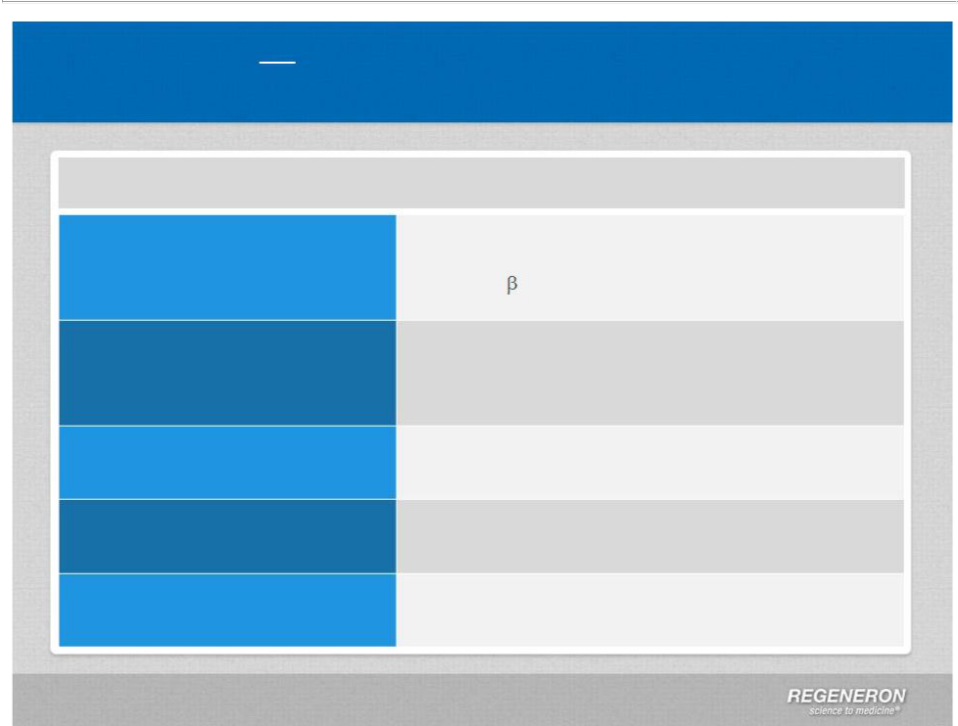
Regeneron Building on Success

Significant News January 2014

What’s New for Regeneron

EYLEA® & Ophthalmology Franchise

Alirocumab

Sarilumab

Dupilumab

Sanofi Collaboration

Early R&D

2014 Financial Guidance

4Q13 and full year 2013 U.S.net sales PDGFR- clinical and business update

Update on data and filing timelines

Amended investor agreement

Regeneron Genetics Center Immuno-Oncology

Non-GAAP SG&A, unreimbursed R&D, and capital expenditures

Page 9 | Copyright Regeneron 2014

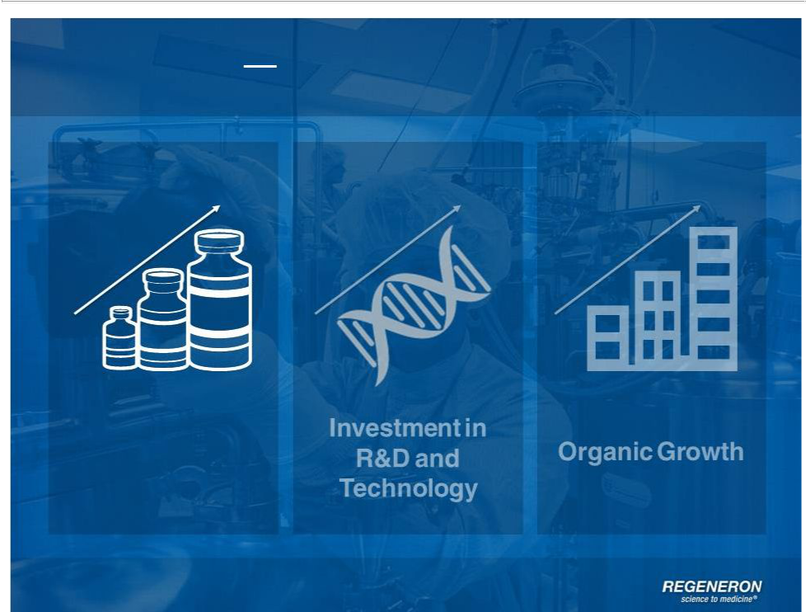
Regeneron Building on Success

Continuing

Top Line Growth

Page 10 | Copyright Regeneron 2014

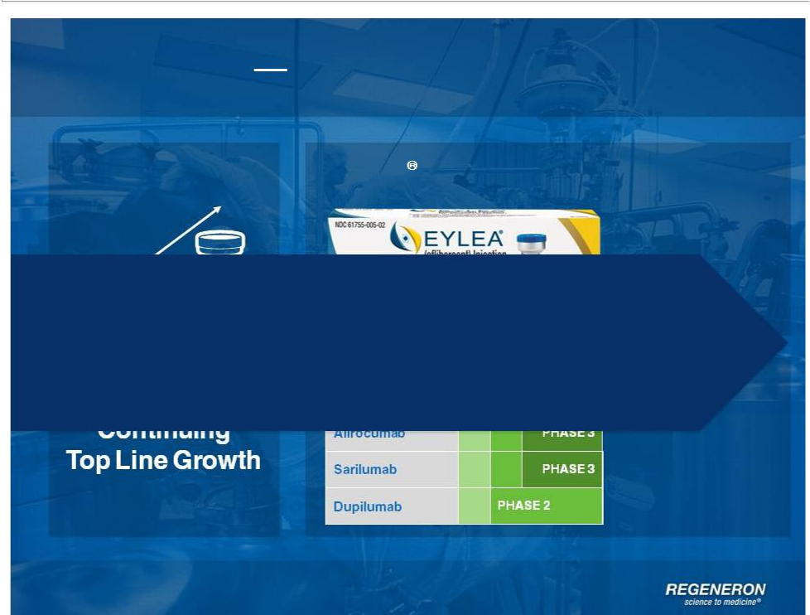
Regeneron Building on Success

EYLEA Franchise

Potential for five major regulatory submissions or approvals in next five years

Page 11 | Copyright Regeneron 2014

EYLEA Franchise

Page 12 | Copyright Regeneron 2014

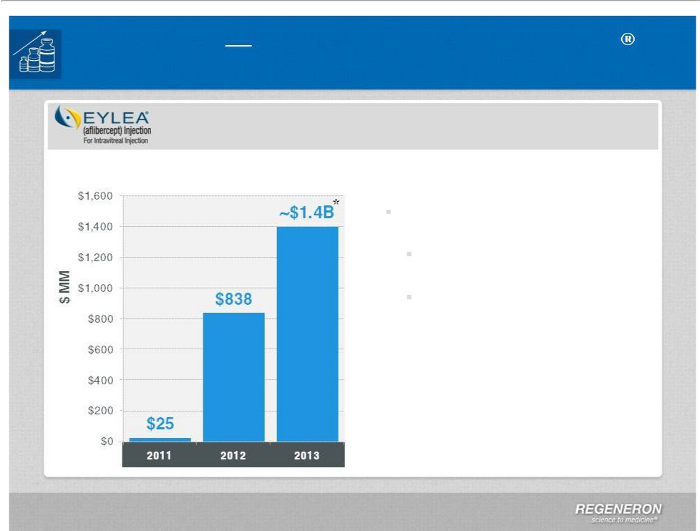
Regeneron Optimize and Extend EYLEA

U.S. EYLEA : Demographics, Market Share, New Indications to Drive Growth

U.S. Net Sales

2013 U.S. Net Sales: ~$1.4 Billion*

4Q13 U.S. Net Sales: ~$400 Million*

- Distributor inventory increased to slightly more than two weeks

Inventory has historically been

1-2 weeks

Commercial terms tightened in

January 2014

Full year guidance during 4Q13 call

DME: PDUFA date of August 18, 2014

BRVO regulatory filing expected in
1Q14

Impact of compounding legislation

uncertain

*Preliminary unaudited numbers DME : Diabetic Macular Edema

BRVO : Branch Retinal vein Occlusion

Page 13 | Copyright Regeneron 2014

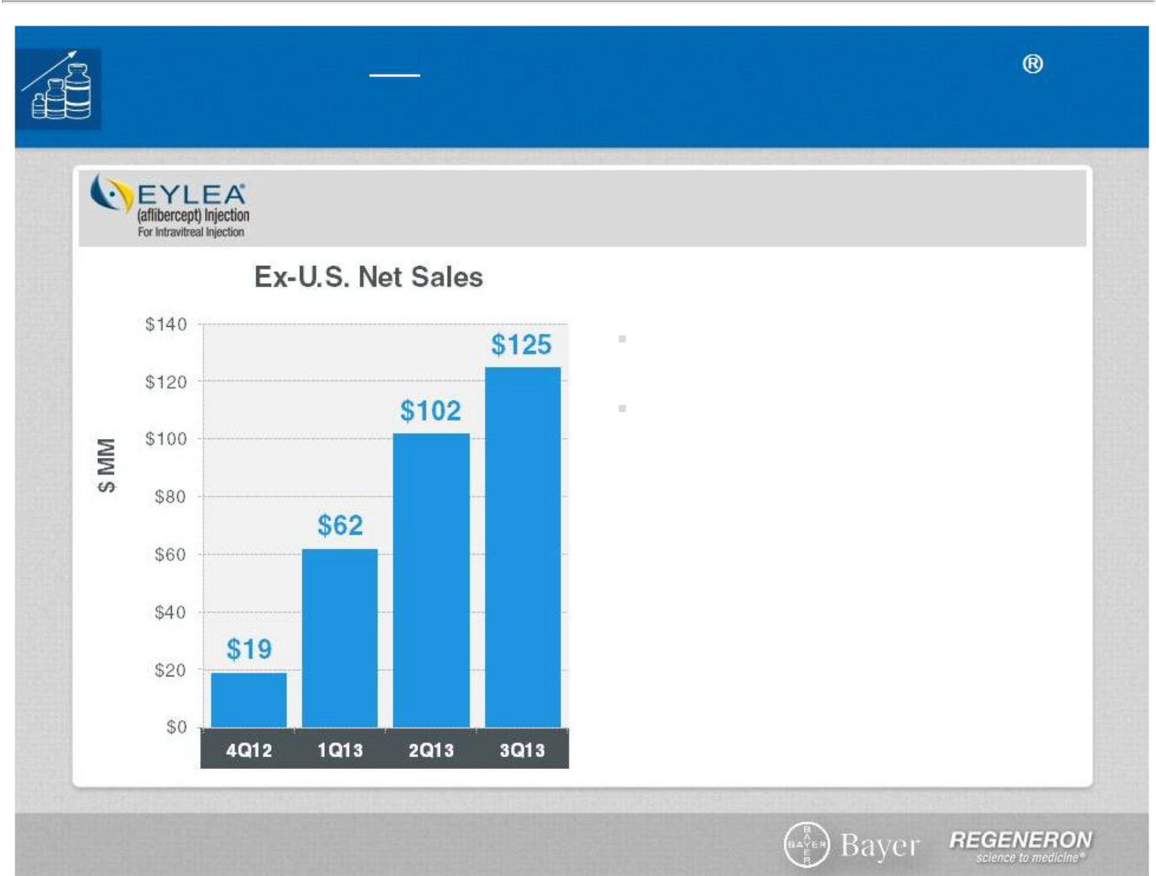
Regeneron Optimize and Extend EYLEA

Ex-U.S. EYLEA: Launch is Still in Early Innings

Ex-U.S. launch by partner, Bayer

HealthCare, continues to do well

In wet-AMD, 40%-50% market share in

Australia, Japan and Germany

Approved for macular edema following

CRVO in EU and Japan

Ex-U.S. sales contributing to bottom line

DME submitted in EU

Myopic CNV filed in Japan

Global macular edema following BRVO

submission expected in 2014

DME : Diabetic Macular Edema

AMD: Age-related macular degeneration

CRVO : Central Retinal Vein Occlusion

BRVO : Branch Retinal vein Occlusion

CNV : Choroidal Neovascularization

Page 14 | Copyright Regeneron 2014

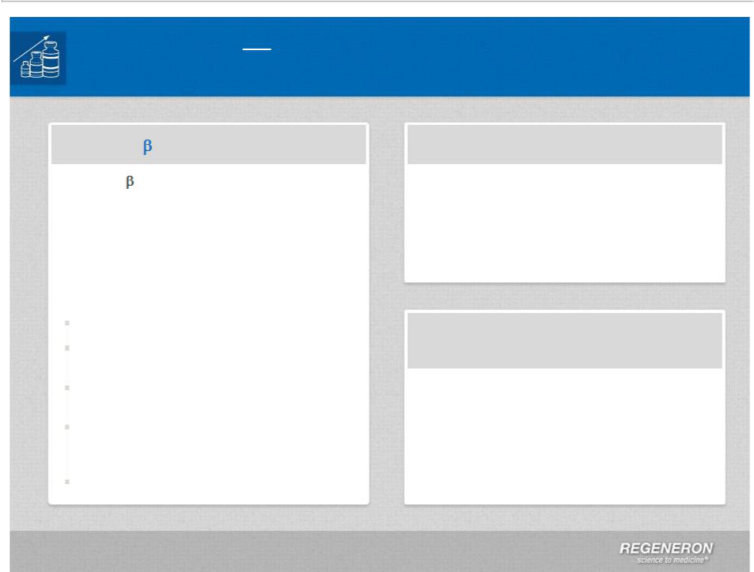
Regeneron Optimize and Extend EYLEA

Protecting the Long Term Value of The Retina Franchise

PDGFR-

PDGFR- /EYLEA® co-formulation IND submitted in December 2013

First patient enrolled in Phase 1 expected in 1Q14

Regeneron owns 100% commercial rights in U.S.

Bayer collaborating outside the U.S.

$25.5M upfront

$40M in option and milestone payments

Bayer/REGN share global development expenses

Bayer responsible for certain third party royalties and share of milestones

Companies share profits equally

ANG2

Intravitreal co-formulation with EYLEA® : IND expected to be submitted in 2014

Ophthalmology Research

Commitment to remain a leader in retinal diseases

Investment in internal research and external collaborations

Page 15 | Copyright Regeneron 2014



Late Stage Pipeline

Page 16 | Copyright Regeneron 2014

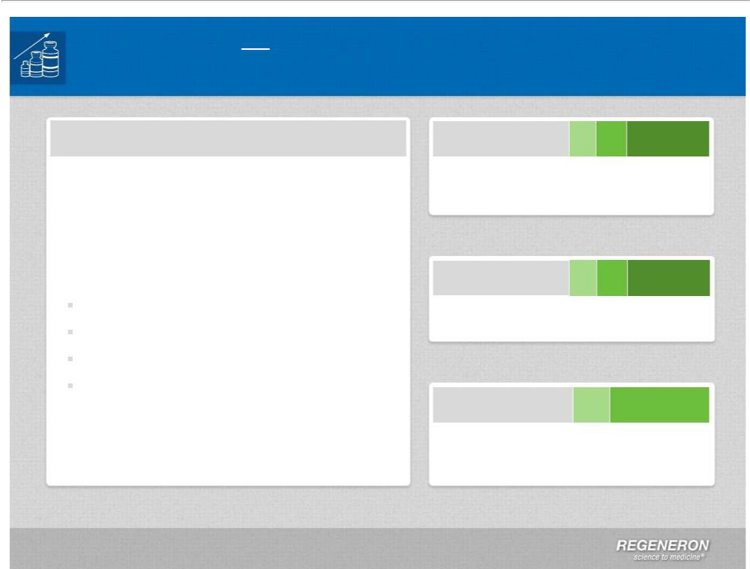
Regeneron Advance Late Stage Pipeline

Late Stage Pipeline Expected to Drive Continued Top-Line Growth

Three Late Stage Programs

All three programs—alirocumab, sarilumab and dupilumab—are part of Sanofi collaboration

Two programs with positive Phase 3 data in 2013: alirocumab & sarilumab

Potential for four major regulatory submissions or approvals in next five years*:

Alirocumab for LDL lowering

Sarilumab for rheumatoid arthritis

Dupilumab for atopic dermatitis Dupilumab for asthma

- Including EYLEA® for DME, five major regulatory submissions or approvals in next five years

Alirocumab PHASE 3

PCSK9 antibody for elevated cholesterol

Sarilumab PHASE 3

IL6R antibody for rheumatoid arthritis

Dupilumab PHASE 2

IL4R antibody for asthma, atopic dermatitis and nasal polyposis

Page 17 | Copyright Regeneron 2014

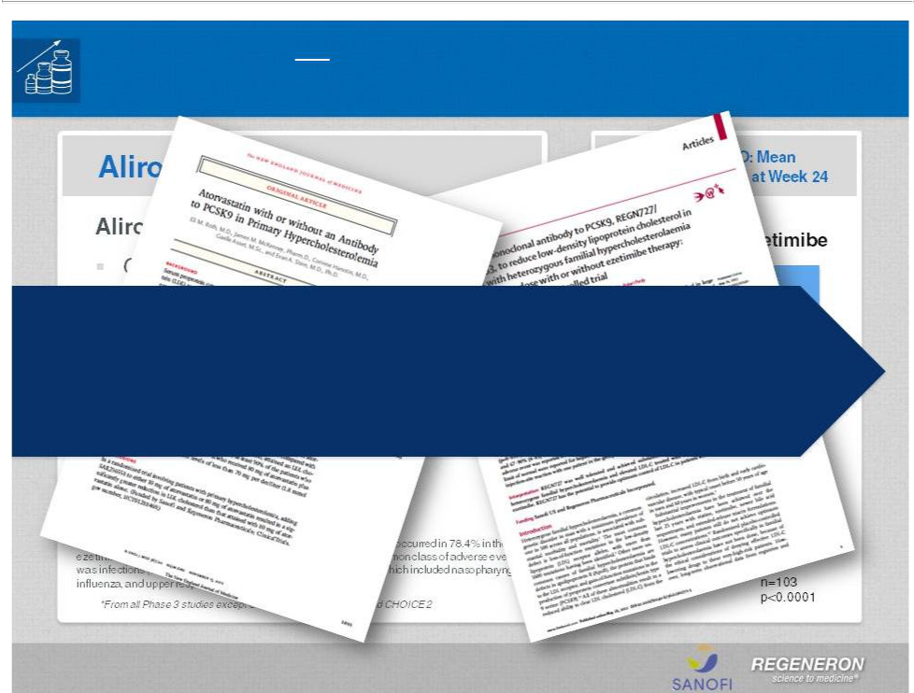
Regeneron Alirocumab

Advancing Late Stage Opportunities

Positive data from the alirocumab clinical trials have been published in peer-reviewed journals such as the New England Journal of Medicine and The Lancet

Page 18 | Copyright Regeneron 2014

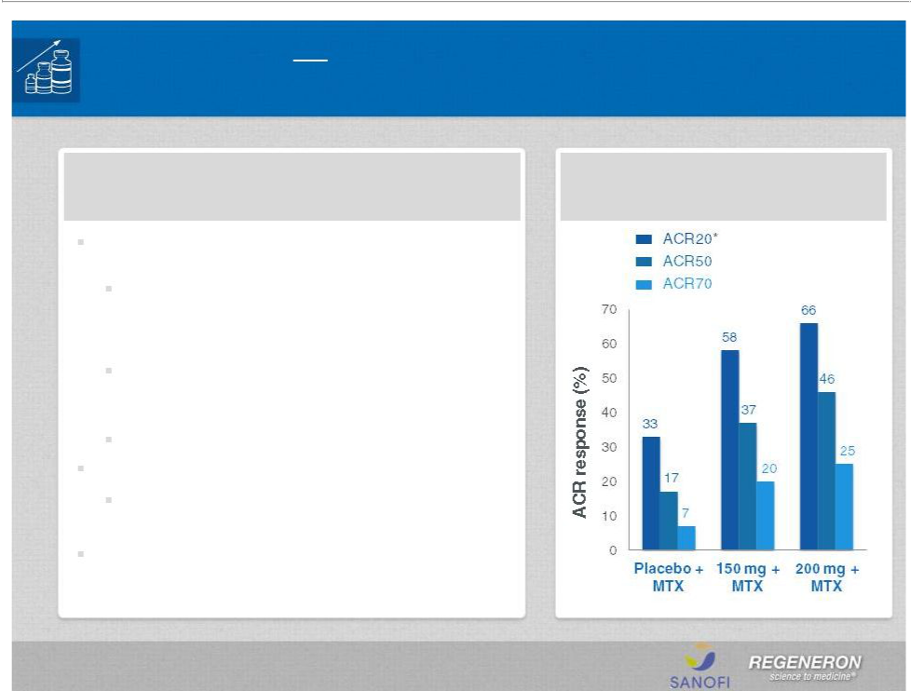
Regeneron Sarilumab

Advancing Late Stage Opportunities

Sarilumab for Rheumatoid Arthritis

Positive Phase 3 data from MOBILITY (N=1,200)

reported 4Q13

Both sarilumab dose groups—150 mg and 200 mg—given subcutaneously, every other week, in combination with methotrexate (MTX) achieved all three co-primary endpoints

Patients receiving 200 mg + MTX showed a 90% reduction in radiographic progression (mTSS) at week 52

Data to be presented at a medical conference Additional Phase 3 data expected in 2015

Ongoing Phase 3 studies are: COMPARE, TARGET, ASCERTAIN, EXTEND

Regulatory submission expected in 2015

Infections were the most frequently reported adverse events and were reported with a higher incidence in the sarilumab groups vs. placebo, all in combination with MTX (39.6% for 200 mg, 40.1% for the 150 mg group and 31.1% for pbo). The incidence of serious infections was 4.0% in the 200 mg + MTX group, 2.6% in the 150 mg + MTX group, and 2.3% in the placebo + MTX group..

Page 19 | Copyright Regeneron 2014

MOBILITY: ACR responses at 24 weeks

*primary endpoint, p<0.0001 vs. pbo

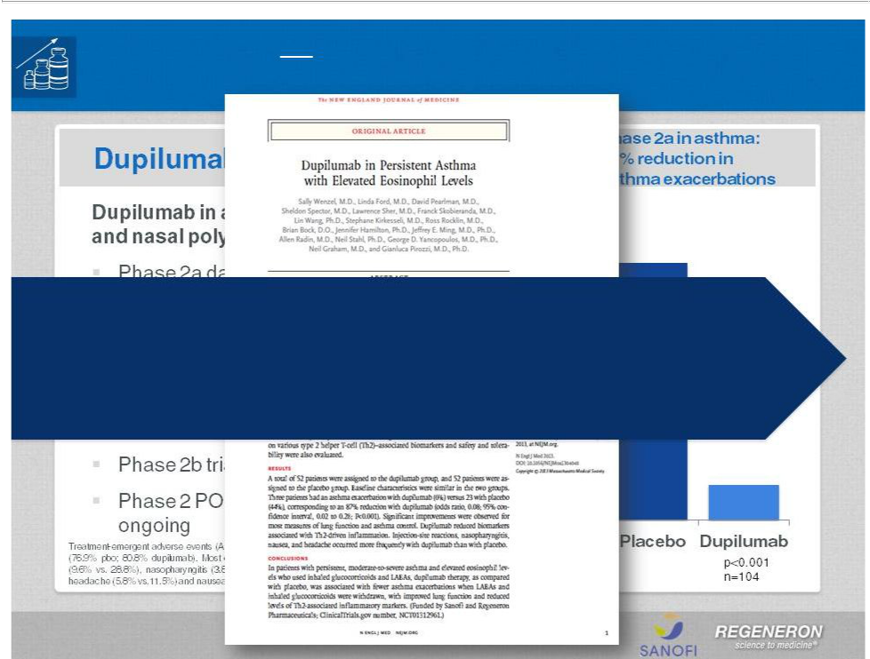
Regeneron Dupilumab

Advancing Late Stage Opportunities

Positive data from the dupilumab asthma clinical trial have been published in the New England Journal of Medicine

Page 20 | Copyright Regeneron 2014

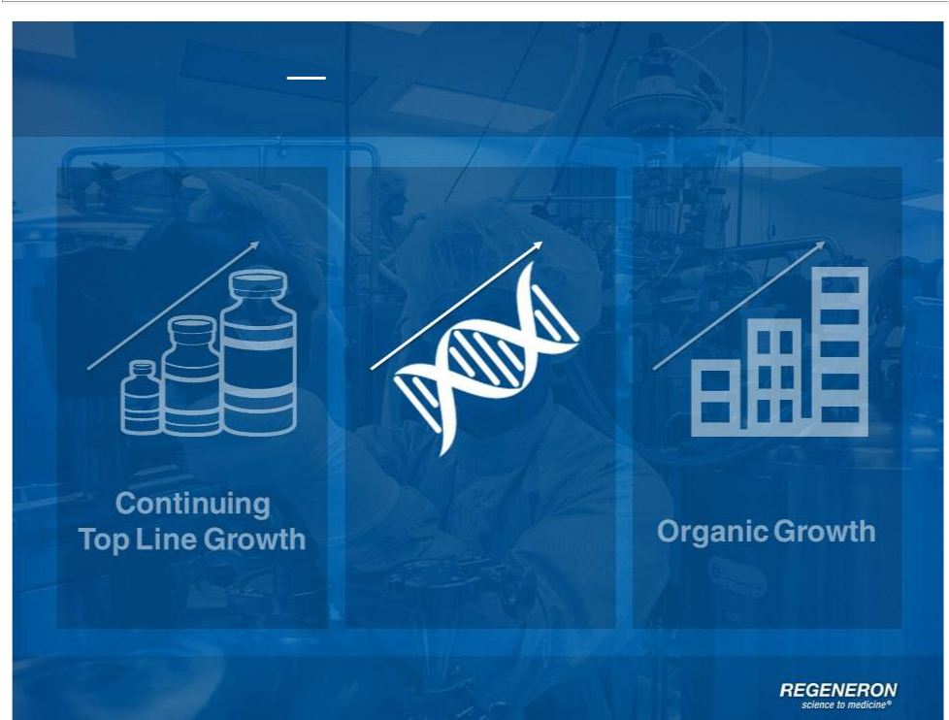
Regeneron Building on Success

Investment in

R&D and

Technology

Page 21 | Copyright Regeneron 2014

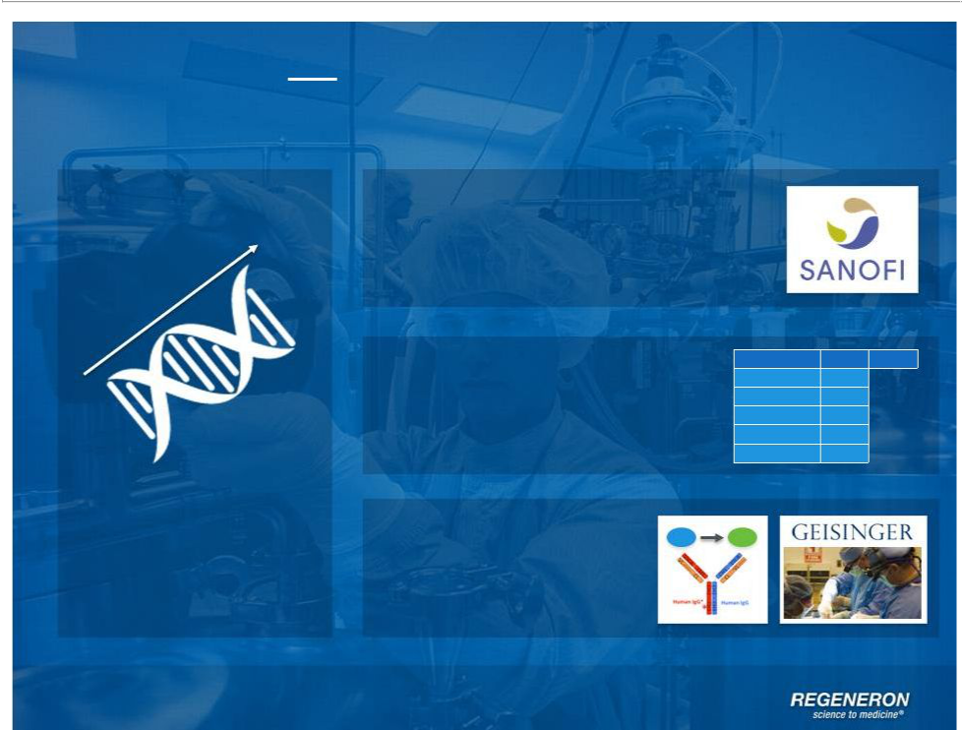
Regeneron Building on Success

Sanofi Collaboration

Wholly-Owned

Pipeline of Products

Investment in
R&D and | Innovative Research
Technology | & Technologies

Page 22 | Copyright Regeneron 2014

Fasinumab* Phase 2

REGN1400 Phase 1

REGN1154 Phase 1

REGN1500 Phase 1

REGN1193 Phase 1

REGN1908-1909 Phase 1

Sanofi Collaboration

Page 23 | Copyright Regeneron 2014

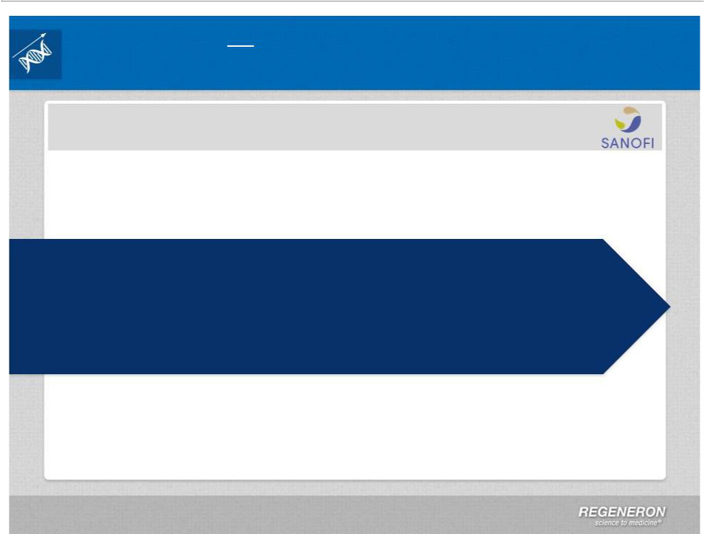
Regeneron Sanofi Collaboration

Sanofi Antibody Collaboration Continues to Provide R&D Leverage

Sanofi Collaboration

Discovery | Development | Commercialization
$160 million of annual funding | Sanofi funds approximately 100% | Regeneron retains
through 2017 (plus possible | of clinical development cost | 50% of profits in US*
tail period through 2020) | REGN funds 20% of Phase 3 | Regeneron retains 35% to 45%
 | costs for an antibody following | 45% of profits ex-US*

 | first positive Phase 3 data for
Ownership / Investor Agreement
 | that antibody | Co-promotion rights
 | that antibody | in US and other major market
• | Sanofi ownership is currently 15.8M shares or ~16% | in US and other major market
• | Sanofi ownership is currently 15.8M shares or ~16% | countries
• |  | countries
• | Sanofi has obtained right to nominate an independent director to Regeneron BOD
when they reach 20% ownership

• Voting rights, lock-up, and standstill limit to 30% ownership

*Regeneron repays Sanofi for 50% of developmentcosts out of profits. Repayment capped in any year at 10% of Regeneron share of total antibody profits

Page 24 | Copyright Regeneron 2014

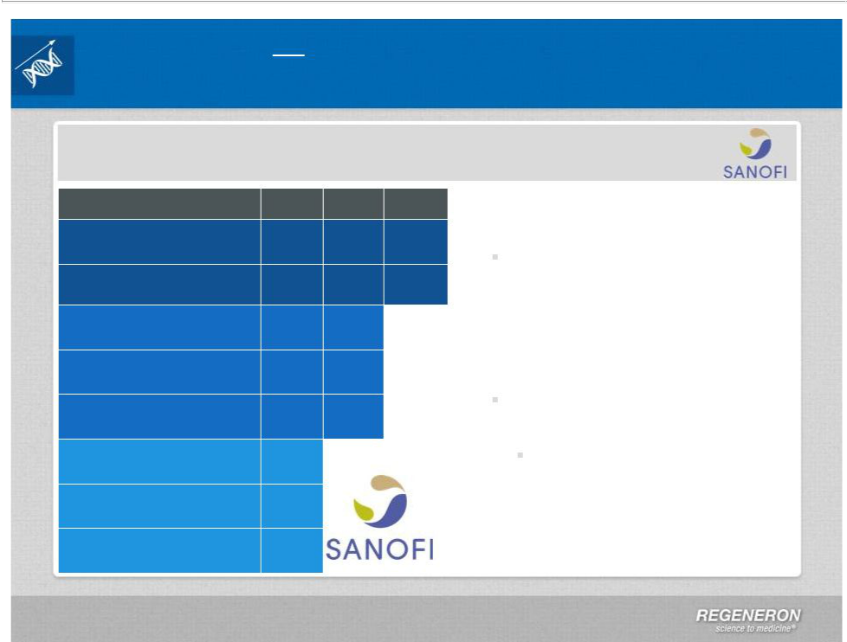
Regeneron Sanofi Collaboration

Sanofi Antibody Collaboration Continues to Provide R&D Leverage

Sanofi Collaboration

Alirocumab (REGN727)
PSCK9 Antibody for LDL cholesterol reduction

Sarilumab (REGN88) IL-6R

Antibody for Rheumatoid arthritis

Dupilumab (REGN668) IL-4R

Antibody for Asthma, Atopic dermatitis, nasal polyposis

Sarilumab (REGN88) IL-6R Antibody for Non-infectious Uveitis

REGN1033 GDF8 Antibody for Metabolic disorders

Enoticumab (REGN421) DII4
Antibody for Advanced malignancies

Nesvacumab (REGN910) Ang2

Antibody for Advanced malignancies

REGN2009 (undisclosed target)

Phase 1 Phase 2 Phase 3 Sanofi collaboration a major

contributor to Regeneron R&D

Sanofi is estimated to spend

more than $1 Billion on

collaboration programs in 2014*

Regeneron contribution to

collaboration R&D funding

increasing in 2014

20% funding of alirocumab and

sarilumab Phase 3 trials

Estimated to be ~$115 MM in

2014

*Regeneron to repay 50% of collaboration clinical development spending out of antibody profits

Page 25 | Copyright Regeneron 2014



Pipeline of Wholly-Owned Antibodies

Page 26 | Copyright Regeneron 2014

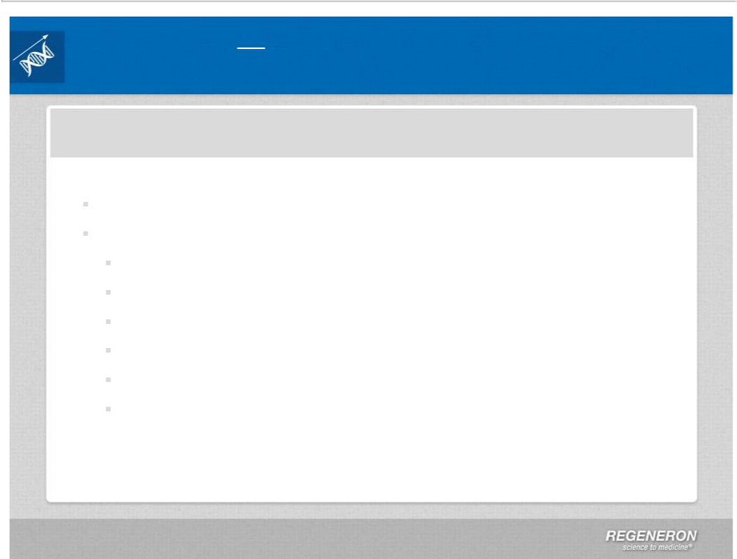
Regeneron Wholly-Owned Antibody Pipeline

Pipeline of Wholly-Owned Antibodies is Growing

Wholly-Owned Clinical Stage Antibodies

Advancing early stage pipeline of Regeneron-owned antibodies

Pipeline compounds address six distinct therapeutic areas

Committed to advance through POC to maximize value

Fasinumab* (Phase 2, NGF antibody)

REGN1400 (Phase 1, ErbB3, advanced malignancies)

REGN1154 (Phase 1, undisclosed target)

REGN1500 (Phase 1, undisclosed target)

REGN1193 (Phase 1, undisclosed target)

REGN1908-1909 (Phase 1, undisclosed target)

As pipeline advances, R&D expense will increase

*Currently on clinical hold by the FDA

Innovative Research and Novel Technologies

Page 28 | Copyright Regeneron 2014

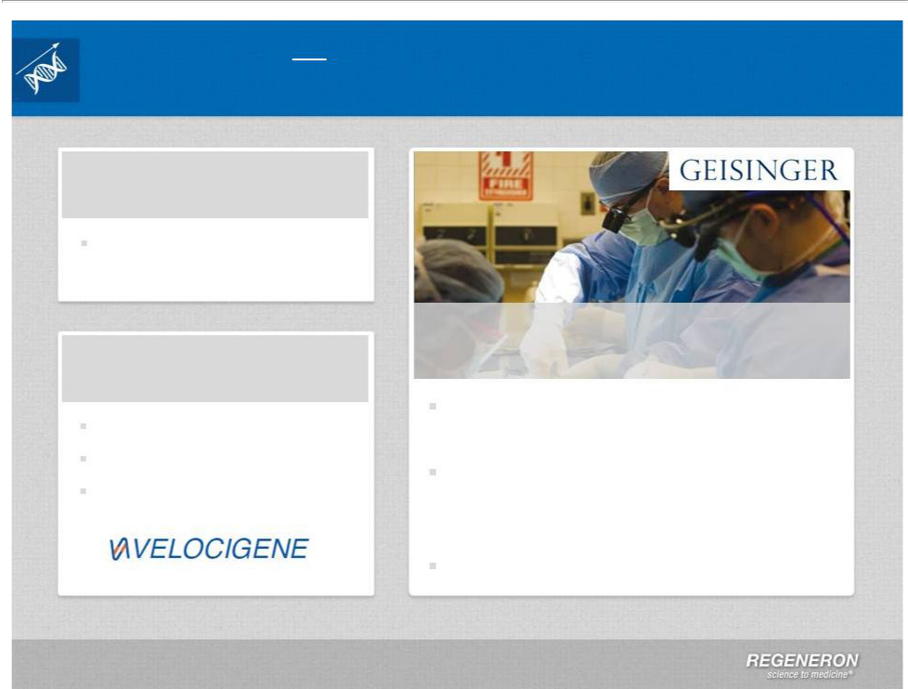
Regeneron Innovating for the Future

Investment in Research & Development and Technology

Immuno-Oncology

CD20-CD3 bispecific antibody expected to enter clinic in 2014

Other Pipeline

Technologies

Long-acting antibodies

Antibody Drug Conjugates

Next Generation

VelocImmune® Mice

Regeneron Genetics Center

Major new investment in human genetics research

Collaboration with Geisinger Health System is cornerstone of population based approach

Additional collaborations expected

Page 29 | Copyright Regeneron 2014

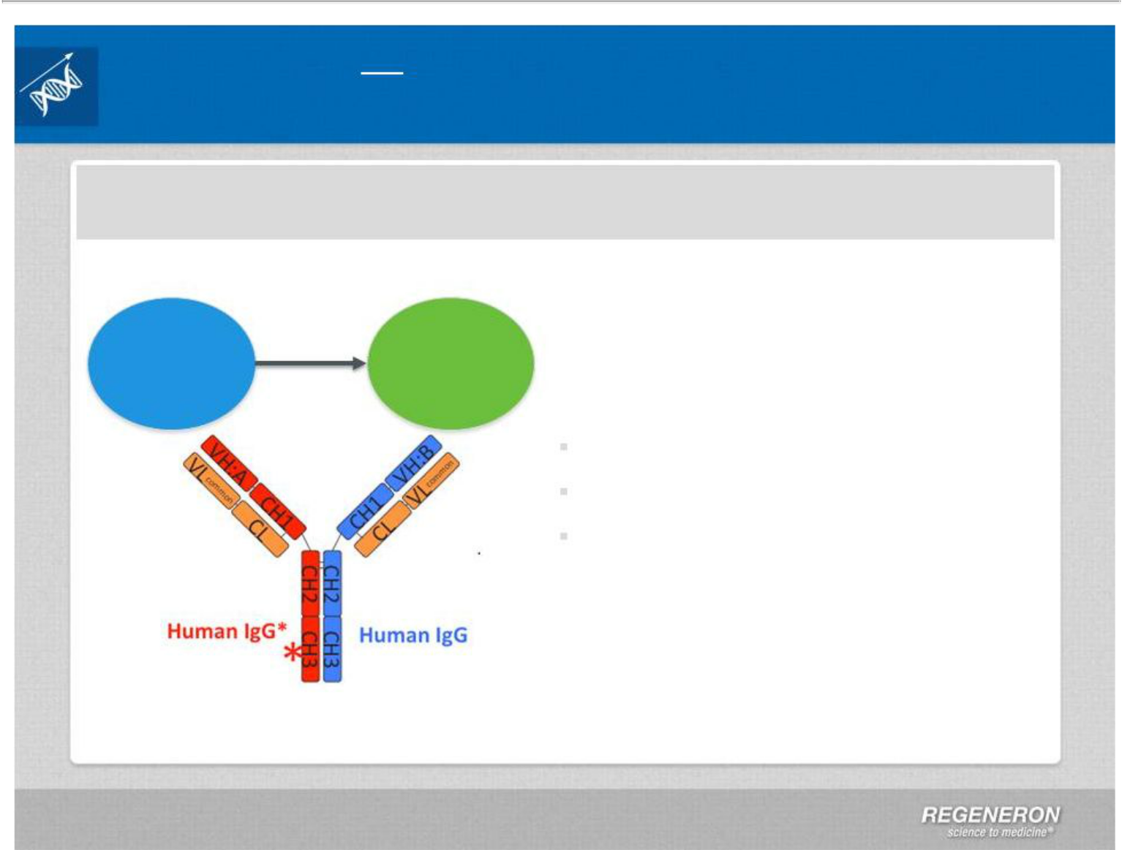
Regeneron Innovating for the Future

Investment in Research & Development and Technology

Immuno-Oncology Approach: CD20-CD3 Bispecific Antibody

Bispecific antibody bind T Cells (via CD3)

and tumor (via specific surface marker)

Killing _{Tumor}

T-cell _{Cell}

Use of modified VelocImmune ® mice to generate fully human bispecific antibodies provides benefits

High affinity to target

Ease of manufacturing

Typical antibody pharmacodynamics

Initial CD20-CD3 antibody expected to enter the clinic in 2014

Additional immuno-oncology approaches in preclinical development

Page 30 | Copyright Regeneron 2014

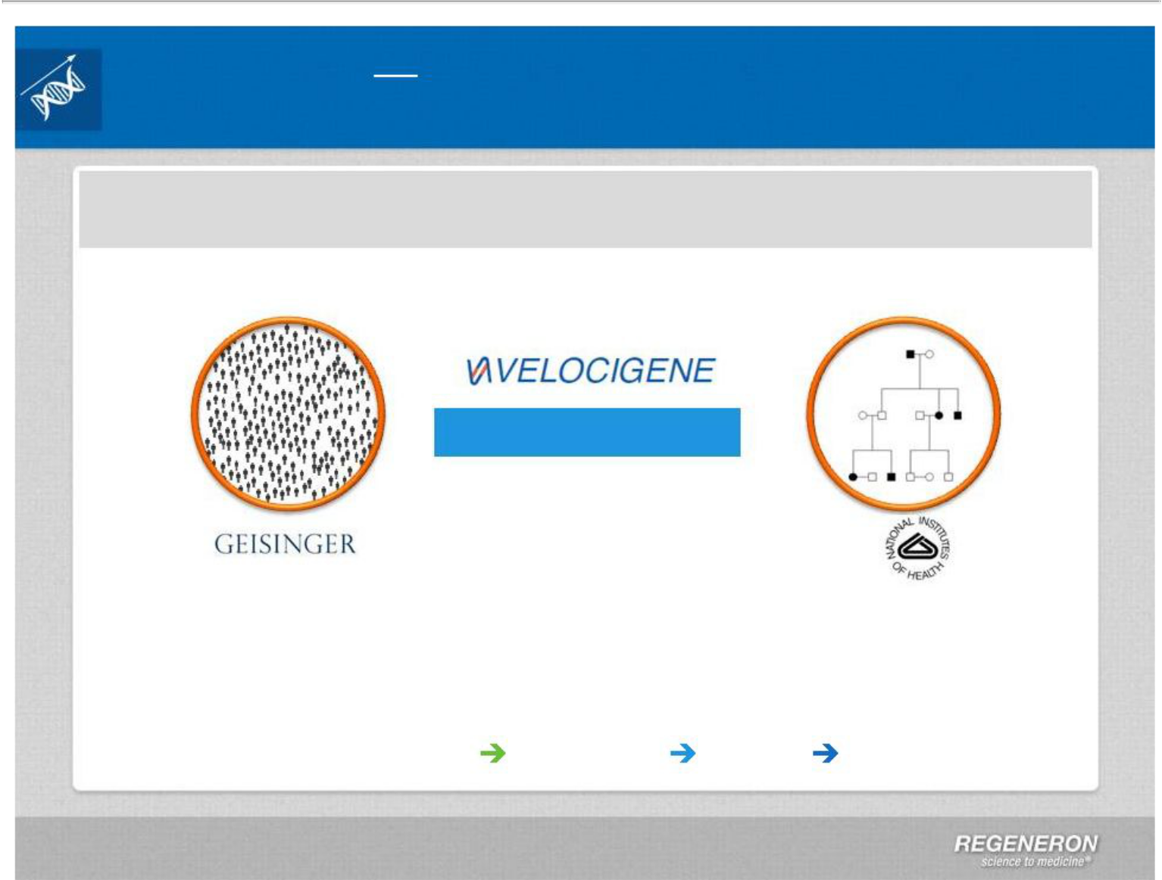
Regeneron Innovating for the Future

Regeneron Genetics Center a Major Initiative in Human Genetics

Regeneron Genetics Center

Population-Based Family-Based

Targets & Indications

Collaborations: Geisinger, NIH, and pursuing more

Approaches: population and family based, consortia, and functional studies

Technology: large scale sequencing, automation, and cloud informatics

Fully Integrated: Sequencing Informatics Biology Drug Development

Page 31 | Copyright Regeneron 2014

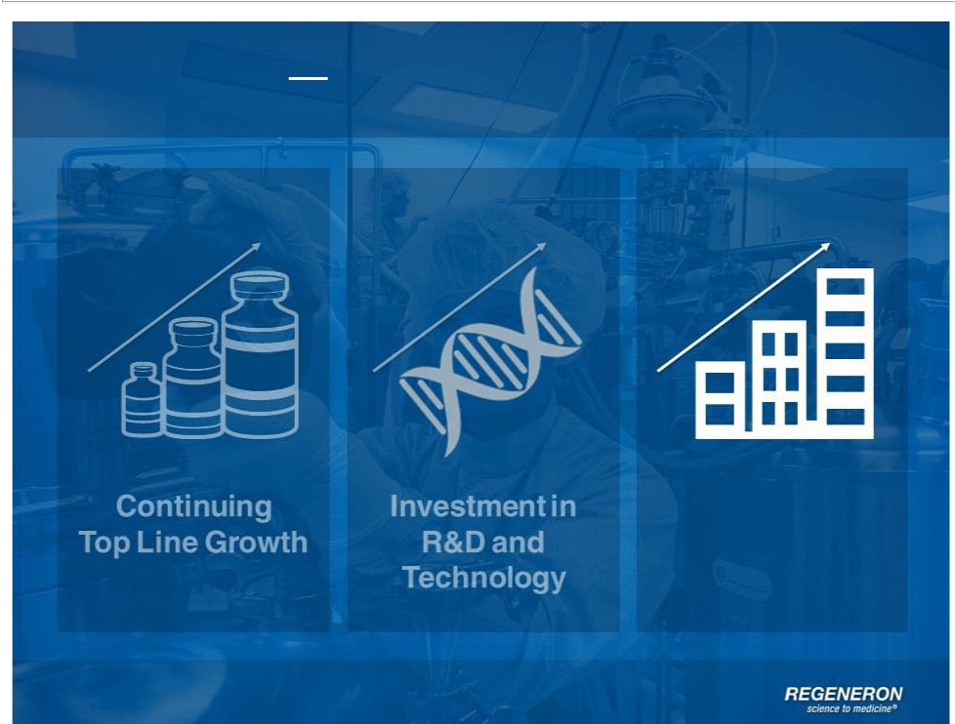
Regeneron Building on Success

Organic Growth

Page 32 | Copyright Regeneron 2014

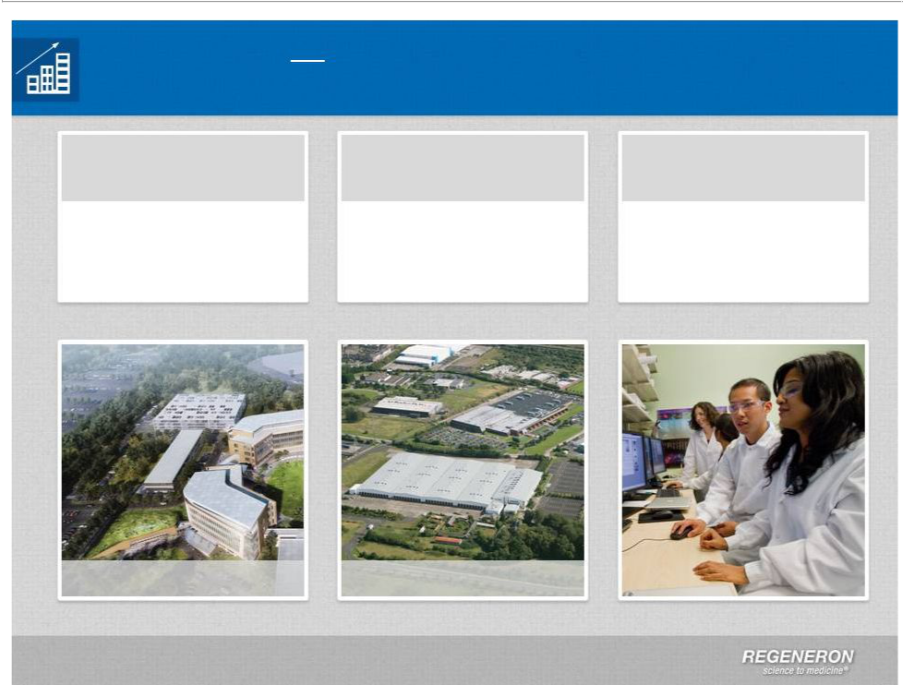
Regeneron Organic Growth

Growth in Manufacturing and at Corporate Headquarters

Expansion in New Manufacturing

Tarrytown, NY Facilities

Two new buildings to Expansion in Rensselaer,

support additional NY and new facility in

research and Limerick, Ireland

development

People

Expect to increase headcount to >4,000 by 2018

Tarrytown, NY Limerick, Ireland

Page 33 | Copyright Regeneron 2014

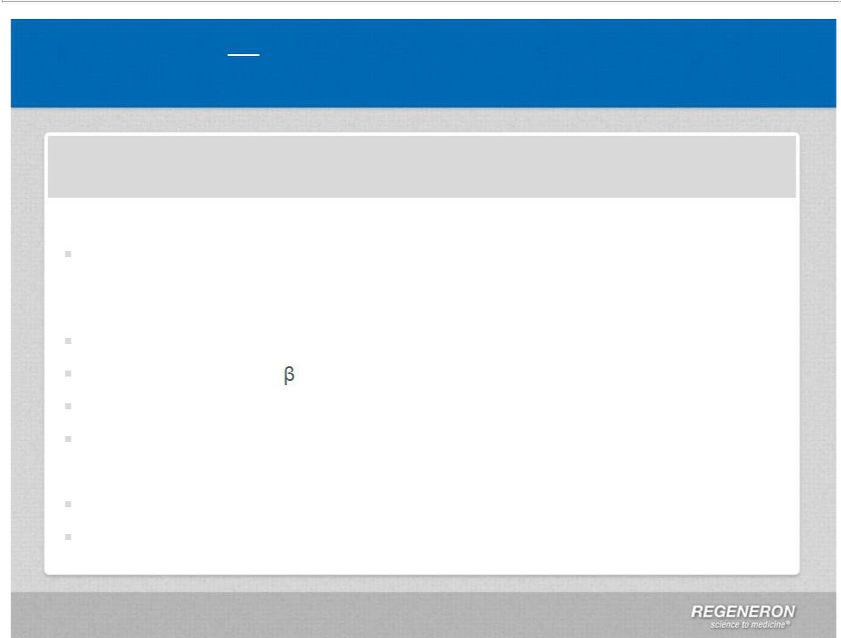
Regeneron Financial Guidance

Financial Guidance

2014 Financial Guidance

Non-GAAP SG&A: $330MM - $380MM

Increase in prelaunch commercial expenses, contribution to patient assistance programs, pharma fee and headcount

Non-GAAP Unreimbursed R&D: $425MM - $475MM

~$115 M in expenses related to alirocumab and sarilumab Phase 3 trials Investment in PDGFR and Ang2 programs Growing wholly-owned antibody pipeline

Early technologies, such as Regeneron Genetics Center

Capital Expenditures: $350MM - $425MM

Manufacturing expansions in Rensselaer and Ireland

R&D and corporate headquarters expansion in Tarrytown

Page 34 | Copyright Regeneron 2014

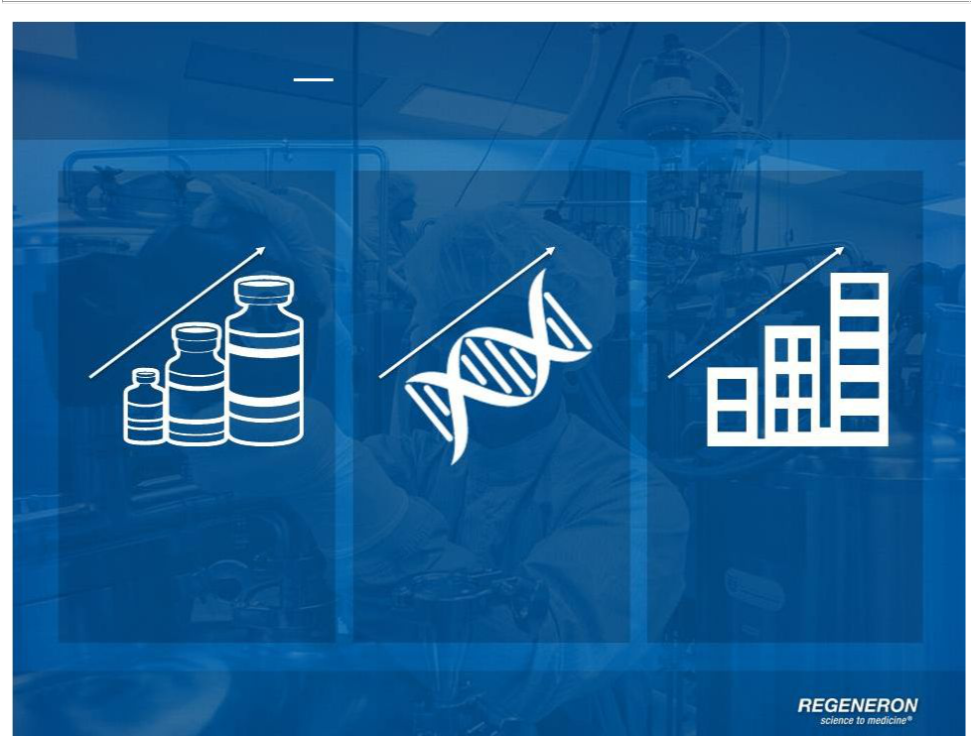
Regeneron Building on Success

Continuing
Top Line | Investment in | Organic Growth
Growth | R&D and | Organic Growth
 | Technology

Page 35 | Copyright Regeneron 2014

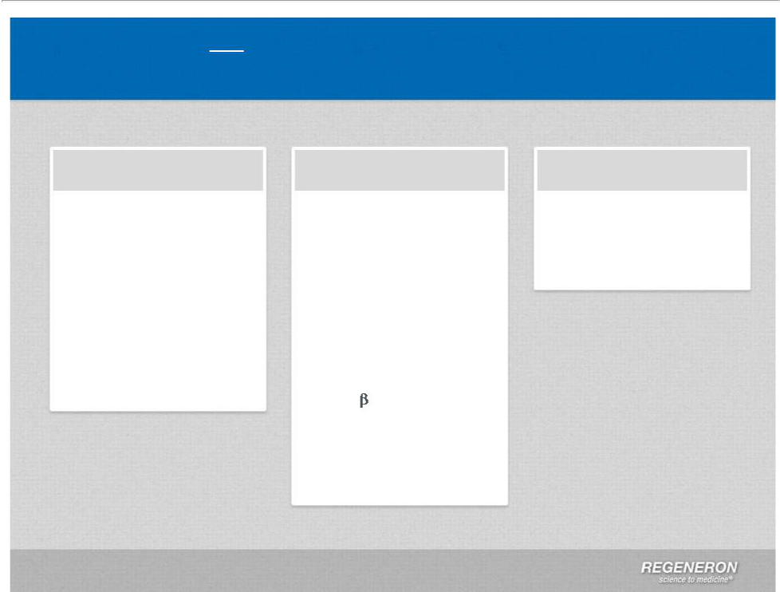
Regeneron 2014 Milestones

Upcoming Milestones

Regulatory Clinical

Commercial

EYLEA for DME PDUFA date of August 18, 2014

Filing of EYLEA for BRVO indication expected in 1Q14

EYLEA for DME regulatory applications submitted outside the U.S.

Phase 2 data for dupilumab in atopic dermatitis in 1H14

Phase 3 trial to start with dupilumab in AD in 2014

Phase 3 data from alirocumab ODYSSEY program in mid-2014 through 3Q14

PDGFR /EYLEA coformulation to enter clinic in 1Q14

CD20-CD3 bispecific antibody to enter clinic

EYLEA U.S. net sales guidance to be provided on 4Q13 conference call

Page 36 | Copyright Regeneron 2014

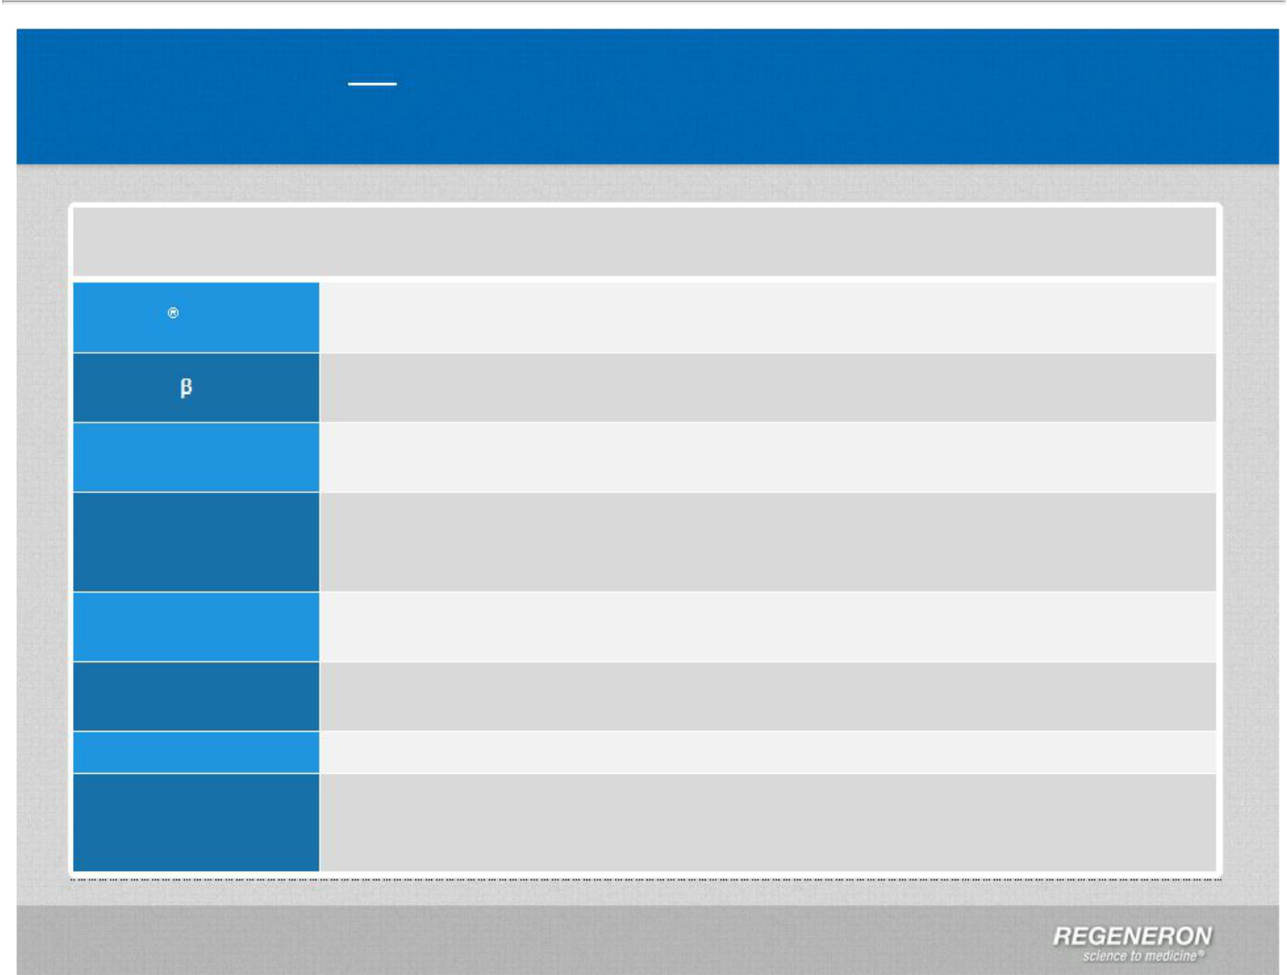
Regeneron News

Significant News Flow at J.P. Morgan

What’s News for Regeneron at J.P. Morgan 2014

EYLEA

PDGFR-

Alirocumab

Dupilumab

Sanofi

Human Genetics Immuno-Oncology
2014 Financial Guidance

Full year 2013 U.S. Net Sales: ~$1.4# Billion

4Q13 U.S. Net Sales: ~$400 Million*#

Clinical trial to start in 1Q14

Signed a collaboration with Bayer HealthCare for commercial rights outside the U.S.

Phase 3 data from ODYSSEY program expected mid-year** Initial regulatory submission ex-US in early 2015, U.S. in 2015

Phase 2a atopic dermatitis data to be presented at AAAAI in March Top-line Phase 2b atopic dermatitis data expected in 2Q14

Plan to initiate Phase 3 trial in atopic dermatitis in 2014

Amended investor agreement to allow for Sanofi to nominate a single director to

Regeneron BOD; amended voting rights, lock-up, and stand still agreement

Announced major effort in human genetics: The Regeneron Genetics Center Entered into first significant genetics collaboration with Geisinger Health System

CD20-CD3 bispecific antibody to enter clinic in 2014

Non-GAAP SG&A: $330MM - $380MM

Non-GAAP unreimbursed R&D: $425MM - $475MM

Capital expenditures: $350MM - $425MM

#Preliminary unaudited numbers
Page 37 | Copyright Regeneron 2014 *Includes increase in distributor inventory

**From all Phase 3 studies except OUTCOMES,CHOICE 1, and CHOICE2

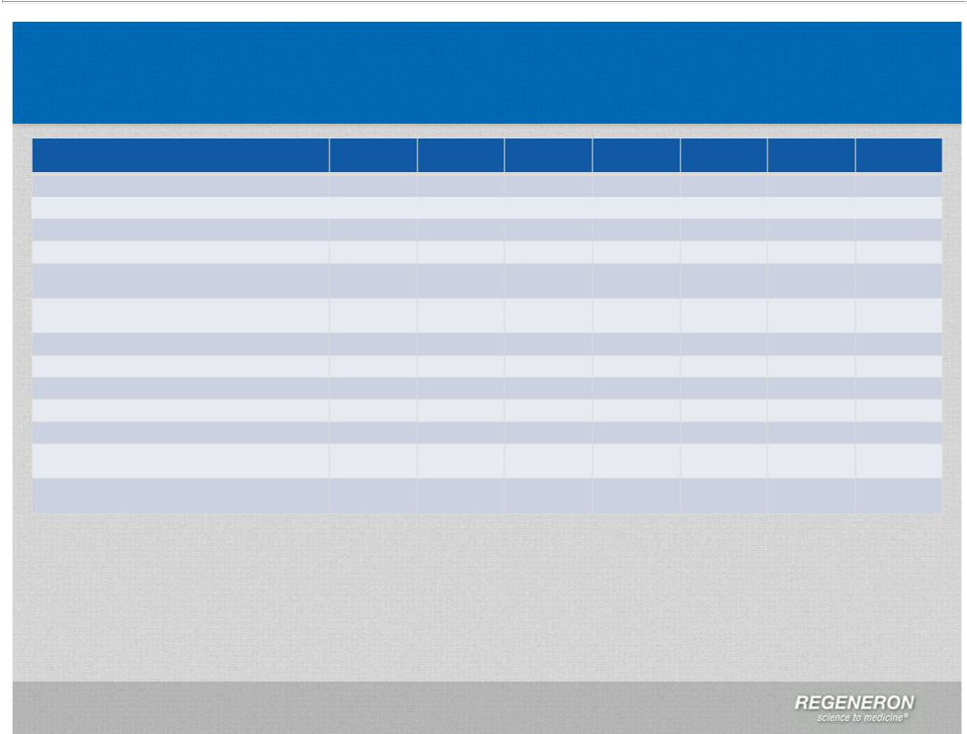
GAAP to Non-GAAP Reconciliation

 | 1Q’12 | 2Q’12
GAAP net income | 11,651 | 76,743
Adjustments
R&D: Non-cash share-based compensation expense⁽¹⁾ | 10,556 | 11,442
SG&A: Non-cash share-based compensation expense⁽¹⁾ | 12,578 | 7,790
COGS: Non-cash share-based compensation expense⁽¹⁾ | 111 | 391
Interest expense: Non-cash interest related to | 5,218 | 5,316
convertible senior notes(2)
Income taxes: Non-cash income tax expense(7)
Income taxes: Release of valuation allowance
Non-GAAP net income | 40,114 | 101,682
Non-GAAP net income per share – basic | 0.43 | 1.07
Non-GAAP net income per share – diluted | 0.37(3) | 0.90(5)
Shares used in calculating Non-GAAP net income per | 93,446 | 94,589
share - basic
Shares used in calculating Non-GAAP net income per | 112,495 | 114,928
share – diluted (4)

- To exclude non-cash compensation expense related to employee stock option and restricted stock award

- To exclude non-cash interest expense related to the amortization of the debt discount and debt issuance costs on the Company's 1.875% convertible senior notes
- For diluted non-GAAP per share calculations, excludes $1.9 million of interest expense related to the contractual coupon interest rate on the Company's 1.875% convertible senior notes, since these securities were dilutive

- Weighted average shares outstanding includes the dilutive effect, if any, of employee stock options, restricted stock awards, convertible senior notes, and warrants
- For diluted non-GAAP per share calculations, excludes $1.9 million of interest expense for the three months ended June 30, 2012 related to the contractual coupon interest rate on the Company's 1.875% convertible senior notes, since these securities were dilutive
- For diluted non-GAAP per share calculations, excludes $1.9 million of interest expense for the three months ended September 30, 2012 related to the contractual coupon interest rate on the Company's 1.875% convertible

senior notes, since these securities were dilutive

7) To exclude GAAP income tax expense as this amount is not payable in cash

- To exclude non-cash tax benefit related to releasing substantially all of the valuation allowance associated with the Company's deferred tax assets

3Q’12 | 4Q’12 | 1Q’13 | 2Q’13 | 3Q’13
191,468 | 470,407 | 98,874 | 87,376 | 141,306
13,337 | 18,498 | 26,761 | 27,722 | 28,258
7,030 | 11,851 | 25,787 | 16,344 | 17,114
150 | 422 | 483 | 376 | 373
5,499 | 5,591 | 5,781 | 5,535 | 5,823
 | 4,308( | 42,957 | 60,316 | 84,378
 | (340,156)(8)
217,484 | 170,921 | 200,643 | 197,669 | 277,252
2.29 | 1.79 | 2.07 | 2.02 | 2.82
1.89(6) | 1.47(9) | 1.78(10) | 1.73(11) | 2.40(12)
95,012 | 95,691 | 96,878 | 97,700 | 98,226
115,830 | 117,237 | 113,730 | 115,261 | 116,068

- For diluted non-GAAP per share calculations, excludes $1.9 million of interest expense for the three months

ended December 31, 2012 related to the contractual coupon interest rate on the Company's 1.875% convertible

senior notes, since these securities were dilutive

- For diluted non-GAAP per share calculations, excludes $1.9 million of interest expense for the three month

ended March 31, 2013 related to the contractual coupon interest rate on the Company's 1.875% convertible

senior notes, since these securities were dilutive

- For diluted non-GAAP per share calculations, excludes $1.8 million of interest expense for the three month periods ended June 30, 2013 related to the contractual coupon interest rate on the Company's 1.875% convertible senior notes, since these securities were dilutive
- For diluted non-GAAP per share calculations, excludes $1.8 million of interest expense for the three months ended September 30, 2013, related to the contractual coupon interest rate on the Company's 1.875% convertible senior notes, since these securities were dilutive



