UNITED STATES

SECURITIES AND EXCHANGE COMMISSION

Washington, DC 20549

SCHEDULE 14A

PROXY STATEMENT PURSUANT TO SECTION 14(a)

OF THE SECURITIES EXCHANGE ACT OF 1934
(Amendment No. )

Filed by the Registrant Filed by a Party other than the Registrant
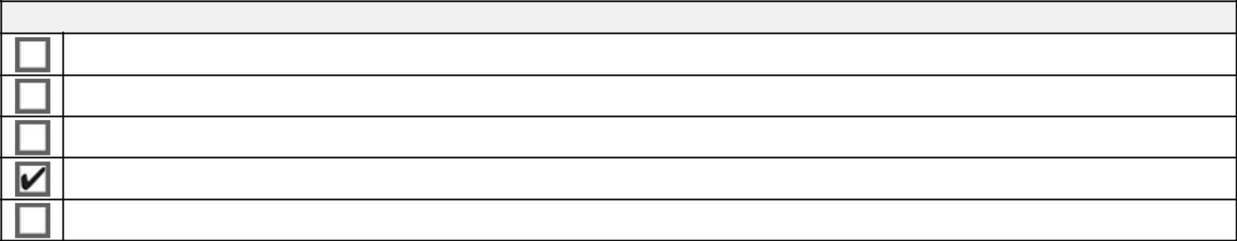

Check the appropriate box:

Preliminary Proxy Statement

Confidential, for Use of the Commission Only (as permitted by Rule 14A-6(E)(2))

Definitive Proxy Statement

Definitive Additional Materials

Soliciting Material under §240.14a-12

REGENERON PHARMACEUTICALS, INC.

(Name of Registrant as Specified in Its Charter)

(Name of Person(s) Filing Proxy Statement, if other than the Registrant)
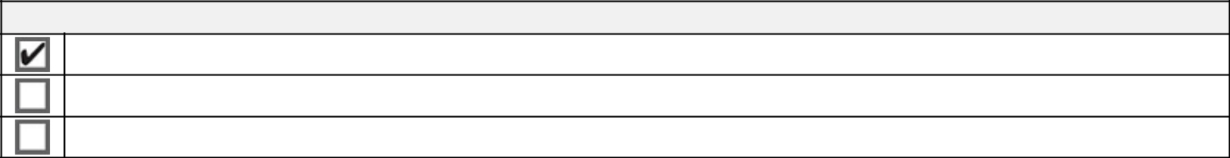

Payment of Filing Fee (Check all boxes that apply):

No fee required.

Fee paid previously with preliminary materials.

Fee computed on table in exhibit required by Item 25(b) per Exchange Act Rules 14a-6(i)(1) and 0-11.


Your Vote Counts!

REGENERON PHARMACEUTICALS, INC.

2024 Annual Meeting

Vote by June 13, 2024 11:59 PM ET for shares held directly

and June 11, 2024 11:59 PM ET for shares held in a Plan.

REGENERON PHARMACEUTICALS, INC.
777 OLD SAW MILL RIVER ROAD
TARRYTOWN, NY 10591-6707
ATTN: CORPORATE SECRETARY

V44776-P04717-Z86869

You invested in REGENERON PHARMACEUTICALS, INC. and it’s time to vote!

You have the right to vote on proposals being presented at the Annual Meeting. This is an important notice regarding the availability of proxy materials for the shareholder meeting to be held on June 14, 2024.

Get informed before you vote

View the Notice and Proxy Statement and Annual Report online OR you can receive a free paper or email copy of the material(s) by requesting them prior to May 31, 2024. If you would like to request a copy of the material(s) for this and/or future shareholder meetings, you may (1) visit www.ProxyVote.com, (2) call 1-800-579-1639 or (3) send an email to sendmaterial@proxyvote.com. If sending an email, please include your control number (indicated below) in the subject line. Unless requested, you will not otherwise receive a paper or email copy.


For complete information and to vote, visit www.ProxyVote.com

Control #

Smartphone users |  | Vote Virtually at the Meeting*
Point your camera here and |  | June 14, 2024
Point your camera here and |  | 10:30 AM ET
vote without entering a
control number |  | Virtually at:
 |  | www.virtualshareholdermeeting.com/REGN2024


*Please check the meeting materials for any special requirements for meeting attendance.

Vote at www.ProxyVote.com

THIS IS NOT A VOTABLE BALLOT

This is an overview of the proposals being presented at the

upcoming shareholder meeting. Please follow the instructions on

the reverse side to vote these important matters.


Voting Items

Board

Recommends

- Election of Directors

Nominees:

1a. | N. Anthony Coles, M.D. | For
1b. | Kathryn Guarini, Ph.D. | For
1c. | Arthur F. Ryan | For
1d. | David P. Schenkein, M.D. | For
1e. | George L. Sing | For
2. | Ratification of the appointment of PricewaterhouseCoopers LLP as the Company’s independent registered public | For
 | accounting firm for the fiscal year ending December 31, 2024. | For
3. | Proposal to approve, on an advisory basis, executive compensation. | For
4. | Non-binding shareholder proposal requesting simple majority voting requirements, if properly presented. | Against

NOTE: Such other business as may properly come before the meeting or any adjournment thereof.

Prefer to receive an email instead? While voting on www.ProxyVote.com, be sure to click “Delivery Settings”.

V44777-P04717-Z86869

