Table of Contents

SECURITIES AND EXCHANGE COMMISSION

WASHINGTON, D.C. 20549

SCHEDULE TO

TENDER OFFER STATEMENT UNDER SECTION 14(d)(1) OR 13(e)(1) OF THE SECURITIES EXCHANGE ACT OF 1934 Amendment No. 1

Regeneron Pharmaceuticals, Inc.

(Name of Subject Company (Issuer))

Regeneron Pharmaceuticals, Inc.

(Name of Filing Person (Offeror))

Options under the 1990 Long-Term Incentive Plan

and 2000 Long-Term Incentive Plan

to Purchase Common Stock, Par Value $.001 Per Share,

Having an Exercise Price Per Share of $18.00 or More

(Title of Class of Securities)

00075886F1

(CUSIP Number of Class of Securities)

(Underlying Common Stock)

Stuart Kolinski, Esq.

Vice President, General Counsel and Secretary

Regeneron Pharmaceuticals, Inc.

777 Old Saw Mill River Road

Tarrytown, New York 10591

(914) 347-7000

(Name, Address and Telephone Number of Person Authorized to

Receive Notices and Communications on Behalf of Filing Person)

Copy to:

Kent A. Coit, Esq.

Skadden, Arps, Slate, Meagher & Flom LLP

One Beacon Street

Boston, MA 02108

Telephone: (617) 573-4800

Facsimile: (617) 573-4822

Table of Contents

 | CALCULATION OF FILING FEE
Transaction Valuation* |  |  | Amount of Filing Fee**
$13,162,587.66 | $1,667.70***

- Calculated solely for purposes of determining the filing fee. This amount assumes that options to purchase 4,847,581 shares of common stock of Regeneron Pharmaceuticals, Inc. having an approximate aggregate value of $13,162,587.66 will be exchanged pursuant to this Offer. The aggregate value of such options was calculated based on the Black-Scholes option pricing model, as of November 3, 2004.

- The amount of the filing fee, calculated in accordance with Rule 0-11 of the Securities Exchange Act of 1934, as amended, equals $126.70 for each $1,000,000 of the aggregate value of this transaction.

- Previously paid.

- Check the box if any part of the fee is offset as provided by Rule 0-11(a)(2) and identify the filing with which the offsetting fee was previously paid. Identify the previous filing by registration statement number, or the Form or Schedule and the date of its filing.

Amount Previously Paid: Not applicable.

Filing Party: Not applicable.

Form or Registration No.: Not applicable.

Date Filed: Not applicable.

- Check the box if the filing relates solely to preliminary communications made before the commencement of a tender offer. Check the appropriate boxes below to designate any transactions to which the statement relates:

- third-party tender offer subject to Rule 14d-1.

- issuer tender offer subject to Rule 13e-4.

- going-private transaction subject to Rule 13e-3.

- amendment to Schedule 13D under Rule 13d-2.

Check the following box if the filing is a final amendment reporting the results of the tender offer: o

TABLE OF CONTENTS

Item 12. Exhibits.
SIGNATURE
INDEX TO EXHIBITS
EX-99.A.1.IX: EMPLOYEE PRESENTATION MATERIALS

EX-99.A.I.X: E-MAIL COMMUNICATION

Table of Contents

This Amendment No. 1 amends and supplements the Tender Offer Statement on Schedule TO initially filed by Regeneron Pharmaceuticals, Inc. (the “Company”) with the Securities and Exchange Commission on December 3, 2004 (the “Schedule TO”) in connection with the Company’s offer, upon the terms and subject to the conditions set forth in the Offer (as defined in the Schedule TO), to exchange eligible options for replacement options to be granted under the Company’s 2000 Long-Term Incentive Plan.

The Company will conduct presentations to eligible employees highlighting certain aspects of the Offer. On Monday, December 6, 2004, the Company’s Vice President, Human Resources sent an e-mail communication to all eligible employees about the Offer. Item 12 of the Schedule TO is hereby amended to include the eligible employee presentation materials as Exhibit (a)(1)(ix) and the December 6th e-mail communication to eligible employees as Exhibit (a)(1) (x).

Item 12. Exhibits.

(a)(1)(i) | Offer to Exchange dated December 3, 2004.*
(a)(1)(ii) | Form of Election Form.*
(a)(1)(iii) | Form of Notice of Withdrawal.*
(a)(1)(iv) | Form of Acceptance Letter.*
(a)(1)(v) | Form of communication to Regeneron Pharmaceuticals, Inc. optionholders confirming receipt of Election Form or Notice of
 | Withdrawal.*
(a)(1)(vi) | Regeneron Pharmaceuticals, Inc. Quarterly Report on Form 10-Q for its fiscal quarter ended September 30, 2004, filed with the
 | Securities and Exchange Commission on November 8, 2004 and incorporated herein by reference.
(a)(1)(vii) | Regeneron Pharmaceuticals, Inc. Annual Report on Form 10-K/A for the fiscal year ending December 31, 2003 filed with the
 | Securities and Exchange Commission on March 19, 2004 and incorporated herein by reference.
(a)(1)(viii) | E-mail communication to Regeneron Pharmaceuticals, Inc. employees dated November 17, 2004 filed as Exhibit 99.2 to the
 | Company’s Schedule TO-C filed with the Securities and Exchange Commission on November 17, 2004 and incorporated herein
 | by reference.
(a)(1)(ix) | Employee Presentation Materials.
(a)(1)(x) | E-mail communication from the Vice President, Human Resources to all eligible employees sent on Monday, December 6, 2004.
(a)(2) | Not applicable.
(a)(3) | Not applicable.
(a)(4) | Not applicable.
(a)(5) | Not applicable.
(b) | Not applicable.
(d)(1) | Regeneron Pharmaceuticals, Inc. 1990 Long-Term Incentive Plan, as amended, filed as Exhibit 10.12 to Amendment No. 4 to the
 | Company’s Registration Statement on Form S-1,

Table of Contents

 | filed with the Securities and Exchange Commission on April 2, 1991 (Registration Statement No. 033-39043) and incorporated
 | herein by reference.
(d)(2) | Regeneron Pharmaceuticals, Inc. 2000 Long-Term Incentive Plan, filed as Exhibit 10.6 to the Form 10-K for Regeneron
 | Pharmaceuticals, Inc. for the fiscal year ended December 31, 2001, filed with the Securities and Exchange Commission on
 | March 22, 2002 and incorporated herein by reference.
(d)(3) | Amendment No. 1 to Regeneron Pharmaceuticals, Inc. 2000 Long-Term Incentive Plan, effective as of June 14, 2002, filed as
 | Exhibit 10.6.1 to the Form 10-K for Regeneron Pharmaceuticals, Inc. for the fiscal year ended December 31, 2002, filed with the
 | Securities and Exchange Commission on March 31, 2003 and incorporated herein by reference.
(d)(4) | Amendment No. 2 to Regeneron Pharmaceuticals, Inc. 2000 Long-Term Incentive Plan, effective as of December 20, 2002, filed
 | as Exhibit 10.6.2 to the Form 10-K for Regeneron Pharmaceuticals, Inc. for the fiscal year ended December 31, 2002, filed with
 | the Securities and Exchange Commission on March 31, 2003 and incorporated herein by reference.
(d)(5) | Amendment No. 3 to Regeneron Pharmaceuticals, Inc. 2000 Long-Term Incentive Plan, effective as of June 14, 2004, filed as
 | Exhibit 10.6.3 to the Form 10-Q for Regeneron Pharmaceuticals, Inc. for the quarterly period ended June 30, 2004, filed with the
 | Securities and Exchange Commission on August 5, 2004 and incorporated herein by reference.
(d)(6) | Amendment No. 4 to the Regeneron Pharmaceuticals, Inc. 2000 Long-Term Incentive Plan, included as Annex A to the
 | Company’s definitive proxy statement on Schedule 14A filed with the Securities and Exchange Commission on November 29,
 | 2004 and incorporated herein by reference.
(d)(7) | Form of Replacement Option Agreement and Notice of Grant of Replacement Options for employees of Regeneron
 | Pharmaceuticals, Inc. other than vice presidents.*
(d)(8) | Form of Replacement Option Agreement and Notice of Grant of Replacement Options for vice presidents of Regeneron
 | Pharmaceuticals, Inc.*
(d)(9) | Form of Replacement Option Agreement and Notice of Grant of Replacement Options for senior vice presidents and executive
 | vice presidents of Regeneron Pharmaceuticals, Inc.*
(d)(10) | Regeneron Pharmaceuticals, Inc. Registration Statements relating to Securities to be offered to employees pursuant to employee
 | benefit plans on Form S-8 and Form S-8 POS, filed with the Securities and Exchange Commission on August 19, 1997 (File
 | No. 333-33891), June 15, 1999 (File No. 333-80663), May 17, 2001 (File No. 333-61132), July 30, 2002 (File No. 333-80663,
 | July 30, 2002 (File No. 333-97375) and September 24, 2004 (File No. 333-119257) and incorporated herein by reference.
(d)(11) | Regeneron Pharmaceuticals, Inc. Registration Statement on Form 8-A filed with the Securities and Exchange Commission on
 | February 20, 1991 as amended by the Registration Statement on Form 8-A/A, filed with the Securities and Exchange
 | Commission on March 27, 1991 and incorporated herein by reference.
(d)(12) | Regeneron Pharmaceuticals, Inc. Registration Statement on Form 8-A, filed with the Securities and Exchange Commission on
 | October 15, 1996 and incorporated herein by reference.

Table of Contents

(d)(13)

Rights Agreement, dated as of September 20, 1996, between Regeneron Pharmaceuticals, Inc. and Chase Mellon Shareholder Services LLC, as Rights Agent, including the form of Rights Certificate as Exhibit B thereto, filed as Exhibit 1 to Regeneron Pharmaceuticals, Inc. Registration Statement on Form 8-A, filed with the Securities and Exchange Commission on October 15, 1996 and incorporated herein by reference.

(g)

Not applicable.

(h)

Not applicable.

- Previously filed.

Table of Contents

SIGNATURE

After due inquiry and to the best of my knowledge and belief, I certify that the information set forth in this Schedule TO is true, complete and correct.

REGENERON PHARMACEUTICALS, INC.

By: /s/ Stuart Kolinski

Name: Stuart Kolinski

Title: Vice President and General Counsel

Date: December 6, 2004

Table of Contents

 |  | INDEX TO EXHIBITS
EXHIBIT |  | DESCRIPTION OF EXHIBIT
NUMBER |  | DESCRIPTION OF EXHIBIT
(a)(1)(i) |  | Offer to Exchange dated December 3, 2004.*
(a)(1)(ii) |  | Form of Election Form.*
(a)(1)(iii) |  | Form of Notice of Withdrawal.*
(a)(1)(iv) |  | Form of Acceptance Letter.*
(a)(1)(v) |  | Form of communication to Regeneron Pharmaceuticals, Inc. optionholders confirming receipt of Election Form or Notice of
 |  | Withdrawal.*
(a)(1)(vi) |  | Regeneron Pharmaceuticals, Inc. Quarterly Report on Form 10-Q for its fiscal quarter ended September 30, 2004, filed with the
 |  | Securities and Exchange Commission on November 8, 2004 and incorporated herein by reference.
(a)(1)(vii) |  | Regeneron Pharmaceuticals, Inc. Annual Report on Form 10-K/A for the fiscal year ending December 31, 2003 filed with the
 |  | Securities and Exchange Commission on March 19, 2004 and incorporated herein by reference.
(a)(1)(viii) |  | E-mail communication to Regeneron Pharmaceuticals, Inc. employees dated November 17, 2004 filed as Exhibit 99.2 to the
 |  | Company’s Schedule TO-C filed with the Securities and Exchange Commission on November 17, 2004 and incorporated herein
 |  | by reference.
(a)(1)(ix) |  | Employee Presentation Materials.
(a)(1)(x) |  | E-mail communication from the Vice President, Human Resources to all eligible employees sent on Monday, December 6, 2004.
(d)(1) |  | Regeneron Pharmaceuticals, Inc. 1990 Long-Term Incentive Plan, as amended, filed as Exhibit 10.12 to Amendment No. 4 to the
 |  | Company’s Registration Statement on Form S-1, filed with the Securities and Exchange Commission on April 2, 1991
 |  | (Registration Statement No. 033-39043) and incorporated herein by reference.
(d)(2) |  | Regeneron Pharmaceuticals, Inc. 2000 Long-Term Incentive Plan, filed as Exhibit 10.6 to the Form 10-K for Regeneron
 |  | Pharmaceuticals, Inc. for the fiscal year ended December 31, 2001, filed with the Securities and Exchange Commission on
 |  | March 22, 2002 and incorporated herein by reference.
(d)(3) |  | Amendment No. 1 to Regeneron Pharmaceuticals, Inc. 2000 Long-Term Incentive Plan, effective as of June 14, 2002, filed as
 |  | Exhibit 10.6.1 to the Form 10-K for Regeneron Pharmaceuticals, Inc. for the fiscal year ended December 31, 2002, filed with the
 |  | Securities and Exchange Commission on March 31, 2003 and incorporated herein by reference.
(d)(4) |  | Amendment No. 2 to Regeneron Pharmaceuticals, Inc. 2000 Long-Term Incentive Plan, effective as of December 20, 2002, filed
 |  | as Exhibit 10.6.2 to the Form 10-K for Regeneron Pharmaceuticals, Inc. for the fiscal year ended December 31, 2002, filed with
 |  | the Securities and Exchange Commission on March 31, 2003 and incorporated herein by reference.

Table of Contents

EXHIBIT |  | DESCRIPTION OF EXHIBIT
NUMBER |  | DESCRIPTION OF EXHIBIT
(d)(5) |  | Amendment No. 3 to Regeneron Pharmaceuticals, Inc. 2000 Long-Term Incentive Plan, effective as of June 14, 2004, filed as
 |  | Exhibit 10.6.3 to the Form 10-Q for Regeneron Pharmaceuticals, Inc. for the quarterly period ended June 30, 2004, filed with the
 |  | Securities and Exchange Commission on August 5, 2004 and incorporated herein by reference.
(d)(6) |  | Amendment No. 4 to the Regeneron Pharmaceuticals, Inc. 2000 Long-Term Incentive Plan, included as Annex A to the
 |  | Company’s definitive proxy statement on Schedule 14A filed with the Securities and Exchange Commission on November 29,
 |  | 2004 and incorporated herein by reference.
(d)(7) |  | Form of Replacement Option Agreement and Notice of Grant of Replacement Options for employees of Regeneron
 |  | Pharmaceuticals, Inc. other than vice presidents.*
(d)(8) |  | Form of Replacement Option Agreement and Notice of Grant of Replacement Options for vice presidents of Regeneron
 |  | Pharmaceuticals, Inc.*
(d)(9) |  | Form of Replacement Option Agreement and Notice of Grant of Replacement Options for senior vice presidents and executive
 |  | vice presidents of Regeneron Pharmaceuticals, Inc.*
(d)(10) |  | Regeneron Pharmaceuticals, Inc. Registration Statements relating to Securities to be offered to employees pursuant to employee
 |  | benefit plans on Form S-8 and Form S-8 POS, filed with the Securities and Exchange Commission on August 19, 1997 (File
 |  | No. 333-33891), June 15, 1999 (File No. 333-80663), May 17, 2001 (File No. 333-61132), July 30, 2002 (File No. 333-80663,
 |  | July 30, 2002 (File No. 333-97375) and September 24, 2004 (File No. 333-119257) and incorporated herein by reference.
(d)(11) |  | Regeneron Pharmaceuticals, Inc. Registration Statement on Form 8-A filed with the Securities and Exchange Commission on
 |  | February 20, 1991 as amended by the Registration Statement on Form 8-A/A, filed with the Securities and Exchange
 |  | Commission on March 27, 1991 and incorporated herein by reference.
(d)(12) |  | Regeneron Pharmaceuticals, Inc. Registration Statement on Form 8-A, filed with the Securities and Exchange Commission on
 |  | October 15, 1996 and incorporated herein by reference.
(d)(13) |  | Rights Agreement, dated as of September 20, 1996, between Regeneron Pharmaceuticals, Inc. and Chase Mellon Shareholder
 |  | Services LLC, as Rights Agent, including the form of Rights Certificate as Exhibit B thereto, filed as Exhibit 1 to Regeneron
Pharmaceuticals, Inc. Registration Statement on Form 8-A, filed with the Securities and Exchange Commission on October 15, 1996 and incorporated herein by reference.

- Previously filed.

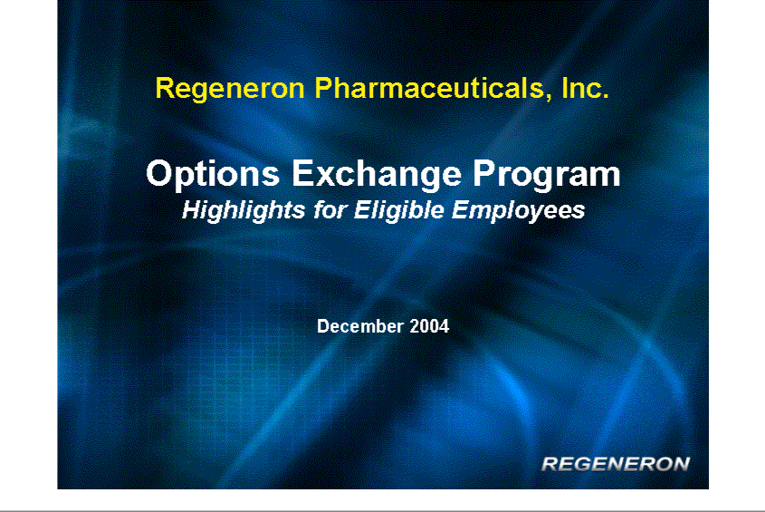

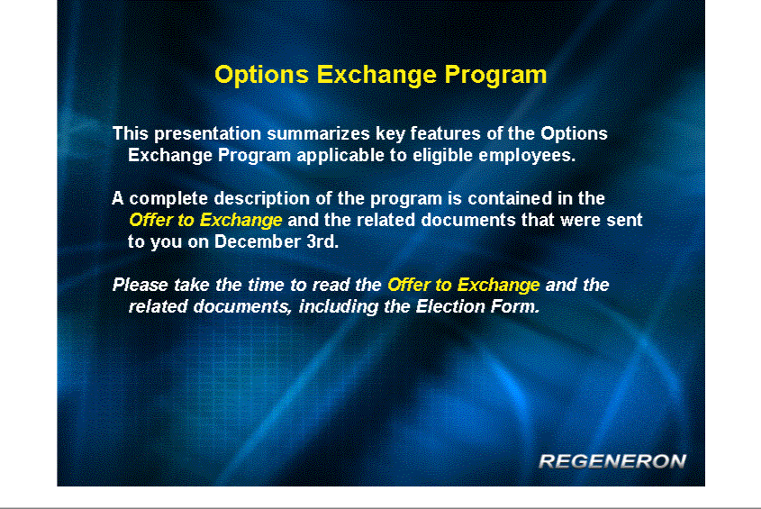

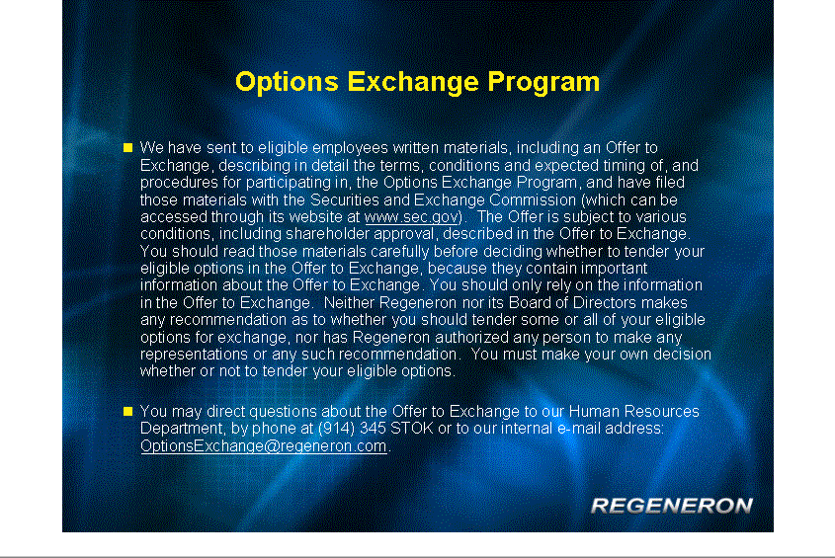

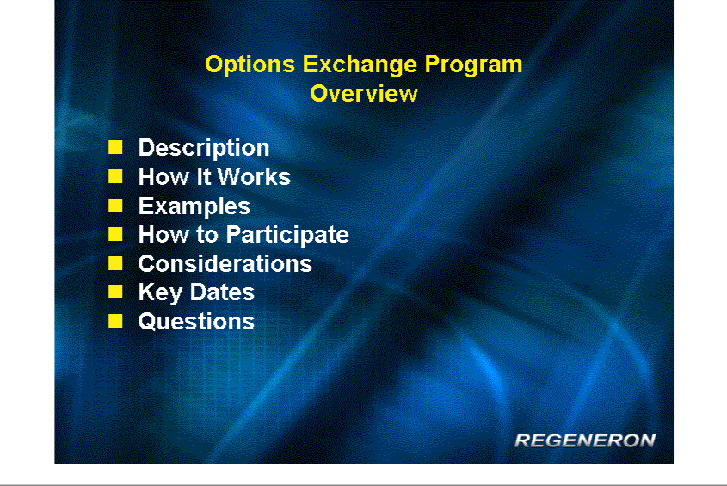

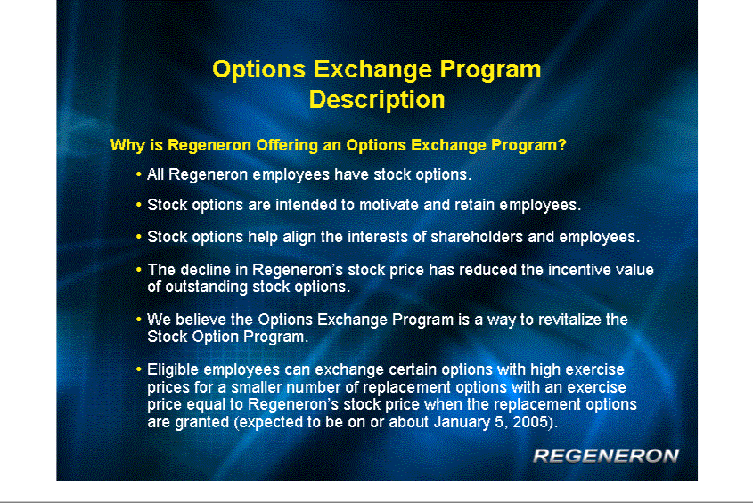

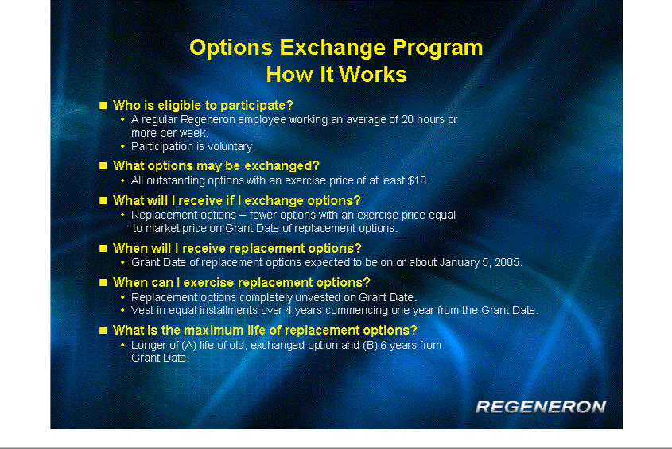

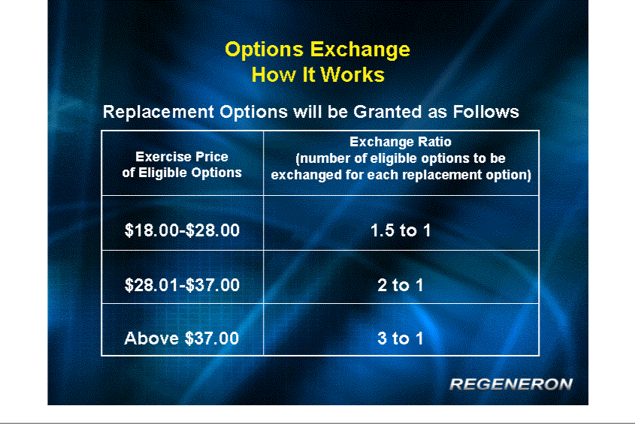

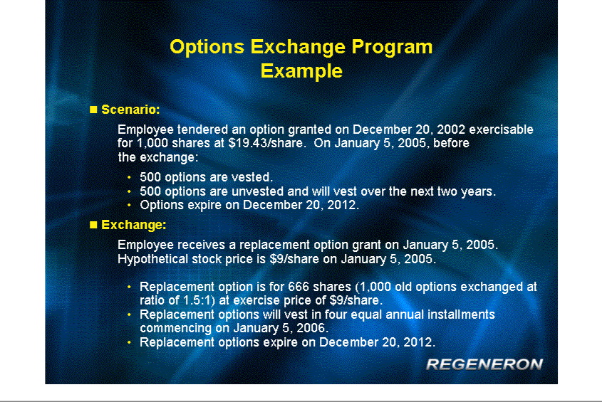

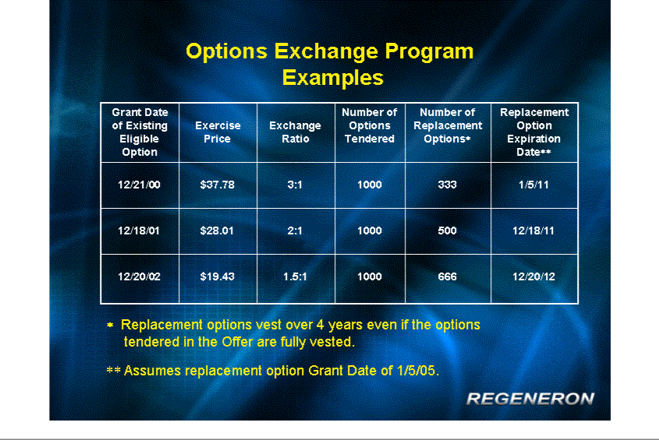

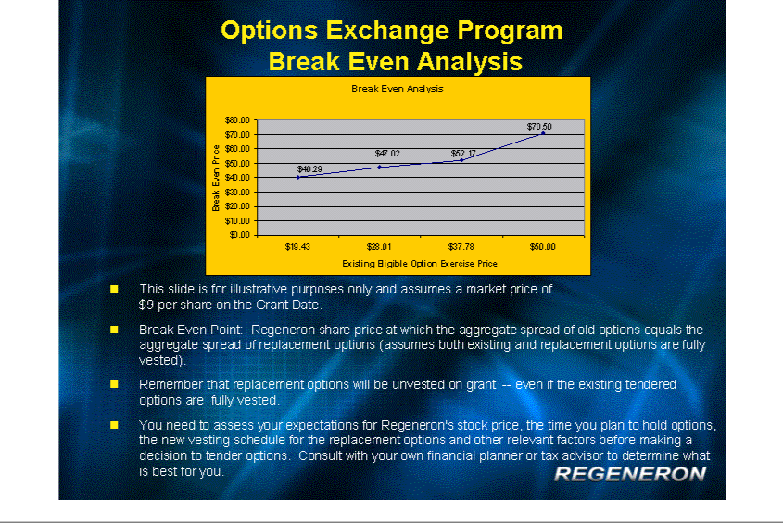

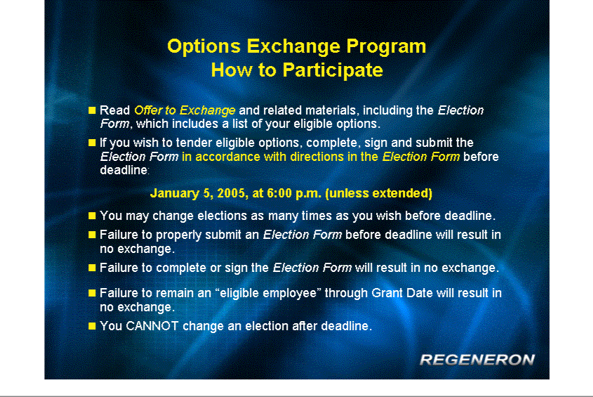

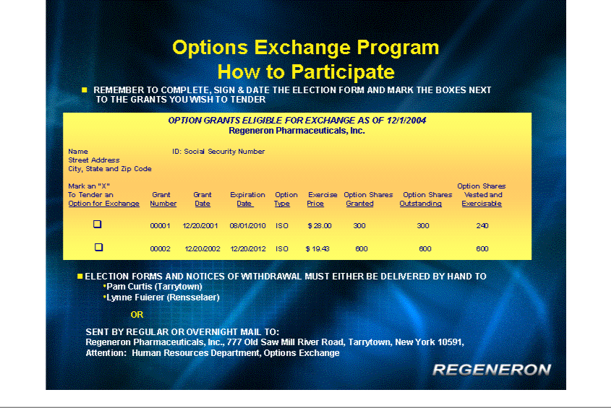

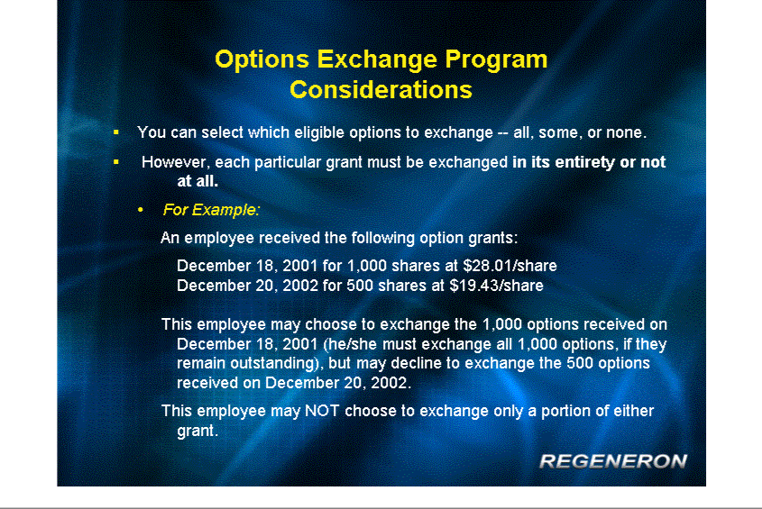

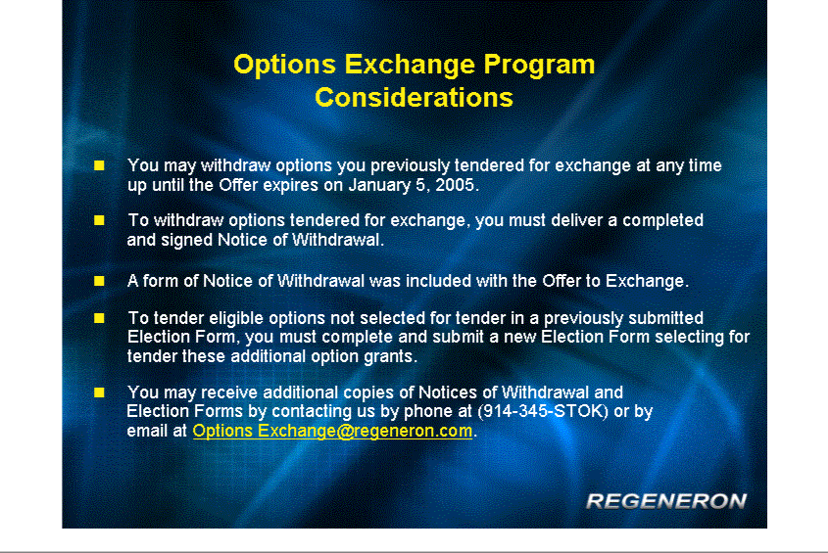

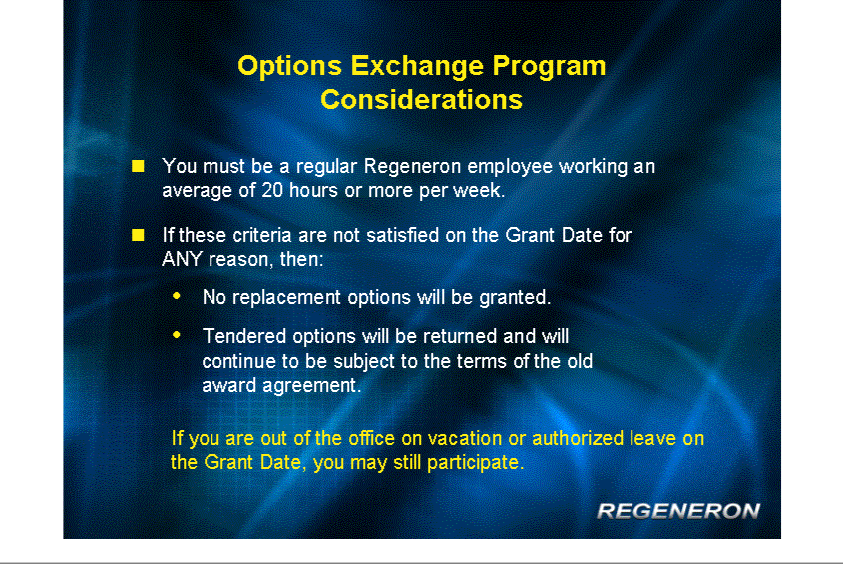

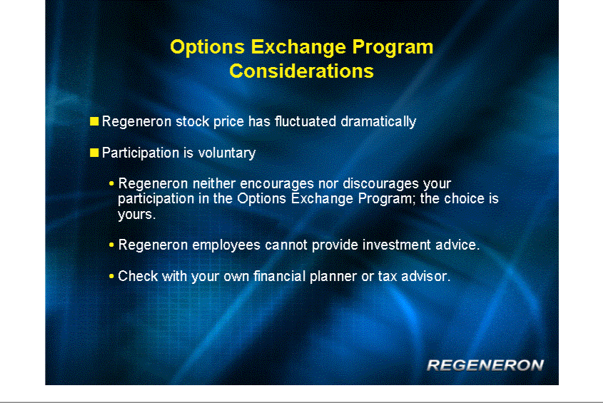

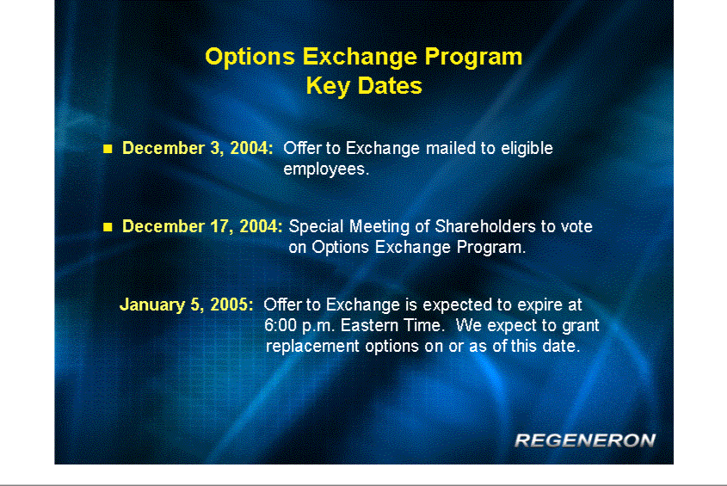

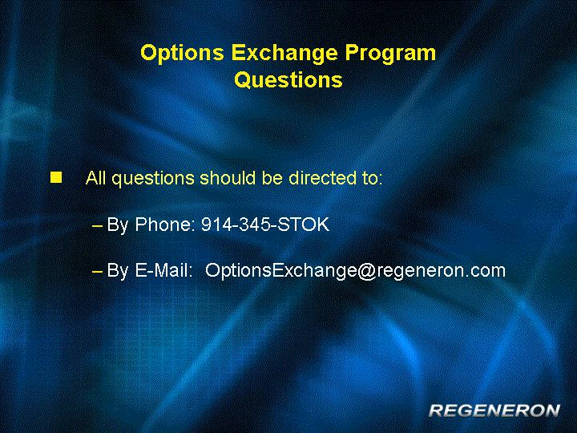

EXHIBIT (a)(1)(x)

Email from Vice President, Human Resources to All Employees Eligible to participate in

the Option Exchange Program, sent on Monday, December 6, 2004

On November 17, I informed you of our intention to commence an offer granting eligible employees an opportunity to exchange their outstanding options with exercise prices of $18 or higher for new replacement options to be issued under our 2000 Long-Term Incentive Plan. You are currently eligible to participate in this Option Exchange Program. On Friday, we mailed materials to your home containing important information on the Options Exchange Program, including the following documents:

- An Offer to Exchange, which describes the Option Exchange Program

- A blue Election Form (which includes a list of all of your stock options eligible to be exchanged) to be completed and returned to Human Resources if you elect to exchange options in the Options Exchange Program

- A lavender Notice of Withdrawal to be completed and returned to Human Resources if you submit an Election Form but later wish to withdraw your election before the Options Exchange Program expires.

If you do not receive the packet of materials by Wednesday, December 8th or are missing any of the forms described above, please contact us at 914-345-STOK or email us at OptionsExchange@regeneron.com.

The Options Exchange Program is currently scheduled to expire at 6:00 p.m., Eastern Time, on Wednesday, January 5, 2005. If you wish to participate in the Options Exchange Program, you must submit a properly completed Election Form no later than 6:00 p.m. on January 5th. Remember, completion of the options exchange is subject to various conditions, including shareholder approval authorizing the Options Exchange Program.

The Options Exchange Program is an important, one-time opportunity. You need to decide whether it makes sense for you. Please take the time to review the Offer to Exchange and the related materials carefully. To assist you in understanding the Options Exchange Program, we included sample “questions and answers” in the Offer to Exchange, which may address some of the questions you have about the program.

We will also hold the following information sessions about the Options Exchange Program in Rensselaer and Tarrytown:

Rensselaer:

Dec. 9:

2:00pm Red Mill

5:00pm Red Mill

10:00pm Bldg. 81

Dec. 10^{t:}

Noon Red Mill

2:00pm Red Mill

Tarrytown: (all in The Westchester Conference Room)

December 13

10:00 am and 2:00 pm

December 14

11:00 am and 3:00 pm

I strongly encourage you to attend one of these sessions and to call 914-345-STOK or email us at OptionsExchange@regeneron.com if you have questions that are not answered at the information session or in the Offer to Exchange. Please note that, while we will try to answer all relevant questions, no one at Regeneron can make any recommendation to you as to whether you should participate in the Option Exchange Program.

We have sent to eligible employees written materials, including an Offer to Exchange, describing in detail the terms, conditions and timing of, and procedures for participating in, the Option Exchange Program, and have filed those materials with the Securities and Exchange Commission (which can be accessed through its website at www.sec.gov). The Offer to Exchange is subject to various conditions, including shareholder approval of an amendment to the 2000 Plan expressly authorizing the Option Exchange Program. Eligible employees should read those materials carefully before deciding whether to tender their eligible options in the Offer to Exchange, because they contain important information about the Offer to Exchange. You should only rely on the information in the Offer to Exchange. Neither the Company nor our board of directors makes any recommendation as to whether you should tender some or all of your eligible options for exchange, nor have we authorized any person to make any representations or any such recommendation. You must make your own decision whether or not to tender your eligible options.

You may direct questions about the Offer to Exchange to our Human Resources Department, Option Exchange, by phone at (914) 345 STOK or to our internal e-mail address: OptionsExchange@regeneron.com.

