SCHEDULE 14A

(Rule 14a-101)

INFORMATION REQUIRED IN PROXY STATEMENT

SCHEDULE 14A INFORMATION

Proxy Statement Pursuant to Section 14(a) of the

Securities Exchange Act of 1934 (Amendment No. )

Filed by the Registrant [X]

Filed by a Party other than the Registrant [ ]

Check the appropriate box:

[ | ] | Preliminary Proxy Statement
[ | ] | Soliciting Material Under Rule 14a-12
[ | ] | Confidential, For Use of the
 |  | Commission Only (as permitted
[ | ] | by Rule 14a-6(e)(2))
[ | ] | Definitive Proxy Statement
- Definitive Additional Materials

Regeneron Pharmaceuticals, Inc.

(Name of Registrant as Specified In Its Charter)

(Name of Person(s) Filing Proxy Statement, if Other Than the Registrant)

Payment of Filing Fee (Check the appropriate box):

- No fee required.

- ] Fee computed on table below per Exchange Act Rules 14a-6(i)(4) and 0-11.

  - Title of each class of securities to which transaction applies:

  - Aggregate number of securities to which transaction applies:

  - Per unit price or other underlying value of transaction computed pursuant to Exchange Act Rule 0-11 (set forth the amount on which the filing fee is calculated and state how it was determined):

  - Proposed maximum aggregate value of transaction:

  - Total fee paid:

[ ] Fee paid previously with preliminary materials:

- ] Check box if any part of the fee is offset as provided by Exchange Act Rule 0-11(a)(2) and identify the filing for which the offsetting fee was paid previously. Identify the previous filing by registration statement number, or the form or schedule and the date of its filing.

  - Amount previously paid:

  - Form, Schedule or Registration Statement No.:

  - Filing Party:

  - Date Filed:

*** Exercise Your Right to Vote ***

Important Notice Regarding the Availability of Proxy Materials for the

Shareholder Meeting to Be Held on June 13, 2014


Meeting Information
REGENERON PHARMACEUTICALS, INC.
Meeting Type: Annual Meeting

For holders as of: April 17, 2014

Date: June 13, 2014 Time: 10:30 AM EDT

Location: Westchester Marriott Hotel

670 White Plains Road
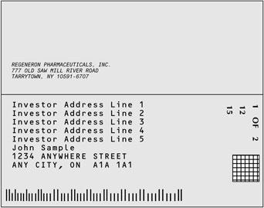

Tarrytown, New York 10591

For Meeting Directions go to:

www.regeneron.com

You are receiving this communication because you hold shares in the above named company.

This is not a ballot. You cannot use this notice to vote these shares. This communication presents only an overview of the more complete proxy materials that are available to you on the Internet. You may view the proxy materials online at www.proxyvote.com or easily request a paper copy (see reverse side).

We encourage you to access and review all of the important information contained in the proxy materials before voting.

See the reverse side of this notice to obtain proxy materials

and voting instructions.
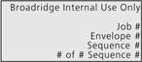

0000211096_1 R1.0.0.51160

— Before You Vote —

How to Access the Proxy Materials

Proxy Materials Available to VIEW or RECEIVE:


1. Notice & Proxy Statement 2. Annual Report

How to View Online:

Have the information that is printed in the box marked by the arrow (located on the following page) and

visit: www.proxyvote.com.

How to Request and Receive a PAPER or E-MAIL Copy:

If you want to receive a paper or e-mail copy of these documents, you must request one. There is NO charge for requesting a copy.

Please choose one of the following methods to make your request:

1) BY INTERNET: |  | www.proxyvote.com
2) | BY TELEPHONE: | 1-800-579-1639
3) | BY E-MAIL*: | sendmaterial@proxyvote.com

* If requesting materials by e-mail, please send a blank e-mail with the information that is printed in the box marked by the arrow (located on the following page) in the subject line.

Requests, instructions and other inquiries sent to this e-mail address will NOT be forwarded to your investment advisor. Please make the request as instructed above on or before May 30, 2014 to facilitate timely delivery.

— How To Vote —

Please Choose One of the Following Voting Methods


Vote In Person: Many shareholder meetings have attendance requirements including, but not limited to, the possession of an attendance ticket issued by the entity holding the meeting. Please check the meeting materials for any special requirements for meeting attendance. At the meeting, you will need to request a ballot to vote these shares.

Vote By Internet: To vote now by Internet, go to www.proxyvote.com. Have the information that is printed in the box marked by the

arrow available and follow the instructions.

Vote By Mail: You can vote by mail by requesting a paper copy of the materials, which will include a proxy card.

Internal Use

Only

0000211096_2 R1.0.0.51160

Voting items
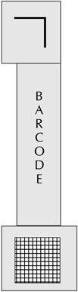

The Board of Directors recommends you vote

FOR the following:

- Election of Directors

Nominees

01 Alfred G. Gilman 02 Joseph L. Goldstein 03 Robert A. Ingram 04 Christine A. Poon 05 P. Roy Vagelos

The Board of Directors recommends you vote FOR the following proposals:

- Proposal to ratify the appointment of PricewaterhouseCoopers LLP as the Company’s independent registered public accounting firm for the fiscal year ending December 31, 2014.

- Proposal to approve, on an advisory basis, executive compensation.

- Proposal to approve the Regeneron Pharmaceuticals, Inc. 2014 Long-Term Incentive Plan.

NOTE: In their discretion, the named proxies may vote on such other business as may properly come before the Annual Meeting or at any adjourned or postponed session thereof.
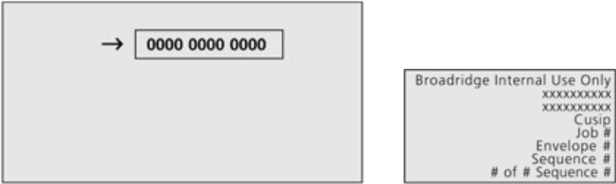

0000211096_3 R1.0.0.51160


NAME
THE COMPANY NAME INC. - COMMON | 123,456,789,012.12345
THE COMPANY NAME INC. - CLASS A | 123,456,789,012.12345
THE COMPANY NAME INC. - CLASS B | 123,456,789,012.12345
THE COMPANY NAME INC. - CLASS C | 123,456,789,012.12345
THE COMPANY NAME INC. - CLASS D | 123,456,789,012.12345
THE COMPANY NAME INC. - CLASS E | 123,456,789,012.12345
THE COMPANY NAME INC. - CLASS F | 123,456,789,012.12345
THE COMPANY NAME INC. - 401 K | 123,456,789,012.12345

THIS SPACE RESERVED FOR SIGNATURES IF APPLICABLE

Broadridge Internal Use Only

Job #
Envelope #
Sequence #

# of # Sequence #

0000211096_4 R1.0.0.51160

