UNITED STATES

SECURITIES AND EXCHANGE COMMISSION
Washington, D.C. 20549

FORM 8-K

CURRENT REPORT

Pursuant to Section 13 or 15(d)
of the Securities Exchange Act of 1934

Date of Report (Date of earliest event reported): March 4, 2014 (March 4, 2014)

REGENERON PHARMACEUTICALS, INC.

(Exact name of registrant as specified in its charter)

New York
(State or other jurisdiction
of incorporation)

000-19034 | 13-3444607
(Commission | (I.R.S. Employer
File Number) | Identification No.)
777 Old Saw Mill River Road, Tarrytown, New York | 10591-6707
(Address of principal executive offices) | (Zip Code)
Registrant’s telephone number, including area code: (914) 847-7000

Check the appropriate box below if the Form 8-K filing is intended to simultaneously satisfy the filing obligation of the registrant under any of the following provisions (see General Instructions A.2. below):

- Written communications pursuant to Rule 425 under the Securities Act (17 CFR 230.425)

- Soliciting material pursuant to Rule 14a-12 under the Exchange Act (17 CFR 240.14a-12)

- Pre-commencement communications pursuant to Rule 14d-2(b) under the Exchange Act (17 CFR 240.14d-2(b))

- Pre-commencement communications pursuant to Rule 13e-4(c) under the Exchange Act (17 CFR 240.13e-4(c))

Item 7.01. Regulation FD Disclosure.

On March 4, 2014, at the annual meeting of the American Academy of Allergy, Asthma & Immunology (AAAAI) held in San Diego, California, data from a Phase 2a trial evaluating dupilumab, a human monoclonal antibody, in patients with atopic dermatitis were presented at an oral session by Prof. Diamant Thaçi, University of Lübeck, Germany. A copy of the slides is furnished as Exhibit 99.1 to this Current Report on Form 8-K and is incorporated by reference herein.

Item 9.01. Financial Statements and Exhibits.

(d) Exhibits

99.1 Presentation entitled “Dupilumab Monotherapy in Adults with Moderate-to-Severe Atopic Dermatitis: A 12-Week, Randomized, Double-Blind, Placebo-Controlled Study.”

SIGNATURES

Pursuant to the requirements of the Securities Exchange Act of 1934, the registrant has duly caused this report to be signed on its behalf by the undersigned thereunto duly authorized.

REGENERON PHARMACEUTICALS, INC.

/s/ Joseph J. LaRosa

Joseph J. LaRosa

Senior Vice President, General Counsel and Secretary

Date: March 4, 2014

 | EXHIBIT INDEX
Number |  | Description
99.1 | Presentation entitled “Dupilumab Monotherapy in Adults with Moderate-to-Severe Atopic Dermatitis: A 12-Week, Randomized, Double-Blind, Placebo-Controlled
 | Study.”

Exhibit 99.1

Dupilumab Monotherapy in Adults with Moderate-to-Severe Atopic Dermatitis: A 12-Week, Randomized, Double-Blind, Placebo-Controlled Study

Thomas Bieber,1 Diamant Thaçi,2 Neil Graham,3 Gianluca Pirozzi,4 Ariel Teper, 4 Haobo Ren,3 Neil Stahl,3 George Yancopoulos,3 Allen Radin3

¹Department of Dermatology and Allergy, Friedrich-Wilhelms University of Bonn, Bonn,
Germany; ²Comprehensive Center Inflammation Medicine, University of Lübeck, Lübeck, Germany; ³Regeneron Pharmaceuticals, Inc., Tarrytown, United States; ⁴Sanofi, Bridgewater, United States


Disclosures

- D Thaçi is a consultant for Astellas, Novartis, Regeneron, Celgene, Abbott, Pfizer, Janssen-Cilag, MSD, Leo-Pharma

- T Bieber is a consultant for Regeneron, Basilea, L’Oréal, Oxagen, Bioalliance, Stern Biologics and a speaker for Astellas

- N Graham, H Ren, N Stahl, G Yancopoulos, and A Radin are employees and shareholders of Regeneron

- G Pirozzi and A Teper are employees and shareholders of Sanofi

- Study (NCT01548404) funded by Regeneron Pharmaceuticals, Inc. and Sanofi

2

Introduction

- Moderate-to-severe atopic dermatitis (AD) is characterized by eczematous dermatitis with intractable pruritus associated with sleep disturbance and lower quality-of-life

- For many patients, current therapies are inadequate and can be associated with unwanted side effects

- IL-4 and IL-13 are thought to be central to T-helper 2 (Th2) inflammation, which mediates many features of AD

3

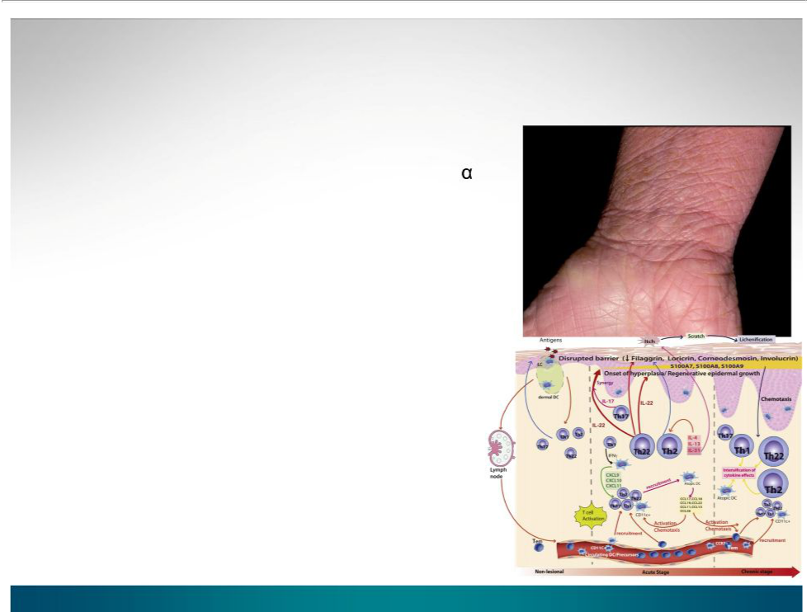
Introduction

- Dupilumab is a fully human monoclonal antibody targeting the IL-4 receptor alpha subunit (IL-4R ), thus blocking the intracellular signaling of both IL-4 and IL-13

- Earlier clinical trials indicated that dupilumab monotherapy had an acceptable safety profile and was efficacious in patients with moderate-to-severe AD who cannot be adequately controlled with topical medications

- We assessed the clinical efficacy of repeated subcutaneous doses of dupilumab monotherapy for 12 weeks in adult patients with moderate-to-severe AD poorly controlled by topical agents

4

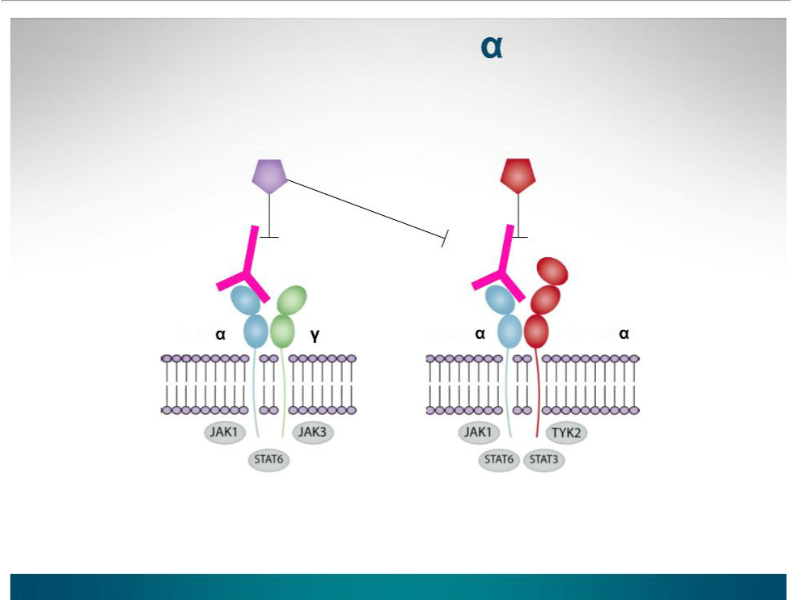
Dupilumab (anti-IL-4R ) blocks the IL-4/IL-13 receptor/ligand system

IL-4 IL-13

IL-4R c IL-4R IL-13R 1

Type I Receptor | Type II Receptor
B cells, T cells, Monocytes, | Epithelial cells, Smooth muscle
Eosinophils, Fibroblasts | cells, Fibroblasts, Monocytes,
 | Activated B cells

5

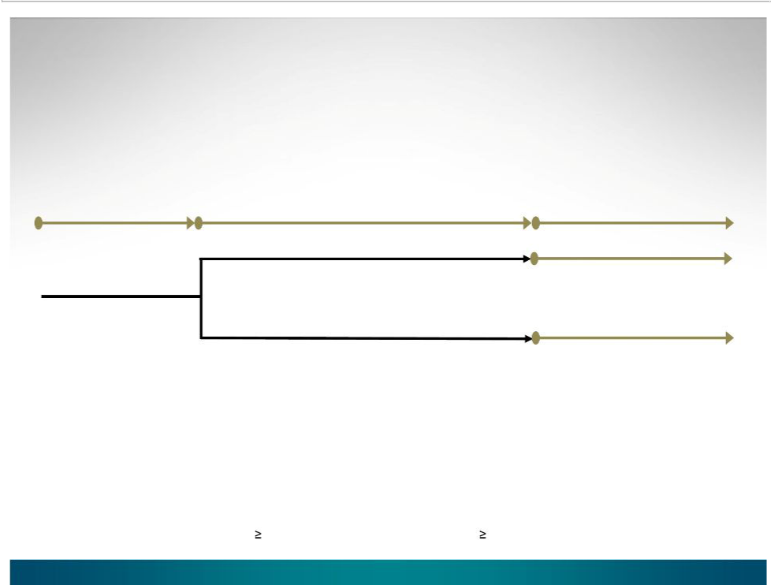
Dupilumab Monotherapy in Adults with Moderate-to-Severe Atopic Dermatitis: A European 12-Week, Randomized, Double-Blind, Placebo-Controlled Phase 2a Study (NCT01548404)

Screening | Study treatment | Safety follow-up
(adult patients | Study treatment | Safety follow-up
with moderate-to- | (weekly SC injection for 12 wks) | (16 wks)
severe AD) | (weekly SC injection for 12 wks) | (16 wks)
 | Dupilumab 300 mg (n=55)
n=109 | Placebo (n=54)

Primary endpoint: Percent change in EASI from baseline to week 12

Secondary endpoints: Changes from baseline to week 12 in EASI, SCORAD, %BSA, pruritus NRS, 5-D pruritus scale, proportion of patients achieving EASI-50/75, IGA 0-1; and safety

EASI=Eczema Area Severity Index; SCORAD=scoring of atopic dermatitis; BSA = baseline body surface area;

NRS=numeric rating scale; EASI-50 50% reduction in EASI score; EASI-75 75% reduction in EASI score

IGA 0-1=Investigator’s Global Assessment score of 0 (“clear”) or 1 (“almost clear”)

6


Key inclusion/exclusion criteria

Inclusion

• Male or female 18 yrs

• Chronic AD 3 yrs

- EASI 16

- IGA 3

- 10% BSA of AD involvement

- History of inadequate response to a stable ( 1 month) regimen of topical corticosteroids or calcineurin inhibitors within 3 months prior to screening visit

Exclusion

- Prior treatment with dupilumab

- Acute or chronic infections

- Recent treatment with topical corticosteroids, calcineurin inhibitors, immunosuppressive/ immunomodulating drugs

- Significant co-morbidities or lab abnormalities

7


Baseline demographics and disease characteristics*

Age, yrs

Caucasian, n (%)

Men, n (%)

BMI, kg/m²

AD diagnosis age, yrs EASI score (0-72) IGA score (0-5) SCORAD score (0-103) %BSA of AD

Pruritus (NRS) score (0-10)

5-D Pruritus Scale (5-25)

 |  |  | Dupilumab
Placebo |  |  | 300 mg
(n=54) |  |  | (n=55)
39.4 |  | (12.3) | 33.7 (10.4)
54 | (100) |  | 55 | (100)
27 (50.0) |  |  | 31 (56.4)
24.51 (4.64) |  |  | 25.89 (4.84)
14.4 | (18.35) |  | 6.6 (10.52)
30.8 | (13.63) |  | 28.4 | (13.57)
4.0 |  | (0.69) | 3.9 (0.67)
69.1 | (13.38) |  | 66.7 | (13.82)
50.8 | (24.14) |  | 46.8 | (24.55)
5.00 (1.40) |  |  | 6.43 (2.00)
18.7 |  | (3.50) | 18.4 (3.04)

*Values shown are mean (SD) or n (%). EASI=Eczema Area Severity Index (range 0-72); IGA=Investigator’s Global Assessment (range 0-5); SCORAD=scoring of atopic dermatitis (range 0-103); BSA = baseline body surface area; NRS=numeric rating scale (range 0-10); 5-D Pruritus Scale (range 5-25)

8

Percent change in EASI and
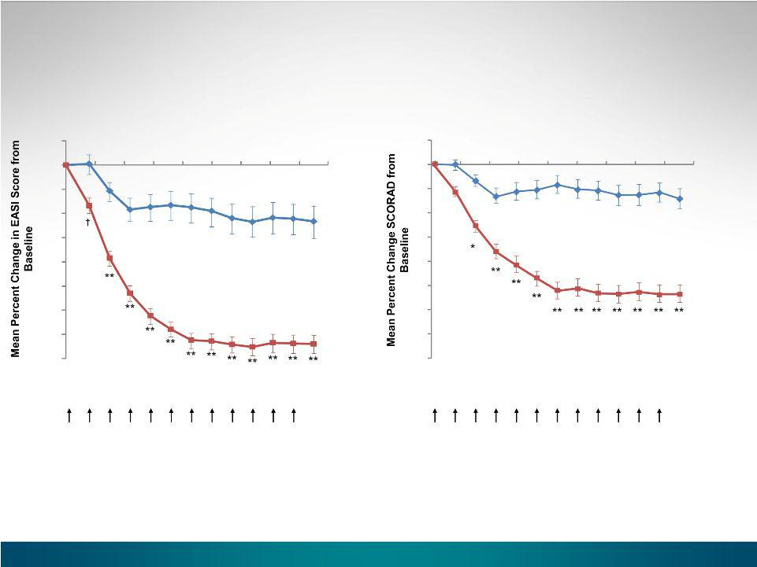

SCORAD scores over 12 weeks

10 |  |  |  |  |  |  |  |  | 10
10 | 20 | 30 | 40 | 50 | 60 | 70 | 80 | 90 | 10 | 20 | 30 | 40 | 50 | 60 | 70 | 80 | 90
0 |  |  |  |  |  |  |  |  | 0

-10 |  | -10 | -14.3%
-10 |  | -10 | Placebo
 | -23.3% |  | Placebo
-20 | -23.3% | -20
-30 | Placebo | -30
-30 |  | -30 | **P<0.0001
 |  | *p<0.001, | **P<0.0001
-40 |  | -40
-50 | † p<0.002, **P<0.0001 | -50 | -53.6%
-60 |  | -60
 |  |  | 300 mg dupilumab
-70 | -74.0% | -70
-80 | -74.0% | -80
 | 300 mg dupilumab
Study Day |  | Study Day
Study drug |  | Study drug
administration |  | administration

*, †**(LOCF)

9

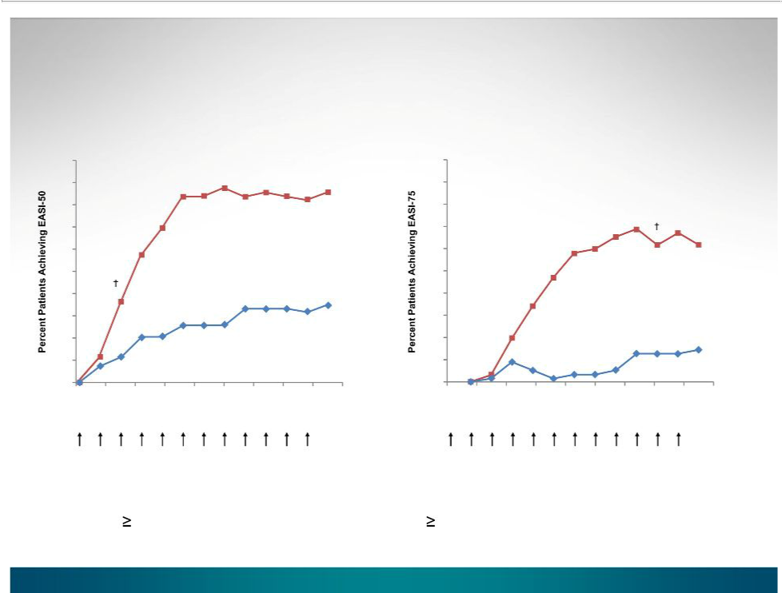
Proportion of patients who achieve EASI-50 and EASI-75 over 12 weeks

100

90

80

70

60

50

40

30

20

10

0

0

Study drug administration

** ** ** ** ** ** ** ** _{85.5%}

** 300 mg dupilumab

*

† p<0.01, *p<0.001, **P<0.0001

35.2%

Placebo

10 20 30 40 50 60 70 80 90

Study Day

100
90
80 |  |  |  |  |  |  | ** |  | **
70 |  |  |  |  |  | ** | ** | ** | **
70 |  |  |  | ** | ** | ** |  |  | 61.8%
60 |  |  |  | ** | ** |  |  |  | 61.8%
60 |  |  |  | ** | ** |  |  | 300 mg dupilumab
 |  |  |  | **
50 |  |  |  | **
40 |  |  | * |  |  | † p<0.01, *p<0.001, **P<0.0001
30
20 |  |  |  |  |  |  |  |  | 14.8%
10 |  |  |  |  |  |  |  |  | 14.8%
10 |  |  |  |  |  |  |  |  | Placebo
0
0 | 10 | 20 | 30 | 40 | 50 | 60 | 70 | 80 | 90

Study Day

Study drug

administration

*, †**(LOCF)

EASI-50 50% reduction in EASI score; EASI-75 75% reduction in EASI score

10

Percent patients achieving IGA 0-1 and mean BSA(%) at day 85

**

40.0

7.4

Placebo 300 mg

dupilumab

- p<0.0001; LOCF

Placebo

300 mg
_{50.8} dupilumab

46.8

41.8

**

19.4

Baseline Day 85

11

Percent change in NRS and 5-D pruritus scores over 12 weeks
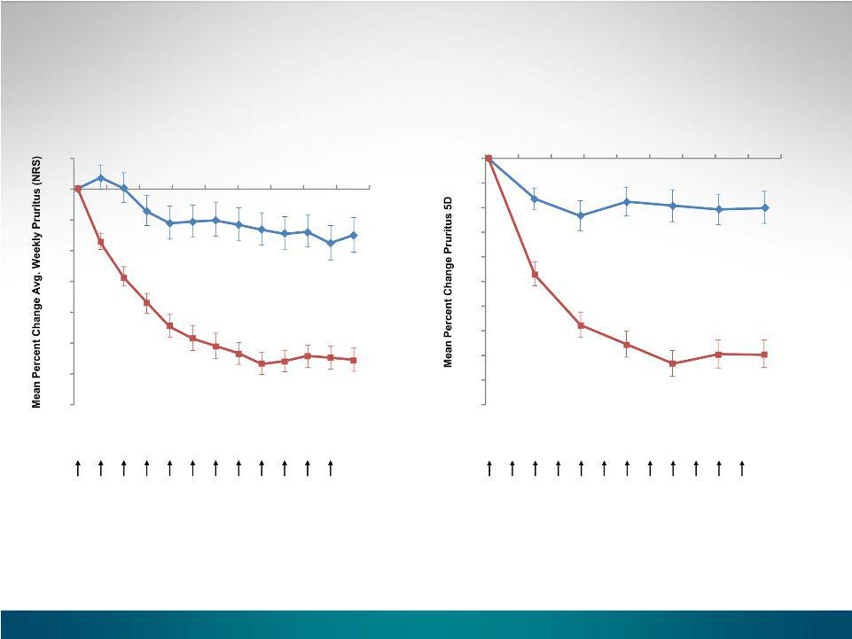

10

0

-10

-20

-30

-40

-50

-60

-70

Study drug administration

 |  |  |  |  |  |  |  |  | 0 | 10 | 20 | 30 | 40 | 50 | 60 | 70 | 80 | 90
 |  |  |  |  |  |  |  |  | 0
10 | 20 | 30 | 40 | 50 | 60 | 70 | 80 | 90 | -5

 |  |  |  | -10 |  |  | -9.9%
 |  |  | -15.1% | -15 |  |  | Placebo
 |  |  | Placebo | -20
** |  |  | **P<0.0001 | -25 |  |  | **P<0.0001
** |  |  | **P<0.0001 | -30 | **
 | ** |  |  | -35
 | ** | ** | -55.7% | -40 | ** |  | -39.7%
 |  |  | ** ** ** ** ** ** ** | -45 | ** |  | 300 mg dupilumab
 |  |  | 300 mg dupilumab |  | **
 |  |  | 300 mg dupilumab | -50 | ** | ** | **
 |  | Study Day |  |  | Study Day
 |  |  |  | Study drug
 |  |  |  | administration

**(LOCF)
NRS=numeric rating scale

12

Treatment emergent adverse


events over 28 weeks

 | Placebo |  | Dupilumab 300 mg
 | (n = 54) |  | (n = 55)
Total number of AEs |  | 159 |  | 163
Total number of AEs related to study drug |  | 45 |  | 49
Total number of serious AEs |  | 11 |  | 1
Deaths |  | 0 |  | 0
Number (%) of patients discontinued from study
Due to AE | 3 | (5.6) | 1 | (1.8)
Due to Lack of Efficacy | 23 | (42.6) | 7 (12.7)
Infections and infestations* | 31 | (57.4) | 31 | (56.4)
Most common AEs ( 10%)
Nasopharyngitis | 10 | (18.5) | 22 | (40.0)
Headache | 7 (13.0) |  | 9 (16.4)
Conjunctivitis | 2 | (3.7) | 7 (12.7)

* System Organ Class

13


Skin infections were less frequent with dupilumab treatment compared to placebo

 | Placebo | Dupilumab 300 mg
 | (n = 54) | (n = 55)
Total number of patients (%) | 13 (24.1%) | 3 (5.5%)
with skin infections
Total number of skin infections* | 14 | 3
Impetigo | 3 | 1
Skin bacterial infection | 3** | 0
Eczema herpeticum | 2** | 0
Skin infection | 2 | 0
Anorectal cellulitis | 1 | 0
Cellulitis | 1** | 0
Infected dermatitis | 1 | 0
Folliculitis | 1 | 0
Infected blister | 0 | 1
Pustular rash | 0 | 1

*based on Standardized MedDRA Query; **one occurrence considered both severe and serious

14


Serious Adverse Events

 | Placebo | Dupilumab 300 mg
 | (n = 54) | (n = 55)
Number of SAEs | 11 | 1
Patients with SAE*, n (%) | 7 (13.0%) | 1 (1.8%)
Facial bones fracture [traumatic] | 0 | 1 (1.8%)
Angina pectoris | 1 (1.9%) | 0
Cellulitis | 1 (1.9%) | 0
Eczema herpeticum | 1 (1.9%) | 0
Skin bacterial infection | 1 (1.9%) | 0
Renal failure | 1 (1.9%) | 0
Asthmatic crisis | 1 (1.9%) | 0
Lung disorder [pneumopathy] | 1 (1.9%) | 0
Dermatitis Atopic | 4 (7.4%) | 0

* MedDRA Preferred Term; all SAEs were classified as such due to hospitalization

15


Summary

- In this Phase 2a study of 109 European adults with moderate-to-severe AD, dupilumab (anti-IL-4R ) 300 mg SC weekly was associated with rapid and marked sustained improvement in EASI, SCORAD, IGA, and BSA%, and pruritus

- At 12 weeks, the dupilumab group achieved statistically superior clinical outcomes compared to the placebo group in all measures of disease activity and pruritus

- There were notably fewer patients with skin infections associated with dupilumab (5.5%) treatment compared with placebo (24.1%)

- There were no infection related SAEs or eczema herpeticum in the dupilumab group

- In the placebo group, 3 patients with skin infections and 4 patients with AD exacerbations required hospitalization

- The most common TEAEs were nasopharyngitis, headache, and conjunctivitis

16


Acknowledgements

All participating patients

Investigators

Olga Filipovska | Thomas Bieber | Jens Ulrich | Lajos Kemeny
Romana Machackova Regina Foelster-Holst |  | Thomas Werfel | Marcin Ambroziak
Petr Trestik | Martin Kaatz | Margitta Worm | Dorota Bystrzanowska
Catherine Goujon | Knut Schaekel | Klara Bajor | Maris Czubek
Jean-Paul Ortonne | Margrit Simon | Noemi Bakos | Maria Juszkiewicz-Borowiec
Carle Paul | Diamant Thaçi | Zita Battyani | Andrzej Kaszuba
Alain Taieb | Athanasios Tsianakas

Sanofi |  | Regeneron
Jennifer Cairns | Marius Ardeleanu | Judy Cusick | Jennifer Hamilton
Jeffrey Ming | Elisa Babilonia | Kristen Dougherty | Richard Kao
Susan Slaytylak-Cheeks | Warren Brooks | Chad Fish | Jacquie Kuritzky
 | Josh Cantor | Melissa Hager | Linda Williams
 | Usman Chaudhry

17



BACK-UP

18

The 5-D itch scale: a new


measure of pruritus

- 5-D Pruritus Scale: Duration, Degree, Direction, Disability, Distribution

– Single-item domain scores (duration, degree and direction) are equal to the value of the response choice

– The disability domain includes four items that assess the impact of itching on daily activities: sleep, leisure social activities, housework errands and work school

– For the distribution domain, the number of affected body parts is tallied

- 5-D scores can potentially range between 5 (no pruritus) and 25 (most severe pruritus)

Elman S et al. Brit J Dermat 2010;162:587-93.

19

