UNITED STATES

SECURITIES AND EXCHANGE COMMISSION

Washington, D.C. 20549

FORM 8-K

CURRENT REPORT

Pursuant to Section 13 or 15(d) of
the Securities Exchange Act of 1934

Date of Report (Date of earliest event reported): January 7, 2019 (January 2, 2019)

REGENERON PHARMACEUTICALS, INC.

(Exact name of registrant as specified in its charter)

New York

(State or other jurisdiction of incorporation)

000-19034 | 13-3444607
(Commission | (I.R.S. Employer
File Number) | Identification No.)
777 Old Saw Mill River Road, Tarrytown, New York | 10591-6707
(Address of principal executive offices) | (Zip Code)

Registrant’s telephone number, including area code: (914) 847-7000

Check the appropriate box below if the Form 8-K filing is intended to simultaneously satisfy the filing obligation of the registrant under any of the following provisions (see General Instructions A.2. below):

o Written communications pursuant to Rule 425 under the Securities Act (17 CFR 230.425)

o Soliciting material pursuant to Rule 14a-12 under the Exchange Act (17 CFR 240.14a-12)

o Pre-commencement communications pursuant to Rule 14d-2(b) under the Exchange Act (17 CFR 240.14d-2(b))

o Pre-commencement communications pursuant to Rule 13e-4(c) under the Exchange Act (17 CFR 240.13e-4(c))

Indicate by check mark whether the registrant is an emerging growth company as defined in Rule 405 of the Securities Act of 1933 (§ 230.405 of this chapter) or Rule 12b-2 of the Securities Exchange Act of 1934 (§ 240.12b-2 of this chapter).

Emerging growth company o

If an emerging growth company, indicate by check mark if the registrant has elected not to use the extended transition period for complying with any new or revised financial accounting standards provided pursuant to Section 13(a) of the Exchange Act. o

Item 1.01. Entry into a Material Definitive Agreement.

On January 2, 2018, Regeneron Pharmaceuticals, Inc. (“Regeneron” or the “Company”) and Sanofi Biotechnology SAS (“Sanofi”) entered into an Amended and Restated Immuno-oncology Discovery and Development Agreement (the “Amended IO Discovery Agreement”), which amended and restated that certain Immuno-oncology Discovery and Development Agreement, dated as of July 1, 2015 and executed as of July 27, 2015, by and between the Company and Sanofi, as amended (the “Original IO Discovery Agreement”). The Amended IO Discovery Agreement has an effective date of December 31, 2018.

Pursuant to the Amended IO Discovery Agreement, the scope of the existing discovery and development activities conducted by the Company (the “IO Development Activities”) has been narrowed to developing therapeutic bi-specific antibodies targeting (i) BCMA and CD3 (the “BCMAxCD3 Program”) and
- MUC16 and CD3 (the “MUC16xCD3 Program”) through clinical proof of concept. The Amended IO Discovery Agreement provides for Sanofi’s payment of $462 million to the Company as consideration for (x) the termination of the Original IO Discovery Agreement, (y) the prepayment for certain IO Development Activities regarding the BCMAxCD3 Program and the MUC16xCD3 Program, and (z) the reimbursement of costs incurred by the Company under the Original IO Discovery Agreement during the fourth quarter of 2018. The Company is required to conduct the IO Development Activities with respect to (i) the BCMAxCD3 Program through the earlier of clinical proof of concept or the expenditure of $70 million (the “BCMAxCD3 Program Costs Cap”) and (ii) the MUC16xCD3 Program through the earlier of clinical proof of concept or the expenditure of $50 million (the “MUC16xCD3 Program Costs Cap”) (the BCMAxCD3 Program Costs Cap and MUC16xCD3 Program Costs Cap, collectively, the “Program Costs Caps”); provided that under certain circumstances, Sanofi will have the option to increase the MUC16xCD3 Program Costs Cap to $70 million by making a payment to the Company in the amount of $20 million. Pursuant to the Amended IO Discovery Agreement, the Company will be primarily responsible for conducting the IO Discovery Activities and, other than certain clinical trials that may be funded separately by Sanofi, will design and conduct all research activities, including antibody development, preclinical activities, toxicology studies, manufacture of preclinical and clinical supplies, filing of Investigational New Drug Applications, and clinical development through proof of concept. The Company is obligated to reimburse Sanofi for half of the development costs that are attributable to clinical development of antibody product candidates under the Amended IO Discovery Agreement from its share of future profits to the extent they are sufficient for this purpose. As the scope of the IO Development Activities has been limited, the exclusivity obligations of the parties under the Amended IO Discovery Agreement have been narrowed.

The Amended IO Discovery Agreement provides that Regeneron retains exclusive rights to all other immuno-oncology programs that were part of the Original IO Discovery Agreement; provided that Sanofi will receive a royalty on global sales of two product candidates currently in clinical development, REGN3767 (antibody to LAG-3 protein) and REGN4659 (antibody to CTLA4).

With regard to the BCMAxCD3 Program and the MUC16xCD3 Program, when clinical proof of concept is established, the applicable Program Costs Cap is reached, or in certain other limited circumstances, Sanofi will have the option to license rights to the product candidate and other antibodies targeting the same targets for immuno-oncology indications pursuant to the Immuno-oncology License and Collaboration Agreement, dated as of July 1, 2015, by and between the Company and Sanofi, as amended. If Sanofi does not exercise its option to license rights to a product candidate, the Company will retain the exclusive right to develop and commercialize such product candidate and Sanofi will receive a royalty on sales. Pursuant to the Amended IO Discovery Agreement, the parties agreed that (i) if Sanofi exercises its option with respect to a BCMAxCD3 Program antibody, Sanofi will lead the development and commercialization of such BCMAxCD3 Program antibody; and (ii) if Sanofi exercises its option with respect to a MUC16xCD3 Program antibody, (x) the Company will lead the development of such MUC16xCD3 Program antibody and commercialization of such MUC16xCD3 Program antibody within the United States and (y) Sanofi will lead the commercialization of such MUC16xCD3 Program antibody outside of the United States. The Amended IO Discovery Agreement will terminate as of the earlier of (a) Sanofi having elected to exercise or not exercise its options with respect to the BCMAxCD3 Program and the MUC16xCD3 Program in accordance with the terms of the Amended IO Discovery Agreement and (b) December 31, 2022.

The Amended IO Discovery Agreement contains other customary covenants and termination provisions, including for material breach by the other party.

2

The foregoing description of the Amended IO Discovery Agreement is qualified in its entirety by reference to the full text of the Amended IO Discovery Agreement, a copy of which will be filed with the United States Securities and Exchange Commission (the “SEC”) as an exhibit to the Quarterly Report on Form 10-Q to be filed by the Company for the quarterly period ending March 31, 2019.

Item 2.02. Results of Operations and Financial Condition.

On January 7, 2019, the Company issued a press release providing a strategic business update in connection with the Company’s presentation at the 37th Annual J.P. Morgan Healthcare Conference in San Francisco, California (the “2019 J.P. Morgan Healthcare Conference”). The press release includes information regarding the Company’s preliminary (unaudited) U.S. net product sales of EYLEA® (aflibercept) Injection of approximately $4.07 billion for the full year 2018 (based on preliminary (unaudited) fourth quarter 2018 U.S. net product sales of EYLEA of approximately $1.07 billion). A copy of the press release is being furnished to the SEC as Exhibit 99.1 to this Current Report on Form 8-K and is incorporated by reference to this Item 2.02.

Item 7.01. Regulation FD Disclosure.

The information set forth under Item 2.02 of this Current Report on Form 8-K and Exhibit 99.1 to this Current Report on Form 8-K is incorporated by reference herein.

On January 7, 2019, at the 2019 J.P. Morgan Healthcare Conference, Leonard S. Schleifer, M.D., Ph.D., President and Chief Executive Officer of Regeneron, and George D. Yancopoulos, M.D., Ph.D., President and Chief Scientific Officer of Regeneron, are providing a corporate update. A copy of the
presentation is furnished as Exhibit 99.2 to this Current Report on Form 8-K and is incorporated by reference herein.

On January 9, 2019, at a sell-side investor meeting at the 2019 J.P. Morgan Healthcare Conference, Robert E. Landry, Executive Vice President, Finance and Chief Financial Officer of Regeneron, is giving a presentation entitled “2019 Financial Overview.” A copy of the presentation is furnished as Exhibit 99.3 to this Current Report on Form 8-K and is incorporated by reference herein.

The information included or incorporated in Item 2.02 and Item 7.01 of this Current Report on Form 8-K, including Exhibits 99.1, 99.2, and 99.3, shall not be deemed “filed” for purposes of Section 18 of the Securities Exchange Act of 1934, as amended, nor shall such information and exhibit be deemed incorporated by reference in any filing under the Securities Act of 1933, as amended, except as shall be expressly set forth by specific reference in such a filing.

Item 9.01. Financial Statements and Exhibits.

(d) Exhibits.

99.1 Press Release, dated January 7, 2019.

99.2 Presentation by Leonard S. Schleifer, M.D., Ph.D., President and Chief Executive Officer of Regeneron Pharmaceuticals, Inc., and George D. Yancopoulos, M.D., Ph.D., President and Chief Scientific Officer of Regeneron Pharmaceuticals, Inc., at the 37th Annual J.P. Morgan Healthcare Conference.

99.3 Presentation by Robert E. Landry, Executive Vice President, Finance and Chief Financial Officer of Regeneron Pharmaceuticals, Inc., entitled “2019 Financial Overview.”

3

 |  |  |  |  |  | EXHIBIT INDEX
Number |  |  |  |  |  | Description
99.1 |  | Press Release, dated January 7, 2019.
99.2 |  | Presentation by Leonard S. Schleifer, M.D., Ph.D., President and Chief Executive Officer of Regeneron Pharmaceuticals, Inc., and George D.
 |  | Yancopoulos, M.D., Ph.D., President and Chief Scientific Officer of Regeneron Pharmaceuticals, Inc., at the 37th Annual J.P. Morgan
 |  | Healthcare Conference.
99.3 |  | Presentation by Robert E. Landry, Executive Vice President, Finance and Chief Financial Officer of Regeneron Pharmaceuticals, Inc.,
 |  | entitled “2019 Financial Overview.”
 |  |  |  |  | 4

SIGNATURES

Pursuant to the requirements of the Securities Exchange Act of 1934, the registrant has duly caused this report to be signed on its behalf by the undersigned thereunto duly authorized.

REGENERON PHARMACEUTICALS, INC.

/s/ Joseph J. LaRosa

Joseph J. LaRosa

Executive Vice President, General Counsel and Secretary

Date: January 7, 2019

5

Exhibit 99.1
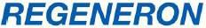

Press Release

Regeneron Provides Update on Commercial and Pipeline Progress at J.P. Morgan Healthcare Conference

TARRYTOWN, N.Y. (January 7, 2019) — Regeneron Pharmaceuticals, Inc. (NASDAQ: REGN) will provide a strategic business update to the investor community today at the 37th Annual J.P. Morgan Healthcare Conference. Leonard S. Schleifer, M.D., Ph.D., President and Chief Executive Officer, and George D. Yancopoulos, M.D., Ph.D., President and Chief Scientific Officer, will discuss commercial and pipeline progress across the company’s portfolio. Slides and a webcast from the presentation may be accessed from the “Investors & Media” page of Regeneron’s website at http://investor.regeneron.com/events.cfm.

“Regeneron continues to advance an innovative, homegrown portfolio of marketed and investigational therapies for patients with a range of serious diseases,” said Dr. Schleifer. “In 2018, we saw continued strong growth for EYLEA® (aflibercept) Injection in retinal diseases and Dupixent® (dupilumab) Injection in atopic dermatitis, as well as a positive initial reception to our two new launches — Libtayo® (cemiplimab-rwlc) Injection for advanced cutaneous squamous cell carcinoma and Dupixent for asthma. On the development front, we now have more than 20 investigational candidates in human clinical trials and look forward to entering several more this year, as we continue to leverage our cutting-edge science and technology to bring new hope to patients in need.”

EYLEA: Strengthening Market Leadership Position

- EYLEA† achieved $4.07 billion in 2018 U.S. net sales (based on preliminary, unaudited fourth quarter 2018 U.S. net sales of $1.07 billion), representing approximately 10 percent growth over 2017. (1)

- The U.S. Food and Drug Administration (FDA) has assigned an action date of May 13, 2019 for a new EYLEA indication in diabetic retinopathy.

- Regeneron is also advancing next-generation ophthalmology treatments, such as a high-dose formulation of EYLEA, which is expected to enter clinical trials in 2019.

Dupixent: Continued Growth and New Indications

  - Dupixent*† uptake continues to accelerate in both its FDA-approved indications with positive trends in new-to-brand prescriptions following a direct-to-consumer television campaign for moderate-to-severe atopic dermatitis and the 2018 asthma launch.

  - Additional important regulatory milestones are expected for Dupixent this year, including a March 11, 2019 FDA action date for adolescent atopic dermatitis (age 12-17), a European Medicines Association (EMA) decision for asthma and an FDA filing for chronic rhinosinusitis with nasal polyps.

  - In 2019, Regeneron also expects to report results from a Phase 3 study of Dupixent in pediatric patients (age 6-11) with atopic dermatitis and initiate a Phase 2/3 program in Chronic Obstructive Pulmonary Disease. Phase 2 studies in grass allergy and peanut allergy are ongoing, as are combination studies with REGN3500* (IL-33 antibody) in atopic dermatitis and asthma.

* Collaboration program with Sanofi

† See full prescribing information

1

Immuno-Oncology Platform

- Regeneron has seen encouraging early uptake from the U.S. launch of Libtayo*† for advanced cutaneous squamous cell carcinoma (CSCC). An EMA decision on Libtayo for advanced CSCC is expected in the first half of 2019, and pivotal and earlier studies in other cancers are continuing to enroll.
- Regeneron’s CD20xCD3 bispecific antibody, REGN1979, continues to progress with a potentially pivotal Phase 2 study in Follicular Lymphoma anticipated to begin in the first half of 2019 and a potentially pivotal Phase 2 study in Diffuse Large B-Cell Lymphoma anticipated to begin in the second half of 2019.

- Supported by Regeneron’s proprietary science and technology platforms, the company is advancing a new class of costimulatory bispecific antibodies for cancer, with two candidates expected to enter human clinical studies in 2019. These therapies have the potential to be used in combination with other Regeneron immuno-oncology therapies to address difficult-to-treat cancers.
- Earlier today, Regeneron and Sanofi announced a restructuring of their 2015 Immuno-oncology Discovery and Development Agreement. Regeneron and Sanofi have selected two investigational bispecific antibodies (MUC16xCD3 for mucin16-expressing cancers and BCMAxCD3 for multiple myeloma) for continued collaborative development. Regeneron will retain exclusive rights to all its other immuno-oncology programs, including additional xCD3 bispecifics and the new class of costimulatory bispecific antibodies. The bispecific antibody REGN1979 (CD20xCD3) remains exclusively owned by Regeneron.

“Over the last few years, we’ve made excellent progress with our immuno-oncology portfolio, which includes Libtayo, the first and only approved treatment for advanced cutaneous squamous cell carcinoma, as well as our first clinical-stage bispecific antibody, REGN1979,” said Dr. Yancopoulos. “Regeneron now has one approved and five clinical-stage immuno-oncology therapies for a range of targets and modalities, which have the opportunity to be used as monotherapy or in combination with other agents. We’re particularly encouraged to be entering two new therapies into the clinic this year from our costimulatory bispecific portfolio. Building on our deep antibody engineering expertise, this new class of bispecific agents has the promise to treat certain cancers where other classes of immunotherapy have proven inadequate.”

Additional Research and Development Updates

  - In 2018, Regeneron entered four new molecules into the clinic: REGN4018, a MUC16xCD3 bispecific antibody for cancer; REGN4461, a leptin receptor (LEPR) agonist for lipodystrophy and obesity; REGN4659, a CTLA-4 antibody for cancer; and REGN5069, a GFRa3 antibody for pain.
  - In 2019, four to six new molecules are expected to enter clinical development, including REGN5458, the BCMAxCD3 bispecific antibody which has already initiated a Phase 1 study, as well as two costimulatory bispecific antibodies for cancer.
  - The Regeneron Genetics Center (RGC) continues to make important discoveries, including validating the genetic role of IL-33 in asthma and identifying a new genetic variant that protects against chronic liver disease. The RGC has now sequenced over 500,000 human exomes linked to detailed patient electronic health records and anticipates sequencing up to 500,000 more exomes in 2019.

* Collaboration program with Sanofi

† See full prescribing information

2

2019 Financial Guidance(2)

Sanofi Collaboration Revenue | $510 | — 560 Million
Reimbursement of Regeneron Commercialization-Related
Expenses
Non-GAAP Unreimbursed R&D(3)(4) | $1,590 | — 1,710 Million
Non-GAAP SG&A(3)(4) | $1,500 | — 1,600 Million
Effective Tax Rate | 14 — 16%
Capital Expenditures | $410 | — 490 Million

- Regeneron records net product sales of EYLEA in the United States. Outside the United States, EYLEA net product sales comprise sales by Bayer in countries other than Japan and sales by Santen Pharmaceutical Co., Ltd. in Japan under a co-promotion agreement with an affiliate of Bayer. The Company recognizes its share of the profits (including a percentage on sales in Japan) from EYLEA sales outside the United States within “Bayer collaboration revenue” in its Statements of Operations.

- The Company’s 2019 financial guidance does not assume the completion of any significant business development transactions not completed as of the date of this press release.

- This press release uses non-GAAP unreimbursed R&D and non-GAAP SG&A, which are financial measures that are not calculated in accordance with U.S. Generally Accepted Accounting Principles (“GAAP”). These non-GAAP financial measures are computed by excluding certain non-cash and other items from the related GAAP financial measure. Non-GAAP adjustments also include the estimated income tax effect of reconciling items.

The Company makes such adjustments for items the Company does not view as useful in evaluating its operating performance. For example, adjustments may be made for items that fluctuate from period to period based on factors that are not within the Company’s control (such as the Company’s stock price on the dates share-based grants are issued or changes in the fair value of the Company’s equity investments) or items that are not associated with normal, recurring operations (such as changes in applicable laws and regulations). Management uses these non-GAAP measures for planning, budgeting, forecasting, assessing historical performance, and making financial and operational decisions, and also provides forecasts to investors on this basis. Additionally, such non-GAAP measures provide investors with an enhanced understanding of the financial performance of the Company’s core business operations. However, there are limitations in the use of these and other non-GAAP financial measures as they exclude certain expenses that are recurring in nature. Furthermore, the Company’s non-GAAP financial measures may not be comparable with non-GAAP information provided by other companies. Any non-GAAP financial measure presented by Regeneron should be considered supplemental to, and not a substitute for, measures of financial performance prepared in accordance with GAAP.

- A reconciliation of full year 2019 non-GAAP to GAAP financial guidance is included below:

3

(In millions) |  |  |  | Projected Range
 |  |  |  | Low |  |  | High
 | GAAP unreimbursed R&D (5) |  | $ | 1,855 |  | $ | 2,000
 | R&D: Non-cash share-based compensation expense |  |  | (265) |  |  | (290)
 | Non-GAAP unreimbursed R&D |  | $ | 1,590 |  | $ | 1,710
 | GAAP SG&A | $ |  | 1,700 |  | $ | 1,830
 | SG&A: Non-cash share-based compensation expense |  |  | (200) |  |  | (230)
 | Non-GAAP SG&A |  | $ | 1,500 |  | $ | 1,600

(5) Unreimbursed R&D represents R&D expenses reduced by R&D expense reimbursements from the Company’s collaborators and/or customers.

About Regeneron

Regeneron (NASDAQ: REGN) is a leading biotechnology company that invents life-transforming medicines for people with serious diseases. Founded and led for 30 years by physician-scientists, our unique ability to repeatedly and consistently translate science into medicine has led to seven FDA-approved treatments and numerous product candidates in development, all of which were homegrown in our laboratories. Our medicines and pipeline are designed to help patients with eye diseases, allergic and inflammatory diseases, cancer, cardiovascular and metabolic diseases, neuromuscular diseases, infectious diseases and rare diseases.

Regeneron is accelerating and improving the traditional drug development process through our proprietary VelociSuite® technologies, such
as VelocImmune® which produces optimized fully-human antibodies, and ambitious research initiatives such as the Regeneron Genetics Center, which is conducting one of the largest genetics sequencing efforts in the world.

For additional information about the company, please visit www.regeneron.com or follow @Regeneron on Twitter.

Regeneron Forward-Looking Statements and Use of Digital Media

This press release includes forward-looking statements that involve risks and uncertainties relating to future events and the future performance of Regeneron Pharmaceuticals, Inc. (“Regeneron” or the “Company”), and actual events or results may differ materially from these forward-looking statements. Words such as “anticipate,” “expect,” “intend,” “plan,” “believe,” “seek,” “estimate,” variations of such words, and similar expressions are intended to identify such forward-looking statements, although not all forward-looking statements contain these identifying words. These statements concern, and these risks and uncertainties include, among others, the nature, timing, and possible success and therapeutic applications of Regeneron’s products, product candidates, and research and clinical programs now underway or planned, including without limitation EYLEA® (aflibercept) Injection, Dupixent® (dupilumab) Injection, Praluent® (alirocumab) Injection, Kevzara® (sarilumab) Injection, Libtayo® (cemiplimab-rwlc) Injection, fasinumab, evinacumab, Regeneron’s immuno-oncology programs (including its costimulatory bispecific portfolio), Regeneron’s earlier-stage product candidates, and the use of human genetics in Regeneron’s research programs; the extent to which the results from Regeneron’s research programs or preclinical testing may lead to advancement of product candidates to clinical trials or therapeutic applications; unforeseen safety issues resulting from the administration of products and product candidates in patients, including serious complications or side effects in connection with the use of Regeneron’s product candidates in clinical trials; the likelihood and timing of possible regulatory approval and commercial launch of Regeneron’s late-stage product candidates and new indications for marketed products, including without limitation EYLEA, Dupixent, Praluent, Kevzara, Libtayo, fasinumab, and evinacumab; the likelihood and timing of achieving any of the anticipated milestones described in this press release; the extent to which the results from the research and development programs conducted by Regeneron or its collaborators may be replicated in other studies and lead to therapeutic applications; ongoing regulatory obligations and oversight impacting Regeneron’s marketed products (such as EYLEA, Dupixent, Praluent, Kevzara, and Libtayo), research and clinical programs, and

4

business, including those relating to patient privacy; determinations by regulatory and administrative governmental authorities which may delay or restrict Regeneron’s ability to continue to develop or commercialize Regeneron’s products and product candidates; competing drugs and product candidates that may be superior to Regeneron’s products and product candidates; uncertainty of market acceptance and commercial success of Regeneron’s products and product candidates and the impact of studies (whether conducted by Regeneron or others and whether mandated or voluntary) on the commercial success of Regeneron’s products and product candidates; the availability and extent of reimbursement of the Company’s products from third-party payers, including private payer healthcare and insurance programs, health maintenance organizations, pharmacy benefit management companies, and government programs such as Medicare and Medicaid; coverage and reimbursement determinations by such payers and new policies and procedures adopted by such payers; the ability of Regeneron to manufacture and manage supply chains for multiple products and product candidates; the ability of Regeneron’s collaborators, suppliers, or other third parties to perform filling, finishing, packaging, labeling, distribution, and other steps related to Regeneron’s products and product candidates; unanticipated expenses; the costs of developing, producing, and selling products; the ability of Regeneron to meet any of its sales or other financial projections or guidance and changes to the assumptions underlying those projections or guidance, including financial guidance relating to Sanofi collaboration revenue, non-GAAP unreimbursed R&D, non-GAAP SG&A, effective tax rate, and capital expenditures; risks associated with intellectual property of other parties and pending or future litigation relating thereto, including without limitation the patent litigation proceedings relating to EYLEA, Dupixent, and Praluent, the ultimate outcome of any such litigation proceeding, and the impact any of the foregoing may have on Regeneron’s business, prospects, operating results, and financial condition; and the potential for any license or collaboration agreement, including Regeneron’s agreements with Sanofi, Bayer, and Teva Pharmaceutical Industries Ltd. (or their respective affiliated companies, as applicable), to be cancelled or terminated without any further product success. A more complete description of these and other material risks can be found in Regeneron’s filings with the U.S. Securities and Exchange Commission, including its Form 10-K for the fiscal year ended December 31, 2017 and its Form 10-Q for the quarterly period ended September 30, 2018, including in each case in the section thereof captioned “Item 1A. Risk Factors.” Any forward-looking statements are made based on management’s current beliefs and judgment, and the reader is cautioned not to rely on any forward-looking statements made by Regeneron. Regeneron does not undertake any obligation to update publicly any forward-looking statement, including without limitation any financial projection or guidance, whether as a result of new information, future events, or otherwise.

Regeneron uses its media and investor relations website and social media outlets to publish important information about the Company, including information that may be deemed material to investors. Financial and other information about Regeneron is routinely posted and is accessible on Regeneron’s media and investor relations website (http://newsroom.regeneron.com) and its Twitter feed (http://twitter.com/regeneron).

Non-GAAP Financial Measures

This press release includes amounts that are considered non-GAAP financial measures under U.S. Securities and Exchange Commission rules. Please refer to important information about these measures, as well as a reconciliation of the non-GAAP financial measures included in this press release to the most directly comparable GAAP measures, in the notes above.

Media Relations

Hala Mirza

Tel: +1 (914) 847-3422

hala.mirza@regeneron.com

Investor Relations

Mark Hudson

Tel: +1 (914) 847-3482

mark.hudson@regeneron.com

5

Exhibit 99.2


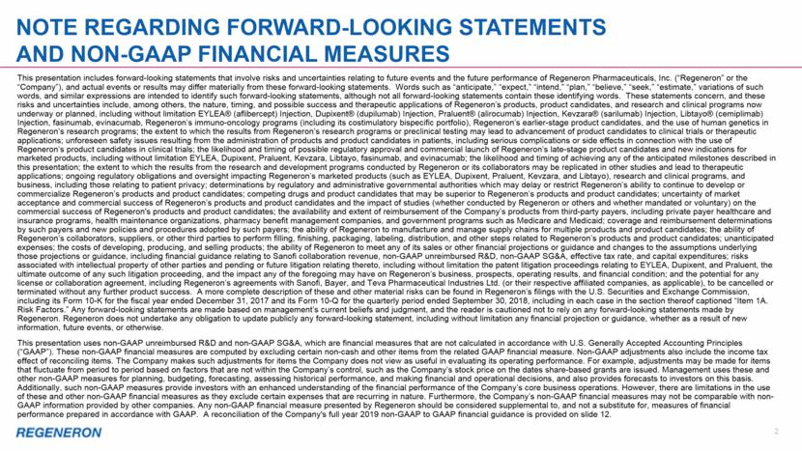

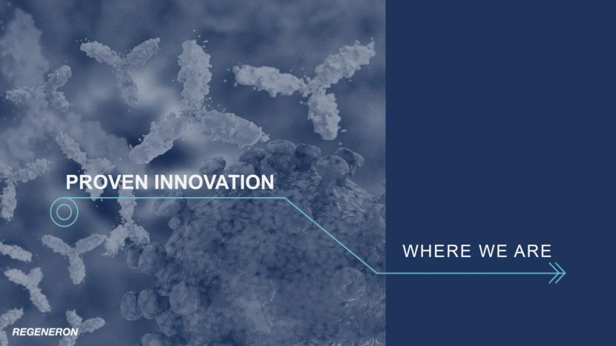

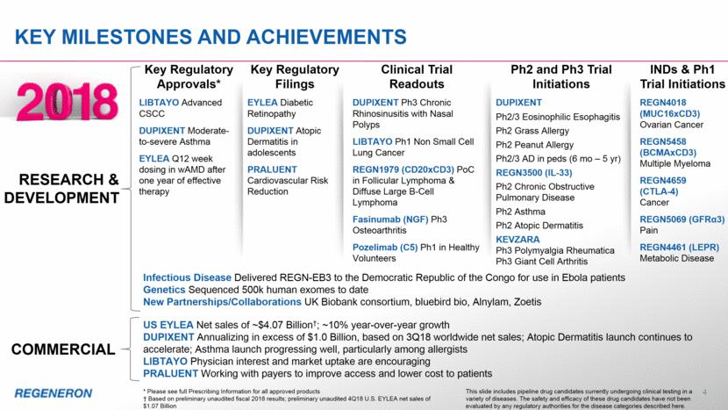

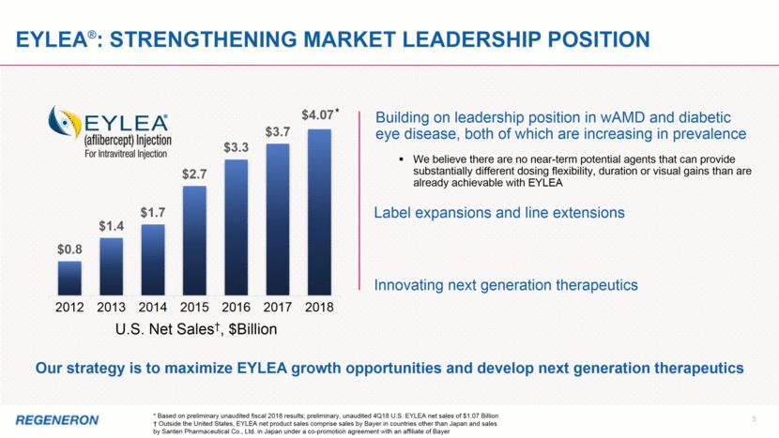

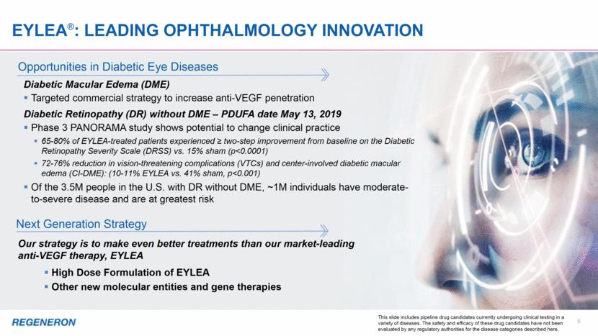

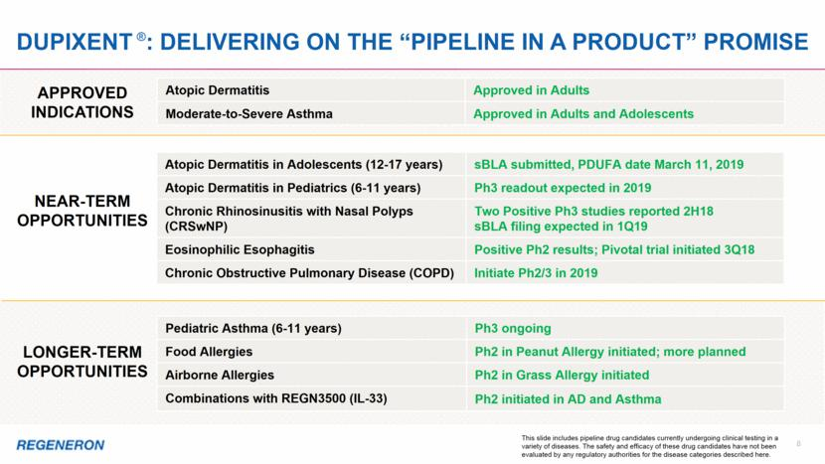

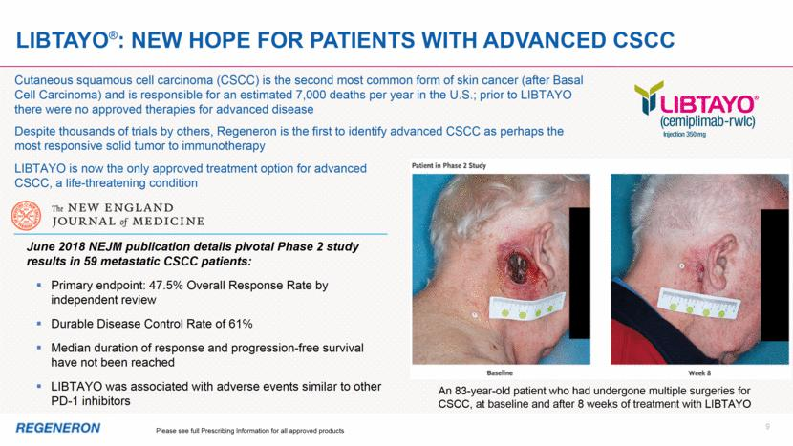

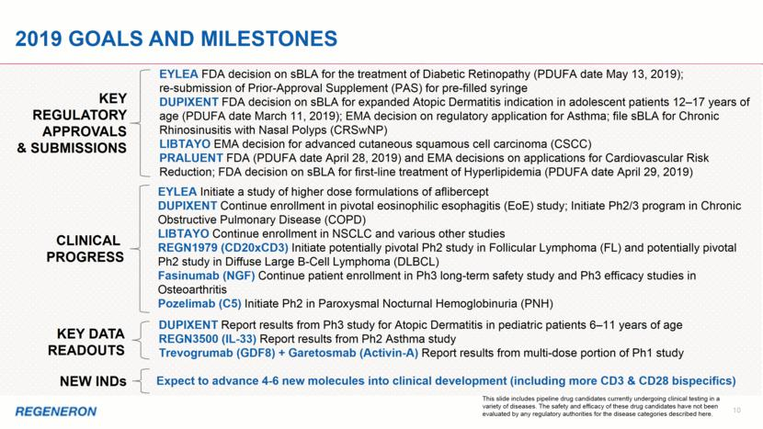

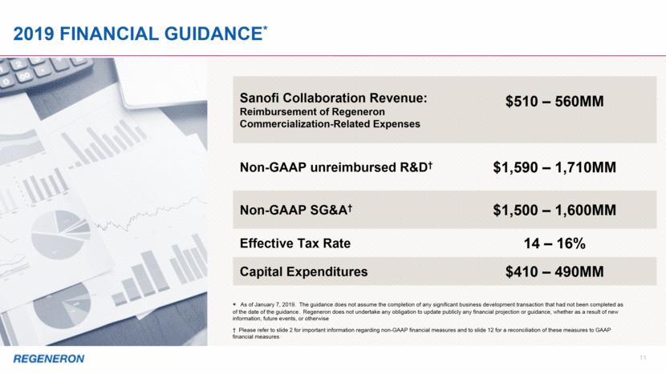

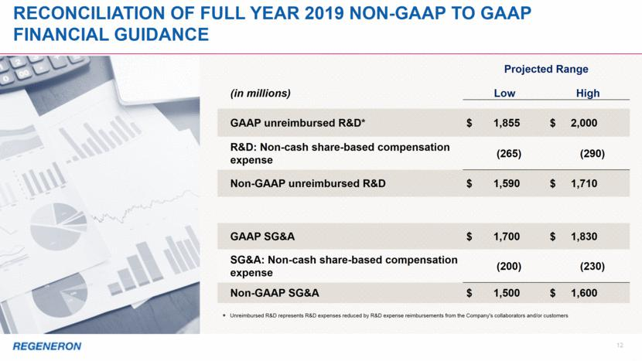

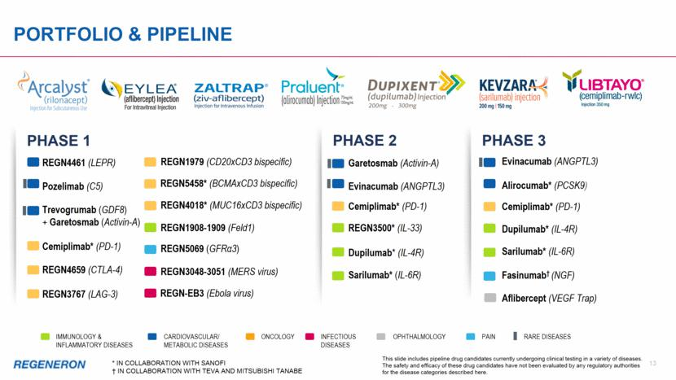

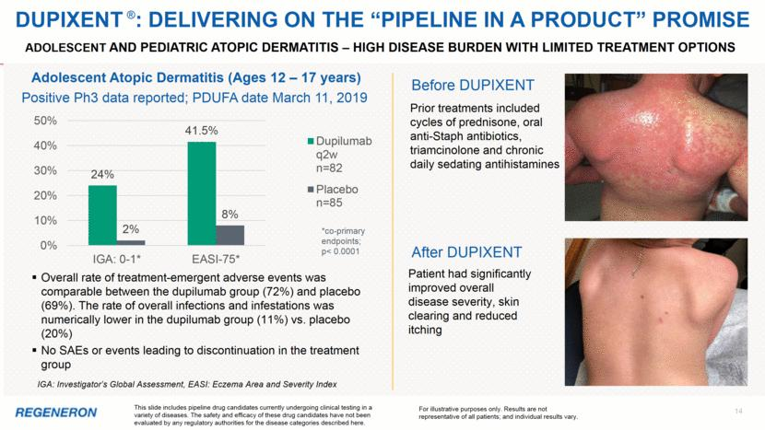

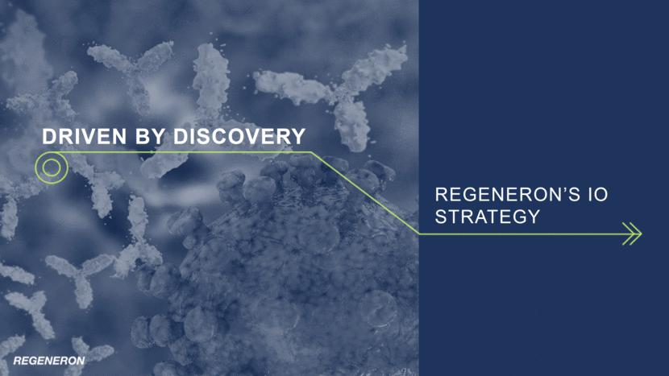

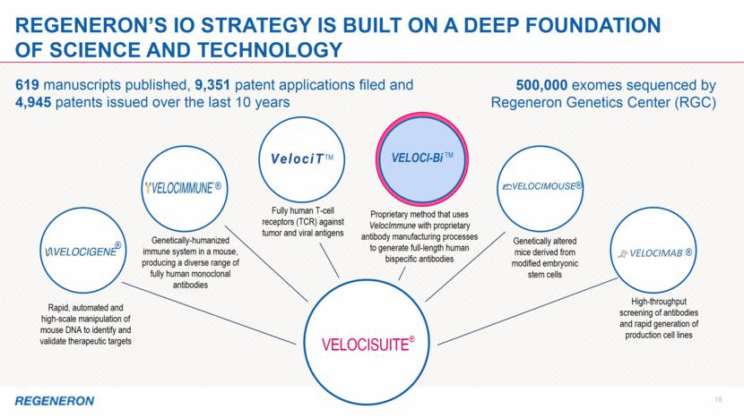

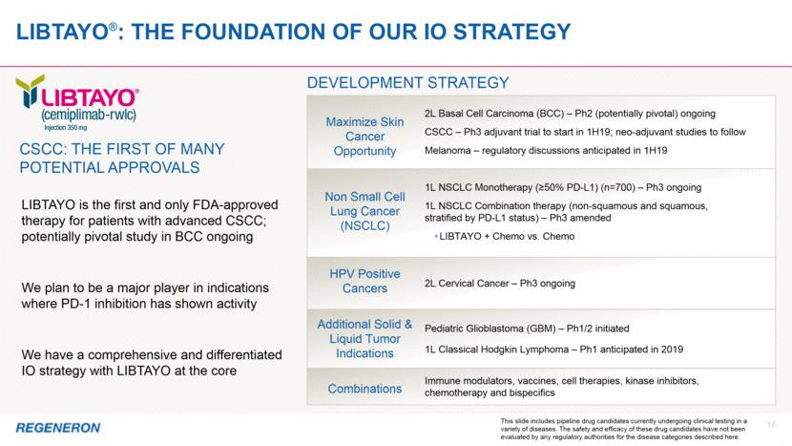

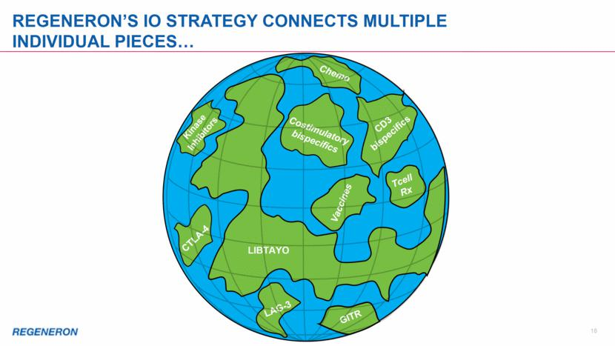

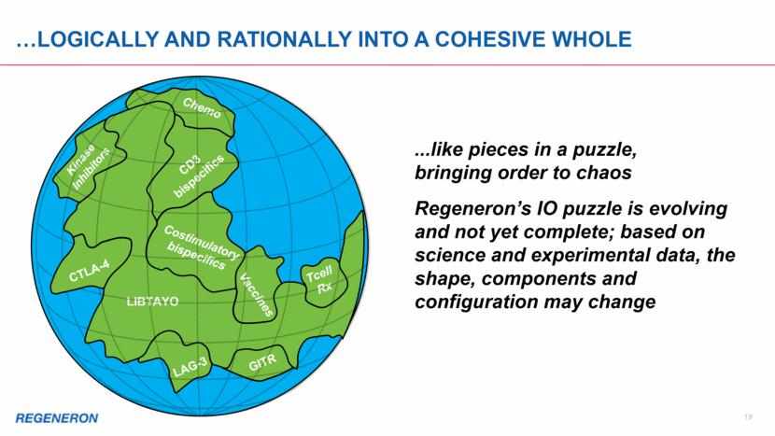

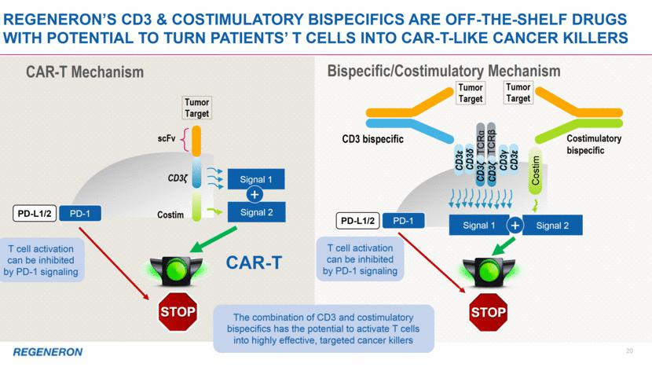

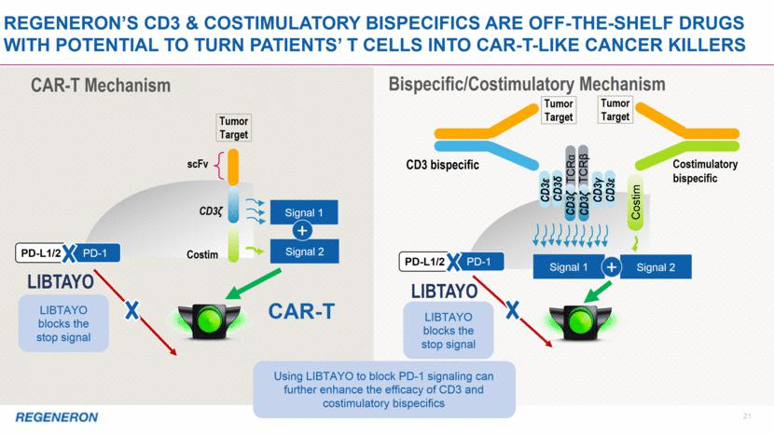

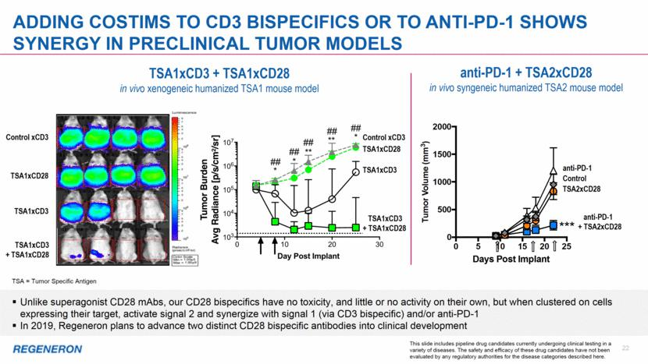

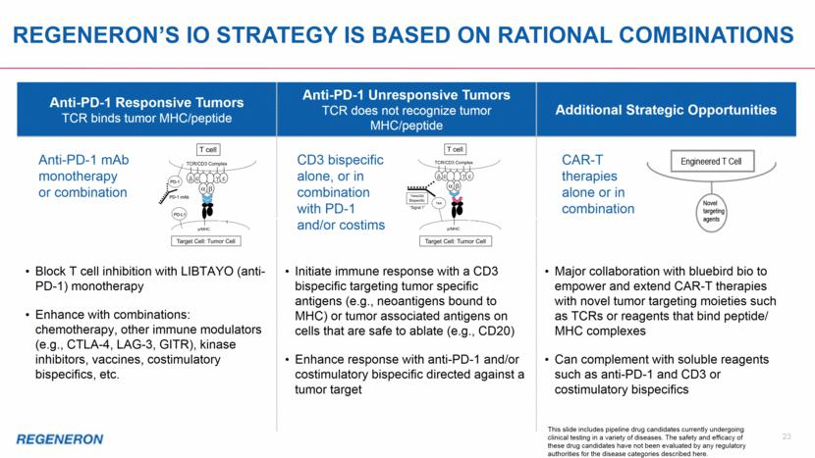

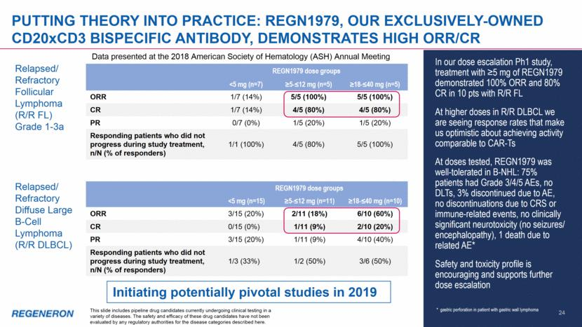

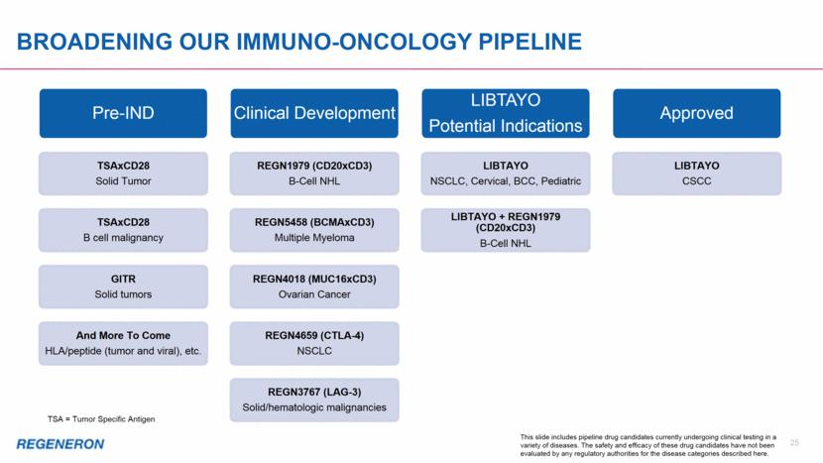

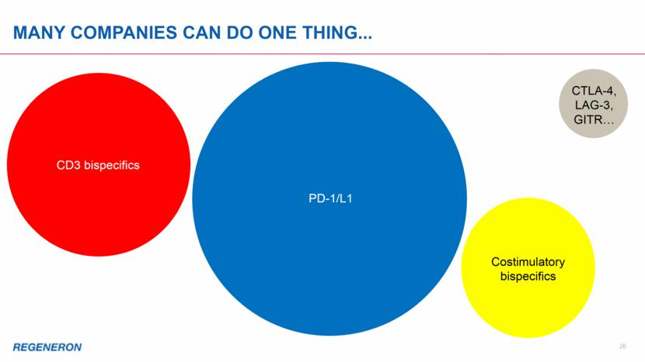

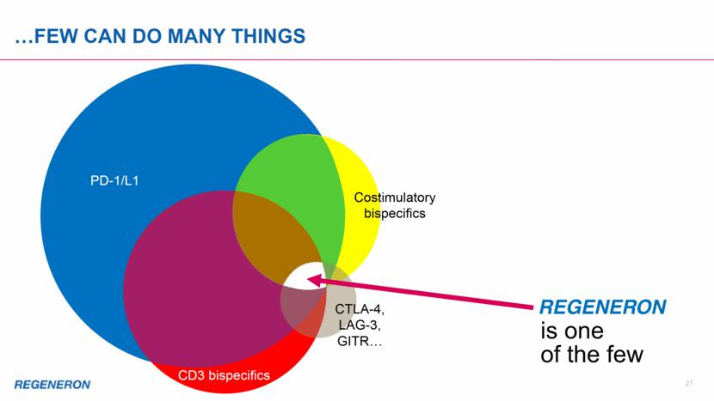

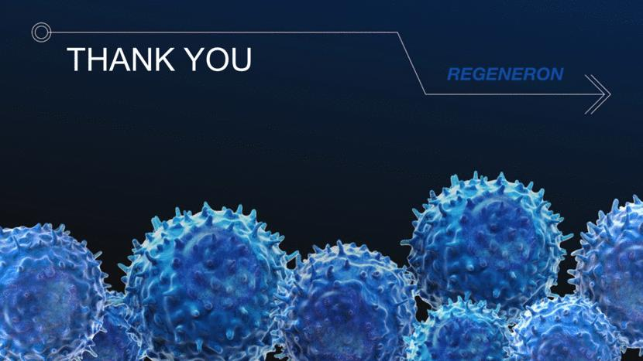

Exhibit 99.3


