UNITED STATES

SECURITIES AND EXCHANGE COMMISSION
Washington, D.C. 20549

FORM 8-K

CURRENT REPORT

Pursuant to Section 13 or 15(d)
of the Securities Exchange Act of 1934

Date of Report (Date of earliest event reported): January 13, 2015 (January 13, 2015)

REGENERON PHARMACEUTICALS, INC.

(Exact name of registrant as specified in its charter)

 | New York
 | (State or other jurisdiction
 | of incorporation)
000-19034 | 13-3444607
(Commission | (I.R.S. Employer
File Number) | Identification No.)
777 Old Saw Mill River Road, Tarrytown, New York | 10591-6707
(Address of principal executive offices) | (Zip Code)

Registrant’s telephone number, including area code: (914) 847-7000

Check the appropriate box below if the Form 8-K filing is intended to simultaneously satisfy the filing obligation of the registrant under any of the following provisions (see General Instructions A.2. below):

- Written communications pursuant to Rule 425 under the Securities Act (17 CFR 230.425)

- Soliciting material pursuant to Rule 14a-12 under the Exchange Act (17 CFR 240.14a-12)

- Pre-commencement communications pursuant to Rule 14d-2(b) under the Exchange Act (17 CFR 240.14d-2(b))

- Pre-commencement communications pursuant to Rule 13e-4(c) under the Exchange Act (17 CFR 240.13e-4(c))

Item 2.02. Results of Operations and Financial Condition.

On January 13, 2015, at the 33rd Annual J.P. Morgan Healthcare Conference in San Francisco, California, Leonard S. Schleifer, M.D., Ph.D., President and Chief Executive Officer of Regeneron Pharmaceuticals, Inc., is providing a corporate update. Dr. Schleifer’s presentation includes on page 26 information regarding the Company’s preliminary U.S. net sales of EYLEA® (aflibercept) Injection for the full year 2014. A copy of the presentation is furnished as Exhibit 99.1 to this Current Report on Form 8-K and is incorporated by reference herein.

The information included or incorporated in this Item 2.02, including Exhibit 99.1, shall not be deemed “filed” for purposes of Section 18 of the Securities Exchange Act of 1934, as amended, nor shall such information and exhibit be deemed incorporated by reference in any filing under the Securities Act of 1933, as amended, except as shall be expressly set forth by specific reference in such a filing.

Item 9.01. Financial Statements and Exhibits

- Exhibits.

99.1 Presentation by Leonard S. Schleifer, M.D., Ph.D., President and Chief Executive Officer of Regeneron Pharmaceuticals, Inc., at the 33rd Annual J.P. Morgan Healthcare Conference.

SIGNATURES

Pursuant to the requirements of the Securities Exchange Act of 1934, the registrant has duly caused this report to be signed on its behalf by the undersigned thereunto duly authorized.

REGENERON PHARMACEUTICALS, INC.

/s/ Joseph J. LaRosa

Joseph J. LaRosa

Senior Vice President, General Counsel and Secretary

Date: January 13, 2015

 | EXHIBIT INDEX
Number |  | Description
99.1 | Presentation by Leonard S. Schleifer, M.D., Ph.D., President and Chief Executive Officer of Regeneron Pharmaceuticals, Inc., at the 33rd Annual J.P.
 | Morgan Healthcare Conference.
Exhibit 99.1


_{January}PMorgan13,Healthcare2015 Conference
Leonard S. Schleifer, M.D., Ph.D.
1President and Chief Executive Officer

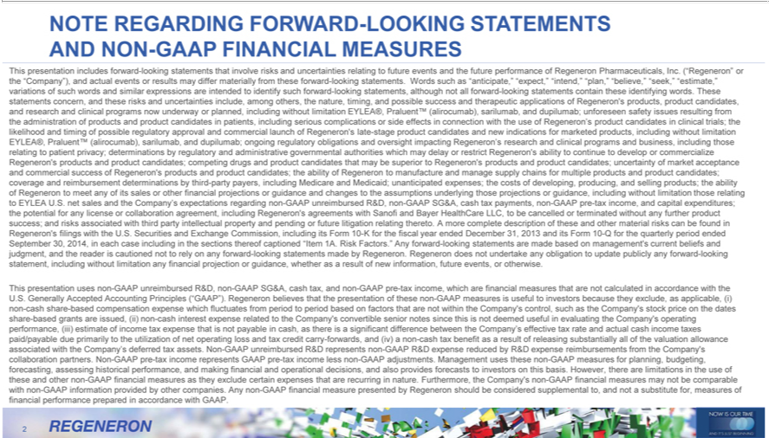

NOTE REGARDING FORWARD-LOOKING STATEMENTS AND NON-GAAP FINANCIAL MEASURES
This | includes forward-looking statements that involve risks and uncertainties relating to future events and the future performance of Regeneron Pharmaceuticals, Inc. (“Regeneron” the “Company”), and
ctualpresentationeventsresults may differ materially from these forward-looking statements. Words such as “anticipate,” “expect,” “intend,” “plan,” “believe,” “seek,” “estimate,” variations of such words and similar expressions
are intended to identify such forward-looking statements, although not all forward-looking statements contain these identifying words. These statements concern, and these risks and uncertainties include, among others,
the nature, timing, and possible success and therapeutic applications of Regeneron’ |  |  |  | products, product candidates, and research and clinical programs now underway or planned, including without limitation EYLEA®,
Praluent™ (alirocumab), |  | and dupilumab; unforeseen safety issues resulting from the administration of products and product candidates in patients, including serious complications or side effects |  |  |  |  |  | connection
with the use of Regeneron’sarilumab,product candidates in clinical trials; the likelihood and timing of possible regulatory approval and commercial launch of Regeneron’s late-stage product candidates and new indications for
marketed products, including without limitation EYLEA®, Praluent™ (alirocumab), sarilumab, and dupilumab; ongoing regulatory obligations and oversight impacting Regeneron’s research and clinical programs and
business, including those relating to patient privacy; determinations by regulatory |  |  |  | administrative governmental |  | which may delay or restrict Regeneron’s ability to continue to develop or commercialize
 |  | competing drugs and product candidates that may be superior to Regeneron’authoritiesproducts and product candidates; uncertainty of market acceptance and commercial success of
Regeneron’s products and product candidates; the ability of Regeneron to manufacture and manage supply chains for multiple products and product candidates; coverage and reimbursement determinations by third-party
payers, including Medicare and Medicaid; unanticipated expenses; the costs of developing, producing, and selling products; the ability of Regeneron to meet any of its sales or other financial projections or guidance and
changes to the assumptions underlying those proj ctions or guidance, |  |  | without limitation those relating to EYLEA U.S. net sales and the Company’s |  |  |  | regarding non-GAAP unreimbursed R&D, non-
GAAP SG&A, cash tax payments, non-GAAP pre-tax income, and capitincludingexpenditures; the potential for any license or collaboration agreement, including Regeneron’expectationsagreements with Sanofi and Bayer HealthCare
LLC, to be cancelled or terminated without any further product success; and risks associated with third party intellectual property and pending or future litigation relating thereto. A more complete description of these and
other material risks can be found in Regeneron’s filings with the U.S. Securities and Exchange Commis ion, including its Form 10-K for the fiscal year ended December 31, 2013 and its Form 10-Q for the quarterly
period ended September 30, 2014, in each case including in the sections thereof captioned “Item 1A. Risk Factors.” Any forward-looking statements are made based on management’s current beliefs and judgment, and
the reader is cautioned not to rely on any forward-looking statements made by Regeneron. Regeneron does not |  |  |  |  |  | any obligation to update
publicly any forward-looking statement, including without limitation any financial projection or guidance, whetherundertakeasresult of new information, future events, or otherwise.
This presentation uses non-GAAP unreimbursed R&D, non-GAAP SG&A, cash tax, and non-GAAP pre-tax income, which are financial measures that are not calculated in accordance with the U.S. Generally Accepted
Accounting Principles (“GAAP”). Rege eron believes that the presentation of |  |  |  | non-GAAP | is useful to investors because they exclude, as applicable, (i) non-cash share-based compensation expense which
fluctuates from period to period based on factors that are not within the Company’thesecontrol, |  |  |  |  | measurestheCompany’s stock price on the dates share-based grants are issued, (ii) non-cash interest expense related to the
Company’s convertible senior notes since this is not deemed useful in evaluating the Company’such operating performance, (iii) estimate of income tax expense that is not payable in cash, there is a |  |  |  |  |  |  |  | difference
between the Company’s effective tax rate and actual cash income taxes paid/payable due primarily to the utilization of net operating loss and tax credit carry-forwards, and (iv) a non-cash tax benefitsignificantasresult of
releasing | all of the valuation allowance associated with the Company’s deferred tax assets. Non-GAAP unreimbursed R&D represents non-GAAP R&D expense reduced by R&D expense reimbursements
from the Company’substantiallycollaboration partners. Non-GAAP pre-tax income represents GAAP pre-tax income less non-GAAP adjustments. Management uses these non-GAAP measures for planning, budgeting, forecasting, _{measures}assesing historical performance, and making financial and operational decisions, and also provides forecasts to investors on this basis. However, there are limitations in the use of these and other non-GAAP financial
as they exclude certain expenses that are recurring in nature. Furthermore, the Company’s non-GAAP financial measures may not be comparable with non-GAAP information provided by other companies. Any non-GAAP financial measure presented by Regeneron should be considered supplemental to, and not a substitute for, measures of financial performance prepared in accordance with GAAP.

2



3For over 25 years, Regeneron’s vision has been to build an innovative company that consistently brings new medicines to patients with serious diseases.



4NOW IS OUR TIME AND IT’S JUST BEGINNING

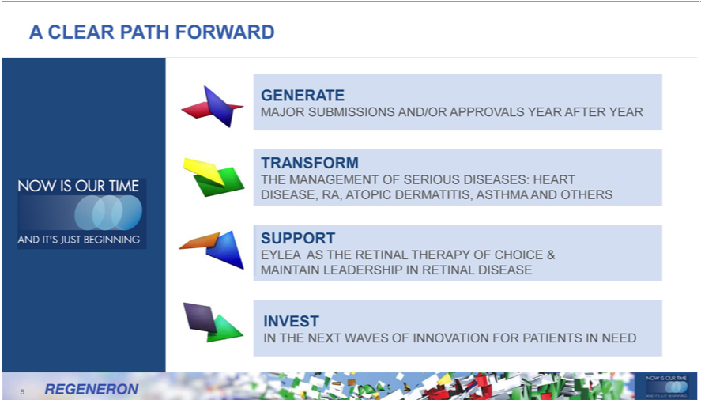

_{GENERA}CLEARTEPATH FORWARD
^{THE}MAJORRANSFORMSUBMISSIONS AND/OR APPROVALS YEAR AFTER YEAR
_{SUPPORMANAGEMENT} OF SERIOUS DISEASES: HEART DISEASE, RA, ATOPIC DERMATITIS, ASTHMA AND OTHERS EYLEA AS THE RETINAL THERAPY OF CHOICE & MAINTAIN LEADERSHIP IN RETINAL DISEASE
_{IN}VEST
₅ THE NEXT WAVES OF INNOVATION FOR PATIENTS IN NEED



^{UNMA}
D THETCHEDENGINE TO MAKE IT A REALITY…
PIPELINE
PEOPLECULTURE OF INNOVATION
PROWESSSCIENCE& TECH
6



PIPELINEANDTHE ENGINE TO MAKE IT A REALITY…
17 antibodies across multiple therapeutic areas
3 in late stage
PEOPLECULTURE OF INNOVATION
PROWESSSCIENCE& TECH
7



PIPELINEANDTHE ENGINE TO MAKE IT A REALITY…
17 antibodies across multiple therapeutic areas
3 in late stage
PEOPLE
SCIENCE Top Employer for 3 years
Rapidly#5Most growingInnovativeCommercialCompany team(Forbes)
PROWESSSCIENCE& TECH
8



PIPELINEANDTHE ENGINE TO MAKE IT A REALITY…
therapeutic17antibodiesareasacross multiple
3 in late stage
PEOPLE
SCIENCE Top Employer for 3 years
Rapidly#5Most growingInnovativeCommercialCompany team(Forbes)
VelocImmune®PROWESS Industrial
BiRegeneron-specificsOperations Genetics Center & Supply
9

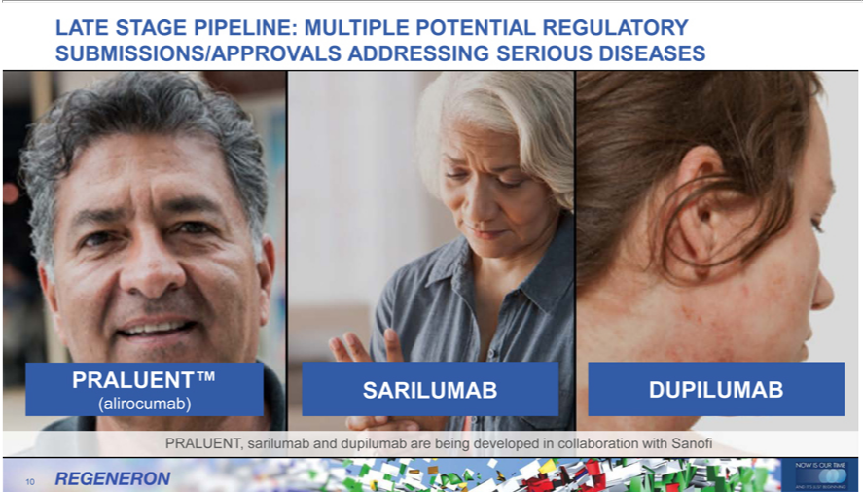

LATE STAGE PIPELINE: MULTIPLE POTENTIAL REGULATORY SUBMISSIONS/APPROVALS ADDRESSING SERIOUS DISEASES PRALUENT™
(alirocumab)
SARILUMAB
DUPILUMAB
10PRALUENT, sarilumab and dupilumab are being developed in collaboration with Sanofi

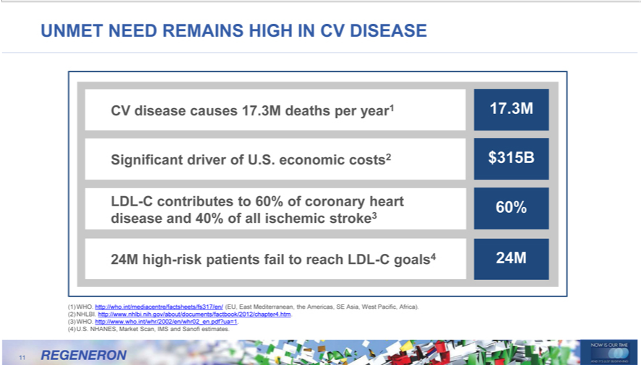

UNMET NEED REMAINS HIGH IN CV DISEASE
CV disease causes 17.3M deaths per year1 17.3M
Significant driver of U.S. economic costs2 $315B
LDL-C contributes to 60% of coronary heart 60% disease and 40% of all ischemic stroke3
24M high-risk patients fail to reach LDL-C goals4 24M |  | (EU, East Mediterranean, the Americas, SE Asia, West Pacific, Africa). (2) NHLBI. http://www.nhlbi.nih.gov/about/documents/factbook/2012/chapter4.htm.
1) | ho.
(3) | WHO. http://wwwint/mediacentre/factsheets/fs317/en/.who.int/whr/2002/en/whr02.pdf?ua=1. (4) U.S. NHANES, Market Scan, IMS and Sanofi estimates.
11

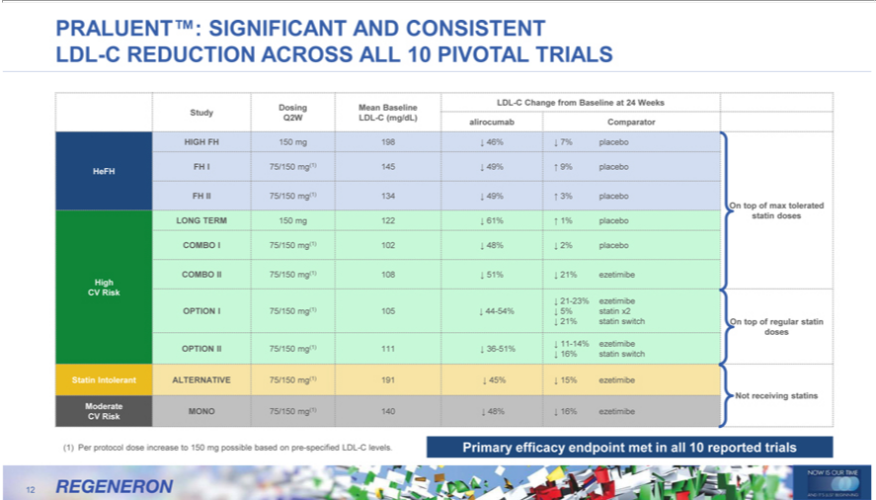

PRALUENT™:LDL-CChange fromSIGNIFICANTBaselineat AND24WeeksCONSISTENTDosingMeanLDLBaseline-CREDUCTIONStudyQ2WACROSSLDL-(mg/dL)ALL10 alirocumabPIVOTAL TRIALSComparator

HeFHHIGH75/150FH150mg(1)19814546%49%7%9%placeboplacebo
II 75/150 mg(1) 134 49% 3% placebo
LONGOntop ofTERMmax 150toleratedmg(1)122statin61%doses1% placebo
COMBOHigh II75/15075/150 mg(1)10210848%51%2%21%placeboezetimibe
21%CVRiskstatin21switch-23% ezetimibeOntopof OPTIONregularstatinI75/150dosesmg(1) 105 44-54% 5% statin x2
(1) 11-14% ezetimibe OPTION II 75/150 _{mg(1)}111 36-51% 16% statin switch

Statin Intolerant ALTERNATIVE 75/150 191 45% 15% ezetimibe
Primary(1)Perprotocolefficacydoseendpointincreasemet toin 150all10mgreportedpossibletrialsbased on pre-specified LDL-C levels.
12

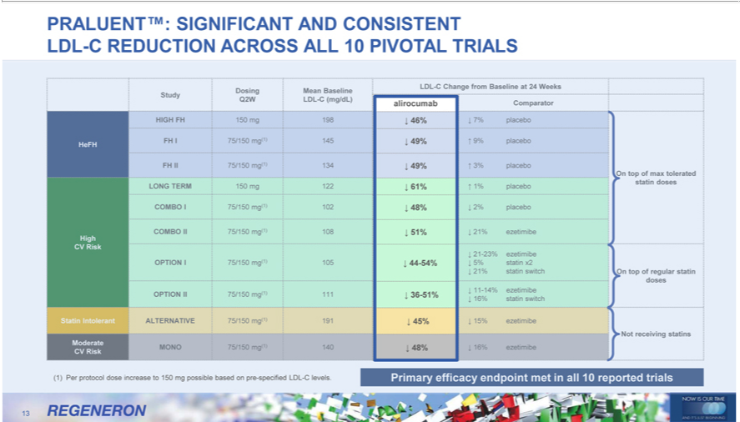

PRALUENT™: SIGNIFICANT AND CONSISTENT LDL-C REDUCTION ACROSS ALL 10 PIVOTAL TRIALS alirocumab
^{48%}
6%-54%49%3649%-51%61%45%48% 51%
13(1) Per protocol dose increase to 150 mg possible based on pre-specified LDL-C levels.

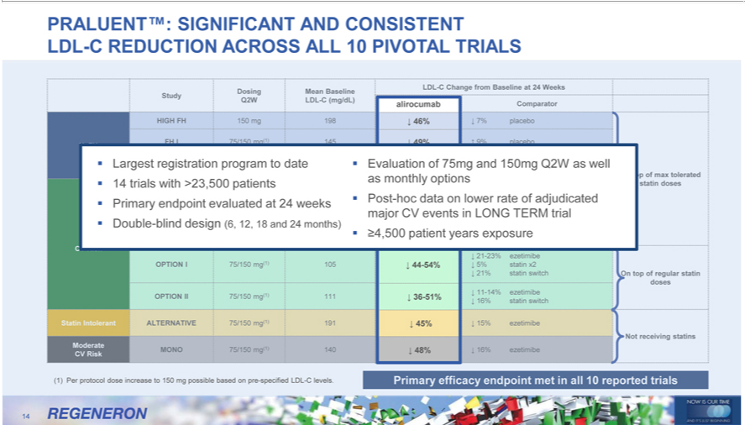

PRALUENT™: SIGNIFICANT AND CONSISTENT LDL-C REDUCTION ACROSS ALL 10 PIVOTAL TRIALS alirocumab
49%^{6%}
Largest registration program to date Evaluation 49% of 75mg and 150mg Q2W as well 14 trials with ³23,500 patients as monthly 61% options Primary endpoint evaluated at 24 weeks Post-hoc data on lower rate of _{Double}adjdicated major CV 48% events in LONG TERM trial
³^{4,500} patient-blind design51%years(6,12,exposure18and 24 months)
_{48%}-54% 36-51% 45%
14(1) Per protocol dose increase to 150 mg possible based on pre-specified LDL-C levels.

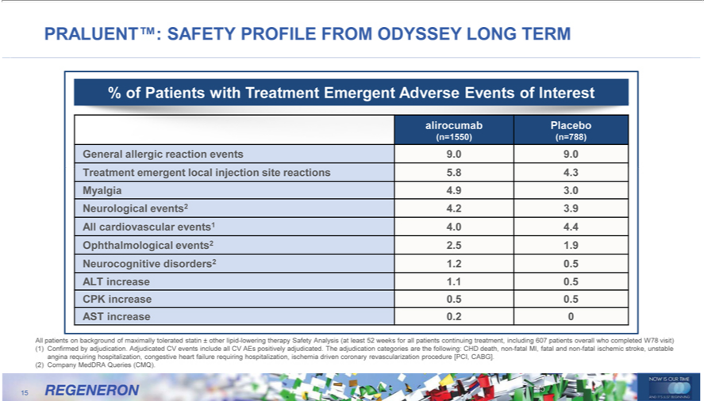

PRALUENT™: PROFILE FROM ODYSSEY LONG TERM
SAFETY
alirocumab%ofPatientsPlacebowith reatment Emergent Adverse Events of Interest
(n=1550) (n=788)
_{Neurocognitive}Gneralallergic reaction events 9.0 9.0 Treatment emergent local injection site reactions 5.8 4.3 Myalgia 4.9 3.0 Neurological events2 4.2 3.9 All cardiovascular events1 4.0 4.4 Ophthalmological events2 2.5 1.9 disorders2 1.2 0.5 ALT increase 1.1 0.5 CPK increase 0.5 0.5 AST increase 0.2 0
All patients on background of maximally tolerated statin ± other lipid-lowering therapy Safety Analysis (at least 52 weeks for all patients continuing treatment, including 607 patients overall who completed W78 visit)
(1) Confirmed by adjudication. Adjudicated CV events include all CV AEs positively adjudicated. The adjudication categories are the following: CHD death, non-fatal MI, fatal and non-fatal ischemic stroke, unstable angina requiring hospitalization, congestive heart failure requiring hospitalization, ischemia driven coronary revascularization procedure [PCI, CABG].
(2) Company MedDRA Queries (CMQ).
15

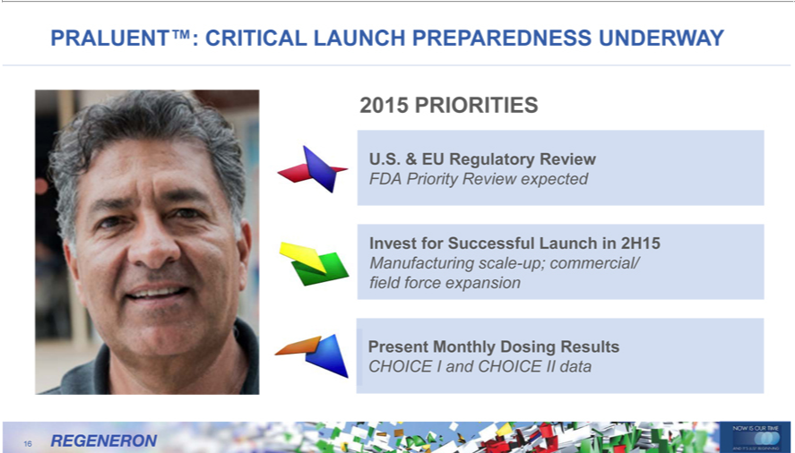

2015PRALUENT™:PRIORITIESCRITICAL LAUNCH PREPAREDNESS UNDERWAY
U.S. & EU Regulatory Review
InvestFDAPriorityforSuccessfulReview Launchexpectedin 2H15
PresentManufacturingMonthlyscaleDosing-up; Resultscommercial/ field force expansion
16CHOICE I and CHOICE II data

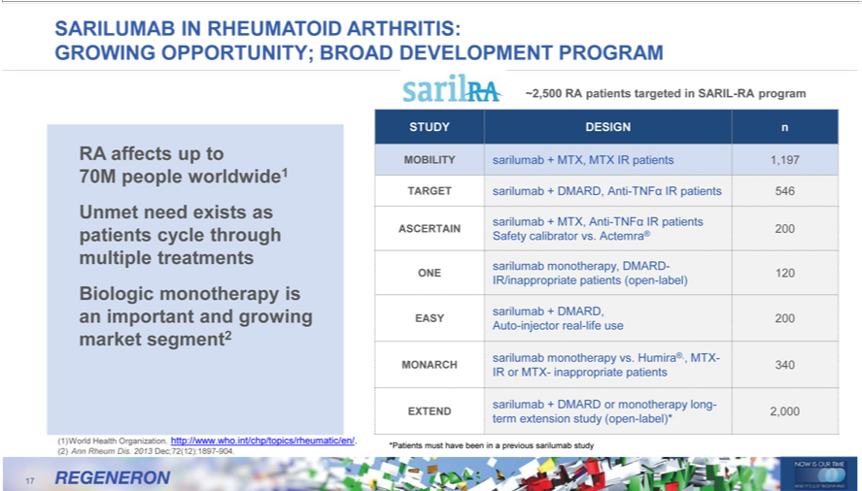

SARILUMAB IN RHEUMATOID ARTHRITIS:
GROWING OPPORTUNITY; BROAD DEVELOPMENT PROGRAM
RA affects up to 70M people worldwide1 Unmet need exists as patients cycle through multiple treatments Biologic monotherapy is an important and growing market segment2 ~2,500 RA patients targeted in SARIL-RA program
STUDY DESIGN n
_{MOBILITY}ARGETsarilumabsarilumab+ DMARD,+MTX,MTXAnti-IRTNFpatientsIRpatients1,197 546
ASCERTAINsarilumab+MTX,®200Anti-TNF IR patients
Safety calibrator vs. Actemra
ONEsarilumab120 monotherapy, DMARD-
sarilumabIR/inappropriate+DMARD,patients (open-label)
AutoEASY-injector200 real-life use
MONARCHsarilumabmonotherapy340 vs. Humira®,, MTX-
IR or MTX- inappropriate patients
EXTENDsarilumab +2,000DMARDterm extensionormonotherapystudy(openlong--label)*
⁽²⁾
1 WorldAnnRheumHealthDis.Organization.2013Dec;72(12):1897http://www.who.int/chp/topics/rheumatic/en/.-904.
17*Patients must have been in a previous sarilumab study

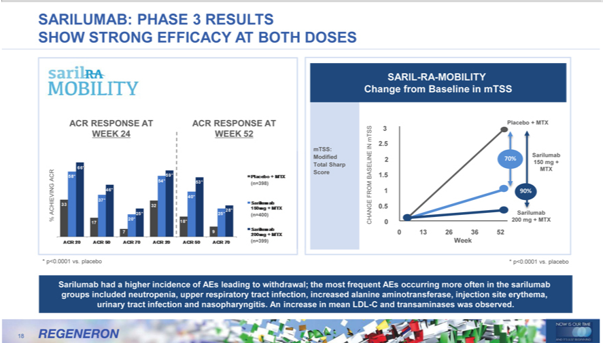

ARILUMAB: PHASE 3 RESULTS
SHOW STRONG | AT BOTH DOSES
_{R} RESPONSE EFFICACYTACRRESPONSE AT WEEK 24 WEEK 52
ACHIEVING (n=398)
% (n=400) (n=399)
* p<0.0001 vs. placebo
SARIL-RA-MOBILITY Change from Baseline in mTSS
Placebo + MTX mTSS 3
IN 2.5 mTSS: Sarilumab Modified 2 70% Total Sharp 150 mg + MTX
Score BASELINE 1.5
FROM 1 90%
.5 Sarilumab CHANGE 0 200 mg + MTX
0 13 26 36 52 Week
* p<0.0001 vs. placebo | ncidence of AEs leading to withdrawal; the most frequent AEs occurring more often in the sarilumab groups included neutropenia, upper respiratory tract infection, increased alanine
Sarilumab had higher
aminotransferase, injection
18 site erythema, urinary tract infection and nasopharyngitis. An increase in mean LDL-C and transaminases was observed.

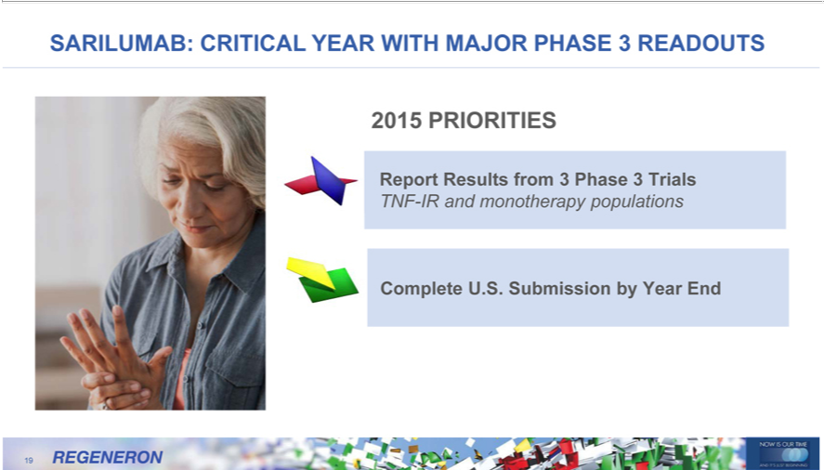

2015SARILUMAB:PRIORITIESCRITICAL YEAR WITH MAJOR PHASE 3 READOUTS
ReportTNF-IRResultsandmonotherapyfrom3Phasepopulations3Trials
19Complete U.S. Submission by Year End

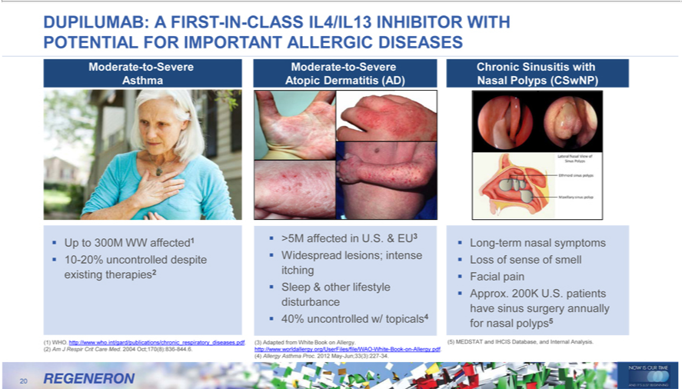

ModerateDUPILUMAB:-to-SevereAFIRSTAsthma-IN-CLASS IL4/IL13 INHIBITOR WITH POTENTIAL FOR IMPORTANT ALLERGIC DISEASES Up to 300M WW affected1 10-20% uncontrolled despite existing therapies2

>5MModerateaffectedSinusitis-to-SevereU.S.Atopic&EU3DermatitisWidespread(AD)lesions; intense itching Sleep & other lifestyle disturbance 40% uncontrolled w/ topicals4 Chronic with Nasal Polyps (CSwNP)
Long-term nasal symptoms Loss of sense of smell Facial pain Approx. 200K U.S. patients have sinus surgery annually for nasal polyps5
(5)1)3) AdaptedWHO.http://www.who.fromWhiteBookint/gard/publications/chronicAllergy.http://www.worldallergy.org/UserFiles/file/WAO_respiratory_diseases.pdf.(2)AmJ-RespirWhite-BookCritCare-on-Allergy.pdf.Med.2004Oct;170(8):836(4)AllergyAsthma-844.6.Proc. 2012 May-Jun;33(3):227-34.

20 MEDSTAT and IHCIS Database, and Internal Analysis.

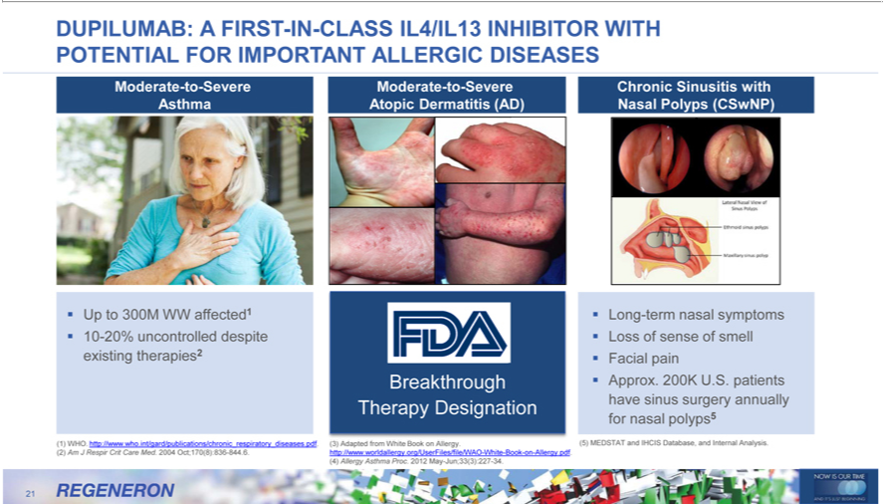

DUPILUMAB: A FIRST-IN-CLASS IL4/IL13 INHIBITOR WITH POTENTIAL FOR IMPORTANT ALLERGIC DISEASES
Moderate-to-Severe Asthma
Up to 300M WW affected1 10-20% uncontrolled despite existing therapies2
Moderate-to-Severe Atopic Dermatitis (AD)
Breakthrough Therapy Designation
Chronic Sinusitis with Nasal Polyps (CSwNP)
Long-term nasal symptoms Loss of sense of smell Facial pain Approx. 200K U.S. patients have sinus surgery annually for nasal polyps5
1) | WHO. http://www.who.int/gard/publications/chronic_respiratory_diseases.pdf.
2) | m J Respir Crit Care Med. 2004 Oct;170(8):836-844.6.
3) | dapted from White Book on Allergy. http://www.worldallergy.org/UserFiles/file/WAO-White-Book-on-Allergy.pdf.
4) | Allergy | Proc. 2012 May-Jun;33(3):227-34.
(5) | MEDSTAsthmaTand IHCIS Database, and Internal Analysis.
21

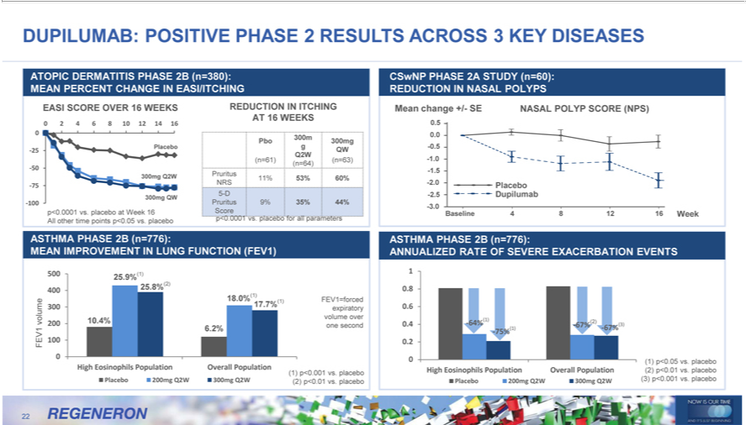

 |  |  | POSITIVE PHASE 2 RESULTS ACROSS 3 KEY DISEASES
DUPILUMAB:TOPICDERMATITIS PHASE 2B (n=380): MEAN PERCENT CHANGE IN EASI/ITCHING
EASI SCORE OVER 16 WEEKS REDUCTION IN ITCHING AT 16 WEEKS
0 2 4 6 8 10 12 14 16 0
 |  | 300m 300mg
Placebo g QW
-25
Q2W
(n=61) (n=64) (n=63)
-50
300mg Q2W Pruritus
11% 53% 60%
-75 NRS
5-D
300mg QW
-100 Pruritus 9% 35% 44% p<0.0001 vs. placebo at Week 16 Score p<0.0001 vs. placebo for all parameters All other time points p<0.05 vs. placebo
CSwNP PHASE 2A STUDY (n=60): REDUCTION IN NASAL POLYPS
Mean change +/- SE NASAL POLYP SCORE (NPS)
0.5 0.0 -0.5 -1.0 -1.5
2 |  | Placebo -2.5 Dupilumab
-3.0 |  | Baseline 4 8 12 16 Week
ASTHMA PHASE 2B (n=776):
MEAN IMPROVEMENT IN LUNG FUNCTION (FEV1)
5 |  | 25.9%(1) 25.8%(2)
400
(1)
 | 8 0% FEV1=forced
17.7%(1)
3 expiratory volume 10.4% volume over
200
6.2% one second
FEV1 100 0
High Eosinophils Population Overall Population
Placebo 200mg Q2W 300mg Q2W (1) p<0.001 vs. placebo
(2) p<0.01 vs. placebo
 | STHMA PHASE 2B (n=776):
ANNUALIZED RATE OF SEVERE EXACERBATION EVENTS
1 0.8 0.
0.4 -64%(1) (2) (3)
₋67% |  |  | -67% 0.2
075%(1)p<0.05 vs. placebo

High Eosinophils Population Overall Population (2) p<0.01 vs. placebo
22

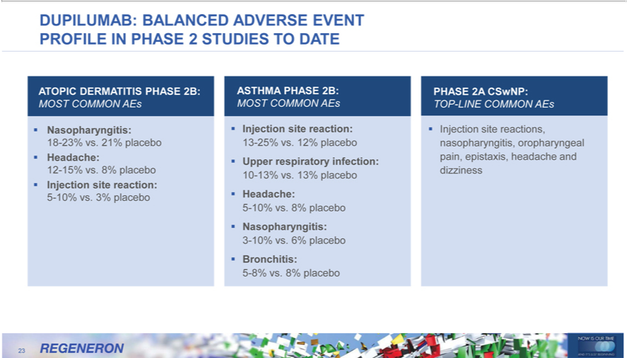

_{DUPILUMAB:} BALANCED ADVERSE EVENT PROFILE IN PHASE 2 STUDIES TO DATE
^{MOST}OPIC DERMATITIS PHASE 2B: ASTHMA PHASE 2B: PHASE 2A CSwNP:
Nasopharyngitis:COMMONInjectionAEsMOSTsitereaction:COMMONInjectionAEsTOPsite-reactions,LINECOMMON AEs
^{and}
Headache:18-23%vs.respiratory21%placeboinfection:13-25%pain,vs.12%epistaxis,placeboheadachenasoph ryngitis,Upperoropharyngeal
Injection12-15%vs.site8%reaction:placebo 10-13% vs. 13% placebo dizziness
5-10% vs. ^{3%}8% placebo ^{Headache:}
Nasopharyngitis:
Bronchitis:3-10%vs.6% placebo
5-8% vs. 8% placebo
23

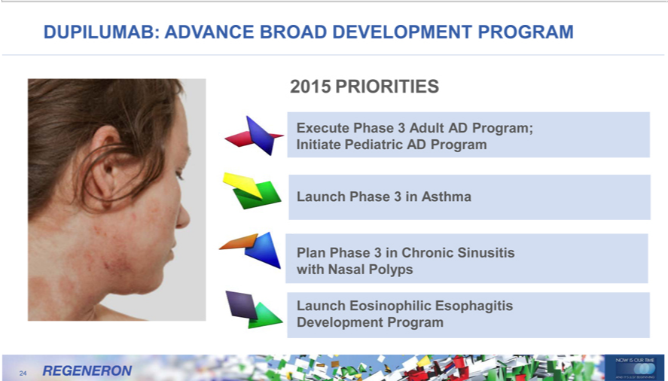

2015DUPILUMAB:PRIORITIESADVANCE BROAD DEVELOPMENT PROGRAM
LaunchExecute PhasePhase 33 inAdultAsthmaAD Program; Initiate Pediatric AD Program
Plan Phase_{Eosinophilic}3Chronic Sinusitis with Nasal Polyps
24Launch Esophagitis Development Program

SUPPORT EYLEA® AS THE RETINAL THERAPY OF CHOICE; MAINTAIN LEADERSHIP IN RETINAL DISEASE ®
25EYLEA will continue to drive top-line growth, supported by a growing body of clinical evidence

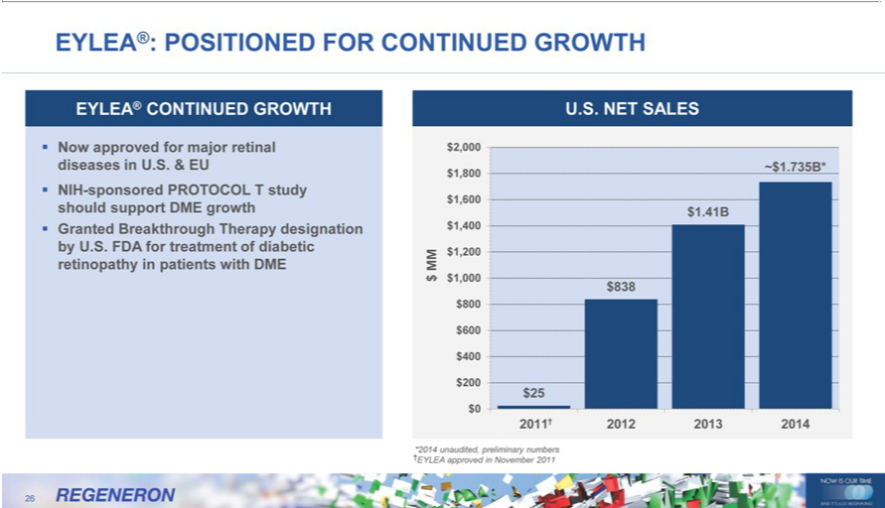

EYLEA®: POSITIONED FOR CONTINUED GROWTH EYLEA® CONTINUED GROWTH U.S. NET SALES Now approved for major retinal diseases in U.S. & EU NIH-sponsored PROTOCOL T study should support DME growth Granted Breakthrough Therapy designation by U.S. FDA for treatment of diabetic retinopathy in patients with DME $2,000 ~$1.735B* $1,800 $1,600 $1.41B $1,400 MM $1,200 $ $1,000 $838$800$600$400$200$25$02011†201220132014†*2014unaudited,preliminarynumbersEYLEAapprovedNovember201126REGENERONNOWISOURTIMEANDIT’SJUSTBEGINNING

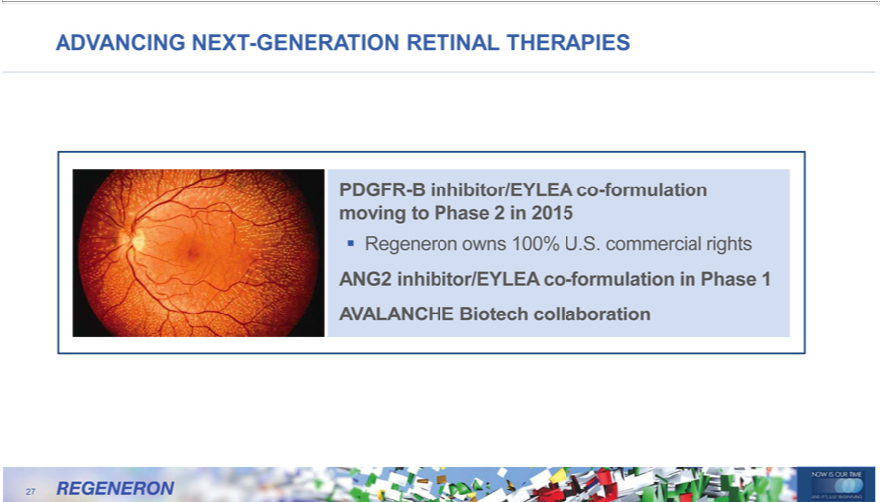

PDGFRADVANCING-Binhibitor/EYLEANEXT-GENERATION_{commercial}-formulationRETINALmovingTHERAPIEStoPhase2 in 2015

Regeneron owns 100% U.S. rights
27ANG2 inhibitor/EYLEA co-formulation in Phase 1 AVALANCHE Biotech collaboration

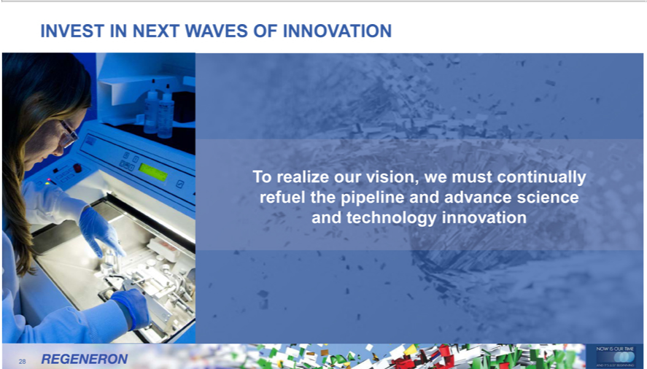

_{INVEST} IN NEXT WAVES OF INNOVATION
o realize our vision, we must continually refuel the pipeline and advance science and technology innovation 28

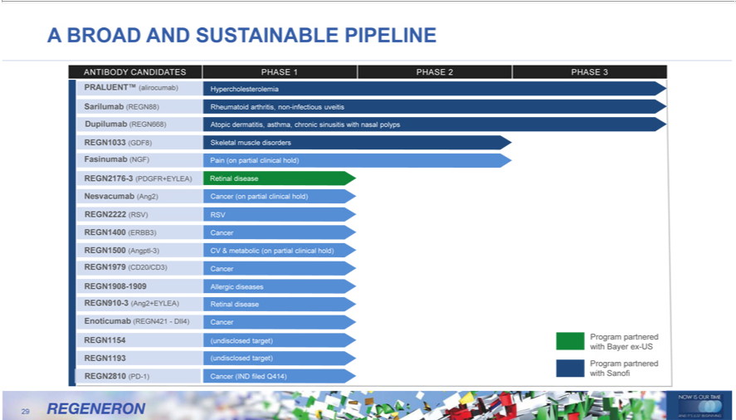

BROAD AND SUSTAINABLE PIPELINE
PRALUENT™ANTIBODYCANDIDATES(alirocumab) HypercholesterolemiaPHASE1PHASE2PHASE 3
Sarilumab (REGN88) Rheumatoid arthritis, non-infectious uveitis
Dupilumabetinal2222disease(REGN668)NesvacumabAtopic(Ang2)dermatitis,Cancerasthma,(onpartialchronicclinicalsinusitishold)with nasal polyps REGN1033 (GDF8) Skeletal muscle disorders Fasinumab (NGF) Pain (on partial clinical hold) REGN2176-3 (PDGFR+EYLEA)
RSV) RSV
REGN15004 (AngptlERBB3)-3)CancerCV& metabolic (on partial clinical hold) REGN1979 (CD20/CD3) Cancer REGN1908-1909 Allergic diseases REGN910-3 (Ang2+EYLEA) Retinal disease Enoticumab (REGN421—DII4)
REGN1193Cancer54 (undisclosed target) Program partnered with Bayer ex-US

Program partnered
29REGN2810 (PD-1) Cancer (IND filed Q414) with Sanofi

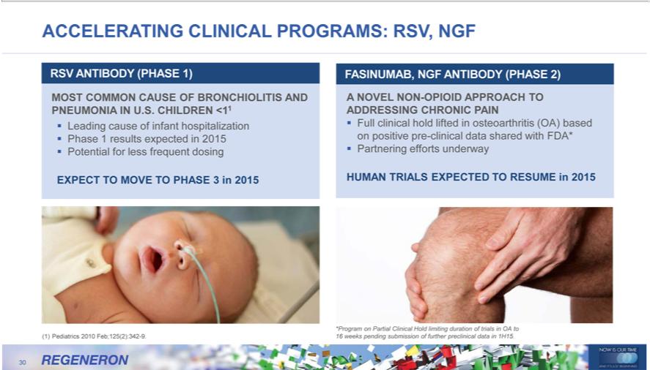

RSVACCELERATINGANTIBODY (PHASECLINICAL1) PROGRAMS: RSV, NGF
MOST COMMON CAUSE OF BRONCHIOLITIS AND PNEUMONIA IN U.S. CHILDREN <11 Leading cause of infant hospitalization Phase 1 results expected in 2015 Potential for less frequent dosing EXPECT TO MOVE _{ANTIBODY}PHASE3 in 2015
FASINUMAB, NGF (PHASE 2)
A NOVEL NON-OPIOID APPROACH^{(OA)}TADDRESSING CHRONIC PAIN
Full clinical hold lifted in osteoarthritis based on positive pre-clinical data shared with FDA* Partnering efforts underway HUMAN TRIALS EXPECTED TO RESUME in 2015
(1) Pediatrics 2010 Feb;125(2):342-9.
30*Program on Partial Clinical Hold limiting duration of trials in OA to 16 weeks pending submission of further preclinical data in 1H15.

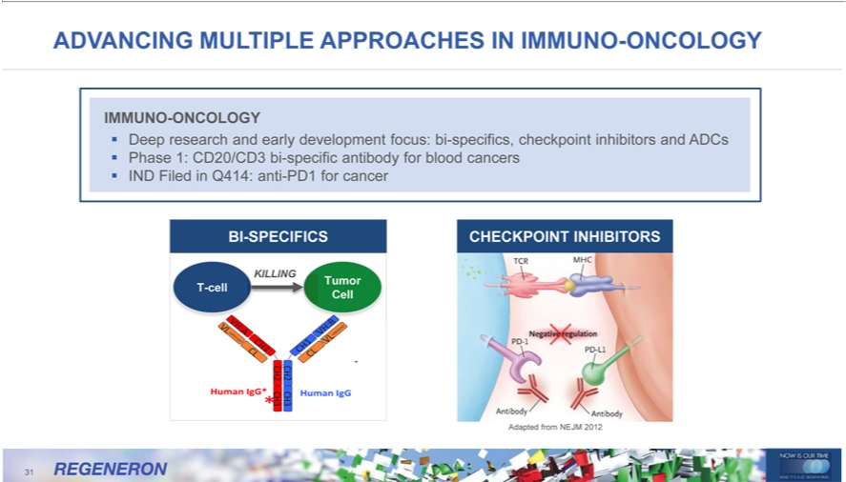

IMMUNOADVANCING-ONCOLOGYMULTIPLE APPROACHES IN IMMUNO-ONCOLOGY
Deep research and early development focus: bi-specifics, checkpoint inhibitors and ADCs Phase 1: CD20/CD3 bi-specific antibody for blood cancers IND Filed in Q414: anti-PD1 for cancer
KILLINGBI-SPECIFICS CHECKPOINT INHIBITORS
Tumor T-cell Cell
31Adapted from NEJM 2012



RAPID PROGRESS WITH REGENERON GENETICS CENTER
32Unprecedented Speed, Scale and Integration in Genetic Research

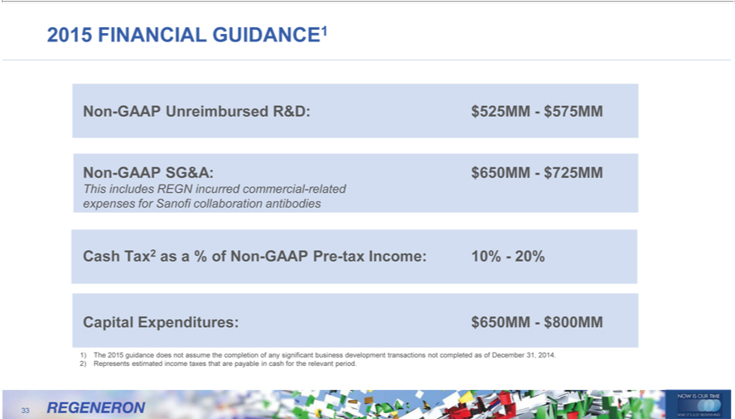

2015 FINANCIAL GUIDANCE1
^{Non-GAAP} Unreimbursed R&D: $525MM—$575MM
SG&A: $650MM—$725MM
_{Capital}ThisshincludesTax2as aREGN%of Nonincurred-GAAPcommercialPre-taxIncome:-related 10%—20%expensesfor Sanofi collaboration antibodies
Expenditures: $650MM—$800MM
²⁾
1)₃₃ RepresentsThe2015guidanceestimateddoesincomenotassumetaxesthatthe arecompletionpayable inof cashany significantfortherelevantbusinessperiod.development transactions not completed as of December 31, 2014.

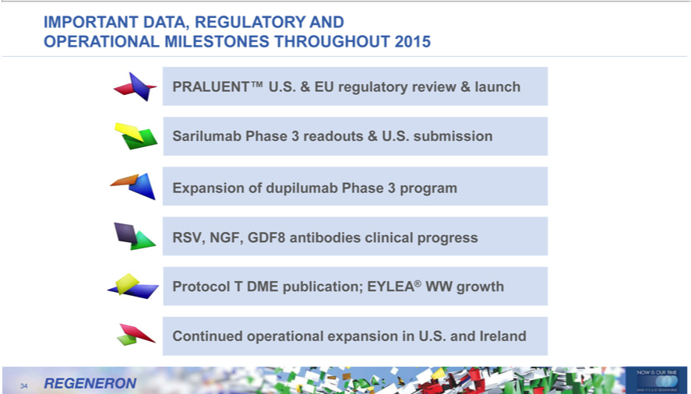

OPERATIONALIMPORTANTDA A, REGULATORYONESTHROUGHOUTAND 2015
PRALUENT™ UMILEST..&EU regulatory review & launch Sarilumab Phase 3 readouts & U.S. submission Expansion of dupilumab Phase 3 program RSV, NGF, GDF8 antibodies clinical progress Protocol T DME publication; EYLEA® WW growth Continued operational expansion in U.S. and Ireland
34



NOW IS OUR TIME
35AND IT’S JUST BEGNNING



36END

